**DRIVER ANALYSIS**

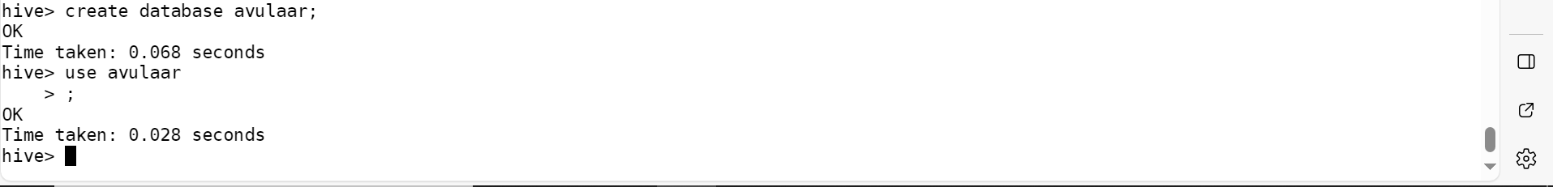

CREATE EXTERNAL TABLE driver_info1 (

> driverId INT,

> name STRING,

> ssn STRING,

> location STRING,

> certified STRING,

> wage_plan STRING

> )

> ROW FORMAT DELIMITED

> FIELDS TERMINATED BY ','

> STORED AS TEXTFILE

> tblproperties(

> "skip.header.line.count"="1"

> );



CREATE EXTERNAL TABLE timesheet_data1 (

> driverId INT,

> week INT,

> hours_logged DOUBLE,

> miles_logged DOUBLE

> )

> ROW FORMAT DELIMITED

> FIELDS TERMINATED BY ','

> STORED AS TEXTFILE

> tblproperties(

> "skip.header.line.count"="1"

> );



**Q1.How many total hours and miles logged by each driver**

SELECT

> t.driverId,

> SUM(t.hours_logged) AS total_hours_logged,

> SUM(t.miles_logged) AS total_miles_logged

> FROM timesheet_data1 t

>

> JOIN driver_info1 d ON t.driverId = d.driverId

>

> GROUP BY t.driverId;

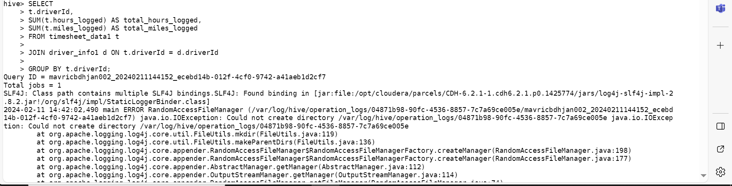

**Q2.Print the name of the driver in the above query**

SELECT

> t.driverId,

> d.name,

> SUM(t.hours_logged) AS total_hours_logged,

> SUM(t.miles_logged) AS total_miles_logged

> FROM timesheet_data1 t

> JOIN driver_info1 d ON t.driverId = d.driverId

> GROUP BY t.driverId, d.name

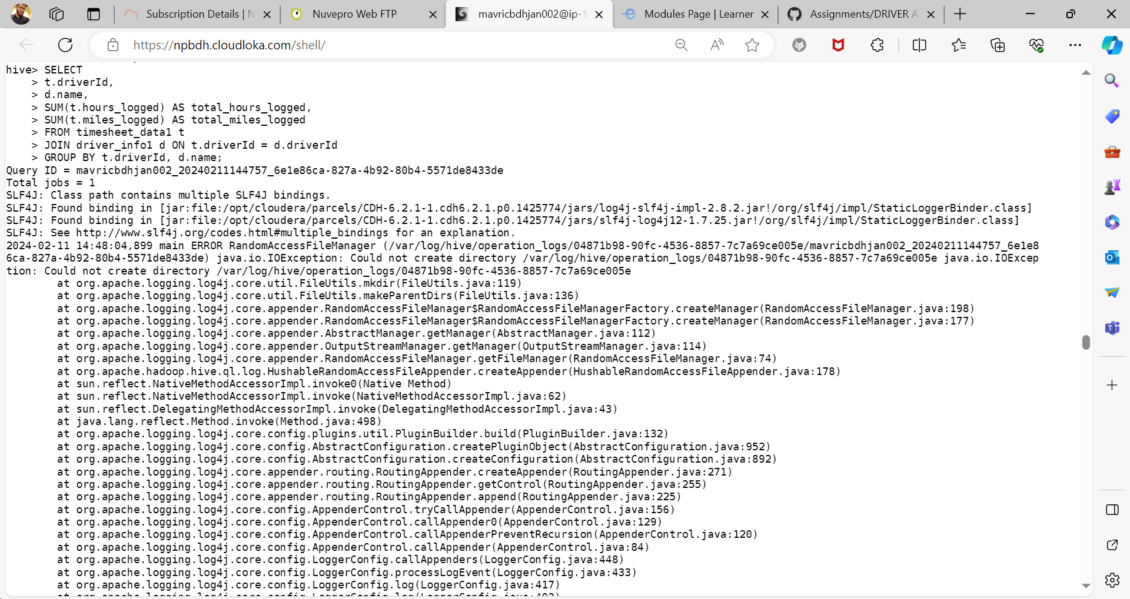

**Q3.Write the above query output in to hdfs director**

