**PROBLEM STATEMENT -1**

**PROBLEM STATEMENT-2**



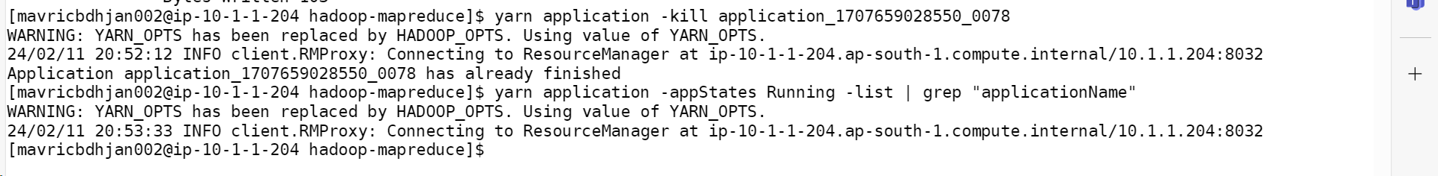

yarn logs -applicationId application_1707659028550_0078 -appOwner mavricbdhjan002

