hdfs dfs -mkdir -p rawdata/airline/flights

hdfs dfs -mkdir -p rawdata/airline/planeinfo

hdfs dfs -mkdir -p rawdata/airline/airport

hdfs dfs -mkdir -p rawdata/airline/carriers

CREATE DATABASE airline_db;

USE airline_db;

CREATE EXTERNAL TABLE Airports_stg (

    IATA STRING,

    Name STRING,

    City STRING,

    State STRING,

    Country STRING,

    Lat DECIMAL(9, 6),

    Long DECIMAL(9, 6)

)

ROW FORMAT DELIMITED

FIELDS TERMINATED BY ','

STORED AS TEXTFILE

LOCATION '/user/mavricbdhjan002/rawdata/airline/airport'

tblproperties(

"skip.header.line.count"="1"

);

CREATE EXTERNAL TABLE Carrier_stg (

    Code STRING,

    Description STRING

)

ROW FORMAT DELIMITED

FIELDS TERMINATED BY ','

STORED AS TEXTFILE

LOCATION '/user/mavricbdhjan002/rawdata/airline/carriers'

tblproperties(

"skip.header.line.count"="1"

);

CREATE EXTERNAL TABLE PlaneInfo_stg (

    tailNum STRING,

    type STRING,

    manufacturer STRING,

    issue_date STRING,

    model STRING,

    status STRING,

    aircraft_type STRING

)

ROW FORMAT DELIMITED

FIELDS TERMINATED BY ','

STORED AS TEXTFILE

LOCATION '/user/mavricbdhjan002/rawdata/airline/planeinfo'

tblproperties(

"skip.header.line.count"="1"

);

CREATE EXTERNAL TABLE Flights_stg (

    Year INT,

    Month INT,

    DayofMonth INT,

    DayOfWeek INT,

    DepTime INT,

    CRSDepTime INT,

    ArrTime INT,

    CRSArrTime INT,

    UniqueCarrier STRING,

    FlightNum STRING,

    TailNum STRING,

    ActualElapsedTime INT,

    CRSElapsedTime INT,

    AirTime INT,

    ArrDelay INT,

    DepDelay INT,

    Origin STRING,

    Dest STRING,

    Distance INT,

    TaxiIn STRING,

    TaxiOut STRING,

    Cancelled STRING,

    CancellationCode STRING,

    Diverted STRING,

    CarrierDelay INT,

    WeatherDelay INT,

    NASDelay INT,

    SecurityDelay INT,

    LateAircraftDelay INT

)

ROW FORMAT DELIMITED

FIELDS TERMINATED BY ','

STORED AS TEXTFILE

LOCATION '/user/mavricbdhjan002/rawdata/airline/flights'

tblproperties(

"skip.header.line.count"="1"

);

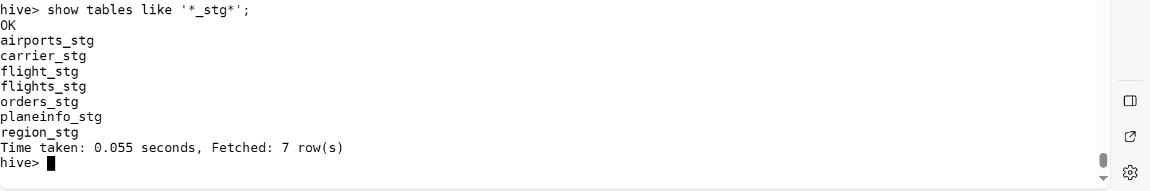

LOAD DATA INPATH 'rawdata/airline/airport/airports.csv' OVERWRITE INTO TABLE Airports_stg;

LOAD DATA INPATH '/rawdata/airline/carriers/carriers.csv' OVERWRITE INTO TABLE Carrier_stg;

LOAD DATA INPATH 'rawdata/airline/plane_info/plane-data.csv' OVERWRITE INTO TABLE PlaneInfo_stg;

LOAD DATA INPATH 'AirlinesOntimeAnalysis/2003.csv' OVERWRITE INTO TABLE Flights_stg;

LOAD DATA INPATH 'AirlinesOntimeAnalysis/2004.csv' OVERWRITE INTO TABLE Flights_stg;

LOAD DATA INPATH 'AirlinesOntimeAnalysis/2005.csv' OVERWRITE INTO TABLE Flights_stg;