Hybrid Neural Dynamics:
Wilson-Cowan + Learned Residual for
Neuropixels Visual Cortex Data
Research Literature Review and Diagnostic Analysis

Mohamad Faour
EECE 798K: Computational Neuroscience
March 2026

1. Introduction
This document presents a research literature review and diagnostic analysis for a hybrid neural dynamics model that combines a mechanistic Wilson-Cowan (WC) ordinary differential equation with a learned neural network residual. The model aims to capture stimulus-driven population dynamics in mouse visual cortex, using extracellular electrophysiology data from the Allen Brain Observatory Neuropixels dataset.
The core model takes the form:
dx/dt = f_WC(x, u(t), θ) + r_φ(x)
where f_WC is the Wilson-Cowan ODE with learnable biophysical parameters θ, u(t) is an external stimulus signal (gabor presentations), and r_φ is a multi-layer perceptron (MLP) residual that captures dynamics not explained by the mechanistic model. This hybrid approach falls under the framework of Universal Differential Equations (UDEs) introduced by Rackauckas et al. (2020), which embed universal function approximators directly within differential equations to combine scientific knowledge with data-driven flexibility.
After three iterations of model development, the hybrid model achieves a 65.5% improvement over the WC baseline (MSE against smoothed target), but the overall R² remains 0.06–0.11, indicating that the model explains only 6–11% of the variance in the neural data. This document systematically reviews the relevant literature, diagnoses the root causes of this poor performance, and proposes research-backed remedies.

2. Background and Theoretical Framework

2.1 The Wilson-Cowan Model
The Wilson-Cowan model (Wilson & Cowan, 1972) describes the mean-field dynamics of interacting excitatory (E) and inhibitory (I) neural populations. The standard equations are:
τ_E dE/dt = -E + S(w_EE · E - w_EI · I + h_E)
τ_I dI/dt = -I + S(w_IE · E - w_II · I + h_I)
where S(·) is a sigmoidal activation function, τ_E and τ_I are time constants, and h_E, h_I are external drives. Despite its simplicity, the model remains a foundational tool in computational neuroscience, capturing fixed points, limit cycles, and bifurcations that correspond to neural circuit behaviors (Destexhe & Sejnowski, 2009).
However, Coombes (2023) and others have emphasized that the Wilson-Cowan equations are only valid for quasi-stationary activity and break down for fast transients and coherent oscillations—precisely the regime of stimulus-driven Neuropixels data where neurons respond at 4Hz gabor frequency. Additionally, the derivation assumes the thermodynamic limit (infinite neurons), while real recordings sample finite populations, introducing mesoscopic noise effects not captured by the mean-field equations (Buice & Chow, 2013).

2.2 Universal Differential Equations
Rackauckas et al. (2020) introduced Universal Differential Equations (UDEs)—a framework that augments known mechanistic models with machine-learnable components. Rather than replacing scientific models entirely with neural networks, UDEs embed neural networks inside the differential equation to capture unknown or mis-specified dynamics. The approach allows end-to-end gradient-based optimization via differentiable ODE solvers and adjoint sensitivity analysis.
The key advantage of UDEs over pure neural ODEs (Chen et al., 2018) is scientific interpretability: the mechanistic parameters retain physical meaning (time constants, connectivity weights), while the neural network residual captures what the mechanistic model cannot. This decomposition allows researchers to ask: what fraction of the dynamics is explained by known biophysics versus unknown factors?

2.3 Neural ODEs and Latent Variable Models
Chen et al. (2018) introduced Neural Ordinary Differential Equations, parameterizing the derivative of a hidden state with a neural network: dz/dt = f_φ(z, t). The output is computed using a black-box differential equation solver, treating network depth as a continuous variable.
Rubanova et al. (2019) extended this to Latent ODEs—a variational autoencoder where the latent dynamics are governed by a neural ODE. An ODE-RNN encoder maps observed (potentially irregularly-sampled) time series into a latent initial condition z_0, and a neural ODE decoder evolves z_0 forward in time. A separate observation model then maps the latent trajectory z(t) to observed data Y(t). This separation is critical: the ODE operates in a space optimized for dynamical modeling, not constrained to match noisy observations directly.

2.4 LFADS and Poisson Observation Models
Pandarinath et al. (2018) developed LFADS (Latent Factor Analysis via Dynamical Systems)—a sequential variational autoencoder specifically designed for neural spiking data. LFADS models observed action potentials as samples from an inhomogeneous Poisson process, with firing rates determined by a low-dimensional dynamical system (an RNN "generator"). The key insight is that spike counts are noisy observations, not the underlying dynamics themselves.
The Poisson observation model specifies that the probability of observing k spikes in a time bin is: P(k | λ) = λ^k e^(-λ) / k!, where λ is the underlying firing rate. For binned spike counts, this means the variance equals the mean—a property that MSE loss on raw counts fails to account for. High-firing neurons contribute disproportionately to MSE, and the model wastes capacity trying to match sampling noise.

2.5 Multiple Shooting for Neural ODEs
Turan et al. (2021) demonstrated that standard single-shooting training of neural ODEs on oscillatory data often results in flattened trajectories that fail to describe the data. They proposed multiple shooting: splitting trajectories into shorter segments integrated in parallel, with a continuity constraint penalizing gaps between consecutive segments.
The continuity constraint takes the form of a penalty: L_cont = λ ∑ ||x(t_k+1) - x_0^(k+1)||^2, where x(t_k+1) is the terminal state of chunk k and x_0^(k+1) is the initial condition of chunk k+1. The penalty weight λ must be carefully tuned—too small and the trajectory is discontinuous, too large and the optimization landscape becomes ill-conditioned. The augmented Lagrangian method (Basir & Senocak, 2023) offers an adaptive alternative that automatically adjusts λ during training.

2.6 Allen Brain Observatory Neuropixels Data
The Allen Brain Observatory (Siegle et al., 2021) provides high-density extracellular electrophysiology recordings from the mouse visual system using Neuropixels probes. The Visual Coding dataset includes recordings from multiple visual cortical areas (VISp, VISl, VISal, VISpm, etc.) during passive viewing of various stimuli including gabor patches, drifting gratings, natural movies, and spontaneous activity.
For this project, we use session 794812542 (functional_connectivity stimulus set), focusing on four visual cortical regions: VISal, VISl, VISp, and VISpm. The first 5 minutes include approximately 69 seconds of spontaneous activity followed by gabor presentations at 4Hz (250ms each, 924 presentations). Spike counts are binned at 20ms resolution and subsampled to 200ms effective bins, yielding 1500 time points across 4 regions.

3. Current Model Architecture and Diagnostic Results

3.1 Model Architecture (Iteration 3)
The current hybrid model combines a multi-region Wilson-Cowan ODE with a 3-layer MLP residual (128 hidden units, tanh activations). Key features include: stimulus input u(t) as a binary gabor indicator fed into the excitatory equation, per-region stimulus sensitivity weights w_stim, multiple shooting with 75 chunks of 20 time steps (4 seconds each), two-phase training (Phase 1: WC-only for 30 epochs, Phase 2: full hybrid for 300 epochs), and Gaussian-smoothed target with σ = 0.6s.
The state space has dimensionality 8 (4 excitatory + 4 inhibitory populations), and the model directly predicts the excitatory states E(t) to match the observed normalized spike counts Y(t). There is no separate observation/decoder model.

3.2 Results Summary
Metric | WC Baseline | Hybrid Model
MSE (smoothed) | 0.00452 | 0.00156
MSE (raw) | 0.01355 | 0.01057
Improvement | — | 65.5% (smooth) / 22% (raw)

Region | Var(smooth) | Hybrid MSE | R²
VISal | 0.00210 | 0.00187 | 0.111
VISl | 0.00180 | 0.00160 | 0.114
VISp | 0.00106 | 0.00100 | 0.061
VISpm | 0.00189 | 0.00177 | 0.063

Table 1: The R² values of 0.06–0.11 indicate the model explains only 6–11% of the smoothed signal variance. For context, LFADS (Pandarinath et al., 2018) achieves R² > 0.8 on similar motor cortex data, though direct comparison is complicated by differences in brain region, task, and recording methodology.
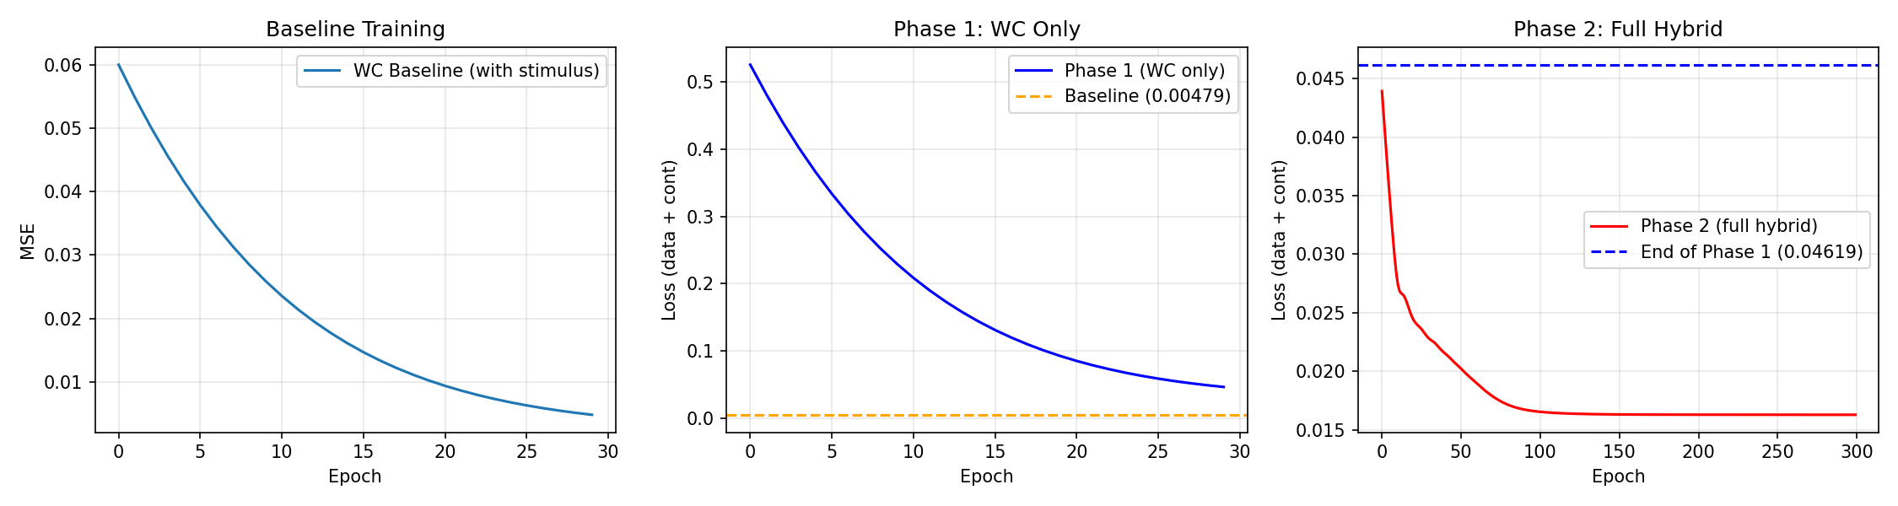
Figure 1: Training loss curves. Phase 1 (WC-only, 30 epochs) shows rapid descent but does not converge. Phase 2 (full hybrid, 300 epochs) plateaus around epoch 100–150, suggesting the model has reached its capacity limit under the current architecture.

4. Diagnostic Analysis: Why the Model Fails

4.1 Missing Observation Model (The Primary Failure)
The most critical architectural flaw is the absence of an observation model. The current design forces the ODE excitatory state E(t) to directly equal the normalized binned spike counts Y(t). This is fundamentally wrong for three reasons.
First, spike counts are Poisson-distributed samples of an underlying firing rate. The expected variance of a Poisson process scales with the mean, meaning high-activity periods have proportionally higher noise. No smooth ODE trajectory can track this sample-to-sample noise—the model is being asked to do something impossible.
Second, the ODE state space is constrained to the observation space. The latent dynamics must live in [0, 1] normalized spike count space rather than a natural latent space where dynamical modeling is easier. This forces the Wilson-Cowan parameters into unphysical regimes—evidenced by the learned W_EE being entirely negative (excitatory connections that are effectively inhibitory).
Third, the Gaussian smoothing applied to the target (with σ = 0.6s) is a band-aid that destroys temporal structure in the very frequency range (1–5 Hz) where stimulus-driven dynamics occur. The gabor presentations at 4Hz create ~250ms transients, and a 0.6s Gaussian filter attenuates these by >50%.

4.2 Insufficient Latent Dimensionality
The model uses only 8 latent dimensions (4E + 4I). Research on neural population latent structure (Cunningham & Yu, 2014; Pandarinath et al., 2018) consistently shows that 4–6 latent dimensions per neural population are needed to capture the shared variability in spike counts. With 4 brain regions, a latent space of 16–32 dimensions is more appropriate.
The current 8-dimensional space forces the Wilson-Cowan model to represent all cross-region dynamics through W_EE (a 4×4 matrix = 16 parameters) and the shared parameters. This is insufficient to capture the diversity of response profiles across VISp (primary), VISl (lateral), VISal (anterolateral), and VISpm (posteromedial).

4.3 Shared Parameters Across Heterogeneous Regions
The current model uses one set of biophysical parameters (one τ_E, one τ_I, one sigmoid gain a, one threshold θ, one h_E, one h_I) for all four brain regions. This is biologically unrealistic.
Research on mouse cortical hierarchy (Harris et al., 2019; Siegle et al., 2021) shows that visual areas differ substantially in their intrinsic timescales, excitatory/inhibitory balance, and stimulus response properties. VISp (primary visual cortex) has shorter temporal integration windows and stronger stimulus-driven responses than higher areas like VISpm. A study by Huang et al. (2022) using Wilson-Cowan models across 37 cortical areas explicitly incorporated per-region excitatory/inhibitory cell density ratios, demonstrating that heterogeneous local parameters are essential for accurate multi-region modeling.
The consequence of shared parameters is visible in the learned values: W_EE is entirely negative (all 16 entries), meaning the excitatory connectivity matrix has become inhibitory to compensate for the inability of the shared sigmoid/time-constant to represent different regional dynamics.

4.4 Broken Multiple Shooting Continuity
The diagnostic analysis reveals that chunk boundary discontinuities average 0.03, compared to within-chunk signal steps of 0.003—a 10x ratio. This means the trajectory is effectively discontinuous at every 4-second boundary, and the model is fitting 75 independent short segments rather than one coherent 300-second trajectory.
Region | Mean Boundary Jump | Mean Signal Step | Ratio
VISal | 0.033 | 0.0034 | 9.7x
VISl | 0.029 | 0.0031 | 9.4x
VISp | 0.025 | 0.0026 | 9.6x
VISpm | 0.032 | 0.0033 | 9.7x

Table 2: Chunk boundary discontinuities versus within-chunk signal steps. The 10x ratio indicates the continuity penalty (λ = 10) is insufficient to enforce trajectory coherence.
The fixed penalty λ = 10 creates a tension: increasing it too much destabilizes early training (the optimization must simultaneously fit data and enforce continuity), while keeping it too low allows discontinuities to persist. The augmented Lagrangian method addresses this by starting with a soft penalty and adaptively tightening it as training progresses (Basir & Senocak, 2023).

4.5 Highly Structured Residual Error
The temporal autocorrelation of the prediction error at lag 1 is 0.93 across all regions, indicating that the model systematically misses slow dynamics on the ~1–5 second timescale. This is the timescale of stimulus-driven modulation (gabor blocks, adaptation effects, and neural population state transitions), suggesting the model architecture cannot represent these dynamics—not that it needs more training.
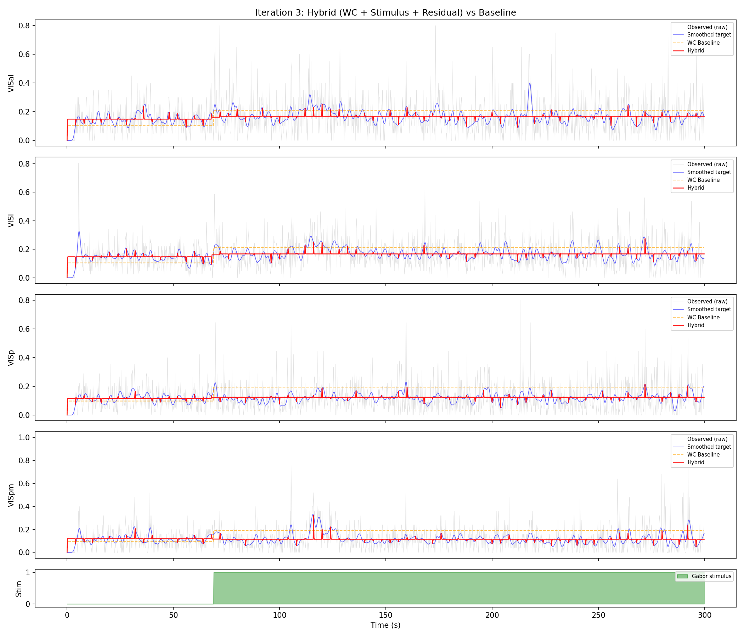
Figure 2: Iteration 3 results. The hybrid model (red) tracks the smoothed target (blue) better than the WC baseline (orange), but systematically undershoots peaks and overshoots troughs, consistent with the high error autocorrelation.

5. Proposed Remedies (Research-Backed)

5.1 Remedy 1: Latent ODE with Observation Decoder
Impact: HIGH. This is the single most important architectural change.
Following Rubanova et al. (2019) and the LFADS framework (Pandarinath et al., 2018), we separate the model into a latent dynamical system and an observation model:
dz/dt = f_WC(z, u(t), θ) + r_φ(z) [latent dynamics in R^d]
Y_hat(t) = g_ψ(z(t)) [observation decoder: R^d → R^4]
The ODE evolves in a d-dimensional latent space (d >> 8), and a small decoder MLP g_ψ maps the latent state to the 4 observed neural regions. This separation offers three benefits: (1) the ODE state is no longer constrained to the [0,1] observation space, allowing the Wilson-Cowan dynamics to operate in a natural regime; (2) the decoder absorbs the observation noise, letting the ODE model smooth underlying dynamics; (3) the latent space can be higher-dimensional, giving the model more capacity to represent complex multi-region interactions.

5.2 Remedy 2: Expanded Latent Dimensionality
Impact: MEDIUM-HIGH. Directly addresses the capacity bottleneck.
Increase the latent state from 8 to 16–24 dimensions. The Wilson-Cowan core retains its E/I structure but with more populations (e.g., 8E + 8I = 16, representing sub-populations within each visual area). The decoder projects this 16-dimensional state down to 4 observed activity values. Research by Cunningham & Yu (2014) on neural population dimensionality suggests that the intrinsic dimensionality of visual cortical activity during stimulus presentation is typically 5–15, supporting a latent space of this size.

5.3 Remedy 3: Per-Region Biophysical Parameters
Impact: MEDIUM-HIGH. Removes the biological constraint violation.
Give each region its own set of Wilson-Cowan parameters: τ_E^(i), τ_I^(i), a^(i), θ^(i), h_E^(i), h_I^(i), and w_stim^(i) for i = 1,...,4. This adds approximately 24 parameters (6 per region) but allows the model to represent the known heterogeneity of visual cortical areas. This approach is supported by Huang et al. (2022), who showed that per-region parameterization of Wilson-Cowan models is necessary for accurate multi-area cortical modeling.

5.4 Remedy 4: Adaptive Continuity via Augmented Lagrangian
Impact: MEDIUM. Fixes the broken trajectory stitching.
Replace the fixed penalty λ = 10 with an augmented Lagrangian scheme. The loss becomes:
L = L_data + μ^T c + (ρ/2) ||c||^2
where c is the vector of continuity violations, μ is a vector of Lagrange multipliers updated after each epoch (μ ← μ + ρ c), and ρ is a penalty parameter that increases when continuity is not improving. This approach starts soft (allowing the model to first find a good data fit) and gradually tightens (forcing trajectory coherence), avoiding the early-training instability of large fixed penalties.

5.5 Remedy 5: Poisson Log-Likelihood Loss
Impact: MEDIUM. Proper noise model for count data.
Replace MSE loss on normalized counts with a Poisson negative log-likelihood:
L_data = -∑ [Y_raw · log(λ) - λ - log(Y_raw!)]
where λ = softplus(g_ψ(z(t))) · (y_max - y_min) + y_min maps the decoder output back to expected spike count space. This properly weights the contribution of each time bin: high-count bins (which have higher Poisson variance) are expected to have larger deviations, while low-count bins are expected to be more precise. This eliminates the need for Gaussian smoothing of the target—the loss function itself handles the noise model.

6. Implementation Plan for Iteration 4
All five remedies are compatible and can be implemented simultaneously within the Kaggle GPU compute budget. The revised model architecture is:
dz/dt = f_WC(z, u(t), {θ_i}) + r_φ(z) where z ∈ R^16
Y_hat = softplus(W_dec · z_E + b_dec)
The following table summarizes the implementation changes:
Component | Current (Iteration 3) | Proposed (Iteration 4)
State dim | 8 (4E + 4I) | 16 (8E + 8I)
Observation | E(t) = Y(t) directly | Y_hat = decoder(z(t))
WC params | Shared across regions | Per-region τ, a, θ, h
Loss function | MSE on smoothed Y | Poisson NLL on raw counts
Continuity | Fixed λ = 10 | Augmented Lagrangian
Target | Gaussian-smoothed | Raw spike counts

Table 3: Summary of architectural changes from Iteration 3 to Iteration 4.

7. References
Basir, S., & Senocak, I. (2023). Enhanced physics-informed neural networks with Augmented Lagrangian relaxation method (AL-PINNs). Neurocomputing, 548, 126390.
Buice, M. A., & Chow, C. C. (2013). Beyond mean field theory: statistical field theory for neural networks. Journal of Statistical Mechanics, P03003.
Chen, R. T. Q., Rubanova, Y., Bettencourt, J., & Duvenaud, D. (2018). Neural Ordinary Differential Equations. NeurIPS 2018. arXiv:1806.07366.
Coombes, S. (2023). Before and beyond the Wilson-Cowan equations. Journal of Neurophysiology, 130(4), 1014-1032.
Cunningham, J. P., & Yu, B. M. (2014). Dimensionality reduction for large-scale neural recordings. Nature Neuroscience, 17(11), 1500-1509.
Destexhe, A., & Sejnowski, T. J. (2009). The Wilson-Cowan model, 36 years later. Biological Cybernetics, 101(1), 1-2.
Harris, J. A., et al. (2019). Hierarchical organization of cortical and thalamic connectivity. Nature, 575(7781), 195-202.
Huang, Z., et al. (2022). Extracting Dynamical Understanding From Neural-Mass Models of Mouse Cortex. Frontiers in Computational Neuroscience, 16, 847336.
Pandarinath, C., et al. (2018). Inferring single-trial neural population dynamics using sequential auto-encoders. Nature Methods, 15(10), 805-815.
Rackauckas, C., et al. (2020). Universal Differential Equations for Scientific Machine Learning. arXiv:2001.04385.
Rubanova, Y., Chen, R. T. Q., & Duvenaud, D. (2019). Latent ODEs for Irregularly-Sampled Time Series. NeurIPS 2019. arXiv:1907.03907.
Siegle, J. H., et al. (2021). Survey of spiking in the mouse visual system reveals functional hierarchy. Nature, 592(7852), 86-92.
Turan, E., & Jäschke, J. (2021). Multiple Shooting for Training Neural Differential Equations on Time Series. arXiv:2109.06786.
Wilson, H. R., & Cowan, J. D. (1972). Excitatory and inhibitory interactions in localized populations of model neurons. Biophysical Journal, 12(1), 1-24.

