Assignment -02
Roll No – 12515000953
Name – Mohammad Ibran
Subject – DSA Recursion

Q1. Print Numbers from 1 to N
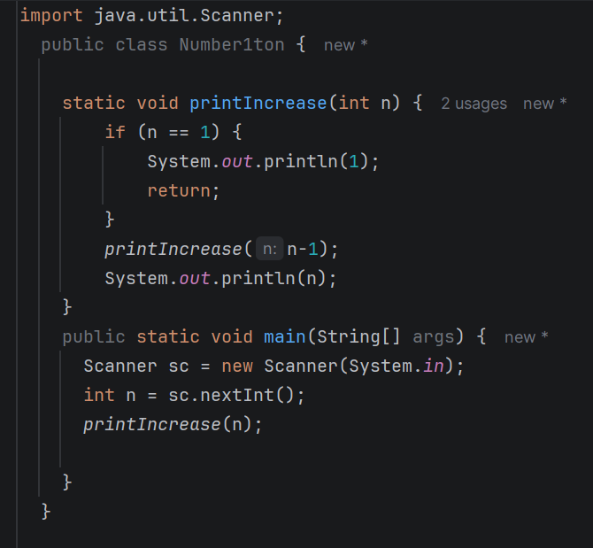
Q2. Print Numbers from N to 1
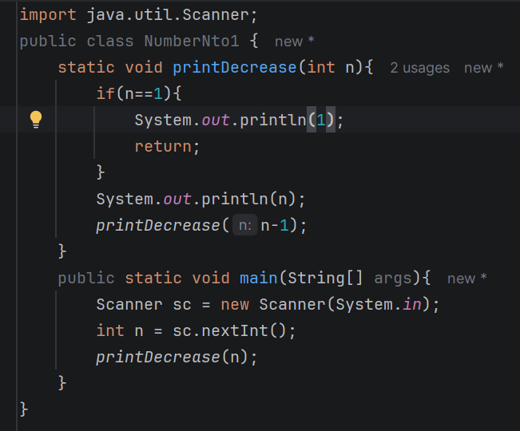
Q3. Print Even Numbers from 1 to N
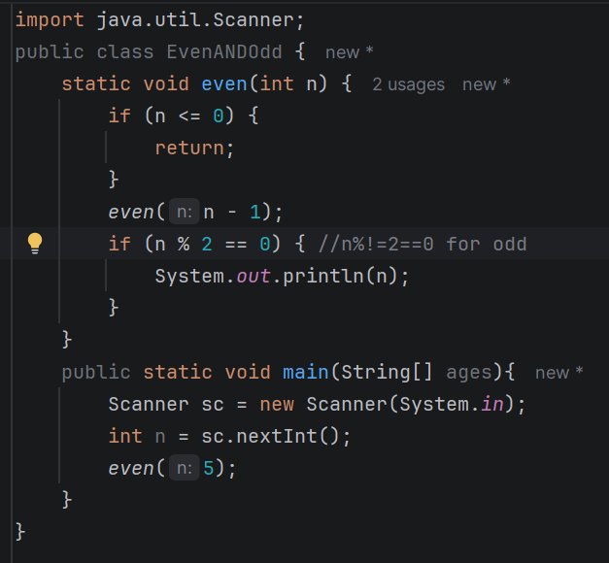
Q4. Print Odd Numbers from 1 to N
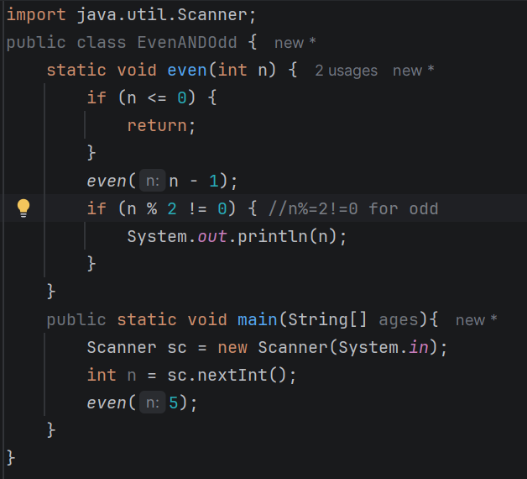
Q5. Sum of Digit N Natural Numbers
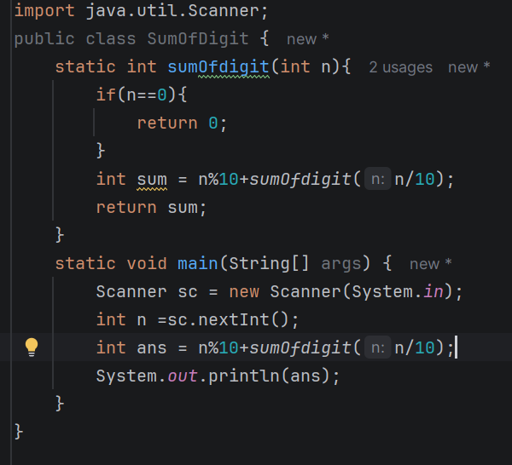
Q6. Factorial of a Number
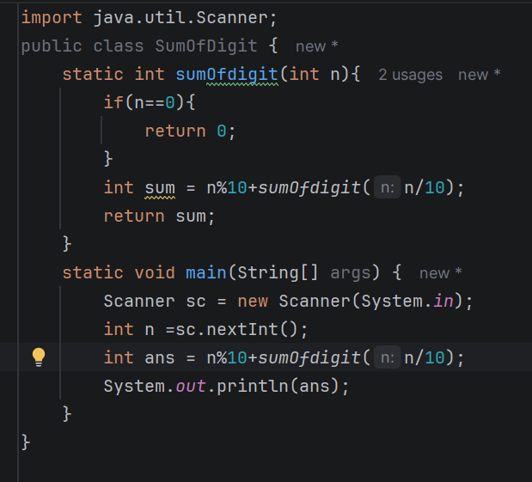
Q7. Reverse a String
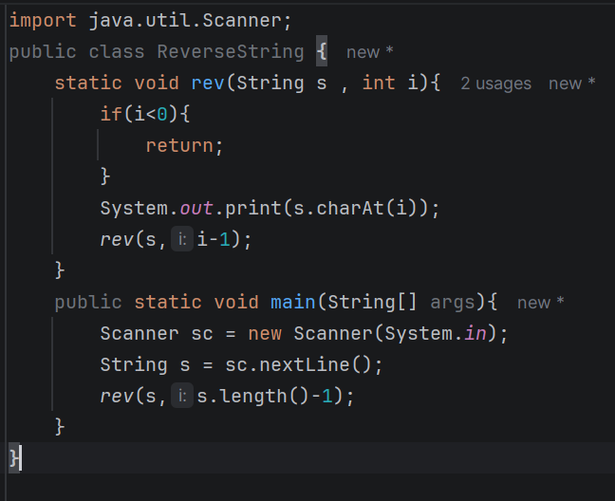
Q8. Check Whether a String Is a Palindrome
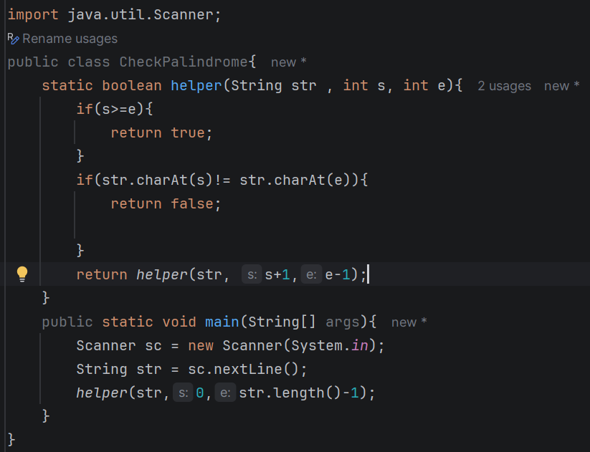
Q9. Reverse a Number
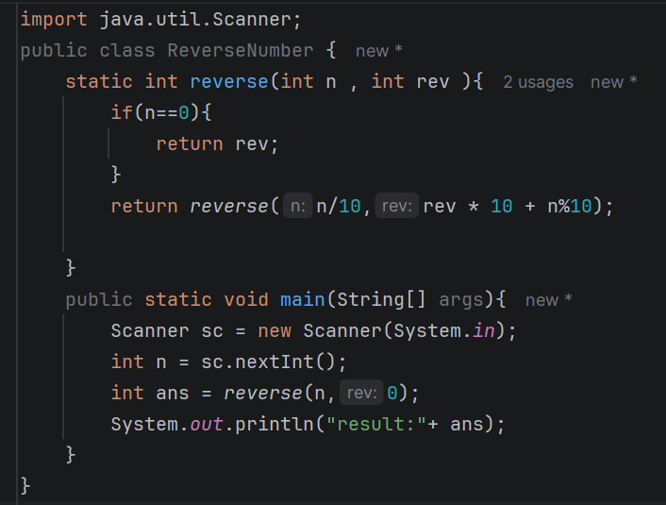
Q13. Power of a Number
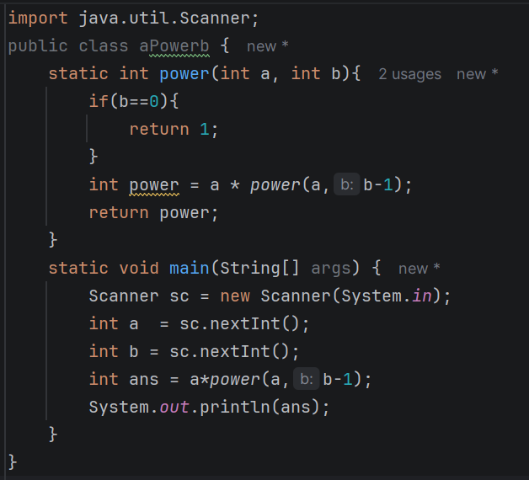
Q14. Fibonacci Series
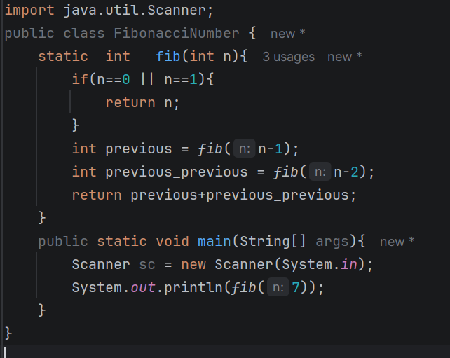
Q15. GCD of Two Numbers
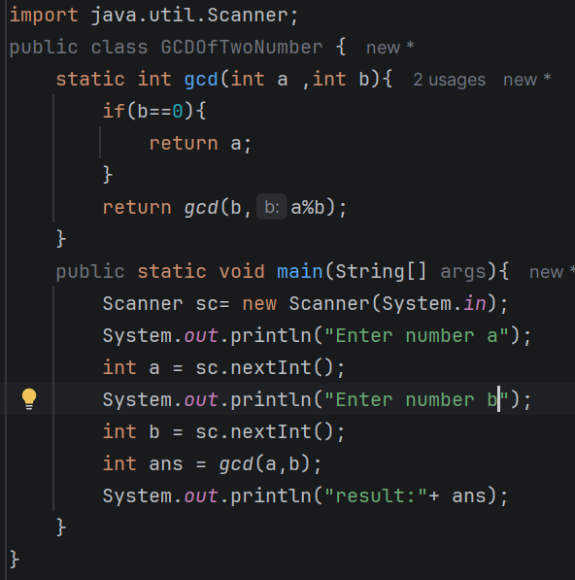
Q22. Check Whether an Array Is Sorted
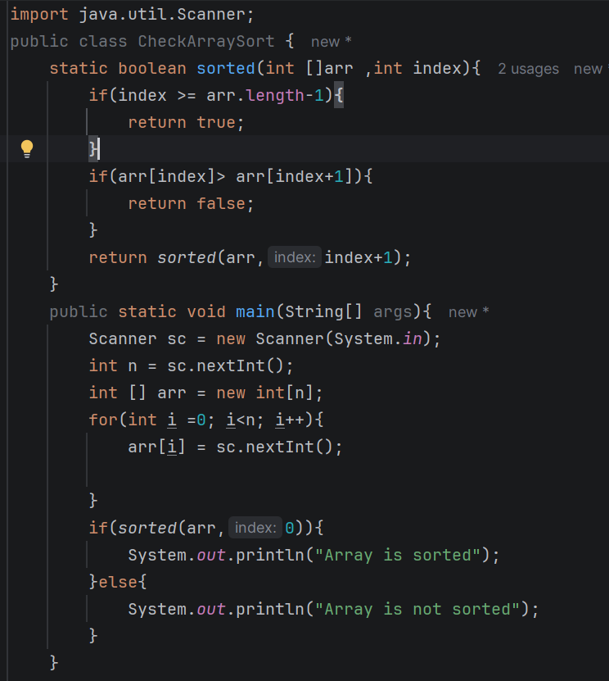
Q23. Find the Maximum Element in an Array
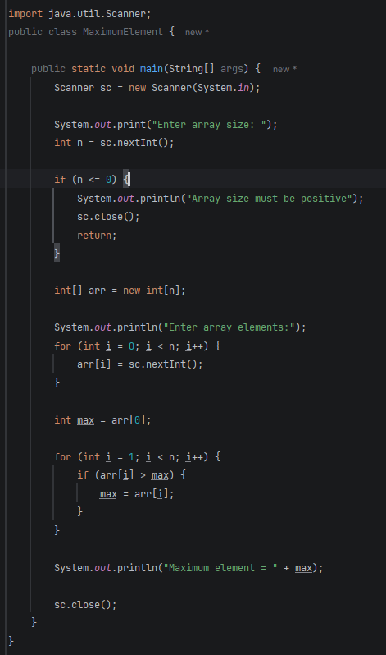
Q24. Find the Minimum Element in an Array

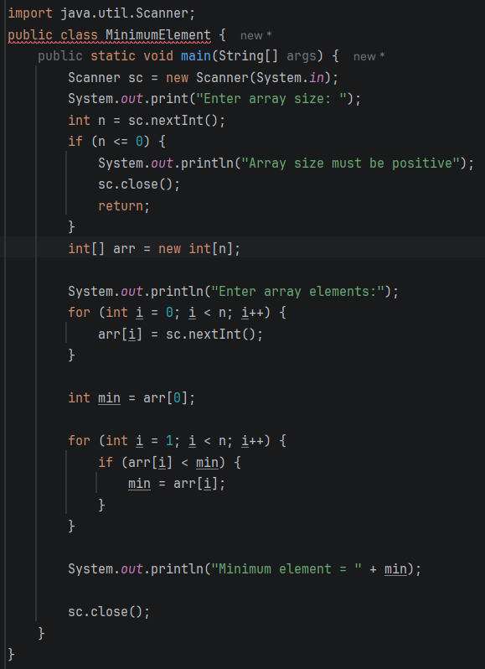
Q25. Binary Search Using Recursion
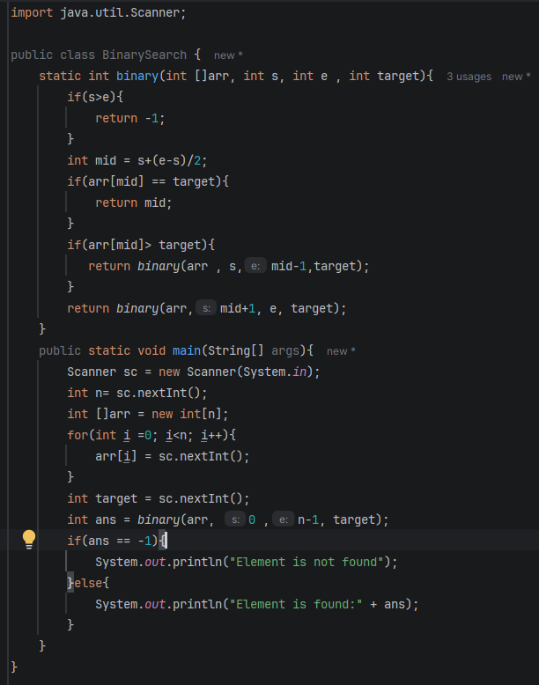
Q26. Linear Search Using Recursion

