MedCore HMS
Hospital Management System — Project Report
A full-stack hospital management platform covering appointment scheduling, clinical records, pharmacy, laboratory workflows, billing, and multi-role access control across nine hospital staff and patient roles.

1. Introduction

1.1 Project Overview
MedCore HMS is a hospital management system built to digitize the day-to-day operations of a multi-hospital healthcare provider. The system covers the full patient journey — from appointment booking and clinical consultation through prescription dispensing, laboratory testing, and invoicing — while supporting nine distinct user roles, each with a dedicated dashboard and permission set: Super Admin, Hospital Admin, Doctor, Nurse, Receptionist, Lab Technician, Pharmacist, Accountant, and Patient.
The platform is built as a pnpm monorepo with a NestJS/Prisma/PostgreSQL backend and a Next.js frontend, and is deployed as a live, publicly accessible system rather than a local-only demo, so that its behaviour under real network and infrastructure conditions can be verified directly.

1.2 Objectives
- Provide role-based clinical and administrative workflows for a multi-hospital deployment.
- Model realistic hospital operations end-to-end: booking → consultation → prescription/lab order → dispensing/results → invoicing.
- Enforce authentication, authorization, and data protection appropriate for handling health-related data.
- Document the system architecture, database design, and API surface to a standard suitable for independent review.
- Deploy the system to a live, publicly reachable environment backed by managed cloud infrastructure.

1.3 Technology Stack
Layer | Technology | Notes
Backend framework | NestJS (Node.js/TypeScript) | Modular controller/service architecture
ORM / Database | Prisma ORM + PostgreSQL | PrismaPg adapter, custom client output path
Frontend framework | Next.js (React/TypeScript) | Nine role-specific dashboards
Cache / Sessions | Redis | Managed via Upstash in production
API Documentation | @nestjs/swagger (OpenAPI) | Live interactive docs at /api/docs
Package management | pnpm workspaces | Monorepo: apps/backend, apps/frontend, packages/shared-types
Containerization | Docker + docker-compose | Backend, frontend, Postgres, Redis, Nginx
Authentication | JWT (access + refresh tokens) | bcrypt password hashing
Payments | Razorpay | Webhook-verified payment confirmation
Notifications | Resend (email), Twilio (SMS) | Integrated via dedicated service modules

2. Requirements & Scope

2.1 User Roles & Functional Scope
The system supports nine roles, each scoped to a specific slice of hospital operations:
Role | Primary Responsibilities
Super Admin | Platform-wide oversight; verifies/rejects new hospital registrations
Hospital Admin | Manages a single hospital’s departments, staff, and operational settings
Doctor | Conducts appointments, writes medical records, prescriptions, and lab orders
Nurse | Supports clinical workflows and patient care coordination
Receptionist | Books and manages patient appointments
Lab Technician | Processes lab orders: sample collection through result entry
Pharmacist | Dispenses prescriptions and manages medicine inventory/batches
Accountant | Generates and finalizes invoices; tracks payments
Patient | Books appointments, views records, prescriptions, invoices, and pays online

2.2 Non-Functional Requirements
- Security: encrypted transport, hashed credentials, role-based authorization on every endpoint, and audit logging of sensitive actions.
- Documentation: an interactive, always-current API reference generated directly from backend code.
- Deployability: the system must run both in a fully local, self-contained environment (docker-compose) and as a live, publicly reachable deployment on managed cloud infrastructure.
- Data integrity: relational constraints enforced at the database layer via a strongly-typed Prisma schema, not just application logic.
- Auditability: every consequential clinical and financial action traceable via structured audit records.

3. System Architecture
MedCore HMS is designed to run in two distinct configurations: a fully self-contained local environment orchestrated with docker-compose, and a live production deployment distributed across managed cloud platforms. Both are documented below, reflecting what is actually built and running rather than a purely aspirational design.

3.1 Local / Development Architecture (docker-compose)
Locally, the system runs as five coordinated containers behind an Nginx reverse proxy: the Next.js frontend, the NestJS backend, PostgreSQL, Redis, and Nginx itself, which routes browser traffic to the appropriate service based on path.
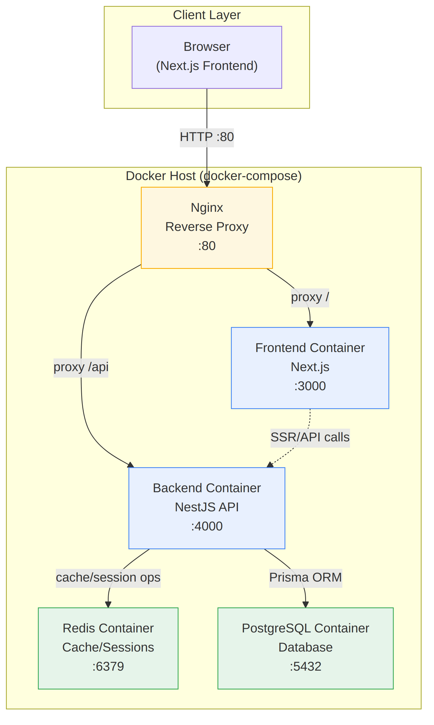
Figure 3.1 — Local development architecture (docker-compose, verified running with all five services).

3.2 Live Production Architecture
The live deployment distributes each concern to a dedicated managed provider rather than a single self-hosted stack. This trades some infrastructure control for substantially lower operational overhead and faster, more reliable deployment — a deliberate choice appropriate for a system of this scope. The frontend is served from Vercel’s edge network; the backend runs as a Docker container on Render; PostgreSQL is hosted on Neon (serverless Postgres); and Redis is hosted on Upstash (serverless Redis). All inter-service traffic uses TLS.
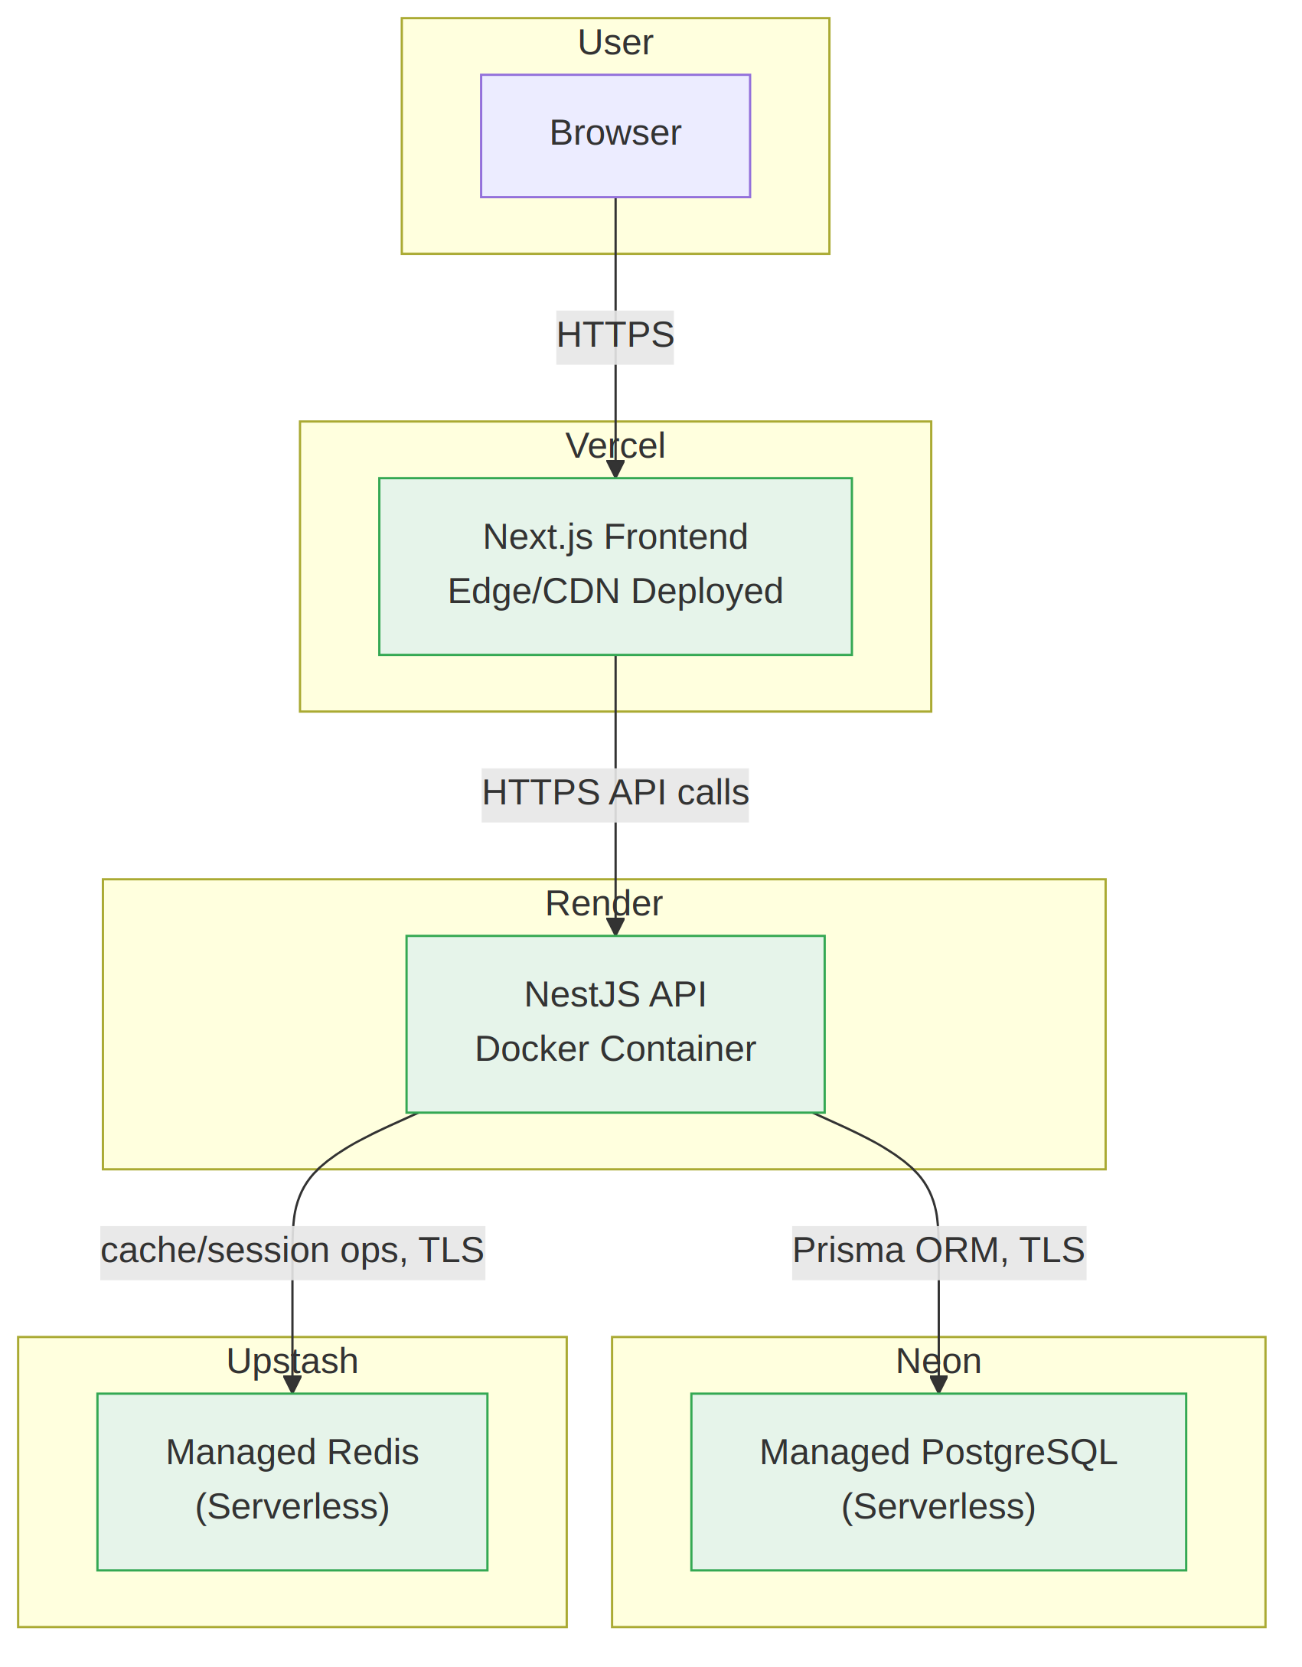
Figure 3.2 — Live production deployment architecture (Vercel + Render + Neon + Upstash).

3.3 Component Responsibilities
Component | Responsibility
Frontend (Next.js) | Renders nine role-specific dashboards; calls the backend REST API
Backend (NestJS) | Enforces business rules, authentication/authorization, and data validation
PostgreSQL / Neon | System of record for all relational data (19 models)
Redis / Upstash | Caching and session-related operations
Nginx (local only) | Reverse-proxies browser traffic to frontend/backend containers
Swagger / OpenAPI | Machine- and human-readable contract for every backend endpoint

4. Database Design

4.1 Entity-Relationship Diagram
The schema comprises 19 models covering identity, hospital administration, clinical workflows, pharmacy, laboratory operations, and billing. The diagram below is generated directly from the live Prisma schema (via prisma-erd-generator), not hand-drawn, so it stays accurate as the schema evolves.
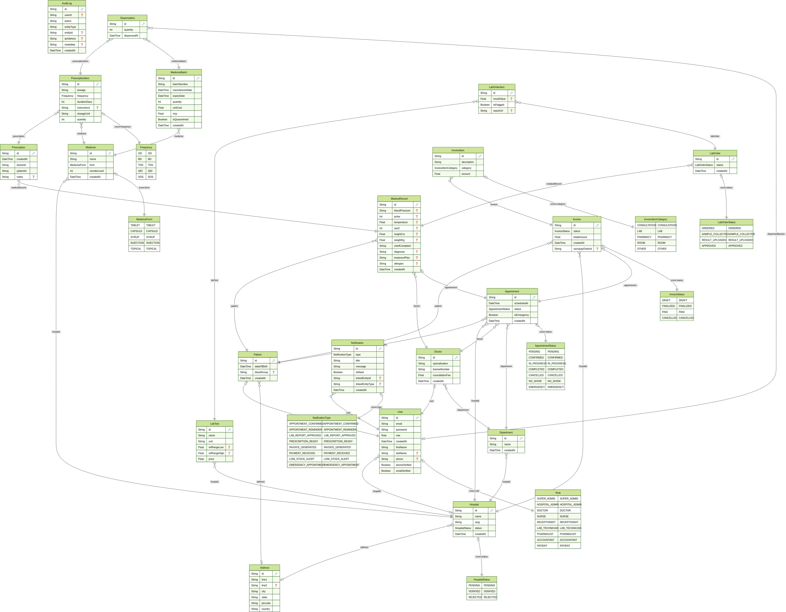
Figure 4.1 — Entity-relationship diagram generated from schema.prisma (19 models).

4.2 Key Design Decisions
- Patient records are hospital-agnostic by design: a Patient has no direct hospitalId. Association with a hospital happens implicitly through Appointment.hospitalId, allowing a single patient record to be treated across multiple hospitals without duplication.
- Staff accounts (User.hospitalId) are nullable specifically to accommodate PATIENT and SUPER_ADMIN roles, which are not scoped to a single hospital, while every staff role is bound to exactly one hospital.
- Prisma’s client is generated to a custom output path (generated/prisma) rather than the default node_modules location, and uses the PrismaPg driver adapter for connection handling.
- Cascading clinical relationships (Appointment → MedicalRecord → Prescription / LabOrder / Invoice) mirror a real consultation’s downstream effects, rather than treating each record type as an independent, disconnected entity.

4.3 Core Enumerations
Enum | Values
Role | 9 values: SUPER_ADMIN, HOSPITAL_ADMIN, DOCTOR, NURSE, RECEPTIONIST, LAB_TECHNICIAN, PHARMACIST, ACCOUNTANT, PATIENT
HospitalStatus | PENDING, VERIFIED, REJECTED
AppointmentStatus | Lifecycle states from booking through completion or cancellation
InvoiceStatus | Lifecycle states from draft through finalized/paid
LabOrderStatus | Lifecycle states from ordered through result approval

5. Implementation

5.1 Backend Modules
The backend exposes a modular REST API, with one controller per clinical or administrative domain:
Module | Representative Endpoints
Appointments | /appointments/today, /appointments/:id
Medical Records | /medical-records, /medical-records/by-appointment/:id
Prescriptions | /prescriptions, /prescriptions/pending
Lab Orders | /lab-orders/queue, /lab-orders/:id/collect, /lab-orders/:id/result, /lab-orders/:id/approve
Pharmacy | /medicines, /medicine-batches, /dispense
Invoices | /invoices/:id/finalize, /invoices/:id/mark-paid, /invoices/suggested-charges/:appointmentId
Payments | /payments/create-order, /payments/webhook (Razorpay integration)
Patients | /patients
Staff | /staff

5.2 Frontend Dashboards
The Next.js frontend implements nine role-specific dashboards, each surfacing only the data and actions relevant to that role, consistent with the backend’s authorization model: Patient, Doctor, Pharmacist, Receptionist, Hospital Admin, Super Admin, Lab Technician, Accountant, and Nurse. Rather than a single generic interface gated by permission checks, each role gets a purpose-built navigation and workflow — a Receptionist sees appointment and invoicing tools, a Doctor sees an encounter-focused clinical workflow, and so on — so the interface itself reflects each person’s actual job rather than exposing a lowest-common-denominator dashboard everyone has to work around.
The screenshots below are taken directly from the live deployment and follow one real patient (Leta Dach) through the appointment-to-invoice workflow across four different role dashboards — demonstrating the same data flowing correctly through the system as different staff members act on it, rather than four disconnected, independently-populated screens.
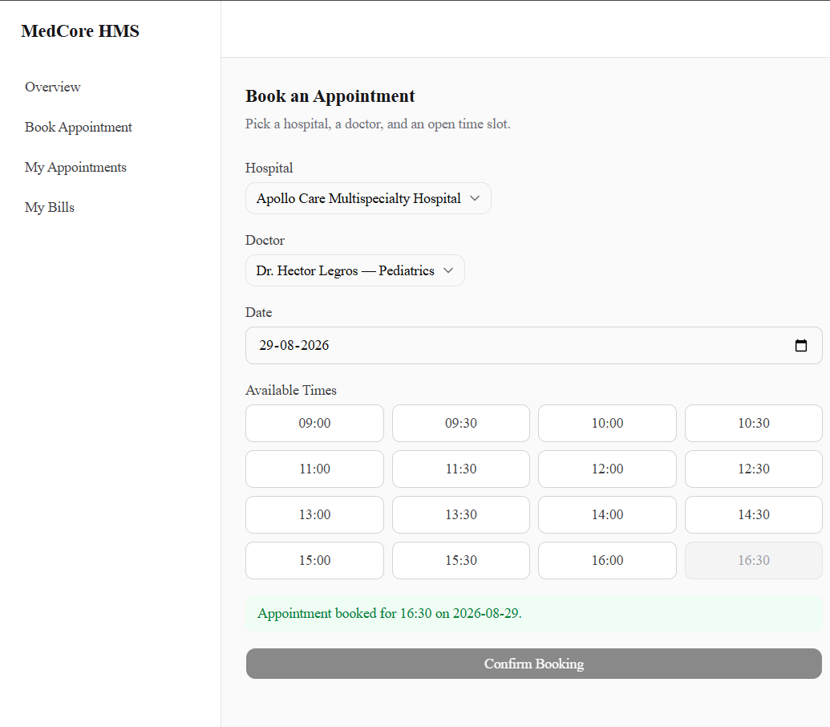  Figure 5.1 — Patient: booking an appointment. | 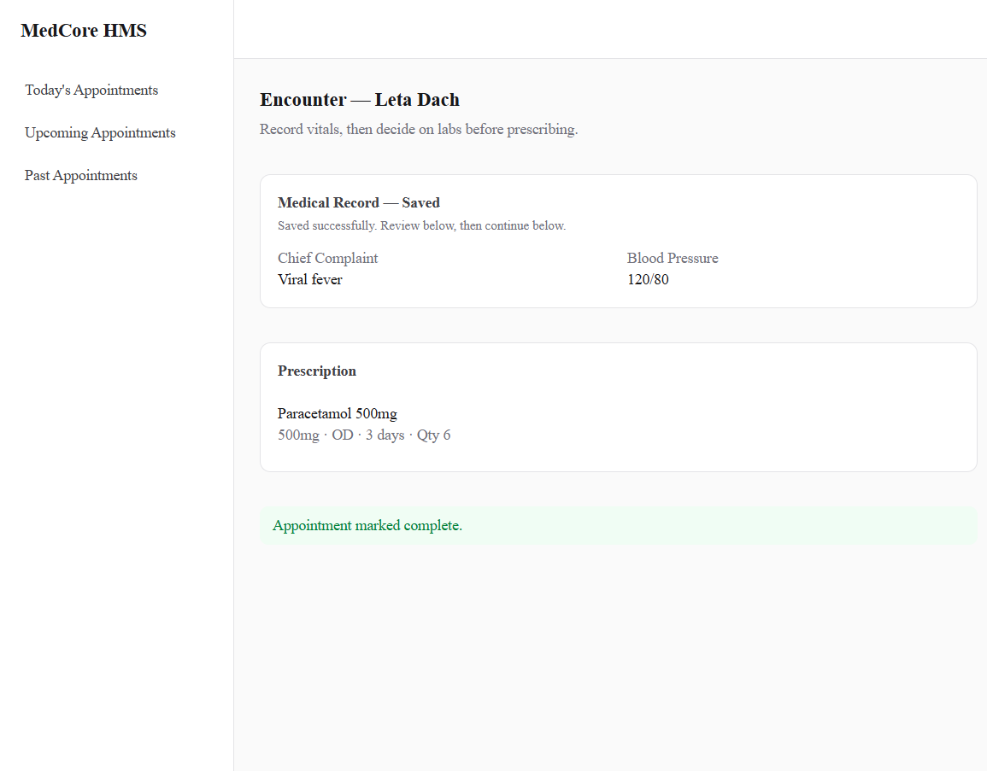  Figure 5.2 — Doctor: completing the encounter with a saved medical record and prescription.

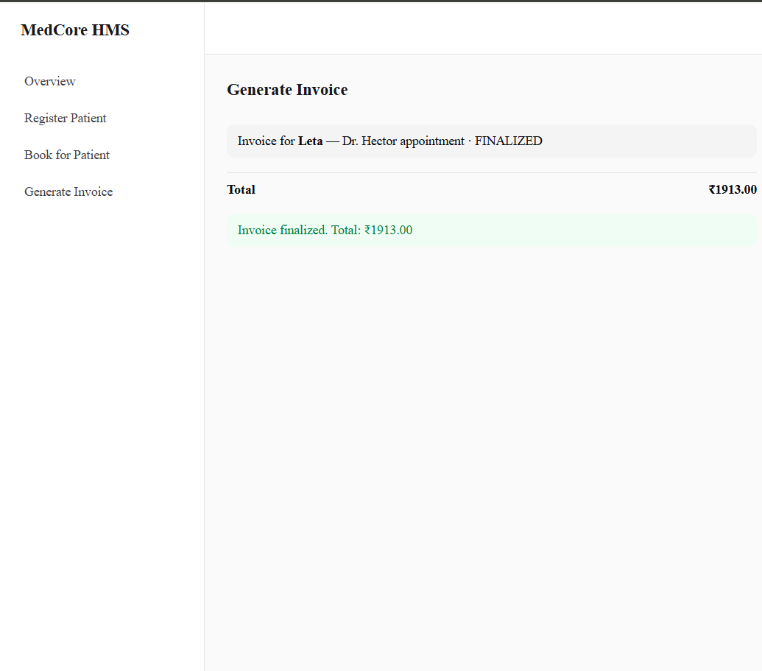  Figure 5.3 — Receptionist: generating and finalizing the invoice. | 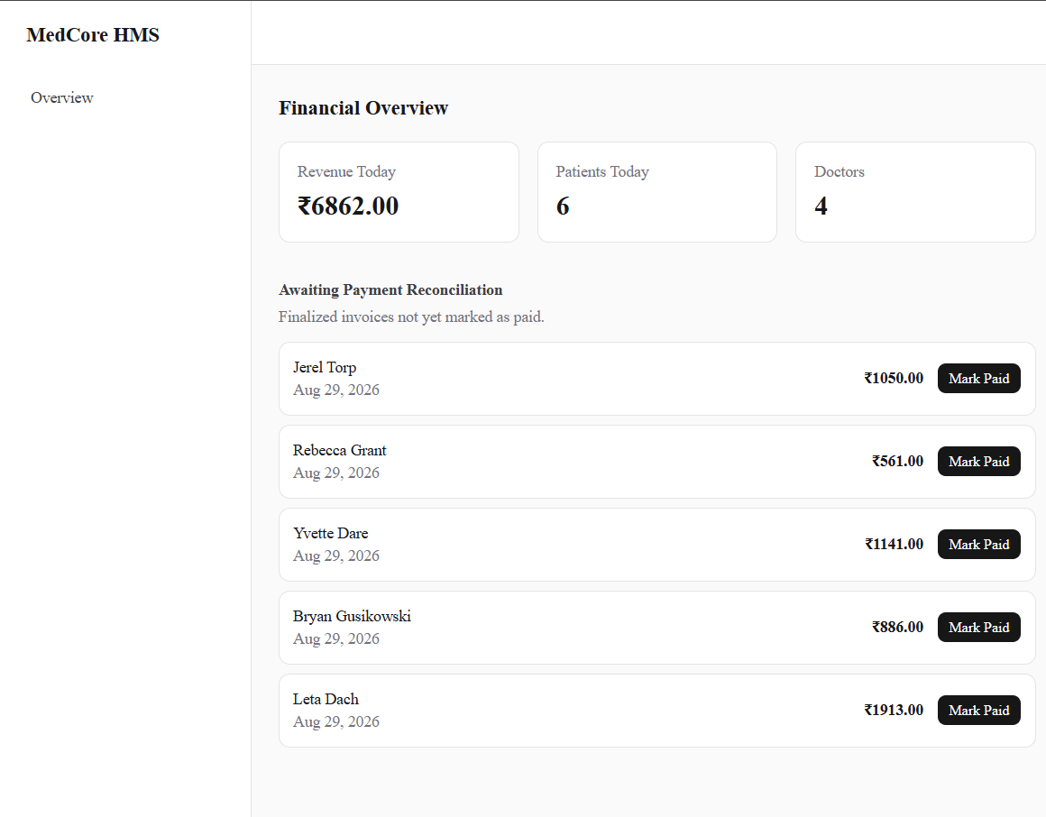  Figure 5.4 — Accountant: live financial overview and payment reconciliation.

5.3 API Documentation
Every backend endpoint is documented via @nestjs/swagger and served as interactive OpenAPI documentation at /api/docs, including request/response schemas and bearer-token authentication, allowing the API to be explored and tested independently of the frontend.

6. Security
Security was treated as a first-class concern throughout the backend rather than added after the fact:
- Authentication: JWT-based, with separate access and refresh token secrets, minimizing the blast radius of a leaked access token.
- Password storage: bcrypt hashing (cost factor 12) — plaintext passwords are never persisted.
- Transport security: Helmet middleware applies standard HTTP security headers on every response.
- Input validation: a global ValidationPipe rejects malformed or unexpected request payloads before they reach business logic.
- CORS: origin is restricted via an environment-driven allow-list (FRONTEND_URL) rather than a permissive wildcard.
- Sensitive-data log sanitization: a custom console patch (patchConsoleForSensitiveData) prevents secrets/PII from leaking into logs.
- Audit logging: an AuditLog model records consequential actions for after-the-fact review.
- Payment integrity: Razorpay webhook events are verified against a webhook secret before being trusted.
- Secret rotation discipline: all credentials used during development and deployment (database, JWT, Redis, third-party API keys) are environment-injected at runtime, never committed to source control, and were rotated immediately after any accidental exposure.

7. Testing Strategy
The backend uses Jest for unit and end-to-end testing, with a dedicated e2e configuration (test/jest-e2e.json) covering core application flows independently of unit-level tests. Coverage is generated via Jest’s built-in --coverage flag (test:cov script), producing a full HTML report broken down by file and module.
Rather than spreading thin, shallow tests across every module to inflate a single headline percentage, unit testing effort was deliberately concentrated on the four modules carrying the highest business risk: authentication (security), payments and invoicing (financial correctness), and appointments (the core clinical workflow and its concurrency-sensitive booking logic). Each of these was tested to a high, meaningful standard — covering both success paths and the realistic failure modes a reviewer would actually worry about, such as cross-hospital access attempts, invalid state transitions, and payment webhook replay.
Module | Statement Coverage | Tests | Representative Cases Covered
auth.service.ts | 69.5% | 13 | Login failure modes, refresh-token reuse detection, password reset, email-enumeration protection
payments.service.ts | 96.0% | 11 | Webhook signature verification, payment idempotency, cross-hospital access control
invoices.service.ts | 97.2% | 23 | Draft → Finalized → Paid state machine, billing-suggestion logic, tenancy checks
appointments.service.ts | 95.8% | 30 | Slot availability/timezone logic, double-booking prevention, status transition rules
Across the full codebase, this effort raised overall statement coverage from a starting baseline of 1.24% to 21.58%, with all 79 unit tests passing. The remaining uncovered modules — lab orders, pharmacy, prescriptions, hospitals, staff, and the HTTP controller layer generally — represent the clearest, most concrete next step for continued testing investment, roughly in that priority order given their operational impact.

7.1 End-to-End Test Suite
In addition to unit tests, six end-to-end scenarios exercise the running application against a real database, covering the system’s highest-consequence edge cases: concurrent booking races, cross-hospital tenancy isolation, refresh-token reuse, invoice total integrity under concurrent updates, and a safety check against dispensing expired medicine stock.
Scenario | What It Verifies
concurrent-booking | Only one of two simultaneous booking requests for the same doctor/slot succeeds
tenancy-isolation | Staff and patients cannot see or access another hospital’s data
refresh-token-reuse | A rotated refresh token cannot be reused after rotation
invoice-integrity | Invoice totals stay correct as items are added, including under concurrent writes
expired-medicine-dispensing | Dispensing is refused when the only available stock has expired
app | Baseline application bootstrap sanity check
All six suites pass (11/11 tests). Running this suite surfaced and led to the correction of a genuine defect in the test environment’s own cleanup helper: LabTest records were never being deleted between test runs, which eventually violated a RESTRICT foreign-key constraint on Hospital deletion once enough LabTest rows accumulated — a small but real illustration of end-to-end tests catching issues that unit tests, by design, cannot.

8. Deployment

8.1 Environments
Environment | Description
Local (docker-compose) | Five containers — Postgres, Redis, backend, frontend, Nginx — verified running end-to-end
Live production | Vercel (frontend) + Render (backend, Docker) + Neon (PostgreSQL) + Upstash (Redis)

8.2 Live Deployment
The live system is publicly reachable at the following URLs:
- Frontend: https://medcore-hms-frontend.vercel.app
- Backend API: https://medcore-backend-1796.onrender.com
- API Documentation: https://medcore-backend-1796.onrender.com/api/docs
The live database is pre-populated with realistic demo data — two verified hospitals, eight departments, eight doctors, thirty patients, and a full spread of appointments, medical records, prescriptions, lab orders, and invoices — generated by a dedicated seeding script and verified by logging in and exercising the system directly against production.

9. Conclusion & Future Work
MedCore HMS delivers a complete, working hospital management workflow — spanning nine roles and the full appointment-to-invoice clinical lifecycle — as a live, publicly deployed system backed by managed cloud infrastructure rather than a purely local demo. The architecture, database schema, and security posture were each treated as first-class deliverables, documented here with diagrams generated directly from the running system and schema rather than produced independently of the actual implementation.
Natural next steps beyond the current scope include:
- Expanding automated test coverage, particularly around edge cases in the billing and lab-result-approval workflows.
- Adding real-time notifications (e.g. WebSocket-based) for time-sensitive events such as emergency appointments.
- Introducing horizontal scaling and load testing now that the system runs on infrastructure that supports it.

