Contents
Introduction: 1
Impact of AI on Healthcare: 1
Historical Impact and Ethical Considerations: 1
AI Contribution to Society: 1
Bottom-up Approach: 1
Techniques and Tools: 1
1) Microservices Architecture: 2
Description: 2
Advantages: 2
Disadvantages: 2
2) Containerization: 2
Description: 2
Advantages: 2
Disadvantages: 2
3) Serverless Computing: 2
Description: 2
Advantages: 2
Disadvantages: 3
4) DevOps Practices: 3
Description: 3
Advantages: 3
Disadvantages: 3
5) Modular Machine Learning Pipelines: 3
Description: 3
Advantages: 3
Disadvantages: 3
Comparison: 3
Conclusion: 4
ML model: 4
Dataset: 4
Method Evaluation: 4
ML Azure Screenshots: 6
Top-down Approach: 12
Techniques and Tools: 12
1) Model-Driven Development (MDD): 13
Description: 13
Advantages: 13
Disadvantages: 13
2) Hierarchical Task Network (HTN) Planning: 13
Description: 13
Advantages: 13
Disadvantages: 13
3) Knowledge-Based Systems: 13
Description: 13
Advantages: 14
Disadvantages: 14
4) Fuzzy Logic Systems: 14
Description: 14
Advantages: 14
Disadvantages: 14
Comparison: 14
Conclusion” 15
Chatbot: 15
Effectiveness: 15
Limitations: 15
Areas of Improvement: 15
Benefits: 15
Emerging AI Technologies in the Health Sector: 15
Intro: 15
Precision Medicine: 16
Description: 16
Example: 16
Future Changes Driven by Emerging AI Technologies in Healthcare: 16
1. AI-Powered Diagnostics: 16
• Description: 16
• Impact: 16
2. Robotics and AI in Surgery: 16
• Description: 16
• Impact: 16
3. AI-Enhanced Drug Discovery: 17
• Description: 17
• Impact: 17
Industrial and Social Implications: 17
Industrial Implications: 17
Social Implications: 17
Future Impact of Emerging AI Technologies: 17
Enhanced patient care: 17
Healthcare Accessibility: 18
Cost Reduction: 18
Ethical and Regulatory Challenges: 18
Continuous Learning and Adaptation: 18
Conclusion: 18

Introduction:

Impact of AI on Healthcare:
Artificial Intelligence (AI) has hugely impacted healthcare by improving diagnostic accuracy, personalizing treatment plans, and optimizing hospital operations. AI systems can process huge amounts of medical data with high speed while providing insights that were previously hard to attain. As an example, AI algorithms were used to detect diseases such as cancer and heart disease at early stages, which will improve the patient's survival rate.
AI’s Fundamental concepts include machine learning, where systems learn from data; natural language processing (NLP), which allows machines to understand human language; and robotics, which combines AI with mechanical processes. AI applications in healthcare include diagnostic systems, predictive analytics, personalized medicine, and robotic surgeries.

Historical Impact and Ethical Considerations:
Over the last twenty years, AI has revolutionized healthcare by giving access to a wide range of tools that can detect diseases earlier, personalized treatment, and efficient hospital management. However, these advancements raise ethical concerns regarding data privacy, informed consent, and potential biases in AI algorithms. For example, AI systems trained on biased data can perpetuate existing healthcare disparities.

AI Contribution to Society:
AI has improved healthcare delivery, reduced costs, and enhanced patient outcomes. AI-driven predictive analytics can identify patients at risk of complications, allowing for timely interventions. Also, AI-powered diagnostic tools improved accuracy and reduced the workload on healthcare professionals, which will enable them to focus on patient care.

Bottom-up Approach:
Bottom-up approaches in AI system deployment involve constructing systems by integrating smaller, simpler components into more complex structures. This method contrasts with top-down approaches, where a system is designed as a whole and then broken down into subsystems. Bottom-up approaches on the other hand are particularly beneficial for AI development due to their modularity, flexibility, and scalability. Here are some techniques and tools used in bottom-up approaches.

Techniques and Tools:
- Microservices Architecture.
- Containerization.
- Serverless Computing.
- DevOps Practices.
- Modular Machine Learning Pipelines.

Microservices Architecture:

Description:
Microservices architecture involves breaking down an AI application into smaller, independent services that communicate through APIs. Each service will handle a certain functionality, such as data preprocessing, model training, or prediction.
Example: Apache Kafka for real-time data streaming.

Advantages:
- Scalability: each AI microservice can be scaled alone.
- Flexibility: multiple technologies can be used on different services.
- Isolation: failures in one service can't impact the other services.

Disadvantages:
- Complexity: managing multiple services can add a lot of complexity.
- Data Management: handling distributed data on multiple services more challenging.
- Overhead: inter-service communication can bring latency.

Containerization:

Description:
Containerization packages an AI application and its dependencies into a container that can run consistently on multiple environments. Docker is the most widely used tool for containerization.
Example: Docker for packaging AI models and their dependencies.

Advantages:
- Portability: containers run on any system with a container runtime.
- Consistency: ensures consistent environments from the development to the production
- Resource Efficiency: Containers share the host OS, making sure the resources are used efficiently.

Disadvantages:
- Security: containers share the same OS kernel, which enhances some potential security risks.
- Orchestration: Managing multiple containers requires certain tools which adds more complexity.

3) Serverless Computing:

Description:
Serverless computing allows developers to run AI functions without managing infrastructure. Function-as-a-service (FaaS) platforms like AWS lambda and Google Cloud Functions are common examples.
Example Tool: AWS Lambda for running AI inference tasks on demand.

Advantages:
- Cost efficiency: Pay only for the compute time used.
- Simplified Management: No need to manage servers and infrastructures.
- Scalability: Automatically scales based on demand.

Disadvantages:
- Cold Start Latency: Initial request latency can be high due to cold start.
- Limited control: less control over the execution environment and infrastructure.
- Complexity: Debugging and monitoring can be hard.

4) DevOps Practices:

Description:
DevOps practices integrate software development (Dev) and IT operations (Ops) to shorten the development lifecycle and produce high-quality AI software continuously.
Example Tool: Jenkins for continuous integration and continuous deployment (CI/CD) of AI models.

Advantages:
- Automation: reduces manual intervention with CI/CD pipelines.
- Collaboration: Enhances collaboration between the operation team and the development team.
- Speed: Speeds the deployment processes

Disadvantages:
- Cultural Shift: Requires a huge cultural change in the organization.
- Tool Complexity: Managing and integrating DevOps tools can be way much more complex.
- Initial Cost: the initial setup cost and training of the employees is very expensive.

5) Modular Machine Learning Pipelines:

Description:
Modular ML pipelines involve breaking down the ML workflow into discrete, reusable components, such as data preprocessing, feature extraction, model training, and evaluation.
Example Tool: Apache Airflow for orchestrating AI workflows.

Advantages:
- Reusability: Components can be reused in more than one project.
- Flexibility: easier to experiment with multiple models and techniques.
- Scalability: Pipelines can be scaled and parallelized efficiently.

Disadvantages:
- Integration: Ensuring seamless integration between parts can be challenging.
- Complexity: Managing dependencies and versioning can be complex.
- Overhead: Potential for increased overhead in orchestrating pipeline components.

Comparison:
Technique/Tool | Advantages | Disadvantages
Microservices Architecture | Scalability, Flexibility, Isolation | Complexity, Data Management, Overhead
Containerization | Portability, Consistency, Resource Efficiency | Security, Orchestration
Serverless Computing | Cost Efficiency, Simplified Management, Scalability | Automation, Collaboration, Speed
DevOps Practices | Automation, Collaboration, Speed | Cultural Shift, Tool Complexity, Initial Cost
Modular ML Pipelines | Reusability, Flexibility, Scalability | Integration, Complexity, Overhead

Conclusion:
Bottom-up approaches for deploying modern intelligent systems offer numerous benefits, particularly in terms of scalability, flexibility, and efficiency. However, they also come with a lot of challenges, including increased complexity, security concerns, and the need for robust management and orchestration tools. The choice of the used technique or tool will depend on your project requirements, scalability needs, more development speed, resource constraints, and the expertise available in the project’s team.

ML model:

Dataset:
This dataset contains medical records of 5000 patients who had heart failure, collected during their follow-up period.

Feature:
- Age (INT)
- Anemia: decrease of red blood cells or hemoglobin (0\1)
- Creatinine Phosphokinase (CPK) level of the CPK enzyme in the blood (INT)
- Diabetes: if the patient has diabetes (0\1)
- Ejection Fraction: percentage of blood leaving the heart at each contraction (percentage)
- High Blood Pressure: (0\1)
- Platelets: platelets in the blood (INT)
- Sex: (0\1)
- serum creatinine: level of serum creatinine in the blood (INT)
- serum sodium: level of serum sodium in the blood (INT)
- smoking: if the patient smokes or not (0\1)
- time: follow-up period in days (INT)
- DEATH_EVENT: if the patient died during the follow-up period (0\1)

Method Evaluation:

Preprocessing:
- Balancing the data: the data was imbalanced since the instances where [“DEATH_EVENT”] = 1 is half of it which equals 2.
- Normalizing the data: using the MinMaxScaler to scale the data in order to help balance the impact of all the features.

KNeighborsClassifier:
A classification algorithm that assigns labels based on the majority of K nearest neighbors.
It calculates the distance between a data point and training points then selects K closest neighbors and chooses the most common class between the closest neighbors.
- Pros:
  - Simple and easy to implement
  - versatility
- Cons:
  - Computationally expensive in large datasets.
  - Sensitive to irrelevant features.

Cross-validation:
A technique that is widely used to evaluate model performance by splitting the data into training and validation sets K times

How it Works:
- Divide the data into K equal parts
- Train the model on K-1 parts and validate the remaining part
- Repeat the same process K times
- The results are calculated by the average metrics for each fold.
Pros:
- Efficient use of data.
- Reduces overfitting.
Cons:
- Computationally intensive.
- More complex than a simple Train-test split

Results:
Models  Metric | Normal | Balanced | Normalized | Normalized and balanced
Accuracy | 0.934 | 0.943 | 0.969 | 0.969
Precision | 0.934 | 0.943 | 0.968 | 0. 968
Recall | 0.934 | 0.943 | 0.969 | 0.969
F1-Score | 0.934 | 0.943 | 0.968 | 0. 968
Confusion matrix | [[662 36]  [ 30 272]] | [[653 49]  [ 29 642]] | [[685 13]  [ 18 284]] | [[685 13]  [ 18 284]]

Insights:
- Normalization: normalization helped in scaling the features, making the distances between data points more meaningful which improved the model’s ability to distinguish between classes.
- Balancing: Balancing ensures that the model has equal representation from all the classes. Which reduced the bias towards the majority class and enhanced the model’s generalizability.
These models gave great results but can be modified through the use of ML Azure techniques which will enhance the results for a better performance and results.

ML Azure Screenshots:
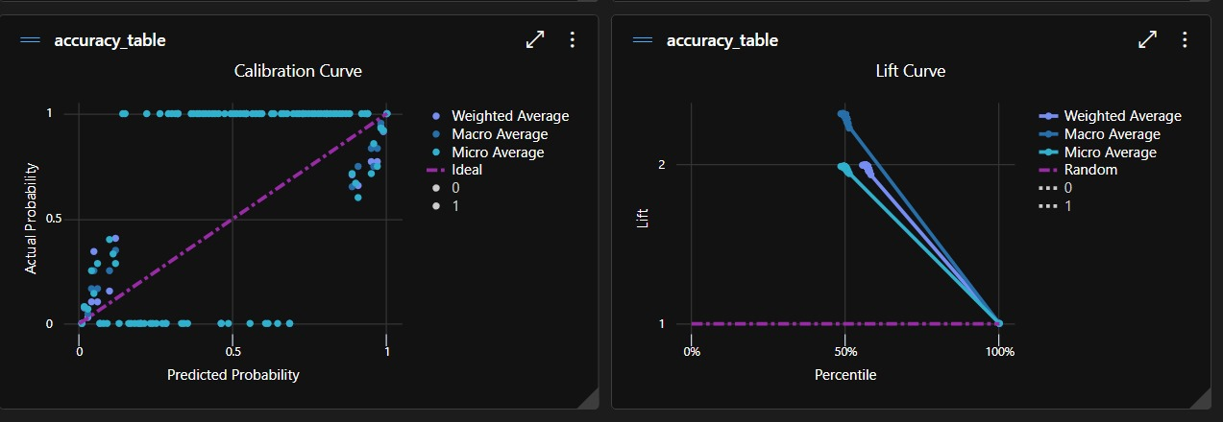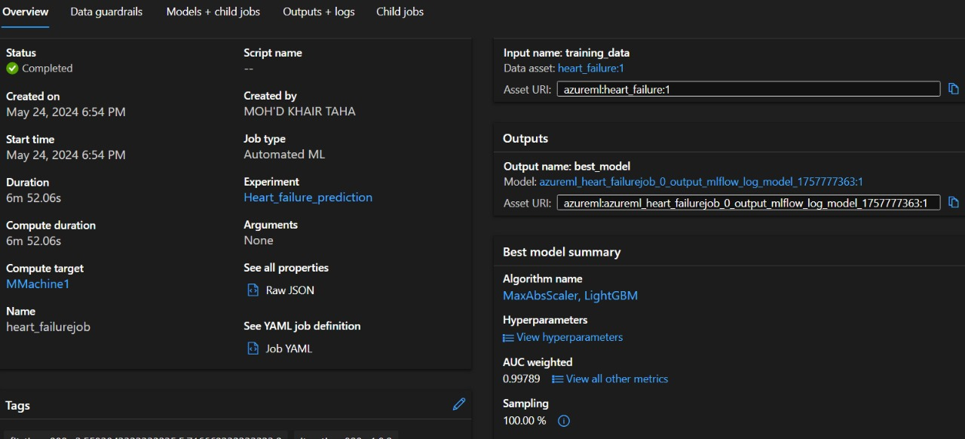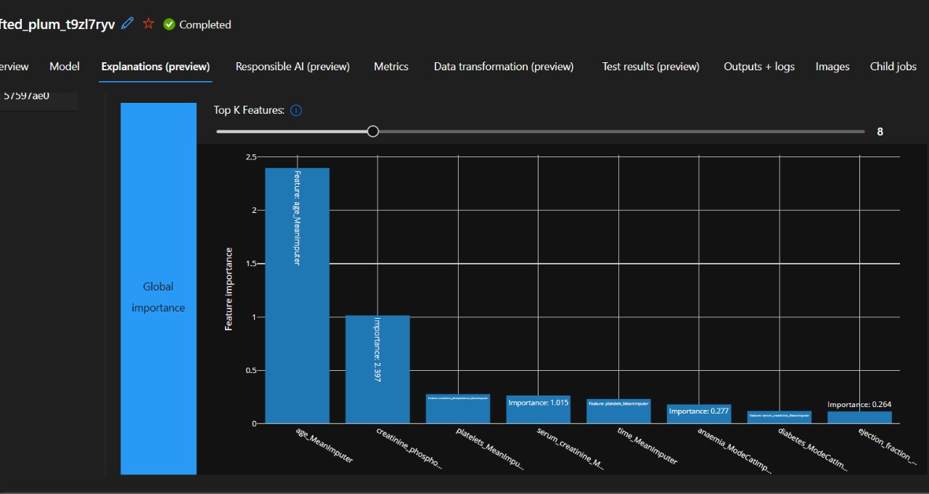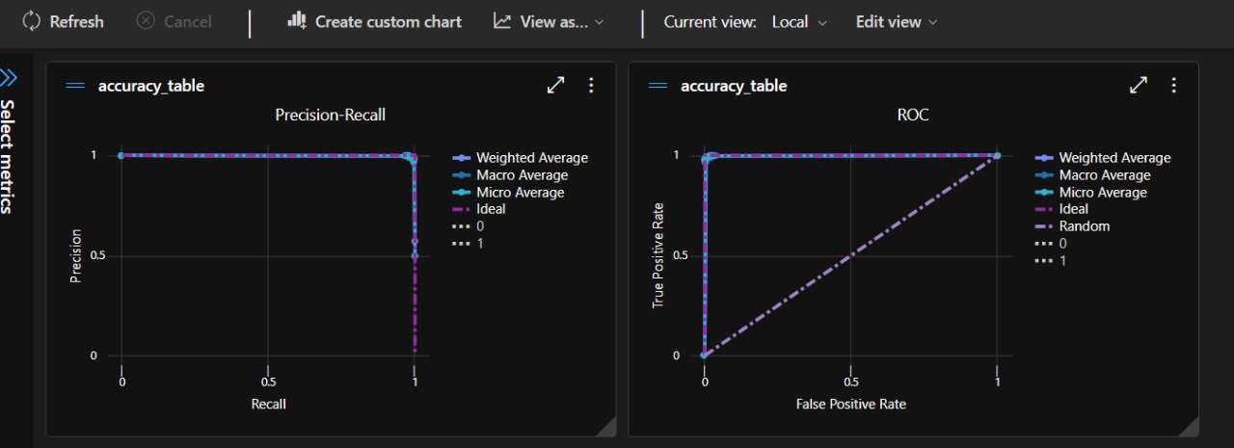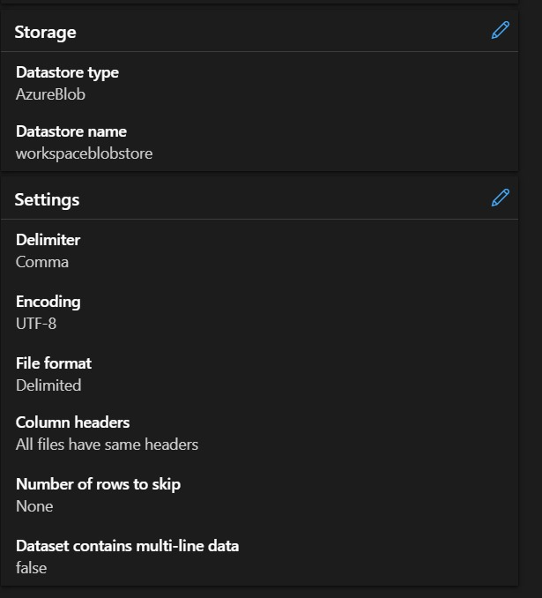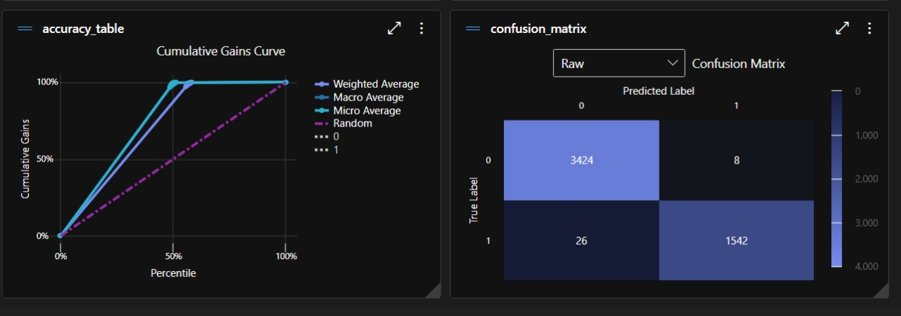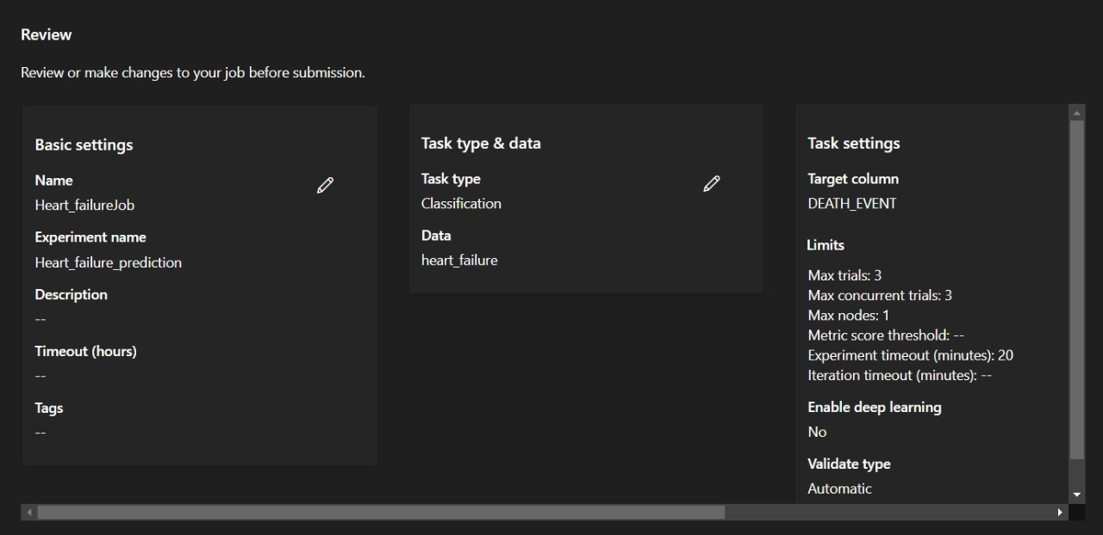

Top-down Approach:
Top-down approaches in deploying intelligent systems involve starting from higher levels of abstraction and breaking down the system into its smaller parts. This method contrasts with the bottom-up approach, which builds systems from the smallest parts up to the whole system. Top-down approaches sometimes are characterized by a strategic overview, focusing on the system’s architecture and design before diving into the specifics of the implementation.

Techniques and Tools:
- Model-Driven Development (MDD)
- Hierarchical Task Network (HTN) planning
- Knowledge-Based Systems
- Fuzzy Logic Systems.

Model-Driven Development (MDD):

Description:
Model-driven development (MDD) focuses on creating and exploiting domain models, which are the conceptual models that define the structure and behavior of any system. Those models are used to drive the development process.
Example: Using unified modeling language (UML) to design the architecture of an intelligent system.

Advantages:
- High-Level Abstraction: it understands and communicates the system structure and behavior.
- Consistency: reduces errors by using standardized modeling.
- Traceability: changes in the model can be tracked through the implementation.

Disadvantages:
- Complexity: it is complex to create and maintain detailed models.
- Tool Dependence: needs specific tools and training.
- Overhead: can introduce overhead in maintaining and keeping the models in sync with the implementation

Hierarchical Task Network (HTN) Planning:

Description:
HTN Planning involves decomposing tasks into subtasks in a hierarchical manner, which provides a clear and structured approach to problem-solving and system designs.

Advantages:
- Structured Decomposition: splits the complex tasks into simpler and more manageable parts.
- Clarity: gives clear task hierarchies, which enhances understanding and organization.
- Reusability: Small and sub-tasks can be used again in different tasks and applications.

Disadvantages:
- Scalability Issues: will become difficult to manage when the number of tasks and subtasks increase.
- Rigidity: is inflexible when adapting to unexpected changes or new requirements.
- Knowledge Intensive: Requires extensive domain knowledge to make effective task hierarchies.

Knowledge-Based Systems:

Description:
KBS uses a database of knowledge about a certain domain and inference rules to solve problems in that domain. KBS are designed to stimulate the human’s problem-solving behavior.
Example: An expert system for medical diagnosis that uses a knowledge base of symptoms and diseases.

Advantages:
- Expertise Capture: can utilize and store human expertise effectively.
- Consistency: gives consistent decision-making based on the knowledge available.
- Explainability: will give explanations for the decisions made.

Disadvantages:
- Knowledge Acquisition: Gathering and encoding expert knowledge is challenging.
- Maintenance: updating and maintaining the knowledge base is complex.
- Scalability: Expanding the knowledge base to cover different domains will require extensive knowledge engineering.

Fuzzy Logic Systems:

Description:
Fuzzy logic Systems use degrees of truth rather than the normal True\False binary logic. They are useful for handling uncertain or unclear information.
Example: Fuzzy control systems in home appliances to optimize performance based on fuzzy input variables.

Advantages:
- Handling Uncertainty: effective in dealing with unclear information.
- Flexibility: can be applied to a wide range of problems.
- Human-like Reasoning: it mimics the human decision-making processes better than the binary logic.

Disadvantages:
- Complexity: Designing and tuning fuzzy systems is complex.
- Interpretability: the results and internal workings can be hard to interpret.
- Computational overhead: is computationally intensive, especially when working with large systems.

Comparison:

Technique/Tool | Advantages | Disadvantages
Model-Driven Development (MDD) | High-Level Abstraction, Consistency, Traceability | Complexity, Tool Dependence, Overhead
HTN Planning | Structured Decomposition, Clarity, Reusability | Scalability Issues, Rigidity, Knowledge Intensive
Knowledge-based Systems | Expertise Capture, Consistency, Explainability | Knowledge Acquisition, Maintenance, Scalability
Fuzzy Logic Systems | Handling Uncertainty, Flexibility, Human-Like Reasoning | Complexity, Interpretability, Computational Overhead

Conclusion”
Top-down approaches for deploying modern intelligent systems offer huge benefits in terms of strategic alignment, consistency, and risk management. On the other hand, they can be complex, inflexible, and resource-dependent. The choice of the technique or tool depends on project needs, the complexity of the system, available expertise, and the need for scalability and flexibility. Balancing top-down tactics with bottom-up techniques can provide a more adaptable and comprehensive approach to system development, leveraging the strengths of both methodologies can achieve the required optimal outcome.

Chatbot:
This rule-based chatbot is handling some predefined questions about the heart failure dataset with simplicity and predictability. However, the chatbot lacks contextual understanding, scalability, and interactivity.

Effectiveness:
- Simplicity: easy to implement and modify.
- Speed: quick responses.
- Predictability: consistent responses.

Limitations:
- Lack of understanding: there is no context or semantics comprehension.
- Limited scope: only predefined questions are handled.
- Scalability: difficult to handle the more rules you have
- Interactivity: no multi-turn conversation capability.

Areas of Improvement:
- Context Management: remembering precious interactions.
- User interface: add visual aids and links.
- Feedback Loop: Collect user feedback in order to improve the performance.
- NLP integration: integrating a pre-trained language model can make the user experience better and will generate more contextual responses.

Benefits:
- Immediate Assistance: instant answers to common questions.
- User education: Explains dataset features and usage.
- Data Interpretation: explains specific data points.
- Support for non-technical users: simplifies complex information.

Emerging AI Technologies in the Health Sector:

Intro:
AI technologies are revolutionizing a lot of industries, and the health sector is no exception.

Precision Medicine:

Description:
AI-driven precision medicine is an advanced AI algorithm that tailors medical treatment to the individual characteristics of each patient. This algorithm integrates genetic, environmental, and lifestyle data to make treatment plans for each person. Machine learning models analyze a huge amount of data from previous clinical records, electronic health records (EHRs), and genomic sequences to predict the best and most effective therapies for each specific patient.

Example:
IBM Watson for Oncology uses AI to analyze patient data and recommend personalized treatment for cancer patients. It preprocesses vast amounts of medical literature and patient data to provide evidence-based treatment suggestions.

Future Changes Driven by Emerging AI Technologies in Healthcare:

AI-Powered Diagnostics:

Description:
AI-powered diagnostics uses machine learning algorithms to access medical images, analyze patient data, and detect any possible diseases early.

Impact:
  - Accuracy: AI can improve diagnostic accuracy by detecting patterns and anomalies that may be missed by humans.
  - Efficiency: Automating the diagnostic process will reduce the time needed for analyzing which will allow for faster diagnosis and treatment.
  - Access: AI diagnostics can be deployed and accessed remotely and in underserved areas, which will provide access to quality healthcare services to new places.

Robotics and AI in Surgery:

Description:
Robotics and AI in surgery will combine robotic systems with AI to assist surgeons in performing complex procedures with higher precision.

Impact:
  - Precision: AI enhances the precision of robotic systems. Which will lead to better surgical outcomes.
  - Minimally Invasive: AI-driven robotic systems will enable minimally invasive surgeries, which will reduce the recovery times and complications.
  - Training: AI can simulate surgical procedures, which provides training and support to surgeons, especially in complex cases.

AI-Enhanced Drug Discovery:

Description:
AI-enhanced drug discovery uses machine learning algorithms to identify potential drug candidates and predict their efficacy and safety.

Impact:
  - Speed: AI accelerates the drug discovery process by analyzing huge datasets and predicting outcomes faster than any traditional method.
  - Cost: Reducing the time and cost to develop drugs which makes the creation of the treatment more affordable
  - Innovation: AI can uncover new drug possibilities and repurpose existing drugs for new indications.

Industrial and Social Implications:

Industrial Implications:
- Innovation and Competition: the adoption of AI technologies drives innovation and makes a competitive landscape where companies needs to continuously evolve to stay competitive and relevant.
- Workforce Transformation: AI will change the healthcare workforce, which will require new skills and roles that focus on AI development, implementation, and maintenance.
- Data Security: the integration of AI with healthcare data raises concerns about data security and patient privacy, which needs robust cybersecurity measures to ensure data privacy and safety.

Social Implications:
- Improved Health Outcomes: AI-driven personalized medicine and early diagnostics will lead to improving health outcomes and quality of life for the patients.
- Equity: Ensuring that the AI technologies are accessed by everyone equally to prevent any disparities in healthcare services.
- Ethical Considerations: the use of AI in healthcare raises ethical questions about data usage, patient consent, and the potential for biased algorithms.

Future Impact of Emerging AI Technologies:

Enhanced patient care:
Emerging AI technologies promise to enhance patient care by giving personalized treatment plans, early disease detection, and efficient healthcare delivery. Patients will benefit from more accurate diagnoses, tailored treatments, and improved health outcomes.

Healthcare Accessibility:
AI has the capability to bridge the gap in healthcare accessibility, especially in remote and underserved areas. AI-powered diagnostics and telemedicine can ensure providing quality healthcare services to people with limited access to healthcare facilities.

Cost Reduction:
By streamlining processes such as diagnostics, treatment planning, and drug discovery, AI can hugely reduce healthcare costs. This will make healthcare more affordable and accessible, which will lead to the change and transformation of the whole industry.

Ethical and Regulatory Challenges:
The integration of AI in healthcare requires addressing ethical and regulatory challenges. Developing transparent, unbiased algorithms and ensuring the patient’s data privacy and security will be crucial. Regulatory frameworks must evolve to keep pace with technological advancements.

Continuous Learning and Adaptation:
AI systems in healthcare will need to learn and adapt continuously since medical knowledge and data are always evolving. This dynamic nature of AI ensures that healthcare practices remain up-to-date with the latest research and clinical guidelines.

Conclusion:
Emerging AI technologies hold tremendous potential to transform the health sector. AI-driven precision medicine, AI-powered diagnostics, robotics in surgery, and AI-enhanced drug discovery are poised to drive significant changes in the industry. While these technologies offer a lot of benefits, including improved patient care, reduced costs, and increased accessibility, they also present challenges related to data security, ethical considerations, and workforce changes. Addressing these challenges will be crucial to fully realizing the potential impact of AI in healthcare and ensuring a future where advanced, personalized, and equitable healthcare is accessed by everyone.

