**PIPELINE FOR TRANSFERRING DATA FROM MYSQL TO HIVE AND THEN AFTER ANALYSIS EXPORTING DATA FROM EXTERNAL TABLE TO MYSQL**

**Step 1:** Transferred the csv file from C:\Users\Admin\Downloads to /home/cloudera/Desktop/

**Step 2:** Created a directory on Hadoop by using hadoop fs -mkdir wallmartproject

**Step 3:** Created a database called stocks then created all 4 tables and removed their headers.

load data infile '/home/cloudera/Desktop/ABMD.csv' into table ABMD fields terminated by "," lines terminated by '\n' ignore 1 lines;

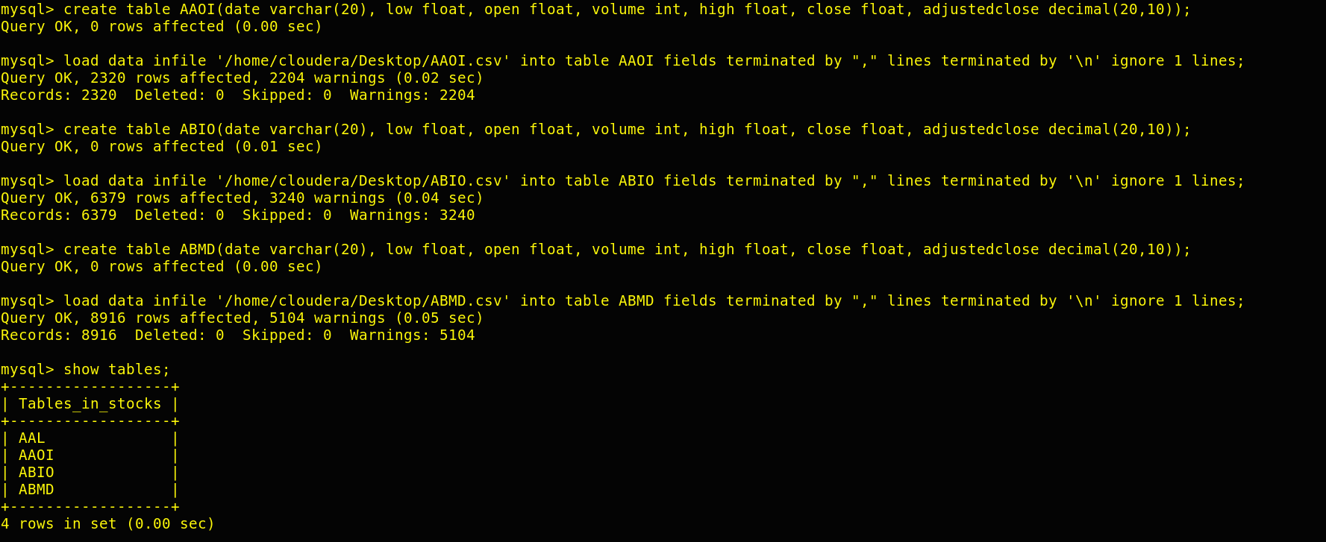

**Step 4:** I have transferred all these tables to Hadoop from mysql.

Command:

sqoop import-all-tables --connect jdbc:mysql://localhost:3306/stocks --username root -password cloudera --warehouse-dir /user/cloudera/wallmartproject/ -m 1

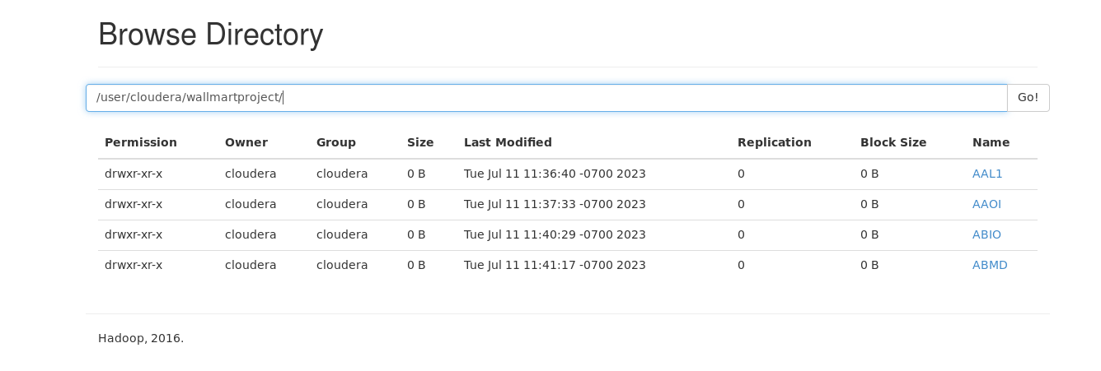

**Step 5:** Loading hdfs data into hive tables

Here we have to create all the tables and load the data by using command:

Create table command:

create table ABIO(date string, low float, open float, volume int, high float, close float, adjustedclose decimal(20,10)) row format delimited fields terminated by ",";

Loading data from hdfs to hive table command:

load data inpath '/user/cloudera/wallmartproject/ABIO/part-m-00000' into table ABIO;

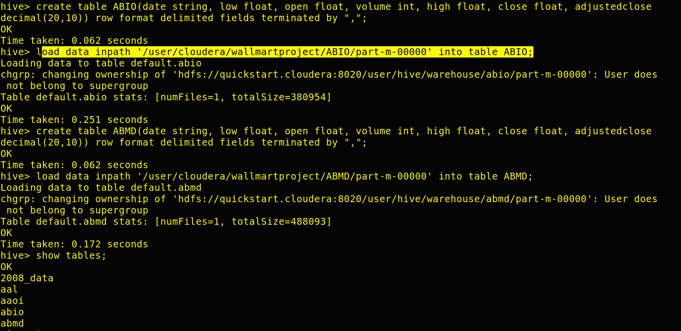

**Displaying 3 records from each hive table:**

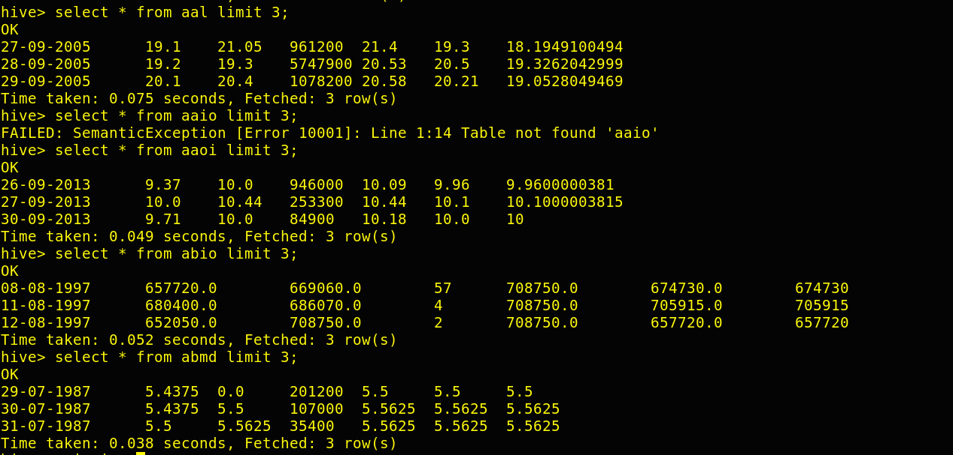

Step 6: After running the HIVE query I have made an external table in a new directory /user/cloudera/projectresult for each result and stored the result in that table. External table creation query and insert query is given below in each question

Step 7: After making external table and inserting data into that table, I have made same number of tables in mysql in a new database with name project_result and exported the data to there by using sqoop query:

Eg: sqoop export --connect jdbc:mysql://localhost:3306/project_result --username root --password cloudera --table scenario3_ext_abmd --export-dir /user/cloudera/projectresult/scenario3_ext_abmd/000000-0 --input-fields-terminated-by ','

**ANALYSIS AND STORAGE HIVE QUERIES -> 7 SCENARIOS**

**Scenario 1 :**  Write a Hive query to identify the top three dates that experienced the largest percentage change in stock price (from open to close) for every stock.

Query:

**For AAL:**

select date, (abs(close-open)/open)*100 as per from aal order by per desc limit 3;

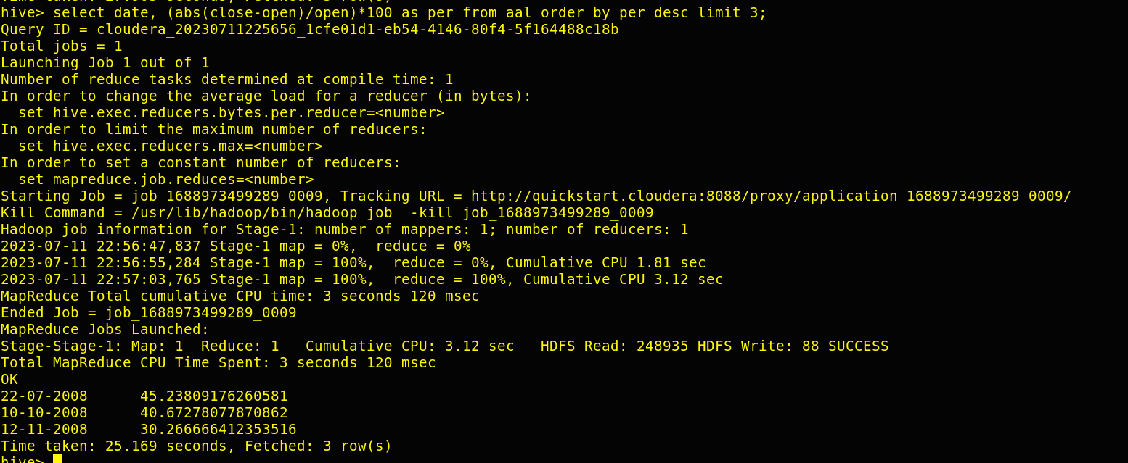

**For ABIO:**

select date, (abs(close-open)/open)*100 as per from abio order by per desc limit 3;

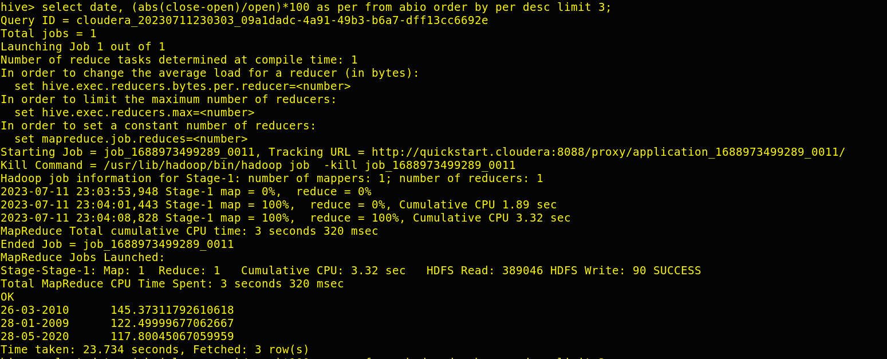

**For AAOI:**

select date, (abs(close-open)/open)*100 as per from aaoi order by per desc limit 3;

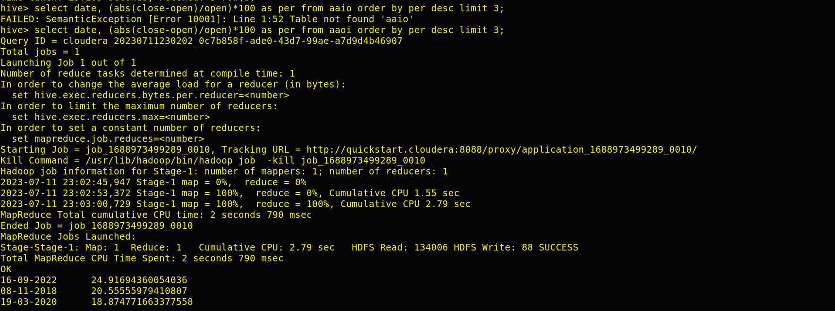

**For ABMD:**

select date, (abs(close-open)/open)*100 as per from abmd order by per desc limit 3;

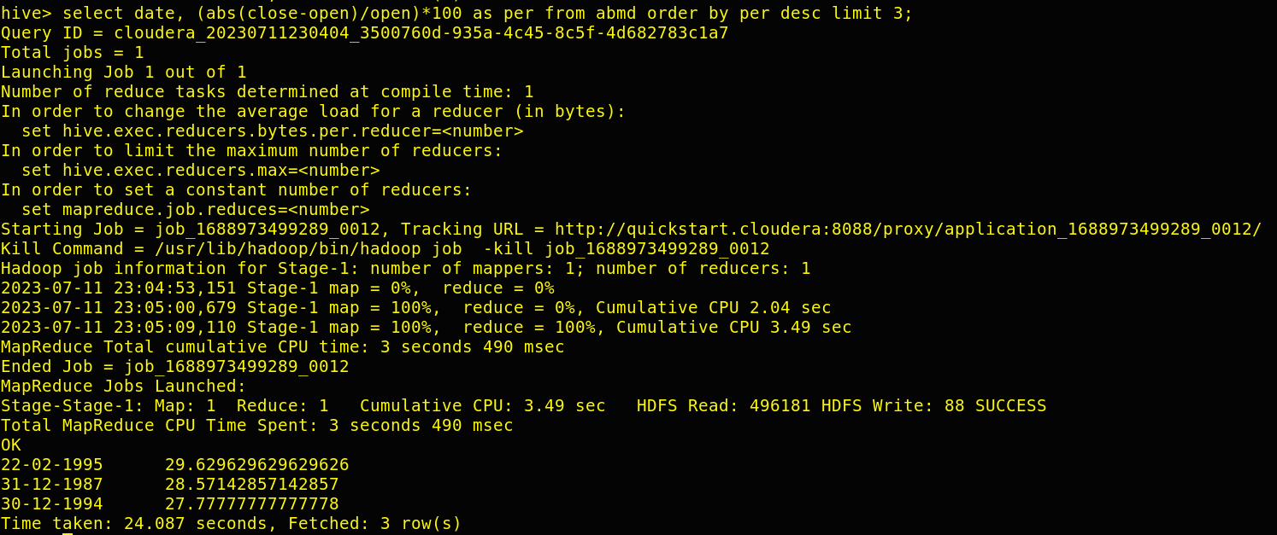

For creating external table, I have used this query:

CREATE EXTERNAL TABLE per_change_AAL/ per_change_ABIO/ per_change_AAOI/per_change_ABMD(

Date string,

Percentage double

)

ROW FORMAT DELIMITED

FIELDS TERMINATED BY ','

STORED AS TEXTFILE

LOCATION '/user/cloudera/projectresult/(AAL_S1/ABIO_S1/ AAOI_S/ABMD_S1)';

And I have used this query to insert result into my external table:

INSERT overwrite table per_change_AAL/ per_change_ABIO/ per_change_AAOI/per_change_ABMD

select date as Date, (abs(close-open)/open)*100 as Percentage from aal/abio/aaoi/abmd order by Percentage desc limit 3;

**Scenario 2:**  Write a Hive query to identify the dates where Low is less than average month low for every stock.

Hive Query:

**For AAL :**

with cte as (SELECT date, low, AVG(low) OVER (PARTITION BY SUBSTRING(date, 4)) AS monthly_avg_low from AAL) select date, low, monthly_avg_low from cte where low<monthly_avg_low order by unix_timestamp(date, 'dd-MM-yyyy');

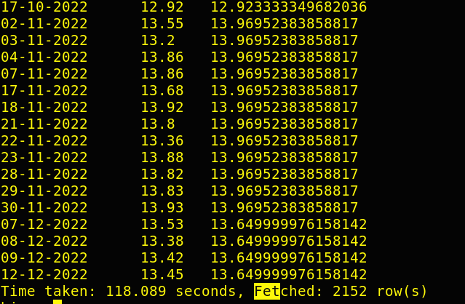

**With Indexing:** Creating index on date column and running the same query then time taken is reduced.

create index date_index on table aal(date) as

'org.apache.hadoop.hive.ql.index.compact.CompactIndexHandler'

WITH DEFERRED REBUILD;

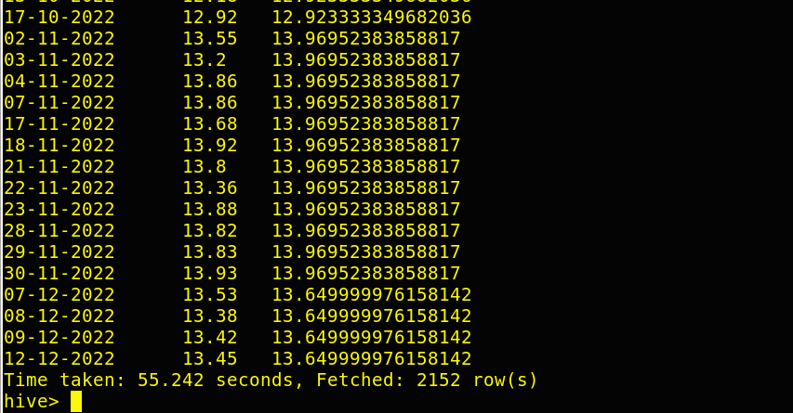

**For AAOI :**

with cte as (SELECT date, low, AVG(low) OVER (PARTITION BY SUBSTRING(date, 4)) AS monthly_avg_low from AAOI) select date,low,monthly_avg_low from cte where low<monthly_avg_low order by unix_timestamp(date, 'dd-MM-yyyy');

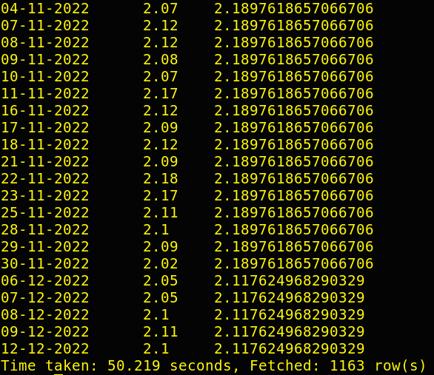

**For ABIO :**

with cte as (SELECT date, low, AVG(low) OVER (PARTITION BY SUBSTRING(date, 4)) AS monthly_avg_low from ABIO) select date,low,monthly_avg_low from cte where low<monthly_avg_low order by unix_timestamp(date, 'dd-MM-yyyy');

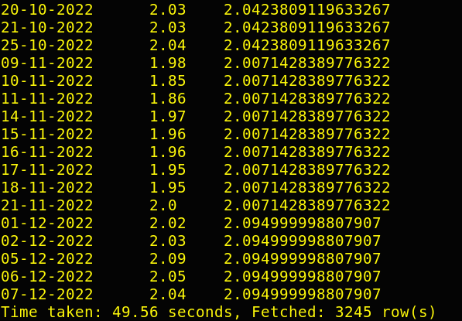

**For ABMD :**

with cte as (SELECT date, low, AVG(low) OVER (PARTITION BY SUBSTRING(date, 4)) AS monthly_avg_low from ABIO) select date,low,monthly_avg_low from cte where low<monthly_avg_low order by unix_timestamp(date, 'dd-MM-yyyy');

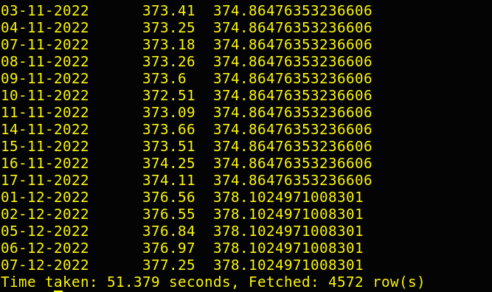

For creating external table, I have used this query:

CREATE EXTERNAL TABLE scenario2_aal/ scenario2_aaoi/ scenario2_abio_main/

scenario2_abmd (date string, low float, avg_low float)

ROW FORMAT DELIMITED

FIELDS TERMINATED BY ','

STORED AS TEXTFILE

LOCATION '/user/cloudera/projectresult/(scenario2_aal/ scenario2_aaoi/ scenario2_abio_main/

scenario2_abmd) ';

And I have used this query to insert result into my external table:

with cte as (SELECT date, low, AVG(low) OVER (PARTITION BY SUBSTRING(date, 4)) AS monthly_avg_low from AAL / AAOI / ABIO/ ABMD) insert overwrite table scenario2_aal/ scenario2_aaoi/ scenario2_abio_main/

scenario2_abmd select date,low,monthly_avg_low from cte where low<monthly_avg_low order by unix_timestamp(date, 'dd-MM-yyyy');

**Scenario 3:** Write a Hive query to find the date with the longest consecutive streak of increasing closing prices for every stock.

Hive Query:

with cte as (SELECT Date,Close,lag(Close) over(order by unix_timestamp(Date, 'dd-MM-yyyy') ) as prev FROM aal/aaoi/abio/abmd),

cte1 as (select Date,Close,if(Close < prev, 0, 1) as is_inc from cte),

cte2 as (select Date,Close, is_inc, lead(is_inc) over(order by unix_timestamp(Date, 'dd-MM-yyyy')) as next_val from cte1),

cte3 as (select Date,Close, is_inc, if( is_inc = 0 and is_inc != next_val,1,0) as is_chg from cte2),

cte4 as (select Date,Close, is_inc, is_chg,sum(is_chg) over( order by unix_timestamp(Date, 'dd-MM-yyyy')) as bucket from cte3 where not (is_inc = 0

and is_chg = 0)),

cte5 as (select Date, Close,is_inc,is_chg,bucket, count(*) over(partition by bucket) as cnt from cte4)

select Date,close from cte5 cross join (select max(cnt) as max_cnt from cte5) cte6 where cte5.cnt = cte6.max_cnt;

For AAL:

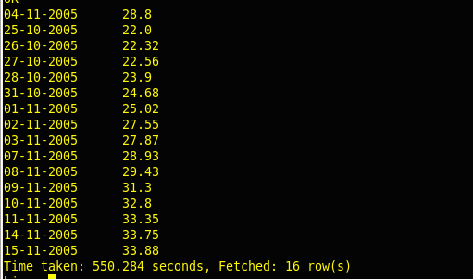

For AAOI:

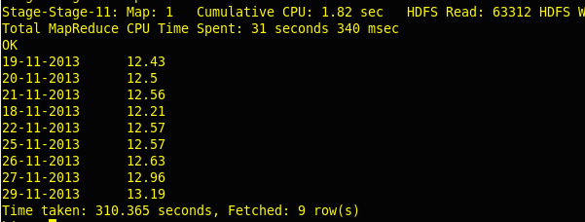

For ABIO:

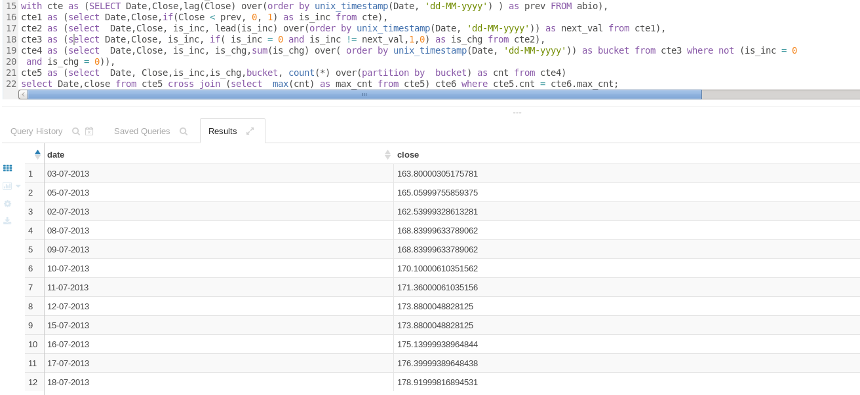

For ABMD:

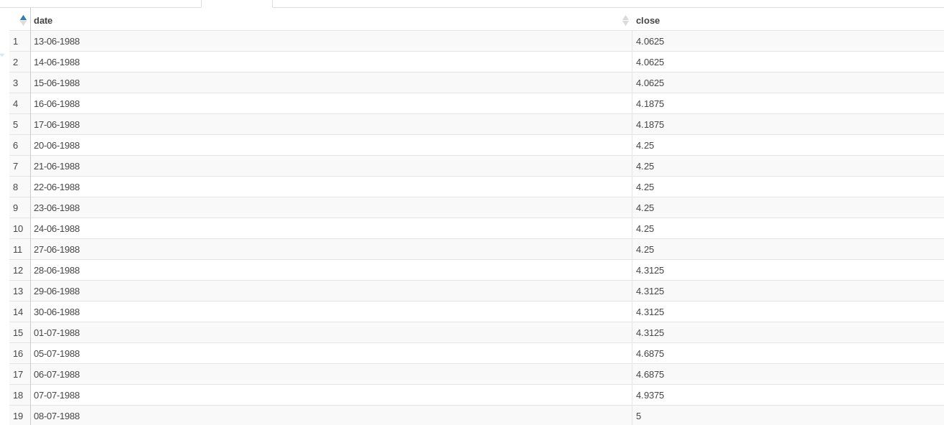

For creating external table, I have used this query:

CREATE EXTERNAL TABLE scenario3_ext_aal/ scenario3_ext_ aaoi/ scenario3_ext_abio/ scenario3_ext_abmd (

date string, close float)

ROW FORMAT DELIMITED

FIELDS TERMINATED BY ',' STORED AS TEXTFILE

LOCATION '/user/cloudera/projectresult/scenario3_ext_aal/scenario3_ext_ aaoi/scenario3_ext_abio/scenario3_ext_abmd’;

And I have used this query to insert result into my external table:

with cte as (SELECT Date,Close,lag(Close) over(order by unix_timestamp(Date, 'dd-MM-yyyy') ) as prev FROM aal/aaoi/abio/abmd),

cte1 as (select Date,Close,if(Close < prev, 0, 1) as is_inc from cte),

cte2 as (select Date,Close, is_inc, lead(is_inc) over(order by unix_timestamp(Date, 'dd-MM-yyyy')) as next_val from cte1),

cte3 as (select Date,Close, is_inc, if( is_inc = 0 and is_inc != next_val,1,0) as is_chg from cte2),

cte4 as (select Date,Close, is_inc, is_chg,sum(is_chg) over( order by unix_timestamp(Date, 'dd-MM-yyyy')) as bucket from cte3 where not (is_inc = 0

and is_chg = 0)),

cte5 as (select Date, Close,is_inc,is_chg,bucket, count(*) over(partition by bucket) as cnt from cte4)

insert overwrite table select Date,close from cte5 cross join (select max(cnt) as max_cnt from cte5) cte6 where cte5.cnt = cte6.max_cnt;

**Scenario 4:** Write a Hive query to find the dates where AAL open price is higher than AAOI open price OR AAL volume greater than AMBD (write your query in an optimised way).

For this I have done bucketing on 4 tables:

For AAL:

create table stock_bucket_aal(date string, low float, open float, volume int, high float, close float, adjusted close float) clustered by (date) into 3 buckets row format delimited fields terminated by ',';

For AAOI:

create table stock_bucket_aaoi(date string, low float, open float, volume int, high float, close float, adjusted close float) clustered by (date) into 3 buckets row format delimited fields terminated by ',';

For ABIO:

create table stock_bucket_abio(date string, low float, open float, volume int, high float, close float, adjusted close float) clustered by (date) into 3 buckets row format delimited fields terminated by ',';

For ABMD:

create table stock_bucket_abmd(date string, low float, open float, volume int, high float, close float, adjusted close float) clustered by (date) into 3 buckets row format delimited fields terminated by ',';

Then perform this query: set hive.enforce.bucketing = true;

Then I have insert data from hive tables that are aal, aaoi, abmd, abio to this bucket table which I have created here:

Insert overwrite table stock_bucket_aal/abio/abmd/aaoi select * from aal/abio/abmd/aaoi;

Hive Query:

select stock_bucket_aal.date, stock_bucket_aal.open as aal_open_price, stock_bucket_aaoi.open aaoi_open_price, stock_bucket_aal.volume aal_volume_price, stock_bucket_abmd.volume abmd_volume_price

from

stock_bucket_aal

join

stock_bucket_aaoi

on stock_bucket_aal.date = stock_bucket_aaoi.date

join

stock_bucket_abmd

on stock_bucket_aal.date = stock_bucket_abmd.date

where stock_bucket_aal.open > stock_bucket_aaoi.open or stock_bucket_aal.volume > stock_bucket_abmd.volume

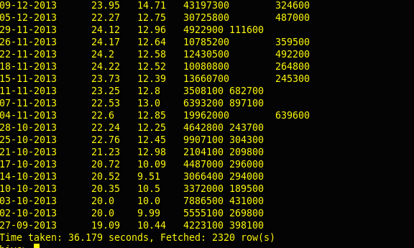

For creating external table, I have used this query:

CREATE EXTERNAL TABLE scenario4_external(

date string, aal_open_price float, aaoi_open_price float, aal_volume_price int , abmd_volume_price int

)

ROW FORMAT DELIMITED

FIELDS TERMINATED BY ','

STORED AS TEXTFILE

LOCATION '/user/cloudera/projectresult/scenario4_external';

And I have used this query to insert result into my external table:

insert overwrite table scenario4_external select stock_bucket_aal.date, stock_bucket_aal.open as aal_open_price, stock_bucket_aaoi.open aaoi_open_price, stock_bucket_aal.volume aal_volume_price, stock_bucket_abmd.volume abmd_volume_price

from

stock_bucket_aal

join

stock_bucket_aaoi

on stock_bucket_aal.date = stock_bucket_aaoi.date

join

stock_bucket_abmd

on stock_bucket_aal.date = stock_bucket_abmd.date

where stock_bucket_aal.open > stock_bucket_aaoi.open or stock_bucket_aal.volume > stock_bucket_abmd.volume;

**Scenario 5:** Write a Hive query to calculate VH ratio(volume to high ratio).

**Hive query:**

**For AAL :**

select DATE,(volume/high) as volume_to_high_ratio from aal ;

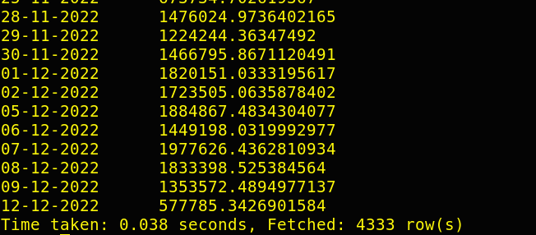

**For AAOI :**

select DATE,(volume/high) as volume_to_high_ratio from aaoi ;

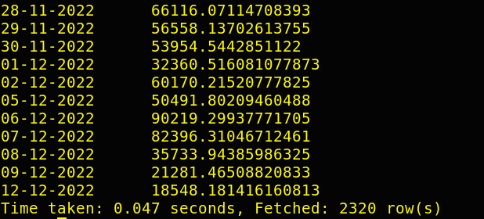

**For ABIO :**

select DATE,(volume/high) as volume_to_high_ratio from abio;

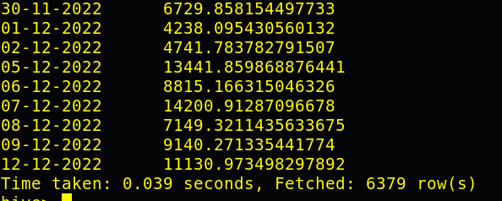

**For ABMD :**

select DATE,(volume/high) as volume_to_high_ratio from abmd ;

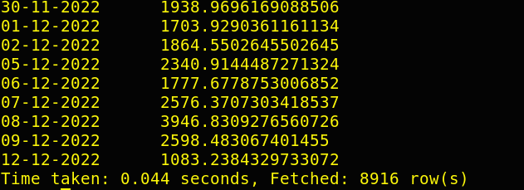

For creating external table, I have used this query:

CREATE EXTERNAL TABLE scenario5_ext_aal/ scenario5_ext_ aaoi/ scenario5_ext_abio/ scenario5_ext_abmd (

date string, volume_to_high_ratio float)

ROW FORMAT DELIMITED

FIELDS TERMINATED BY ',' STORED AS TEXTFILE

LOCATION '/user/cloudera/projectresult/ scenario5_ext_aal/ scenario5_ext_ aaoi/ scenario5_ext_abio/ scenario5_ext_abmd’;

And I have used this query to insert result into my external table:

Insert overwrite table scenario5_ext_aal/scenario5_ext_ aaoi/scenario5_ext_abio/scenario5_ext_abmd select DATE,(volume/high) as volume_to_high_ratio from aal/aaoi/abio/abmd;

**Scenario 6:** Write a Hive query to find the dates where previous day close and current day open difference is greater than 0 for each stock.

**For AAL :**

select from_unixtime(date) as req_date from( select unix_timestamp(date, 'dd-MM-yyyy') as date,lag(Close) over (order by unix_timestamp(date, 'dd-MM-yyyy')) as previous_close, Open as current_open from aal) subquery where abs(current_open - previous_close )> 0 order by req_date;

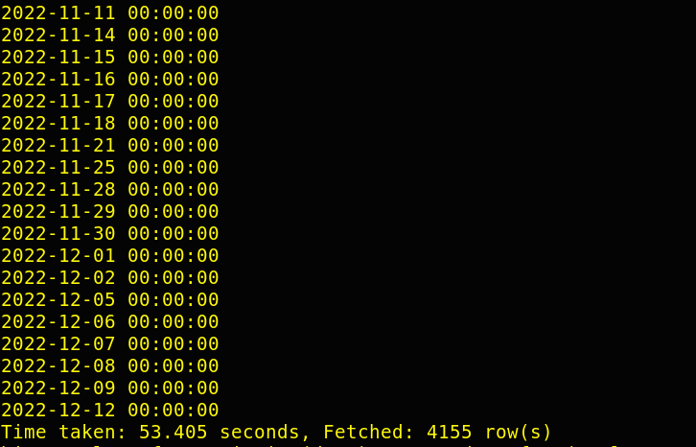

**For AAOI :**

select from_unixtime(date) as req_date from( select unix_timestamp(date, 'dd-MM-yyyy') as date,lag(Close) over (order by unix_timestamp(date, 'dd-MM-yyyy')) as previous_close, Open as current_open from aaoi) subquery where abs(current_open - previous_close )> 0 order by req_date;

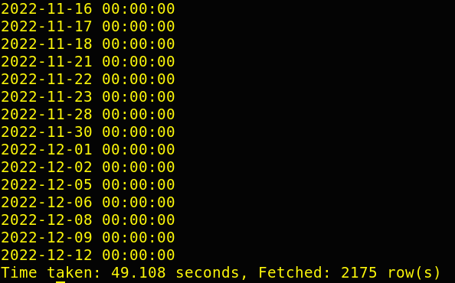

**For ABIO :**

select from_unixtime(date) as req_date from( select unix_timestamp(date, 'dd-MM-yyyy') as date,lag(Close) over (order by unix_timestamp(date, 'dd-MM-yyyy')) as previous_close, Open as current_open from abio) subquery where abs(current_open - previous_close )> 0 order by req_date;

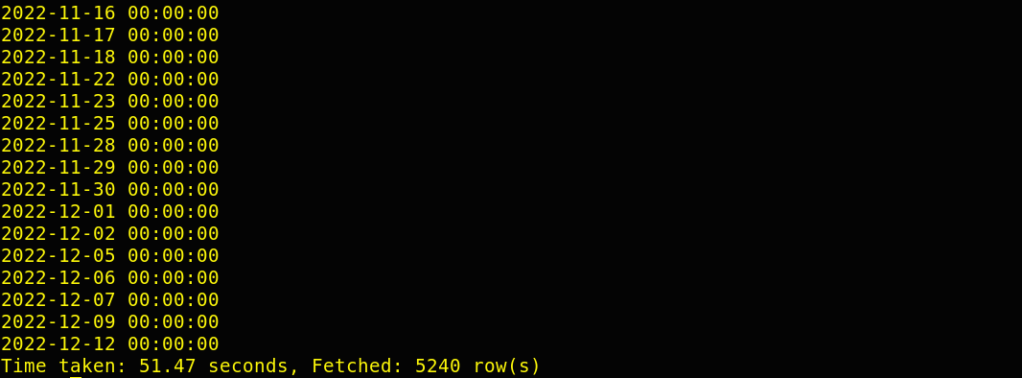

**For ABMD :**

select from_unixtime(date) as req_date from( select unix_timestamp(date, 'dd-MM-yyyy') as date,lag(Close) over (order by unix_timestamp(date, 'dd-MM-yyyy')) as previous_close, Open as current_open from abmd) subquery where abs(current_open - previous_close )> 0 order by req_date;

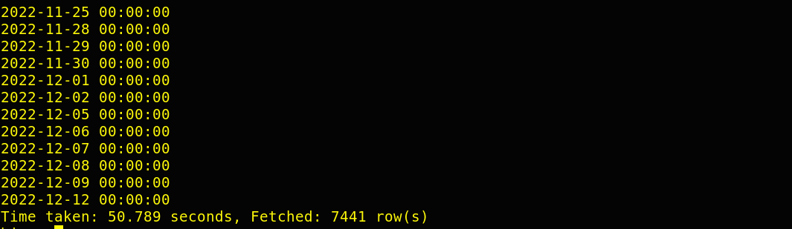

For creating external table, I have used this query:

CREATE EXTERNAL TABLE scenario6_ext_aal/ scenario6_ext_ aaoi/ scenario6_ext_abio/ scenario6_ext_abmd (

from_unixtime string)

ROW FORMAT DELIMITED

FIELDS TERMINATED BY ',' STORED AS TEXTFILE

LOCATION '/user/cloudera/projectresult/ scenario6_ext_aal/ scenario6_ext_ aaoi/ scenario6_ext_abio/ scenario6_ext_abmd’;

And I have used this query to insert result into my external table:

Insert overwrite table scenario6_ext_aal/scenario6_ext_ aaoi/scenario6_ext_abio/scenario6_ext_abmd

select from_unixtime(date) as req_date from( select unix_timestamp(date, 'dd-MM-yyyy') as date,lag(Close) over (order by unix_timestamp(date, 'dd-MM-yyyy')) as previous_close, Open as current_open from aal/aaoi/abio/abmd) subquery where abs(current_open - previous_close )> 0 order by req_date;

**Scenario 7:**  Find median of volume for ABIO.

Query:

select percentile_approx(volume, 0.5) as median from abio;

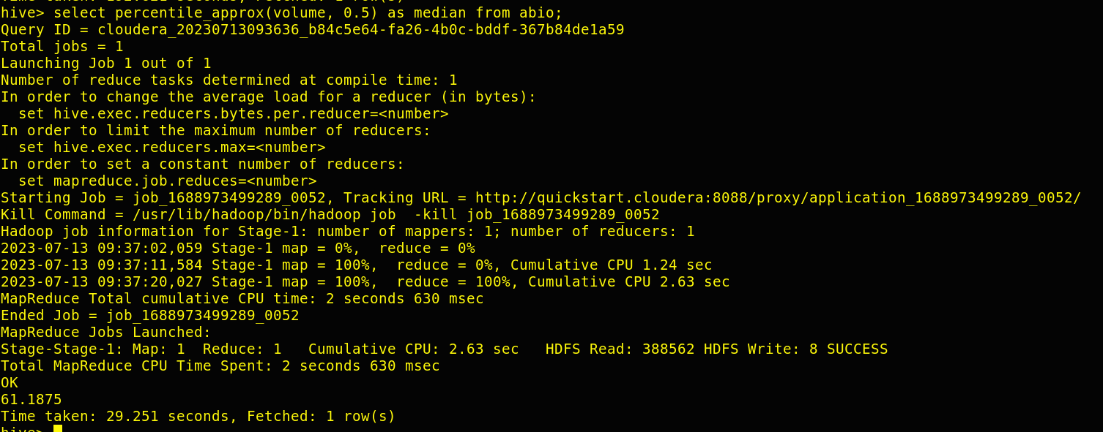

For creating external table, I have used this query:

CREATE EXTERNAL TABLE scenario7_external (

from_unixtime string)

ROW FORMAT DELIMITED

FIELDS TERMINATED BY ',' STORED AS TEXTFILE

LOCATION '/user/cloudera/projectresult/ scenario7_external;

And I have used this query to insert result into my external table:

Insert overwrite table scenario7_external select percentile_approx(volume, 0.5) as median from abio;

**FILE: 2** 🡪 **Walmart Stock**

I have downloaded the Walmart Stock csv file directly to my google collab from where I am accessing the data and running my commands get the result of various scenario.

**Scenario 1:** Print out first 5 columns.

Loading the data from local system to MySQL-

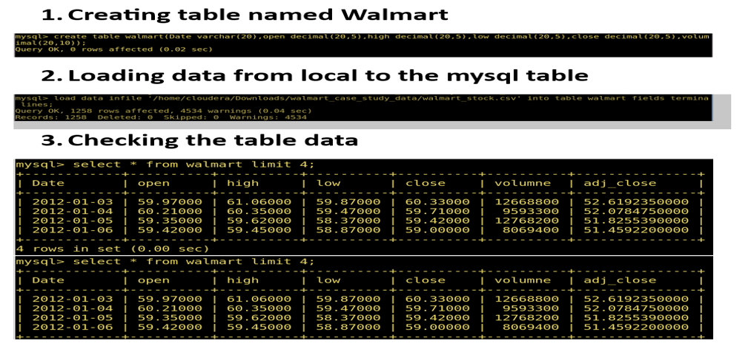

Loading data into HBASE-

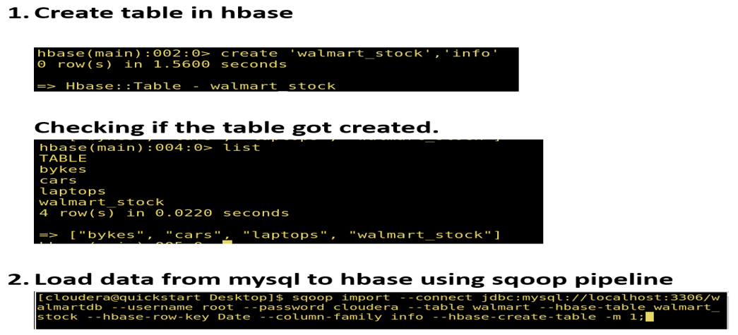

Printing out first 5 columns-

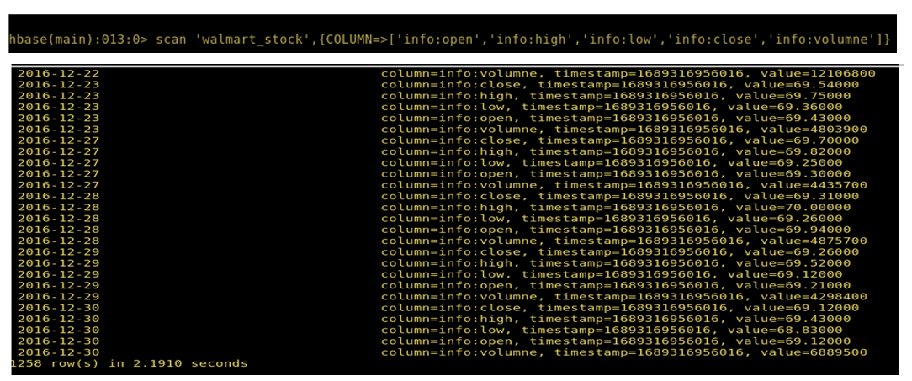

**Scenario 2:** There are too many decimal places for mean and stddev in the describe() dataframe. Format the numbers to just show up to two decimal places.

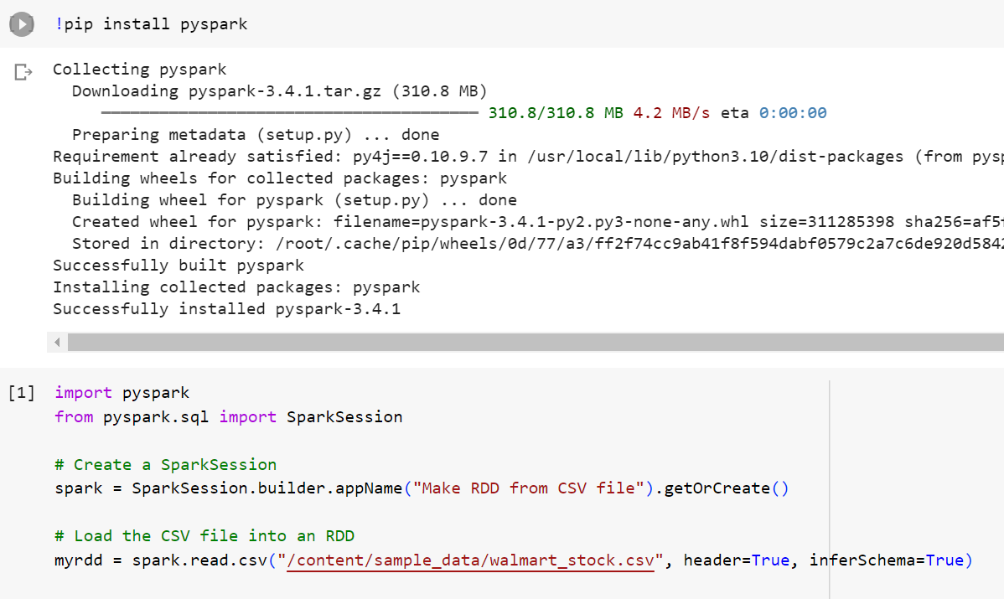

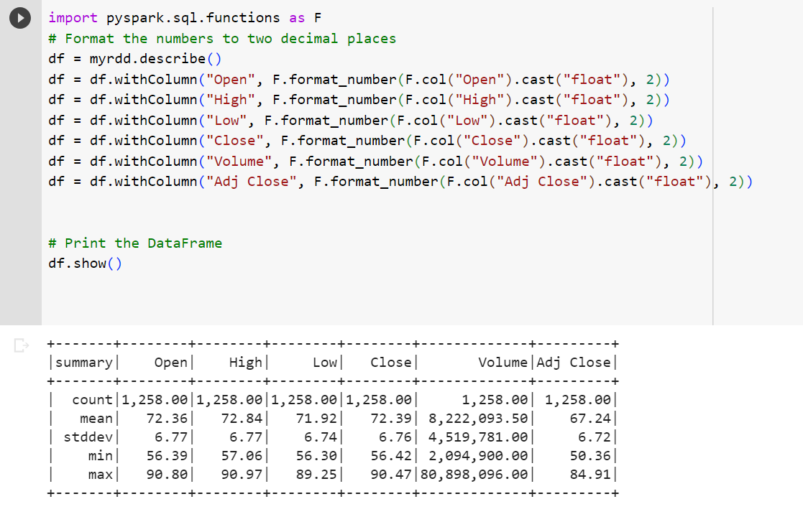

**Scenario 3:** Create a new dataframe with a column called HV Ratio that is the ratio of the High Price versus volume of stock traded for a day.

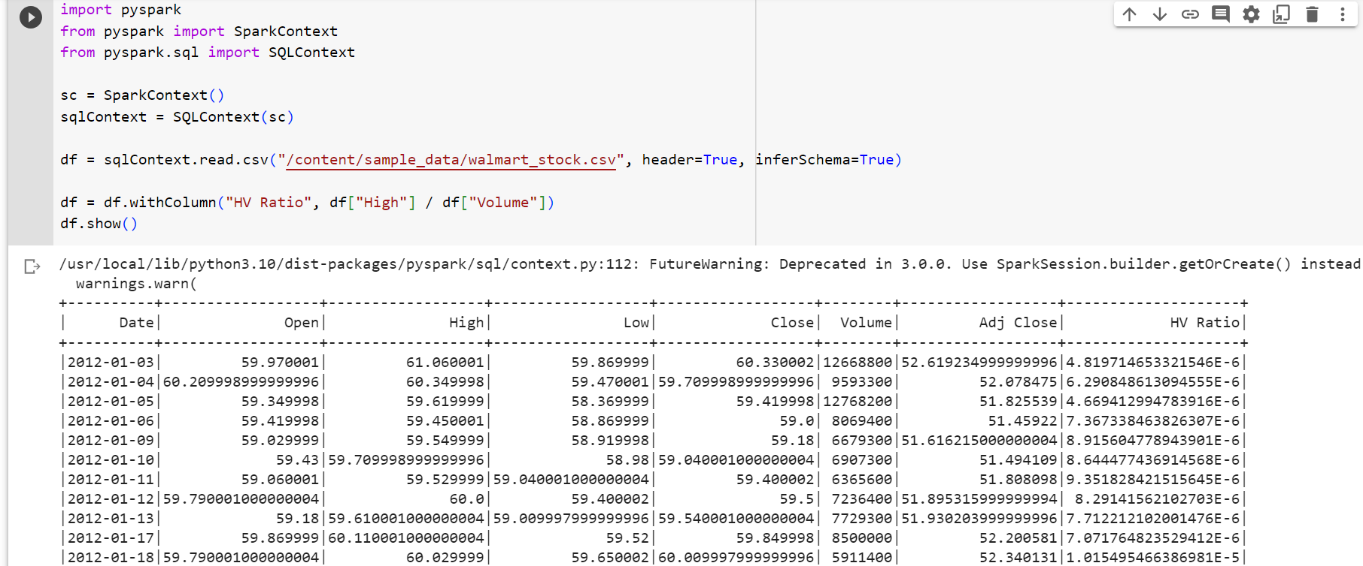

**Scenario 4:** What day had the Peak High in Price?

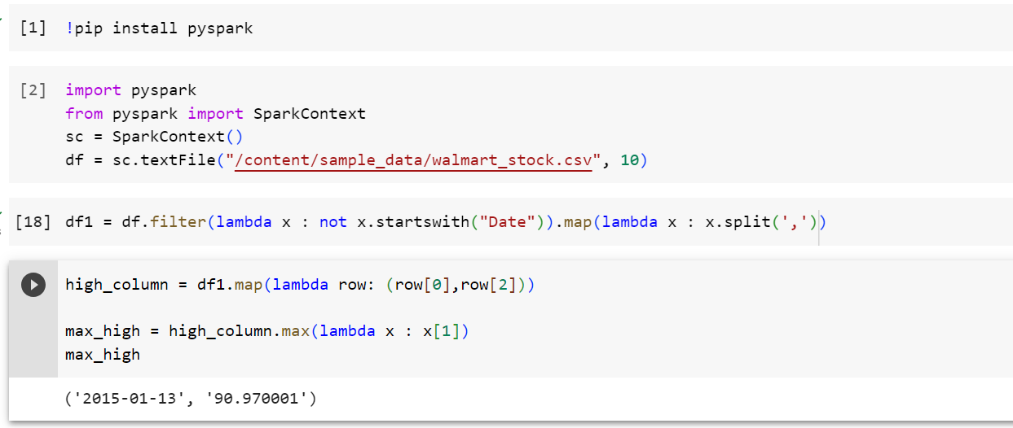

**Scenario 5:** What is the mean of the Close column??

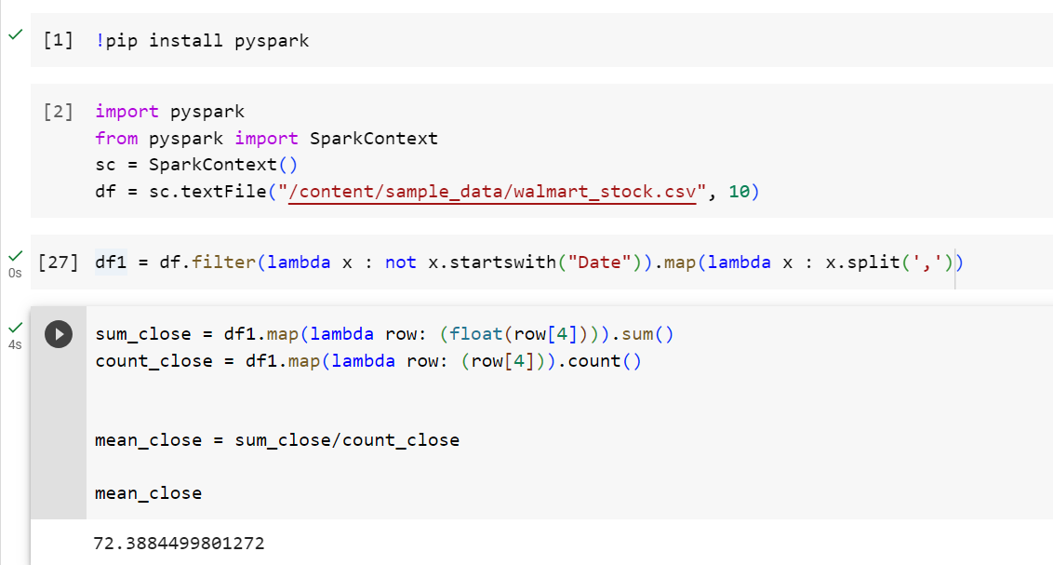

**Scenario 6:** What is the max and min of the Volume column?

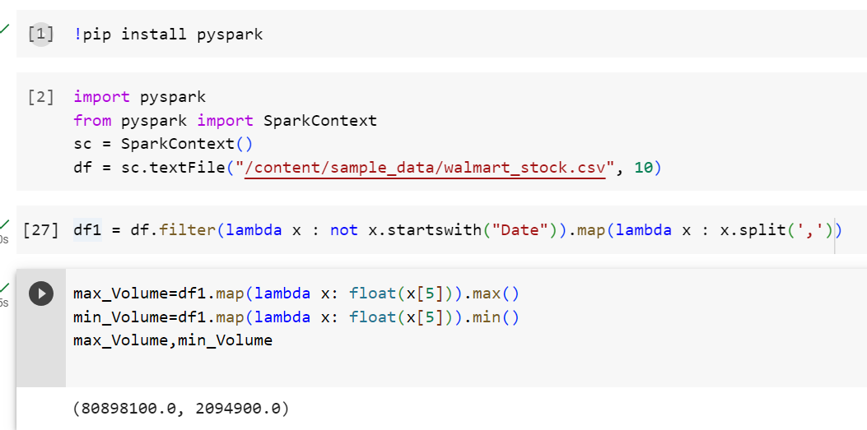

**Scenario 7:** How many days was the Close lower than 60 dollars?

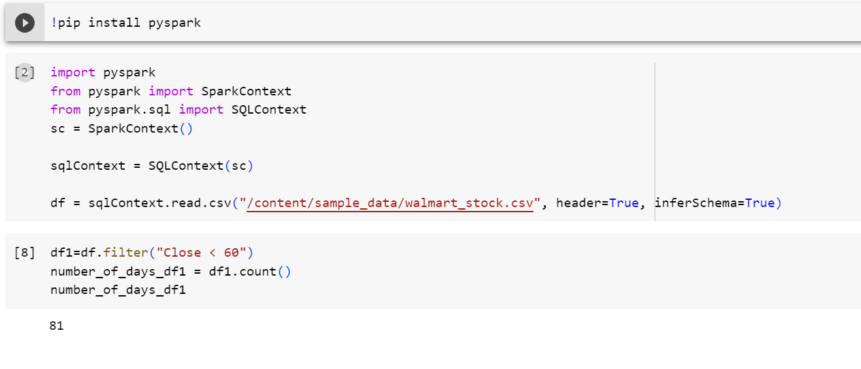

**Scenario 8:** What percentage of the time was the High greater than 80 dollars?

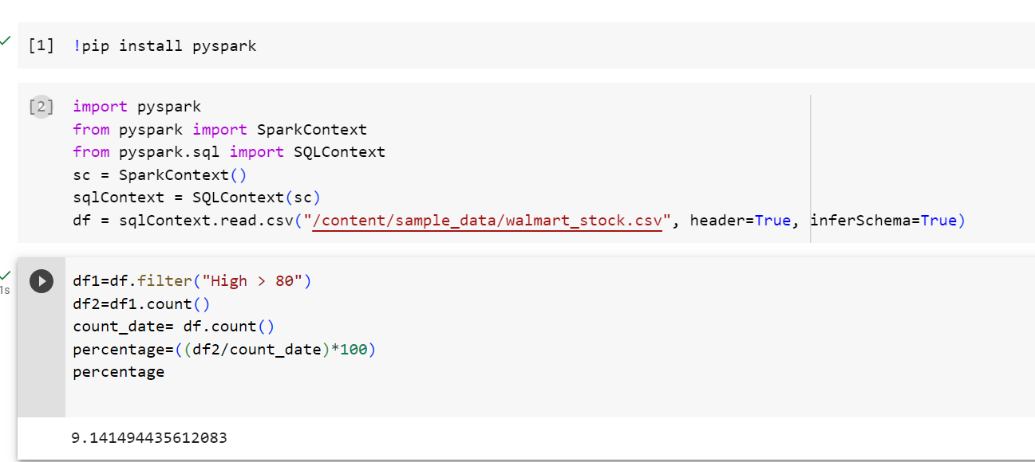

**Scenario 9:** What is the max High per year?

