EC2-Task 01
- Launch one EC2 using Amazon Linux 2 image and add a script in user data to install Apache
- launch one instance using AMI amazon linux and instance type is t3 and select as existance key login
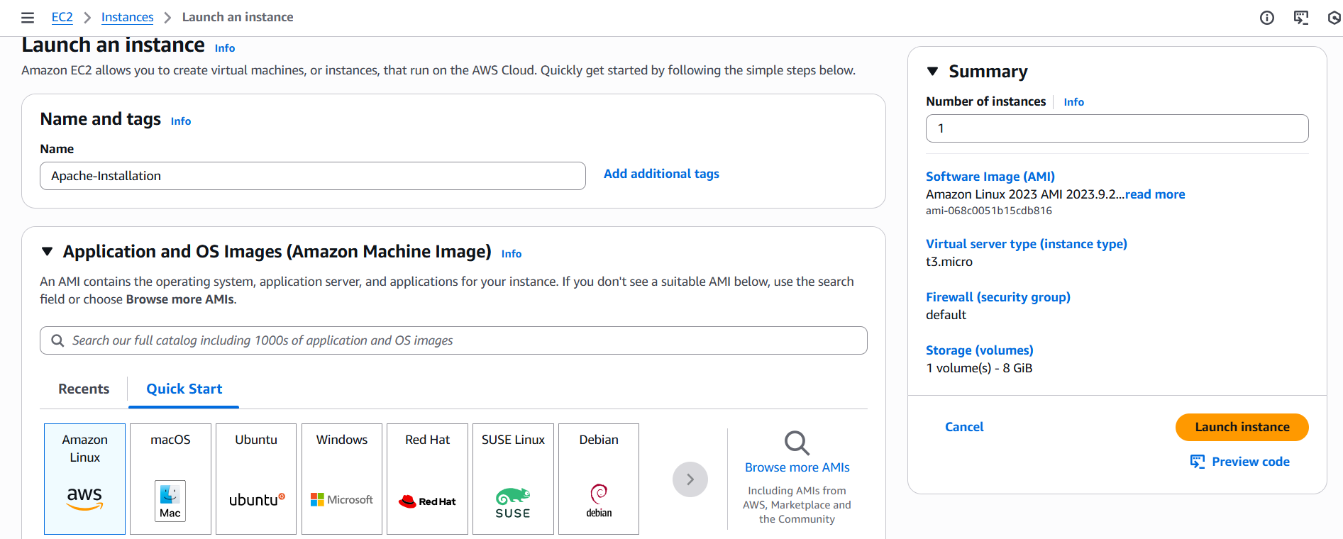
- Then go to advanced info and search for user data and write the script
#!/bin/bash
yum update -y
yum install -y httpd
systemctl start httpd
systemctl enable httpd
- and launch the instance and got to git bash and connect it, check status whether service is running or not
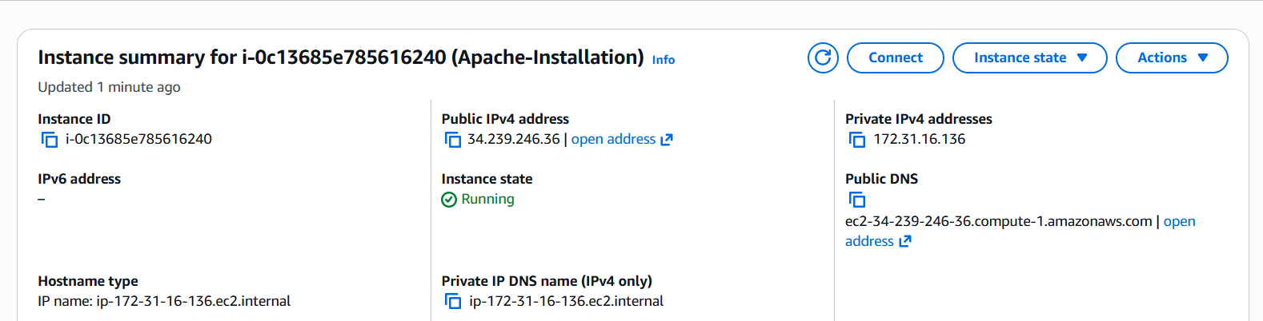
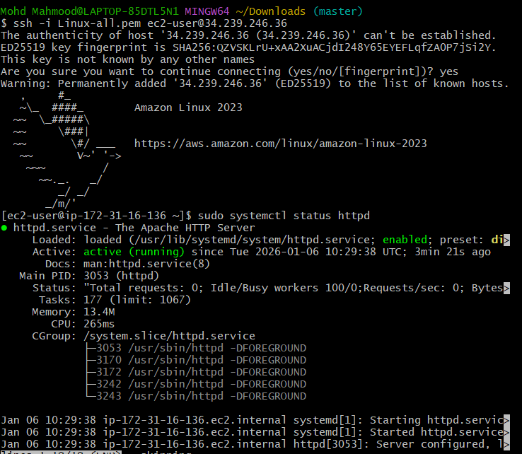
- Launch one EC2 using Ubuntu image and add a script in user data to install Nginx
- Launch one instance and select AMIs as ubuntu image and go for advance info and search for user-data and write script
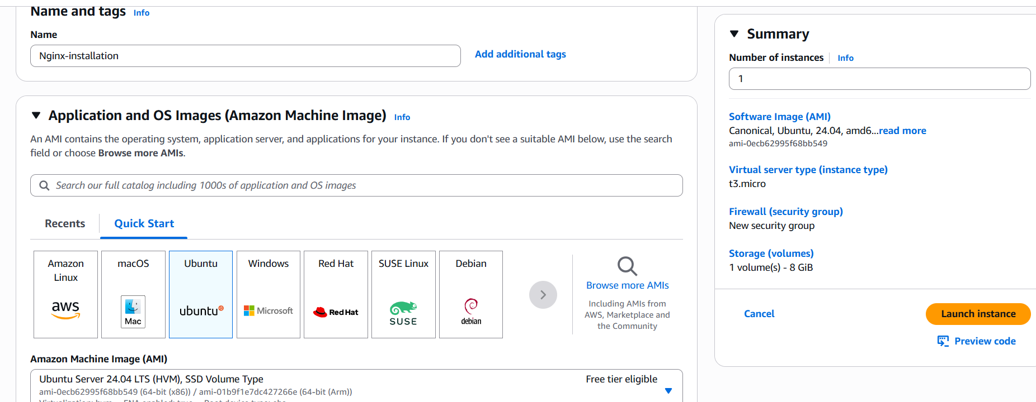
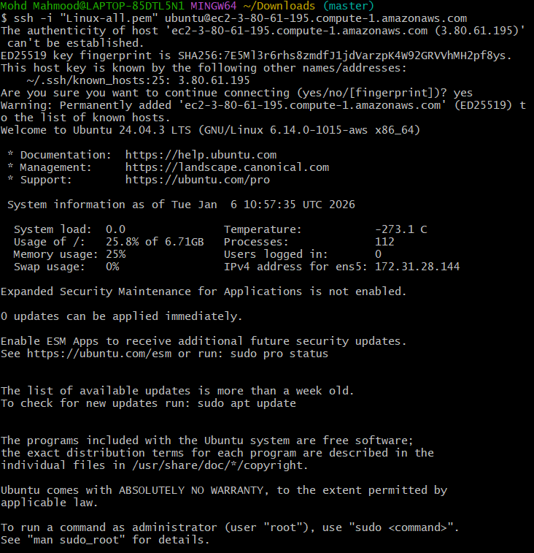
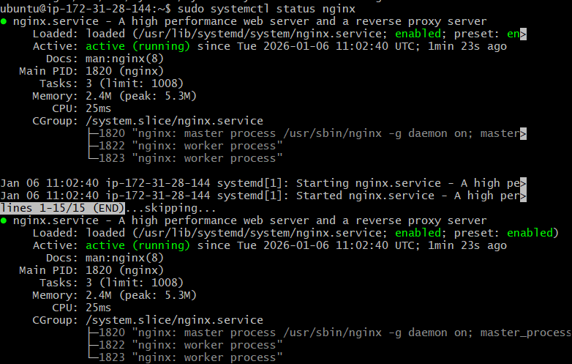
- Launch one Windows server and install Tomcat on Windows
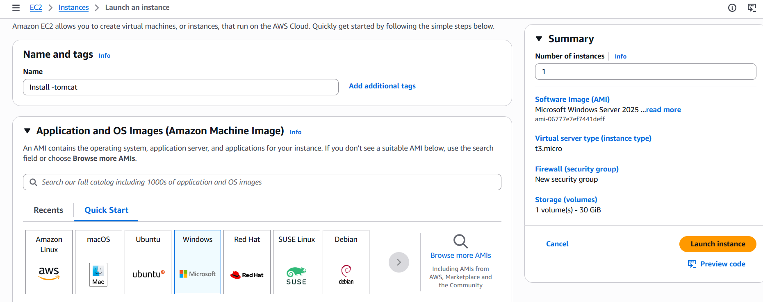
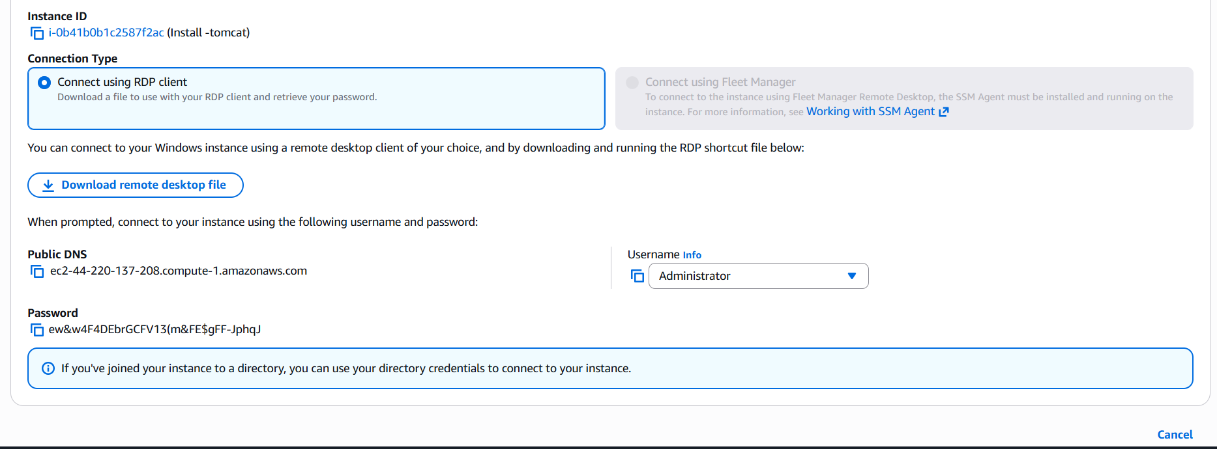

- Take a snapshot of the instance created in Task 1
-go to task 1 and check for storage and click on volume and go to actions and click on create snapshot
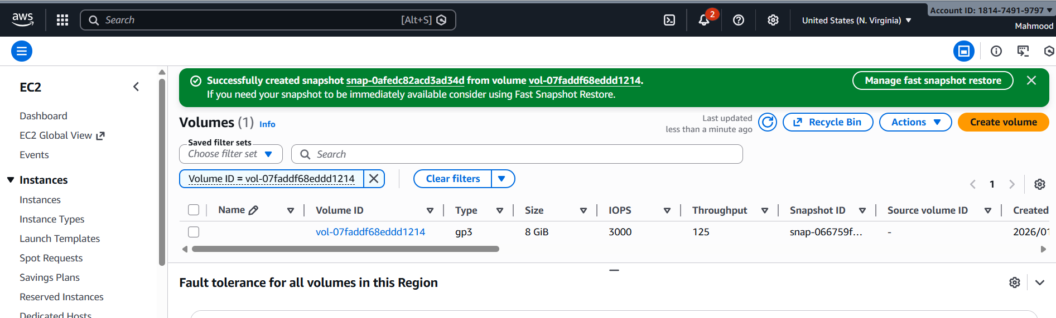
- Assign passwordless authentication for the EC2 created in Task 2
ssh-keygen to generate the public key then copy the public key and cat /c/Users/Mohd Mahmood/.ssh/id_rsa.pub
- 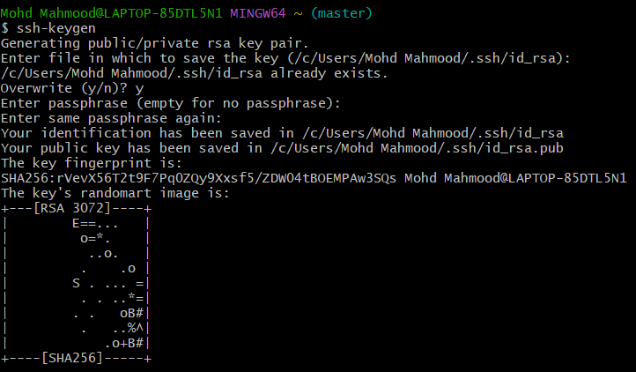
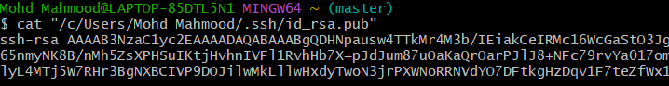
- Then go to instance open console and go to cd .ssh
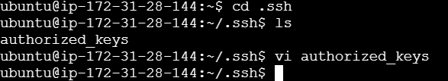
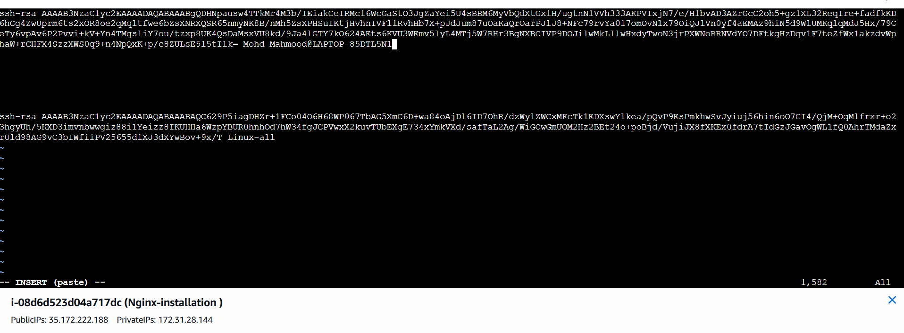
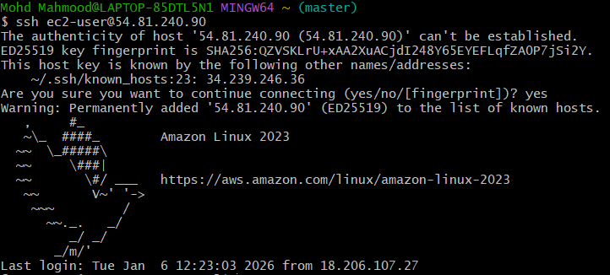
- Launch any EC2 using the spot purchasing option
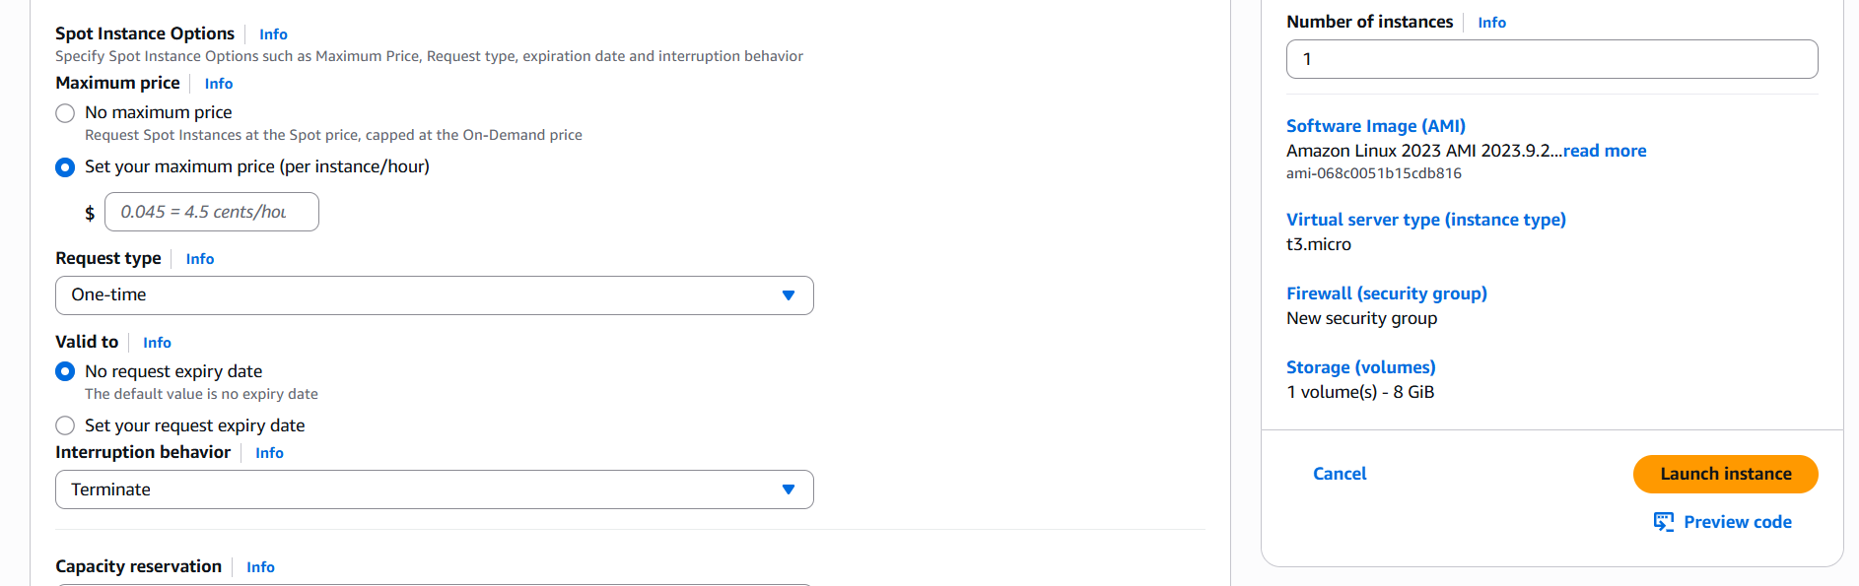
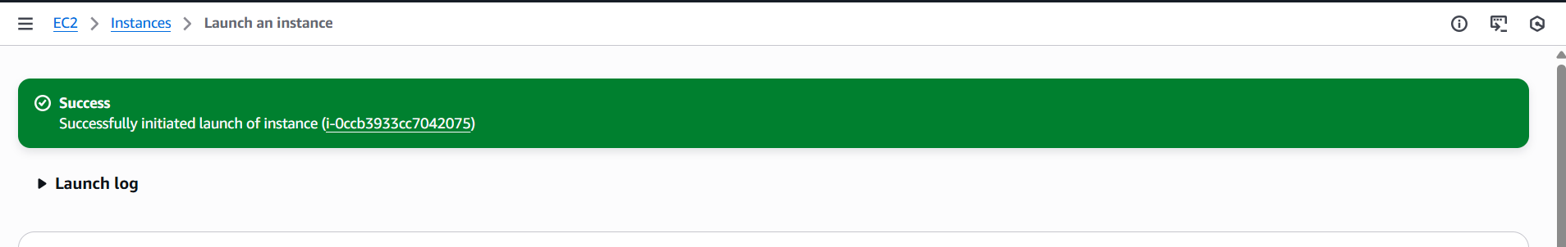
- Enable termination policy on the EC2 created in Task 2
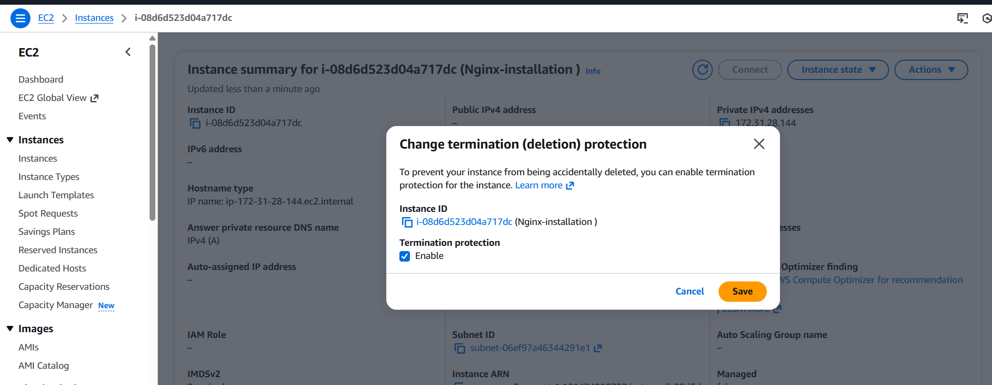
- Launch one EC2 using AWS CLI
Open this link in your browser (Chrome/Edge): https://awscli.amazonaws.com/AWSCLIV2.msi
And to IAM and create a user and select cli and description as optional
