IAM-TASK
- Create one IAM user and assign EC2 and S3 full access roles
Create a new user in IAM and set permissions
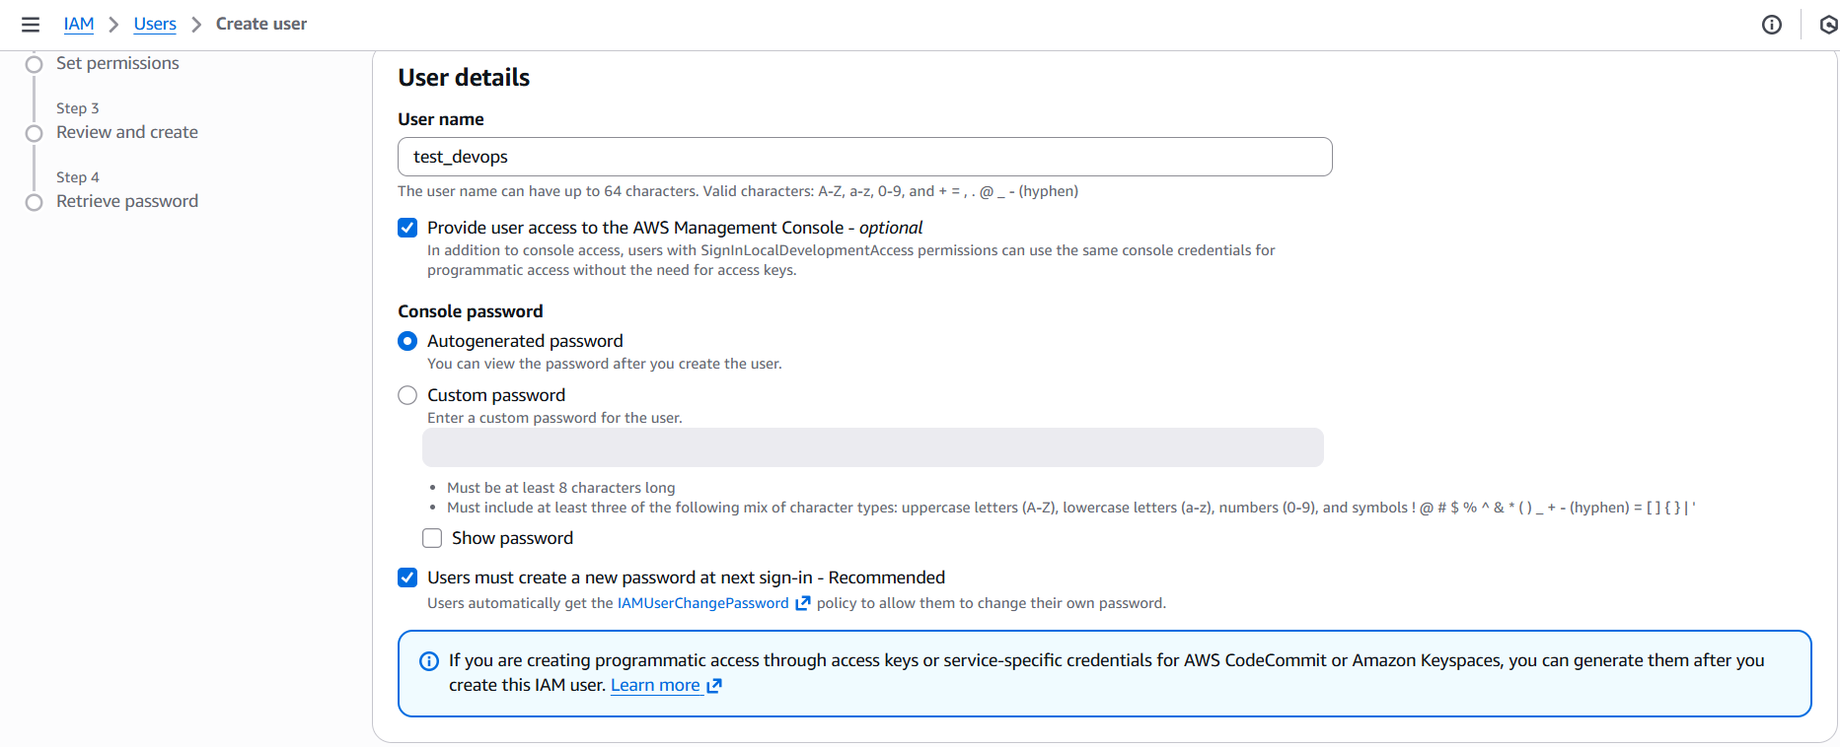
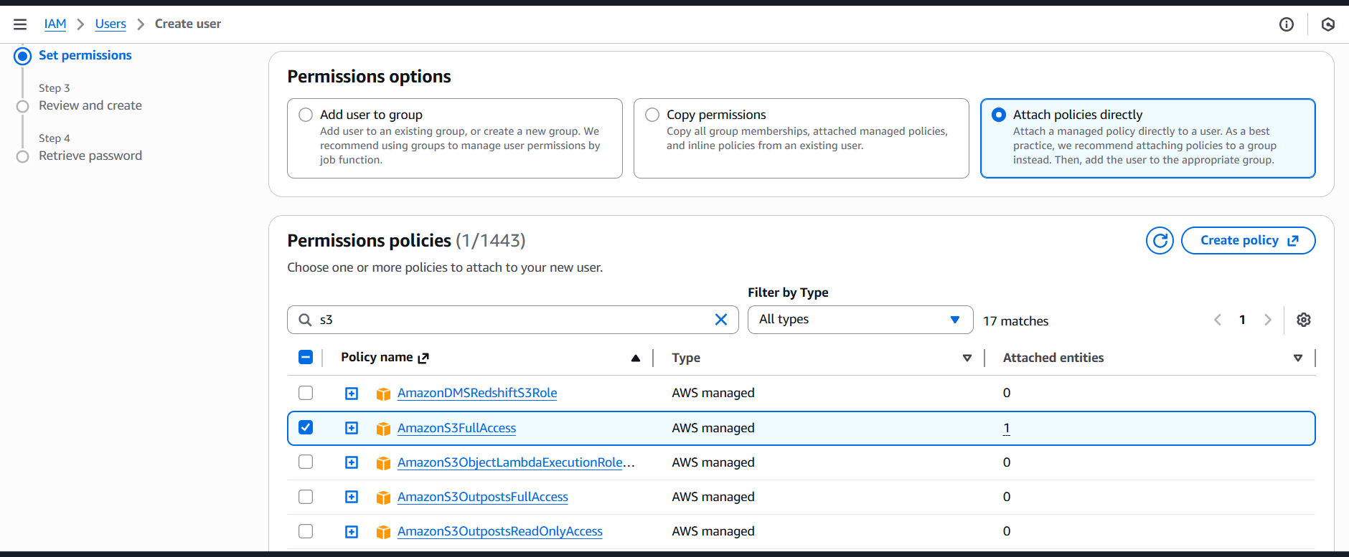
User created and downloaded CSV file
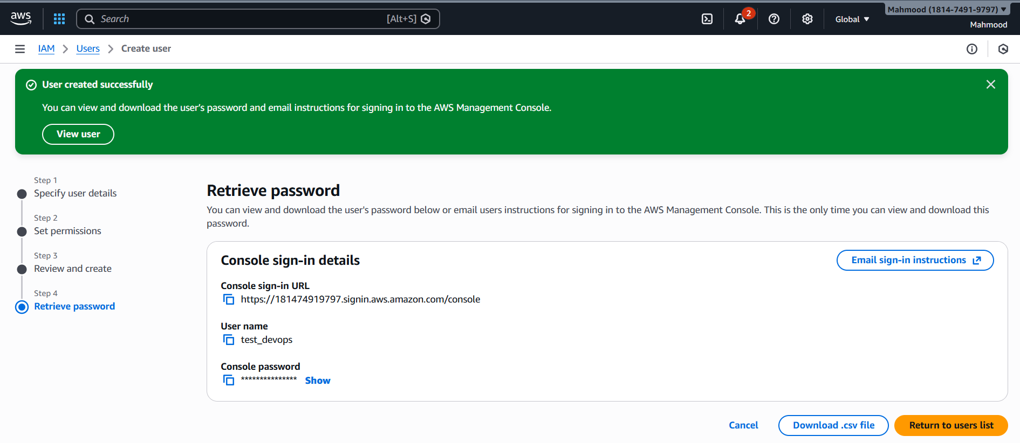
Then add user to the group by creating new group
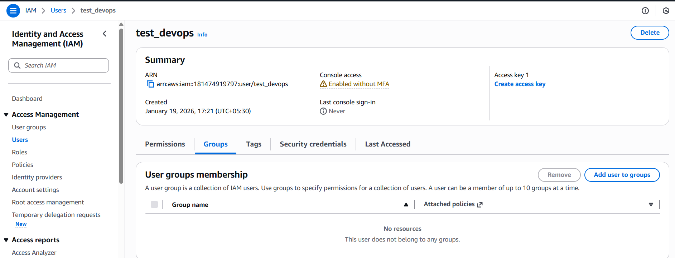
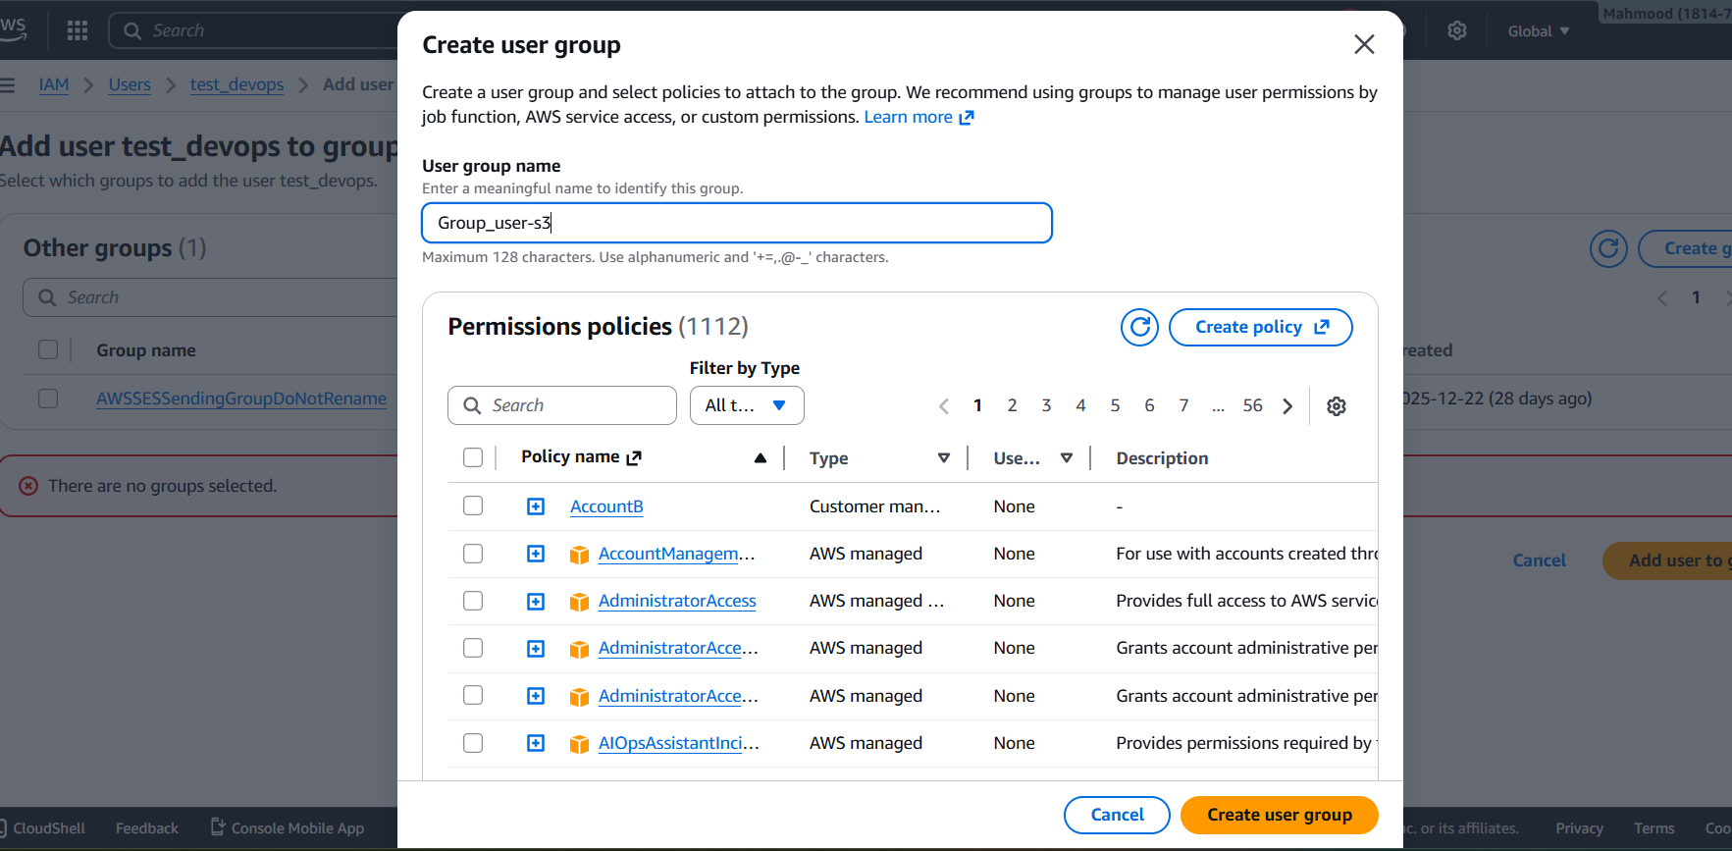
After creating the group add user in to the group the give permissions
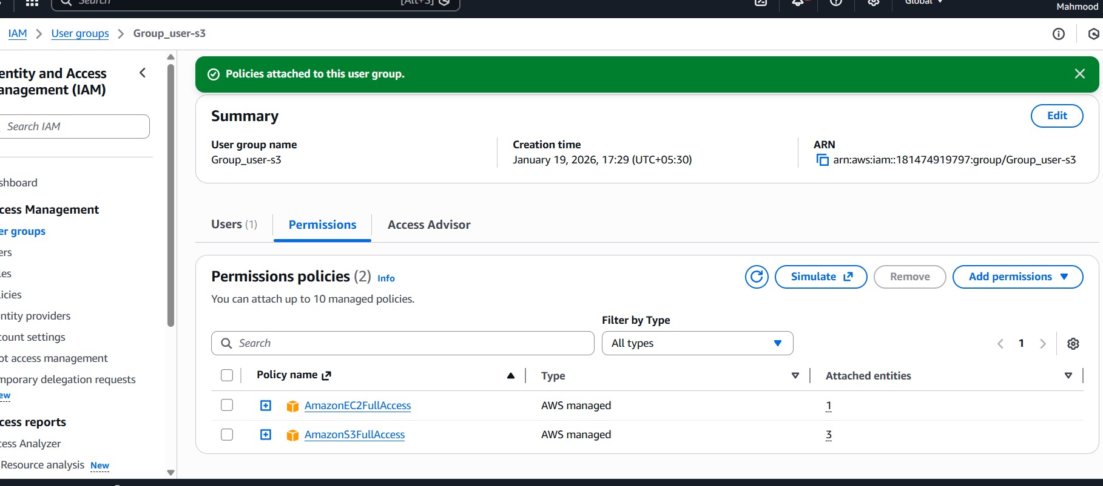
- Create one group in IAM and assign read access for EC2
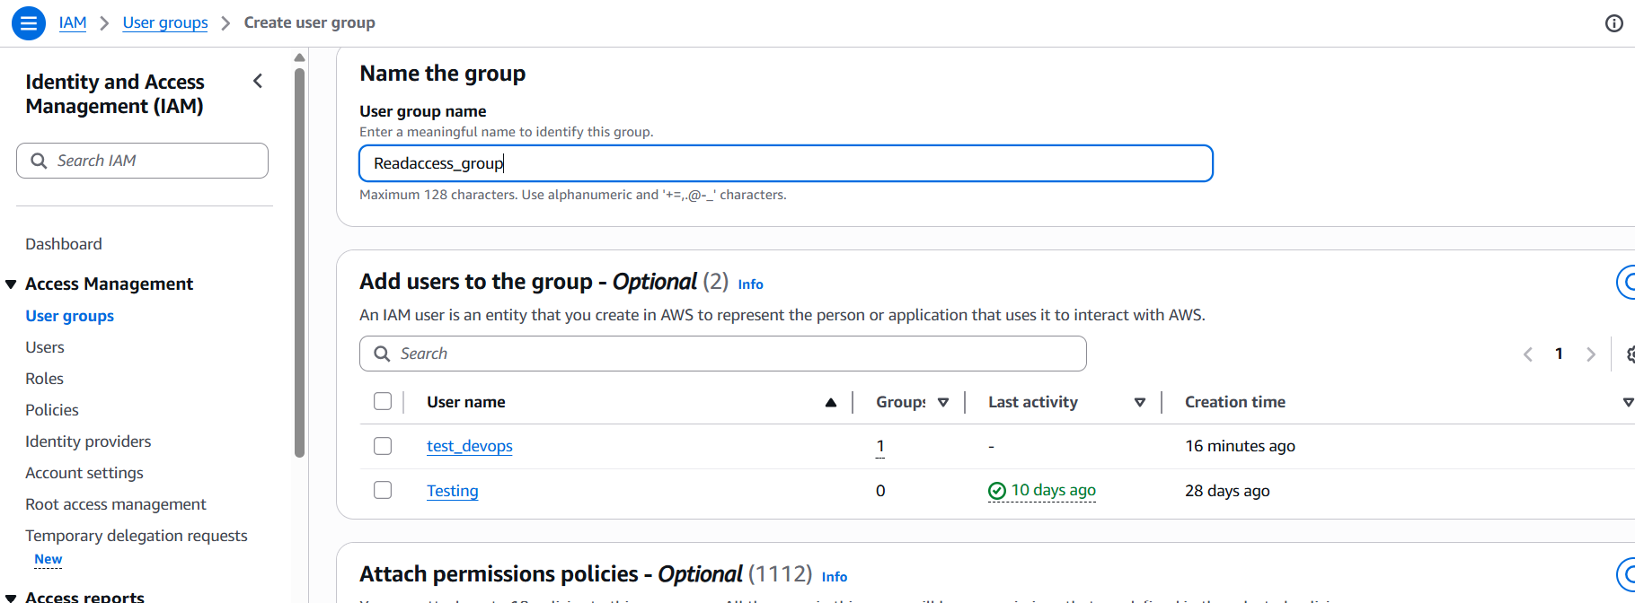
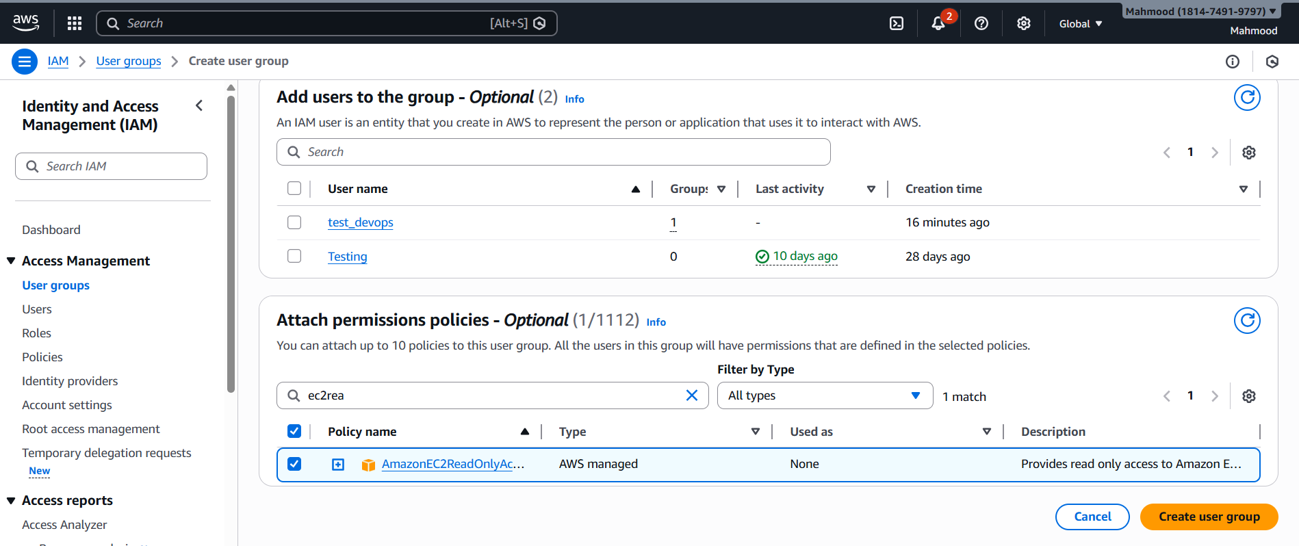
New group created in the name of readaccess and attached policy as read only access
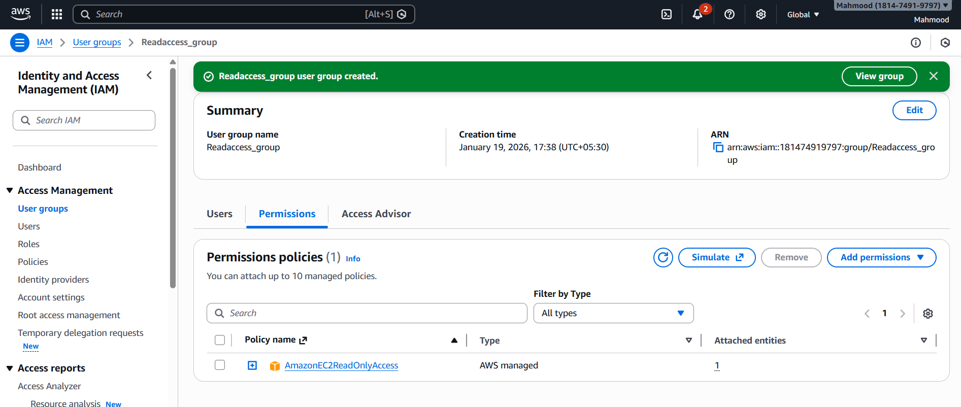
- Create a new user named "Devops" and add to the group created in task 2
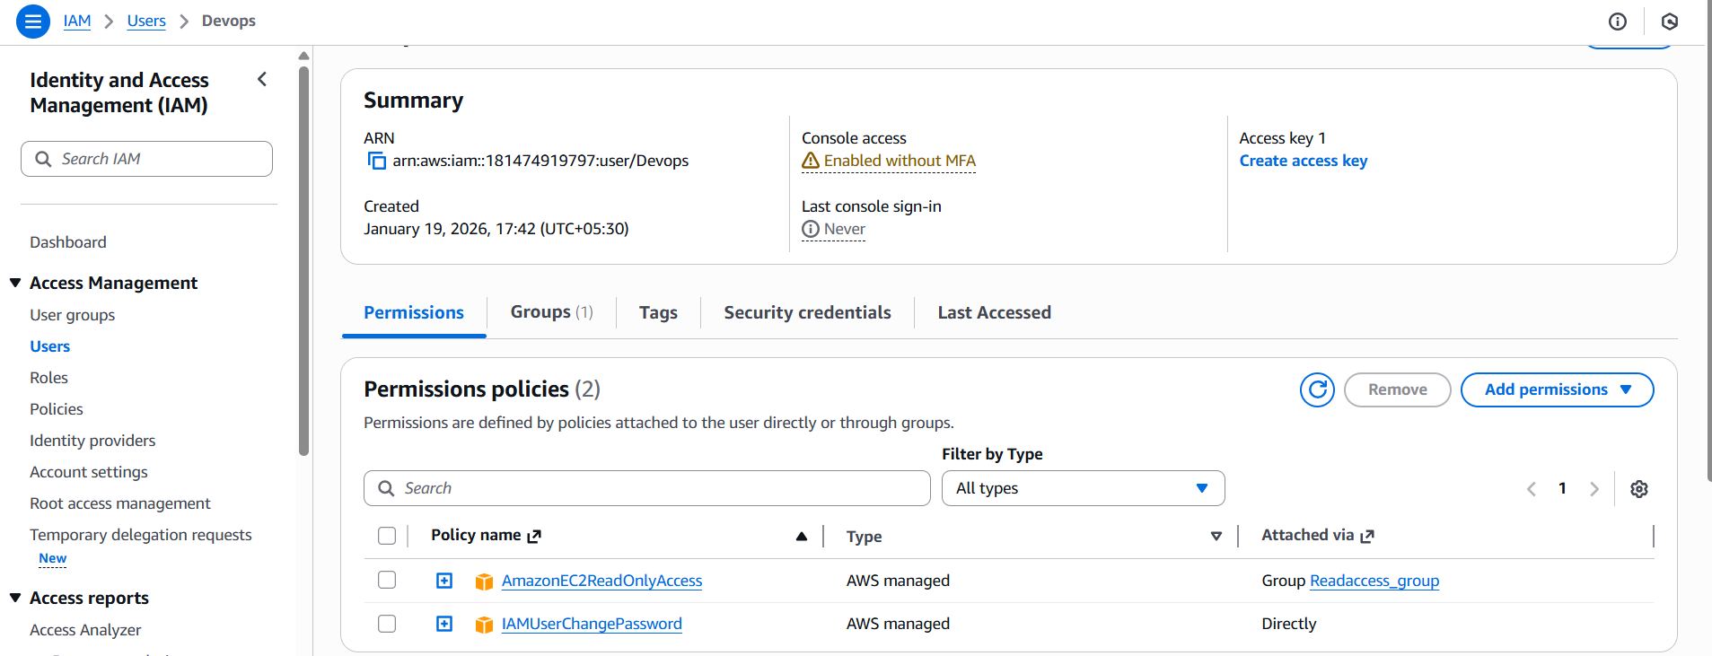
- Write a bash script to create an IAM user with VPC full access
Create a user with Devops name and configure it
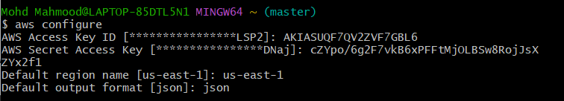
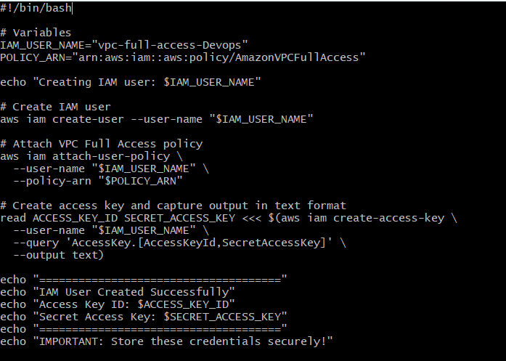
Provide permissions and execute
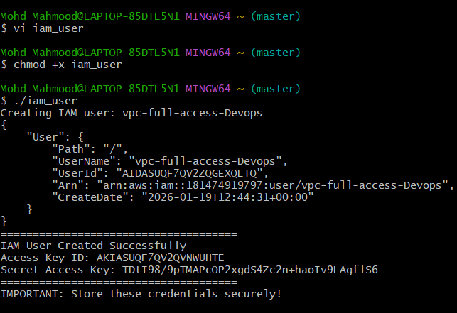
- Create an IAM policy to allow EC2 access for a specific user in specific regions only
Create a new user with custom password to login IAM
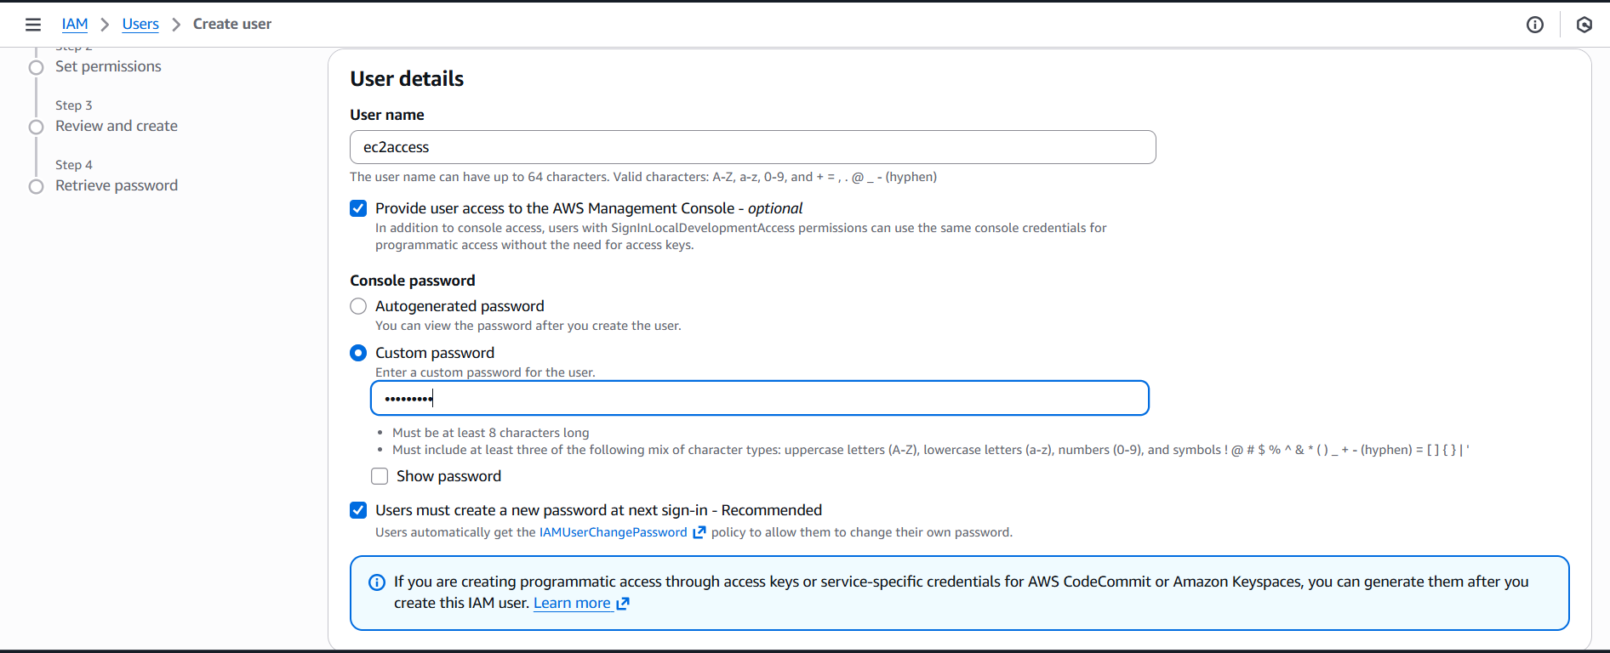
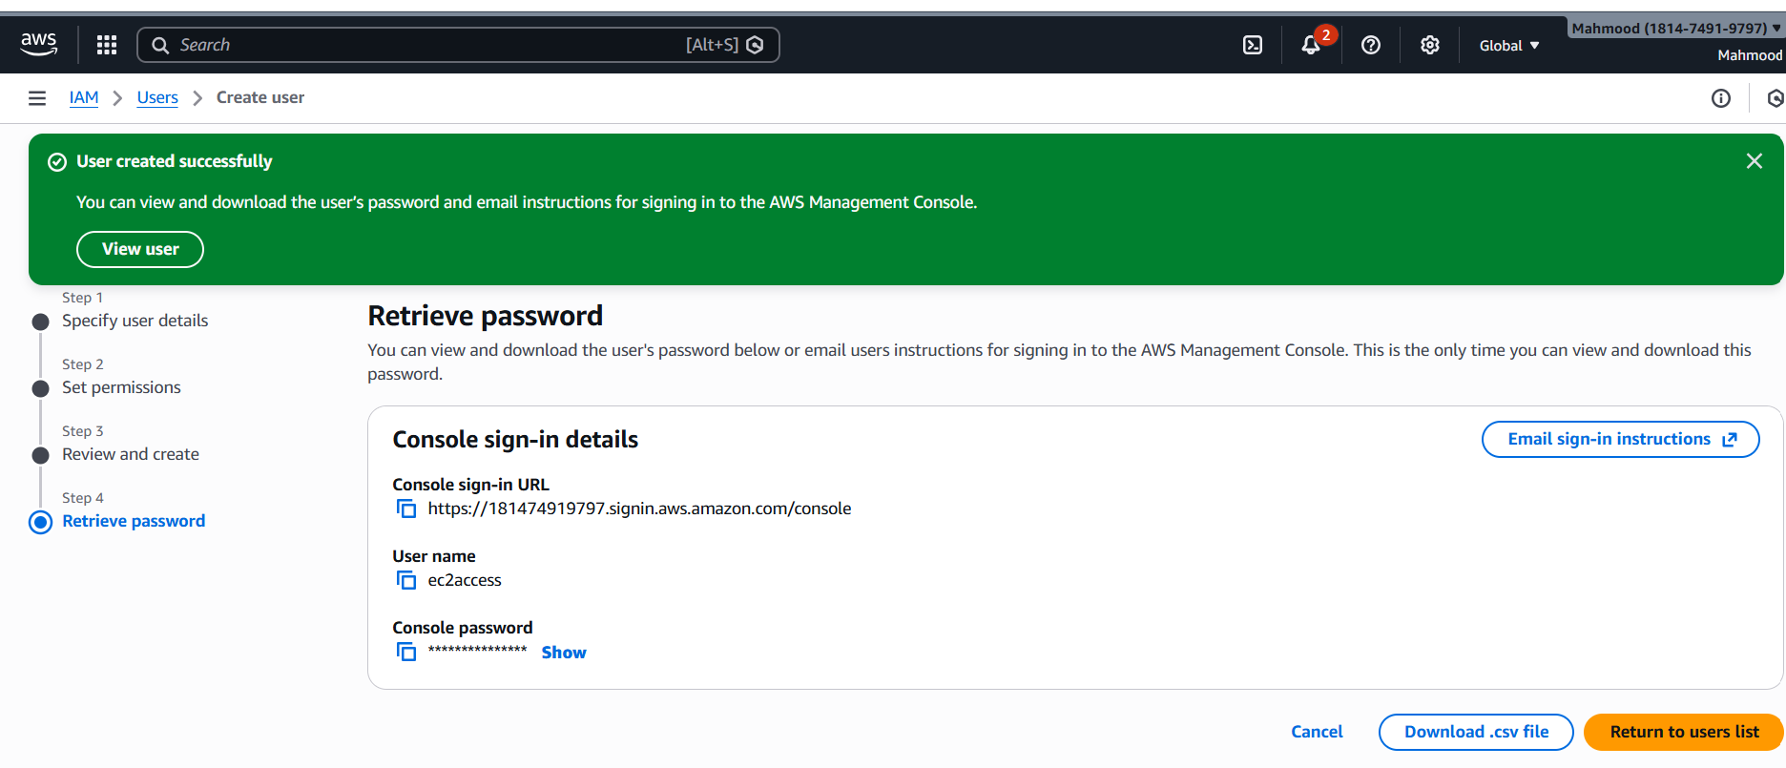
And login to console
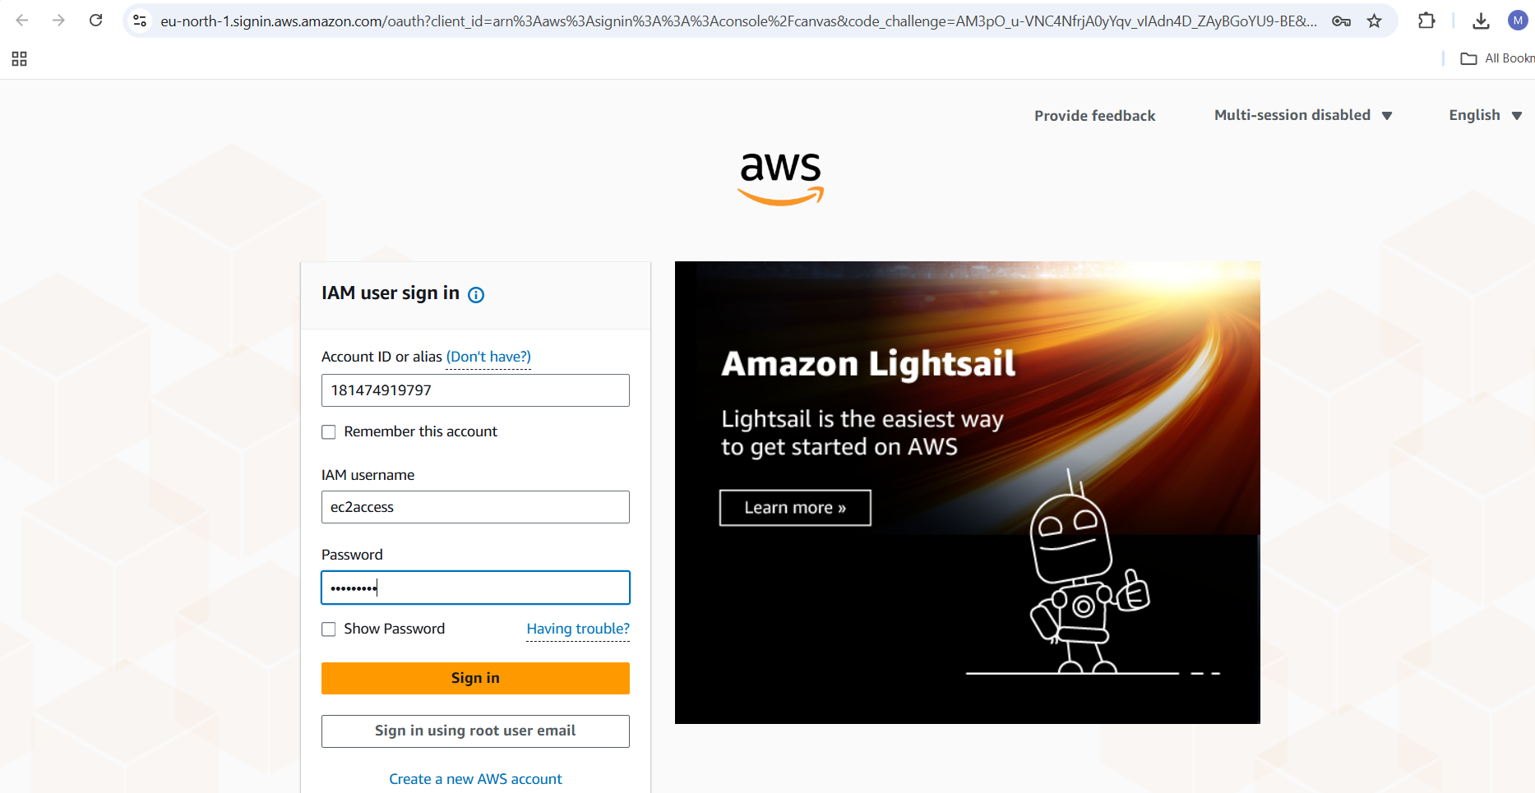
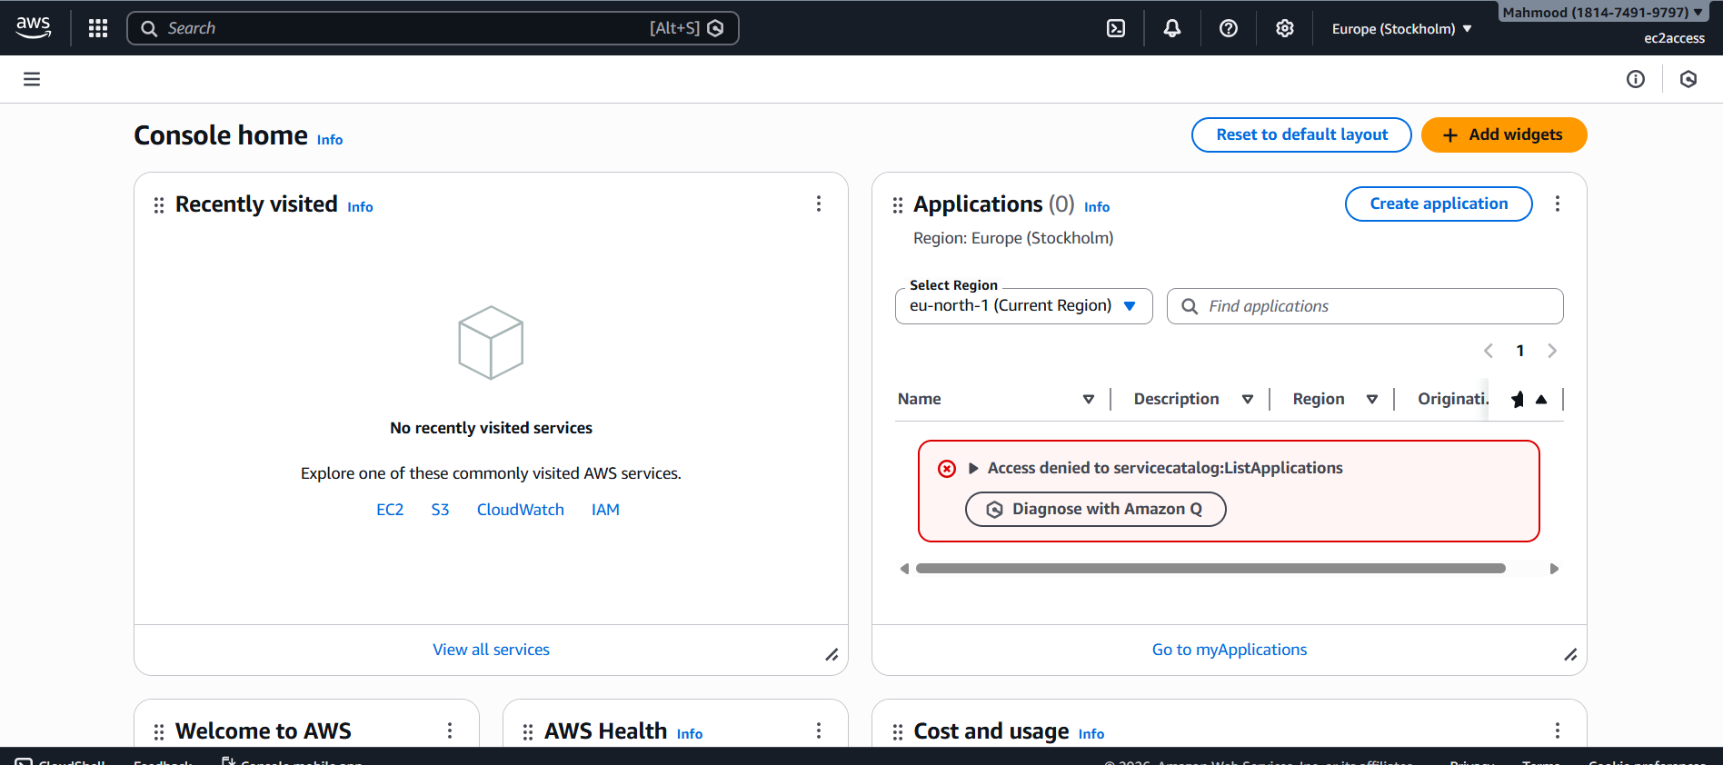
User created and now provide permissions
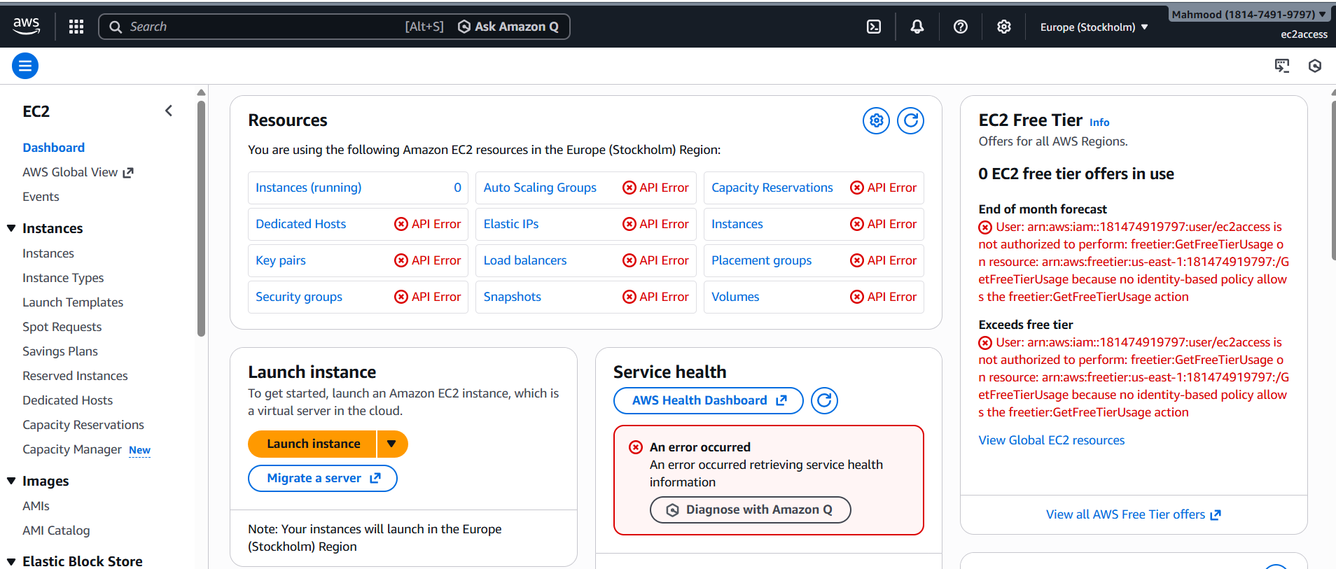
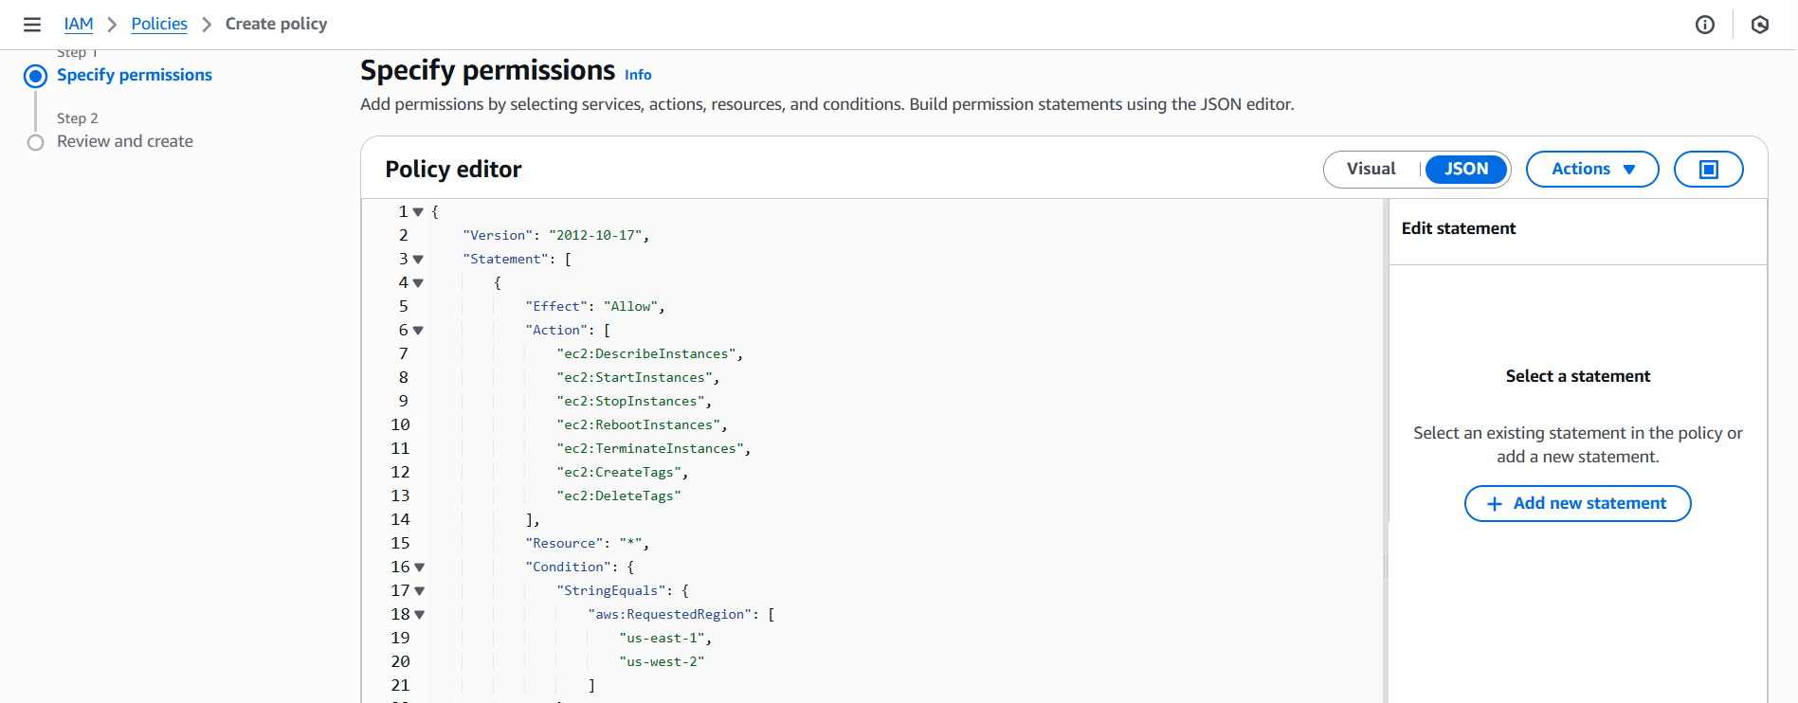
Explanation:
- Actions (Action): Only EC2 actions the user can perform. You can expand this list depending on your needs.
- Resource (Resource): * allows access to all EC2 resources, but you can narrow it to specific instance ARNs if required.
- Condition (Condition): Restricts actions to specific regions. Replace "us-east-1" and "us-west-2" with the regions you want the user to have access to.
- User attachment: Attach this policy to a specific IAM user.
- Create a s3 bucket and edit policy and enter the policy
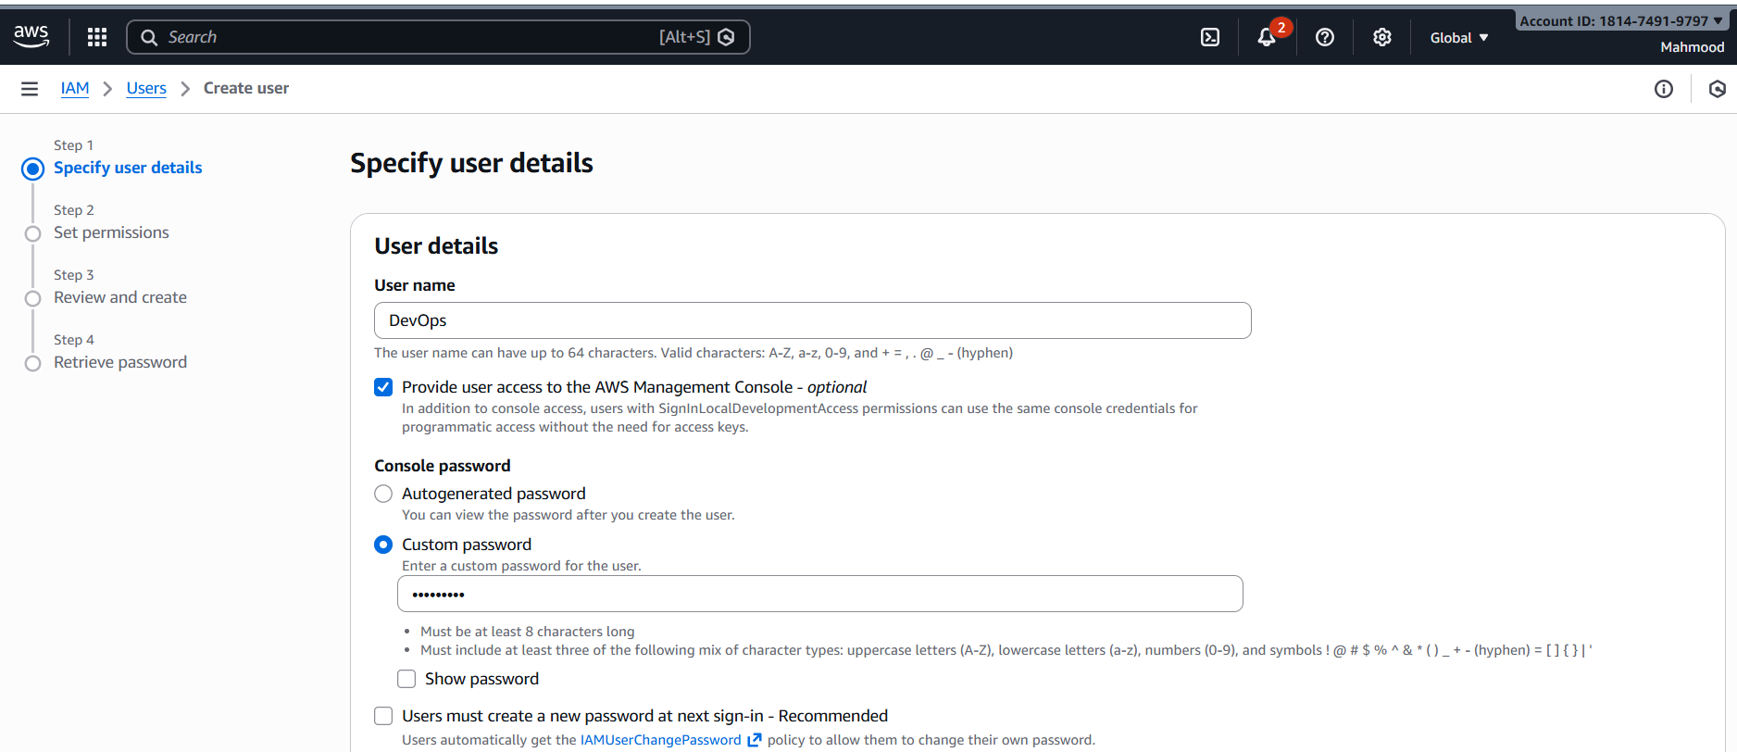
Create policy and attach s3 policy to the role
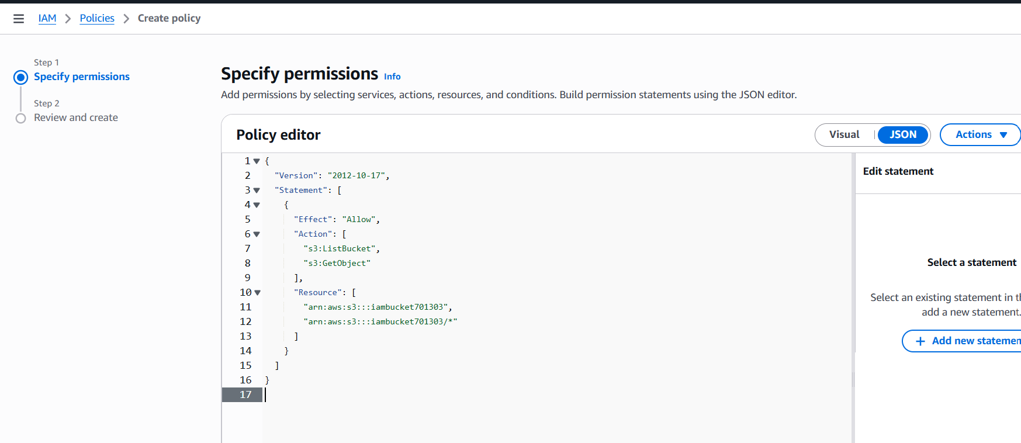
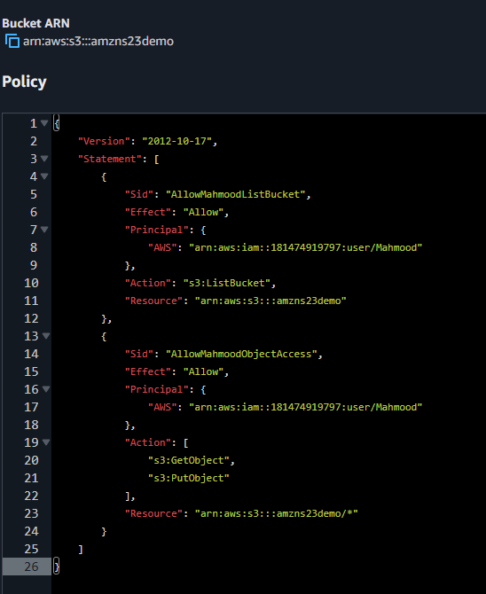
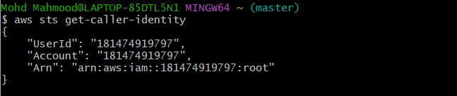
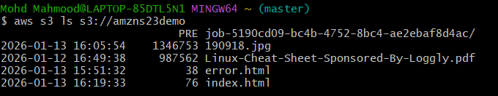
Successfully completed all assigned AWS IAM tasks, including user, group, policy
management, automation, and secure cross-account S3 access.

