S3 - Task01
Summary - Amazon S3 (Simple Storage Service) is a scalable cloud storage service by AWS that lets us store and retrieve any amount of data over the internet. It’s designed for high durability, availability, and security, and is commonly used for backups, data lakes, media storage, and hosting static websites.
- Create an S3 bucket and upload some objects to S3
Create a s3 bucket by unique name and click on create bucket
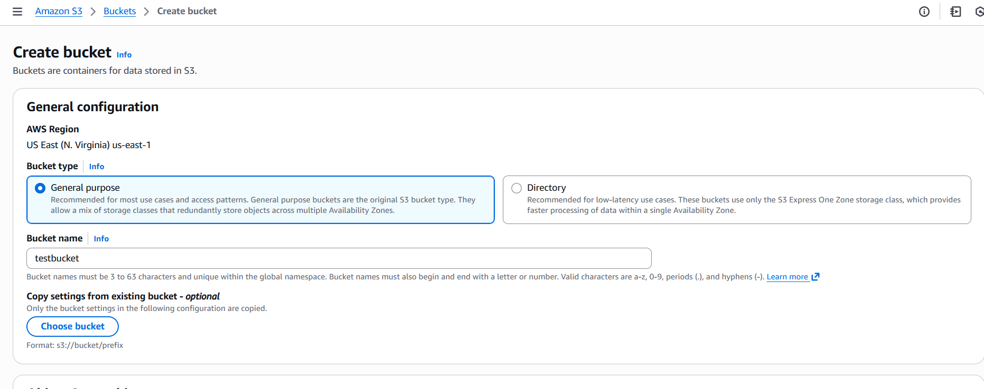
open bucket and upload files
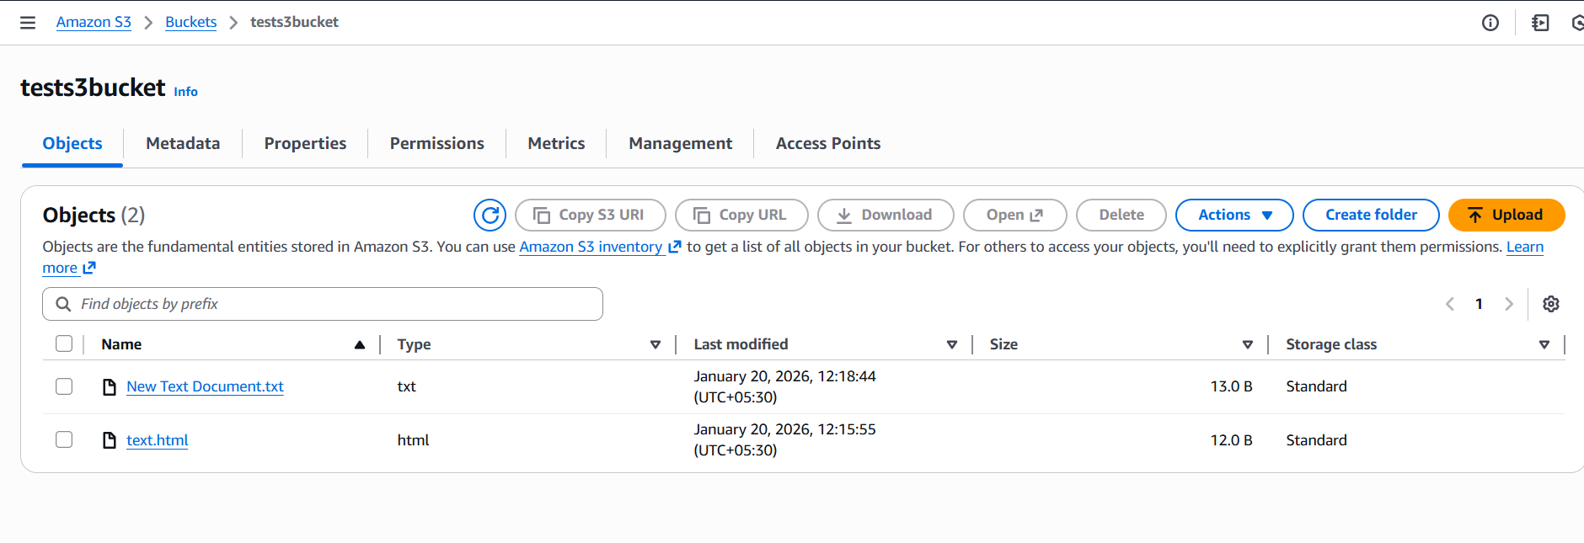
And off block all public access then enable access control list ACLS and make public using ACls
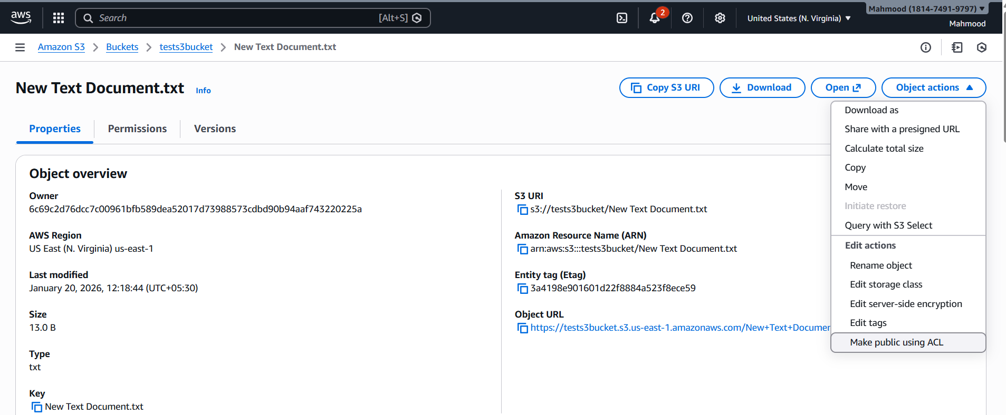
And copy the object url and paste it on browser
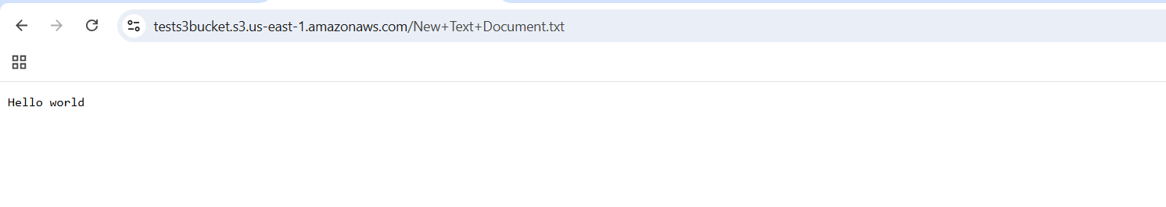
- Deploy a static website in the S3 bucket
Enable static website hosting by visiting properties in our backet and enable
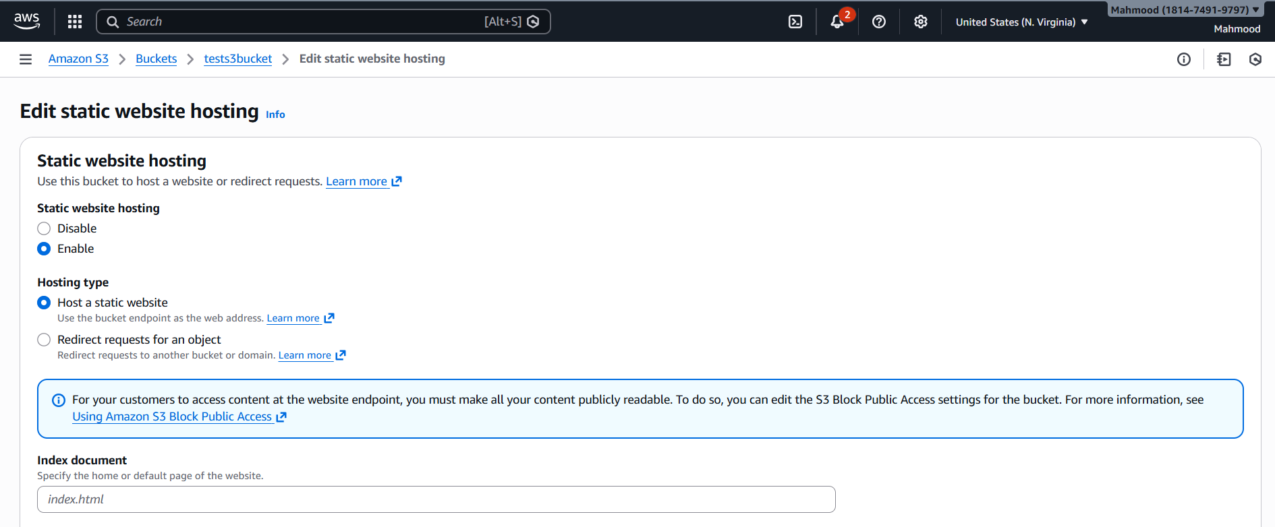
Index document- login.html
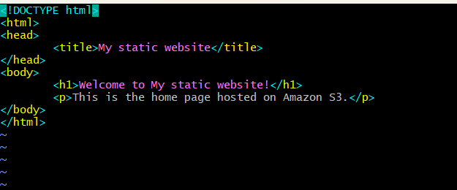
Error document- error.html
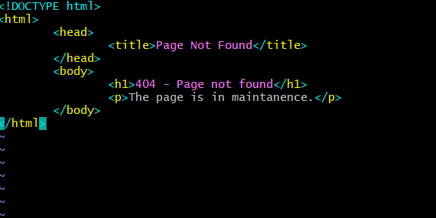
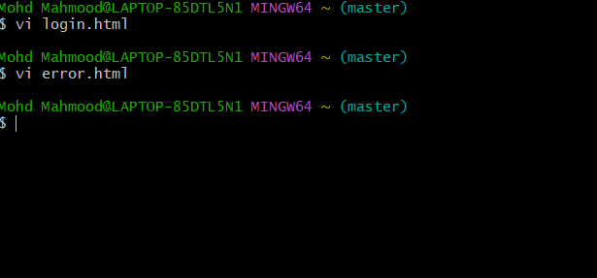
And upload the file and click on save changes then copy the bucket url from properties and paste in on browser
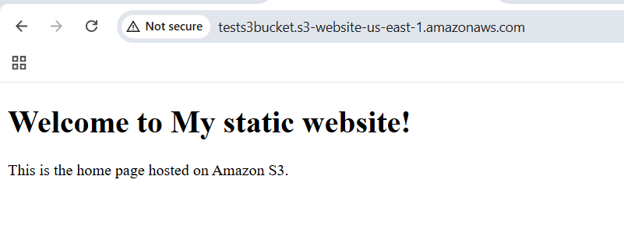
And delete the index.html file to see the error.html in website
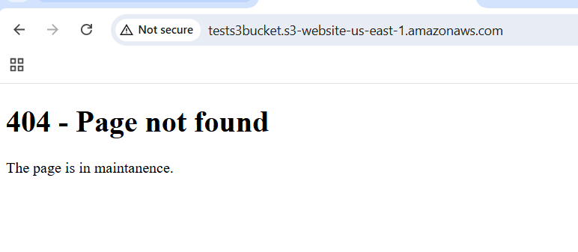
- Enable cross-region replication on S3 buckets
create A bucket from north Virginia and another B bucket from California
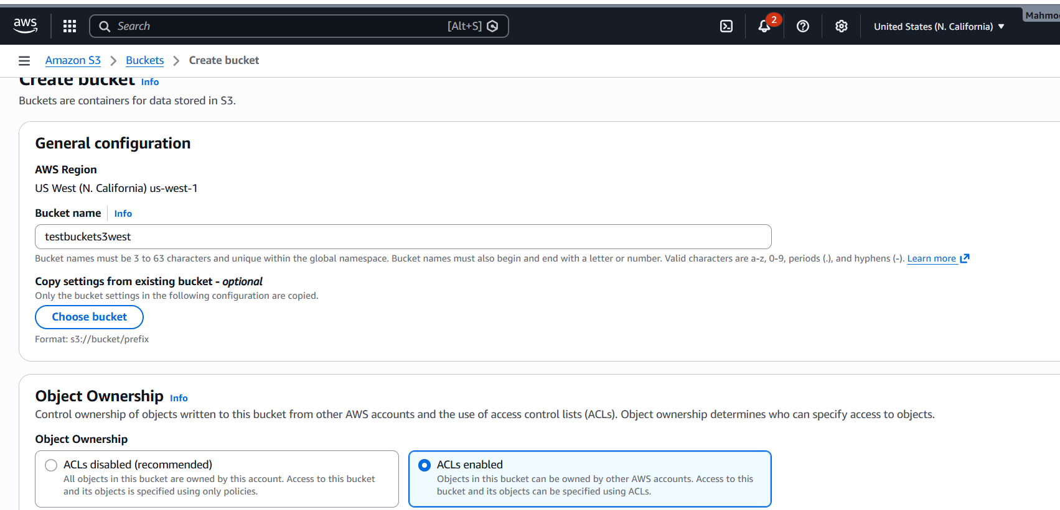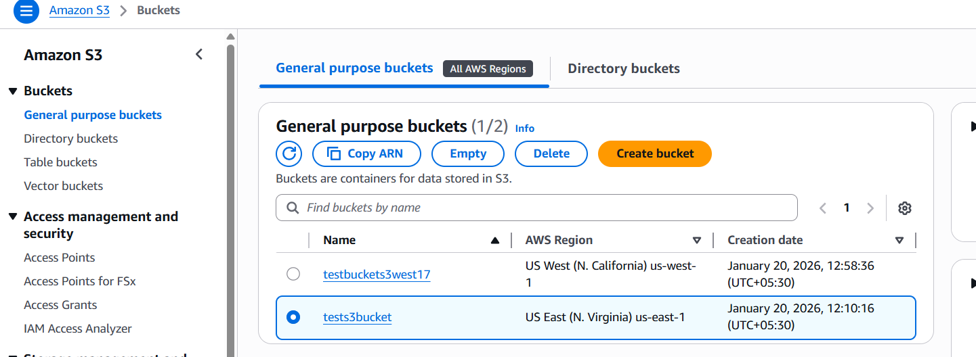
And enable versioning on both buckets
Now go to source A bucket is tests3bucket and click on management tab and provide replication rule name as tests3 and source bucket to apply all objects, then destination choose the bucket B and create a new role in IAM role and save
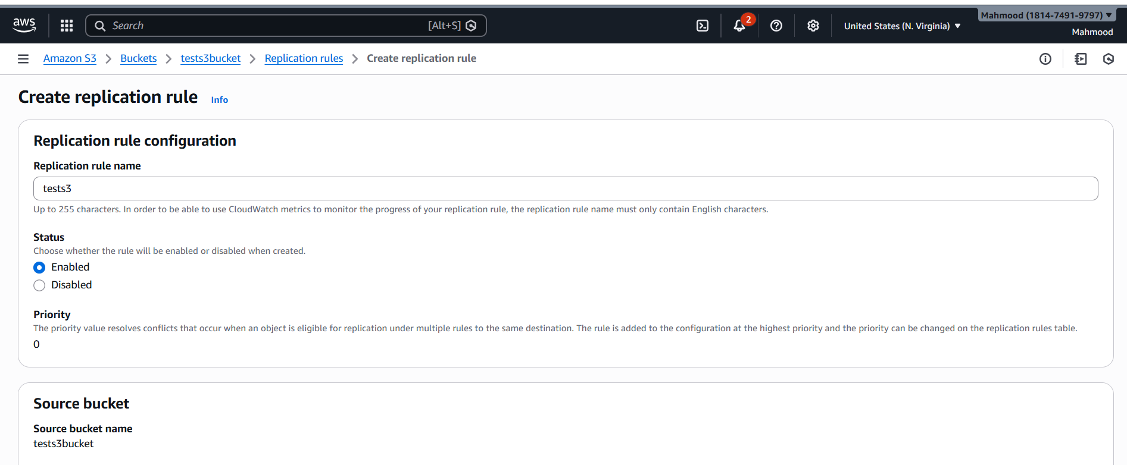
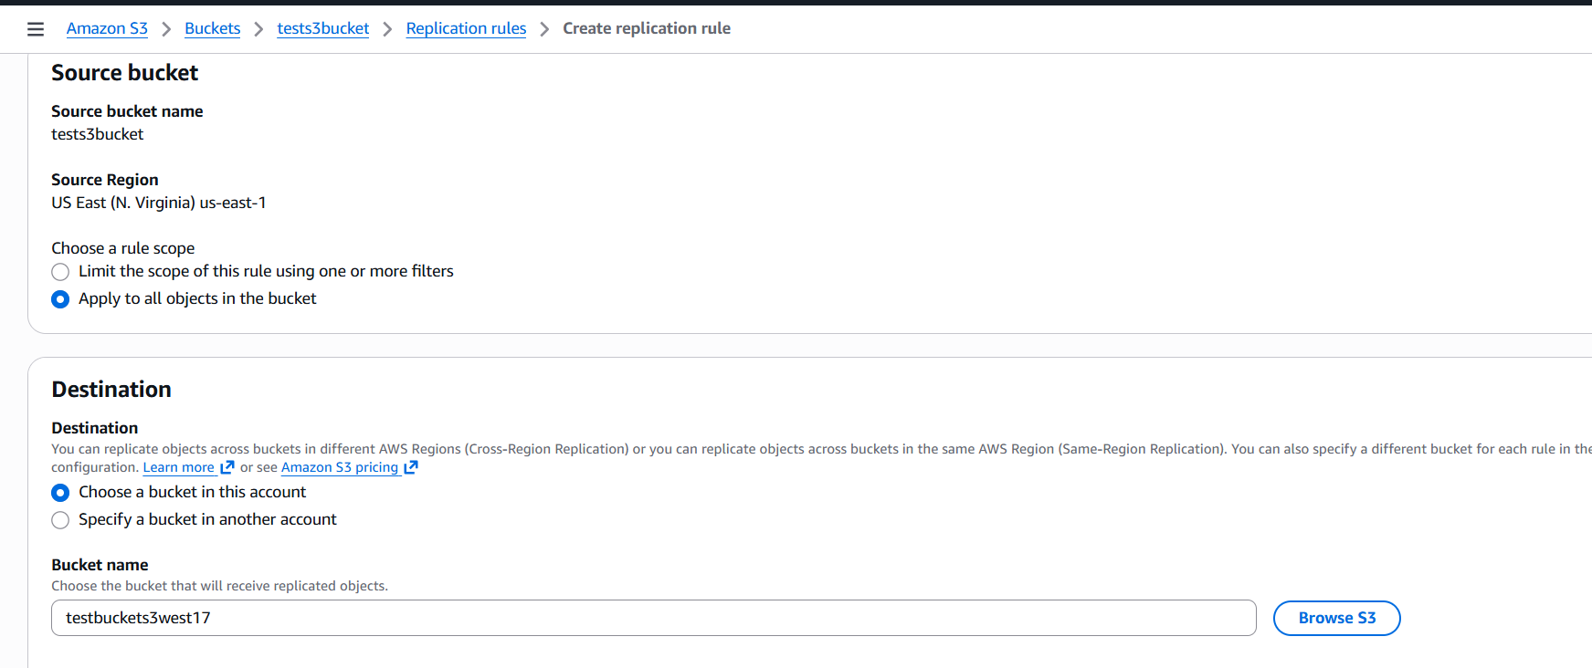
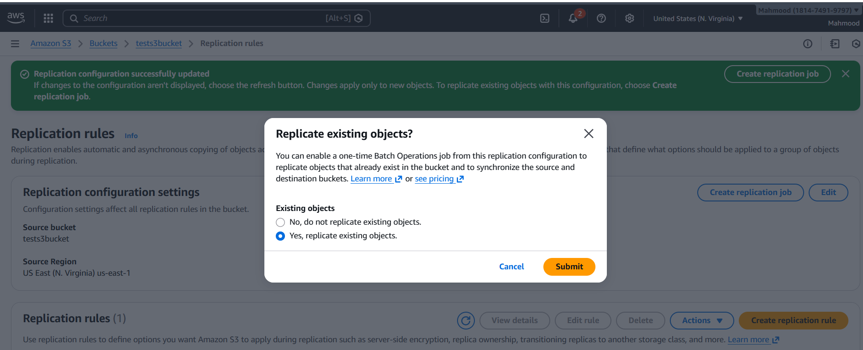
And upload a document in A bucket and it gets automatically reflect in B bucket
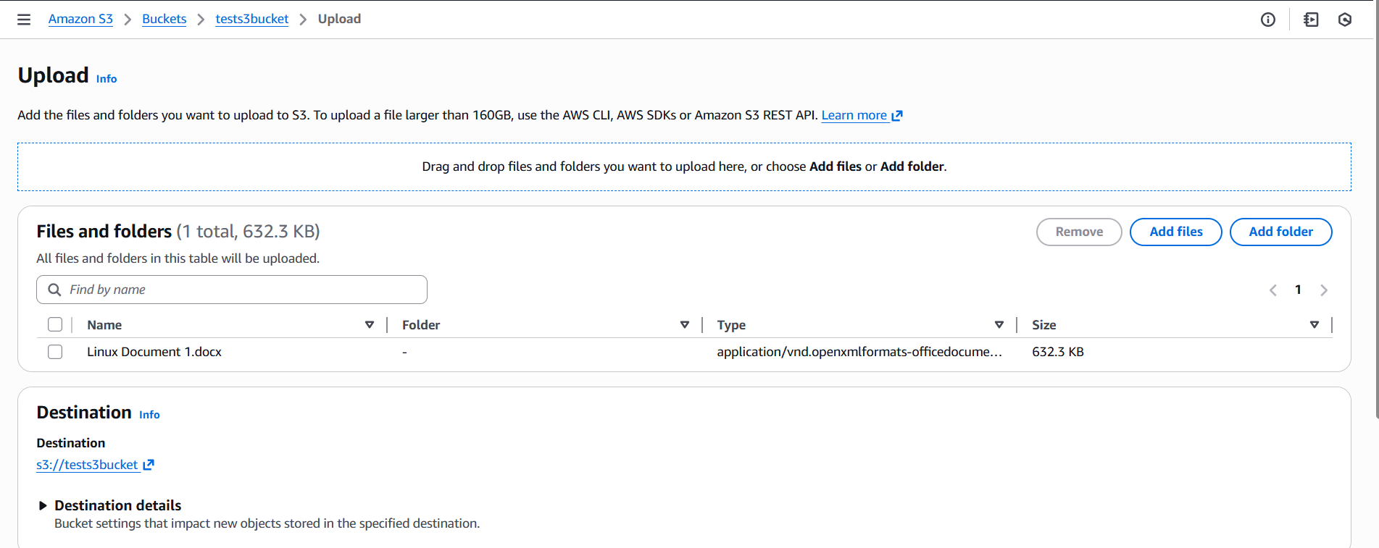
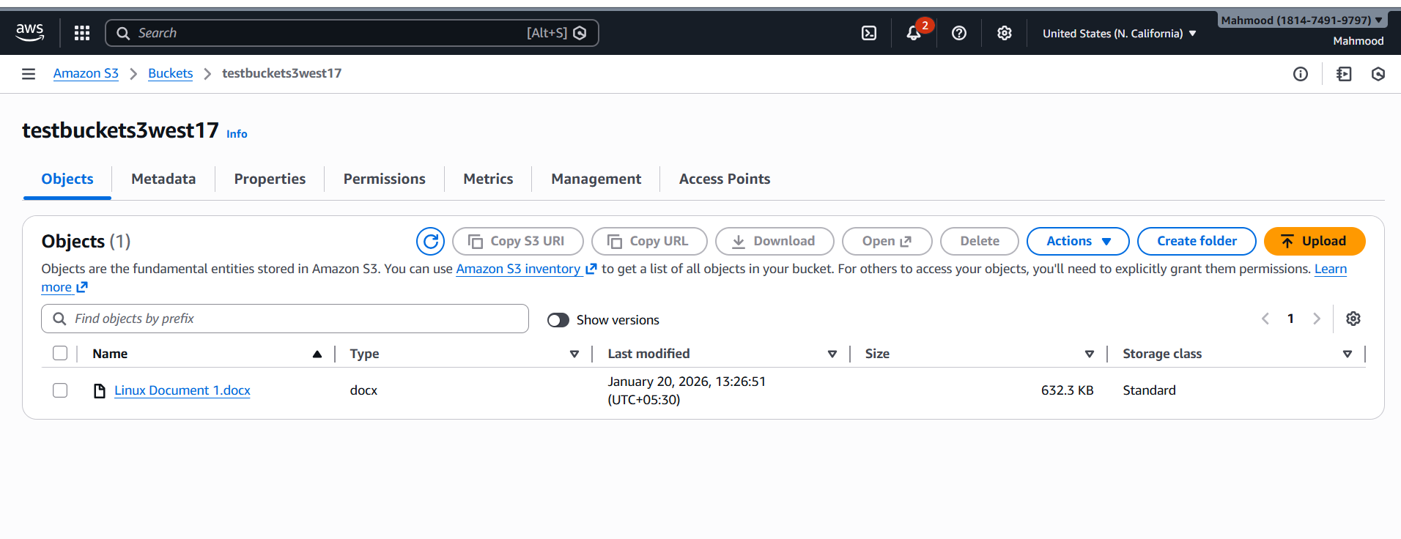
S3 Cross-Region Replication –
Short Steps
1. Create 2 buckets o Source bucket → Region 1 (example: us-east-1), Destination bucket → Region 2 (example: ap-west-1)
2. Enable Versioning o Go to S3 → Source bucket → Properties → Versioning → Enable o Go to S3 → Destination bucket → Properties → Versioning → Enable
3. Open Source Bucket o S3 → Source bucket → Management tab
4. Create Replication Rule o Click Replication rules → Create rule o Rule scope: Apply to all objects
5. Select Destination o Choose Another AWS Region o Select the destination bucket
6. IAM Role o Choose Create new role (AWS creates it automatically)
7. Create Rule o (Optional) Enable Replicate existing objects o Click Create rule 8. Verify o Upload a file to source bucket o File appears automatically in destination bucket
- Configure a bucket policy so only the Admin user can see the objects of the S3 bucket
Add permissions to user as administrator access
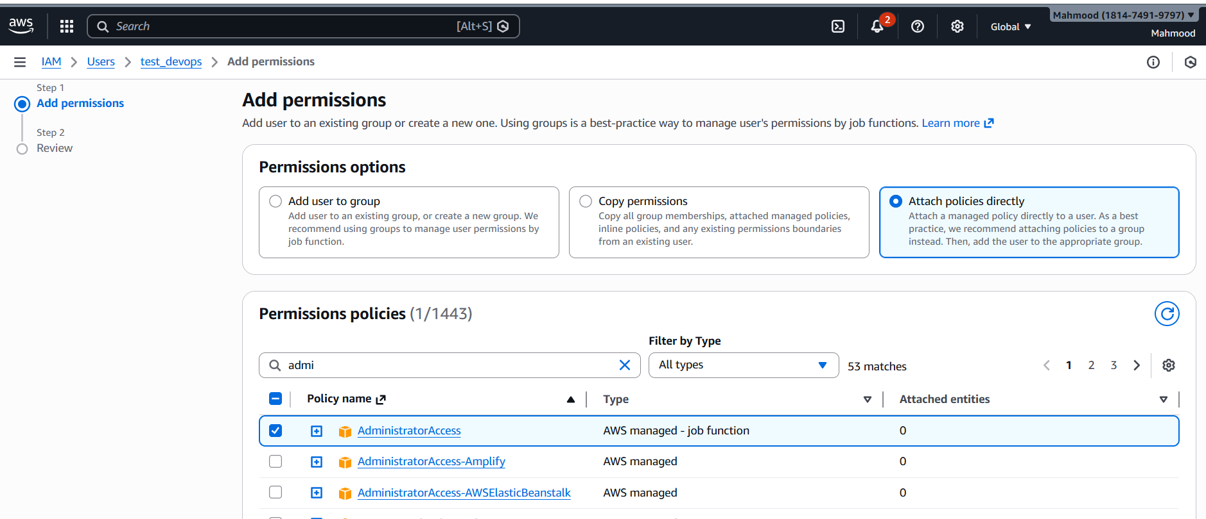
Go to s3 bucket and select the bucket and go to edit policy and provide policies only to admin
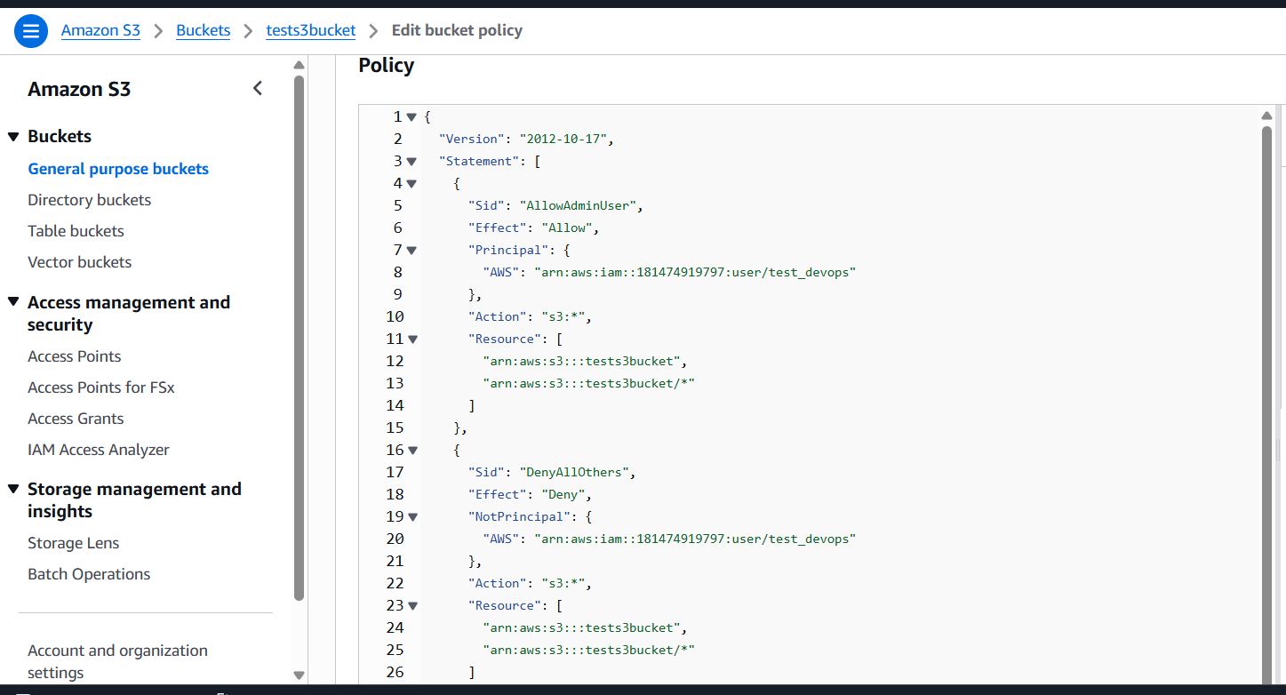
- Set up lifecycle policies to automatically transition or delete objects based on specific criteria
Go to bucket and select the bucket we want and go to management tab and create life cycle rules and enter the lifecycle rule name and click on lifecycle rule actions
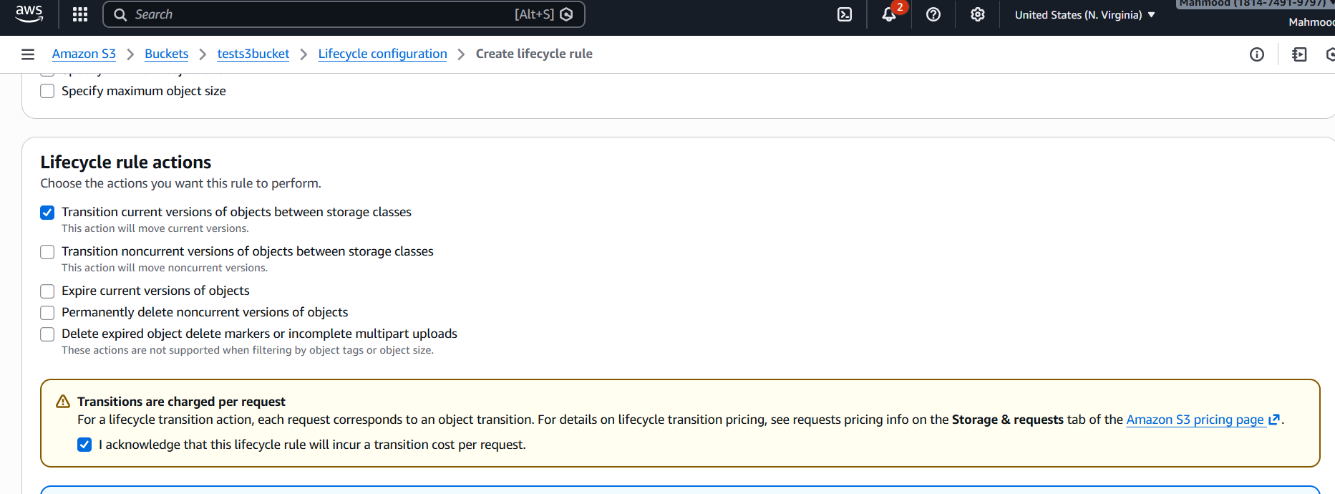
and choose storage class transactions to standard IA and then save changes
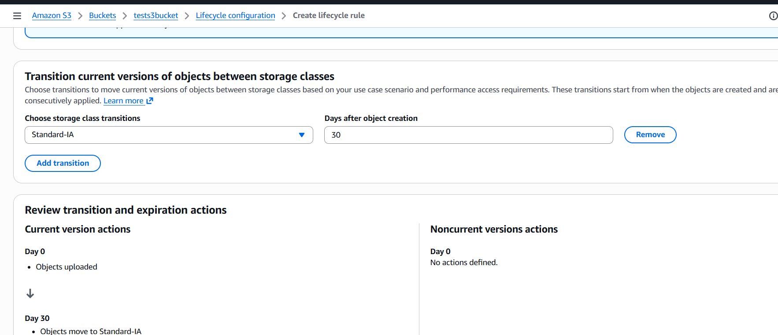
- Push some objects to S3 using the AWS CLI
First we need to check aws –version then aws configure and login with access key and then create a file and to move file from cli to s3 we use aws s3 cp world s3://tests3bucket/
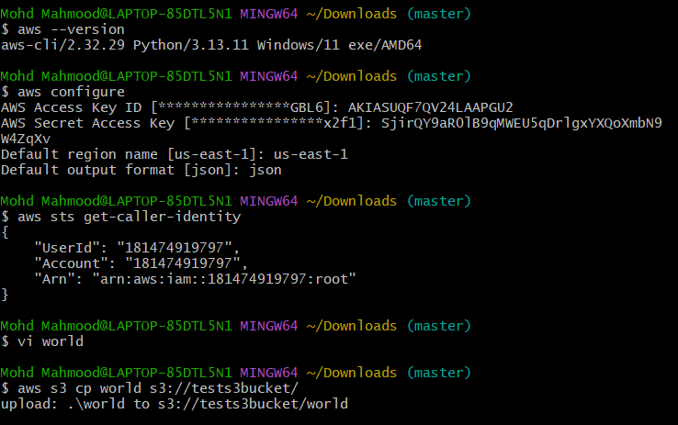
And we can see world file in s3
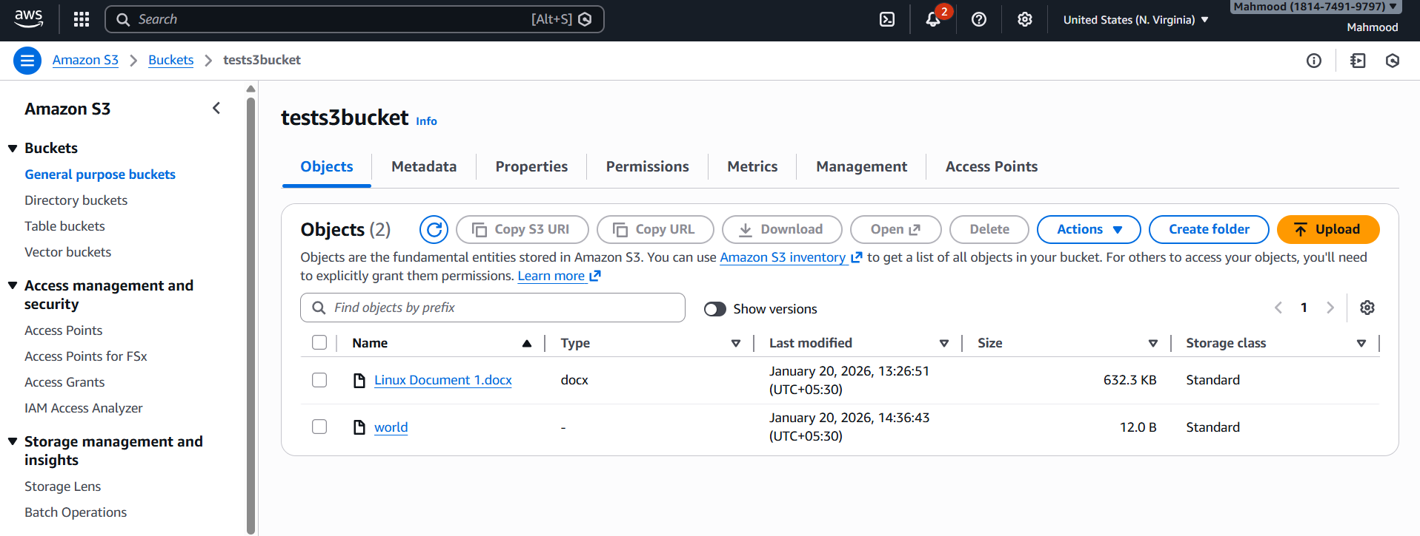
- Write a Bash script to create an S3 bucket
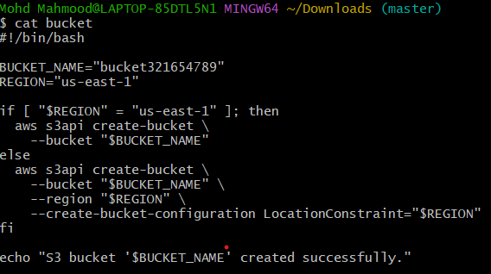
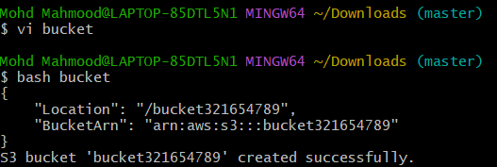
Bucket is created successfully
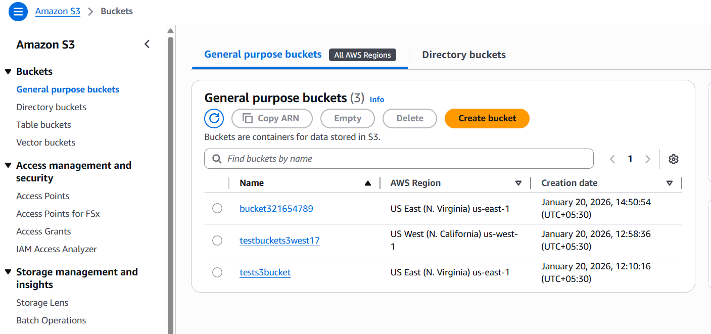
- Upload a 1 GB file to S3 using the CLI
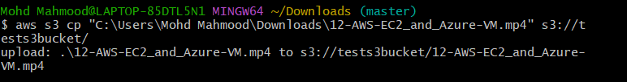
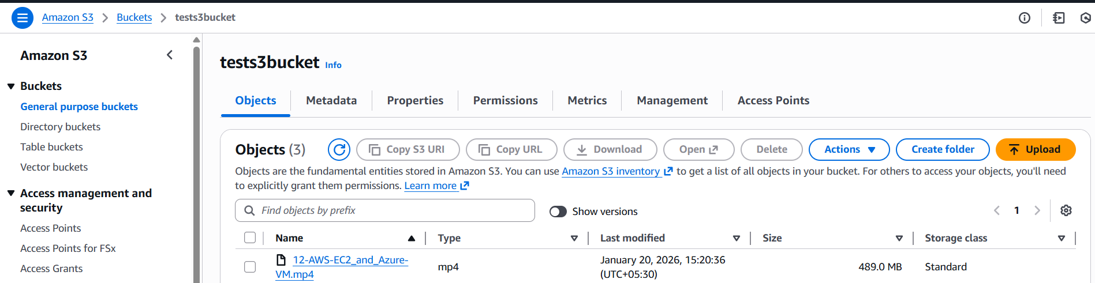
- Issues faced- To get the bucket policy and I copy paste the policy from chat gpt
- Conclusion- successfully completed all assigned tasks, created s3 bucket and deployed it and configure the bucket policy also pushed objects from CLI and written the bash script to create an s3 bucket and finally uploaded the large mb file from CLI to S3

