- Install Apache and run Apache on port number 81
- 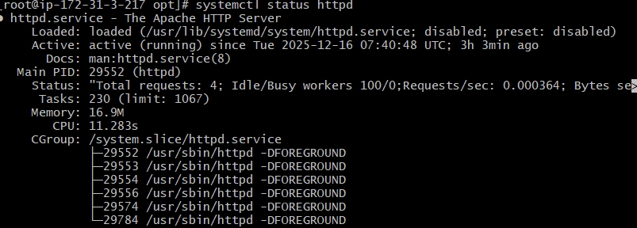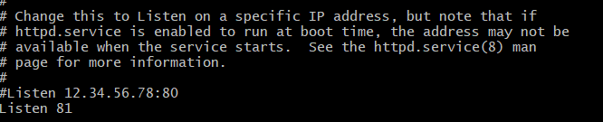
- Deploy a sample index.html file on Apache.
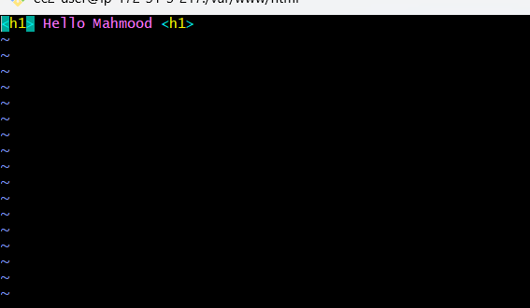
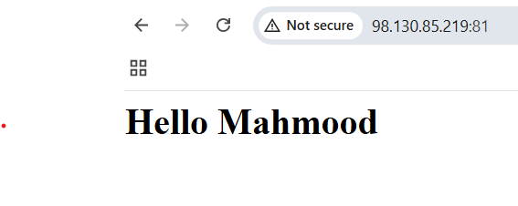
- Install nginx and run nginx on port number 82.
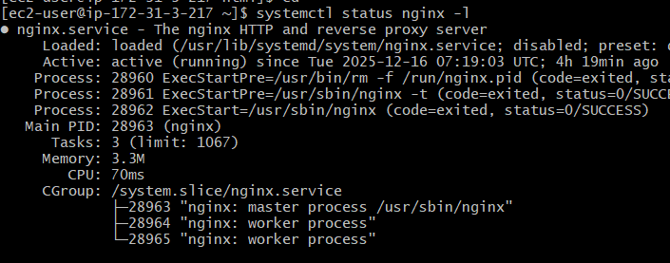
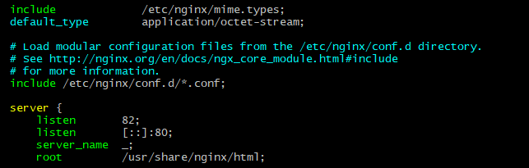
- Deploy a sample index.html file on nginx
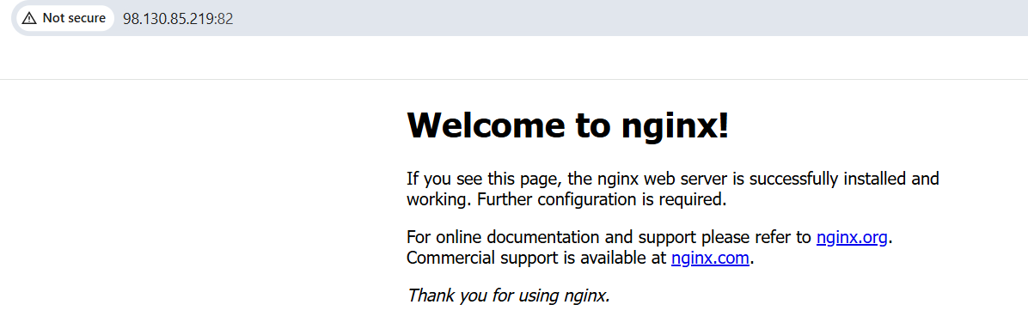
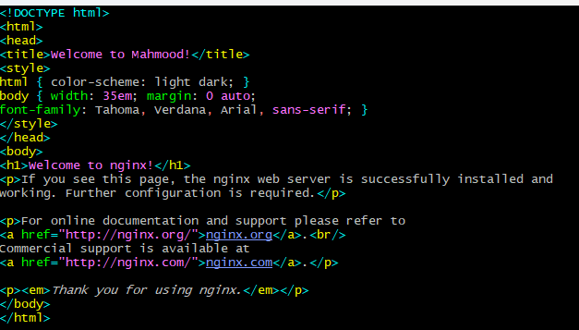
- Install Apache Tomcat on port 8082
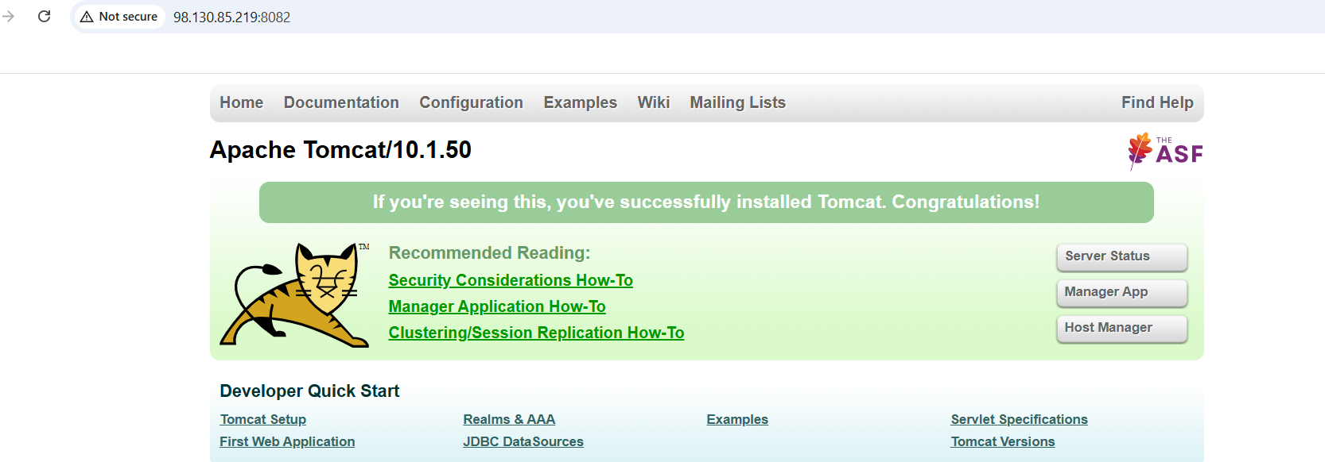
- Deploy a sample app on we apps
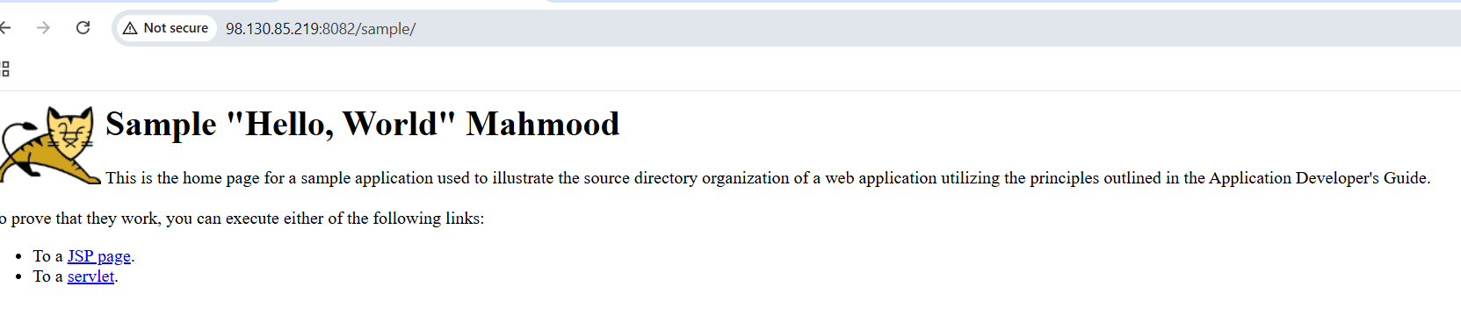
- Configure HA proxy server
- Installed HA proxy server
