Wireframe Document for Flight Fare Prediction Project

Project Overview

Project Name:

Flight Fare Prediction

Objective:

Provide a preview of the front-end design for the Flight Fare Prediction system, showcasing the user interface for both input and output screens.

Wireframes

1. Home Page

Description:

The home page allows users to enter the details of their flight to get a fare prediction.

Components:

Header: Project title and navigation links.

Input Form: Fields for flight details.

Submit Button: Button to submit the form and get the fare prediction.

Wireframe:

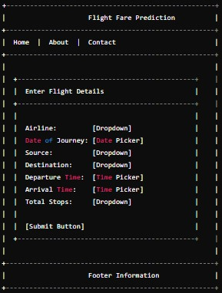

2. Result Page

Description:

The result page displays the predicted fare based on the user's input.

Components:

Header: Project title and navigation links.

Prediction Result: Section showing the predicted fare.

Details Summary: Summary of the flight details entered.

Back Button: Button to return to the home page.

Wireframe:

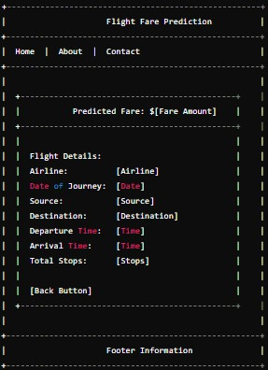

3. About Page

Description:

The about page provides information about the project, its purpose, and the team behind it.

Components:

Header: Project title and navigation links.

Project Information: Section detailing the project.

Team Information: Section listing team members and their roles.

Wireframe:

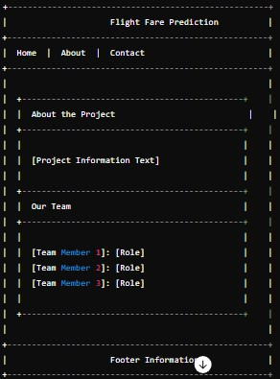

4. Contact Page

Description:

The contact page provides a form for users to get in touch with the project team.

Components:

Header: Project title and navigation links.

Contact Form: Fields for user to enter their name, email, and message.

Submit Button: Button to submit the contact form.

Wireframe:

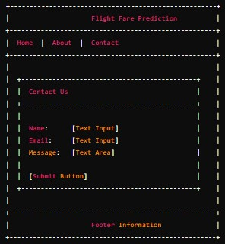

Conclusion

This Wireframe Document provides a visual guide to the front-end design of the Flight Fare Prediction system. The wireframes depict the layout and components of the main pages, serving as a blueprint for the development team to create the user interface.