IAM-Identifier Access Manager

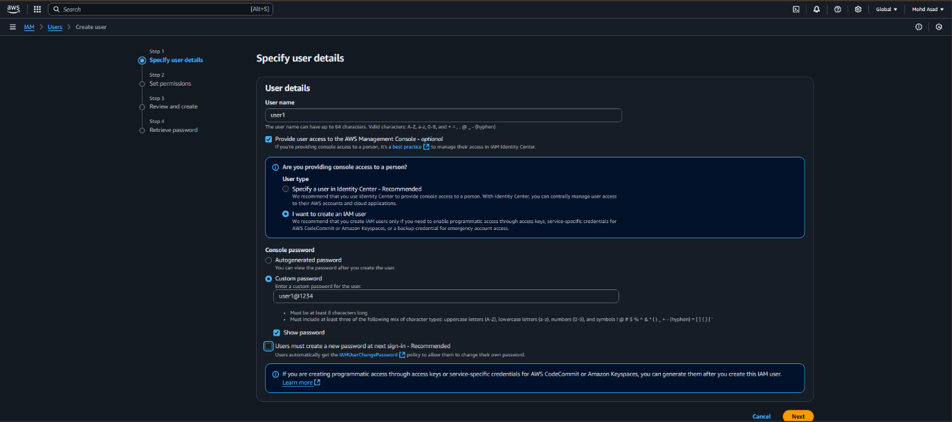creating user

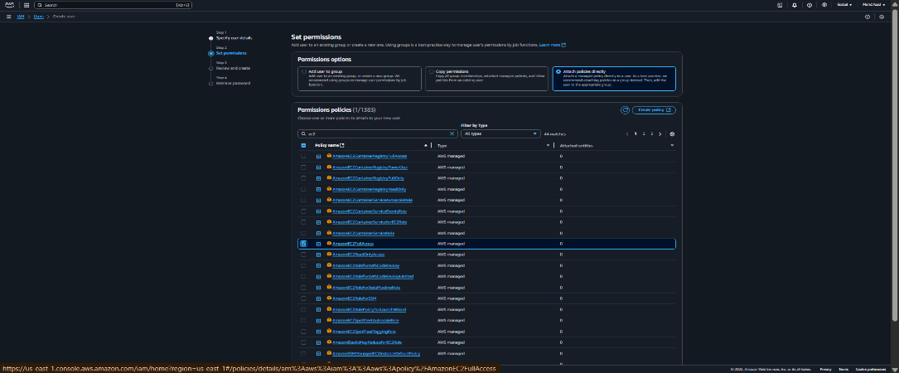

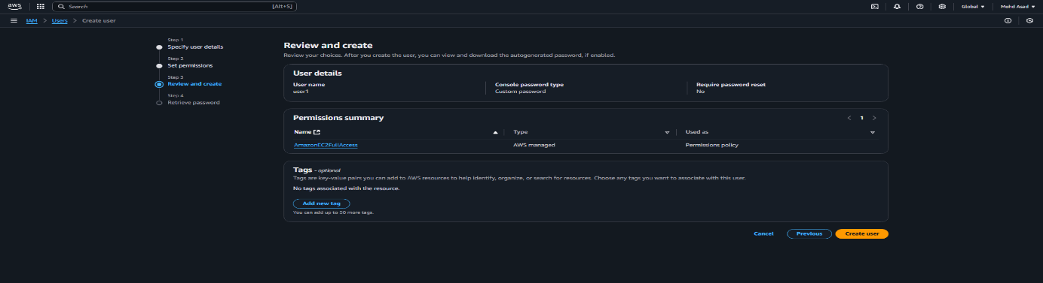

Now user created , then we need to follow the link and open it in incognito or in the another browser.

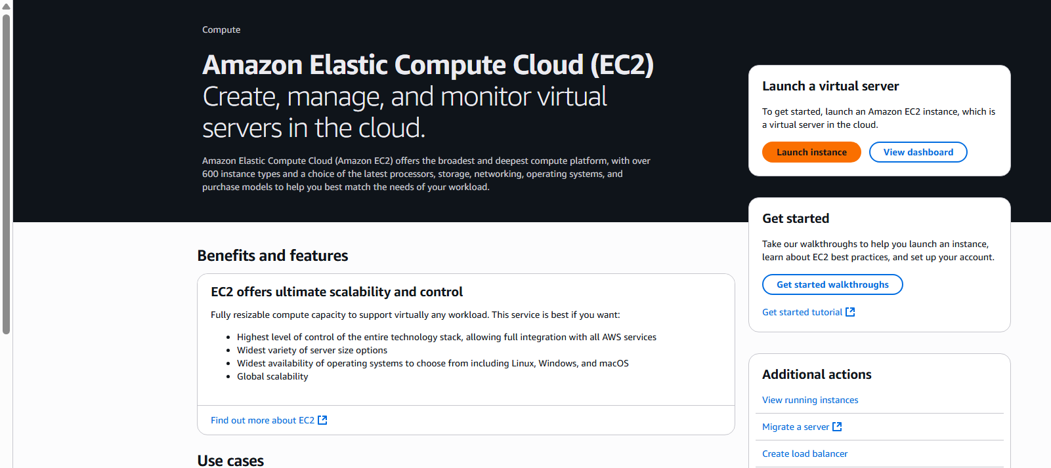now we have given the full permission to the EC2 , we will launch an instance , it will launch as usual.

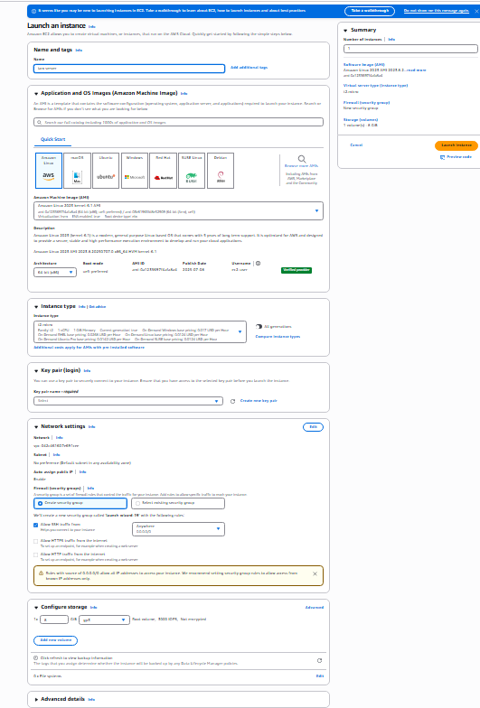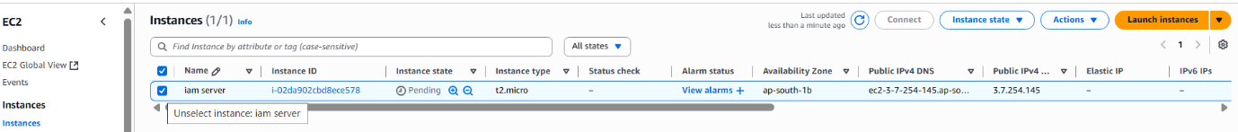

Now lets change the permission policy and see the activity.

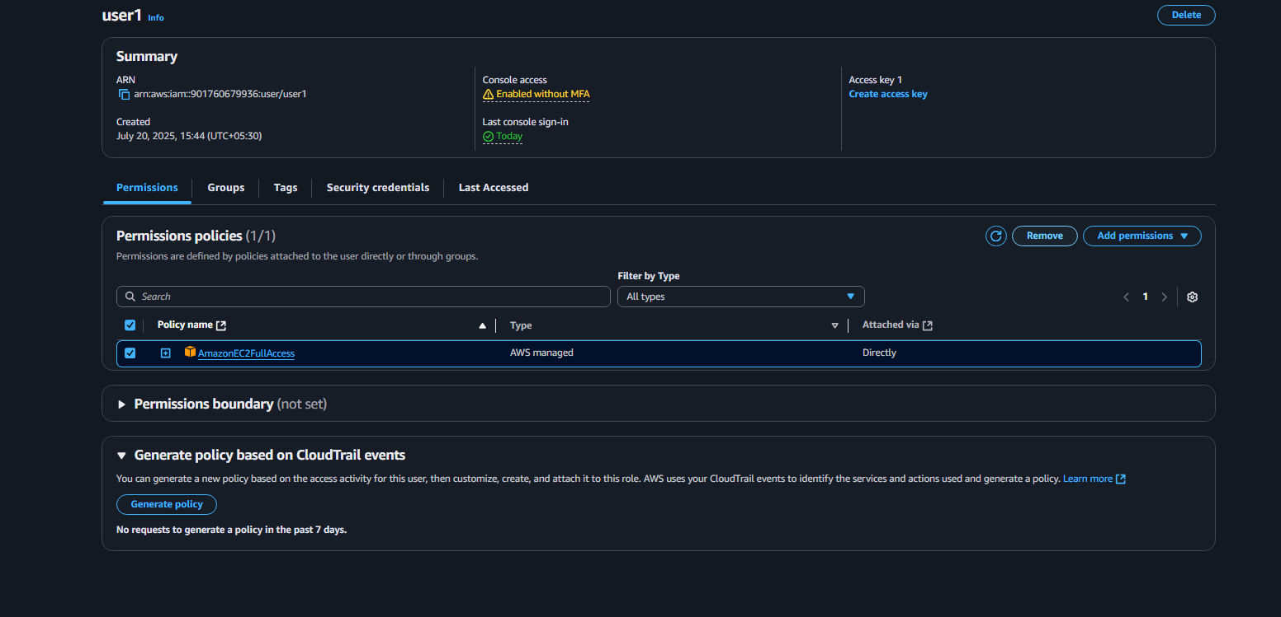

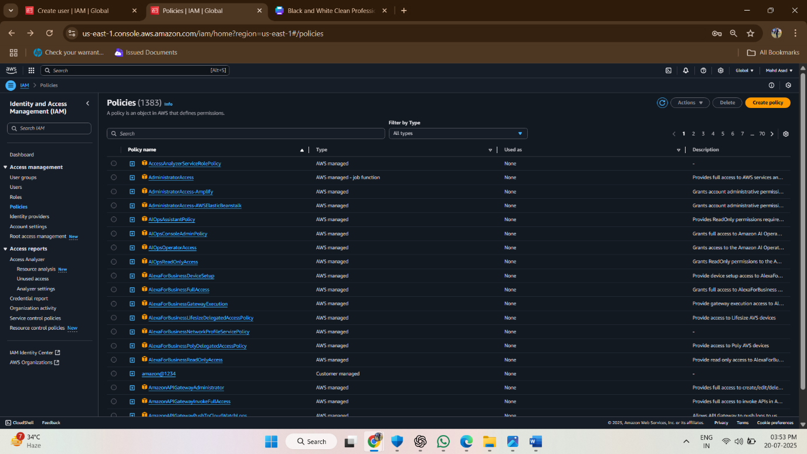

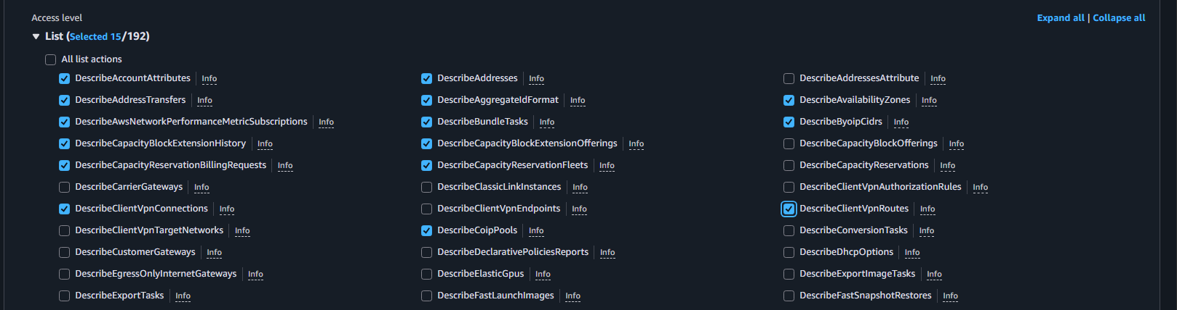

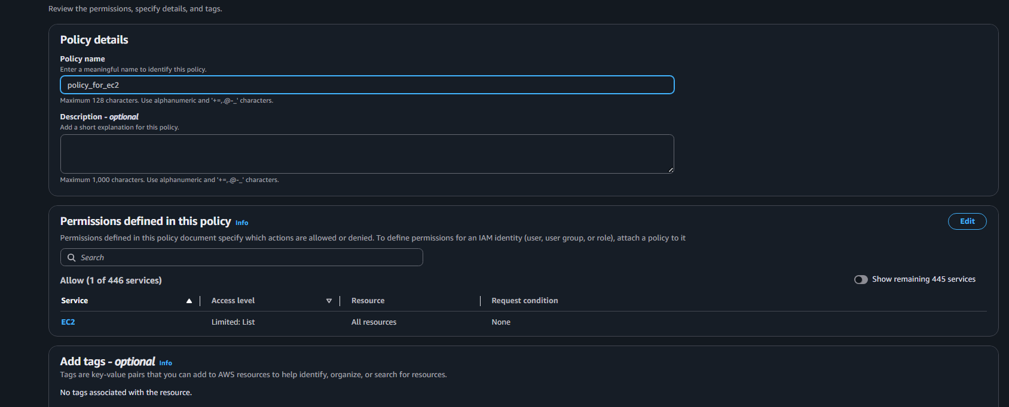

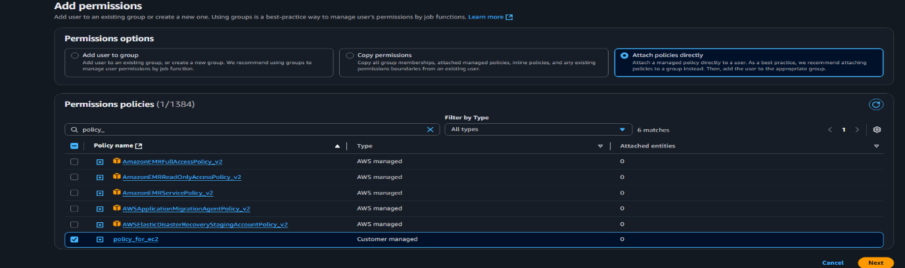

In the below screen shot it is shown that it is not loading or deleting as I change the policy to read only.

