SQS 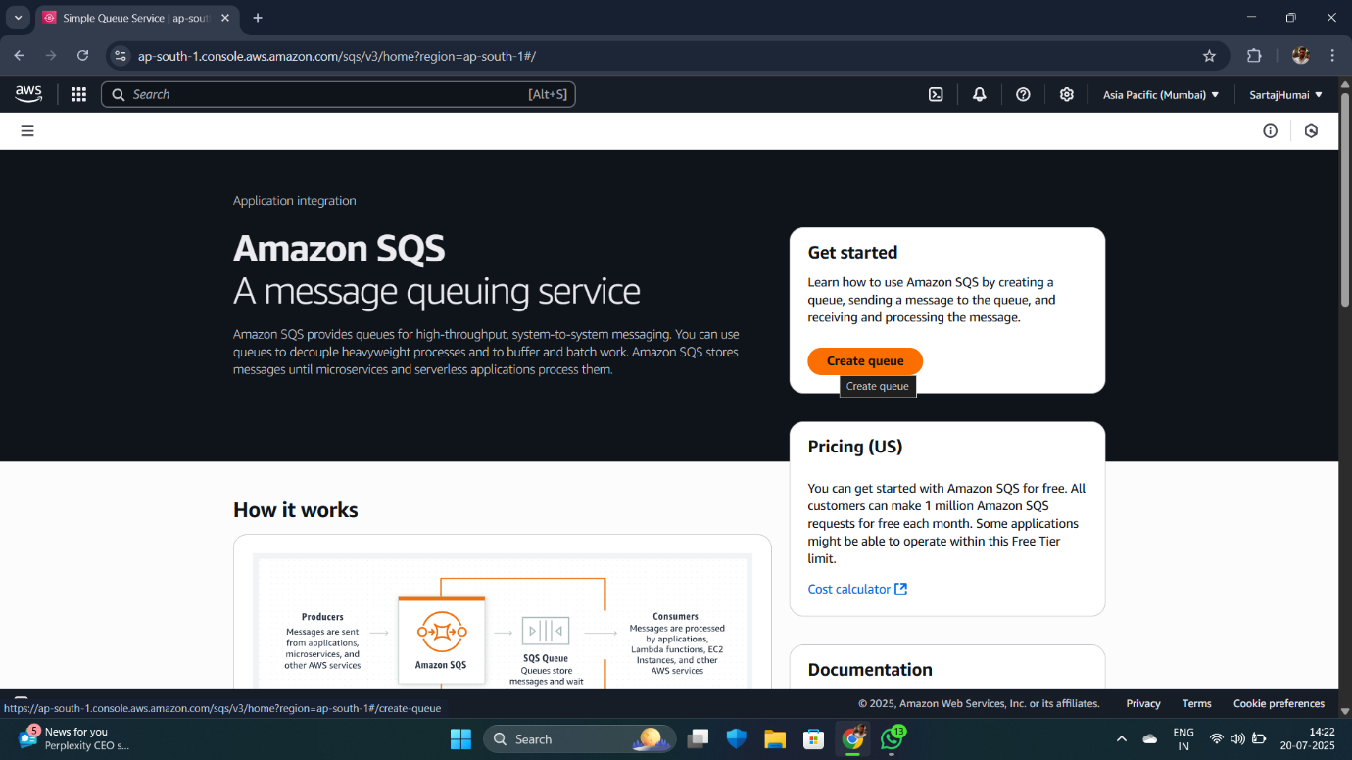

Click on the create queue , then start creating it .

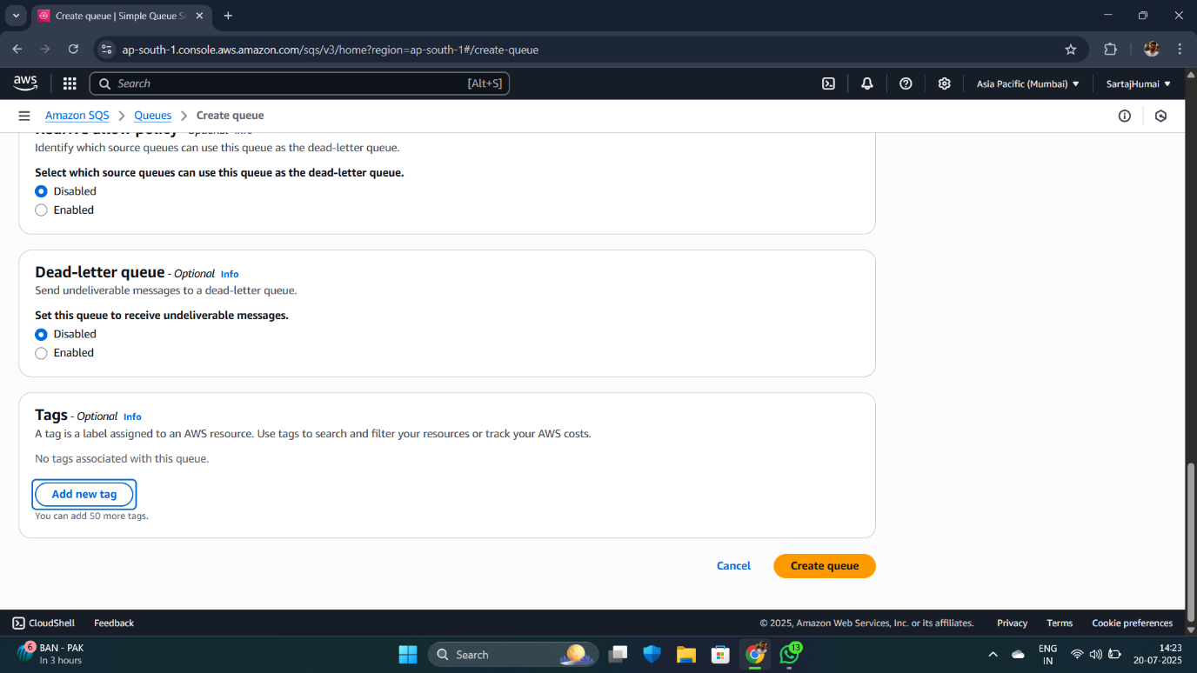



After creating queue , you must have topic in SNS , if not , create it

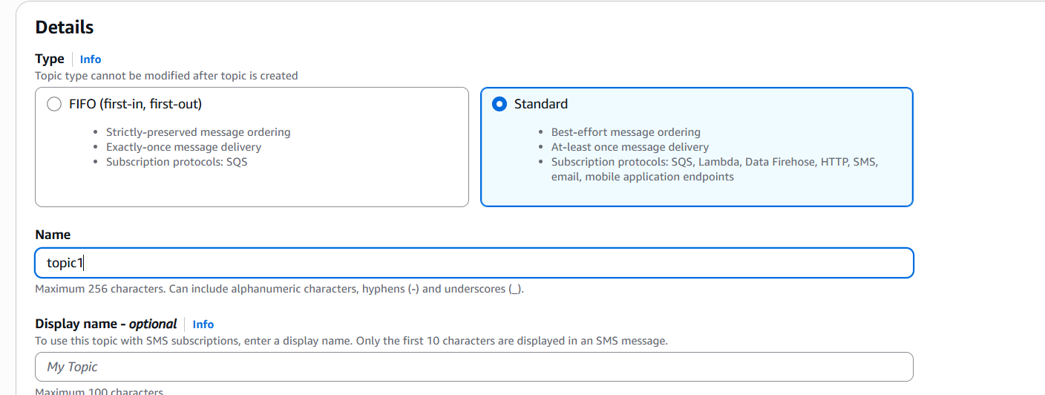

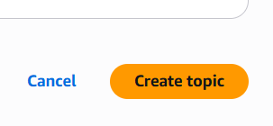 click on create topic .

After creating topic , create subscription like below.

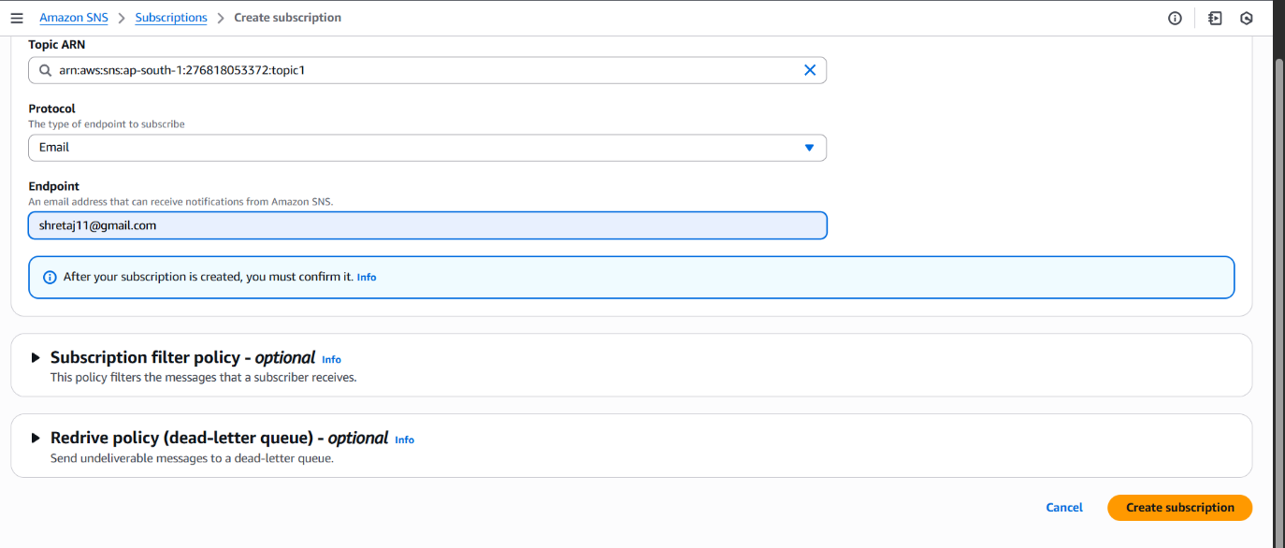

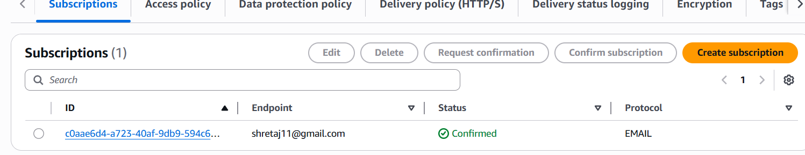

Subscription is created..

Go to publish and publish msg.

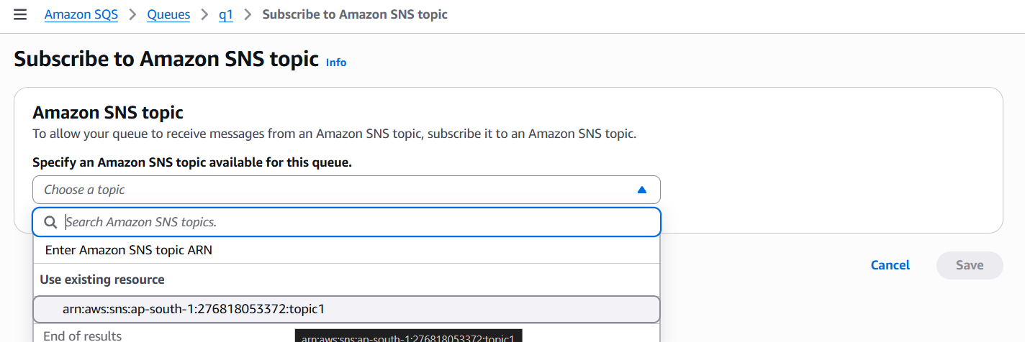

Now go to action in SQS and connect QUEUE to the TOPIC and then trigger LAMBDA FUNCTION from the function

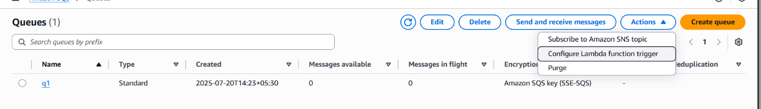

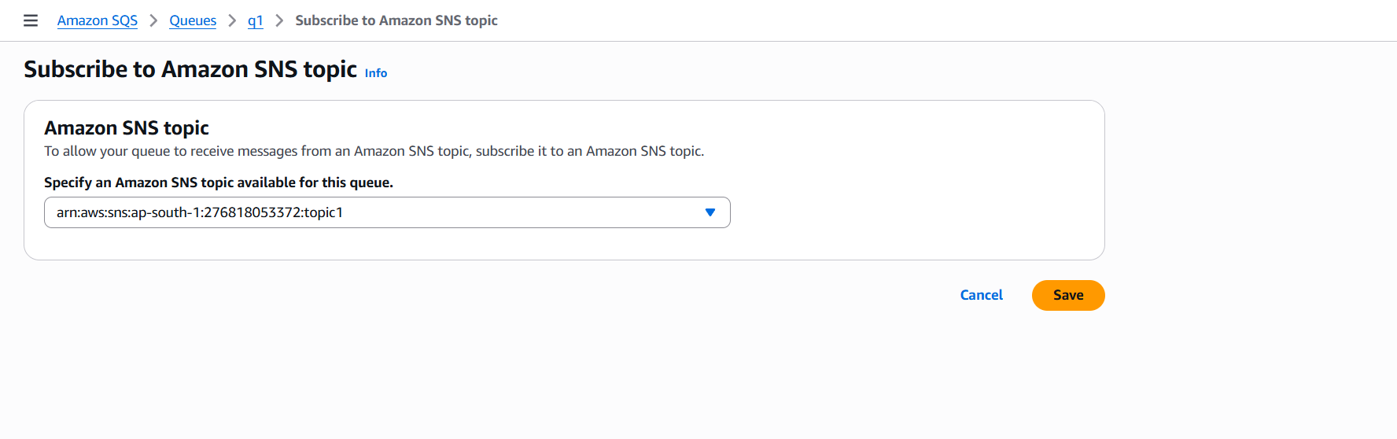

Creating function in lambda

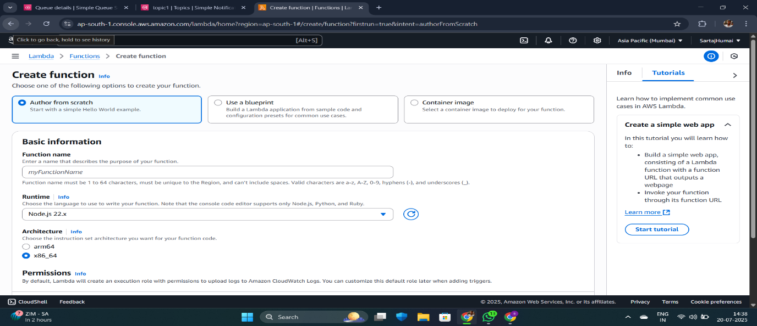

The function is selected.

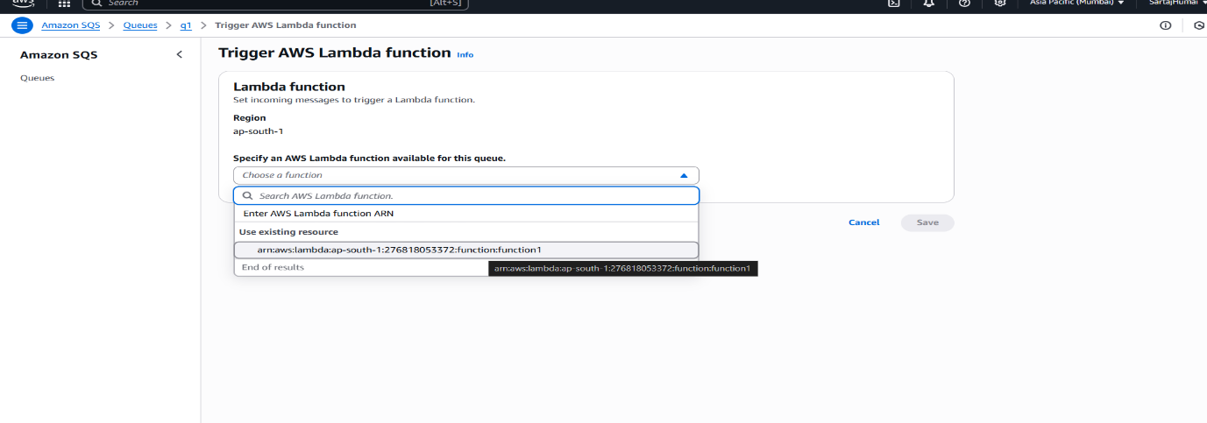

The final mail is seen on my mail account through function .

