1. Launch one Linux instance in aws.

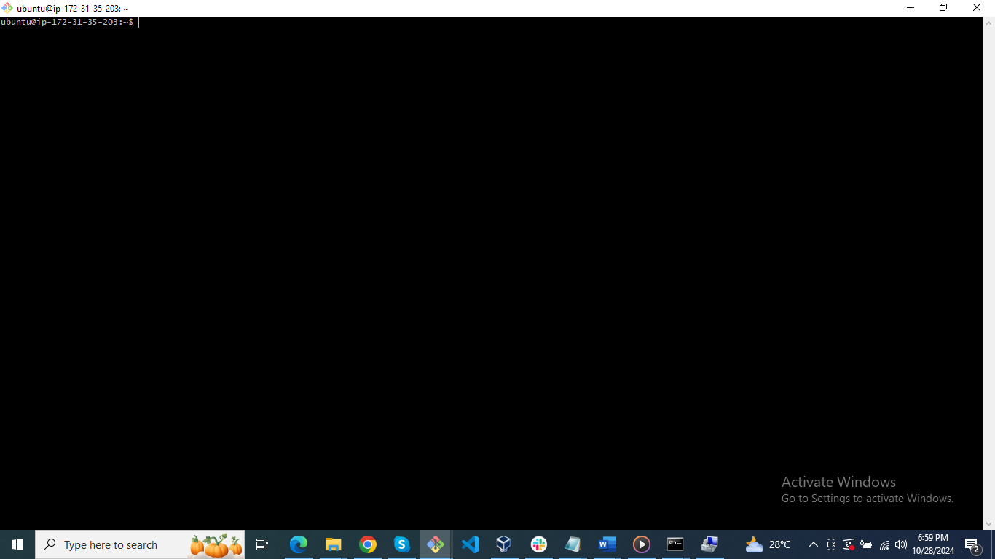

1. Create on file with name Techie_horizon

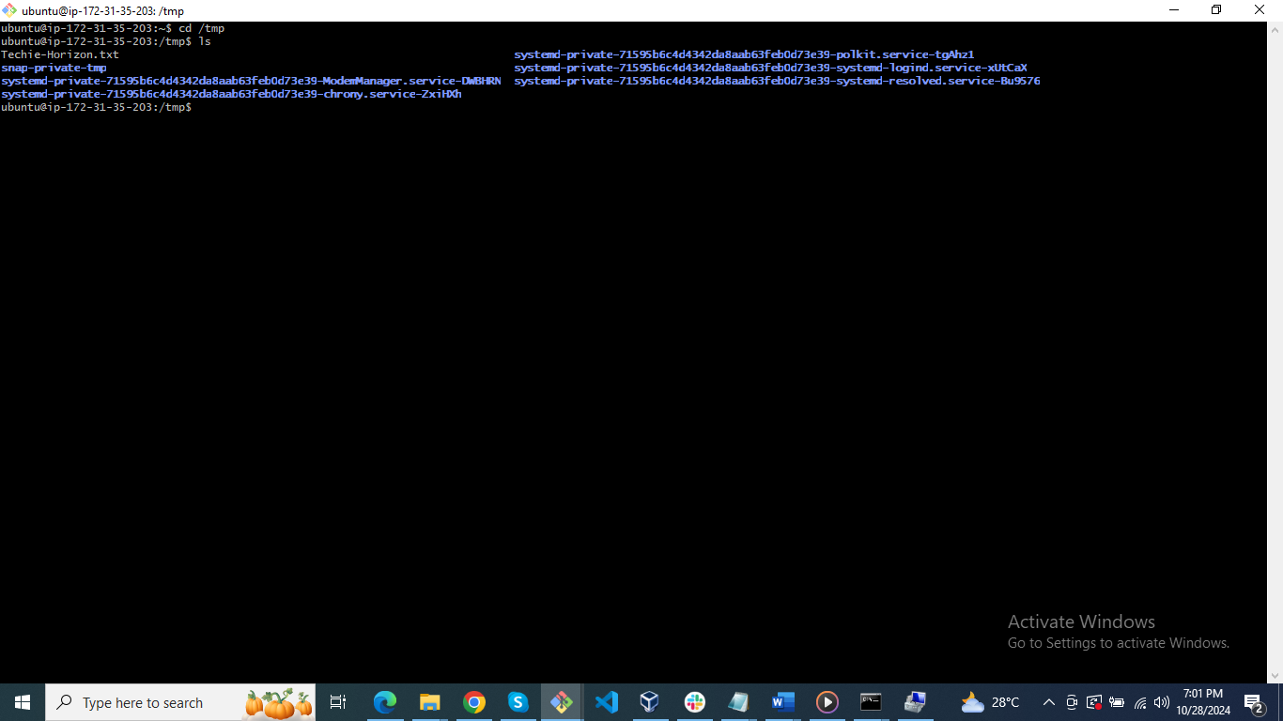

1. Copy the file "Techie_Horizon" from aws instance to windows machine.

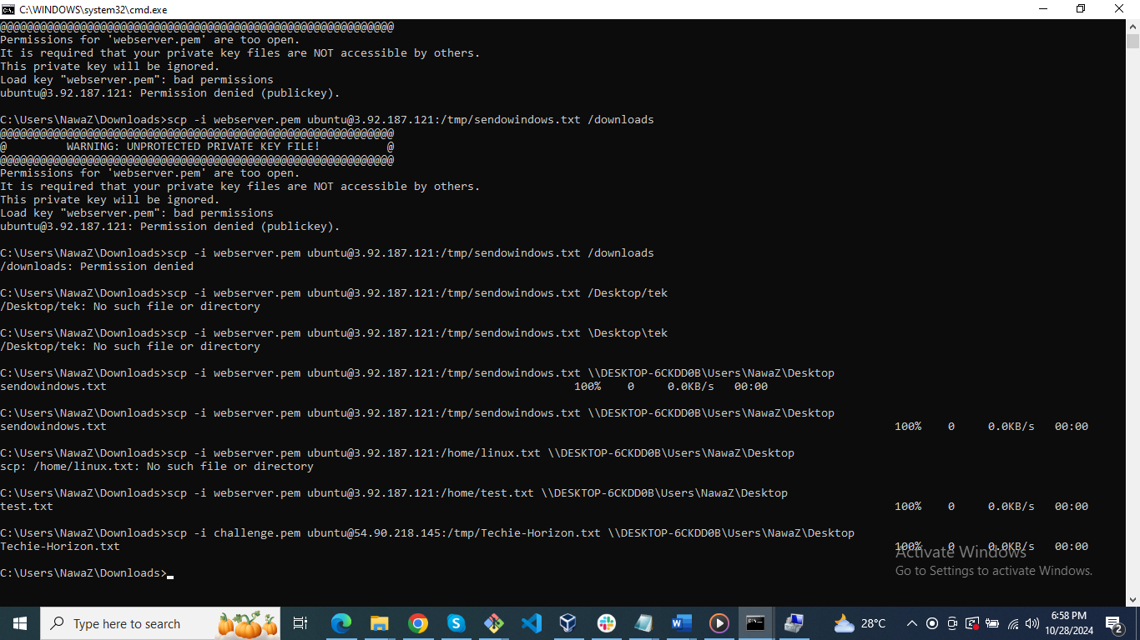

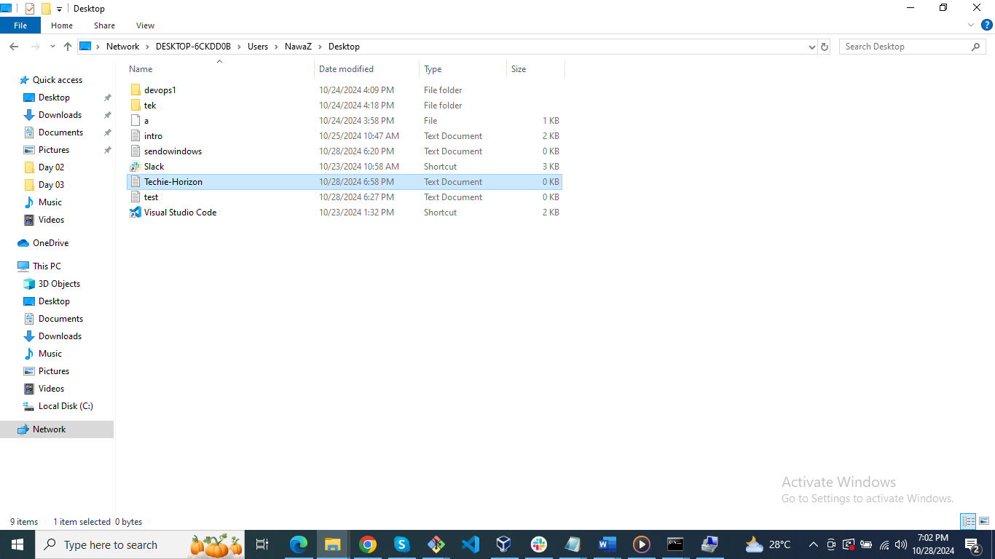

1. Install Jenkins in the server created in step 1.

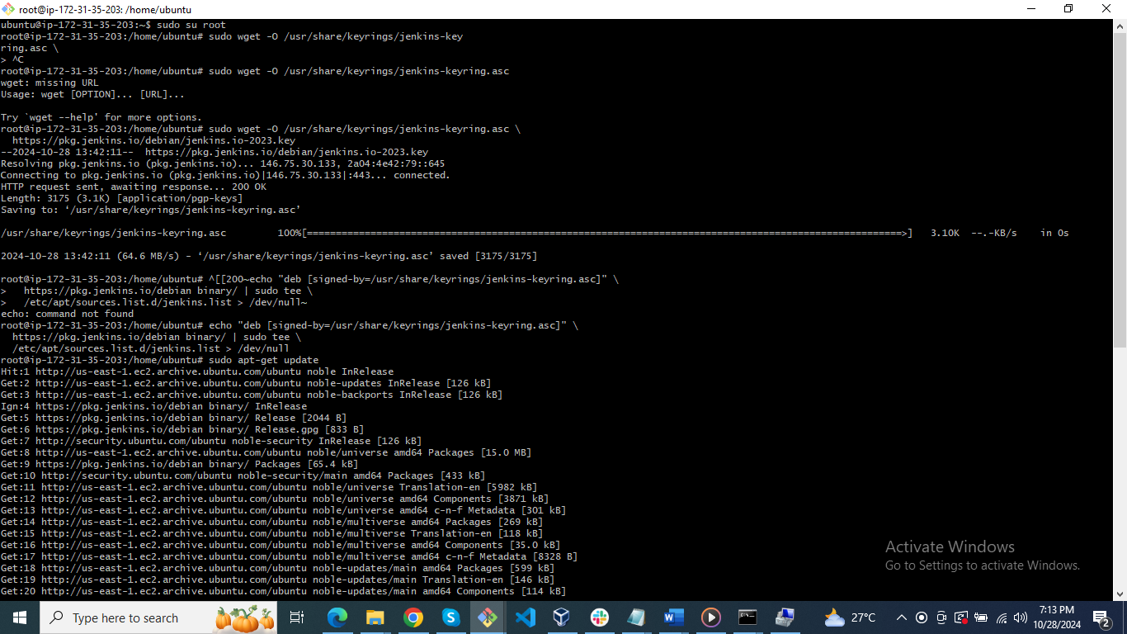

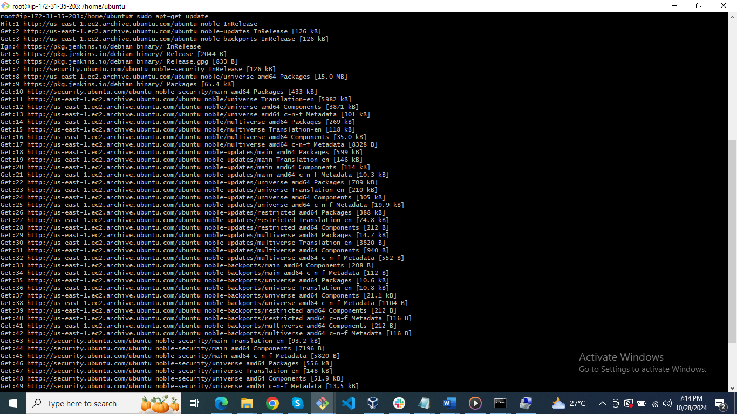

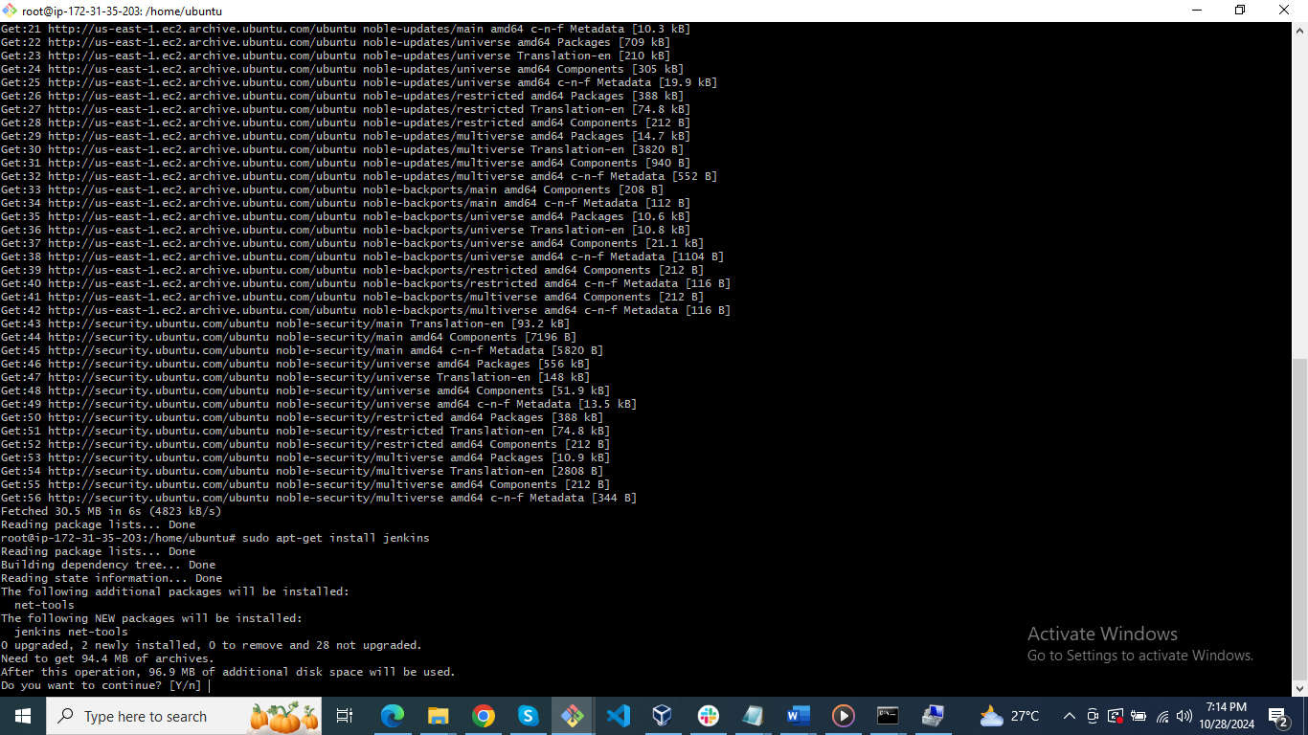

1. Install httpd,ngin

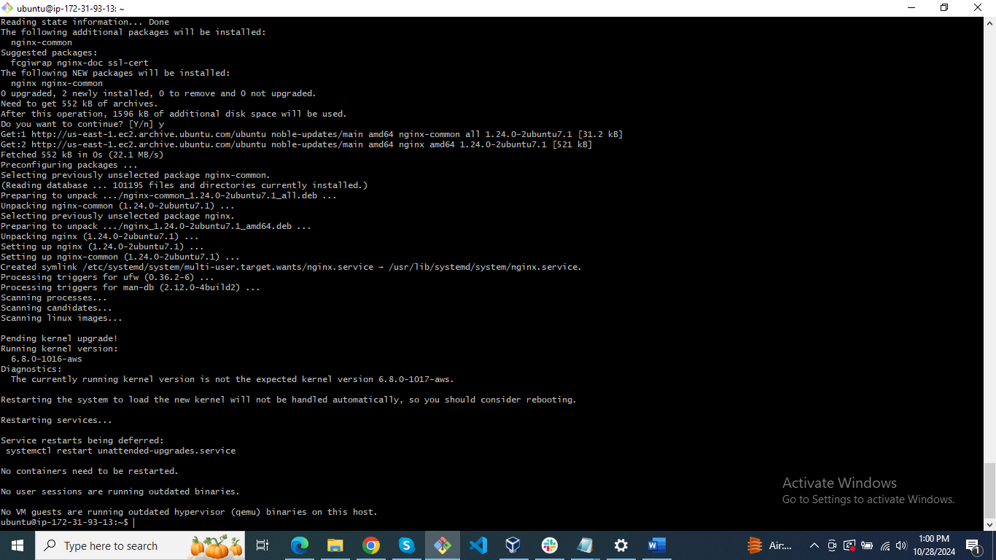

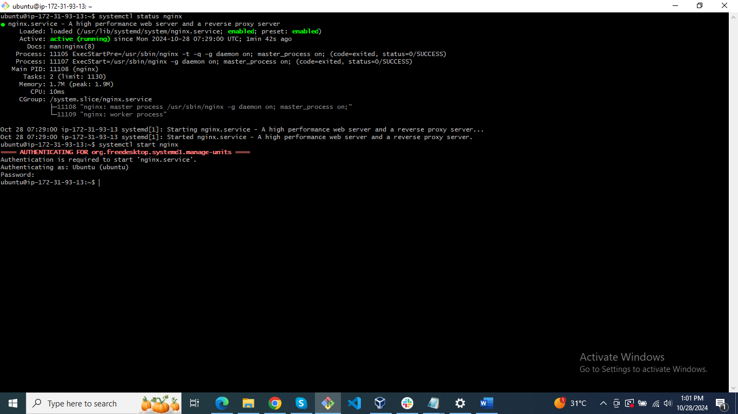

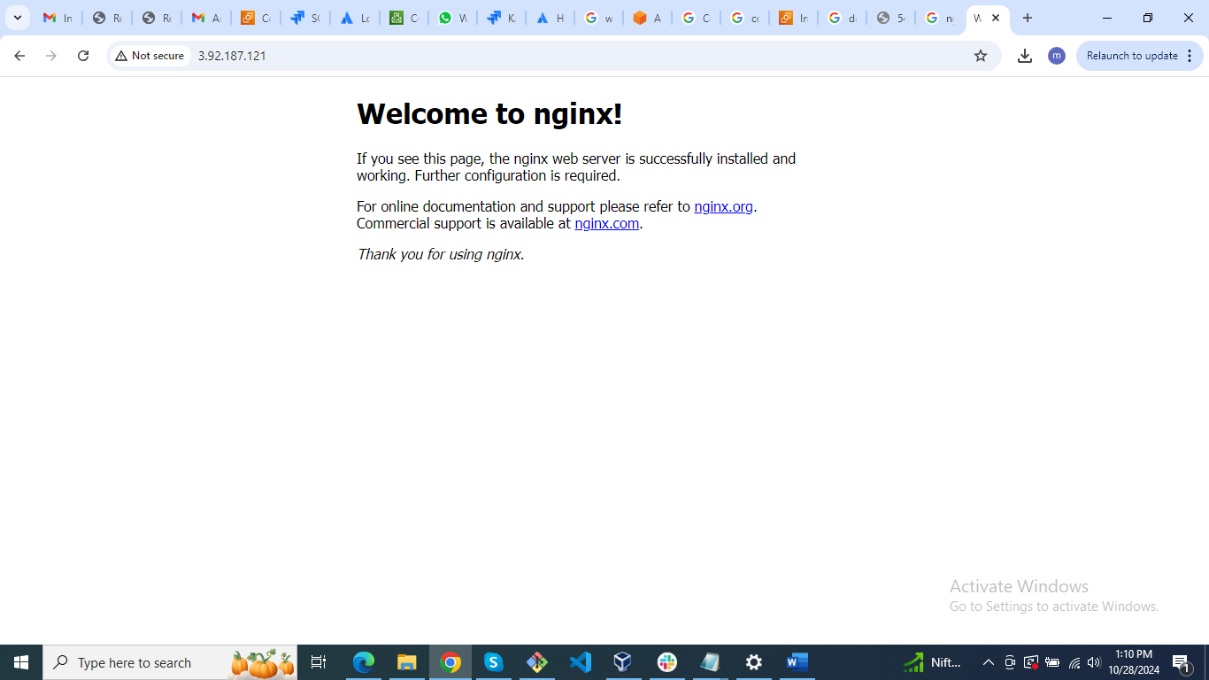

Tomcat

<https://www.atlantic.net/dedicated-server-hosting/how-to-install-tomcat-10-on-ubuntu-22-04/>

download app <https://dlcdn.apache.org/tomcat/tomcat-10/v10.1.31/bin/apache-tomcat-10.1.31.tar.gz>

