### **Bug Report 1: Product Card Alignment Issue**

* **Bug ID**: BUG_UI_001
* **Title**: Misalignment of Product Cards Due to Different Image Resolutions
* **Severity**: Medium
* **Priority**: P3
* **Environment**: All Browsers
* **Steps to Reproduce**:
  1. Navigate to the product listing page.
  2. Observe the alignment of product images, names, and prices.
* **Expected Result**: Product card elements (images, text, and prices) should be aligned consistently with proper spacing.
* **Actual Result**: Product images with different resolutions cause misalignment and inconsistent spacing across product cards.
* **Impact**: Misalignment affects the visual appeal of the page, leading to a poor user experience.
* **Suggested Fix**: Standardize image resolutions or adjust the layout to accommodate
* varying image sizes.

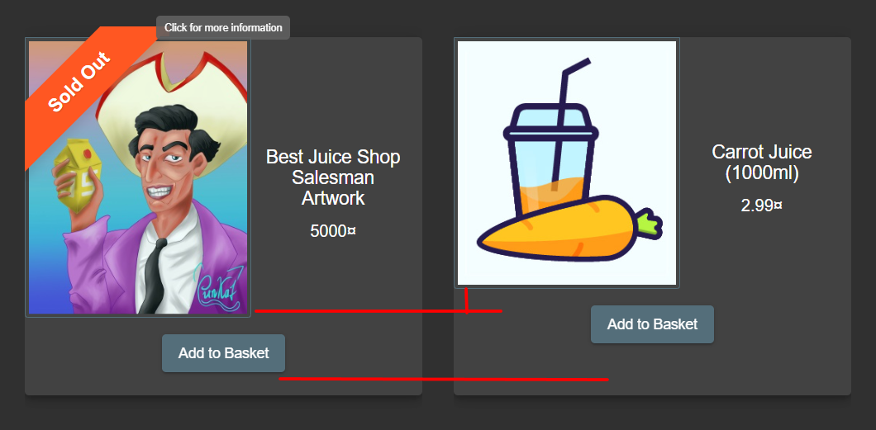

### **Bug Report 2: Header Functionality Issue**

* **Bug ID**: BUG_UI_002
* **Title**: Header Disappears While Scrolling
* **Severity**: Low
* **Priority**: P3
* **Environment**: All Browsers
* **Steps to Reproduce**:
  1. Scroll down the page using the mouse scroll wheel.
* **Expected Result**: The header should remain fixed at the top of the page while scrolling.
* **Actual Result**: The header disappears entirely when scrolling, causing a disruption in navigation.
* **Impact**: The disappearance of the header affects navigation and usability.
* **Suggested Fix**: Implement a fixed-position CSS property for the header to ensure it remains visible during scrolling.

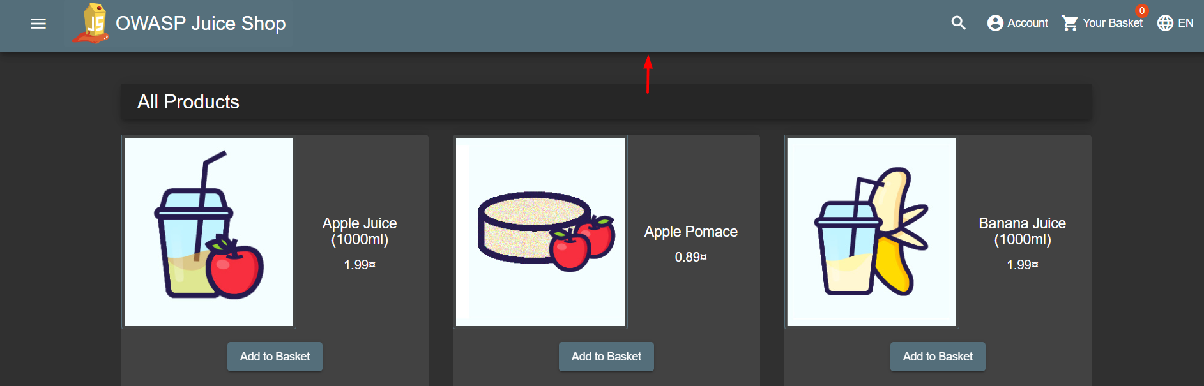

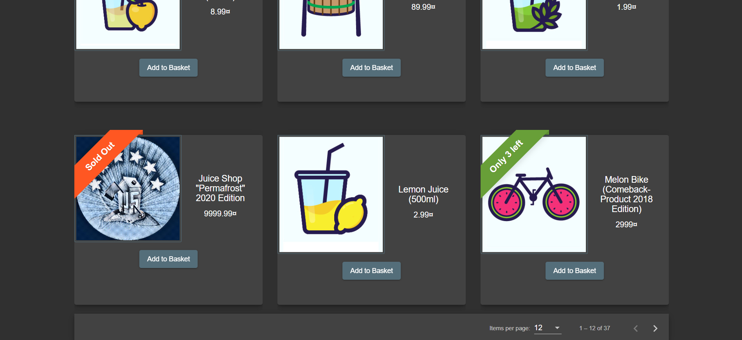

### 

### 

### **Bug Report 3: Currency Symbol Display Issue**

* **Bug ID**: BUG_UI_003
* **Title**: Incorrect Currency Symbol Displayed
* **Severity**: Low
* **Priority**: P3
* **Environment**: All Browsers
* **Steps to Reproduce**:
  1. Navigate to the product listing page.
  2. Observe the currency symbol next to product prices.
* **Expected Result**: The currency symbol should match the user's region or be a standard symbol (e.g., $, ₹, €).
* **Actual Result**: A generic currency symbol (¤) is displayed instead of the region-specific symbol.
* **Impact**: Incorrect display of the currency symbol affects user trust and site localization.
* **Suggested Fix**: Implement proper currency symbol logic based on the user's region or settings.

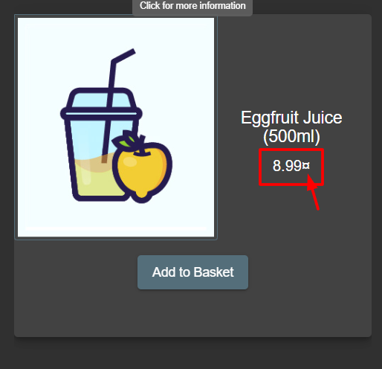

**Bug Report 4: Language Selector Hover Indicator Missing**

* **Bug ID**: BUG_UI_004
* **Title**: Missing Hover Indicator for Language Selector
* **Severity**: Medium
* **Priority**: P2
* **Environment**: All Browsers
* **Steps to Reproduce**:
  1. Locate the "EN" language option.
  2. Hover over the language option and check for any visual indicator.
* **Expected Result**: The language selector should have a hover effect or dropdown icon to indicate it's clickable.
* **Actual Result**: There is no visual indicator to show that "EN" is clickable.
* **Impact**: Users may not realize they can interact with the language selector, leading to usability issues.
* **Suggested Fix**: Add a hover effect or a dropdown indicator to the language selector.

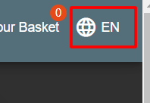

### 

### **Bug Report 5: GitHub Link Behavior Issue**

* **Bug ID**: BUG_UI_005
* **Title**: GitHub Link Opens in the Same Tab
* **Severity**: Low
* **Priority**: P3
* **Environment**: All Browsers
* **Steps to Reproduce**:
  1. Click on the GitHub link in the navigation menu.
* **Expected Result**: The GitHub link should open in a new tab.
* **Actual Result**: The link opens in the same tab, causing the session to be lost.
* **Impact**: Losing the session can cause inconvenience for users who wish to navigate back to the site.
* **Suggested Fix**: Implement the target="_blank" attribute for opening the GitHub link in a new tab.

### 

### **Bug Report 6: Add to Basket Button Visibility Issue**

* **Bug ID**: BUG_UI_006
* **Title**: Add to Basket Button Not Visible Unless Logged In
* **Severity**: High
* **Priority**: P1
* **Environment**: All Browsers
* **Steps to Reproduce**:
  1. Navigate to the product listing page.
* **Expected Result**: The "Add to Basket" button should be visible for all users.
* **Actual Result**: The button is not visible unless the user logs in.
* **Impact**: Users cannot interact with the product unless they log in, which hinders the shopping experience.
* **Suggested Fix**: Make the "Add to Basket" button visible for all users, regardless of login status.

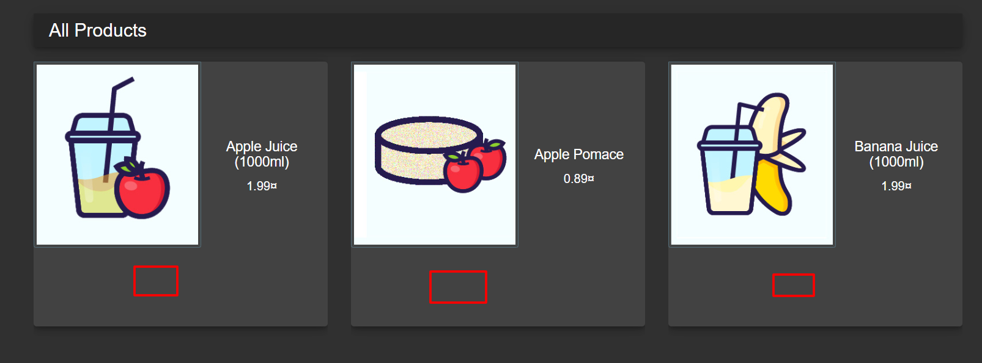

### 

### **Bug Report 7: User Name Not Reflecting After Login**

* **Bug ID**: BUG_UI_007
* **Title**: User Name Not Displayed After Login
* **Severity**: High
* **Priority**: P1
* **Environment**: All Browsers
* **Steps to Reproduce**:
  1. Navigate to the Home page or Product Listing Page.
  2. Check the user name in the header at the top right.
* **Expected Result**: The user name should be displayed in the account section.
* **Actual Result**: The user name is not reflecting even after login.
* **Impact**: Users cannot see their account name, causing confusion and a poor user experience.
* **Suggested Fix**: Ensure the user name is properly fetched and displayed in the header after login.

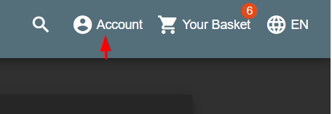

### 

### **Bug Report 8: Basket Quantity Not Updating After Login**

* **Bug ID**: BUG_UI_008
* **Title**: Basket Quantity Not Updating After Login
* **Severity**: High
* **Priority**: P1
* **Environment**: All Browsers
* **Steps to Reproduce**:
  1. Navigate to the homepage.
  2. Log in with Google and add a product to the basket.
  3. Log out and log in again using Google.
* **Expected Result**: The quantity in the basket should update according to the products added.
* **Actual Result**: After logging in via Google, the basket quantity is not reflecting the added products.
* **Impact**: Users might think the products are not added to the basket, affecting their shopping experience.
* **Suggested Fix**: Ensure that the basket quantity is correctly reflected after Google login.

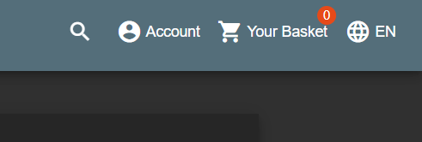

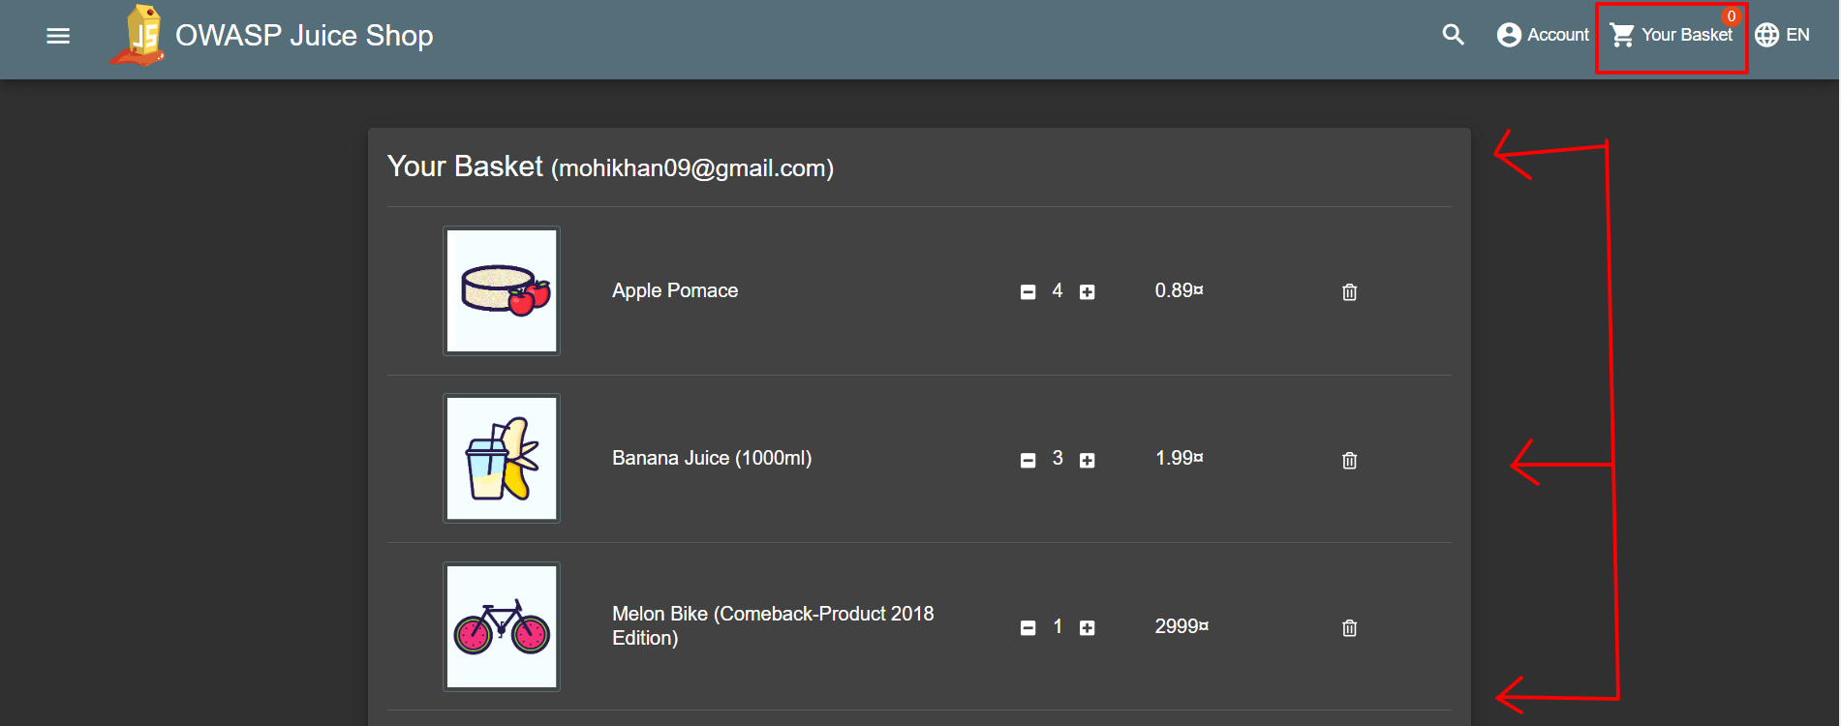

### 

### **Bug Report 9: Content Not Translating After Language Change**

* **Bug ID**: BUG_UI_009
* **Title**: Some Website Sections Not Translated After Language Change
* **Severity**: Medium
* **Priority**: P2
* **Environment**: All Browsers
* **Steps to Reproduce**:
  1. Go to the header and click on the "EN" language selector.
  2. Select another language.
* **Expected Result**: All website content should be translated according to the selected language.
* **Actual Result**: Some sections of the website are not translated.
* **Impact**: Inconsistent translations hinder the user experience, especially for non-English speakers.
* **Suggested Fix**: Ensure full content translation for all website sections.

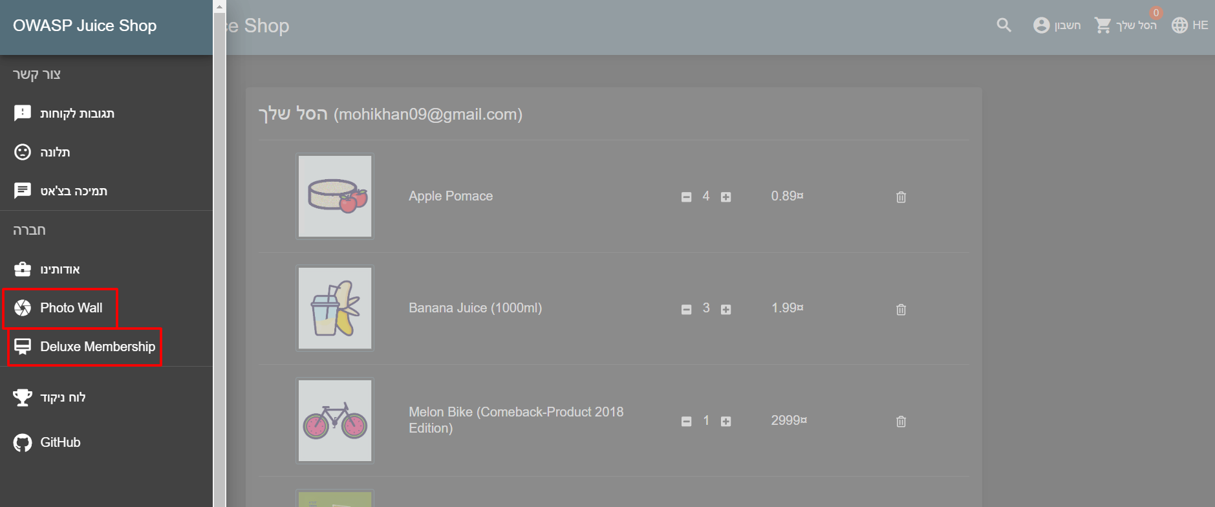

### 

### **Bug Report 10: Header Appears in Login Page**

* **Bug ID**: BUG_UI_010
* **Title**: Account Menu Visible on Login Page
* **Severity**: Low
* **Priority**: P3
* **Environment**: All Browsers
* **Steps to Reproduce**:
  1. Click on "Account" in the header.
  2. Click on "Login."
  3. Observe the header on the Login page.
* **Expected Result**: The header should not display the account menu while on the Login page.
* **Actual Result**: The header displays the account menu even on the Login page.
* **Impact**: The presence of the account menu on the login page can cause confusion.
* **Suggested Fix**: Hide the account menu when on the Login page.

### 

### **Bug Report 11: Back Button Missing on Some Pages**

* **Bug ID**: BUG_UI_011
* **Title**: No Back Button on Certain Pages
* **Severity**: Medium
* **Priority**: P2
* **Environment**: All Browsers
* **Steps to Reproduce**:
  1. Navigate through different pages on the website.
  2. Observe whether a back button is available on each page.
* **Expected Result**: Every page should have a back button to allow users to navigate back.
* **Actual Result**: Some pages do not have a back button, causing navigation issues.
* **Impact**: Users may get stuck on certain pages, negatively impacting usability.
* **Suggested Fix**: Add a back button to all pages where navigation is required.

**Bug Report 12: Forgot Password Fields Disabled**

* **Bug ID**: BUG_UI_012
* **Title**: Forgot Password Fields Not Accepting Input
* **Severity**: High
* **Priority**: P1
* **Environment**: All Browsers
* **Steps to Reproduce**:
  1. Click on "Account" as a guest user.
  2. Click on "Login."
  3. Select "Forgot Password."
* **Expected Result**: The fields should accept the user's email for password reset.
* **Actual Result**: The input fields are disabled and do not accept any data.
* **Impact**: Users cannot reset their password, leading to a critical usability issue.
* **Suggested Fix**: Ensure that the input fields are enabled and functional in the "Forgot Password" section.

**Technical Details:**

* The issue occurs because the input field for the security question answer is rendered with the disabled attribute, preventing the user from entering any data.

**HTML Code causing the issue:**

html

Copy code

* <input _ngcontent-ycr-c34="" id="securityAnswer" type="password" matinput="" aria-label="Field for the answer to the security question" class="mat-input-element mat-form-field-autofill-control ng-tns-c21-20 ng-untouched ng-pristine cdk-text-field-autofill-monitored" **disabled**="" required="" data-placeholder="" aria-required="true">

**Suggested Fix**:

* The disabled attribute in the input field needs to be removed or conditionally set depending on the page logic so that the user can enter the necessary details for password reset.

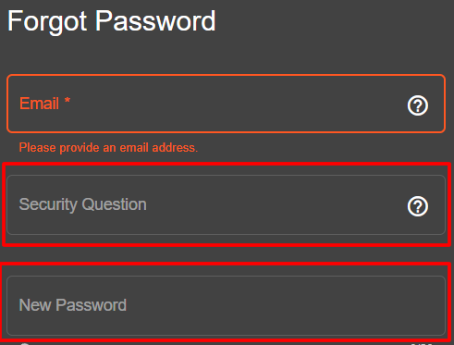

### 

### 

### **Bug Report 13: Google Login Behavior Issue**

* **Bug ID**: BUG_UI_013
* **Title**: Google Login Skips Account Selection Screen
* **Severity**: High
* **Priority**: P1
* **Environment**: All Browsers
* **Steps to Reproduce**:
  1. Click on "Account" as a guest user.
  2. Click on "Login."
  3. Navigate to the Login Page.
  4. Click on "Login with Google."
  5. Enter Gmail account credentials.
  6. Enter the password.
  7. After login, click on "Account."
  8. Click on "Logout."
  9. Repeat steps 1-4.
* **Expected Result**: After clicking "Login with Google," the user should be prompted to select which Google account they wish to log in with.
* **Actual Result**: The user is logged in immediately without being asked to choose a Google account.
* **Impact**: The lack of an account selection prompt could result in logging into the wrong Google account, which is a significant issue for users who have multiple accounts.
* **Suggested Fix**: Ensure that the Google login flow prompts the user to select their account if they are signed into multiple Google accounts.

### 

### 

### **Bug Report 14: Missing Placeholder in Search Box**

* **Bug ID**: BUG_UI_014
* **Title**: No Placeholder or Indication in the Search Box
* **Severity**: Medium
* **Priority**: P2
* **Environment**: All Browsers
* **Steps to Reproduce**:
  1. Observe the search box on each page.
* **Expected Result**: There should be a clear indication or placeholder text in the search box (e.g., "Search products...").
* **Actual Result**: The search box is empty, with no placeholder text or indication of its purpose.
* **Impact**: Users may not immediately recognize that the field is for searching, which can negatively affect the user experience.
* **Suggested Fix**: Add a placeholder text in the search box to indicate its function, such as "Search products..."

### **Bug Report 15: Search Box Appears on Irrelevant Pages**

* **Bug ID**: BUG_UI_015
* **Title**: Search Box Appears on Irrelevant Pages (e.g., Login, Forgot Password)
* **Severity**: Low
* **Priority**: P3
* **Environment**: All Browsers
* **Steps to Reproduce**:
  1. Navigate to the Login page.
  2. Navigate to the Forgot Password page.
  3. Observe the appearance of the search box on these pages.
* **Expected Result**: The search box should only appear on pages like the Product Listing Page (PLP) or the Basket page where search functionality is needed.
* **Actual Result**: The search box appears on irrelevant pages like the Login and Forgot Password pages, where it serves no purpose.
* **Impact**: The presence of the search box on irrelevant pages can confuse users and clutter the interface.
* **Suggested Fix**: Remove the search box from irrelevant pages like the Login and Forgot Password pages, ensuring it only appears where it is relevant (e.g., PLP, Basket).

### 

### **Bug Report 16: Edit/Delete Address Functionality is missing**

* **Bug ID**: BUG_UI_016
* **Title**: Edit/Delete Address option is not there.
* **Severity**: Medium
* **Priority**: P3
* **Environment**: All Browsers
* **Steps to Reproduce**:
  1. Do the login
  2. Add Product into Basket.
  3. Save Address
  4. Select Address and see edit/delete option is not there.
* **Expected Result:**After selecting an address, the "Edit" and "Delete" options should be available to manage the saved address.
* **Actual Result:**The "Edit" and "Delete" options are missing from the address management interface, making it impossible for users to modify or remove saved addresses.
* **Suggested Fix:**Add "Edit" and "Delete" options to the address management section to enable users to update or remove their saved addresses as needed.

**Bug Report 17: Address Unselection Issue**

**Bug ID:** BUG_UI_017  
**Title:** Address remains selected after unselection, & "Continue" button gets disabled.  
**Severity:** Medium  
**Priority:** P2  
**Environment:** All Browsers

**Steps to Reproduce:**

1. Log in to the application.
2. Add a product to the basket.
3. Proceed to the address selection screen.
4. Select a saved address.
5. Unselect the selected address by clicking on it again.

**Expected Result:**After unselecting the address, it should no longer appear as selected, and the "Continue" button should remain enabled if other mandatory fields are completed.

**Actual Result:**After unselecting the address:

1. The address still visually appears as selected.
2. The "Continue" button becomes disabled, preventing the user from proceeding.

**Impact:**This issue confuses users by presenting incorrect UI feedback and blocks them from progressing in the checkout process, potentially resulting in transaction abandonment.

**Suggested Fix:**

1. Ensure that when an address is unselected, it no longer appears selected visually.
2. Update the state of the "Continue" button to remain enabled as long as the necessary conditions are met.
3. Test for consistent behavior across all browsers and scenarios involving address selection and unselection.

**Bug Report 18: Card Details Unselection Issue  
Bug ID:** BUG_UI_018  
**Title:** Card details remain selected after unselection.  
**Severity:** Medium  
**Priority:** P2  
**Environment:** All Browsers

**Steps to Reproduce:**

1. Log in to the application.
2. Add a product to the basket and proceed to the payment screen.
3. Add card details and select the newly added card for payment.
4. Attempt to unselect the card by clicking on it again.

**Expected Result:**After unselecting the card, it should no longer appear as selected, and the payment section should reset to allow the user to select a different payment method or card.

**Actual Result:**After unselecting the card, it still visually appears as selected, preventing the user from choosing a different card or payment method.

**Impact:**This issue creates confusion by presenting incorrect UI feedback and limits the user's ability to switch between payment options, potentially causing frustration and abandonment of the payment process.

**Suggested Fix:**Ensure that when a card is unselected, it no longer appears visually selected, and the payment section resets appropriately. Validate that the user can seamlessly select or unselect cards and payment methods without UI inconsistencies. Test for consistent behavior across all browsers and scenarios involving card selection and unselection.

**Bug Report 19: Email Displayed Instead of Name on Payment Page  
Bug ID:** BUG_UI_019  
**Title:** User email is displayed instead of their name on the payment page.  
**Severity:** Medium  
**Priority:** P3  
**Environment:** All Browsers

**Steps to Reproduce:**

1. Log in to the application.
2. Add a product to the basket and proceed to the payment page.
3. Observe the user information displayed on the payment page.

**Expected Result:**The user’s full name, as registered in their profile, should be displayed on the payment page.

**Actual Result:**The user’s email address is displayed instead of their name on the payment page.

**Impact:**This issue can confuse users, detract from the user experience, and reduce trust in the payment process.

**Suggested Fix:**Ensure that the correct user data is fetched and displayed on the payment page by showing the registered name instead of the email address. Test for consistent behavior across all browsers and scenarios.