## Starting nodes

This is a onetime activity and assumes that docker and docker-compose is installed already.

Steps:

1. Go location where this repo is cloned
2. go to docker_quorum folder by typing "cd docker_quorum"
3. type "sudo su"
4. type "docker-compose up -d"
5. type “docker ps”

You should see something like this

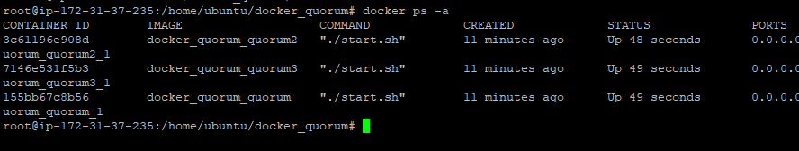

1. If there is any issue starting the nodes, or if you see the node restarting often proceed to the next step
2. Go to logs directory in “/data”
3. For each nodes there are different logs l1,l2,l3 etc
4. Go inside the folder of malfunctioning nodes and check quorum and constellation logs

## Interacting with the Nodes.

1. Type command ‘docker ps’
2. You should see something like this



1. Then go to geth interface by typing. This

‘docker exec -it 3c61196e908d geth attach <http://localhost:8545>’

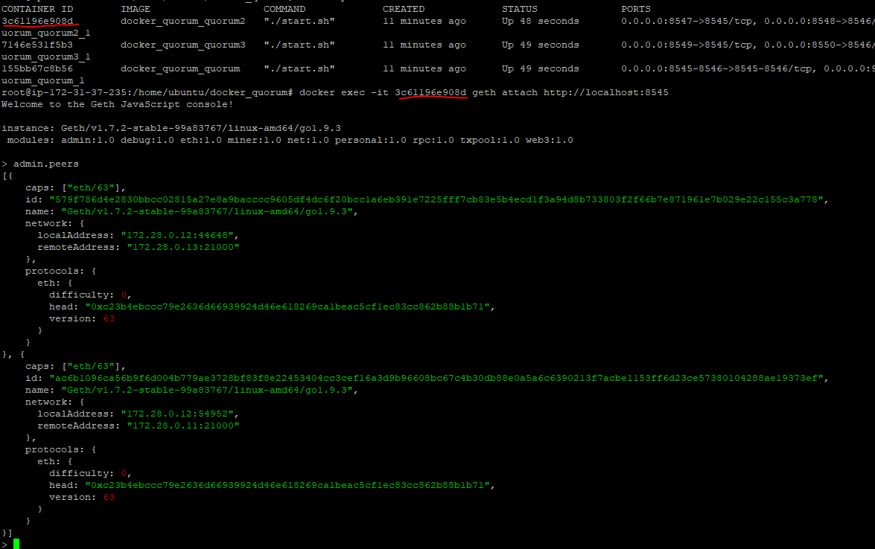

This is limited terminal and for advanced functionality, install geth client locally and interact it with typing “geth attach <http://localhost:8545>”

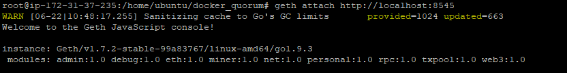

1. Then you can start interacting with the geth nodes via web3 using the port assigned in the docker-compose for geth rpc; usually it is 8545, but in case of multimode the default configured ports are 8545, 8547 and 8549 for each of the nodes. These ports needs to accessible from outside to interact with the node.
2. By default, there are no accounts created in the nodes. So, it is recommended that an account be created for testing purposes by typing “personal.newAccount()” in geth terminal. Make sure to remember the passphrase as this account details will be used to make transactions.

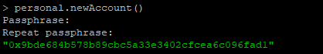

The green color info is the Ethereum account of the newly created account. Accounts are required to create Ethereum transactions.

1. To make any transaction to the Blockchain, the account need to be unlocked. This can be done via web3 client or via geth client

For testing purposes we can unlock it infinitely using geth terminal by typing

“personal.unlockAccount(<account>,<password>,0);”

