Household Energy Consumption
Analytics Dashboard
Project Report
Type | Stack | Dataset | Entry point
Data Analytics / EDA Dashboard | Python · Streamlit · Plotly · Pandas | UCI ML Repository (~2 M rows · 4 years) | app.py

1. Project Overview
This project delivers a fully interactive analytics dashboard for exploring four years of minute-level household electricity readings (December 2006 – November 2010). The goal is to turn raw sensor data into actionable business metrics — total consumption, peak demand, appliance-level breakdowns, and usage-pattern heatmaps — without any machine-learning models: pure exploratory data analysis and visualisation.
Users can slice the entire dataset by date range, switch between hourly / daily / monthly aggregation, and tune a local electricity rate to compute an estimated cost — all from a responsive sidebar. Results update instantly across three analytical tabs.

2. Technology Stack & Dependencies
Package | Pinned Version | Role
streamlit | ≥ 1.35 (installed: 1.64.0) | Web UI framework — layout, widgets, caching, tabs
pandas | ≥ 2.0 (installed: 3.0.6) | Data loading, resampling, pivoting, aggregation
plotly | ≥ 5.20 (installed: 7.1.0) | All interactive charts — line, donut, scatter, heatmap, area
numpy | ≥ 1.26 (installed: 2.5.3) | Numerical operations and rounding
scipy | ≥ 1.11 (installed: 1.18.1) | Required transitive dependency for statsmodels
statsmodels | ≥ 0.14 (installed: 0.15.0) | OLS trendline computation in Plotly Express scatter plots
Tags: Python 3.x · Streamlit · Pandas · Plotly · NumPy · SciPy · Statsmodels · EDA · Time-Series · UCI Dataset

3. Project Structure

Household Energy Consumption /
│
├── app.py # Main Streamlit application
├── household_power_consumption.txt # Raw dataset (UCI, ~500 MB, not committed)
├── requirements.txt # Python dependency pins
├── README.md # Repository documentation
│
└── assets/ # Screenshot folder
├── screenshot_tab1.png
├── screenshot_tab2.png
├── screenshot_tab3_heatmap.png
└── screenshot_tab3_scatter.png

4. Dataset

Property | Detail
Source | UCI Machine Learning Repository — Georges Hébrail & Alice Bérard
File | household_power_consumption.txt
Coverage | December 2006 – November 2010 (~4 years)
Granularity | 1-minute intervals
Size | ~2 million rows · ~500 MB on disk
Separator | Semicolon (;)
Missing values | Encoded as ? · dropped on load for Global_active_power

4.1.Columns
Column |  | Unit | Description
Date | — |  | Day/Month/Year
Time | — |  | hh:mm:ss
Global_active_power | kW |  | Total active power consumed by the household
Global_reactive_power | kW |  | Total reactive power
Voltage | V |  | Average mains voltage
Global_intensity | A |  | Average current intensity
Sub_metering_1 | Wh |  | Kitchen: dishwasher, oven, microwave
Sub_metering_2 | Wh |  | Laundry: washing machine, dryer, fridge
Sub_metering_3 | Wh |  | Climate: electric water heater & AC unit
Sub_metering_remainder ⭐ | Wh |  | Derived — unmonitored energy: (GAP × 1000/60) − SM1 − SM2 − SM3

5. Dashboard Tabs

Tab 1 — Executive Overview
📈 Tab 1 · Executive KPI Overview
- 4 KPI metric cards — Total Energy (kWh), Peak Demand (kW + timestamp), Avg Daily Use (kWh/day), Estimated Cost ($)
- Global Active Power Trend — Plotly line chart at the selected granularity with dark theme
- Voltage & Intensity (expandable) — Side-by-side line charts for average voltage (V) and current intensity (A)

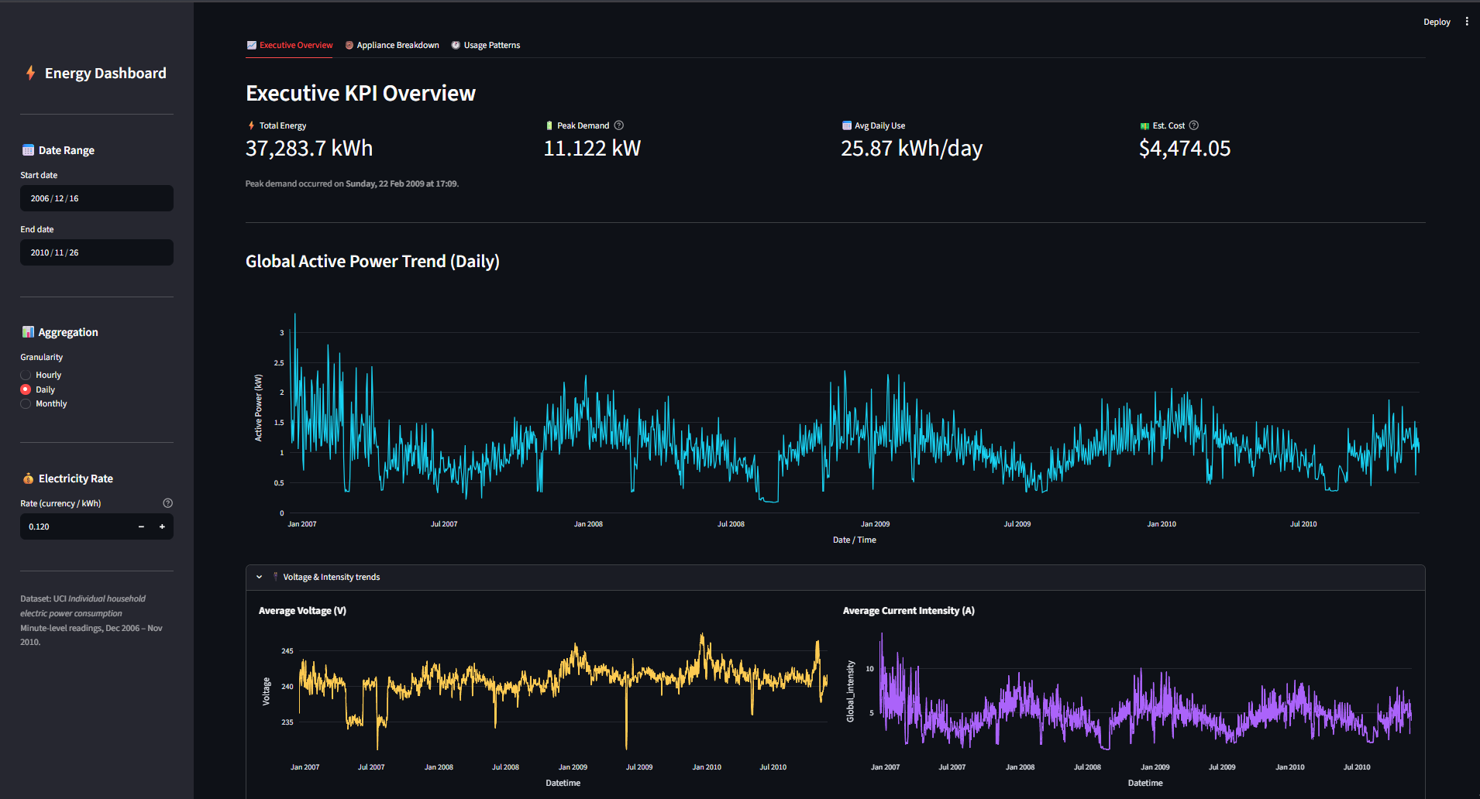

Tab 2 — Voltage & Intensity (expandable section)

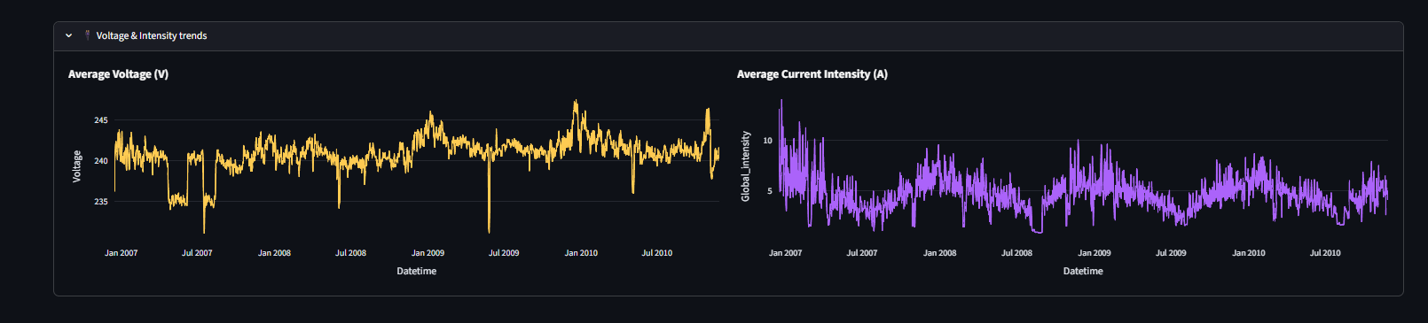

Tab 3 — Usage Patterns

🍩 Tab 2 · Appliance Energy Breakdown
- Donut chart — Share of total energy split across Kitchen, Laundry, AC & Water Heating, and Other/Unmetered
- Zone Totals panel — Colour-coded labels with kWh totals, percentage shares, and progress bars
- Stacked Area chart — All four sub-metering streams stacked over time at selected granularity

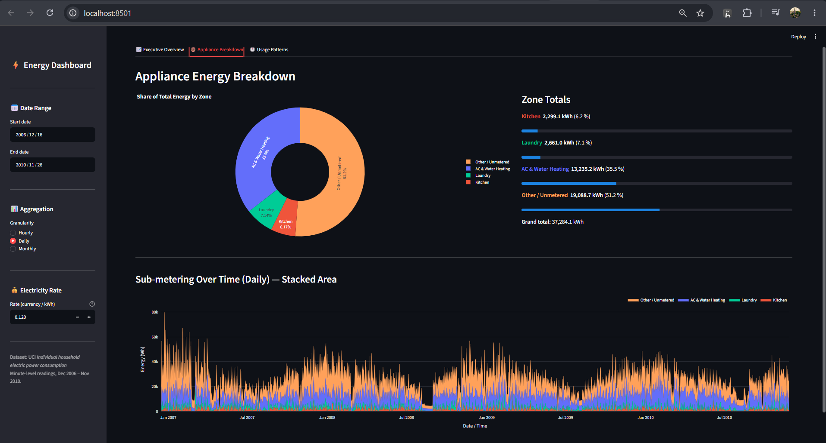
Full Correlation Matrix (expandable)
🕐 Tab 3 · Usage Patterns & Peak Hours
- Hourly Heatmap — Average power consumption by Hour of Day (x) × Day of Week (y) using the Plasma colour scale
- Scatter: Power vs Voltage — 8 000-point sample with OLS trendline
- Scatter: Power vs Current Intensity — 8 000-point sample with OLS trendline
- Full Correlation Matrix (expandable) — Pearson r heatmap across all 7 measurement columns (RdBu scale)

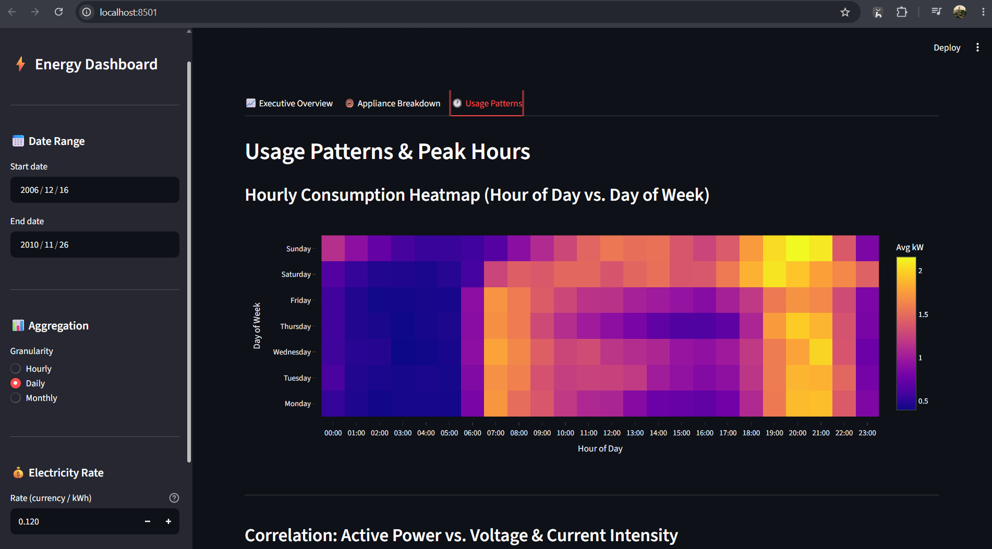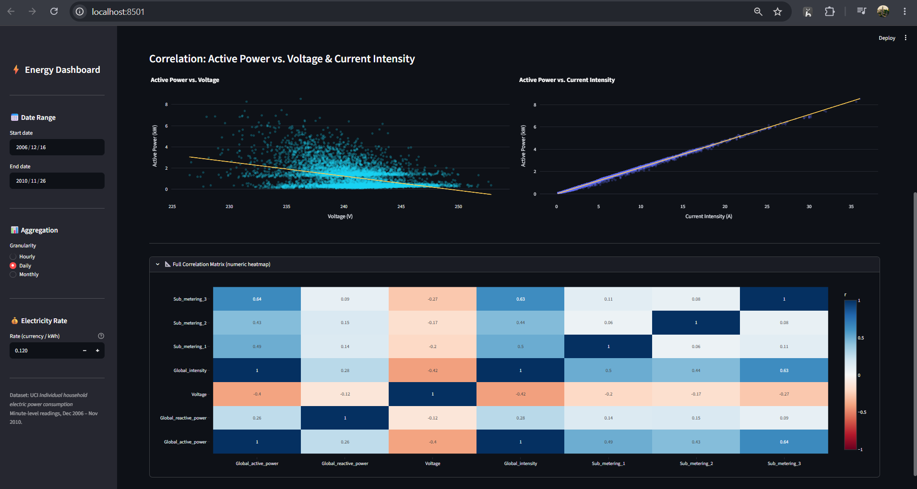

6. Project Analysis
The dashboard performs exploratory data analysis on minute-level household electricity measurements covering December 2006 to November 2010. The analysis is designed to convert raw sensor readings into understandable measures of total consumption, demand, appliance-zone usage, electrical conditions, and time-based usage patterns. It is an analytics project rather than a predictive machine-learning system.

6.1 Consumption & Demand Analysis
The primary measure is Global_active_power, which represents total active power consumed by the household. The dashboard calculates total energy in kWh and identifies peak demand together with its timestamp. These KPIs are calculated from the filtered minute-level data rather than only from the aggregated chart data, preserving accuracy for the headline measures.
The Global Active Power Trend is then displayed at the user's selected granularity. Hourly, daily, and monthly views allow the same underlying measurements to be examined at different time scales. This makes it possible to distinguish short-term fluctuations from broader changes in household electricity use.

6.2 Appliance / Zone Analysis
The three sub-metering columns are used to separate monitored energy into practical household zones. Sub_metering_1 represents Kitchen usage, Sub_metering_2 represents Laundry usage, and Sub_metering_3 represents Climate / AC and water heating. A derived Sub_metering_remainder captures unmonitored or other energy after subtracting the three monitored streams from total active energy.
The dashboard presents this analysis through a donut chart, zone totals, percentage shares, progress bars, and a stacked area chart. Together, these views support comparison of how the household's electricity consumption is distributed between monitored and unmonitored activities.

6.3 Electrical Behaviour Analysis
Voltage and Global_intensity are analysed alongside active power. The dashboard provides separate trend charts for average mains voltage and current intensity, while scatter plots examine the relationship between active power and these electrical measurements. OLS trendlines are used in the scatter visualisations to make the direction of the observed relationship easier to inspect.

7. Setup & Quick Start

Step | Command / Action
1. Clone repository | git clone <repo-url>
2. Create virtual environment | python -m venv .venv
3. Activate (Windows) | .\.venv\Scripts\Activate.ps1
4. Install dependencies | pip install -r requirements.txt
5. Add dataset | Place household_power_consumption.txt in project root
6. Launch app | streamlit run app.py → opens at http://localhost:8501

