DATABASE MANAGEMENT SYSTEMS

(BTCSE406)

LAB REPORT

Submitted by

MOHD SHAHIQUE QAMAR SIDDIQI

2016-310-060

in partial fulfilment for the award of the degree of

B.Tech (Computer Science)

Under the guidance of

MRS. KARUNA YOGESH SUNAMI



Department of Computer Science & Engineering
School of Engineering Sciences & Technology

JAMIA HAMDARD

New Delhi-110062

INDEX

S.No. | Topic | Assigned Date | Signatures | Remarks
1 | Creating & Describing Tables | January 29, 2018
2 | SQL Select Queries, Sort & Between | February 13, 2018
3 | SQL Wild card characters | February 13, 2018
4 | SQL Expressions & Custom outputs | February 20, 2018
5 | SQL Operators & Variables | February 20, 2018
6 | SQL Tables | February 22, 2018
7 | SQL Queries | February 27, 2018
8 | SQL Queries with Date | March 13, 2018
9 | SQL Queries with Minimum, Maximum & Average | March 13, 2018
10 | Joins | March 15, 2018
11 | Views | March 27, 2018
12 | PL/SQL Basics | April 10, 2018

Assignment-1 Creating & Describing Tables

Problem Statement:

- Create Tables as follows:
SALGRADE TABLE
GRADE | LOSAL | HISAL
1 | 700 | 1200
2 | 1201 | 1400
3 | 1401 | 2000
4 | 2001 | 3000
5 | 3001 | 9999
EMP TABLE
EMPNO | ENAME | JOB | MGR | HIREDATE | SAL | COMM | DEPTNO
7369 | SMITH | CLERK | 7902 | 17-DEC-80 | 800 |  | 20
7499 | ALLEN | SALESMAN | 7698 | 20-FEB-81 | 1600 | 300 | 30
7521 | WARD | SALESMAN | 7698 | 22-FEB-81 | 1250 | 500 | 30
7566 | JONES | MANAGER | 7839 | 02-APR-81 | 2975 |  | 20
7654 | MARTIN | SALESMAN | 7698 | 28-SEP-81 | 1250 | 1400 | 30
7698 | BLAKE | MANAGER | 7839 | 01-MAY-81 | 2850 |  | 30
7782 | CLARK | MANAGER | 7839 | 09-JUN-81 | 2450 |  | 10
7788 | SCOTT | ANALYST | 7566 | 19-APR-87 | 3000 |  | 20
7839 | KING | PRESIDENT |  | 17-NOV-81 | 5000 |  | 10
7844 | TURNER | SALESMAN | 7698 | 08-SEP-81 | 1500 | 0 | 30
7876 | ADAMS | CLERK | 7788 | 23-MAY-87 | 1100 |  | 20
7900 | JAMES | CLERK | 7698 | 03-DEC-81 | 950 |  | 30
7902 | FORD | ANALYST | 7566 | 03-DEC-81 | 3000 |  | 20
7934 | MILLER | CLERK | 7782 | 23-JAN-82 | 1300 |  | 10
DEPT TABLE
DEPTNO | DNAME | LOC
10 | ACCOUNTING | NEW YORK
20 | RESEARCH | DALLAS
30 | SALES | CHICAGO
40 | OPERATIONS | BOSTON
- Select all information of various tables SALGRADE, EMP and DEPT; See the structure of these tables.
Please note that we will use these tables for all the assignments in this lab, so do use COMMIT to save this data permanently.

Screenshots of Inputs, Outputs & Queries:

- Creation of Tables:
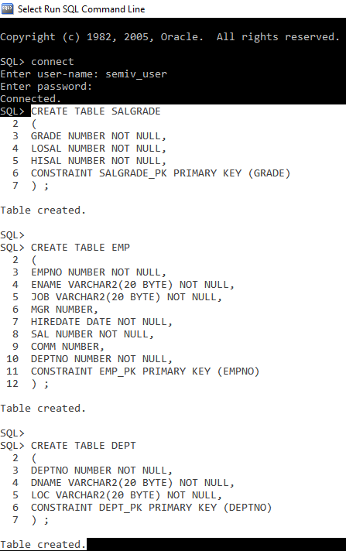

- Inserting entries in the created Tables:
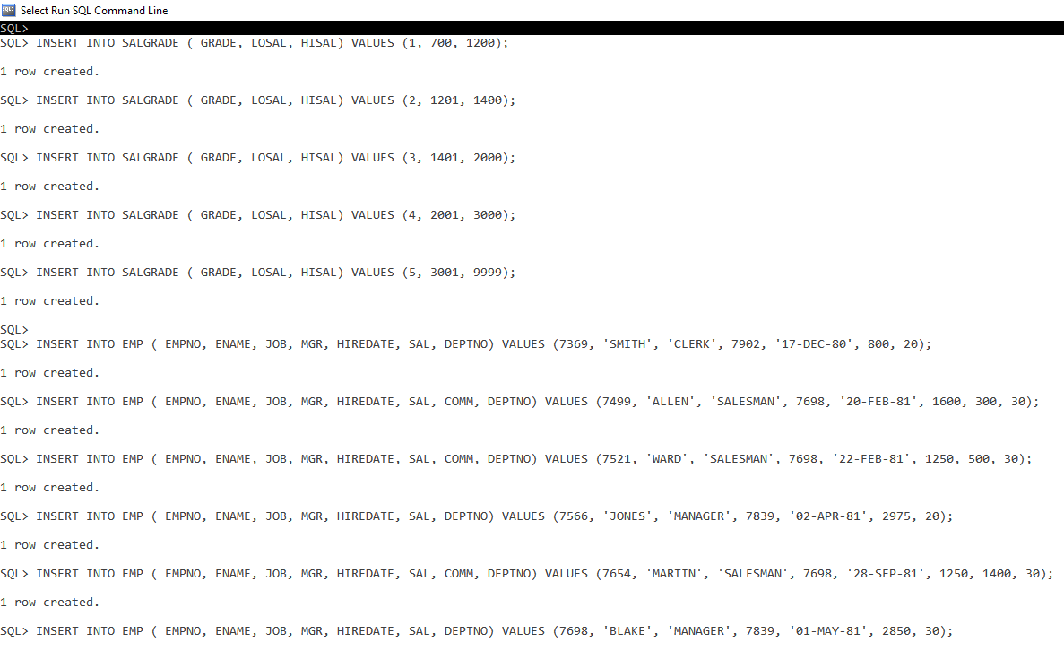
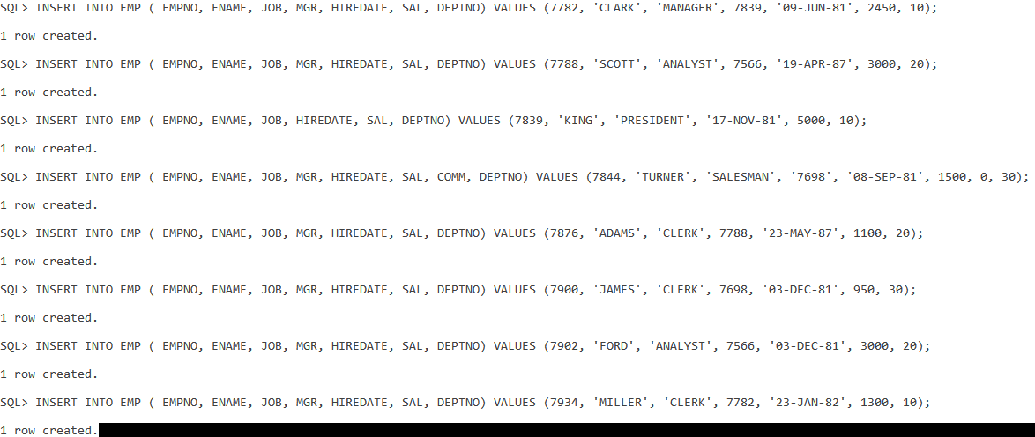
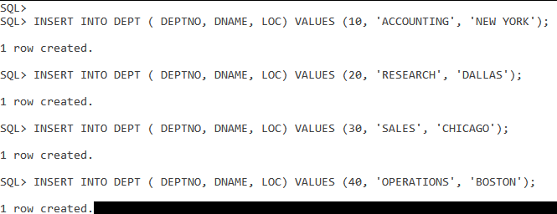

- All selected information of various tables SALGRADE, EMP and DEPT:
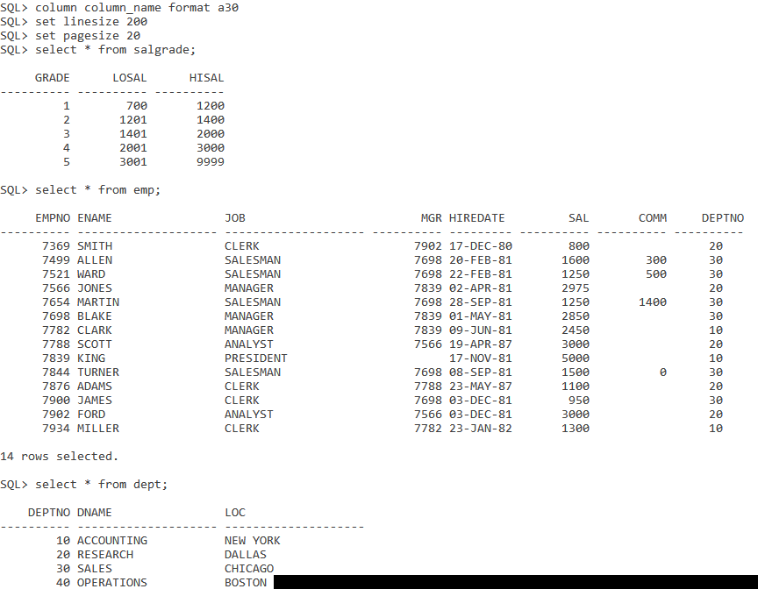
I encountered a problem during the output; The output wasn’t aligned. So I fixed it using the commands:
- column column_name format a30
- set linesize n; where ‘n’ is a custom integer
- set pagesize n; where ‘n’ is a custom integer

- Structure of the tables:
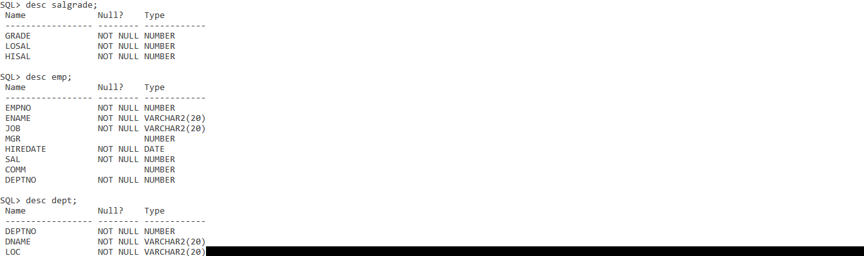

Assignment-2 SQL Select Queries, Sort & Between

Problem Statement:

- List all information whose salary in between 1000 and 3000. Use EMP table.
- List name and salary only of employees. Use EMP table.
- List the above in sorted order. Sort by name. Use EMP table.
- List all employee name and dept no who are in dept 10 and 30. Use EMP table.
- List name, job of all clerks in dept 20. Use EMP table.
List name, job of all clerks in dept 20 and 30. Use EMP table.

Screenshots of Inputs, Outputs & Queries:

- All information of whose salary is in b/w 1000-3000 [EMP Table]:
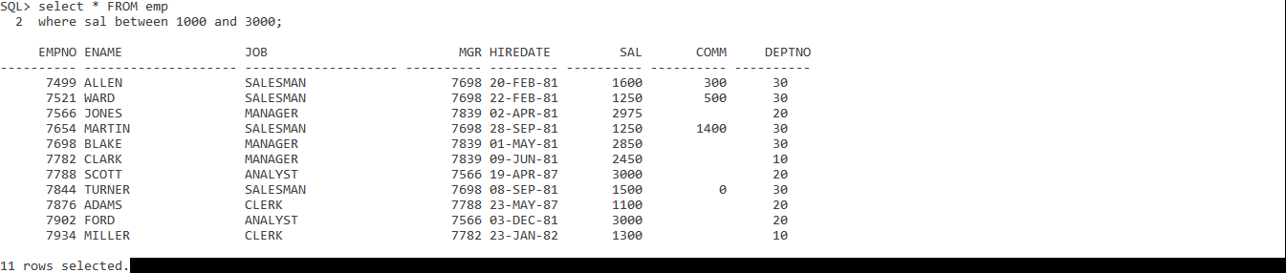
- Name and salary only of employees:
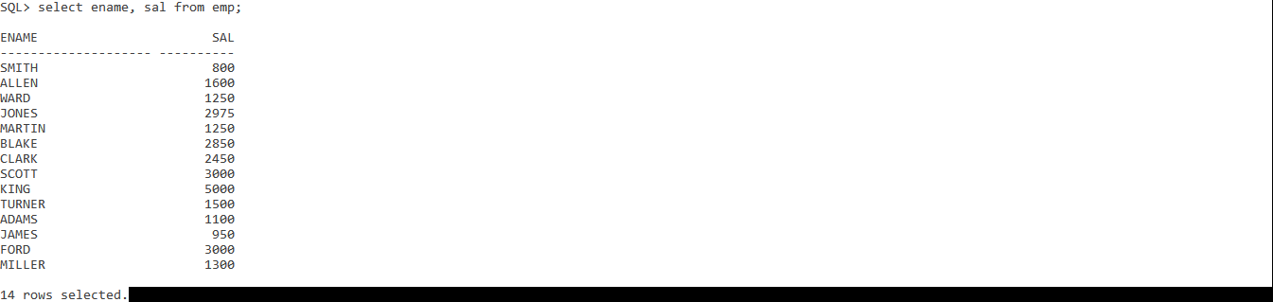
- Sorted by name:
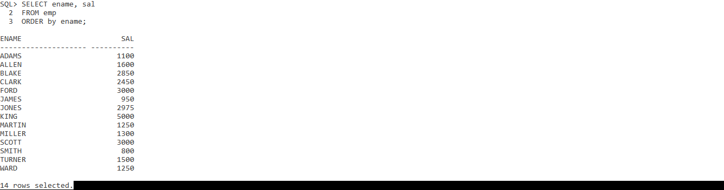

- All employee name and deptno who are in 10 and 30:
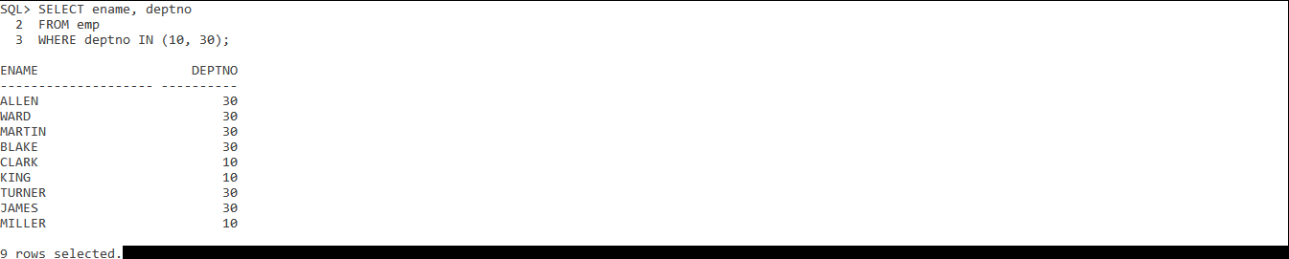
- Name, job of all clerks in dept 20:
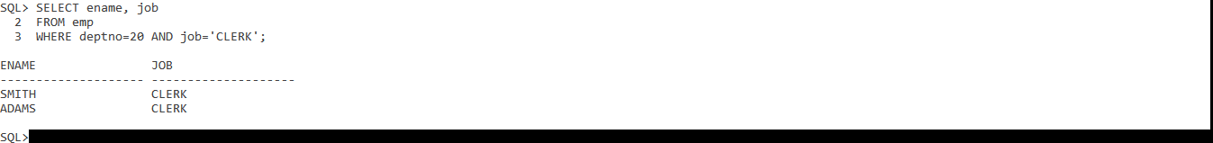

Assignment-3 SQL Wild card characters

Problem Statement:

- Display all employees whose name starts with ‘S’. Use EMP table.
- Display all employees whose name has four characters only. Use EMP table.
- Display all employees whose name ends with ‘L’. Use EMP table.
- List all employees who have a manager. Use EMP table.
- List all employees who do not have a manager. Use EMP table.

Screenshots of Inputs, Outputs & Queries:

- All employees whose name starts with ‘S’:
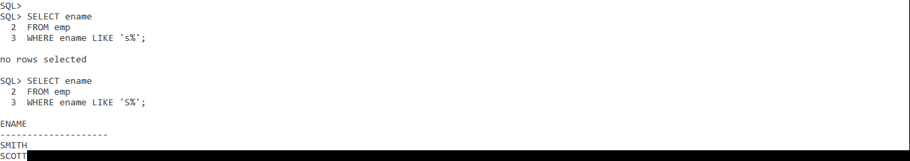
In the Oracle SQL cmd, I figured out that the entries were case sensitive. So while fetching some data from the table on terminal, values passed in the commands must be case sensitive as well.
- All employees whose name has four characters only:
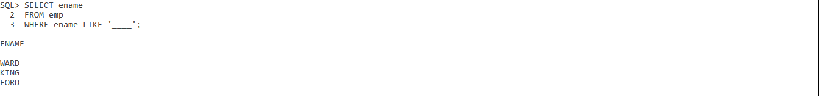
- All employees whose name ends with ‘L’:
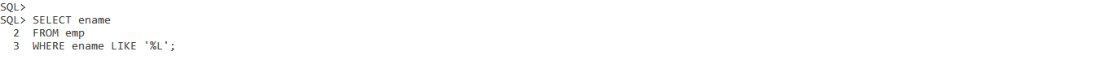
- All employees who have a manager:
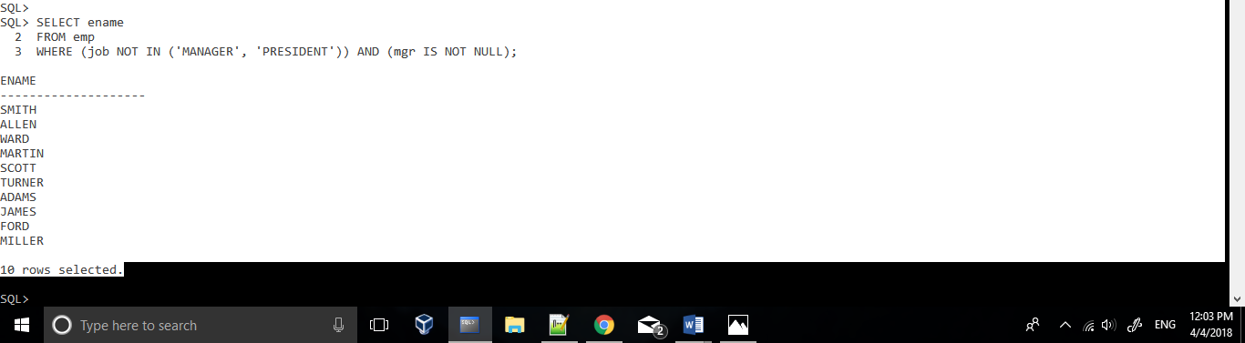

- All employees who don’t have a manager:
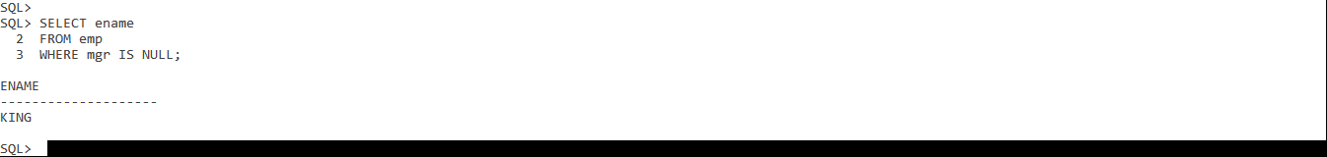
Assignment-4 SQL Expressions & Custom outputs

Problem Statement:

- List name and Total of salary i.e. sal+commission. Use EMP table.
- List name and Annual Salary i.e. sal*12. Use EMP table.
- List all employees who joined in the year 1991. Use EMP table.
- Display data as who, what, when and how much display should look like E.g.: SMITH HAS HELD THE POSITION OF CLERK IN DEPARTMENT 20 SINCE ’12-OCT-1990’AND EARNS 1500.

Screenshots of Inputs, Outputs & Queries:
- Name and Total of salary i.e sal+commission:
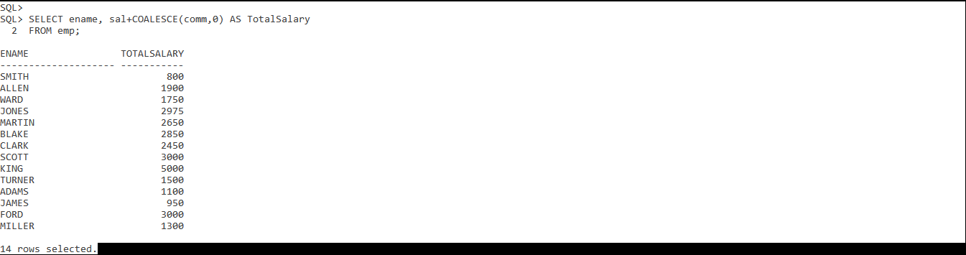
- Name and Annual Salary i.e sal*12:
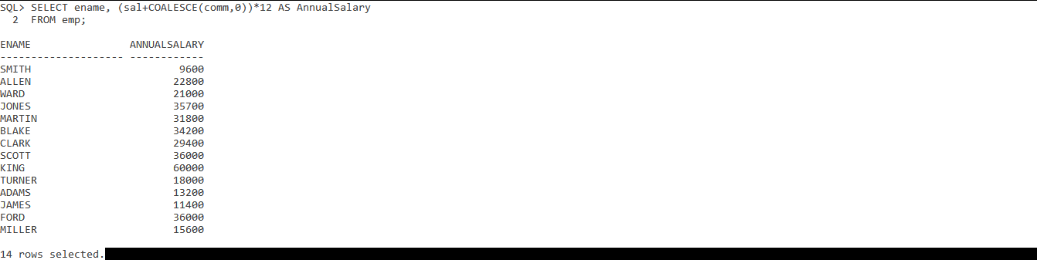
- All employees who joined in the year 1981:
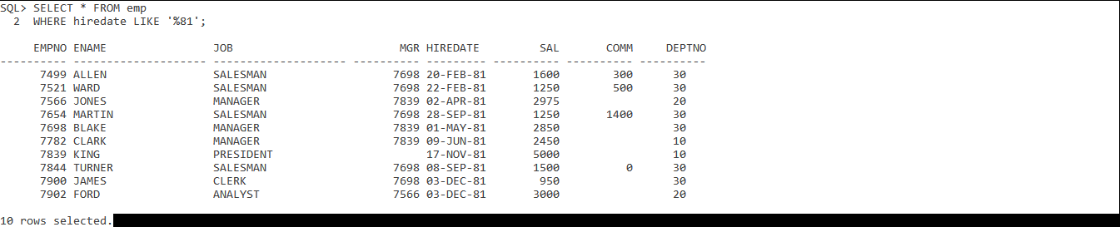

- Display data as who, what, when and how much display should look like:
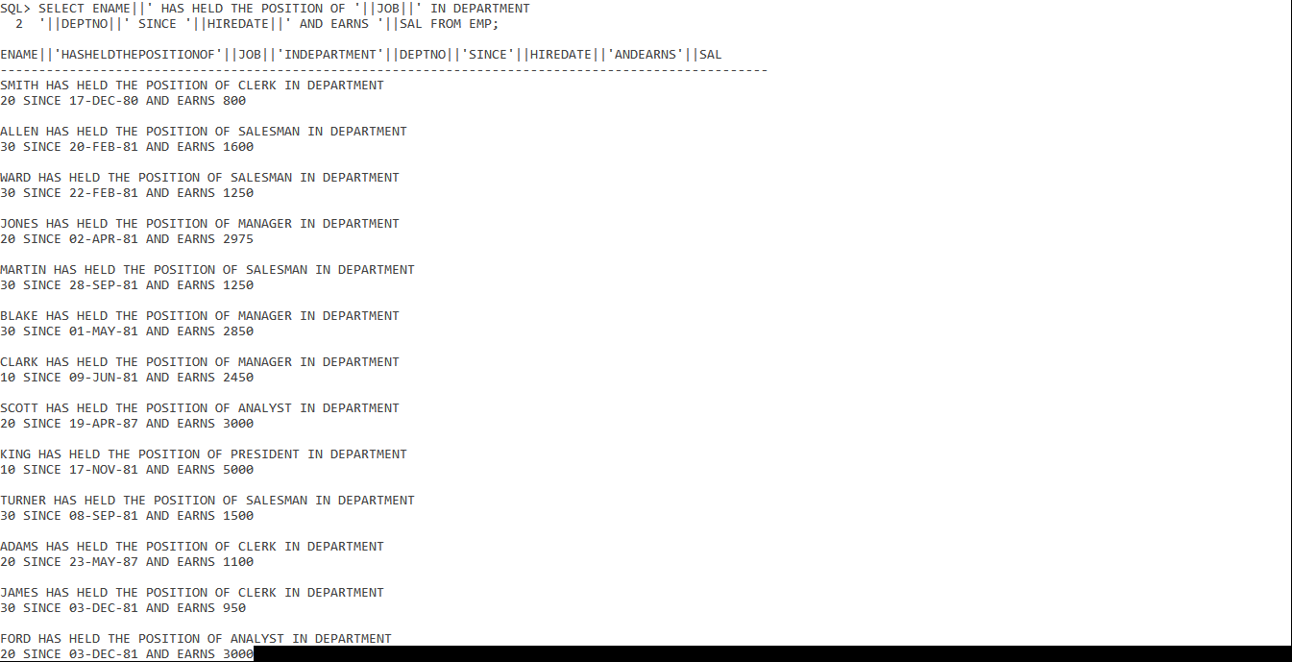
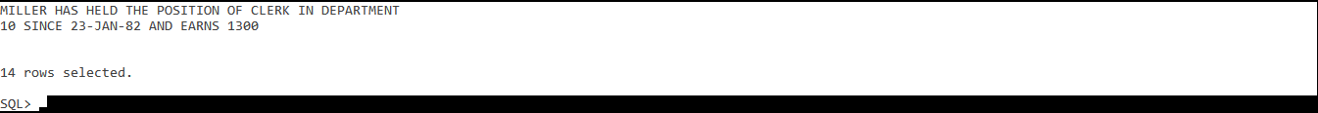
- Display data as who, what, when and how much display should look like E.g.: SMITH HAS HELD THE POSITION OF CLERK IN DEPARTMENT 20 SINCE ’12-OCT-1990’AND EARNS 1500:
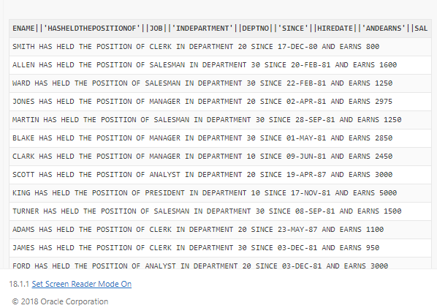
Assignment-5 SQL Operators & Variables

Problem Statement:

- Supply values at runtime and display all employees in the user specified job title.
- Find all employees joined on a specified date entered by the user.
- Generate a query that accepts two dates i.e. the joining dates of EMP (range) at runtime and gives the output. Rerun it and then change the substitution variables with && and return it twice.
- Define one variable i.e. the REM= ‘sal*12+NVL(comm.,0)
- Use the variable to find all employees who earn $10000 a year or more.

Screenshots of Inputs, Outputs & Queries:
- Supply values at runtime and display all employees in the user specified job title:
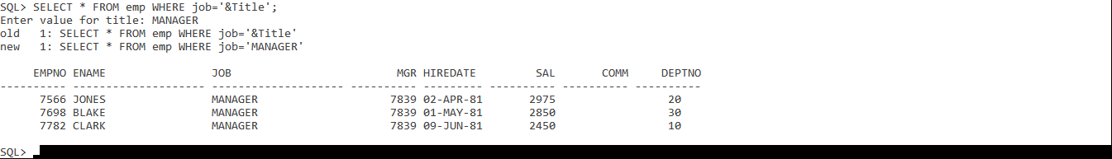
- Find all employees joined on a specified date entered by the user:
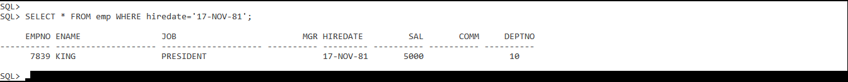
- Generate a query that accepts two dates i.e. the joining dates of EMP(range) at runtime and gives the output. Rerun it and then change the substitution variables with && return it twice:
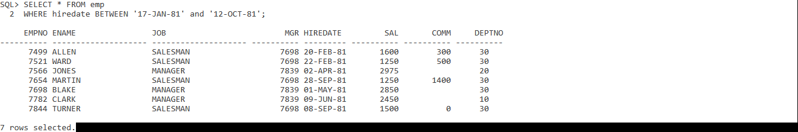
- Define one variable i.e. the REM= ‘sal*12+NVL(comm.,0):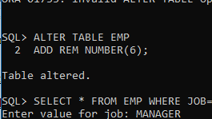

- Use the variable to find all employees who earn $10000 a year or more:
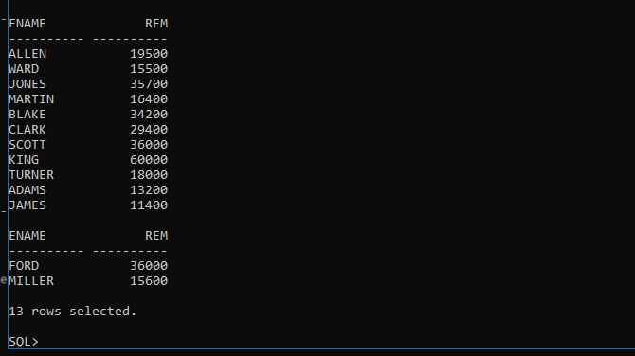

Assignment-6 SQL Tables

Problem Statement:

- Create a EMP10 table which has the following fields:
Empno NUMBER (2)
Ename VARCHAR2 (25)
Date_join DATE
Deptno NUMBER (2)
Salary NUMBER (10, 2)
Job VARCHAR2 (10)
Comm NUMBER (7, 2)
- Create another table with the following constraints:
Empno NUMBER (2)
Ename VARCHAR2 (25)
Date_join DATE
Deptno NUMBER (2)
Salary NUMBER (10, 2)
Job VARCHAR2 (10)
Comm NUMBER (7, 2)
- Give different field names to the table. Create a table emp20 with only name, sal and job from EMP table with employees of department 20.

Screenshots of Inputs, Outputs & Queries:
- Create a EMP10 table:
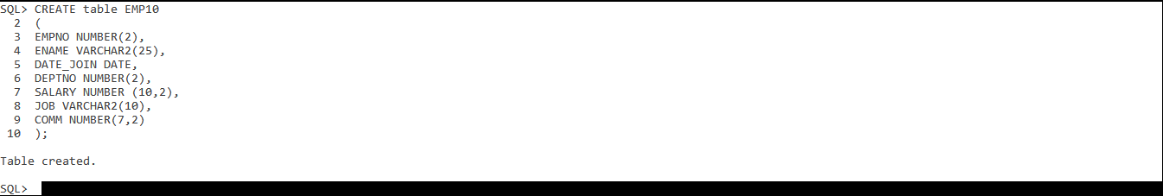

- Create another table:
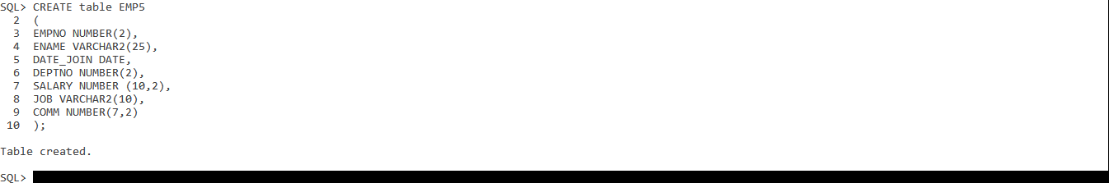

- Give different field names to the table. Create a table emp20 with only name, sal and job from EMP table with employees of department 20:
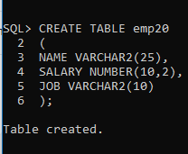
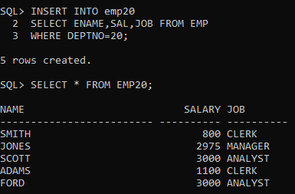

Assignment-7 SQL Queries

Problem Statement:

- List the employees name and salary increased by 20% and expressed as whole numbers of dollars.
- Display ename and job with an alias EMPLOYEE_AND_JOB.
- Try this command and find the difference with previous question.
SELECT RPAD (ENAME, 10) || LPAD (JOB, 10) EMPLOYEE_AND_JOB FROM EMP;
- Try this command.
SELECT ENAME||’(‘|| INITCAP(JOB) || ‘ )’ EMPLOYEE_AND_JOB FROM EMP;
- Search for the list of employees with a job that the user enters.
NOTE: The search should be case insensitive.
- Change the designation of salesman with sales person in department 20 as there are woman salespersons in the organisation.

Screenshots of Inputs, Outputs & Queries:
- List the employees name and salary increased by 20% and expressed as whole numbers of dollars:
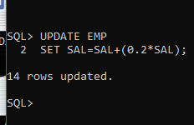
- Display ename and job with an alias EMPLOYEE_AND_JOB:
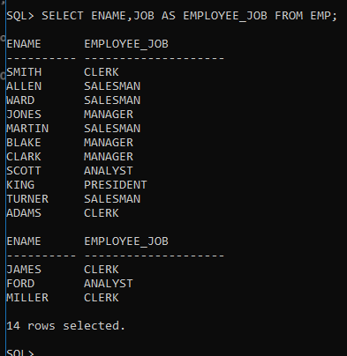

- Try this command and find the difference with previous question. SELECT RPAD (ENAME, 10) || LPAD (JOB, 10) EMPLOYEE_AND_JOB FROM EMP;
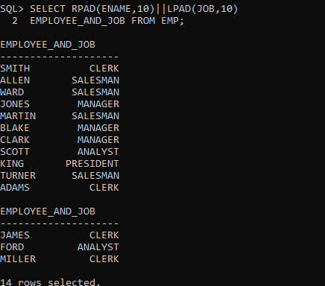
- Try this command. SELECT ENAME||’(‘|| INITCAP(JOB) || ‘ )’ EMPLOYEE_AND_JOB FROM EMP;
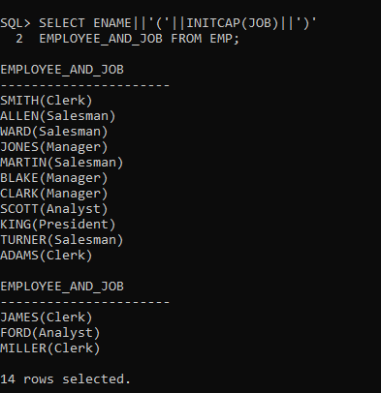

- Search for the list of employees with a job that the user enters. NOTE: The search should be case insensitive:
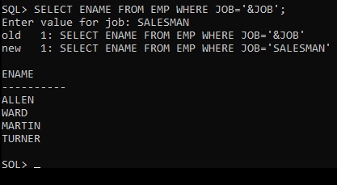
- Change the designation of salesman with sales person in department 20 as there are woman salespersons in the organisation:
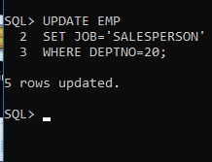

Assignment-8 SQL Queries with Date

Problem Statement:

- Display name, Hiredate from EMP Table. Hiredate should be in the displayed in the form of Thirteen June 1998.
- Display the date of completing probation of an employee. Add 12 months to the hire_date and then order by the hire_date.
- Now order by ADD_MONTH (HIRE_DATE, 12). Note the difference.
- Display the salary of an employee. If salary is greater 1500 then the salary is to be displayed. If 1500 then display ‘On target’, if less then display below 1500. Hint: Use DECODE Function.
- Display the day of the week of today. Use the sysdate and the format of DD.MM.YY.
- Write a query to calculate the length of service an employee has put in the company. Use DEFINE.
- Given a string of the format ‘nn/nn’, Verify that the first and last 2 characters are numbers and that the middle character is a ‘/. Print the expression ‘YES’ if valid else Print ‘no’. Use the values for testing:’12/34/,’01/1a’,’99/88’.
- Employees hired on or before the 15th of any month are paid on the last Friday of that month.

Screenshots of Inputs, Outputs & Queries:
- Display name, Hiredate from EMP Table. Hiredate should be in the displayed in the form of Thirteen June 1998:
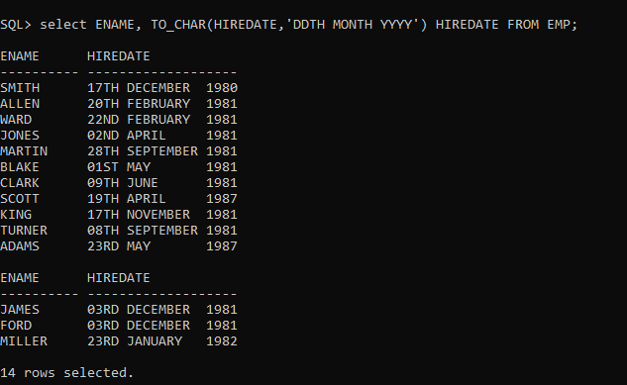
- Display the date of completing probation of an employee. Add 12 months to the hire_date and then order by the hire_date:
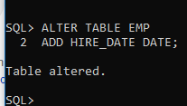
- Now order by ADD_MONTH (HIRE_DATE, 12). Note the difference:
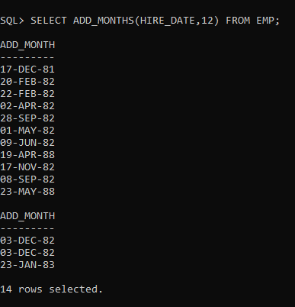

- Display the salary of an employee. If salary is greater 1500 then the salary is to be displayed. If 1500 then display ‘On target’, if less then display below 1500. Hint: Use DECODE Function:
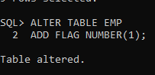
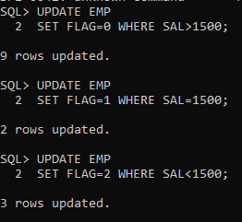
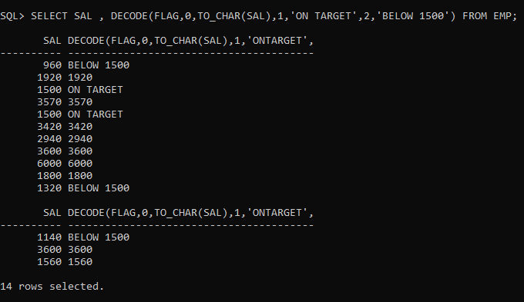
- Display the day of the week of today. Use the sysdate and the format of DD.MM.YY:
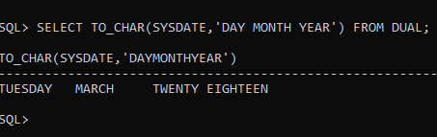

- Employees hired on or before the 15th of any month are paid on the last Friday of that month:
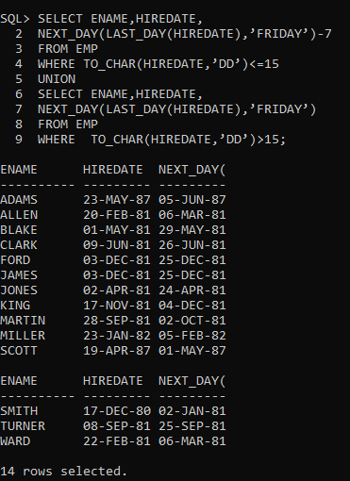

Assignment-9 SQL Queries with Minimum, Maximum & Average

Problem Statement:

- Find the minimum salary of all employees.
- Find the minimum, maximum and average salaries of all employees.
- Use the minimum and maximum salary for each job type.
- Find out how many managers there are without listing them.
- Find the average salary and average total remuneration for each job type. Remember salesman earn commission.
- Find out the difference between highest and lowest salaries.
- Find all departments which have more than 3 employees
- Check whether all employee numbers are indeed unique.
- Use lowest paid employees working for each manager. Exclude any groups where the minimum salary is less than 1000. Sort the output by salary.

Screenshots of Inputs, Outputs & Queries:
- Find the minimum salary of all employees:
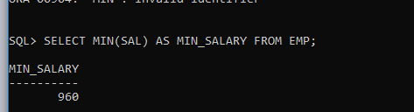
- Find the minimum, maximum and average salaries of all employees:
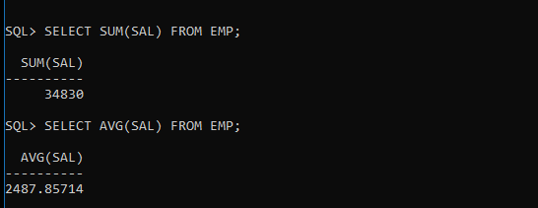
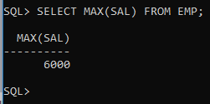
- Use the minimum and maximum salary for each job type:
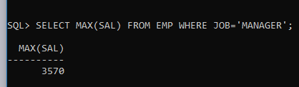
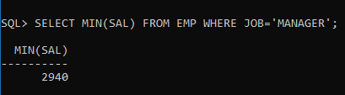
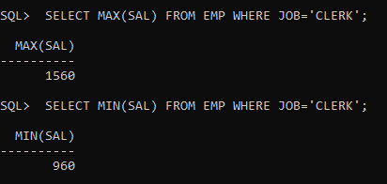
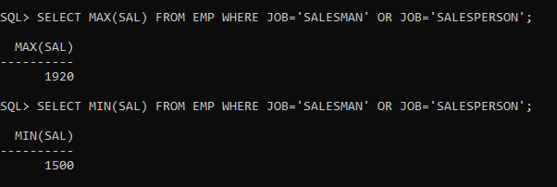
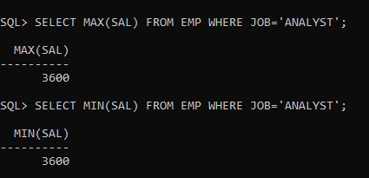
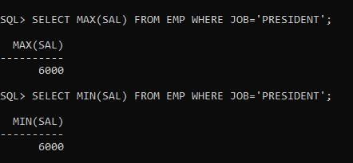
- Find out how many managers there are without listing them:
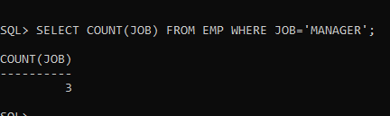
- Find the average salary and average total remuneration for each job type. Remember salesman earn commission:
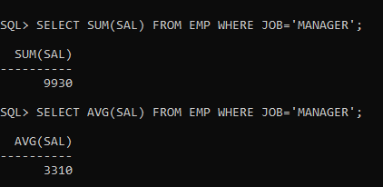
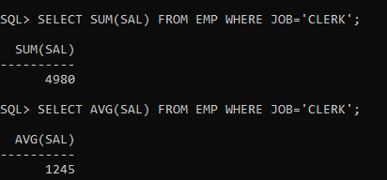
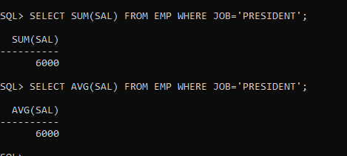
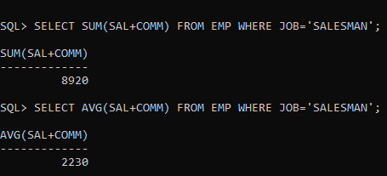
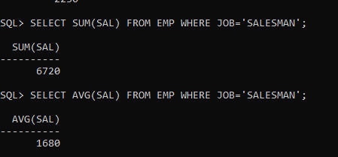

- Find out the difference between highest and lowest salaries:
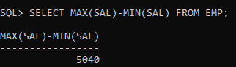
- Find all departments which have more than 3 employees:
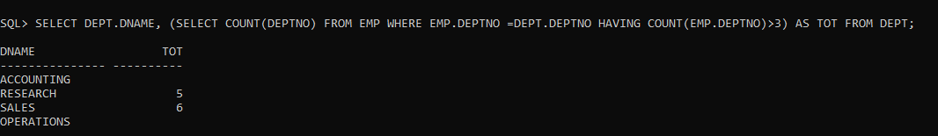
- Check whether all employee numbers are indeed unique:
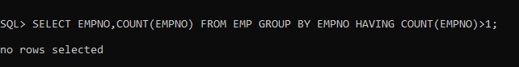
- Use lowest paid employees working for each manager. Exclude any groups where the minimum salary is less than 1000. Sort the output by salary:
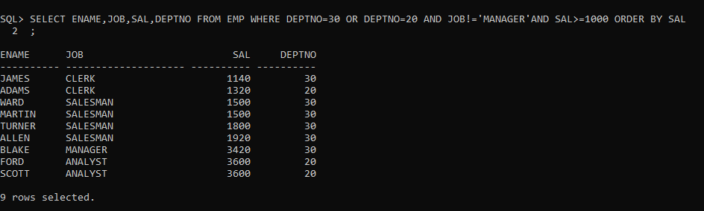

Assignment-10 Joins

Problem Statement:

- Display all employee names and their department name, in department name order.
- Display the name, location and department of employees whose salary is more than 1500 a month.
- Find employee(s) who earn the highest salary in each job type. Sort in descending order of salary.
- Find the employees who earn the minimum salary for their job. Display the result in ascending order of salary.
- Find the most recently hired employees in each department. Order by hiredate.
- Show the following details for any employee who earns a salary greater than the average for their department. Sort in department number order.
- List all the departments where there are no employees.(Using , a subquery this time)

Screenshots of Inputs, Outputs & Queries:
- Display all employee names and their department name, in department name order:

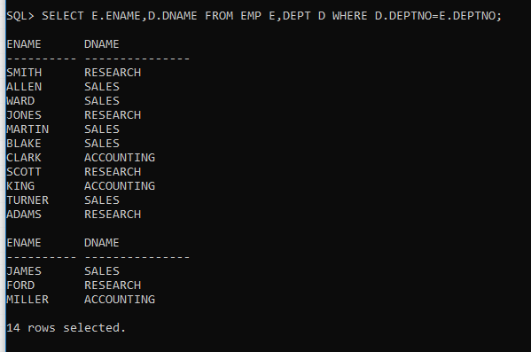

- Display the name, location and department of employees whose salary is more than 1500 a month:

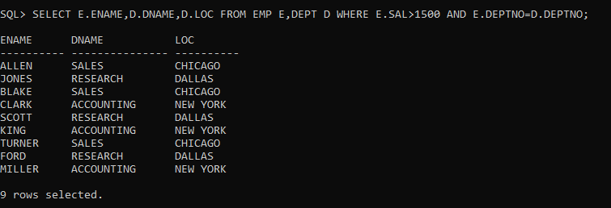
- Find employee(s) who earn the highest salary in each job type. Sort in descending order of salary:

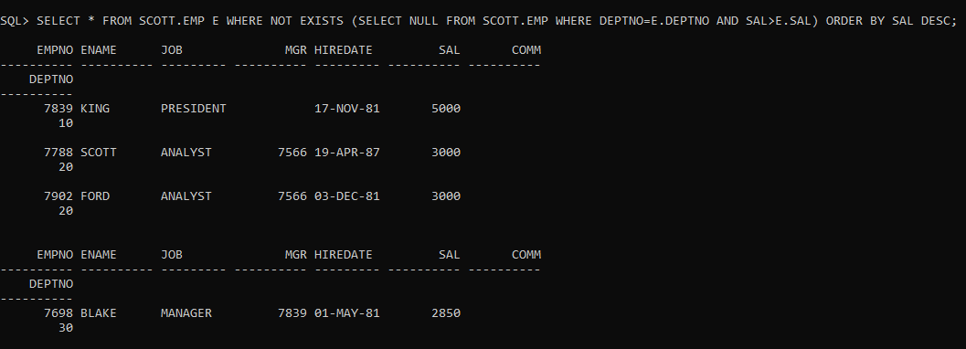
- Find the employees who earn the minimum salary for their job. Display the result in ascending order of salary:

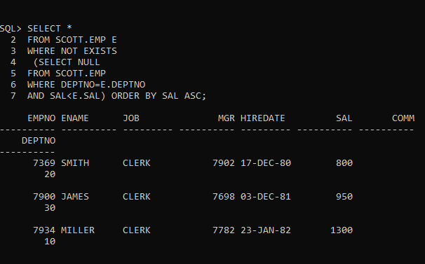

- Find the most recently hired employees in each department. Order by hiredate:

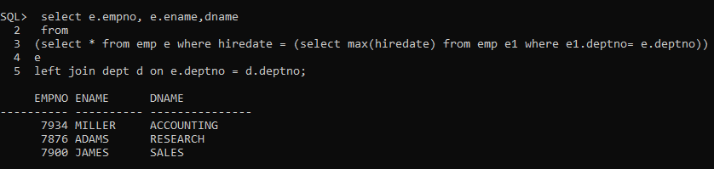
- Show the following details for any employee who earns a salary greater than the average for their department. Sort in department number order:

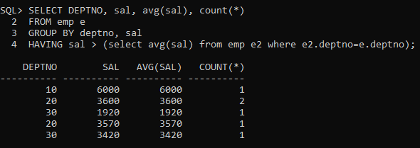
- List all the departments where there are no employees.(Using , a subquery this time):

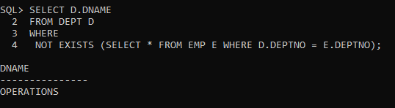

Assignment-11 Views

Problem Statement:

- Define a view which will produce the following output when referenced in a query.
Run a query to test the view.
DEPTNO AVERAGE MAX MIN SUM NO-SALS NO-COMMS
------------- -------------- --------- ------- ------ ------------- --------------
10 2916.66667 5000 1300 8750 3 0
20 2175 3000 1800 10875 5 0
- Using the view from question 1, extract the following information. Employee number should be entered at run-time.
Enter value for no: 7902
EMPNO ENAME JOB SAL HIREDATE MIN MAX AVERAGE
----------- ------------ ----- ----- -------------- ------- ------- ---------------
7902 FORD ANALYST 30000 5-DEC-83 800 3000 2175
- Create a view to enforce the following restriction when inserting data into the DEPT table. DEPTNO must be less than 100.
- Create a sequence as SEQUENCE1 with a start value of 1 and end value of 100.
- Create a sequence as SEQUENCE2 with a start value of 1 and no end value.

Screenshots of Inputs, Outputs & Queries:

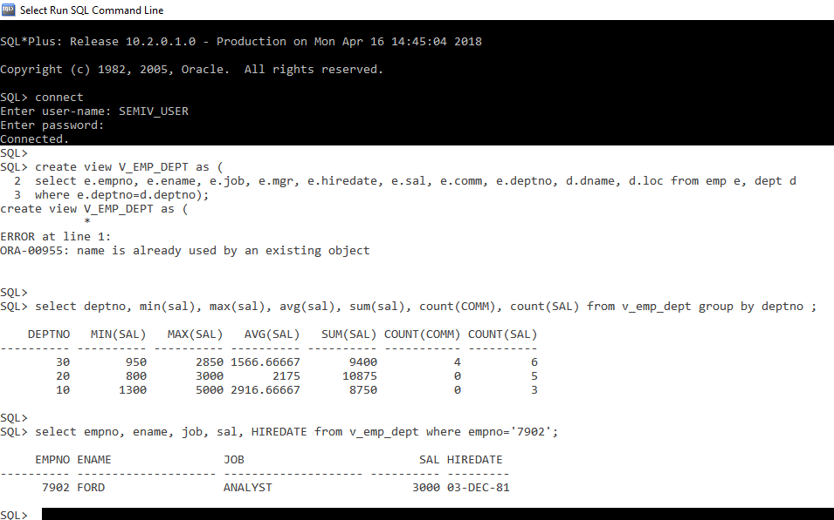

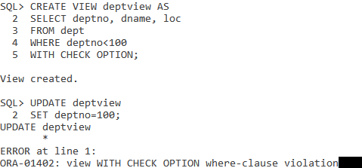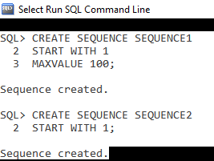
Assignment-12 PL/SQL Basics

Problem Statement:

- Write a PL/SQL BLOCK; If-Then-Else
For a given account number see the balance and then only update the account (of the account Number i.e. customer)
Select the ENAME, HIREDATE and SAL columns from EMP where EMPNO equals a number input at run-time. Having selected columns into variables, insert a row into MESSAGES based on the following criteria:
Criteria Message
---------------------------- ----------------------------
Salary greater than 1200 salary more than 1200
ENAME contains as ‘T’ Name contains a”T”
HIREDATE is month December December
None of the above **None**
Test the block for employee numbers 7654,7369,7900,7876.
HINT: You may use PROCEDURES, FUNCTIONS & TRIGGERS.

Screenshots of Inputs, Outputs & Queries:

