ADVANCED COMPUTER ARCHITECTURE LAB FILE

[BTCSE 703]

Submitted by

MOHD SHAHIQUE QAMAR SIDDIQI, 2016-310-060
in partial fulfillment for the award of the degree of

BACHELOR OF TECHNOLOGY (COMPUTER SCIENCE AND ENGINEERING)

Under the supervision of
Dr. SHERIN ZAFAR and Dr. ABDUL AHAD


(Copy from www.jamiahamdard.ac.in)

Department of Computer Science & Engineering
School of Engineering Sciences & Technology

JAMIA HAMDARD

New Delhi-110062

(2019)

INDEX
S.No. | Title | Date | Sign
1 | Matrix multiplication(2-D) using the concept of parallel processing on 3x3 matrix.
2 | Matrix multiplication(2-D) using the concept of parallel processing on 4x4 matrix.
3 | Matrix multiplication(2-D) using the concept of parallel processing on 5x5 matrix.
4 | Matrix multiplication(2-D) using the concept of parallel processing on 1000x1000 matrix.
5 | Implementation of Booth Multiplication.
6 | WAP to calculate Collision Vector.
7 | Implementation of State Diagram.
8 | WAP for the calculation of Speedup Factor.
9 | Implementation of Direct Mapping.
10 | Implementation of Associative Mapping.
11 | Implementation of Set-Associative Mapping.

CODE
/**
* Implementing the concept of parallel processing on matrix multiplication 3x3
*
* @author ashra.
* Created Sep 22, 2019.
*/
import java.util.*;
import java.io.*;

public class MatrixMultiplication extends Thread {
/*** declaration ***/
private int i,j,k;
static int m1[][];
static int m2[][];
static int result[][];
/*** multi-threading ***/
public MatrixMultiplication ( int i, int j, int k) {
this.i = i;
this.j = j;
this.k = k;
}
public void run() {
result[i][j] += m1[i][k]*m2[k][j];
}
public static void main(String args[]) {
Scanner reader = new Scanner(System.in);
System.out.println("Enter the dimension of the matrix:");
int dm = reader.nextInt(); //getting dimension of the matrix

/*** initialization ***/
m1 = new int[dm][dm];
m2 = new int[dm][dm];
result = new int [dm][dm];

/*** input ***/
System.out.println("Enter the first matrix:");
for(int i=0; i<dm; i++) {
for(int j=0; j<dm; j++) {
try {
m1[i][j]=reader.nextInt();
}catch(Exception e) {}
}
}
System.out.println("Enter the second matrix:");
for(int i=0; i<dm; i++) {
for(int j=0; j<dm; j++) {
try {
m2[i][j]=reader.nextInt();
}catch(Exception e) {}
}
}

/*** matrix multiplication ***/
for(int i=0; i<dm; i++) {
for(int j=0; j<dm; j++) {
for (int k=0; k<dm; k++) {
try {
new MatrixMultiplication(i, j, k).start(); //formula for multiplying two matrices
}catch(Exception e) {}
}
}
}
/*** Output ***/
System.out.println("The matrix after parallel processing multiplication:");
for(int i=0; i<dm; i++) {
for(int j=0; j<dm; j++)
System.out.print(result[i][j]+" ");
System.out.println();
}
}
}

OUTPUT
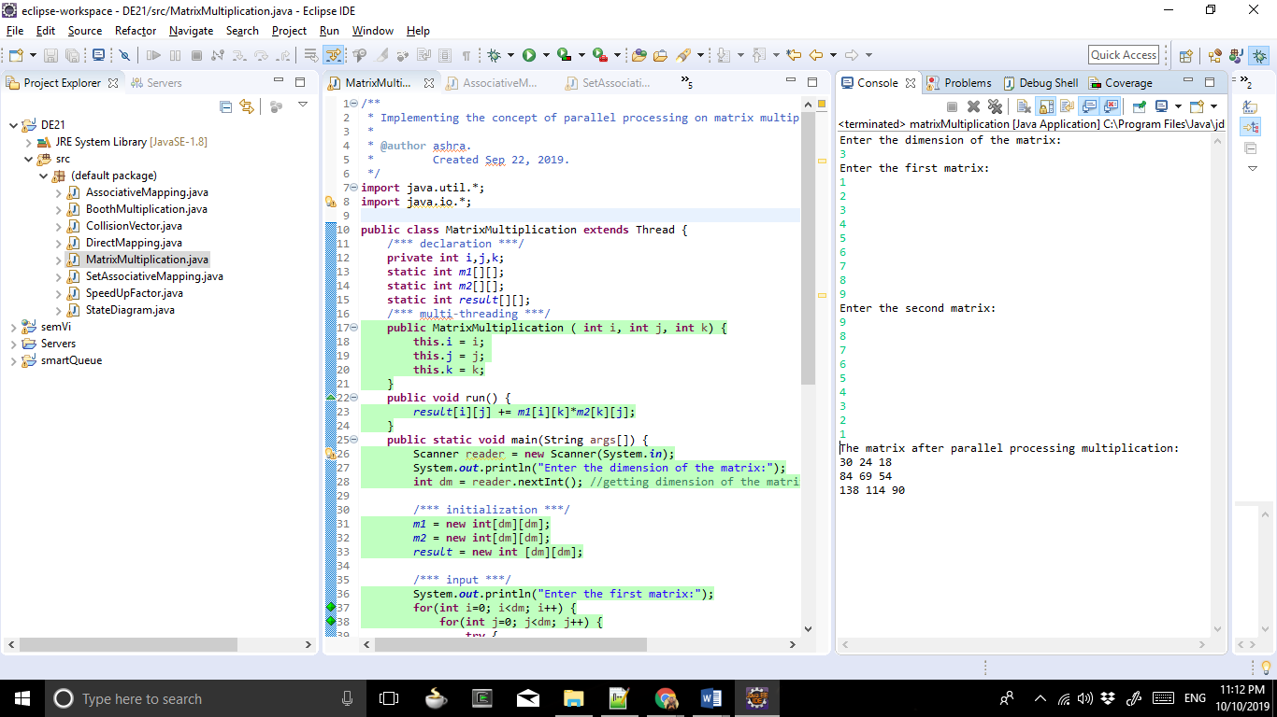

CODE
/**
* Implementing the concept of parallel processing on matrix multiplication 4x4
*
* @author ashra.
* Created Sep 22, 2019.
*/
import java.util.*;
import java.io.*;

public class MatrixMultiplication extends Thread {
/*** declaration ***/
private int i,j,k;
static int m1[][];
static int m2[][];
static int result[][];
/*** multi-threading ***/
public MatrixMultiplication ( int i, int j, int k) {
this.i = i;
this.j = j;
this.k = k;
}
public void run() {
result[i][j] += m1[i][k]*m2[k][j];
}
public static void main(String args[]) {
Scanner reader = new Scanner(System.in);
System.out.println("Enter the dimension of the matrix:");
int dm = reader.nextInt(); //getting dimension of the matrix

/*** initialization ***/
m1 = new int[dm][dm];
m2 = new int[dm][dm];
result = new int [dm][dm];

/*** input ***/
System.out.println("Enter the first matrix:");
for(int i=0; i<dm; i++) {
for(int j=0; j<dm; j++) {
try {
m1[i][j]=reader.nextInt();
}catch(Exception e) {}
}
}
System.out.println("Enter the second matrix:");
for(int i=0; i<dm; i++) {
for(int j=0; j<dm; j++) {
try {
m2[i][j]=reader.nextInt();
}catch(Exception e) {}
}
}

/*** matrix multiplication ***/
for(int i=0; i<dm; i++) {
for(int j=0; j<dm; j++) {
for (int k=0; k<dm; k++) {
try {
new MatrixMultiplication(i, j, k).start(); //formula for multiplying two matrices
}catch(Exception e) {}
}
}
}
/*** Output ***/
System.out.println("The matrix after parallel processing multiplication:");
for(int i=0; i<dm; i++) {
for(int j=0; j<dm; j++)
System.out.print(result[i][j]+" ");
System.out.println();
}
}
}

OUTPUT
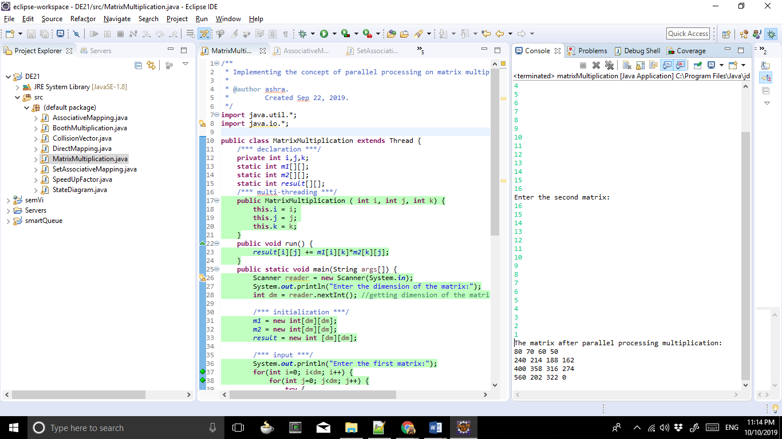

CODE
/**
* Implementing the concept of parallel processing on matrix multiplication 5x5
*
* @author ashra.
* Created Sep 22, 2019.
*/
import java.util.*;
import java.io.*;

public class MatrixMultiplication extends Thread {
/*** declaration ***/
private int i,j,k;
static int m1[][];
static int m2[][];
static int result[][];
/*** multi-threading ***/
public MatrixMultiplication ( int i, int j, int k) {
this.i = i;
this.j = j;
this.k = k;
}
public void run() {
result[i][j] += m1[i][k]*m2[k][j];
}
public static void main(String args[]) {
Scanner reader = new Scanner(System.in);
System.out.println("Enter the dimension of the matrix:");
int dm = reader.nextInt(); //getting dimension of the matrix

/*** initialization ***/
m1 = new int[dm][dm];
m2 = new int[dm][dm];
result = new int [dm][dm];

/*** input ***/
System.out.println("Enter the first matrix:");
for(int i=0; i<dm; i++) {
for(int j=0; j<dm; j++) {
try {
m1[i][j]=reader.nextInt();
}catch(Exception e) {}
}
}
System.out.println("Enter the second matrix:");
for(int i=0; i<dm; i++) {
for(int j=0; j<dm; j++) {
try {
m2[i][j]=reader.nextInt();
}catch(Exception e) {}
}
}

/*** matrix multiplication ***/
for(int i=0; i<dm; i++) {
for(int j=0; j<dm; j++) {
for (int k=0; k<dm; k++) {
try {
new MatrixMultiplication(i, j, k).start(); //formula for multiplying two matrices
}catch(Exception e) {}
}
}
}
/*** Output ***/
System.out.println("The matrix after parallel processing multiplication:");
for(int i=0; i<dm; i++) {
for(int j=0; j<dm; j++)
System.out.print(result[i][j]+" ");
System.out.println();
}
}
}

OUTPUT
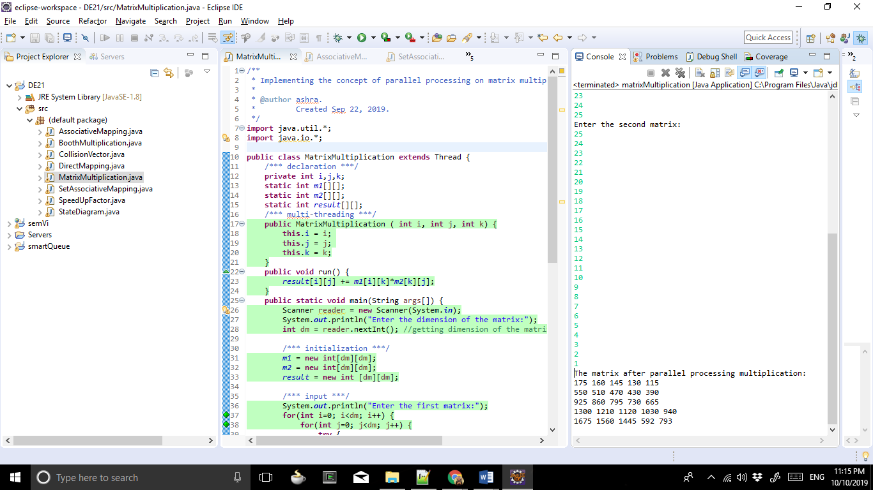

CODE
/**
* Implementing the concept of parallel processing on matrix multiplication on 1000x1000 matrix
*
* @author ashra.
* Created Sep 22, 2019.
*/
import java.util.*;
import java.io.*;

public class MatrixMultiplication extends Thread {
/*** declaration ***/
private int i,j,k;
static int m1[][];
static int m2[][];
static int result[][];
/*** multi-threading ***/
public MatrixMultiplication ( int i, int j, int k) {
this.i = i;
this.j = j;
this.k = k;
}
public void run() {
result[i][j] += m1[i][k]*m2[k][j];
}
public static void main(String args[]) {
long start = System.currentTimeMillis(); //timestamp before execution
Scanner reader = new Scanner(System.in);
System.out.println("Enter the dimension of the matrix:");
int dm = reader.nextInt(); //getting dimension of the matrix

/*** initialization ***/
m1 = new int[dm][dm];
m2 = new int[dm][dm];
result = new int [dm][dm];
int max = 10;
int min = 1;
int range = max - min + 1;

/*** input ***/
//System.out.println("First matrix:");
for(int i=0; i<dm; i++) {
for(int j=0; j<dm; j++) {
try {
m1[i][j]=(int)(Math.random()*range)+min;
}catch(Exception e) {}
}
}
//System.out.println("Second matrix:");
for(int i=0; i<dm; i++) {
for(int j=0; j<dm; j++) {
try {
m2[i][j]=(int)(Math.random()*range)+min;
}catch(Exception e) {}
}
}
//the output matrix 1
System.out.println("Matrix 1:");
for(int i=0; i<dm; i++) {
for(int j=0; j<dm; j++)
System.out.print(m1[i][j]+" ");
System.out.println();
}
//the output matrix 2
System.out.println("Matrix 2:");
for(int i=0; i<dm; i++) {
for(int j=0; j<dm; j++)
System.out.print(m2[i][j]+" ");
System.out.println();
}

/*** matrix multiplication ***/
for(int i=0; i<dm; i++) {
for(int j=0; j<dm; j++) {
for (int k=0; k<dm; k++) {
try {
new MatrixMultiplication(i, j, k).start(); //formula for multiplying two matrices
Thread.sleep(120);
}catch(Exception e) {}
}
}
}
/*** Output ***/
System.out.println("The matrix after parallel processing multiplication:");
for(int i=0; i<dm; i++) {
for(int j=0; j<dm; j++)
System.out.print(result[i][j]+" ");
System.out.println();
}
long end = System.currentTimeMillis(); //timestamp after execution
float sec = (end - start) / 1000F;
System.out.println(sec + " seconds");
}
}

OUTPUT
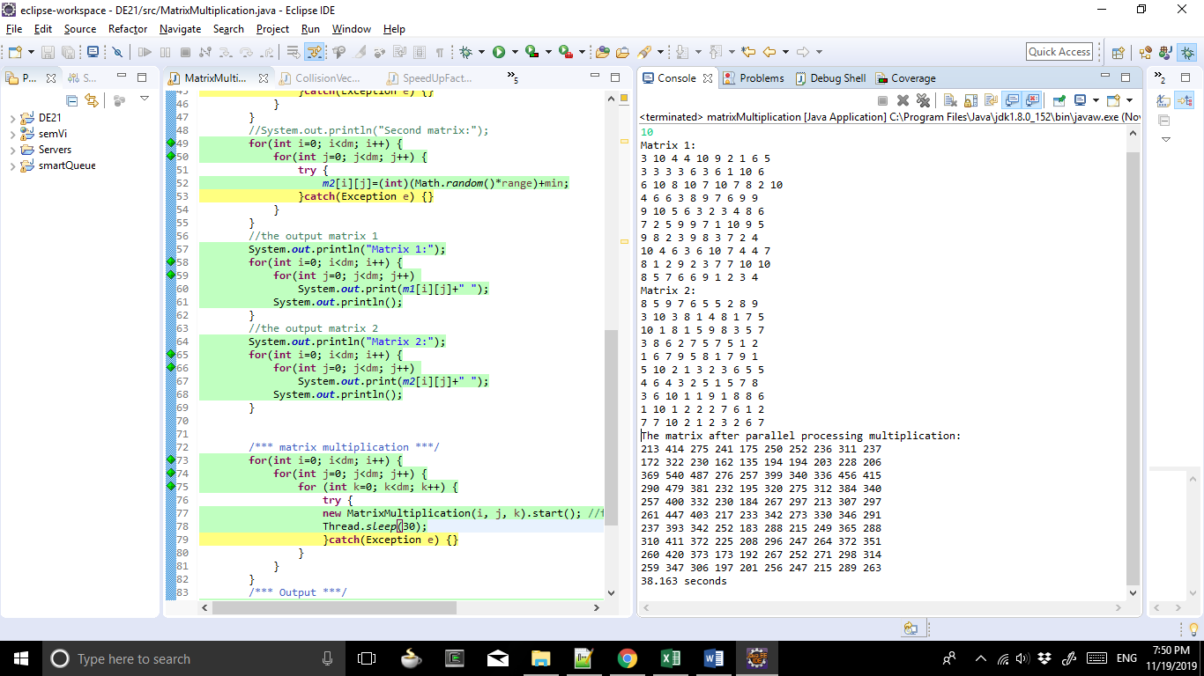

CODE
/**
* Implementing the concept of booth multiplication
*
* @author ashra.
* Created Sep 22, 2019.
*/

import java.util.*;

public class BoothMultiplication {
/*** multiplication function ***/
public int multiply(int n1, int n2) {
int m[] = binary(n1);
int m1[] = binary(-n1);
int r[] = binary(n2);
int A[] = new int[9];
int S[] = new int[9];
int P[] = new int[9];
for (int i=0; i<4; i++) {
A[i] = m[i];
S[i] = m1[i];
P[i + 4] = r[i];
}
display(A, 'A');
display(S, 'S');
display(P, 'P');
System.out.println();

for (int i=0; i<4; i++) {
if(P[7]==0 && P[8]==0);
// do nothing
else if(P[7]==1 && P[8]==0)
add(P, S);
else if(P[7]==0 && P[8]==1)
add(P, A);
else if(P[7]==1 && P[8]==1);
// do nothing

rightShift(P);
display(P, 'P');
}
return getDecimal(P);
}
/*** decimal equivalent of P ***/
public int getDecimal(int[] B) {
int p = 0;
int t = 1;
for(int i=7; i>=0; i--, t*=2)
p += (B[i] * t);
if(p>64)
p = -(256-p);
return p;
}
/*** right shift array function ***/
public void rightShift(int[] A) {
for(int i=8; i>=1; i--)
A[i] = A[i - 1];
}
/*** adding two binary arrays ***/
public void add(int[] A, int[] B) {
int carry = 0;
for(int i=8; i>=0; i--) {
int temp = A[i]+B[i]+carry;
A[i] = temp%2;
carry = temp/2;
}
}
/*** binary of a number ***/
public int[] binary(int n) {
int bin[] = new int[4];
int ctr = 3;
int num = n;
/*** for negative numbers 2's complement ***/
if(n<0)
num = 16+n;
while(num!=0) {
bin[ctr--] = num%2;
num/=2;
}
return bin;
}
/*** Function to print array ***/
public void display(int[] P, char ch) {
System.out.print("\n"+ ch +" : ");
for(int i=0; i<P.length; i++) {
if(i==4)
System.out.print(" ");
if(i==8)
System.out.print(" ");
System.out.print(P[i]);
}
}
public static void main (String[] args) {
Scanner reader = new Scanner(System.in);
System.out.println("Booth Algorithm Test\n");
/** Make an object of Booth class **/
BoothMultiplication b = new BoothMultiplication();

/** Accept two integers **/
System.out.println("Enter two integer numbers\n");
int n1 = reader.nextInt();
int n2 = reader.nextInt();
int result = b.multiply(n1, n2);
System.out.println("\n\nResult : "+ n1 +" * "+ n2 +" = "+ result);
}
}

OUTPUT
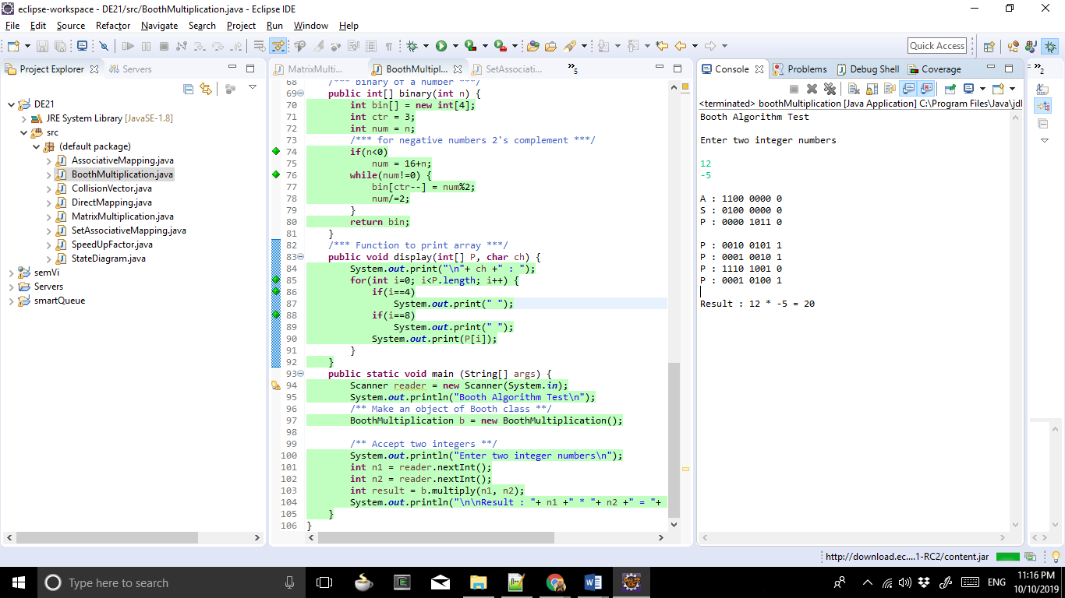

CODE
/**
* Implementing the concept of collision vector
*
* @author ashra.
* Created Sep 26, 2019.
*/
import java.util.*;

public class CollisionVector {
public static void main(String args[]) {
Scanner reader = new Scanner(System.in);
System.out.println("Enter the number of columns in the reservation table:");
int n = reader.nextInt(); // getting number of columns in the reservation table
System.out.println("Enter the forbidden latencies:");
long fl = reader.nextLong(); // getting the forbidden latencies
getCollisionVector(n, fl);
}
public static void getCollisionVector(int n, Long fl) {
int C[] = new int [n-1]; // defining the length of the collision vector
int rC[] = new int [n-1]; //reverse array for calculation
int flLength = String.valueOf(fl).length();
/*** Checking for the final collision vector ***/
if(flLength <= C.length) {
while(fl != 0) {
if((fl%10) != 0)
C[((int)(fl%10))-1] = 1;
fl/=10;
}
}
else
System.out.println("Error! The number of forbidden latencies are more than the column length!");

System.out.print("\nCollision Vector: ");
for(int i=(C.length-1); i>=0; i--)
rC[(C.length-1)-i] = C[i];

System.out.println(Arrays.toString(rC));
}
}

OUTPUT
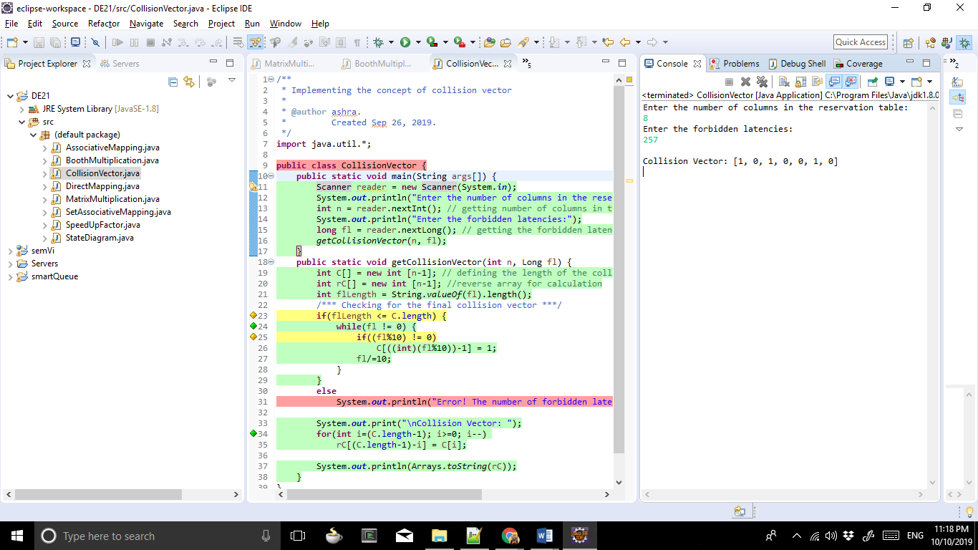

CODE
/**
* Implementing the concept of state diagram
*
* @author ashra.
* Created Sep 26, 2019.
*/
import java.util.*;

public class StateDiagram {
public static void main(String args[]) {
Scanner reader = new Scanner(System.in);
System.out.println("Enter the number of columns in the reservation table:");
int n = reader.nextInt(); // getting number of columns in the reservation table
System.out.println("Enter the forbidden latencies:");
long fl = reader.nextLong(); // getting the forbidden latencies
getCollisionVector(n, fl);
}
public static void getCollisionVector(int n, Long fl) {
int C[] = new int [n-1]; // defining the length of the collision vector
int rC[] = new int [n-1]; //reverse array for calculation
int flLength = String.valueOf(fl).length();
/*** Checking for the final collision vector ***/
if(flLength <= C.length) {
while(fl != 0) {
if((fl%10) != 0)
C[((int)(fl%10))-1] = 1;
fl/=10;
}
}
else
System.out.println("Error! The number of forbidden latencies are more than the column length!");

System.out.print("\nCollision Vector: ");
for(int i=(C.length-1); i>=0; i--)
rC[(C.length-1)-i] = C[i];

System.out.println(Arrays.toString(rC));
/*** Checking for the state diagram ***/
Arrays.setAll(C, i -> 0);
/*** Performing the right shift on CV ***/
System.out.print("\nCV 1-bit right shifted: ");
for(int i=0; i<C.length; i++) {
if(i==(C.length-1))
C[i] = rC[0];
else
C[i] = rC[i+1];
}
System.out.println(Arrays.toString(C));
int sd[] = new int [n-1];
System.out.print("\nState Diagram: ");
for(int i=0; i<sd.length; i++) {
if(C[i]==1 || rC[i]==1) //condition for getting the state diagram
sd[i] = 1;
}
System.out.println(Arrays.toString(sd));
}
}

OUTPUT
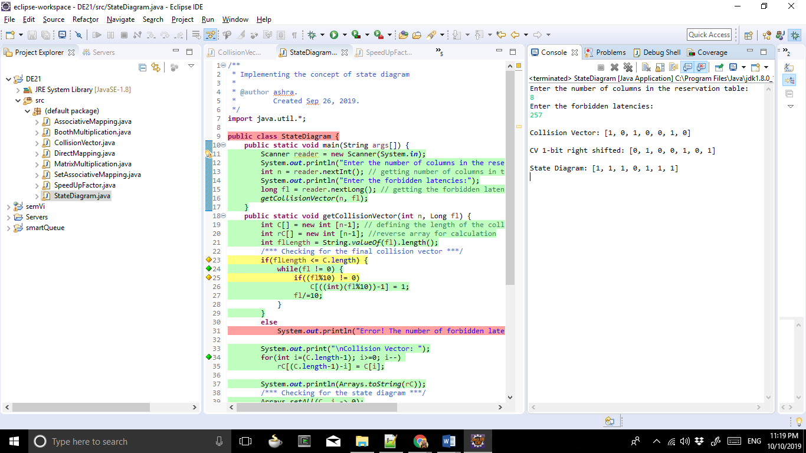

CODE
/**
* Implementing the concept of speed-up factor
*
* @author ashra.
* Created Oct 2, 2019.
*/
import java.util.*;

public class SpeedUpFactor {
public static void main(String args[]) {
Scanner reader = new Scanner(System.in);
System.out.println("Enter the number of tasks:"); //number of tasks to be operated upon
int task = reader.nextInt();
System.out.println("Enter the number of pipeline stages:"); //number of pipline sstages
int stages = reader.nextInt();
System.out.println("Enter the time required for completing a single task in seconds:"); //get the time
double time = reader.nextDouble();
System.out.println("Execution time for non-pipeline system: "+task*stages*time+" sec.");
System.out.println("Execution time for pipeline system: "+(task+stages-1)*time+" sec.");
double speedup = (task*stages*time)/((task+stages-1)*time);
System.out.println("Speedup factor: "+speedup);
}
}
OUTPUT
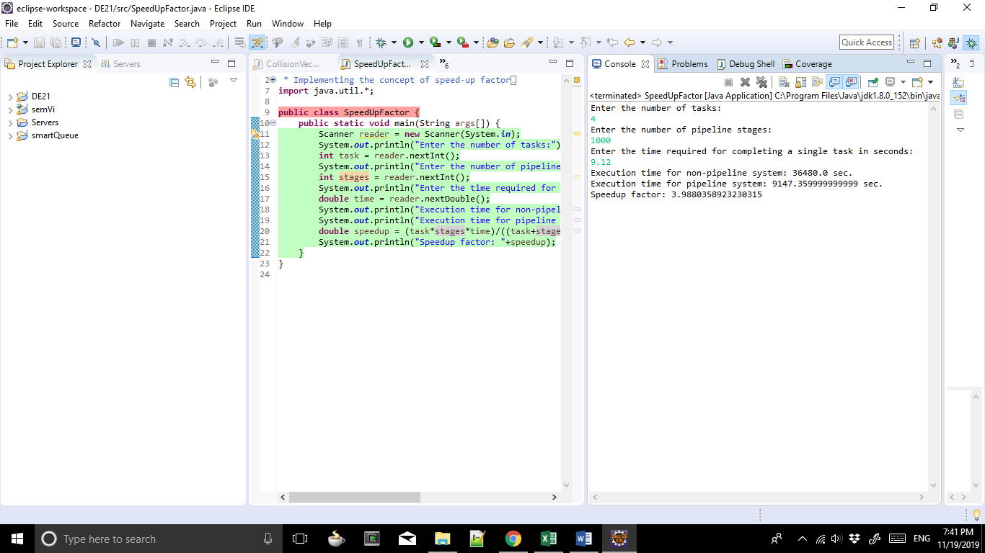

CODE
/**
* Implementing the concept of direct mapping
*
* @author ashra.
* Created Oct 10, 2019.
*/
import java.util.*;
import java.math.*;

public class DirectMapping {
public static void main(String args[]) {
Scanner reader = new Scanner(System.in);
System.out.println("Enter the Total Memory Size in bits:");
int tM = reader.nextInt(); // getting size of Main memory
System.out.println("Enter the number of blocks:");
int nB = reader.nextInt(); // getting the number of blocks in the cache memory
getAssociativeMappedValue(tM, nB);
}
public static void getAssociativeMappedValue(int tM, int nB) {
int block = (int)(Math.log(nB)/Math.log(2));
int index = (int)(Math.log(block)/Math.log(2));
int tag = tM - (block+index);
System.out.println("Word: "+block+"\nIndex: "+index +"\nTag: "+tag);
}
}

OUTPUT
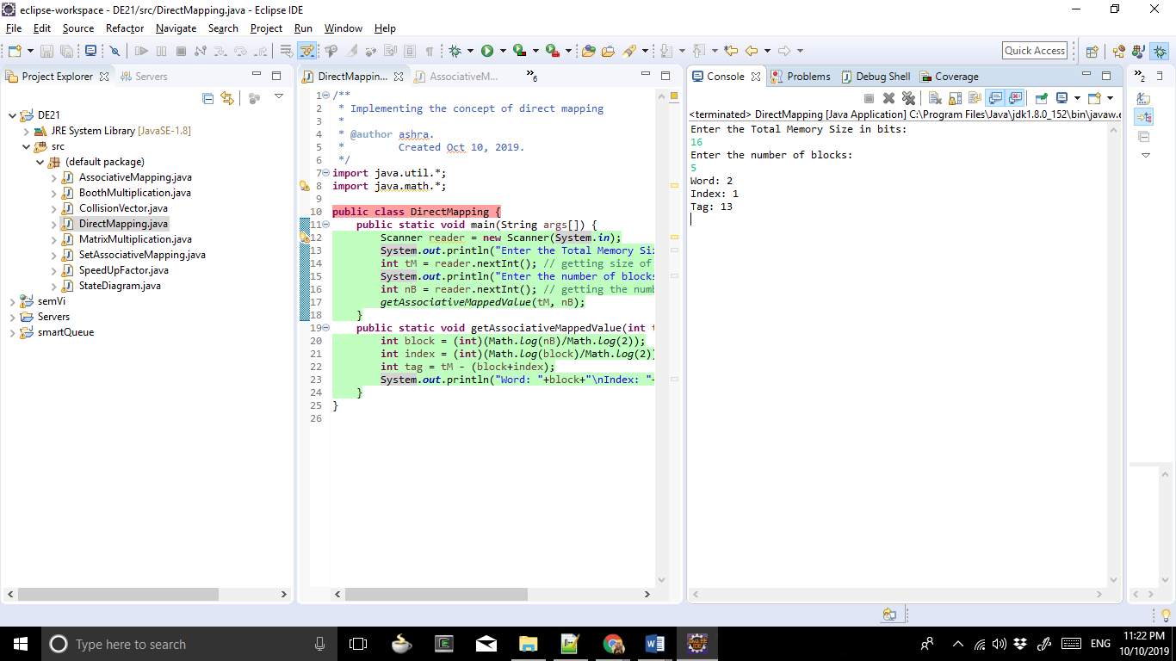

CODE
/**
* Implementing the concept of associative mapping
*
* @author ashra.
* Created Oct 10, 2019.
*/
import java.util.*;
import java.math.*;

public class AssociativeMapping {
public static void main(String args[]) {
Scanner reader = new Scanner(System.in);
System.out.println("Enter the Total Memory Size in bits");
int tM = reader.nextInt(); // getting size of Main memory
System.out.println("Enter the number of blocks:");
int nB = reader.nextInt(); // getting the number of blocks in the cache memory
getAssociativeMappedValue(tM, nB);
}
public static void getAssociativeMappedValue(int tM, int nB) {
int block = (int)(Math.log(nB)/Math.log(2));
int tag = tM - block;
System.out.println("Word: "+block+"\nTag: "+tag);
}
}

OUTPUT
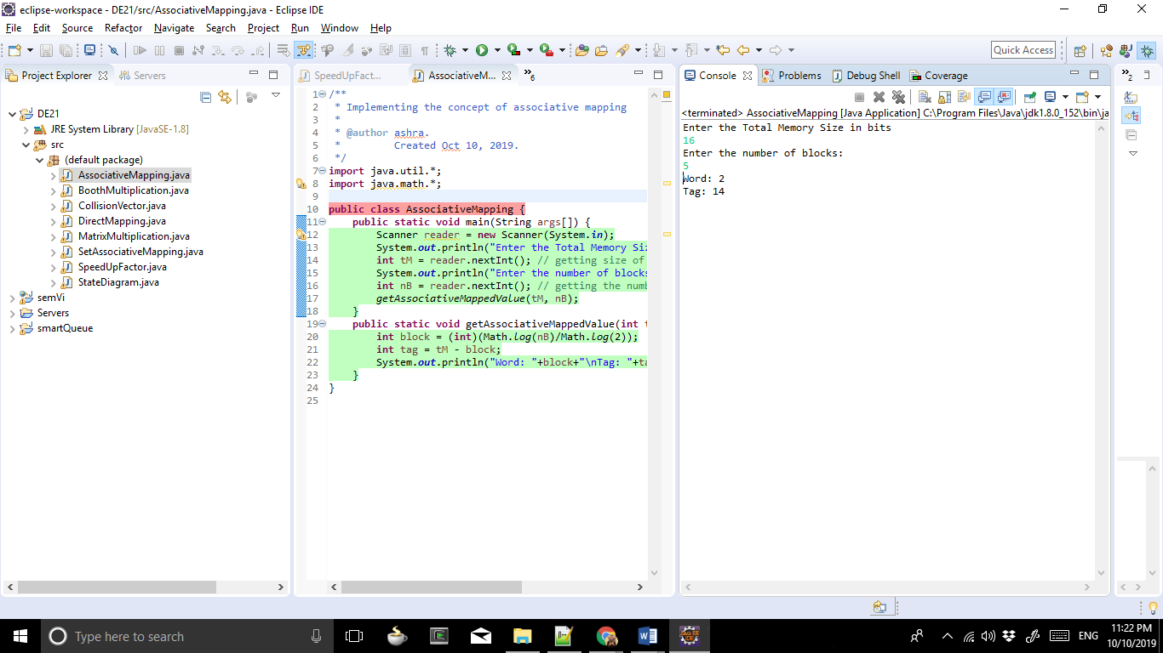

CODE
/**
* Implementing the concept of set associative mapping
*
* @author ashra.
* Created Oct 10, 2019.
*/
import java.util.*;
import java.math.*;

public class SetAssociativeMapping {
public static void main(String args[]) {
Scanner reader = new Scanner(System.in);
System.out.println("Enter the Total Memory Size in bits:");
int tM = reader.nextInt(); // getting size of Main memory
System.out.println("Enter the number of blocks:");
int nB = reader.nextInt(); // getting the number of blocks in the cache memory
System.out.println("Enter the number of sets in cache memory:");
int nSC = reader.nextInt(); // getting the number of sets in cache
getAssociativeMappedValue(tM, nB, nSC);
}
public static void getAssociativeMappedValue(int tM, int nB, int nSC) {
int block = (int)(Math.log(nB)/Math.log(2));
int set = (int)(Math.log(nSC)/Math.log(2));
int tag = tM - (block+set);
System.out.println("Word: "+block+"\nSet: "+set+"\nTag: "+tag);
}
}

OUTPUT
