ADVANCED DATABASE MANAGEMENT SYSTEM LAB FILE

[BTCSE 803]

Submitted by

MOHD SHAHIQUE QAMAR SIDDIQI, 2016-310-060
in partial fulfillment for the award of the degree of

BACHELOR OF TECHNOLOGY (COMPUTER SCIENCE AND ENGINEERING)

Under the supervision of
Dr. SHERIN ZAFAR and Dr. MOHD ABDUL AHAD


(Copy from www.jamiahamdard.ac.in)

Department of Computer Science & Engineering
School of Engineering Sciences & Technology

JAMIA HAMDARD

New Delhi-110062

(2020)
INDEX
S.No | Assignment | Date | Signature
1. | Create a row trigger to insert existing values of student table into a new table when the student table is updated. | 4/10/2020
2. | Create a trigger such that after deleting any row, the message “you deleted a row” should be printed. | 4/10/2020
3. | Consider a student Marks table with attributes(Roll_no,Name,Sub1,Sub2,totalPercent , division).Create a trigger such that before inserting a new row in a table, the system calculates the total percentage and division for that student. | 4/10/2020
4. | Create a cursor named as Student_record. Declare that cursor for the select query. Open the cursor and fetch the cursor to the record. Display the roll no. and name of the student in Student_record. | 4/10/2020
5. | Write a trigger to ensure that no employee of age<25 can be inserted in Database. | 4/10/2020
6. | Update the salary of certain employees and using implicit cursor, display if there was an update or not. | 4/10/2020
7. | Create a trigger which will work before deletion in an Emp table and create a duplicate copy of the record in another table Employee_backup. | 4/10/2020
8. | Create a trigger to count number of new tuples inserted before using each insert statement. | 4/10/2020
9. | Declare, define and invoke a simple PL /SQL code to reverse a number. | 4/10/2020
10. | Declare, define and invoke a simple PL /SQL code to find the factorial of a number. | 4/10/2020
11. | Declare, define and invoke a simple PL /SQL code to find the square root of a number. | 4/10/2020
12. | Code for implementation of Conflict Serializability. | 4/15/2020
13. | Code for implementation of View Serializability. | 4/15/2020

Solution:
Ques.1) Create a row trigger to insert existing values of student table into a new table when the student table is updated.
Ans. 1)
CREATE OR REPLACE TRIGGER TRG_STUDENT
BEFORE UPDATE
ON STUDENT
FOR EACH ROW
BEGIN
INSERT INTO STUDENT_BACKUP(ID, NAME, AGE, ADDRESS, OPERATIONS) VALUES(:NEW.ID, :NEW.NAME, :NEW.AGE, :NEW.ADDRESS, 'UPDATE');
END;
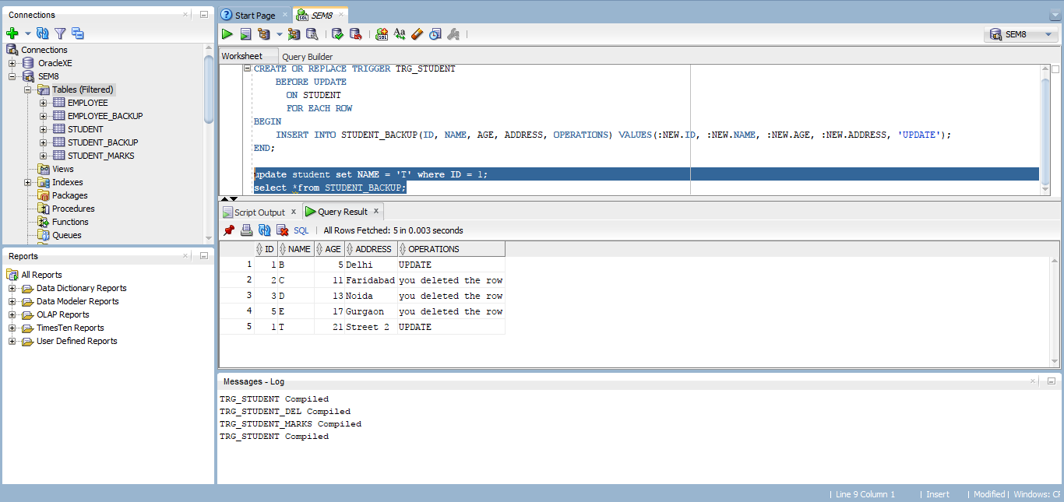

Ques. 2) Create a trigger such that after deleting any row, the message “you deleted a row” should be printed.
Ans. 2)
CREATE OR REPLACE TRIGGER TRG_STUDENT_DEL
AFTER DELETE
ON STUDENT
FOR EACH ROW
BEGIN
SYS.DBMS_OUTPUT.PUT_LINE('YOU DELETED A ROW');
INSERT INTO STUDENT_BACKUP(ID, NAME, AGE, ADDRESS, OPERATIONS) VALUES(:OLD.ID, :OLD.NAME, :OLD.AGE, :OLD.ADDRESS, 'YOU DELETED THE ROW');
END;
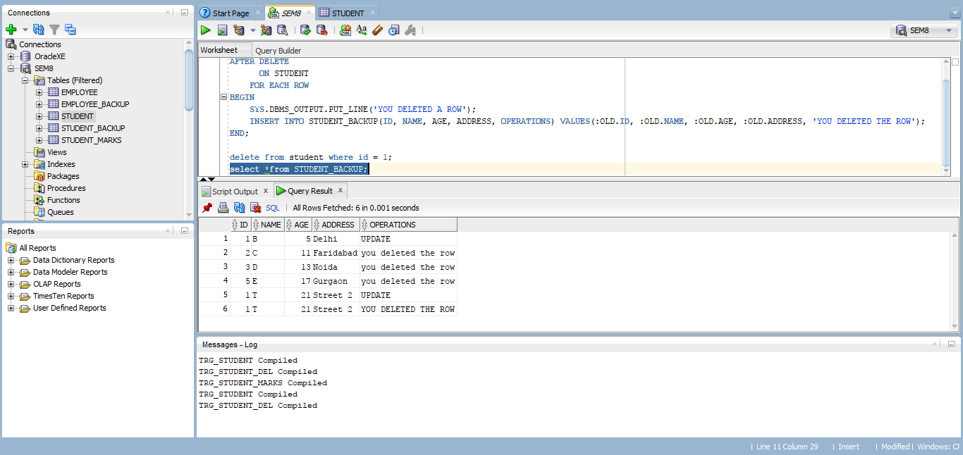

Ques. 3) Consider a student Marks table with attributes(Roll_no,Name,Sub1,Sub2,totalPercent , division).Create a trigger such that before inserting a new row in a table, the system calculates the total percentage and division for that student.
Ans. 3)
CREATE OR REPLACE TRIGGER TRG_STUDENT_MARKS
BEFORE INSERT OR UPDATE
ON STUDENT_MARKS
FOR EACH ROW
BEGIN
:NEW.TOTAL_PERCENT := ((:NEW.SUB1 + :NEW.SUB2)/2);
IF :NEW.TOTAL_PERCENT >= 60 THEN
:NEW.DIVISION := 'A';
ELSIF :NEW.TOTAL_PERCENT >= 45 AND :NEW.TOTAL_PERCENT < 60 THEN
:NEW.DIVISION := 'B';
ELSIF :NEW.TOTAL_PERCENT >= 33 AND :NEW.TOTAL_PERCENT < 45 THEN
:NEW.DIVISION := 'C';
ELSE
:NEW.DIVISION := 'F';
END IF;
END;
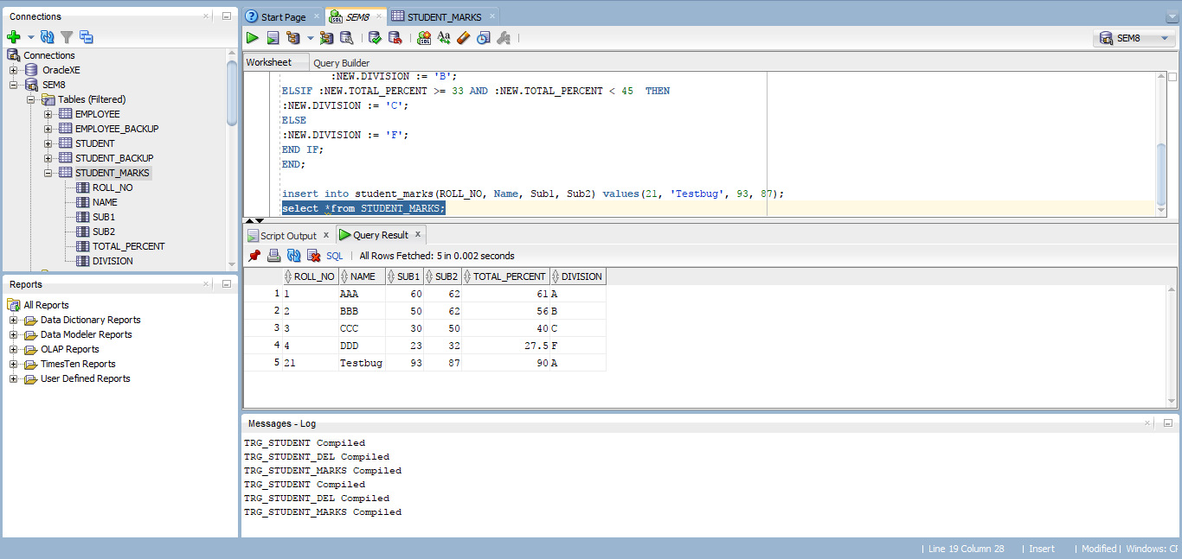
Ques. 4) Create a cursor named as Student_record. Declare that cursor for the select query. Open the cursor and fetch the cursor to the record. Display the roll no. and name of the student in Student_record.
Ans. 4)
SET SERVEROUTPUT ON;
DECLARE
ROLL_NO NUMBER;
NAME VARCHAR2(200);
CURSOR STUDENT_RECORDS IS SELECT * FROM STUDENT;
BEGIN
FOR STUDENT_RECORD IN STUDENT_RECORDS
LOOP
ROLL_NO:= STUDENT_RECORD.ID;
NAME:= STUDENT_RECORD.NAME;
SYS.DBMS_OUTPUT.PUT_LINE('ROLL NO.' || ROLL_NO || ' NAME ' || NAME);
END LOOP;
END;
/
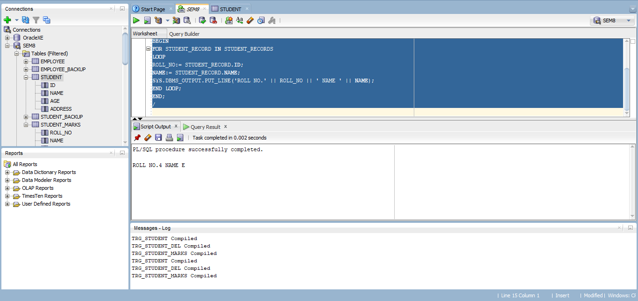
Ques. 5) Write a trigger to ensure that no employee of age<25 can be inserted in Database.
Ans. 5)
CREATE OR REPLACE TRIGGER TRG_EMPLOYEE
BEFORE INSERT OR UPDATE ON EMPLOYEE
FOR EACH ROW
BEGIN
IF :NEW.AGE < 25 THEN
RAISE_APPLICATION_ERROR(-20000, 'EMPLOYEE BELOW AGE 25 IS NOT ELIGIBLE.');
END IF;
END;
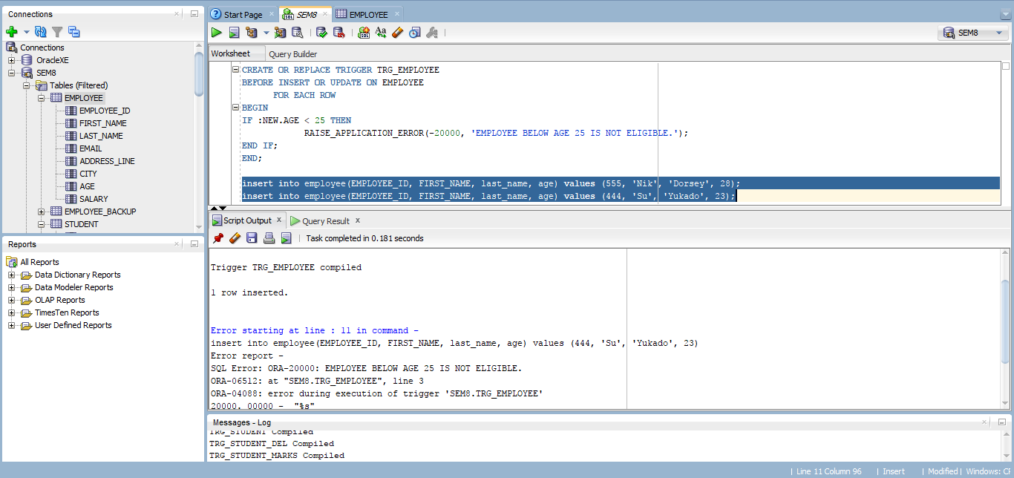

Ques. 6) Update the salary of certain employees and using implicit cursor, display if there was an update or not.
Ans. 6)
DECLARE
TOTAL_ROWS NUMBER(2);
BEGIN
UPDATE EMPLOYEE
SET SALARY = SALARY + 500 WHERE AGE > 30;
IF SQL%NOTFOUND THEN
DBMS_OUTPUT.PUT_LINE('NO EMPLOYEE SELECTED');
ELSIF SQL%FOUND THEN
TOTAL_ROWS := SQL%ROWCOUNT;
DBMS_OUTPUT.PUT_LINE( TOTAL_ROWS || ' EMPLOYEE SELECTED ');
END IF;
END;
/
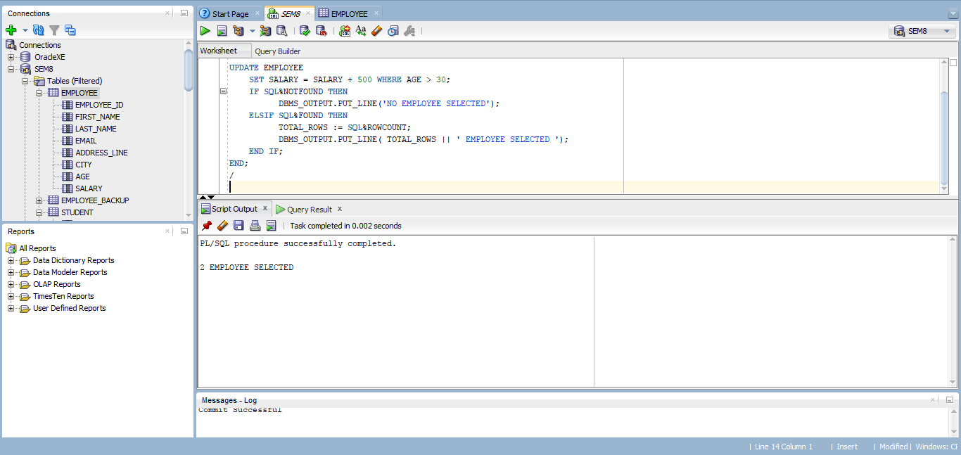

Ques. 7) Create a trigger which will work before deletion in an Emp table and create a duplicate copy of the record in another table Employee_backup.
Ans. 7)
CREATE OR REPLACE TRIGGER TRG_EMPLOYEE_DEL
BEFORE DELETE ON EMPLOYEE
FOR EACH ROW
BEGIN
INSERT INTO EMPLOYEE_BACKUP(EMPLOYEE_ID, FIRST_NAME, LAST_NAME, EMAIL, ADDRESS_LINE, CITY, AGE, OPERATIONS) VALUES(:OLD.EMPLOYEE_ID, :OLD.FIRST_NAME, :OLD.LAST_NAME, :OLD.EMAIL, :OLD.ADDRESS_LINE, :OLD.CITY, :OLD.AGE, 'DELETE');
END;
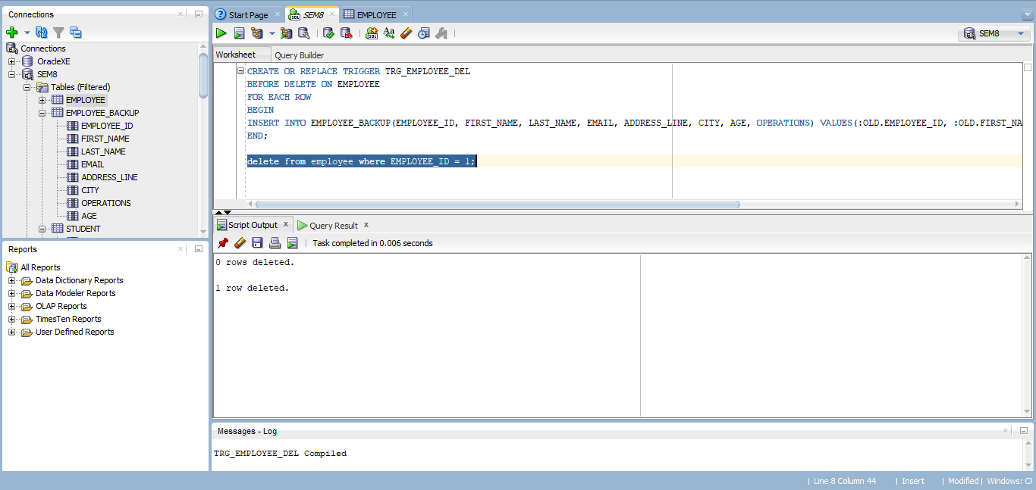

Ques. 8) Create a trigger to count number of new tuples inserted before using each insert statement.
Ans. 8)
CREATE OR REPLACE TRIGGER TRG_EMPLOYEE_CNT
BEFORE INSERT ON EMPLOYEE
FOR EACH ROW
DECLARE
CNT INT;
BEGIN
SELECT COUNT(*) INTO CNT FROM EMPLOYEE;
SYS.DBMS_OUTPUT.PUT (CNT || 'RECORDS PRESENT IN EMPLOYEE TABLE');
END;
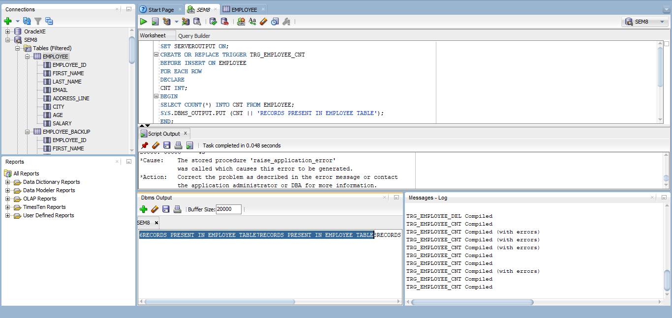
Ques. 9) Declare, define and invoke a simple PL /SQL code to reverse a number.
Ans. 9)
SET SERVEROUTPUT ON;
DECLARE
NUM NUMBER;
REV NUMBER;
BEGIN
NUM :=12345;
REV:=0;
WHILE NUM>0 LOOP
REV:=(REV*10) + MOD(NUM,10);
NUM:=FLOOR(NUM/10);
END LOOP;
DBMS_OUTPUT.PUT_LINE('REVERSED NUMBER IS: ' || REV);
END;
/
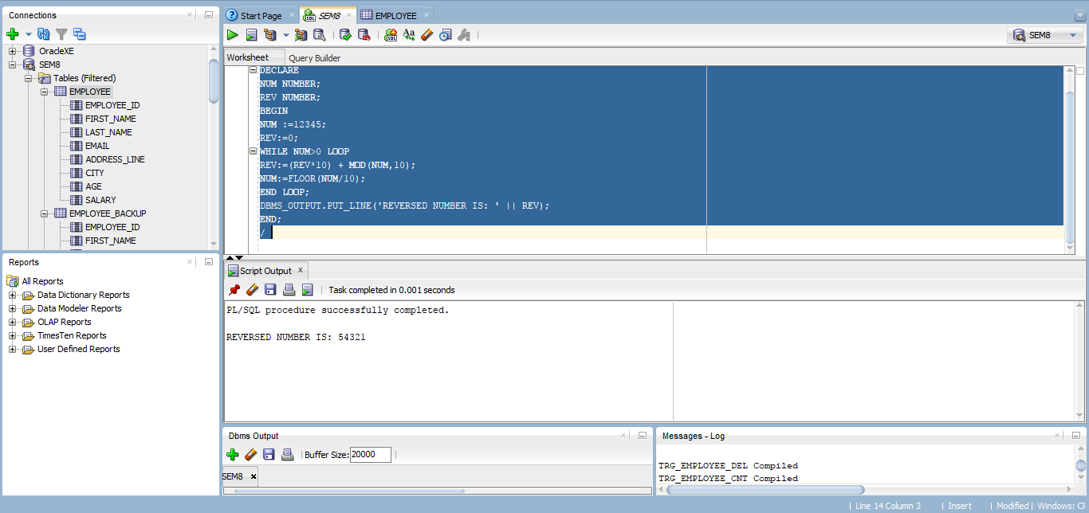
Ques. 10) Declare, define and invoke a simple PL /SQL code to find the factorial of a number.
Ans. 10)
SET SERVEROUTPUT ON;
DECLARE
NUM NUMBER;
FACT NUMBER;
BEGIN
NUM :=5;
FACT :=1;
WHILE NUM>1 LOOP
FACT:= FACT*NUM;
NUM:= NUM-1;
END LOOP;
DBMS_OUTPUT.PUT_LINE('FACTORIAL OF 5 NUMBER IS: ' || FACT);
END;
/
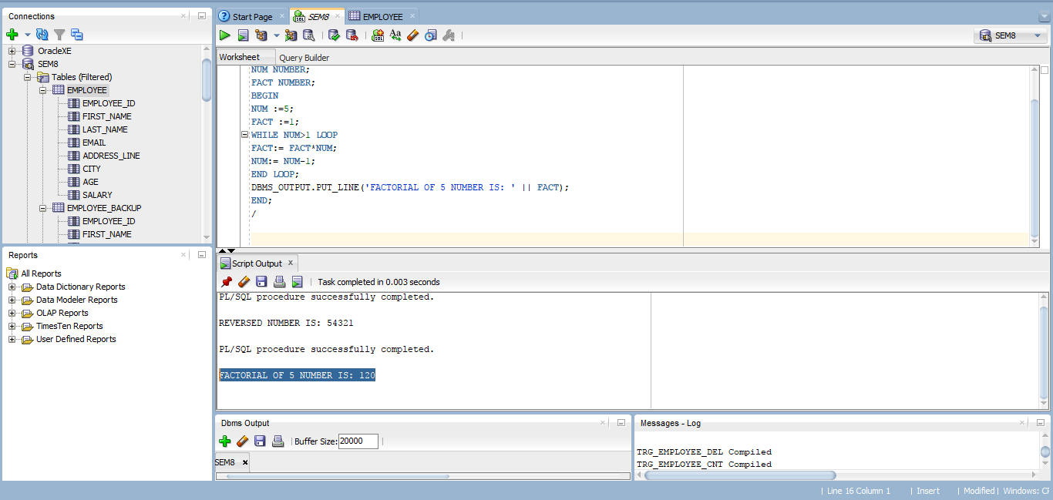

Ques. 11) Declare, define and invoke a simple PL /SQL code to find the square root of a number.
Ans. 11)
SET SERVEROUTPUT ON;
DECLARE
NUM NUMBER;
SROOT NUMBER;
BEGIN
NUM :=2;
SELECT SQRT(NUM) INTO SROOT FROM DUAL;
DBMS_OUTPUT.PUT_LINE('SQUARE ROOT OF 2 NUMBER IS: ' || SROOT);
END;
/
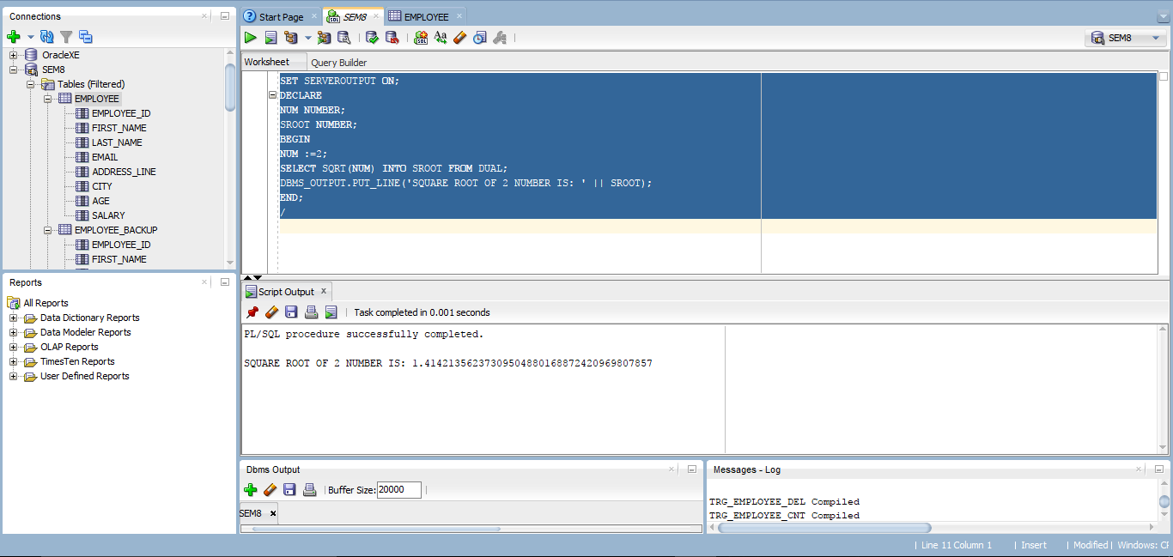

Ques. 12) Code for implementation of Conflict Serializability.
Ans. 12)
/**
* Implementation of conflict serializability
*
* @author ashra.
* Created Apr 15, 2020.
*/
import java.util.ArrayList;
import java.util.LinkedList;
import java.util.List;

public class conflictSerializability {
public static void main(final String[] args) {
final String schedule = "R2(A);W2(A);R3(C);W2(B);W3(A);W3(C);R1(A);R1(B);W1(A);W1(B)";
final boolean result = isConflictSerializable(schedule);
if (result) {
System.out.println("Cycle found in the Precedence Graph.");
System.out.println("Therefore the schedule is not conflict serializable.");
}
else {
System.out.println("Cycle not found in the Precedence Graph.");
System.out.println("Therefore the schedule is conflict serializable.");
}
}
public static boolean isConflictSerializable(final String str) {
final String[] tokenArray = str.split(";");
final Graph graph = new Graph(5);
int i, j, len, source, destination;
char opNum1, operation1, data1;
char opNum2, operation2, data2;
len = tokenArray.length;
System.out.println("Given Schedule : " + str + "\n");
System.out.println("Conflicts And Precedence Graph Edge");
for (i = 0; i < len; i++) {
for (j = i; j < len; j++) {
opNum1 = tokenArray[i].charAt(1);
opNum2 = tokenArray[j].charAt(1);
operation1 = Character.toLowerCase(tokenArray[i].charAt(0));
operation2 = Character.toLowerCase(tokenArray[j].charAt(0));
data1 = tokenArray[i].charAt(3);
data2 = tokenArray[j].charAt(3);
if (opNum1 != opNum2 && data1 == data2 && (operation1 == 'w' || operation2 == 'w')) {
source = Integer.parseInt(String.valueOf(opNum1));
destination = Integer.parseInt(String.valueOf(opNum2));
graph.addEdge(source, destination);
System.out.print(tokenArray[i] + " " + tokenArray[j] + " ");
System.out.println(opNum1 + " -> " + opNum2);
}
}
}
return graph.isCyclic() ? true : false;
}
}

class Graph {
private final int V;
private final List<List> adj;
public Graph(final int V) {
this.V = V;
adj = new ArrayList<>(V);

for (int i = 0; i < V; i++)
adj.add(new LinkedList());
}
public boolean isCyclicUtil(int i, boolean[] visited, boolean[] recStack) {
if (recStack[i])
return true;
if (visited[i])
return false;
visited[i] = true;
recStack[i] = true;
final List<Integer> children = adj.get(i);
for (final Integer c : children)
if (isCyclicUtil(c, visited, recStack))
return true;
recStack[i] = false;
return false;
}
public void addEdge(final int source, final int dest) {
adj.get(source).add(dest);
}
public boolean isCyclic() {
final boolean[] visited = new boolean[V];
final boolean[] recStack = new boolean[V];
for (int i = 0; i < V; i++)
if (isCyclicUtil(i, visited, recStack)) {
return true;
}
return false;
}
}
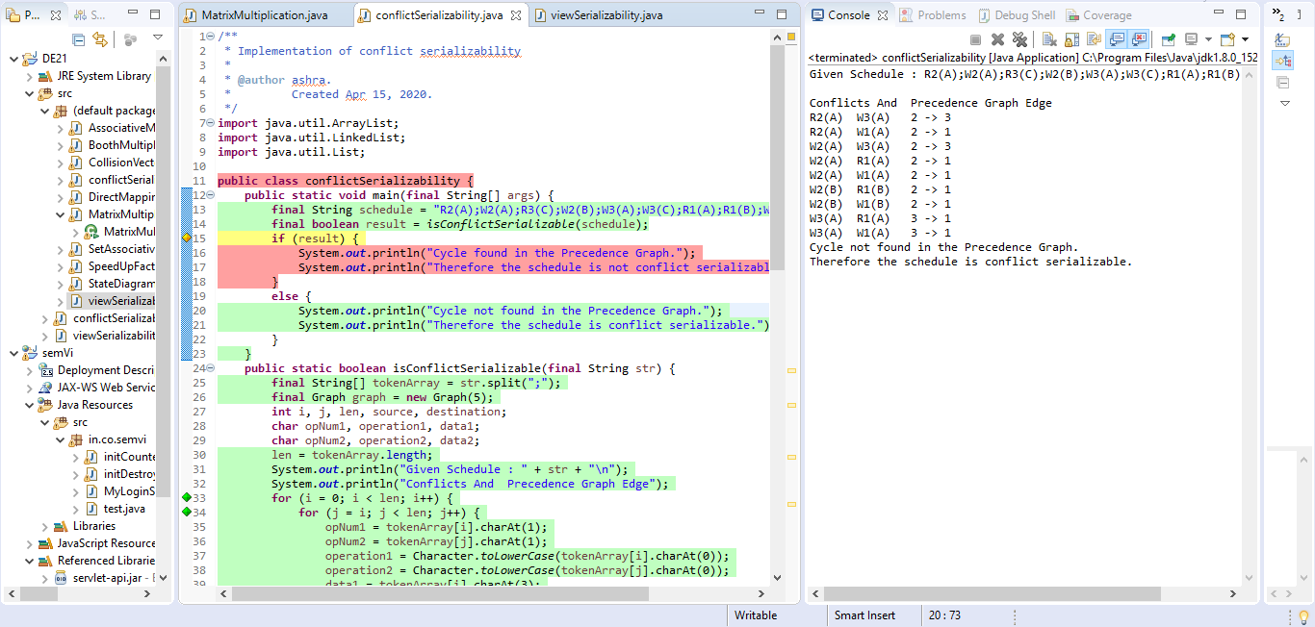

Ques. 13) Code for implementation of View Serializability.
Ans. 13)
/**
* Implementation of view serializability
*
* @author ashra.
* Created Apr 15, 2020.
*/
public class viewSerializability {
public static void main(String[] args) {
String schedule = "R2(C);R2(B);W2(B);R3(B);R3(C);R1(A);W1(A);W3(B);W3(C);R2(A);R1(B);W1(B);W2(A)";
boolean result = isConflictSerializable(schedule);
if (result) {
System.out.println("As the schedule is not conflict serializable.");
System.out.println("Therefore the schedule may/may not be view serializable.");
}
else {
System.out.println("As the schedule is conflict serializable.");
System.out.println("Therefore the schedule is view serializable.");
}
}
public static boolean isConflictSerializable(String str) {
String[] tokenArray = str.split(";");
Graph graph = new Graph(5);
int i, j, len, source, destination;
char opNum1, operation1, data1;
char opNum2, operation2, data2;
len = tokenArray.length;
System.out.println("Given Schedule : " + str + "\n");
System.out.println("Conflicts & Precedence Graph Edge");
for (i = 0; i < len; i++) {
for (j = i; j < len; j++) {
opNum1 = tokenArray[i].charAt(1);
opNum2 = tokenArray[j].charAt(1);
operation1 = Character.toLowerCase(tokenArray[i].charAt(0));
operation2 = Character.toLowerCase(tokenArray[j].charAt(0));
data1 = tokenArray[i].charAt(3);
data2 = tokenArray[j].charAt(3);
if (opNum1 != opNum2 && data1 == data2 && (operation1 == 'w' || operation2 == 'w')) {
source = Integer.parseInt(String.valueOf(opNum1));
destination = Integer.parseInt(String.valueOf(opNum2));
graph.addEdge(source, destination);
System.out.print(tokenArray[i] + " " + tokenArray[j] + " ");
System.out.println(opNum1 + " -> " + opNum2);
}
}
}
return graph.isCyclic() ? true : false;
}
}

