/**
* TO print Fibonacci series upto ‘n’ terms, where ‘n’ is a user input
*
* @author ashra.
* Created Nov 29, 2018.
*/
import java.io.*;
import java.util.*;

public class fibonacciSeries {
public static void main(String args[]) throws IOException {
Scanner reader = new Scanner(System.in);
System.out.println("Enter the number:");
int n = reader.nextInt();
fibonacci(n);
}
public static void fibonacci(int n) {
int a[]= new int[20];
System.out.println("The fibonacci series upto "+n+" terms is:");
a[0]=-1; a[1]=1;
for(int i=2;i<=n+1;i++){
a[i]=a[i-1]+a[i-2];
System.out.print(a[i]+" ");
}
}
}

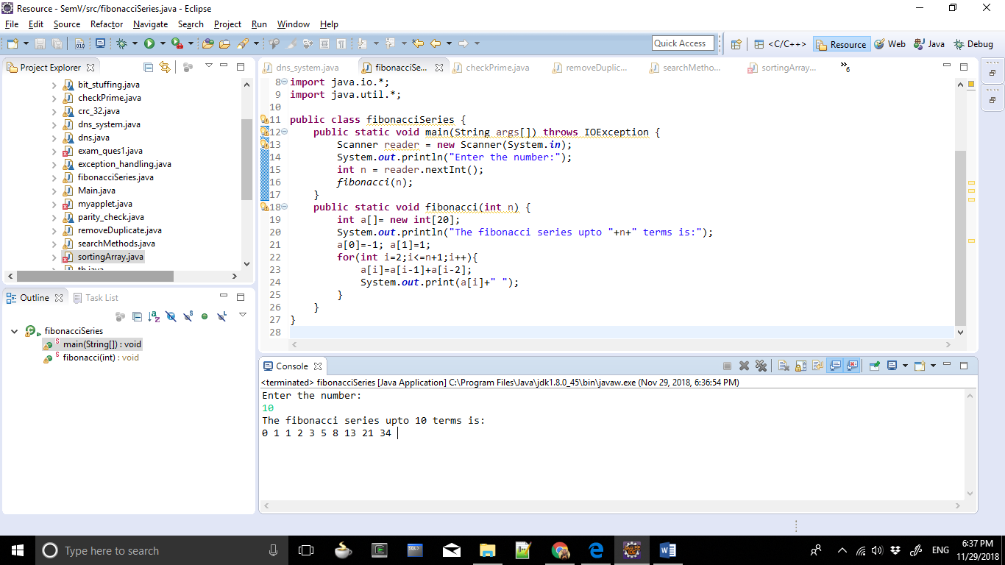

/**
* To check whether the input number is prime or not.
*
* @author ashra.
* Created Nov 29, 2018.
*/
import java.io.*;
import java.util.*;

public class checkPrime {
public static void main(String args[])throws IOException {
Scanner reader = new Scanner(System.in);
System.out.println("Enter the number:");
int n = reader.nextInt();
primeNumber(n);
}
public static void primeNumber(int n) {
boolean flag = true;
for(int i=2;i<=n/2;i++) {
if(n%i==0) {
flag = false;
break;
}
}
if(flag==true)
System.out.println(n+" is a Prime number.");
else
System.out.println(n+" is a Composite number.");
}
}

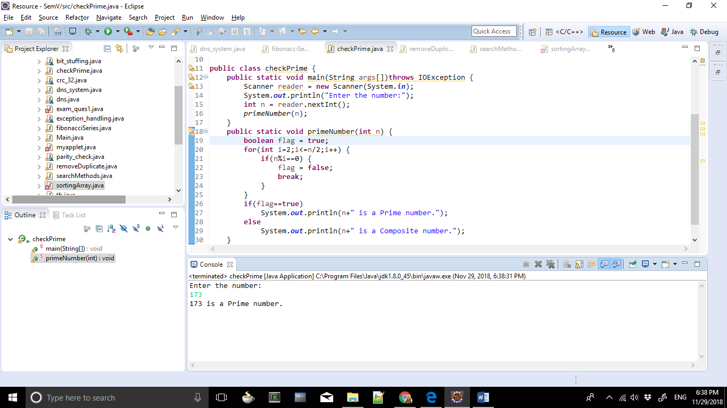

/**
* To remove duplicate elements from the array.
*
* @author ashra.
* Created Nov 29, 2018.
*/
import java.io.*;
import java.util.*;

public class removeDuplicate {
public static void main(String args[])throws IOException {
Scanner reader = new Scanner(System.in);
System.out.println("How many numbers you want to enter?");
int num = reader.nextInt();
int array[] = new int[num];
System.out.println("Enter the "+num+" numbers now...");
for(int i=0;i<array.length;i++) {
array[i] = reader.nextInt();
}
num=checkDuplicate(array, num);
System.out.println("This is the updated array:");
for (int i=0; i<num; i++)
System.out.print(array[i]+" ");
}
public static int checkDuplicate(int arr[], int n) {
if (n==0 || n==1) {
return n;
}
int j = 0;
for (int i=0; i < n-1; i++) {
if (arr[i] != arr[i+1]) {
arr[j++] = arr[i];
}
}
arr[j++] = arr[n-1];
return j;
}
}

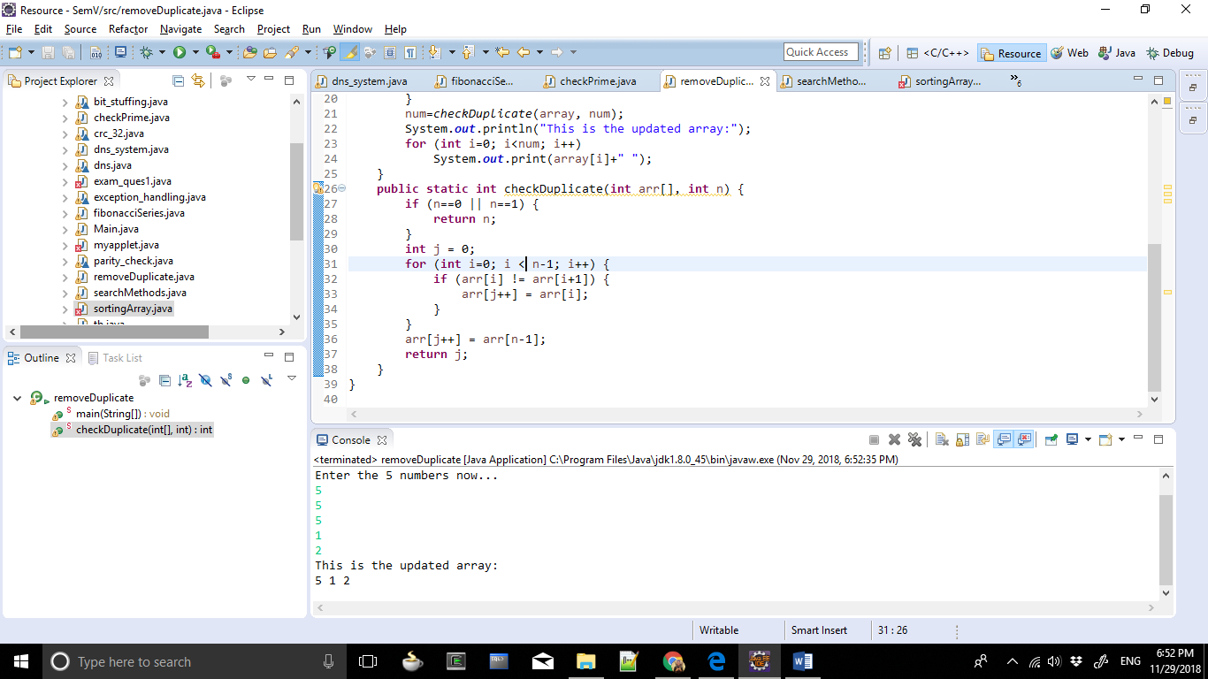

/**
* TODO Put here a description of what this class does.
*
* @author ashra.
* Created Nov 29, 2018.
*/
import java.io.*;
import java.util.*;

public class searchMethods {
public static void main(String args[])throws IOException {
Scanner reader = new Scanner(System.in);
System.out.println("Select, please:\n1 - Binary Search\n2 - Linear Search");
int ch = reader.nextInt();
switch(ch) {
case 1:
System.out.println("How many numbers you want to enter?");
int num = reader.nextInt();
int array[] = new int[num];
System.out.println("Enter the "+num+" numbers now...");
for(int i=0;i<array.length;i++)
array[i] = reader.nextInt();
System.out.println("Enter the number to search:");
int key = reader.nextInt();
binarySearch(array, key);
break;
case 2:
System.out.println("How many numbers you want to enter?");
int num2 = reader.nextInt();
int array2[] = new int[num2];
System.out.println("Enter the "+num2+" numbers now...");
for(int i=0;i<array2.length;i++)
array2[i] = reader.nextInt();
System.out.println("Enter the number to search:");
int key2 = reader.nextInt();
linearSearch(array2, key2);
break;
default:
System.out.println("Invalid Choice!");
}
}
public static void binarySearch(int array[], int key) {
int first = 0, last = array.length-1;
int mid = (first + last)/2;
while( first <= last ) {
if( array[mid] < key )
first = mid + 1;
else if( array[mid] == key ){
System.out.println("After Binary Search Element is found at index: " + mid);
break;
}
else
last = mid - 1;
mid = (first + last)/2;
}
if ( first > last ){
System.out.println("Element is not found!");
}
}
public static void linearSearch(int array[], int key) {
boolean flag = false;
int i;
for(i=0;i<array.length;i++) {
if(array[i] == key) {
flag = true;
break;
}
}
if(flag==true)
System.out.println("After Linear Search Element is found at index: " + i);
else
System.out.println("Element is not found!");
}
}

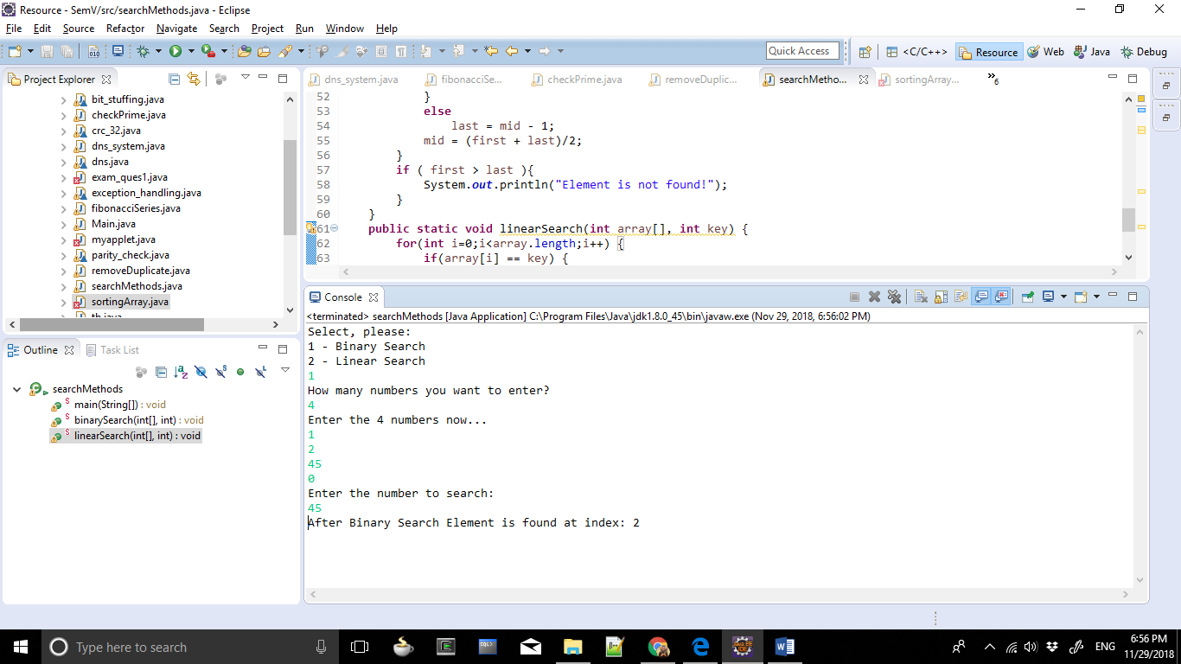
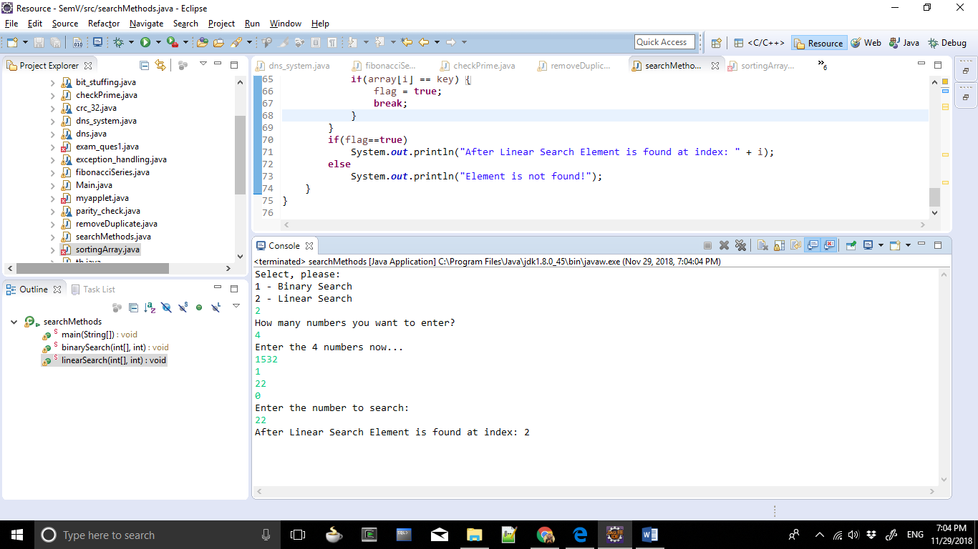

/**
* To sort elements of an array.
*
* @author ashra.
* Created Nov 29, 2018.
*/
import java.io.*;
import java.util.*;

public class sortingArray {
public static void main(String args[]) {
Scanner reader = new Scanner(System.in);
System.out.println("How many numbers you want to enter?");
int num = reader.nextInt();
int array[] = new int[num];
System.out.println("Enter the "+num+" numbers now...");
for(int i=0;i<num;i++)
array[i] = reader.nextInt();
bubbleSort(array);
}
public static void bubbleSort(int array[]) {
for(int i=0;i<array.length;i++) {
for (int j=0;j<array.length-i-1;j++) {
if(array[j]>array[j+1]) {
int temp = array[j];
array[j] = array[j+1];
array[j+1] = temp;
}
}
}
System.out.println("After performing Bubble Sort:");
for(int i=0;i<array.length;i++)
System.out.print(array[i]+" ");
}
}

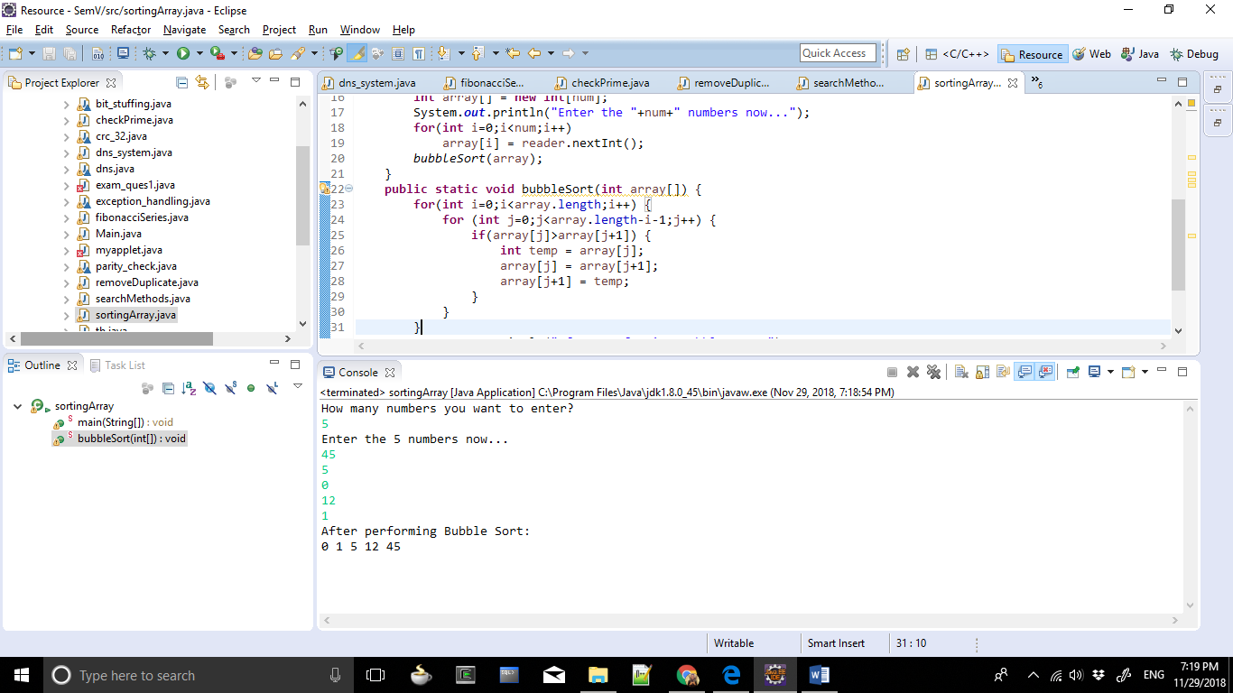

/**
* To add two 3x3 matrices.
*
* @author ashra.
* Created Nov 29, 2018.
*/
import java.io.*;
import java.util.*;

public class sumMatrices {
public static void main(String args[]) throws IOException {
Scanner reader = new Scanner(System.in);
int m1[][] = new int[3][3];
int m2[][] = new int[3][3];
int sum[][] = new int[3][3];
int i,j;
System.out.println("Enter the first matrix:");
for(i=0;i<=2;i++)
for(j=0;j<=2;j++)
m1[i][j]=reader.nextInt();
System.out.println("Enter the second matrix:");
for(i=0;i<=2;i++)
for(j=0;j<=2;j++)
m2[i][j]=reader.nextInt();
for(i=0;i<=2;i++) {
for(j=0;j<=2;j++)
System.out.print(m1[i][j]+m2[i][j]+" ");
System.out.println();
}
}
}

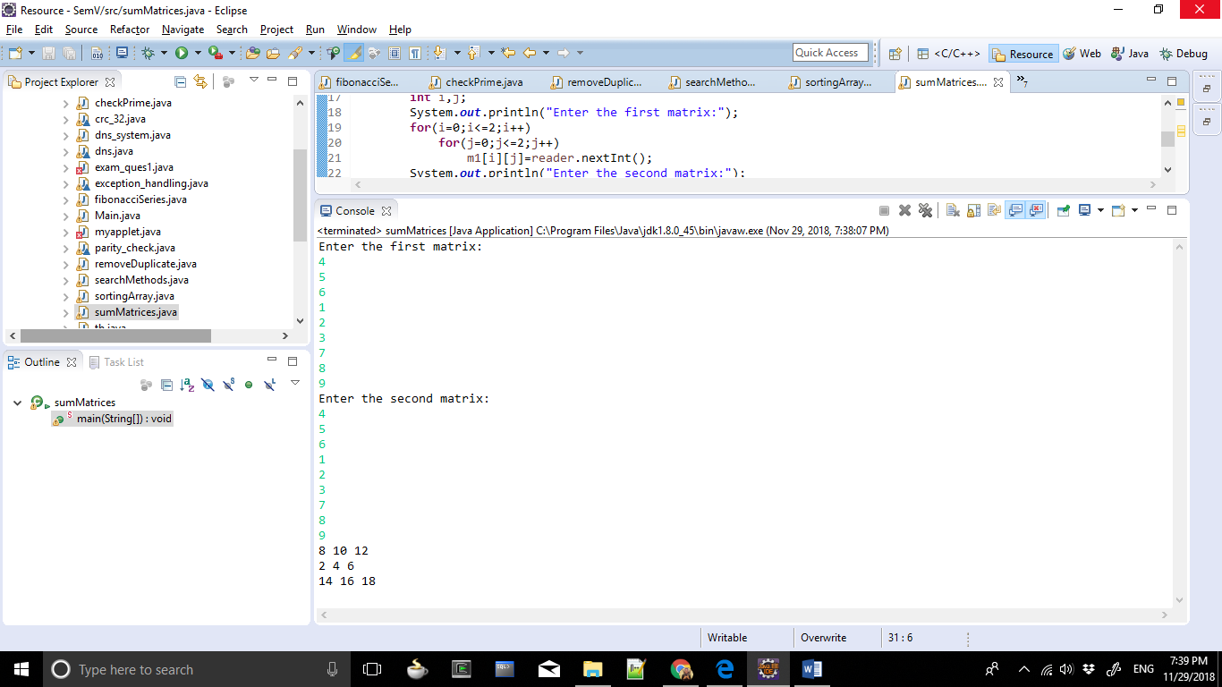
/**
* To perform various operation on a string:
* a.)Find the length of the string b.)Replace all vowels with letter 'r' c.)Find the total number of words in the text
*
* @author ashra.
* Created Nov 29, 2018.
*/
import java.io.*;
import java.util.*;

public class stringOperation {
public static void main(String args[])throws IOException {
Scanner reader = new Scanner(System.in);
System.out.println("Enter any string.");
String context = reader.nextLine();
System.out.println("Length of the string:"+context.length());
replaceVowels(context);
}
public static void replaceVowels(String context) {
String contextNew="\0";
int wordCount=1;
for(int i=0;i<context.length();i++) {
char ch=context.charAt(i);
if(ch=='a' || ch=='e' || ch=='i' || ch=='o' || ch=='u' || ch=='A' || ch=='E' || ch=='I' || ch=='O' || ch=='U')
contextNew+='r';
else
contextNew+=ch;
if(ch==' ')
wordCount++;
}
System.out.println("After replacing vowels with 'r': "+contextNew);
System.out.println("Number of words: "+wordCount);
}
}
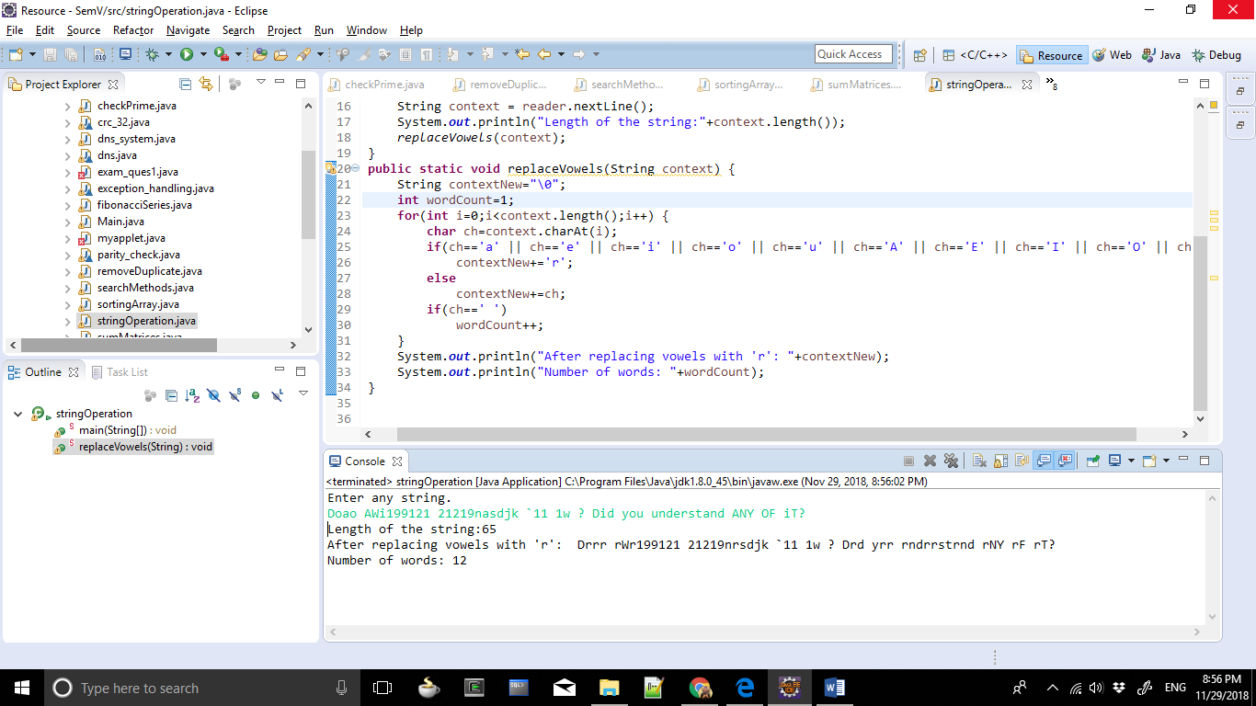

/**
* To implement the concept of function overloading.
*
* @author ashra.
* Created Nov 29, 2018.
*/
public class conceptOverloading {
public static void main(String args[]) {
conceptOverloading obj=new conceptOverloading();
obj.area(9.0);
obj.area(3,4,5);
obj.area(9,8);
obj.area(7);
}
void area(double radius) {
double area=3.14*radius*radius;
System.out.println("Area of Circle: "+area);
}
void area(int a,int b, int c) {
double s=(a+b+c)/2;
double area=Math.sqrt((s-a)*(s-b)*(s-c));
System.out.println("Area of Triangle:"+area);
}
void area(int length, int breadth) {
double area=length*breadth;
System.out.println("Area of Rectangle:"+area);
}
void area(int edge) {
double area=edge*edge;
System.out.println("Area of Square:"+area);
}
}

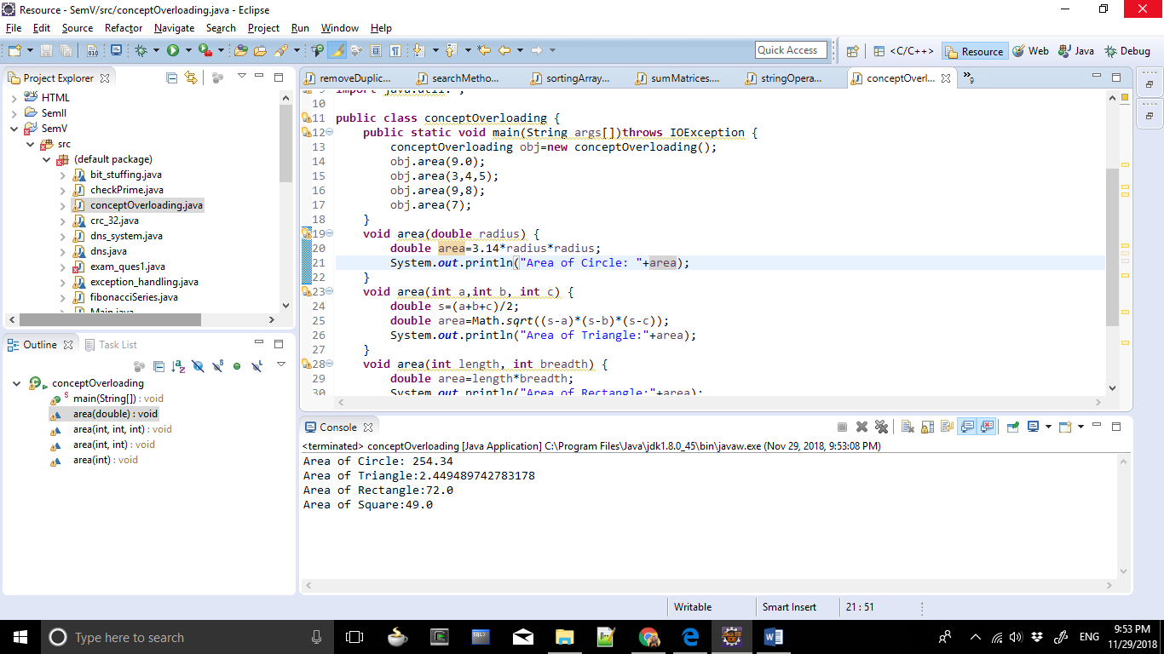

/**
* To create a user defined exception and throw it when the average of three number exceeds 50
*
* @author ashra.
* Created Nov 29, 2018.
*/
import java.io.*;
import java.util.*;

class myException extends Exception {
public String toString() {
return("Average exceeds 50");
}
}
public class userException {
public static void main(String args[])throws IOException {
Scanner reader = new Scanner(System.in);
System.out.println("Enter three numbers of which you want the average:");
int a = reader.nextInt();
int b = reader.nextInt();
int c = reader.nextInt();
int avg=(a+b+c)/3;
try {
if(avg>50)
throw new myException();
else
System.out.println("Average:"+avg);
}
catch(myException obj) {
System.out.println(obj);
}
}
}

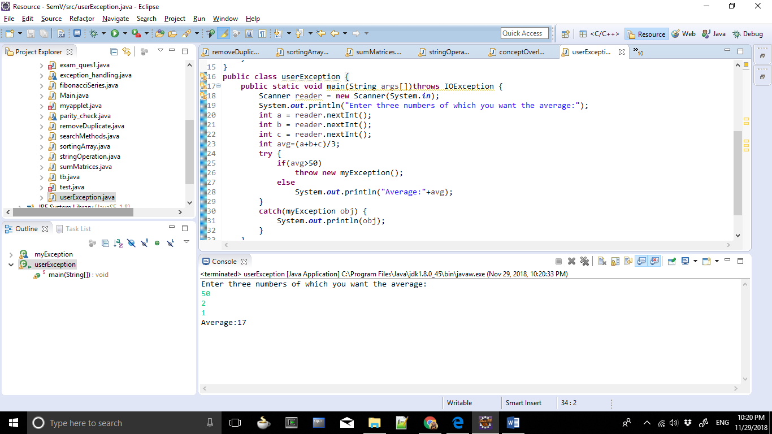

/**
* TODO Put here a description of what this class does.
*
* @author ashra.
* Created Nov 29, 2018.
*/
import java.io.*;
import java.util.*;

public class gcd {
static int GCD(int a, int b) {
if(b==0)
return a;
return GCD(b,a%b);
}
public static void main(String args[])throws IOException {
Scanner reader = new Scanner(System.in);
System.out.println("Enter any two numbers:");
int a = reader.nextInt();
int b = reader.nextInt();
System.out.println("GCD of "+a+" and "+b+" is "+GCD(a,b));
}
}

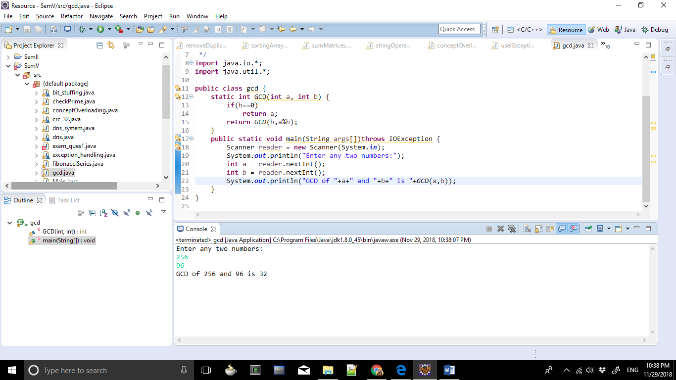

/**
* To print a figure using applet
*
* @author ashra.
* Created Nov 29, 2018.
*/
import java.applet.Applet;
import java.awt.Graphics;

public class appletFigure extends Applet {
public void paint(Graphics g)
{
g.drawLine(100,200,200,200);
g.drawLine(100,200,100,100);
g.drawLine(200,100,200,200);
g.drawLine(95,100,100,100);
g.drawLine(200,100,205,100);

g.drawLine(150,200,150,150);
g.drawLine(150,150,185,150);
g.drawLine(185,150,185,200);
g.drawLine(153,200,153,153);
g.drawLine(153,153,182,153);
g.drawLine(182,153,182,200);

g.drawOval(175,175,5,5);

g.drawLine(110,140,140,140);
g.drawLine(110,140,110,110);

g.drawLine(110,110,140,110);
g.drawLine(140,110,140,140);

g.drawLine(113,137,137,137);
g.drawLine(113,137,113,113);
g.drawLine(113,113,137,113);
g.drawLine(137,113,137,137);

g.drawLine(95,100,150,50);
g.drawLine(150,50,205,100);
g.drawLine(100,100,150,55);
g.drawLine(150,55,200,100);
}
}

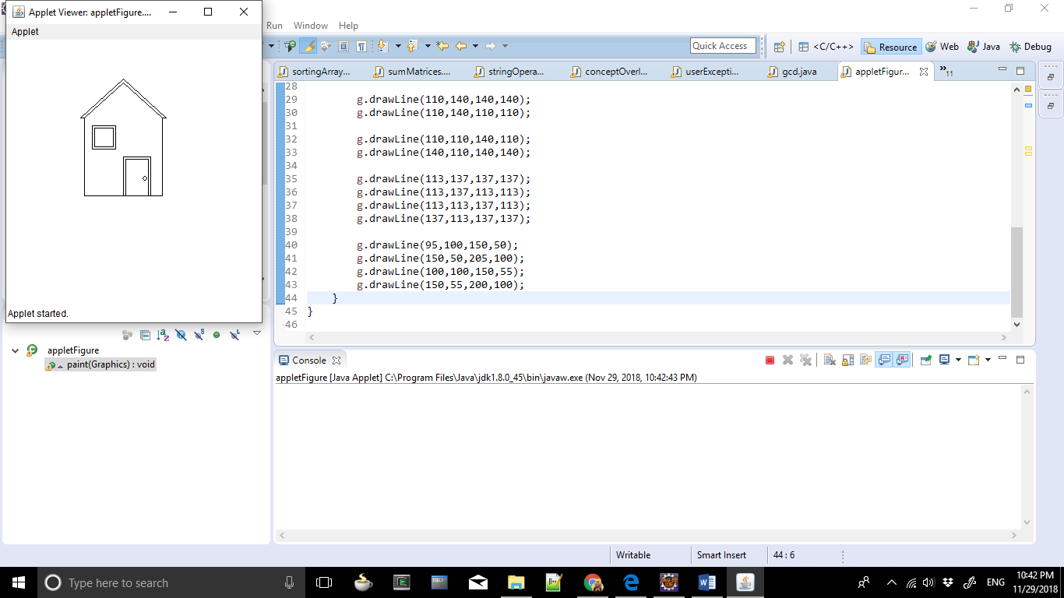

/**
* To implement multi-level inheritance
*
* @author ashra.
* Created Nov 29, 2018.
*/
class billionaire {
public void info1() {
System.out.println("Mark Zuckerberg");
}
}
class companyList extends billionaire {
public void info2() {
System.out.println("Facebook, Instagram, Whatsapp; THE SOCIAL MEDIA!");
}
public void networth3() {
System.out.println("Net Worth: 5,080 USD");
}
}
class mulInheritance extends companyList {
public void info() {
System.out.println("Bill Gates");
System.out.println("Microsft; OOP's did we just say it?!");
}
public void networth() {
System.out.println("Net Worth: 9,620 USD");
}
public void conclusion() {
System.out.println("Gates is way too rich, Zuck you got to work more!");
}
public static void main(String args[]) {
mulInheritance testTime = new mulInheritance();
testTime.info1();
testTime.info2();
testTime.networth3();
testTime.info();
testTime.networth();
testTime.conclusion();
}
}
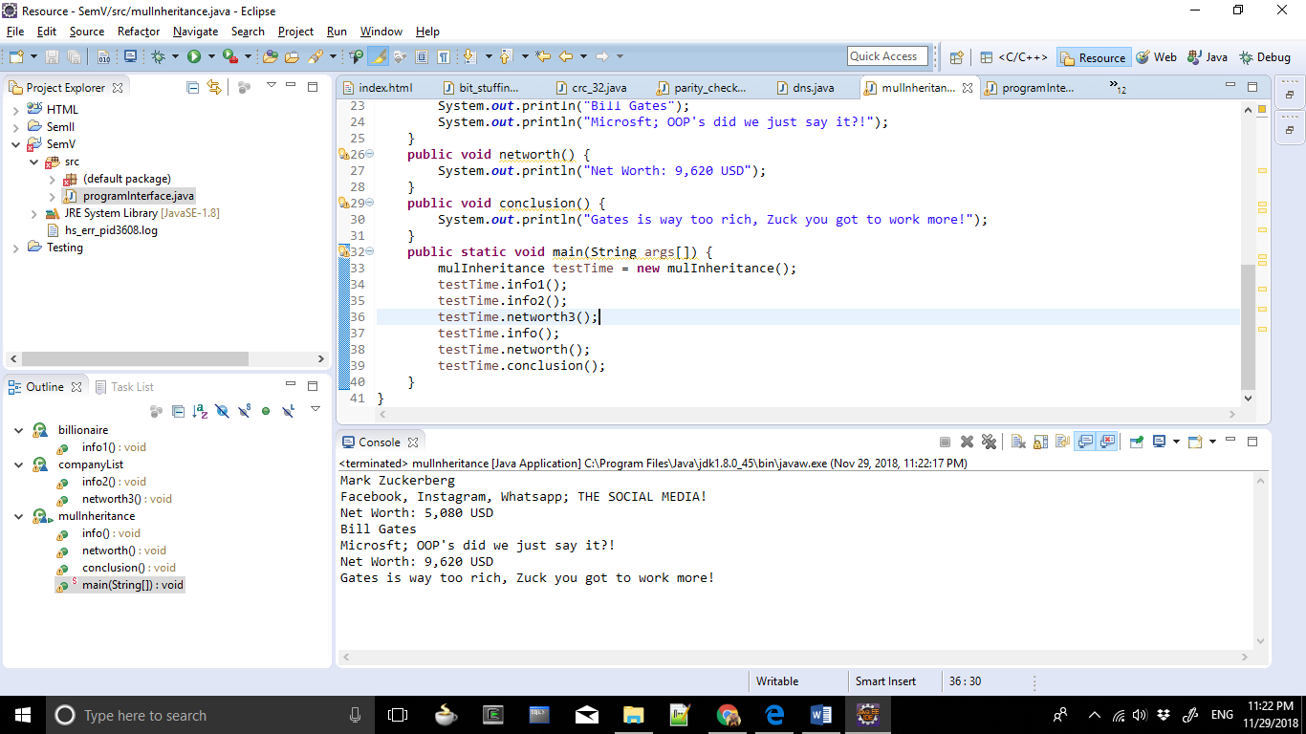

/**
* To explain the use of interface.
*
* @author ashra.
* Created Nov 29, 2018.
*/

interface MyInterface {
public void method1();
public void method2();
}
class programInterface implements MyInterface {
public void method1() {
System.out.println("In method1.");
}
public void method2() {
System.out.println("In method2.");
}
public static void main(String arg[]) {
MyInterface obj = new programInterface();
obj.method1();
obj.method2();
}
}

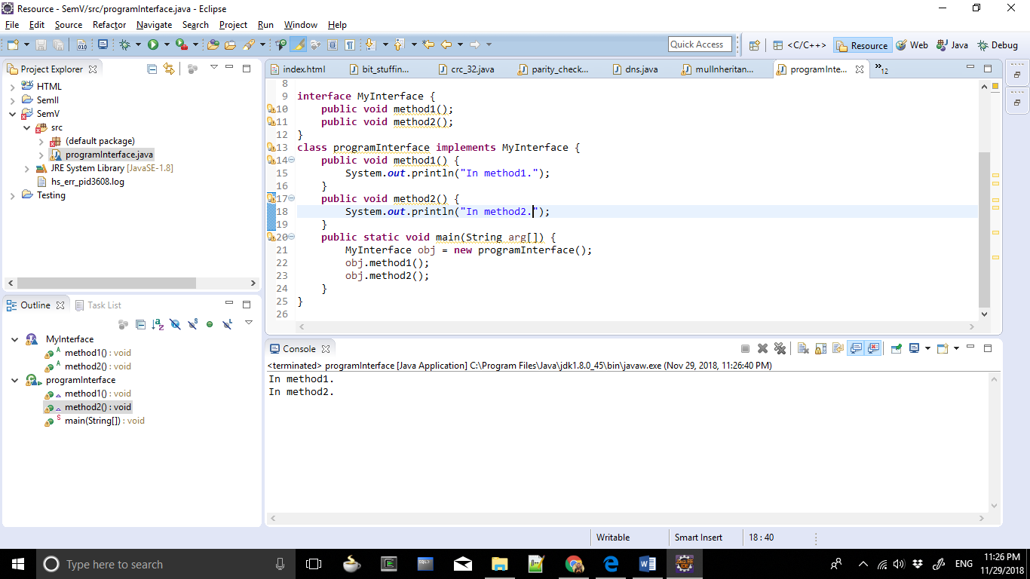

/**
* To create multiple thread using thread class.
*
* @author ashra.
* Created Nov 29, 2018.
*/
class multithreading extends Thread {
public void run() {
try {
System.out.println("Thread "+Thread.currentThread().getId()+" is running.");
}
catch (Exception e) {
System.out.println("Exception is caught.");
}
}
}
public class threadClass {
public static void main(String[] args) {
int n = 8;
for (int i=0;i<n;i++) {
multithreading obj = new multithreading();
obj.start();
}
}
}

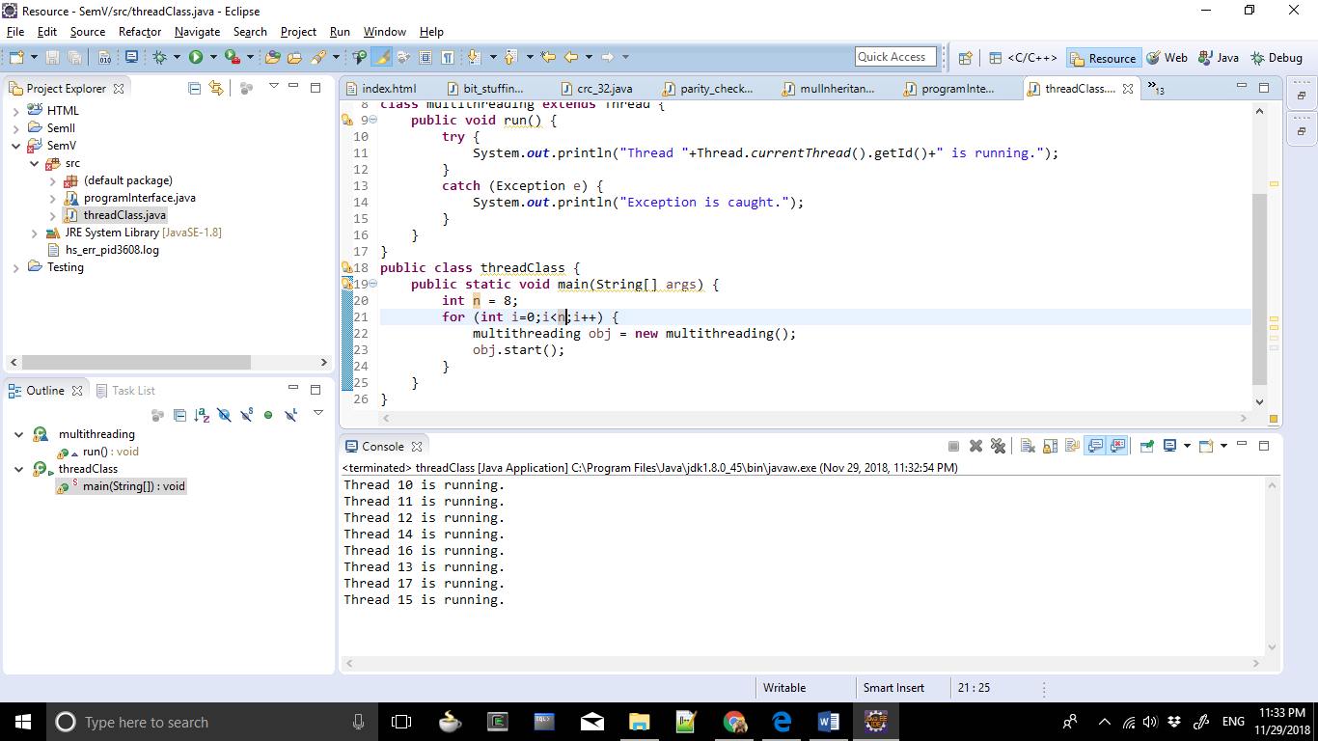

/**
* To create multiple threads using runnable interfaces.
*
* @author ashra.
* Created Nov 29, 2018.
*/
class multiple implements Runnable {
public void run() {
try {
System.out.println("Thread "+Thread.currentThread().getId()+" is running.");
}
catch (Exception e) {
System.out.println("Exception is caught.");
}
}
}

public class runInterface {
public static void main(String[] args) {
int n = 8;
for (int i=0;i<n;i++) {
Thread object = new Thread(new multiple());
object.start();
}
}
}

