# **Adyen Payment Gateway Plugin Documentation**

## **Plugin Overview**

The **Adyen Payment Gateway** plugin is an add-on for Easy Digital Downloads (EDD) that enables seamless integration with Adyen's payment services. This documentation will guide you through the installation and setup process for the plugin.

## **Installation**

1. **Download the Plugin**:  
   * Obtain the plugin package (ZIP file) from the source provided.
2. **Upload and Activate the Plugin**:  
   * Navigate to your WordPress admin dashboard.
   * Go to **Plugins > Add New**.
   * Click **Upload Plugin** and upload the downloaded ZIP file.
   * Click **Install Now**, then **Activate** the plugin.
3. **Ensure EDD is Installed**:  
   * This plugin requires Easy Digital Downloads (EDD). Ensure EDD is installed and activated before proceeding.

## **Plugin Setup**

### **1. Configure Active and Default Gateways**

1. Navigate to **EDD > Settings > General**.
2. Under the **Active Gateways** section:
   * Check the box for **Adyen** to enable it as a payment gateway.
3. Under the **Default Gateway** section:
   * Select **Adyen** as the default payment gateway if desired.
4. Save changes.

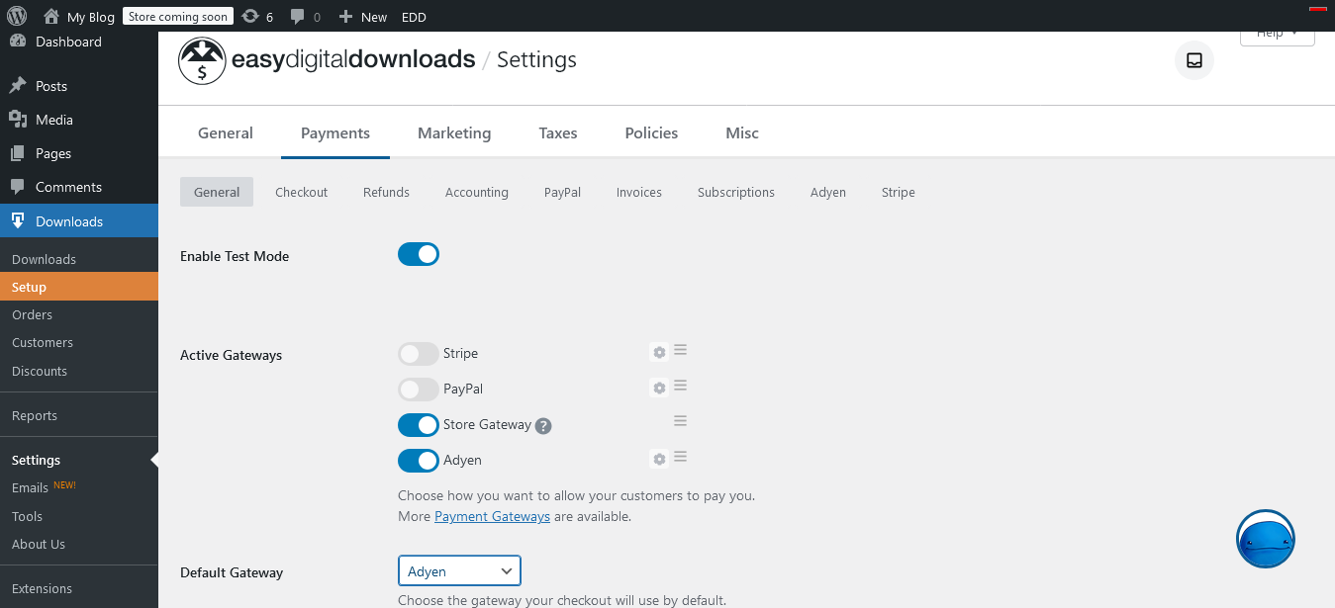

### **2. Configure Adyen Payment Settings**

1. Go to **EDD > Settings > Payments**.
2. Click on the **Adyen** sub-tab.

The following options are available for configuration:

#### **Test or Live Settings**

* Choose whether to operate in **Test** or **Live** mode.
  + **Test**: Use Adyen’s sandbox environment.
  + **Live**: Use Adyen’s production environment.

#### **Live API Key**

* **Purpose**: Required for authenticating with Adyen’s live environment.
* **How to Get It**:
  1. Log in to your Adyen account.
  2. Go to **Developers > API Credentials**.
  3. Create or select an existing API key for the live environment.
  4. Copy the API key and paste it into this field.

#### **Test API Key**

* **Purpose**: Required for authenticating with Adyen’s test environment.
* **How to Get It**:
  1. Log in to your Adyen Sandbox account.
  2. Go to **Developers > API Credentials**.
  3. Create or select an existing API key for the test environment.
  4. Copy the API key and paste it into this field.

#### **Live API Endpoint URL**

* **Purpose**: The base URL for API requests in live mode.
* **How to Get It**:
  1. Log in to your Adyen account.
  2. Refer to the latest Adyen documentation for live API endpoint URLs.
  3. Copy the endpoint and paste it into this field.

#### **Test API Endpoint URL**

* **Purpose**: The base URL for API requests in test mode.
* **How to Get It**:
  1. Log in to your Adyen Sandbox account.
  2. Refer to the latest Adyen documentation for test API endpoint URLs.
  3. Copy the endpoint and paste it into this field.

#### **Merchant Account**

* **Purpose**: Identifies your Adyen account.
* **How to Get It**:
  1. Log in to your Adyen account.
  2. Go to **Account > Merchant Accounts**.
  3. Copy the merchant account name and paste it into this field.

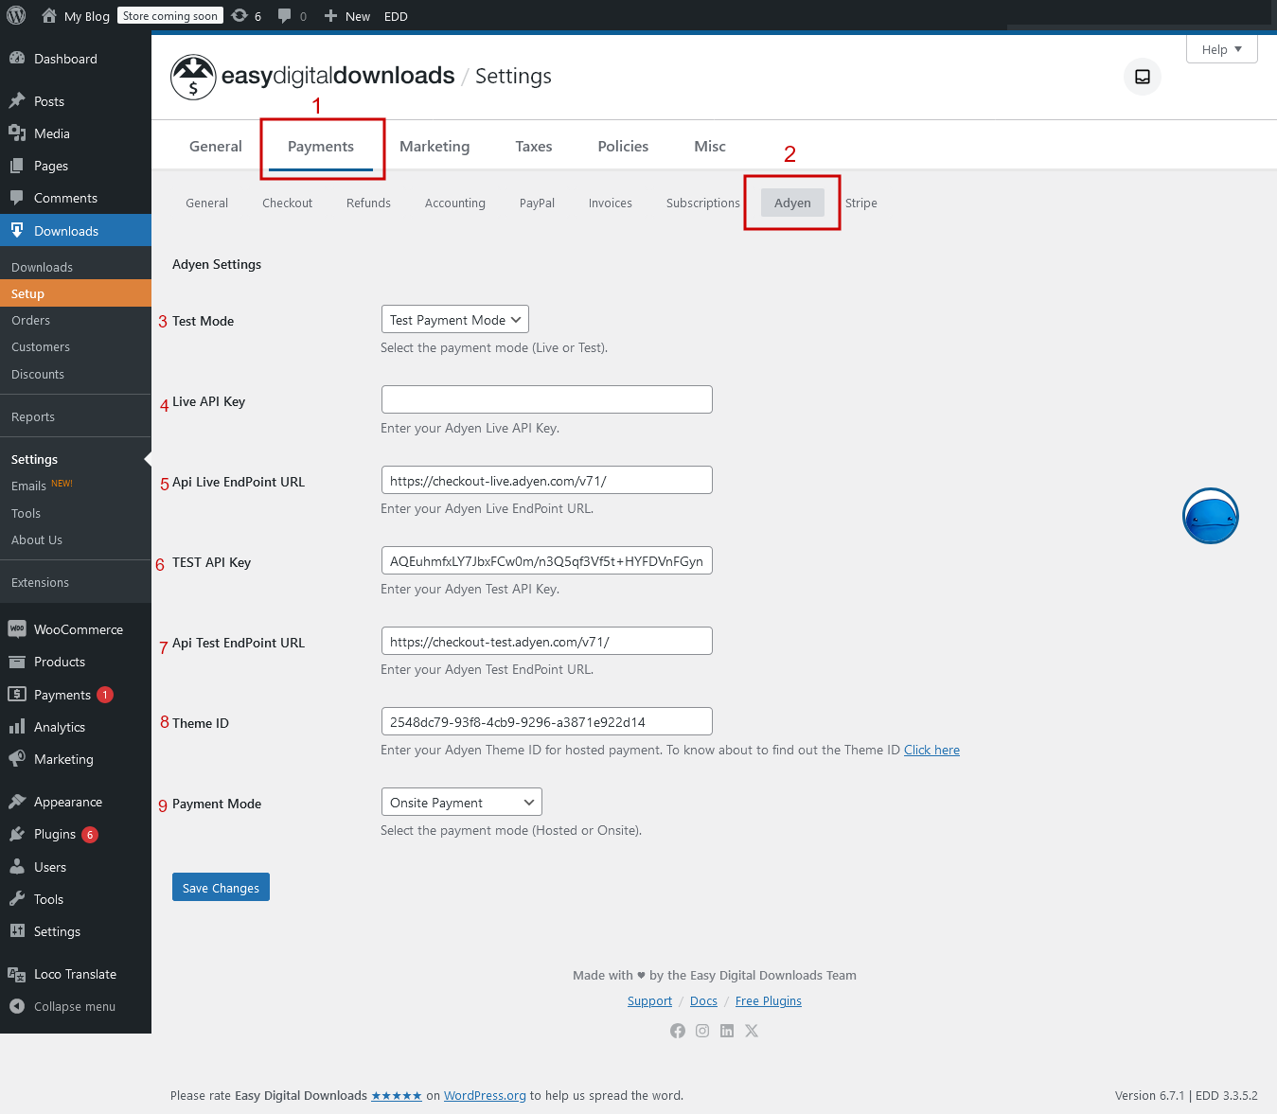

#### **Theme ID**

* Optional setting for customizing the appearance of payment forms. Contact Adyen support for Theme ID configuration if needed.

#### **Payment Mode (Onsite/Hosted)**

* **Onsite**: Payments are processed directly on your website.
* **Hosted**: Payments are processed on Adyen’s secure hosted payment page.
* Choose the mode that best fits your security and user experience needs.

When the shopper goes to checkout on your website, you redirect them to a Hosted Checkout page. After they make the payment, the shopper gets redirected to your page, and you show the shopper the outcome of the payment session.

## **How to Get the Theme ID for Hosted Payment**

To create a theme, you must have one of the following [user roles](https://docs.adyen.com/account/user-roles#account):

* Merchant admin
* Hosted Checkout and Pay by Link Settings

To create a new theme:

1. Log in to your [Customer Area](https://ca-test.adyen.com/) and switch to your merchant account if necessary.
2. Go to **Pay by Link** > **Themes**.
3. Select **Create a new theme**.
4. Enter a **Theme name**. This name helps you to identify different themes.
5. Enter a **Display name**. This name is visible to the shopper on the Hosted Checkout page.
6. Upload a brand logo.
7. Upload a background image.
8. Enter a background color. This color is used instead of the background image if the shopper's internet connection is too slow.
9. If you want this to be the default theme for all Hosted Checkout pages, select **Set as default**. Available only on the merchant account.
10. Select **Create**.

Get the theme ID:

1. Go to **Pay by Link** > **Themes**.
2. Select the options icon from the theme.
3. Select **Copy theme ID.** This copies the theme ID to your system's clipboard.

## **Save Settings**

After filling in all the required fields, click **Save Changes** to apply your configurations.

## **Testing Your Integration**

1. Set the plugin to **Test** mode.
2. Use Adyen’s test API key and test endpoint URL.
3. Perform a test transaction to ensure the payment gateway is working as expected.

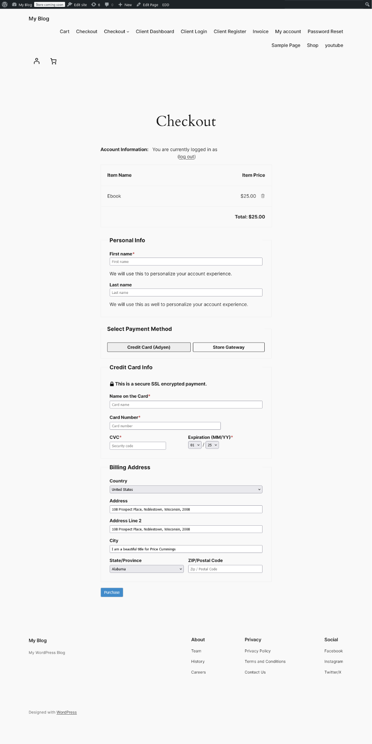

## **Going Live**

Once testing is complete and successful:

1. Switch the plugin to **Live** mode.
2. Enter your live API key, live endpoint URL, and merchant account.
3. Perform a live transaction to confirm the integration is fully operational.

For additional support, refer to Adyen’s official documentation or contact the plugin developer for assistance.

## 