Adding 3 Virtual machines to us-east-2 region(Zone1)

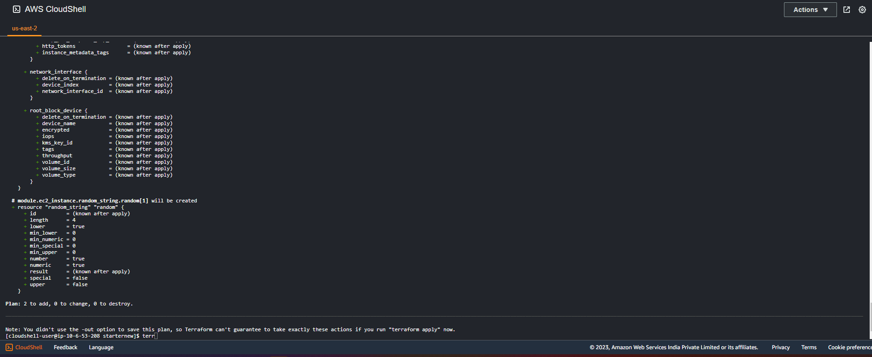

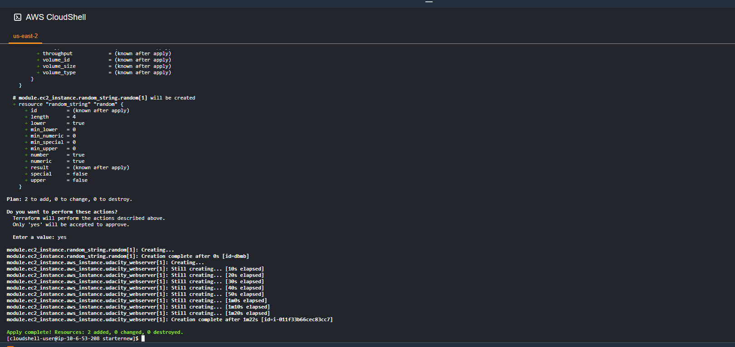**A**

Adding ALB to Zone1 us-east-2

# module.alb.aws_lb_target_group.my-target-group will be created

+ resource "aws_lb_target_group" "my-target-group" {

+ arn = (known after apply)

+ arn_suffix = (known after apply)

+ connection_termination = false

+ deregistration_delay = "300"

+ id = (known after apply)

+ lambda_multi_value_headers_enabled = false

+ load_balancing_algorithm_type = (known after apply)

+ name = "my-test-tg"

+ port = 80

+ preserve_client_ip = (known after apply)

+ protocol = "HTTP"

+ protocol_version = (known after apply)

+ proxy_protocol_v2 = false

+ slow_start = 0

+ tags_all = (known after apply)

+ target_type = "instance"

+ vpc_id = "vpc-077baef119aed7908"

+ health_check {

+ enabled = true

+ healthy_threshold = 5

+ interval = 10

+ matcher = (known after apply)

+ path = "/"

+ port = "traffic-port"

+ protocol = "HTTP"

+ timeout = 5

+ unhealthy_threshold = 2

}

+ stickiness {

+ cookie_duration = (known after apply)

+ cookie_name = (known after apply)

+ enabled = (known after apply)

+ type = (known after apply)

}

}

# module.alb.aws_lb_target_group_attachment.my-alb-target-group-attachment1 will be created

+ resource "aws_lb_target_group_attachment" "my-alb-target-group-attachment1" {

+ id = (known after apply)

+ port = 80

+ target_group_arn = (known after apply)

+ target_id = "appserver-instance-aw5y9"

}

# module.alb.aws_lb_target_group_attachment.my-alb-target-group-attachment2 will be created

+ resource "aws_lb_target_group_attachment" "my-alb-target-group-attachment2" {

+ id = (known after apply)

+ port = 80

+ target_group_arn = (known after apply)

+ target_id = "appserver-instance-awdbmb"

}

# module.alb.aws_security_group.my-alb-sg will be created

+ resource "aws_security_group" "my-alb-sg" {

+ arn = (known after apply)

+ description = "Managed by Terraform"

+ egress = (known after apply)

+ id = (known after apply)

+ ingress = (known after apply)

+ name = "my-alb-sg"

+ name_prefix = (known after apply)

+ owner_id = (known after apply)

+ revoke_rules_on_delete = false

+ tags_all = (known after apply)

+ vpc_id = "vpc-077baef119aed7908"

}

# module.alb.aws_security_group_rule.inbound_http will be created

+ resource "aws_security_group_rule" "inbound_http" {

+ cidr_blocks = [

+ "0.0.0.0/0",

]

+ from_port = 80

+ id = (known after apply)

+ protocol = "tcp"

+ security_group_id = (known after apply)

+ self = false

+ source_security_group_id = (known after apply)

+ to_port = 80

+ type = "ingress"

}

# module.alb.aws_security_group_rule.inbound_ssh will be created

+ resource "aws_security_group_rule" "inbound_ssh" {

+ cidr_blocks = [

+ "0.0.0.0/0",

]

+ from_port = 22

+ id = (known after apply)

+ protocol = "tcp"

+ security_group_id = (known after apply)

+ self = false

+ source_security_group_id = (known after apply)

+ to_port = 22

+ type = "ingress"

}

# module.alb.aws_security_group_rule.outbound_all will be created

+ resource "aws_security_group_rule" "outbound_all" {

+ cidr_blocks = [

+ "0.0.0.0/0",

]

+ from_port = 0

+ id = (known after apply)

+ protocol = "-1"

+ security_group_id = (known after apply)

+ self = false

+ source_security_group_id = (known after apply)

+ to_port = 0

+ type = "egress"

}

Terraform code status

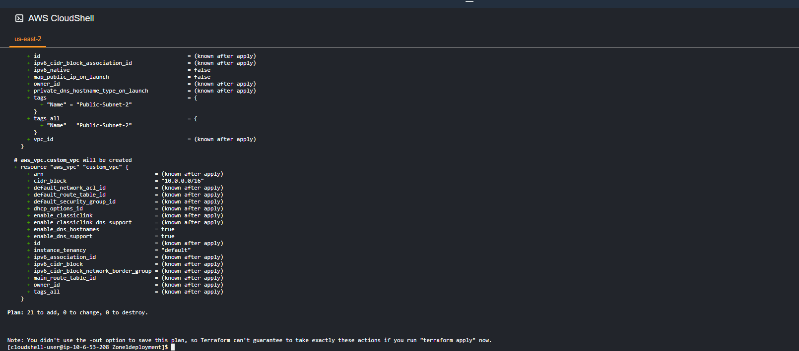

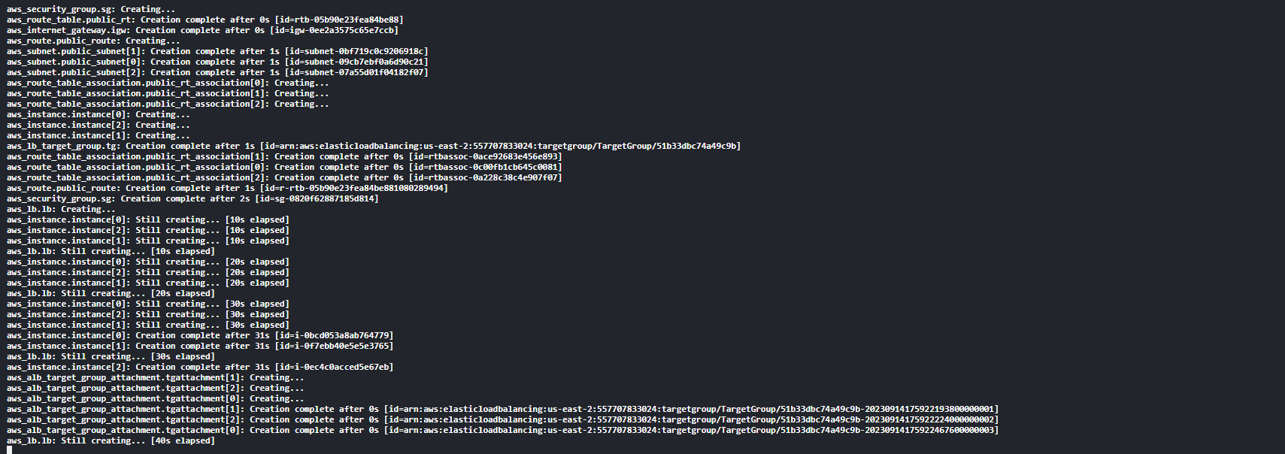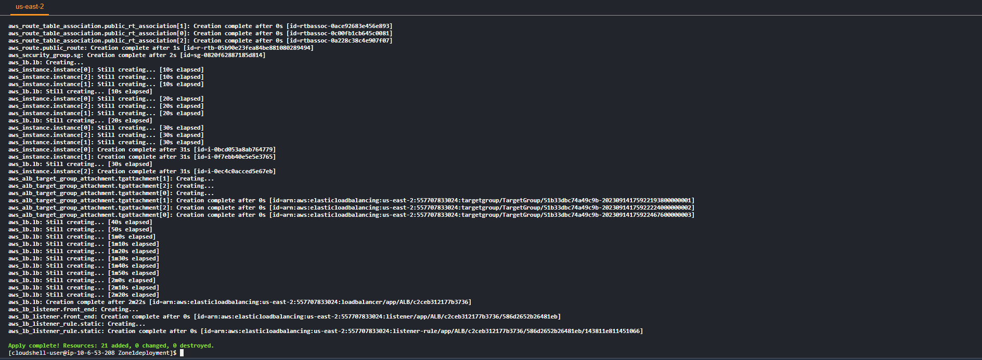 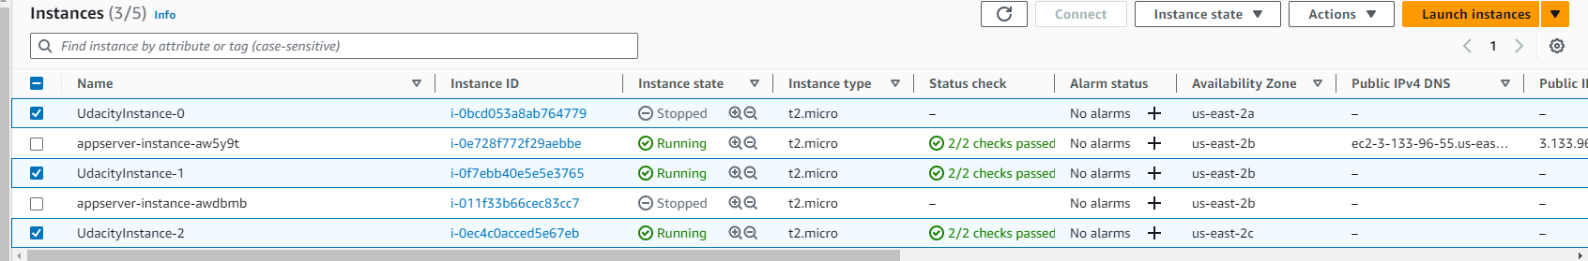

VPC has ip in multiple Az

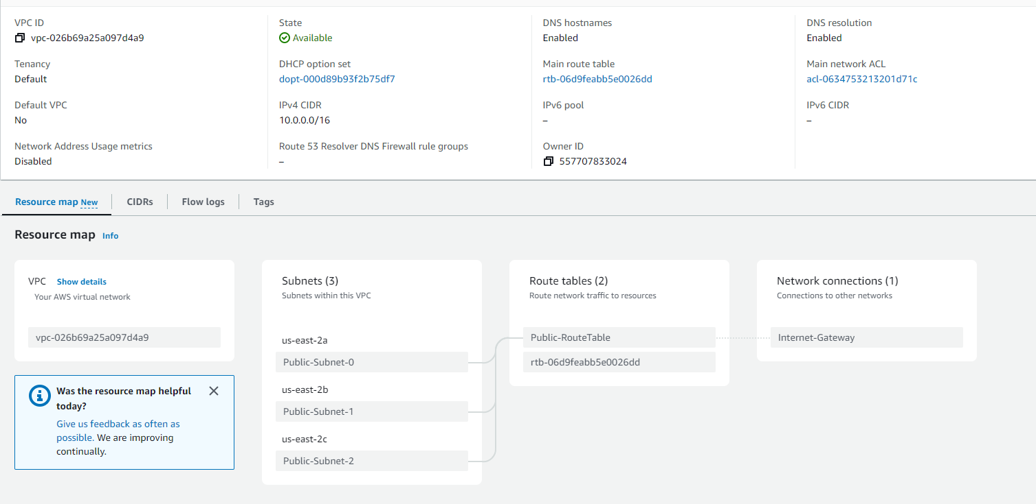

ALB setup

