**CS5590/490 Python-DeepLearning**

**Deep-Learning**

**LAB**

**Assignment-2**

**Submitted by: Shajee Uddin Zain Mohammed**

**Student ID: 16230179**

**Class ID: 28**

CNN model Text classification.

Introduction:

Convolutional neural network is an important concept in machine learning. Feed forward artificial neural networks that is used to analyse imagery visualization. It uses a multilayer perceptron design to require minimal pre-processing. Feed-forward neural networks is used to learn about the features and to classify data.

Objectives:

In this project we have implemented the CNN model to classify the text and predict the crime for the finance company Kaggle Sanfransisco Fraud incidents.

Approach/Method:

Here in this approach I have implemented the text classification using CNN on the Kaggle Sanfransisco Crime dataset. It consists of 39 classes. This dataset contains criminal incidents recorded from from SFPD Crime occurrence detailing framework. It contains the information fields, for example, Dates, Category, Descript, and Day of week, District, Resolution and address. Here, I have built up a model of numerous layers. To start with layer implants words into low-dimensional vectors. The following layer performs convolutions over the inserted word vectors utilizing numerous channel sizes.

Workflow:

First I divided the dataset into training dataset and testing dataset. Here I train the data and apply it on the model and then test the data and analyse then results.

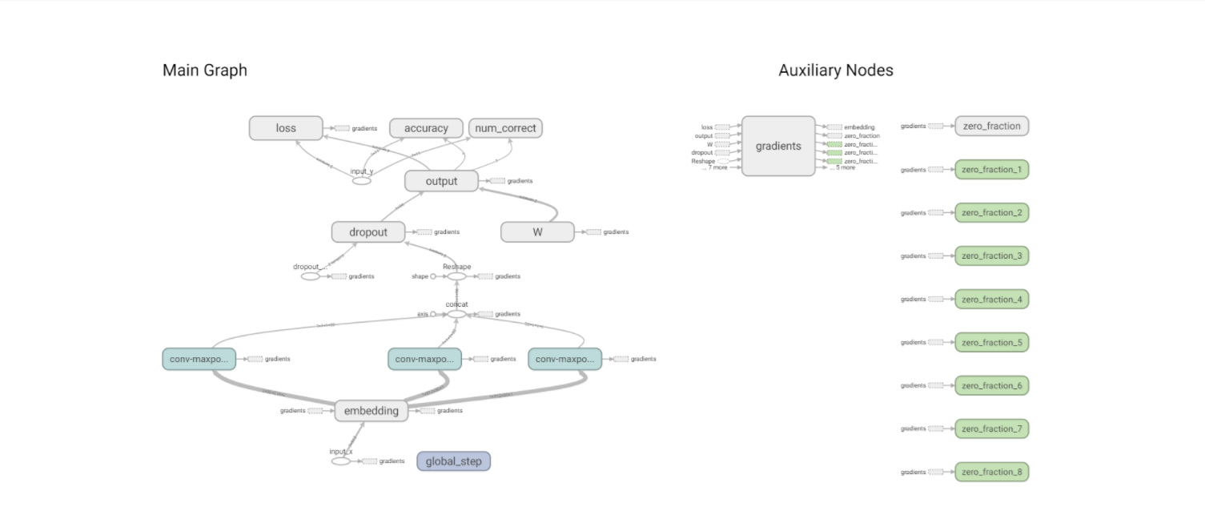

Dataset:

Kaggle San Fransisco Crime Dataset.

Consumer_Complaints Dataset.

Evaluation & Discussion:

This is the code for the traning data

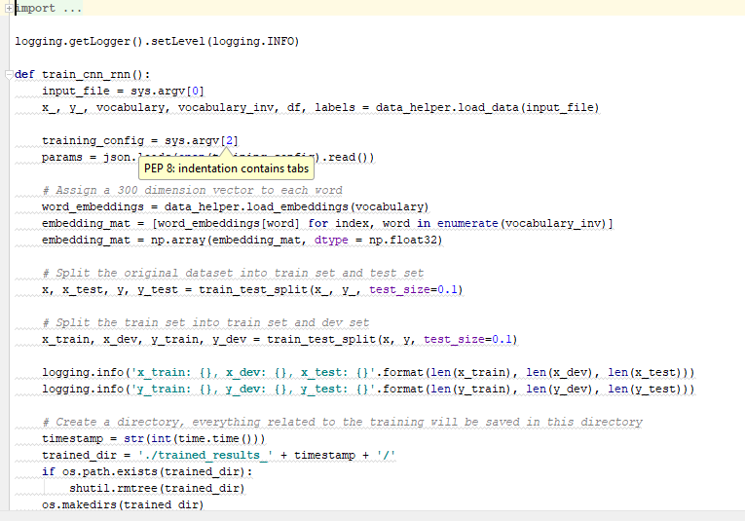

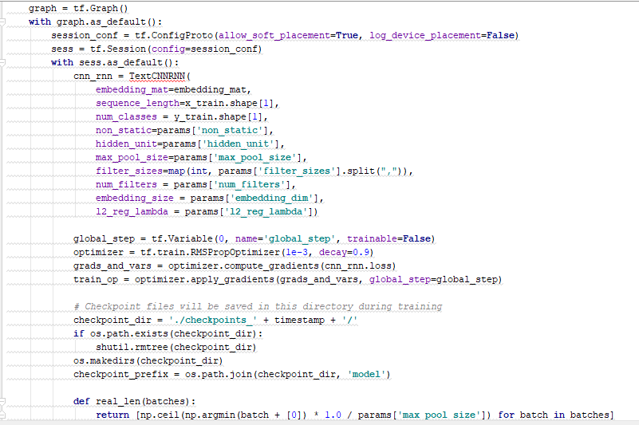

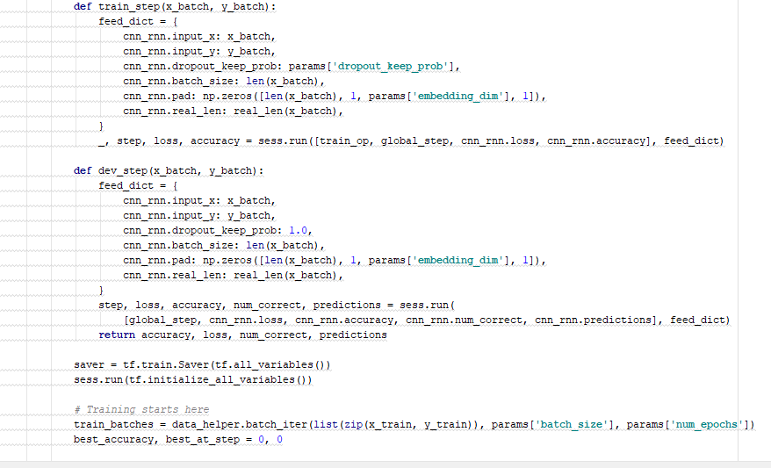

Output:

