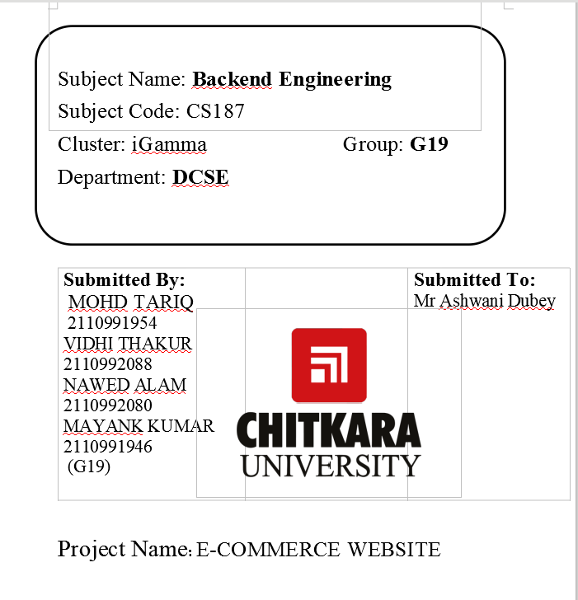**Project Documentation: [E-COMMERCE WEBSITE]**

**1. Introduction**

**Overview of the eCommerce Website:**

Provide detailed information on the nature of the website, its core functionalities, and the specific products or services it offers.

**Purpose and Goals**:

Elaborate on the primary objectives of the eCommerce website, whether it's to increase sales, reach a wider audience, or provide a unique shopping experience.

**Target Audience and Market Segment:**

Define the demographic or market segment your website caters to, including potential customer profiles and their preferences.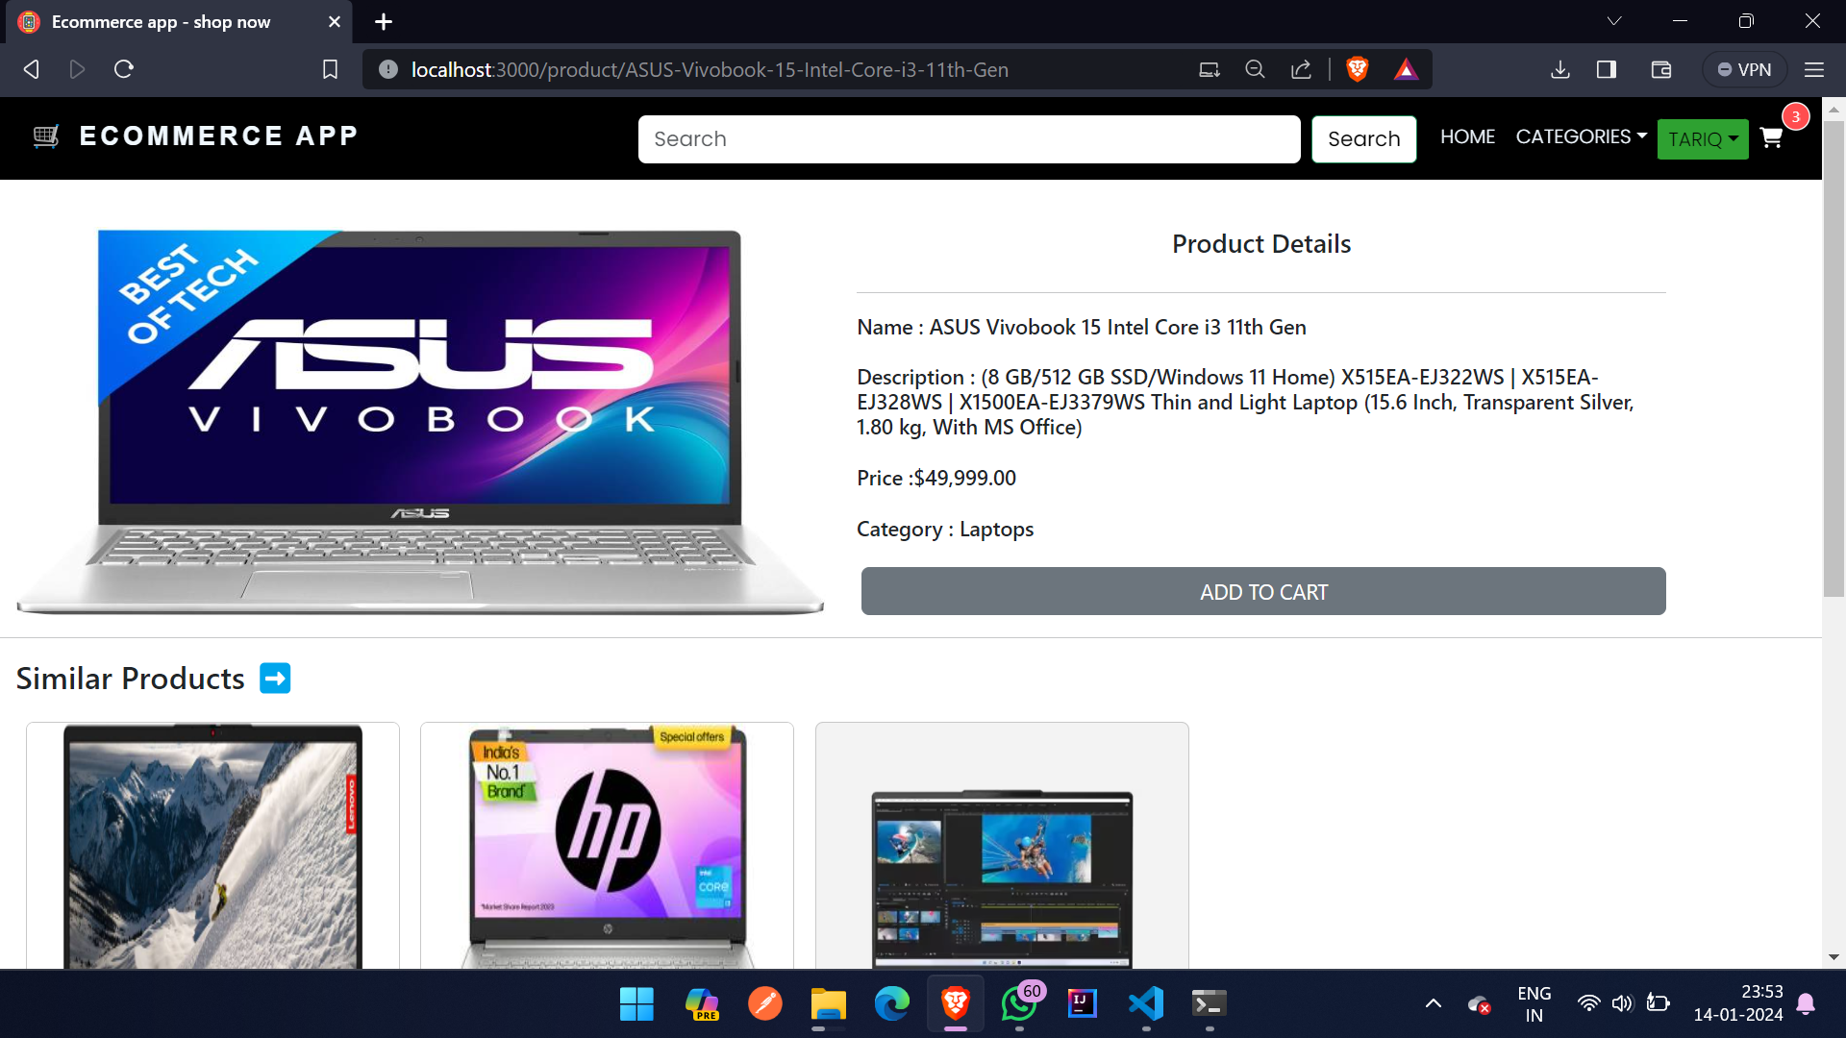

**2. System Architecture**

**High-level Architecture:**

Offer an in-depth explanation of the architecture, breaking down components such as the frontend, backend, databases, and external services.

**Technologies Used:**

Detail the specific technologies and frameworks utilized , explaining the reasons behind their selection and any alternatives considered.

**3. Features**

**Key Features:**

Enumerate and elaborate on the primary features of the eCommerce website, such as product catalog , user accounts, checkout process, and any innovative features.

**Unique Selling Points (USPs):**

Highlight any distinctive aspects that set your website apart from competitors, contributing to its value proposition.

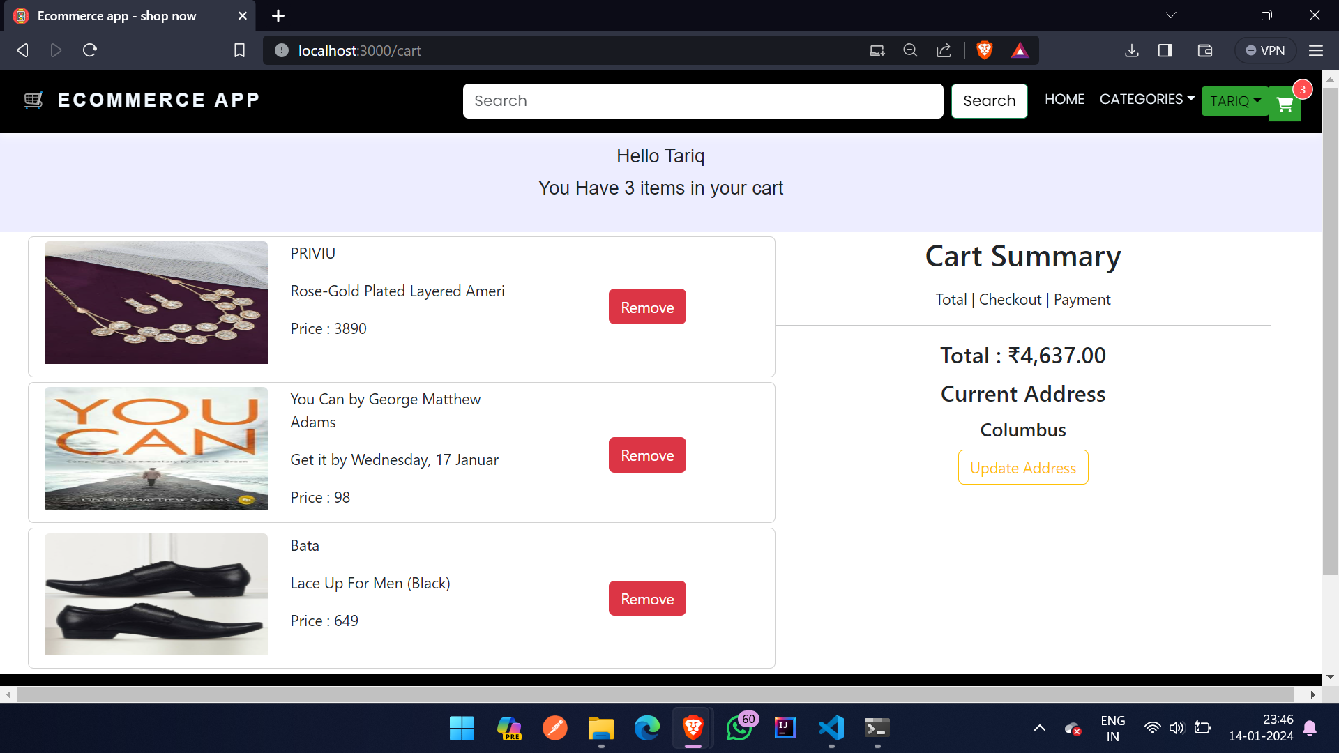

**4. User Interface Design**

**Wireframes or Mockups:**

Showcase the visual representation of the user interface, explaining the design choices and how they contribute to a seamless user experience.

**User Experience Principles:**

Discuss the principles of user experience (UX) that influenced the design, ensuring a user-friendly and intuitive interface.

**5. Database Design**

**Schema Overview:**

Provide an overview of the database schema, detailing the structure of tables, relationships, and any indexing strategies.

**Normalization Process:**

Explain the normalization process applied to ensure efficient data organization and reduce redundancy.

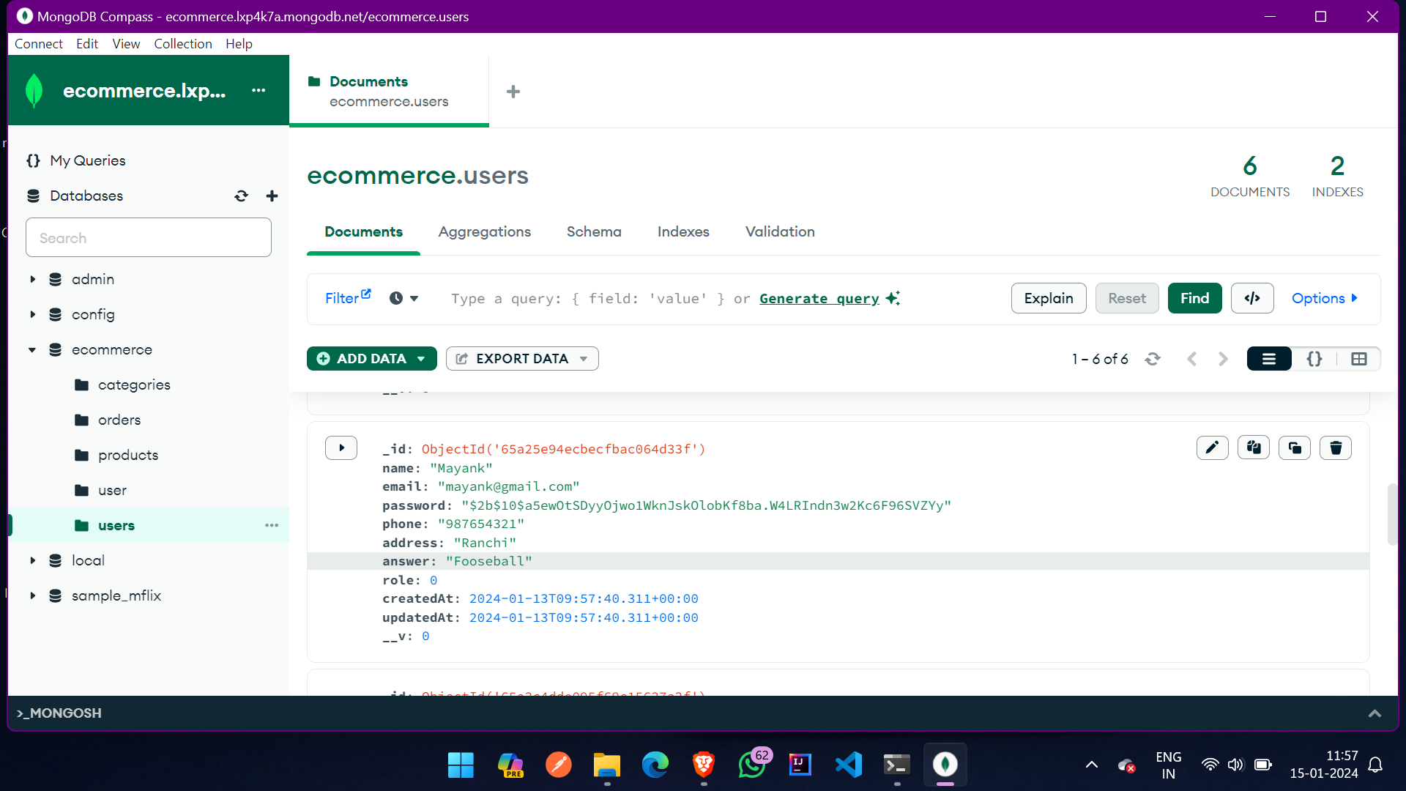

**6. Technical Implementation**

**Code Structure:**

Break down the code structure, highlighting major components, modules, and their interconnections.

**Major Algorithms or Functionalities:**

Discuss any complex algorithms or functionalities implemented, explaining their purpose and impact on the overall system.

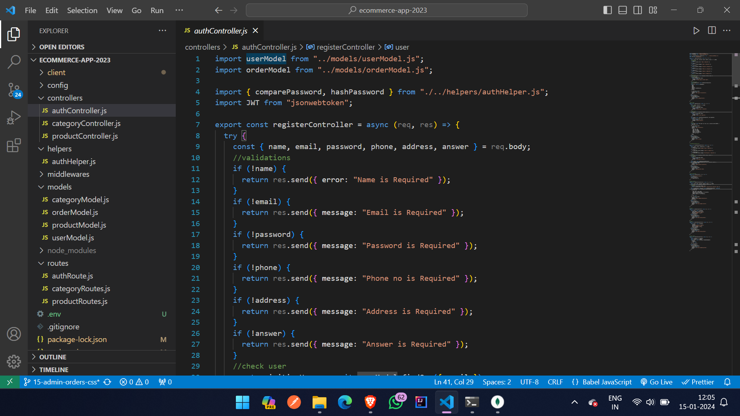

**7. Testing**

**Testing Process Overview:**

Explain the testing methodologies employed, including unit testing, integration testing, and user acceptance testing.

**Test Cases and Results:**

Provide detailed test cases and the corresponding results, demonstrating the reliability and functionality of the eCommerce website.

**8. Deployment**

**Deployment Strategy:**

Describe the strategy for deploying the website, including version control, continuous integration, and any rollback procedures.

**Server and Hosting Details:**

Specify the server configurations and hosting infrastructure used, addressing scalability considerations and potential challenges encountered during deployment.

**9. Security Measures**

**Explanation of Security Features:**

Detail the security features integrated into the website, covering aspects like data encryption, user authentication, and protection against common vulnerabilities.

**Vulnerability Assessments:**

Discuss any vulnerability assessments or penetration testing conducted to ensure the robustness of the security measures.

**10. User Manual**

**- *Instructions for Using the Website:\***

Provide comprehensive, step-by-step instructions for users on how to navigate the website, create accounts, make purchases, and troubleshoot common issues.

**- *Troubleshooting Tips:\***

Include troubleshooting tips for potential challenges users might encounter, ensuring a smooth and user-friendly experience.

**11. Future Improvements**

**- *Potential Enhancements:\***

Propose specific enhancements or features that could be implemented in future iterations, based on user feedback and emerging industry trends.

**- *Scalability Options:\***

Discuss options for scalability, addressing how the website can accommodate increased traffic and data volumes.

**12. Conclusion**

**- *Summary of the Project:\***

Summarize the key findings, achievements, and challenges encountered throughout the development process.

**- *Reflection on the Development Process:\***

Reflect on the lessons learned, improvements made, and areas for growth in future projects.

**13. Reference:**

**- *Citations for Tools and Libraries:\***

Provide proper citations for the tools, frameworks, and libraries used in the development process.

**- *Acknowledgment of Third-party Assets:\***

Acknowledge any third-party assets or libraries integrated into the website, giving credit to their respective creators.

This expanded content should offer a more detailed and comprehensive documentation framework for your eCommerce website project. Adjust and customize each section based on the specific details of our project.