Name : Mohd Zaid

Usn: 22BTRAD025

QUESTION:

Run functional commands in Scala command promt.... is due

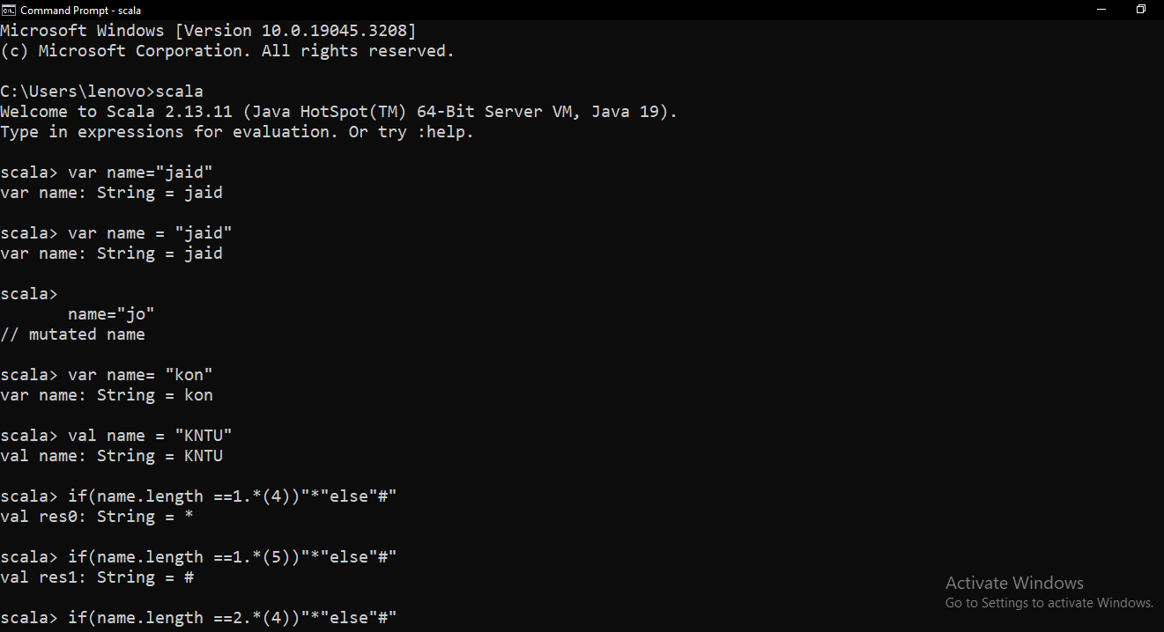

2..

