Name : Mohd Zaid

Usn : 22BTRAD025

Online class assignment(based on string)

1.

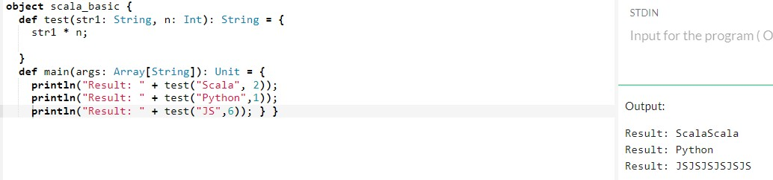

2.

