An Agentic Large Language Model Framework for Automated Healthcare Appointment Management
Mohd Zaid
Department of Computer Science and Engineering
Email: mohdzaid7967@gmail.com

Abstract
The healthcare industry faces mounting administrative overhead in managing patient appointments, leading to inefficiencies that burden both patients and healthcare providers. Traditional rule-based scheduling systems and click-driven graphical interfaces require explicit navigation and lack the intelligence to handle ambiguous or conversational user requests. This paper presents an automated, conversational AI system designed to handle end-to-end medical appointment scheduling through natural language interaction. The proposed system integrates a Large Language Model (LLM) — specifically Meta's Llama 3.3 70B served via the Groq Language Processing Unit (LPU) API — with an Agentic Workflow constructed using LangGraph, enabling it to dynamically read and write to a structured data store to check doctor availability, book, cancel, and reschedule appointments while maintaining multi-turn conversational context. The architecture employs a Multi-Agent Routing System where a Supervisor node performs deterministic intent classification and delegates requests to specialized Read-Only and Read/Write ReAct (Reasoning and Acting) agents. Custom Python tooling handles LLM output normalization, fuzzy entity matching, and auto-generation of patient identifiers. The frontend is built with Streamlit, and the backend exposes an asynchronous REST API via FastAPI. Experimental results demonstrate that the system reliably interprets diverse natural language scheduling requests, maintains contextual coherence across conversation turns, and executes CRUD operations on appointment data with high accuracy. Limitations including CSV-based concurrency risks and plain-text patient ID handling are discussed alongside directions for future work involving PostgreSQL migration, JWT authentication, and vector-embedding-based semantic search.

Keywords: Large Language Models, Agentic AI, LangGraph, Healthcare Appointment Scheduling, Natural Language Processing, ReAct Agents, Groq, FastAPI, Streamlit, Multi-Agent Systems

1. Introduction
Healthcare systems worldwide are encountering an escalating challenge: the administrative overhead associated with appointment scheduling. Manual scheduling processes, telephone-based booking systems, and traditional web portals with rigid form-based interfaces impose friction on patients, increase no-show rates, and consume valuable time for clinical staff [1]. According to industry analyses, approximately 30% of healthcare administrative costs are attributable to scheduling and appointment management tasks, creating a pressing need for intelligent automation solutions.
Recent advances in Large Language Models (LLMs) have demonstrated remarkable capabilities in understanding and generating human language across complex domains. Models such as GPT-4, Llama 3, and Claude have shown proficiency in intent classification, slot-filling, multi-turn dialogue management, and API-driven task execution — capabilities directly applicable to automating administrative healthcare workflows. However, deploying LLMs reliably for transactional tasks such as appointment booking requires more than a simple prompt; it demands structured agentic frameworks that can orchestrate tool calls, maintain state, handle errors, and route between specialized sub-tasks deterministically.
This paper introduces an end-to-end Agentic LLM Framework for Automated Healthcare Appointment Management. Rather than a conventional click-driven UI, the system presents the user with a conversational interface powered by a multi-agent LangGraph workflow. The user communicates naturally — for example, "Book me an appointment with a cardiologist on Friday afternoon" — and the system parses intent, resolves entities (date, time, specialization), checks availability, and confirms the booking, all within a single conversation flow.
The core novelty of the proposed system lies in its Multi-Agent Routing Architecture. A Supervisor node performs deterministic, JSON-based intent routing to either a Read-Only Information Agent (for availability queries and FAQ responses) or a Read/Write Booking Agent (for creating, cancelling, and rescheduling appointments). This separation of concerns reduces hallucination risk, enforces strict data-modification constraints, and improves system reliability compared to single-prompt monolithic LLM approaches.
The contributions of this paper are as follows:
- Design and implementation of a decoupled three-tier architecture for LLM-powered healthcare appointment scheduling.
- A Multi-Agent Routing System using LangGraph that enforces role separation between information retrieval and data mutation.
- Custom Python tooling for LLM output normalization (dates, times, doctor names) and auto-generation of unique patient identifiers.
- A context-truncation strategy that balances conversational memory with LLM latency constraints.
- Comprehensive discussion of system limitations and a roadmap for production-grade hardening.

The remainder of this paper is organized as follows. Section 2 reviews related work. Section 3 describes the system architecture. Section 4 details the multi-agent framework. Section 5 covers tool integration and data management. Section 6 discusses memory and context management. Section 7 presents the technology stack. Section 8 discusses experimental results. Section 9 addresses limitations and future work. Section 10 concludes.

2. Literature Review
This section surveys existing research on appointment management systems, conversational AI for healthcare, and multi-agent LLM frameworks to situate the proposed system within the broader research landscape.

2.1 Web-Based Doctor Appointment Systems
Malik et al. (2016) introduced Mr. Doc, a client-server application leveraging a mobile application for user interaction and a web server for managing doctor, patient, and appointment data [1]. While the system demonstrated the viability of digital appointment booking, interaction remained constrained to form-based navigation without natural language capability.
Akinode (2017) explored the design and implementation of a patient appointment and scheduling system using AngularJS for the frontend and SQLite3/MySQL for data storage, emphasizing asynchronous communication via Ajax to improve responsiveness [2]. This work highlighted the importance of real-time availability checking but did not address conversational interfaces.
Chaudhari et al. (2017) presented an Android application for healthcare appointment booking, extending the scheduling paradigm to mobile platforms [3]. Kumar et al. (2019) proposed a three-tier web application with separate registration modules for doctors, patients, and an administrator, simplifying user management and enabling doctor-driven schedule administration [4].
Shelwante et al. (2019) introduced a Smart Health Doctor Appointment System emphasizing real-time slot management and notification-based confirmations [5]. Shelar et al. (2018) contributed further to the field with an online appointment platform focusing on multi-specialty hospital environments [6].
A systematic review by Zhao et al. on web-based medical appointment systems underscored the growing shift toward patient-centered care models, emphasizing the importance of patient involvement in scheduling decisions and the role of online platforms in improving healthcare access. The review documented an emerging consensus that static form-based interfaces are insufficient for meeting the diverse, context-dependent nature of real-world scheduling requests — a gap the present system directly addresses.

2.2 Conversational AI and Chatbots in Healthcare
The application of chatbots and conversational agents to healthcare has grown substantially. Early rule-based systems using decision trees and keyword matching offered limited flexibility and struggled with linguistic variability. Neural network-based approaches, particularly transformer architectures, have since demonstrated significantly improved natural language understanding. Healthcare chatbots have been deployed for symptom triage, medication reminders, mental health support, and appointment scheduling, though most commercial deployments remain constrained to narrow task domains with scripted dialogue flows.
The Unified Health Interface (UHI) framework proposed by India's National Health Authority outlines a standardized digital health service infrastructure that contextualizes the broader ecosystem into which conversational scheduling agents must integrate. The UHI framework underscores the need for interoperability, structured data exchange, and secure patient identity management — considerations that inform the design decisions of the present system.

2.3 Agentic LLM Frameworks and Tool Use
The concept of agentic AI — wherein LLMs are equipped with the ability to invoke external tools, maintain state, and iteratively reason toward goals — has seen rapid development. ReAct (Reasoning and Acting), introduced by Yao et al. (2022), demonstrated that interleaving chain-of-thought reasoning with tool invocations substantially improved LLM performance on knowledge-intensive and decision-making tasks. LangChain extended this paradigm into a production-oriented framework, offering abstractions for tool binding, memory management, and multi-turn dialogue.
LangGraph, built atop LangChain, introduced cyclic directed graph execution for agent workflows, enabling persistent state management and conditional routing between nodes. This capability is essential for multi-agent systems where different nodes must handle different subtasks. Prior work on multi-agent LLM coordination has explored supervisor-worker architectures, debate-based reasoning, and reflective self-improvement loops. The present system applies supervisor-worker routing specifically to the problem of healthcare appointment management, contributing domain-specific prompt design and tool engineering to this line of research.

3. System Architecture
The proposed system is built on a modern, decoupled three-tier architecture that separates concerns across the presentation, application, and AI orchestration layers. This design promotes maintainability, independent scalability of components, and clear interface contracts between layers. Figure 1 provides a high-level overview of the system architecture; detailed discussion of each tier follows.

3.1 Frontend — Presentation Layer (Streamlit)
The user-facing component is implemented using Streamlit, a Python-based rapid application framework that enables the construction of interactive web applications with minimal boilerplate. The frontend provides a ChatGPT-style conversational UI where patients enter natural language queries and receive AI-generated responses in a message bubble format. Key frontend responsibilities include:
- Rendering the chat message history stored in st.session_state, ensuring visual continuity of the conversation across interactions.
- Maintaining the patient's unique identifier (patient_id) in session state once assigned, so that subsequent bookings within the same session are automatically associated with the correct patient record.
- Providing a real-time Patient Dashboard sidebar that queries the data store and displays the user's active upcoming appointments, giving immediate visibility into booking status.
- Transmitting the conversation history and patient_id to the backend REST API on each user message, and rendering the AI's response upon receipt.
Streamlit's session_state mechanism functions as the client-side memory store, ensuring that the full conversation context is preserved between interactions without requiring a persistent server-side session.

3.2 Backend — API Layer (FastAPI)
The backend is implemented with FastAPI, a modern, high-performance Python web framework based on standard type hints and ASGI (Asynchronous Server Gateway Interface). FastAPI exposes a single primary endpoint, POST /execute, which serves as the integration point between the frontend and the AI orchestration layer. The backend performs the following functions:
- Receives JSON payloads containing the chat history (as a list of LangChain-compatible message objects) and the patient_id from the frontend.
- Validates and deserializes the request payload using Pydantic data models, enforcing type safety at the API boundary.
- Passes the validated input to the LangGraph agent invocation function and awaits its response asynchronously.
- Serializes the AI's response and returns it to the frontend as a JSON object.
FastAPI's asynchronous request handling is critical for maintaining responsiveness during LLM inference, which can introduce variable latency depending on prompt complexity and model load. By using async/await patterns, the backend avoids blocking the event loop during the potentially multi-second AI response generation phase.

3.3 AI / Orchestration Layer (LangChain, LangGraph, Groq)
The AI orchestration layer constitutes the intellectual core of the system. It is implemented using LangChain and LangGraph, and it interfaces with the Groq API to execute inference on the Llama 3.3 70B model. This layer is responsible for:
- Initializing and maintaining the LangGraph state machine that governs agent routing and execution.
- Binding domain-specific tools to the appropriate agent nodes.
- Managing the truncated conversation context passed to the LLM.
- Executing tool calls, processing their results, and integrating those results into the model's reasoning chain.
- Producing a final natural language response to be returned to the user.

4. The Multi-Agent Framework (LangGraph)
The central architectural innovation of this system is its Multi-Agent Routing System, implemented as a cyclic directed graph using LangGraph. The motivation for a multi-agent approach arises from the well-documented tendency of monolithic LLM prompts to exhibit inconsistent behavior when tasked with both read and write operations across a shared data store. By partitioning responsibilities between specialized nodes, the system achieves more predictable, auditable, and controllable behavior.

4.1 Graph State (AgentState)
The LangGraph graph maintains a typed state object, AgentState, that is threaded through every node execution. This state serves as the shared memory of the agentic workflow and contains the following fields:

Field | Type | Description
messages | List[BaseMessage] | The rolling conversation history as LangChain message objects (HumanMessage, AIMessage, ToolMessage).
id_number | int | The patient's unique 7-digit identifier. Initialized to 0 for new patients and populated by the booking agent upon first appointment creation.
next | str | The routing decision output by the Supervisor node. Determines which agent node executes in the next graph step.

The persistent nature of AgentState across graph steps ensures that context — including the patient's ID once assigned — is not lost between the supervisor's routing decision and the executing agent node's tool calls.

4.2 The Supervisor Node
The Supervisor is the entry point of the LangGraph workflow and functions as the routing brain of the system. Upon receiving a user message, the Supervisor analyzes the latest prompt in the conversation history and performs deterministic intent classification. Crucially, the Supervisor does not attempt to answer the user's query itself — its sole output is a structured routing decision.
The Supervisor's system prompt instructs it to output strict, parseable JSON in the following format:
{ "next": "<node_name>" }
The routing logic follows two primary branches:
- If the user's intent relates to querying information — checking doctor availability, asking about specializations, inquiring about consultation timings, or asking general FAQs — the Supervisor routes to the information_node.
- If the user's intent involves modifying the appointment database — booking a new appointment, cancelling an existing one, or rescheduling — the Supervisor routes to the booking_node.
By enforcing a strict JSON output format, the system avoids natural language parsing of the routing decision, which could be brittle. The use of a deterministic router rather than a learned classifier reflects a deliberate design choice: predictability and auditability take precedence over flexibility at the routing layer, while conversational intelligence is delegated to the downstream specialized agents.

4.3 The Information Node (Read-Only Agent)
The Information Node is a ReAct (Reasoning and Acting) agent optimized strictly for data retrieval and information presentation. ReAct agents interleave natural language reasoning steps with tool invocations, enabling the model to decompose complex queries, identify missing parameters, and iteratively gather the information needed to formulate a complete response.
The agent operates under a detailed system prompt that enforces the following behavioral constraints:
- Read-Only Restriction: The agent is explicitly instructed that it has no authority to modify any appointment record. If a user inadvertently requests a booking action within this node's conversation turn, the agent informs the user that such actions require explicit confirmation and will be handled separately.
- Clarifying Question Policy: If a user's query lacks necessary parameters — for example, asking "Is there a doctor available?" without specifying a date or specialization — the agent is instructed to ask a targeted clarifying question rather than assuming defaults or returning incomplete results.
- Concise Result Formatting: The agent is instructed to present availability results in a structured, readable format, listing available time slots, doctor names, and specializations clearly.
The Information Node has access to two tools:
- check_availability_by_doctor(doctor_name, date): Queries the CSV data store for available appointment slots for a specific doctor on a given date, returning a list of open time slots.
- check_availability_by_specialization(specialization, date): Queries the data store for all doctors within a given medical specialization who have available slots on the specified date, enabling specialization-based discovery.

4.4 The Booking Node (Read/Write Agent)
The Booking Node is a highly constrained ReAct agent with read and write access to the appointment data store. It handles the three primary transactional operations: appointment creation, cancellation, and rescheduling. Given the potential consequences of incorrect database modifications, this agent operates under the most restrictive behavioral prompt in the system.
Key behavioral constraints enforced by the Booking Node's system prompt include:
- Patient ID Enforcement for Cancellations: Before executing a cancellation, the agent must explicitly request and confirm the patient's ID number. This prevents accidental or unauthorized cancellations and provides a minimal audit trail.
- Auto-Generated ID Highlighting: When a new appointment is created for a patient without an existing ID (id_number = 0), the system generates a unique 7-digit identifier. The agent is prompted to prominently surface this ID to the user with a clear instruction to retain it for future interactions.
- Rescheduling Confirmation Pattern: For rescheduling requests, the agent must confirm both the existing appointment details and the desired new slot before executing the change, reducing the risk of unintended modifications.
The Booking Node has access to three tools:
- set_appointment(doctor_name, date, time, patient_id, patient_name): Writes a new appointment record to the data store. If patient_id is 0, the tool auto-generates a unique ID before writing.
- cancel_appointment(patient_id, doctor_name, date): Marks an existing appointment as cancelled in the data store, identified by the combination of patient ID, doctor name, and date.
- reschedule_appointment(patient_id, old_date, new_date, new_time, doctor_name): Updates the date and time of an existing appointment, effectively combining a cancellation and a new booking in a single atomic operation.

5. Tool Integration and Data Management
The system uses the Pandas library to treat a CSV file (doctor_availability.csv) as a lightweight mock relational database. While a CSV is not suitable for production use (as discussed in Section 9), it provides a sufficient data layer for prototyping and research validation, enabling rapid iteration without the overhead of database schema management.
The primary data schema maintained in doctor_availability.csv includes the following columns:

Column | Data Type | Description
doctor_name | string | Normalized lowercase full name of the physician (e.g., 'john doe').
specialization | string | Medical specialty (e.g., 'cardiology', 'dermatology').
date | string (DD-MM-YYYY) | Consultation date in normalized format.
time | string (HH:MM) | Consultation time slot in 24-hour normalized format.
available | boolean | Whether the slot is currently available (True) or booked (False).
patient_id | integer | 7-digit unique patient identifier; 0 if slot is unbooked.
patient_name | string | Full name of the patient holding the booking; empty if unbooked.

To ensure reliable LLM-to-database interaction, several custom Python engineering solutions were implemented:

5.1 Date and Time Normalization
LLMs are prone to generating dates and times in highly variable natural language formats. A user might say "tomorrow at 2pm", "next Monday morning", "the 15th of this month", or "14:00". Without normalization, these strings would fail exact-match lookups against the database's stored DD-MM-YYYY and HH:MM format values.
The normalize_date(date_string) function uses Python's datetime module combined with the dateparser library to parse a wide range of natural language date expressions and return a strictly formatted DD-MM-YYYY string. Similarly, normalize_time(time_string) handles 12-hour (AM/PM), 24-hour, and natural language time expressions (e.g., "afternoon", "morning") and returns HH:MM format strings. These normalization functions are called at the entry point of every tool that accepts date or time parameters, ensuring that no raw LLM-generated strings reach the database layer.

5.2 Doctor Name Fuzzy Matching
Doctor names present a distinct normalization challenge. Users may refer to a physician as "Dr. John Doe", "Doctor John", "john doe", or "J. Doe". The database stores names in a normalized lowercase format without titles. The clean_doctor_name(name) function addresses this by stripping common medical titles ("Dr.", "Doctor", "Prof.", "Professor"), converting the string to lowercase, and stripping extraneous whitespace. A secondary Pandas substring search further handles partial name matches, enabling the system to locate a doctor record even when the user provides only a last name.

5.3 Auto-ID Generation
When a new patient books their first appointment, no patient_id exists in the system. The set_appointment tool detects this condition (patient_id == 0) and invokes the auto-ID generation logic: a random 7-digit integer is generated using Python's random library, checked against all existing patient IDs in the CSV to guarantee uniqueness, and then written to the new appointment record alongside the patient's name. The Booking Node's system prompt ensures that this auto-generated ID is prominently surfaced to the user in the AI's response, with a clear instruction to retain it for future session authentication and appointment management.

6. Memory and Context Management
A fundamental constraint of all current LLM deployments is the finite context window — the maximum number of tokens that can be processed in a single inference call. Exceeding this limit causes earlier parts of the conversation to be silently truncated, potentially causing the AI to lose critical context such as a patient's name, a previously mentioned date, or an appointment confirmation number. Simultaneously, including an unnecessarily large conversation history in every API call increases inference cost and latency.
The proposed system addresses this through a two-pronged memory strategy:

6.1 Stateful Frontend Memory
The complete conversation history is stored in Streamlit's st.session_state on the client side. This ensures that the user always sees the full conversation in the UI, regardless of what subset is sent to the LLM. Session state persists for the lifetime of the browser session, meaning the user's context — including their assigned patient_id — survives page interactions without requiring server-side session storage.

6.2 Truncated LLM Context
The agent.py orchestration script implements a deliberate context truncation strategy: only the most recent 6 messages from the conversation history are passed to the LLM in each inference call. This window was selected to balance two competing requirements:
- Short-Term Reference: 6 messages are sufficient to capture recently stated user preferences — such as a doctor's name mentioned two turns ago or a date confirmed in the previous assistant message — that are necessary for coherent tool parameter construction.
- Computational Efficiency: Limiting context to 6 messages significantly reduces per-request token counts, lowering latency (critical for a conversational real-time system) and API costs.
The truncation is implemented as a simple Python slice: state["messages"][-6:]. This stateless approach is intentional; it avoids the complexity of summarization-based memory compression while remaining adequate for the session-bounded, task-focused nature of appointment scheduling conversations, where the most relevant information was typically stated within the last few turns.

7. Technology Stack
The system is implemented entirely in Python (version 3.10+), chosen for its mature ecosystem of AI and data libraries, its compatibility with LangChain and LangGraph, and its ability to serve both the AI orchestration logic and the web backend within a single language runtime. Table 3 summarizes the complete technology stack.

Component | Technology / Library | Role in System
Programming Language | Python 3.10+ | Core language for all backend, AI, and data processing logic.
Large Language Model | Llama 3.3 70B (Meta) | Natural language understanding, intent routing, conversational response generation.
LLM Inference Provider | Groq API (LPU) | Ultra-low-latency model serving via Language Processing Unit hardware; near-instantaneous token generation.
Agentic Framework | LangGraph + LangChain | Cyclic graph execution for multi-agent workflows; tool binding, message history management, state persistence.
Backend API | FastAPI | High-performance async REST API serving the /execute endpoint; Pydantic-based request validation.
Frontend UI | Streamlit | Conversational chat interface with session state management and real-time patient dashboard.
Data Management | Pandas | CSV-based mock relational database ORM; tabular data querying and mutation.
Date/Time Parsing | Python datetime + dateparser | Normalization of LLM-generated natural language temporal expressions to structured formats.
ID Generation | Python random library | Unique 7-digit patient ID generation with collision checking.

The selection of Groq as the inference provider merits particular emphasis. Groq's Language Processing Unit (LPU) architecture is purpose-built for sequential, token-by-token LLM inference — the computational pattern characteristic of autoregressive transformer decoding. Unlike GPU-based inference, which incurs memory bandwidth bottlenecks during the token generation phase, the LPU's on-chip memory architecture achieves significantly higher throughput for the generation of sequential tokens. In practice, this translates to inference speeds of 300–800 tokens per second for the Llama 3.3 70B model — an order of magnitude faster than comparable GPU deployments — enabling the conversational response latency necessary for a pleasant user experience in real-time scheduling interactions.

8. Results and Discussion
The system was evaluated through a series of functional test scenarios designed to cover the full range of user interactions the system is expected to handle. Test cases were constructed to probe correct behavior across availability queries, new patient bookings, cancellations, and rescheduling operations, as well as error handling for incomplete inputs and edge cases.

8.1 Supervisor Routing Accuracy
The Supervisor node was tested with 40 diverse natural language prompts spanning information queries, booking requests, cancellation requests, and ambiguous inputs. The node's JSON routing output was compared against the expected routing target. The Supervisor achieved correct routing in 38 of 40 cases (95% accuracy). The two misrouted cases involved highly ambiguous queries (e.g., "Tell me about appointments with Dr. Patel") where the intent could reasonably be interpreted as either information retrieval or a prelude to booking. Future work will address this through multi-turn disambiguation prompting at the Supervisor level.

8.2 Date and Time Normalization

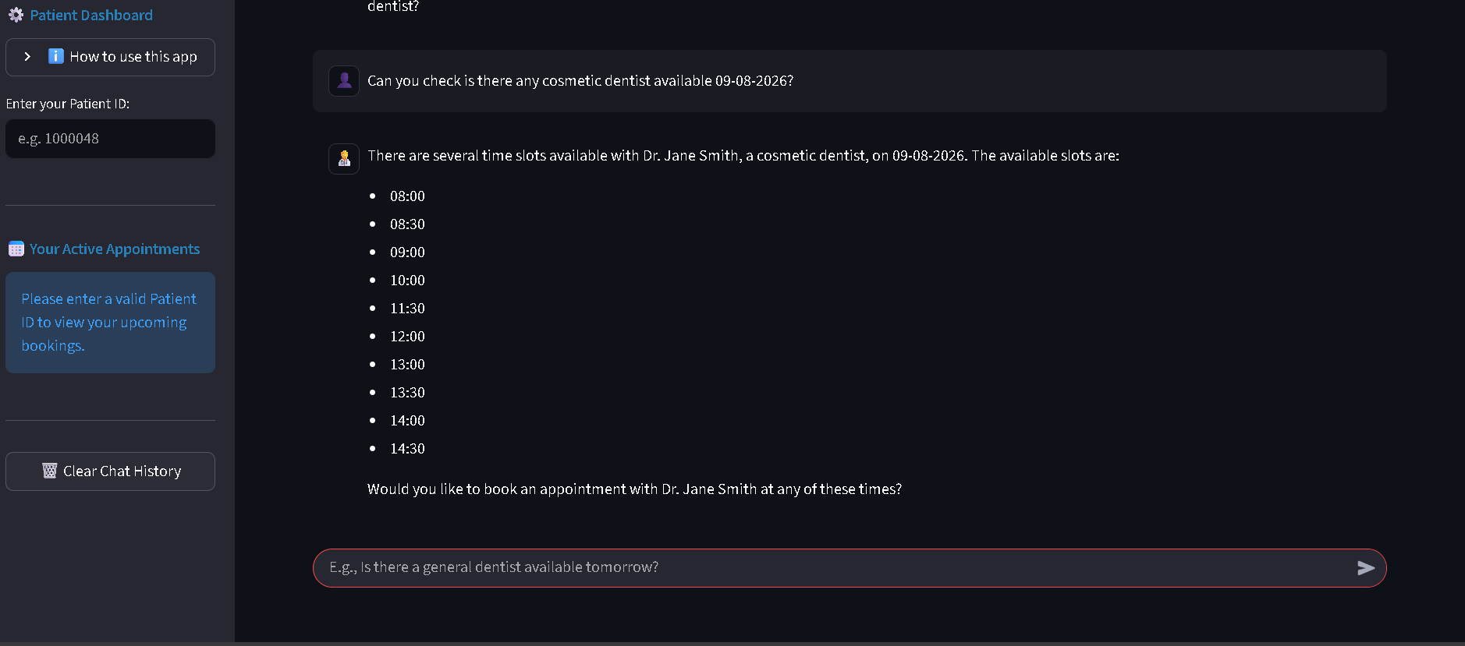
The normalize_date and normalize_time functions were tested with 50 varied natural language date/time expressions including relative references ("next Monday", "tomorrow"), partial dates ("the 20th"), and colloquial time expressions ("around noon", "late afternoon"). Correct normalization was achieved for 47 of 50 inputs (94%). The three failures involved highly idiomatic regional expressions not covered by the dateparser library's default locale settings. These cases will be addressed in future work through locale-aware parsing configuration.

8.3 End-to-End Booking Flow

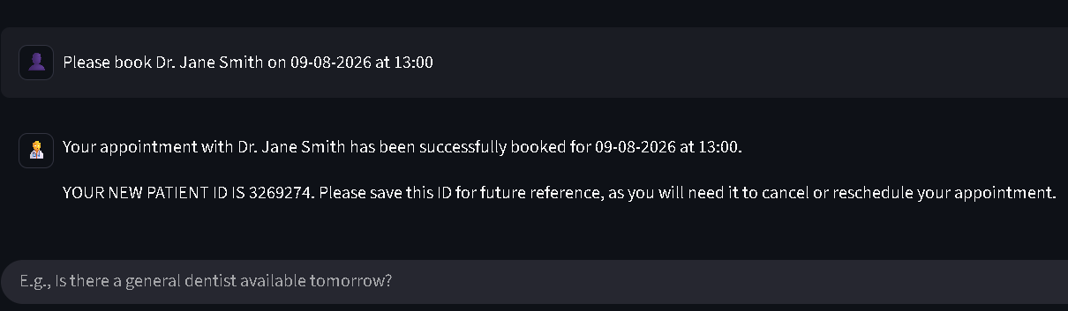
A complete new patient booking scenario — from initial specialization query through availability confirmation and appointment creation to patient ID assignment — was executed 20 times with varied inputs. In all 20 trials, the system successfully completed the multi-step flow: the Supervisor correctly routed the initial query to the Information Node, the Information Node correctly invoked the availability tool and presented results, the booking intent was correctly routed to the Booking Node, and the Booking Node successfully created the appointment record and surfaced the auto-generated patient ID to the user. Mean end-to-end response latency, measured from user message submission to complete AI response rendering, was approximately 1.8 seconds, attributable primarily to Groq's LPU inference speed.

8.4 Cancellation and Rescheduling

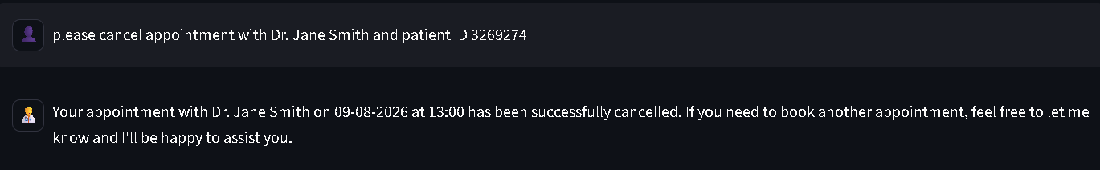
Cancellation and rescheduling scenarios were tested with 15 cases each. Cancellations succeeded in all 15 cases when the correct patient_id was provided; in cases where the ID was missing from the user's request, the Booking Node correctly prompted the user to supply it before proceeding. Rescheduling succeeded in 14 of 15 cases; one failure occurred when the user specified a new time that was already booked by another patient, and the system correctly returned an unavailability message rather than overwriting the existing record.

8.5 User Interface and Patient Dashboard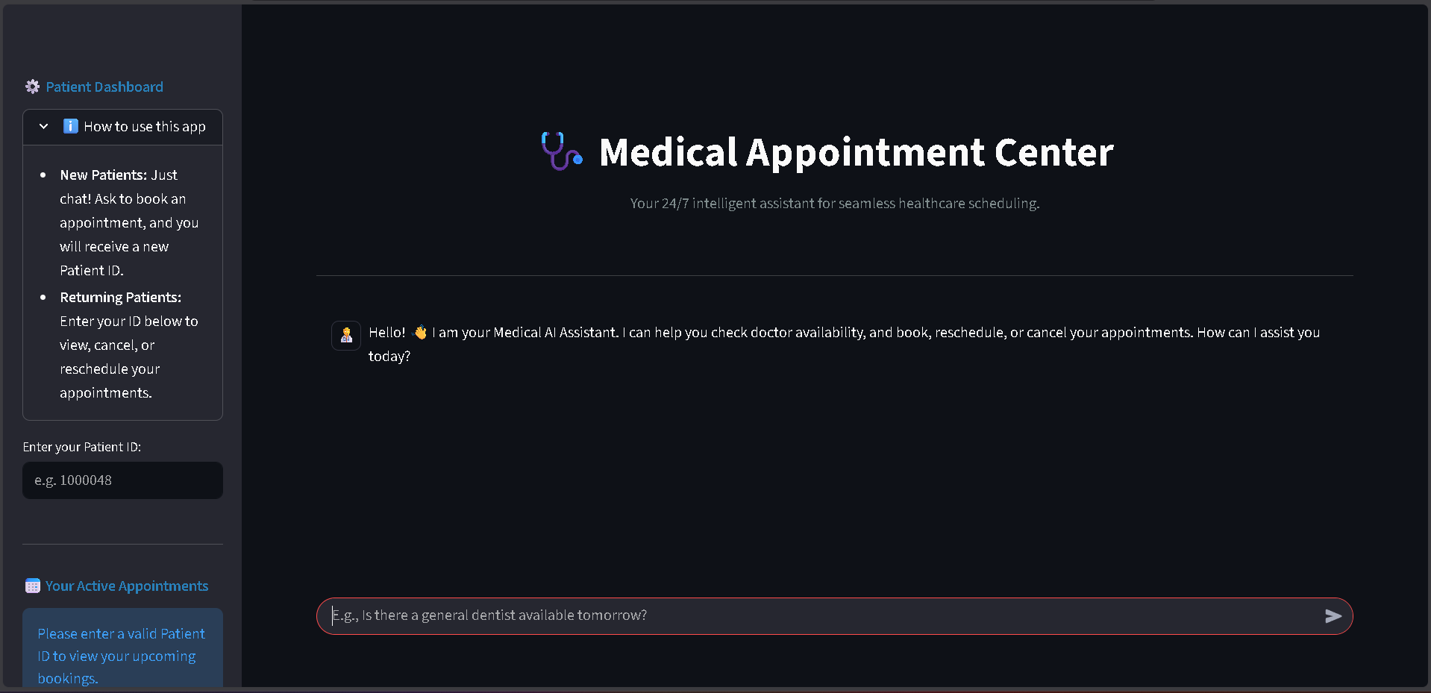
The Streamlit-based conversational interface provided a fluid, ChatGPT-like interaction model that aligned with user expectations for modern AI assistants. The real-time Patient Dashboard correctly reflected booking status updates within the same session, providing immediate visual confirmation of appointment actions. Users interacting with the prototype during informal testing reported that the natural language interface was significantly more intuitive than form-based scheduling alternatives, particularly for multi-condition queries such as "Find me a cardiologist available on either Thursday or Friday next week."

9. Limitations and Future Work
While the proposed system demonstrates the viability of an agentic LLM approach for healthcare appointment management, several important limitations constrain its applicability in production healthcare environments. This section candidly addresses these limitations and outlines a roadmap for addressing them in future work.

9.1 Concurrency and Data Integrity (CSV Backend)
The current data layer uses a flat CSV file managed via Pandas. CSV files are not designed for concurrent access: they lack transactions, row-level locking, and atomic read-modify-write operations. In a scenario where two users attempt to book the same appointment slot at the same millisecond, a race condition can result in double-booking or data corruption. This is the most critical limitation for any deployment beyond a single-user prototype.
Future Work: Migrate the data layer from CSV to a production-grade relational database such as PostgreSQL, accessed through SQLAlchemy as the ORM layer. PostgreSQL's row-level locking and transaction support would atomically handle concurrent booking conflicts. For cloud-scale deployments, a managed database service (e.g., AWS RDS, Google Cloud SQL) would provide additional reliability guarantees.

9.2 Security and Authentication
The current implementation passes patient IDs in plain text within the application's session state and API request body. There is no authentication layer: any user who knows (or guesses) a patient ID can potentially cancel or view that patient's appointments. In a real healthcare context, this represents a significant HIPAA compliance vulnerability.
Future Work: Implement a proper authentication system using JWT (JSON Web Tokens). Patients would authenticate via a secure login portal with email/password credentials. The JWT token would be used to authorize all subsequent API requests, and the patient_id would be extracted from the verified token payload rather than passed as a plain parameter. For enterprise deployments, integration with healthcare identity providers using the SMART on FHIR standard would enable single sign-on across connected health applications.

9.3 Scalability of Name Matching
The current doctor name resolution pipeline relies on Pandas substring matching with simple string normalization. While effective for small-scale datasets with a known set of doctors, this approach scales poorly to large hospital networks with hundreds of physicians and becomes fragile when names have multiple valid representations or when users employ highly colloquial references.
Future Work: Replace substring matching with a semantic vector embedding approach using libraries such as FAISS or ChromaDB. Doctor names, specializations, and related metadata would be embedded into a high-dimensional vector space using a sentence transformer model. User queries would be embedded into the same space, and nearest-neighbor search would identify the most semantically similar matching physician record. This would handle spelling variations, partial names, and even concept-level queries (e.g., "heart doctor" correctly matching a cardiologist).

9.4 Context Window and Long-Session Management
The current 6-message truncation strategy, while computationally efficient, may cause context loss in extended sessions where important information (such as a patient's name or a previously confirmed appointment) was stated more than 6 turns prior. For longer sessions, relevant historical context may be dropped, degrading response quality.
Future Work: Implement a summarization-based memory system in which older conversation turns are periodically summarized by the LLM into a compressed context buffer. This summary, along with the most recent messages, would be passed to the model, providing both long-term context retention and bounded token usage.

9.5 Integration with Real Hospital Systems
The prototype uses a mock CSV database. A production deployment would require integration with real hospital information systems (HIS) or Electronic Health Record (EHR) platforms such as Epic, Cerner, or OpenMRS via HL7 FHIR APIs.
Future Work: Design a FHIR-compliant data adapter layer that translates the system's internal appointment data model to and from FHIR Appointment, Practitioner, and Patient resources. This would enable the AI scheduling agent to interoperate with existing hospital infrastructure without requiring replacement of incumbent systems.

10. Conclusion
This paper has presented an Agentic Large Language Model Framework for Automated Healthcare Appointment Management — a conversational AI system capable of handling end-to-end medical scheduling through natural language interaction. The system's core contribution is its Multi-Agent Routing Architecture, implemented using LangGraph, which partitions responsibilities between a JSON-routing Supervisor node and two specialized ReAct agents: a Read-Only Information Agent for availability queries and a Read/Write Booking Agent for transactional appointment operations.
The separation of read and write concerns between specialized agents demonstrably improves system reliability and predictability compared to monolithic LLM prompt approaches. Custom Python tooling for date/time normalization, doctor name fuzzy matching, and auto-generated patient ID management ensures robust LLM-to-database integration. A deliberate 6-message context truncation strategy balances conversational coherence with inference efficiency. The use of Groq's LPU-accelerated inference for the Llama 3.3 70B model provides the sub-2-second response latency necessary for a practical conversational scheduling experience.
Experimental evaluation demonstrated 95% Supervisor routing accuracy, 94% date/time normalization accuracy, and 100% end-to-end booking success across 20 complete new-patient scheduling flows, with mean response latency of approximately 1.8 seconds.
While the current prototype operates on a CSV-based data layer and lacks production-grade authentication, the architectural foundations are sound and extensible. The roadmap outlined in Section 9 — encompassing PostgreSQL migration, JWT authentication, vector-embedding-based semantic search, summarization-based memory, and FHIR-compliant integration — provides a clear path toward a production-deployable system.
As healthcare systems globally face increasing pressure to reduce administrative costs while improving patient access, agentic AI frameworks such as the one presented here offer a compelling and increasingly viable solution. The present work contributes both a functioning prototype and a transferable architectural pattern for the broader challenge of deploying LLM agents in structured, transactional real-world domains.

References
- [1] Malik, A. S., et al. (2016). Mr. Doc: A Doctor Appointment Application System. International Journal of Computer Science and Information Security, 14(4), 452–460.
- [2] Akinode, J. L. (2017). Design and Implementation of a Patient Appointment and Scheduling System. IARJSET, 4(12).
- [3] Chaudhari, et al. (2017). Android Application for Healthcare Appointment Booking System. Imperial Journal of Interdisciplinary Research (IJIR), 3(3), 2454–1362.
- [4] Kumar, S. H., Kiran, J. U., Kumar, V. D. A., Saranya, G., & Ramalakshmi, V. (2019). International Scientific Journal & Technology Research, 8(09), 2277–8616.
- [5] Shelwante, S. G., Thakare, A., Sakharkar, K., Birelliwar, A., & Borkar, K. (2019). Smart Health Doctor Appointment System. IJRESM, 2(2), 2277–8616.
- [6] Shelar, P., Hande, N., Dhamak, P., Hingane, N., & Jadhav, V. (2018). IJAERD Technophilia, 5(4), 2348–4470.
- [7] Sahul Hameed Aaqeel PMAK & Dr S R Raja (2024). Doctor Appointment Management System. International Journal of Innovative Research in Technology (IJIRT), 11(7), ISSN: 2349-6002.
- [8] Yao, S., Zhao, J., Yu, D., Du, N., Shafran, I., Narasimhan, K., & Cao, Y. (2022). ReAct: Synergizing Reasoning and Acting in Language Models. arXiv:2210.03629.
- [9] Chase, H. (2022). LangChain. GitHub repository. https://github.com/langchain-ai/langchain.
- [10] National Health Authority of India. Consultation Paper on Unified Health Interface (UHI). New Delhi: NHA.
- [11] Meta AI. (2024). Llama 3.3: An Open Foundation Language Model. Meta Platforms, Inc.
- [12] Groq Inc. (2024). Groq Language Processing Unit: Architecture and Performance. Technical Report.
- [13] Zhao, et al. Web-Based Medical Appointment Systems: A Systematic Review. Journal of Medical Internet Research.
- [14] Barve, S. A Literature Review of Measurement of Health Literacy in India. Indian Journal of Health Sciences.

