SIGNAL CONDITIONING CIRCUIT DESIGN

MINI PROJECT ON

DENSITY BASED TRAFFIC SIGNAL USING ARDUINO AND INFRARED SENSOR

UNDER THE GUIDANCE OF

Prof. Suvarna Mahale

SUBJECT INCHARGE

Prof. Diptee S. Patil

PROJECT BY

Akashlal Bathe 13IN1091

Chirayu Mahadeshwar 13IN2005

Nilesh Suryavanshi 13IN1046

DEPARTMENT OF INSTRUMENTATION ENGNEERING

RAMRAO ADIK INSTITUTE OF TECHNOLOGY

NERUL, NAVI MUMBAI

OCTOBER - 2015



RAMRAO ADIK INSTITUTE OF TECHNOLOGY

(Affiliated to the University of Mumbai)

D. Y. Patil Vidyanagar, Sector 7, Nerul, Navi Mumbai – 400706

CERTIFICATE

This is to certify that, the project titled  
“DENSITY BASED TRAFFIC CONTROL USING ARDUINO”  
is a bonafide work done by

Akashlal Bathe 13IN1091

Chirayu Mahadeshwar 13IN2005

Nilesh Suryavanshi 13IN1046

and is submitted in the fulfilment of the requirement for the subject of

Signal Conditioning Circuit Design

Instrumentation Engineering

University of Mumbai

Guide Subject In charge Internal Examiner   
(Ms. Suvarna Mahale) (Ms. Diptee S. Patil)

External Examiner HOD Principal

ACKNOWLEDGEMENT

We express our special thanks to our guide, Ms. Suvarna Mahale mam for the invaluable guidance provided to us at various stages of the project. The task of information collection and understanding was made simple thanks to the extensive literature and advice provided by her.

We also extend our deep gratitude to our respected H.O.D., faculty and towards all our friends and colleagues who have encouraged us with our work and assisted wherever needed.

Our cordial thanks to all those who contributed their sincere co-operation directly and indirectly and material help in works or deeds for the preparation of this project.

iv

ABSTRACT

Arduino is an open-source computer hardware and software company, project and user community that designs and manufactures microcontroller-based kits for building digital devices and interactive objects that can sense and control the physical world.

The project is designed to develop a density based dynamic traffic signal system. The signal timing changes automatically on sensing the traffic density at the junction. Traffic congestion is a severe problem in many major cities across the world and it has become a nightmare for the commuters in these cities.

Conventional traffic light system is based on fixed time concept allotted to each side of the junction which cannot be varied as per varying traffic density. Junction timings allotted are fixed. Sometimes higher traffic density at one side of the junction demands longer green time as compared to standard allotted time.

The proposed project using an Arduino Uno interfaced with sensors, changes the junction timing automatically to accommodate movement of vehicles smoothly avoiding unnecessary waiting time at the junction.

The sensors used in this project are Infrared Proximity sensors in line of sight configuration across the loads to detect the density at the traffic signal. The density of the vehicles is measured in a number of zones based on which timings are allotted accordingly.

Further the project can be enhanced by synchronizing all the traffic junctions in the city by establishing a network among them. The network can be wired or wireless. This synchronization will greatly help in reducing traffic congestion.

**INDEX**

Abstract iv

List of Figures v

List of Tables vi

1. Introduction 9
2. List of components with specifications 10
3. Block diagram 11
4. Circuit diagram 12
5. Working 14
   1. Program 15
6. Advantages , Disadvantages and Applications 24
7. Future scope of the project 25
8. Conclusion 25

Bibliography 25

v

**List of Figures**

Arduino Uno Diagram

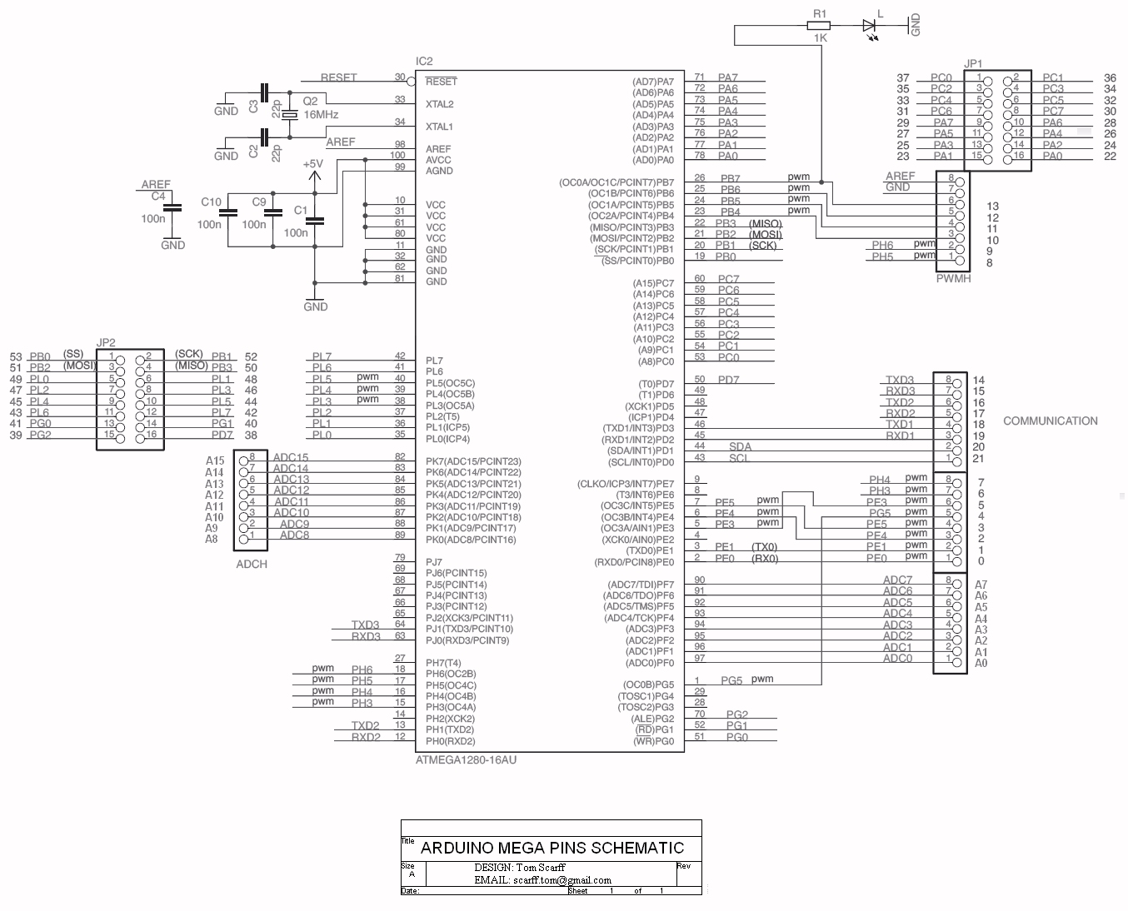

Infrared Sensor

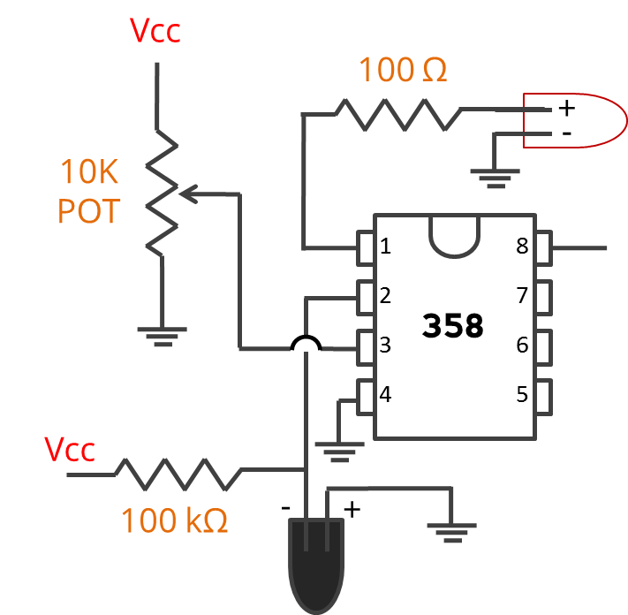

7404 NOT gate

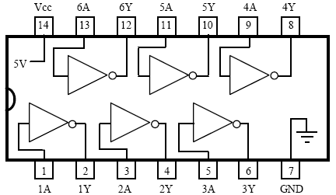

vi

**Table of components with associated cost**

|  |  |  |  |
| --- | --- | --- | --- |
| Number | Part | Cost (in Rs. ) | Description |
| 1 piece | IC 7404 | 5 | NOT gate |
| 1 piece | Arduino | 1500 | Model- Uno |
| 4 pieces | IR Sensor | 300 | For proximity detection |
| 8 pieces | LEDs | 40 | For indication |
| 12 meters | Connecting wires | 120 | For connection |
| 1 piece` | PCB | 10 | For mounting |
| 1 piece | Thermocol | 50 | For model |
| 1 piece | Paper | 15 | For road detailing |
| Total cost | | 2040 | |

**Introduction**

Nowadays, controlling the traffic becomes major issue because of rapid increasein automobiles and also because of large time delays between traffic lights. So, in orderto rectify this problem, we will go for density based traffic lights system.

This project harnesses the processing capabilities and interfacing simplicity of arduino to measure load input (here, the number of vehicles in each lane ) and sets delay of corresponding signal LEDs accordingly.

The heart of this circuit is an Arduino, which is connected to four IR sensors measuring the number of vehicles passing through the four lanes. During the first 10 seconds, all the vehicles passing through the lane is measured which is then processed and accordingly delays are set. Thus, the road with more vehicles is shown green light for a more duration which makes it possible for efficient traffic control.

**List of components with specifications**

Below is a list of components used in this project:

* Arduino Uno
* Connecting wires
* IR sensor
* NOT gate (IC 7404)
* LEDs

**Arduino Uno:**

The Uno is a microcontroller board based on the ATmega328P.

It has

* 14 digital input/output pins (of which 6 can be used as PWM outputs)
* 6 analog inputs
* 16 MHz quartz crystal
* USB connection
* Power jack
* ICSP header
* Reset button

It contains everything needed to support the microcontroller; simply connect it to a computer with a USB cable or power it with a AC-to-DC adapter or battery to get started.. The only bad thing that can generally happen is chip damage, which can be replaced for a few hundred bucks.

**IC 7404 (NOT Gate) :**

It is a basic 6-set not gate, with below specifications (Absolute Maximum Ratings) :

Supply Voltage - 7V

Input Voltage - 5.5V

Operating Free Air Temperature - 0 degree C to (+)70 degree C

Storage Temperature Range - (-)65 degree C to (+)150 degree C

**Working**:

This project uses an Arduino Uno as a microcontroller. Arduino gets its four inputs from IR sensor which are set so that they receive signals from vehicles coming towards the road. The IR readings are logged into the Arduino memory for the first 10 seconds. After the initial 10 seconds, the readings are compared to set levels so that the output delay for LED is calculated. This happens for every of the four main control lines for the signal output.

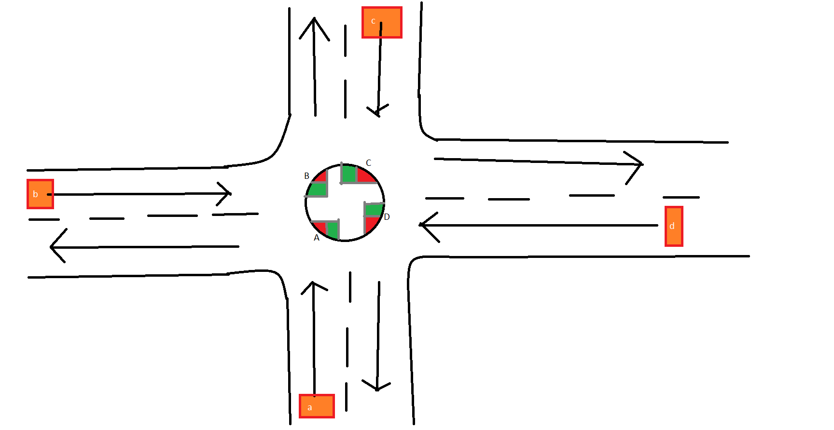

In the next pages, the working of this signal system is explained with the help of program used.

**Program**:

void setup() {

// Setup code, to run once:

pinMode(4,INPUT);

pinMode(5,INPUT);

pinMode(6,INPUT);

pinMode(7,INPUT);

pinMode(8,OUTPUT);

pinMode(9,OUTPUT);

pinMode(10,OUTPUT);

pinMode(11,OUTPUT);

}

void loop() {

int i,j,a,b,c,d,temp,t,p,q,r,s,d0,d1,d2,d3,x[10];

a=0;

b=0;

c=0;

d=0;

if(a==0&&b==0&&c==0&&d==0)

{

digitalWrite(8,LOW);

digitalWrite(9,LOW);

digitalWrite(10,LOW);

digitalWrite(11,LOW);

}

for (t=0;t<1000;t++)

{

if(digitalRead(4)==HIGH)

a++;

if(digitalRead(5)==HIGH)

b++;

if(digitalRead(6)==HIGH)

c++;

if(digitalRead(7)==HIGH)

d++;

delay(10);

}

x[0]=a;

x[1]=b;

x[2]=c;

x[3]=d;

//d0

if(x[0]==0)

{

d0=0;

}

if(x[0]<4)

{

d0=9000;

}

if(x[0]>3&&x[0]<9)

{

d0=15000;

}

if(x[0]>8&&x[0]<15)

{

d0=25000;

}

if(x[0]>14)

{

d0=60000;

}

//d1

if(x[1]==0)

{

d1=0;

}

if(x[1]<4)

{

d1=9000;

}

if(x[1]>3&&x[1]<9)

{

d1=15000;

}

if(x[1]>8&&x[1]<15)

{

d1=25000;

}

if(x[1]>14)

{

d1=60000;

}

//d2

if(x[2]==0)

{

d2=0;

}

if(x[2]<4)

{

d2=9000;

}

if(x[2]>3&&x[2]<9)

{

d2=15000;

}

if(x[2]>8&&x[2]<15)

{

d2=25000;

}

if(x[2]>14)

{

d2=60000;

}

//d3

if(x[3]==0)

{

d3=0;

}

if(x[3]<4)

{

d3=9000;

}

if(x[3]>3&&x[3]<9)

{

d3=15000;

}

if(x[3]>8&&x[3]<15)

{

d3=25000;

}

if(x[3]>14)

{

d3=60000;

}

digitalWrite(8,HIGH);

digitalWrite(9,LOW);

digitalWrite(10,LOW);

digitalWrite(11,LOW);

delay(d0);

digitalWrite(8,LOW);

digitalWrite(9,HIGH);

digitalWrite(10,LOW);

digitalWrite(11,LOW);

delay(d1);

digitalWrite(8,LOW);

digitalWrite(9,LOW);

digitalWrite(10,HIGH);

digitalWrite(11,LOW);

delay(d2);

digitalWrite(8,LOW);

digitalWrite(9,LOW);

digitalWrite(10,LOW);

digitalWrite(11,HIGH);

delay(d3);

}

**Working with program blocks:**

The understanding of working of this circuit will be made simpler when the program is broken down into blocks, as shown below:

void setup() {

// Setup code, to run once:

pinMode(4,INPUT);

pinMode(5,INPUT);

pinMode(6,INPUT);

pinMode(7,INPUT);

pinMode(8,OUTPUT);

pinMode(9,OUTPUT);

pinMode(10,OUTPUT);

pinMode(11,OUTPUT);

}

**This block of code sets the pin connections for input and output in the Arduino Uno.**

void loop() {

int i,j,a,b,c,d,temp,t,p,q,r,s,d0,d1,d2,d3,x[10];

**This block contains all the variables used throughout the program. a,b,c,d are inputs, d0 through d3 are delays for output delays**

a=0;

b=0;

c=0;

d=0;

if(a==0&&b==0&&c==0&&d==0)

{

digitalWrite(8,LOW);

digitalWrite(9,LOW);

digitalWrite(10,LOW);

digitalWrite(11,LOW);

}

for (t=0;t<1000;t++)

{

if(digitalRead(4)==HIGH)

a++;

if(digitalRead(5)==HIGH)

b++;

if(digitalRead(6)==HIGH)

c++;

if(digitalRead(7)==HIGH)

d++;

delay(10);

}

**Inputs are initialized to zero, and for the first 10 seconds the number of vehicles are counted.**

x[0]=a;

x[1]=b;

x[2]=c;

x[3]=d;

**A backup of inputs are taken into an array**

//Delay

if(x[0]==0)

{

d0=0;

}

if(x[0]<4)

{

d0=9000;

}

if(x[0]>3&&x[0]<9)

{

d0=15000;

}

if(x[0]>8&&x[0]<15)

{

d0=25000;

}

if(x[0]>14)

{

d0=60000;

}

**Based on the inputs, delays are set. This code is repeated four times, to get four delays**

digitalWrite(8,HIGH);

digitalWrite(9,LOW);

digitalWrite(10,LOW);

digitalWrite(11,LOW);

delay(d0);

digitalWrite(8,LOW);

digitalWrite(9,HIGH);

digitalWrite(10,LOW);

digitalWrite(11,LOW);

delay(d1);

digitalWrite(8,LOW);

digitalWrite(9,LOW);

digitalWrite(10,HIGH);

digitalWrite(11,LOW);

delay(d2);

digitalWrite(8,LOW);

digitalWrite(9,LOW);

digitalWrite(10,LOW);

digitalWrite(11,HIGH);

delay(d3);

}

**Now that we have the delays based on number of vehicles on each lane, we can light up signals accordingly**

**Advantages**

* For faster transfer of traffic in road junction
* Reduced time of traveling
* Increased efficiency
* Fuel saving
* Saves peoples time
* Reduced accidents

**Disadvantages**

* IR sensors sometimes may absorb normal light also. As a result, traffic system works in improper way.
* IR sensors work only for fewer distances
* We have to arrange IR sensors in accurate manner otherwise they may not detect the traffic density.
* If sensing is done via image processing, the output would be more accurate but it becomes more complex
* IR sensor may give inaccurate output, if dust particles are logged near to the transmitter receiver signal

**Applications**

* For traffic signal monitoring and controlling
* If a number of signals are synchronized, its possible to build a smart city
* Automated driving vehicles can communicate with the signals wirelessly, so indicators may become redundant.

**Future scope of project:**

This project may spearhead the revolution of Digital India

Building a smart city with automatic traffic transmission is possible as vehicles can communicate with the traffic system wirelessly and take decisions on their own, making autopilot more of a reality.

This project may replace current traffic system and open up more avenues for a future ready world.

**Conclusion**

Thus we have successfully designed and implemented the circuit of density based traffic control system, with IR sensor, Arduino and a few LEDs for indication.

**Bibliography**

<https://www.arduino.cc/en/Main/ArduinoBoardUno>

<http://www.instruconnect.net/arduino>

<http://www.udemy.com/beginning-arduino>

[http://www.quora.com/building-first-arduino-circuit](http://www.quora.com/building-first-arduino-circuit.html)

[http://en.wikipedia.org/wiki/arduino](http://www.wikipedia/)