Clinical ctDNA Report — Research Use Only
Patient ID | Tier | Total Score | Date
BR200023 | No Recurrence Signal | 11.34/100 | 2026-07-29

Score Breakdown
Tumor Burden (0-40): 3.3 Clonal Expansion (0-25): 8.0 Driver Inc. (0-25): 0.0 Mutation Gain (0-10): 0.0
Total: 11.34/100

Component Interpretation
- Tumor Burden (0-40): Low
- Clonal Expansion (0-25): Low
- Driver Inc. (0-25): None
- Mutation Gain (0-10): None

Visual Summary
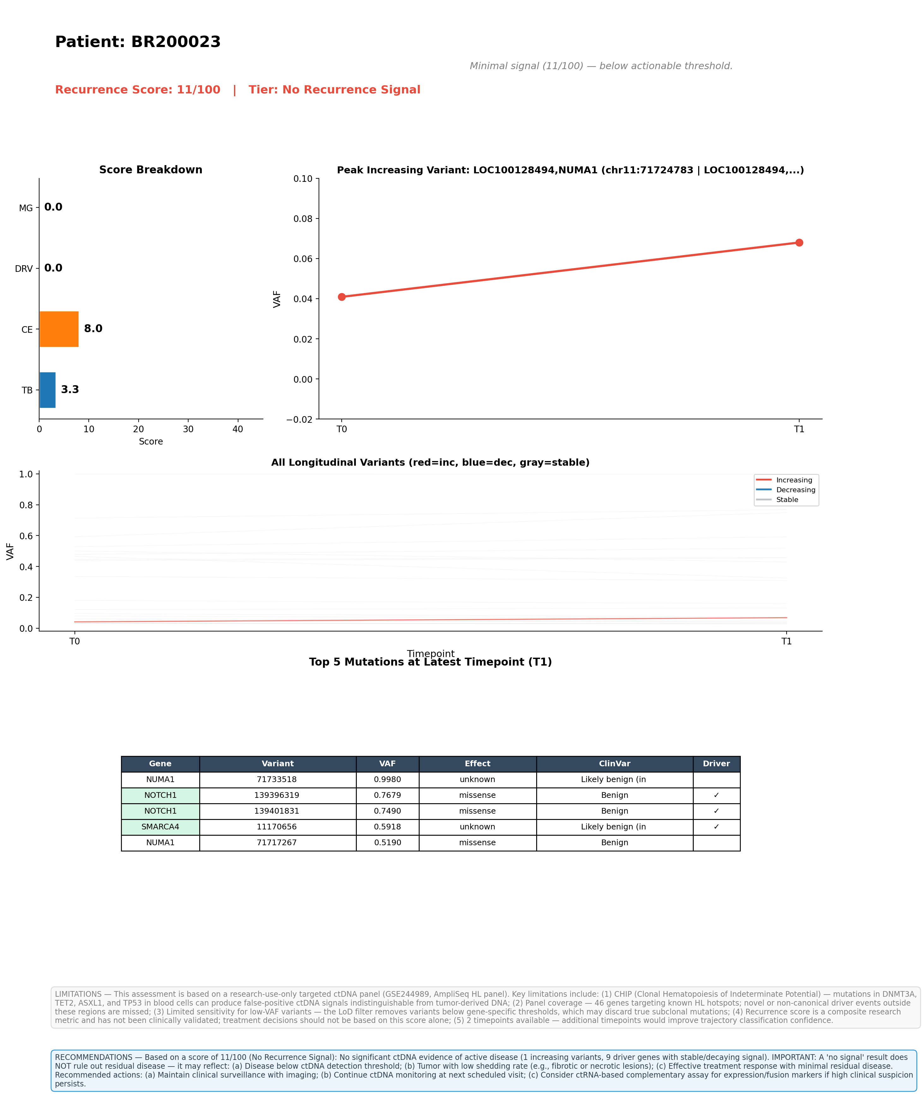

Top 5 Variants by VAF (Latest Timepoint)
See visual summary above for variant details.

Limitations
1. CHIP (Clonal Hematopoiesis): Mutations in DNMT3A, TET2, ASXL1, TP53 from blood cells can produce false-positive ctDNA signals.
2. Panel coverage: 46-gene targeted AmpliSeq panel; novel drivers outside these regions are missed.
3. Sensitivity: Gene-specific LoD filters may discard true subclonal mutations.
4. Research use only: This score is not clinically validated.
5. Timepoints: 3 available; trajectory confidence improves with more timepoints.

Recommendations
No significant ctDNA evidence of active disease. IMPORTANT: Does NOT rule out residual disease. May reflect: (a) Disease below detection threshold; (b) Low-shedding tumor; (c) Effective treatment response. Recommended: (a) Maintain clinical surveillance; (b) Continue ctDNA monitoring; (c) Consider ctRNA assay if high clinical suspicion.

