Clinical ctDNA Report — Research Use Only
Patient ID | Tier | Total Score | Date
LH200002 | Possible Recurrence | 50.52/100 | 2026-07-29

Score Breakdown
Tumor Burden (0-40): 27.5 Clonal Expansion (0-25): 8.0 Driver Inc. (0-25): 10.0 Mutation Gain (0-10): 5.0
Total: 50.52/100

Component Interpretation
- Tumor Burden (0-40): High
- Clonal Expansion (0-25): Low
- Driver Inc. (0-25): Low
- Mutation Gain (0-10): Low

Visual Summary
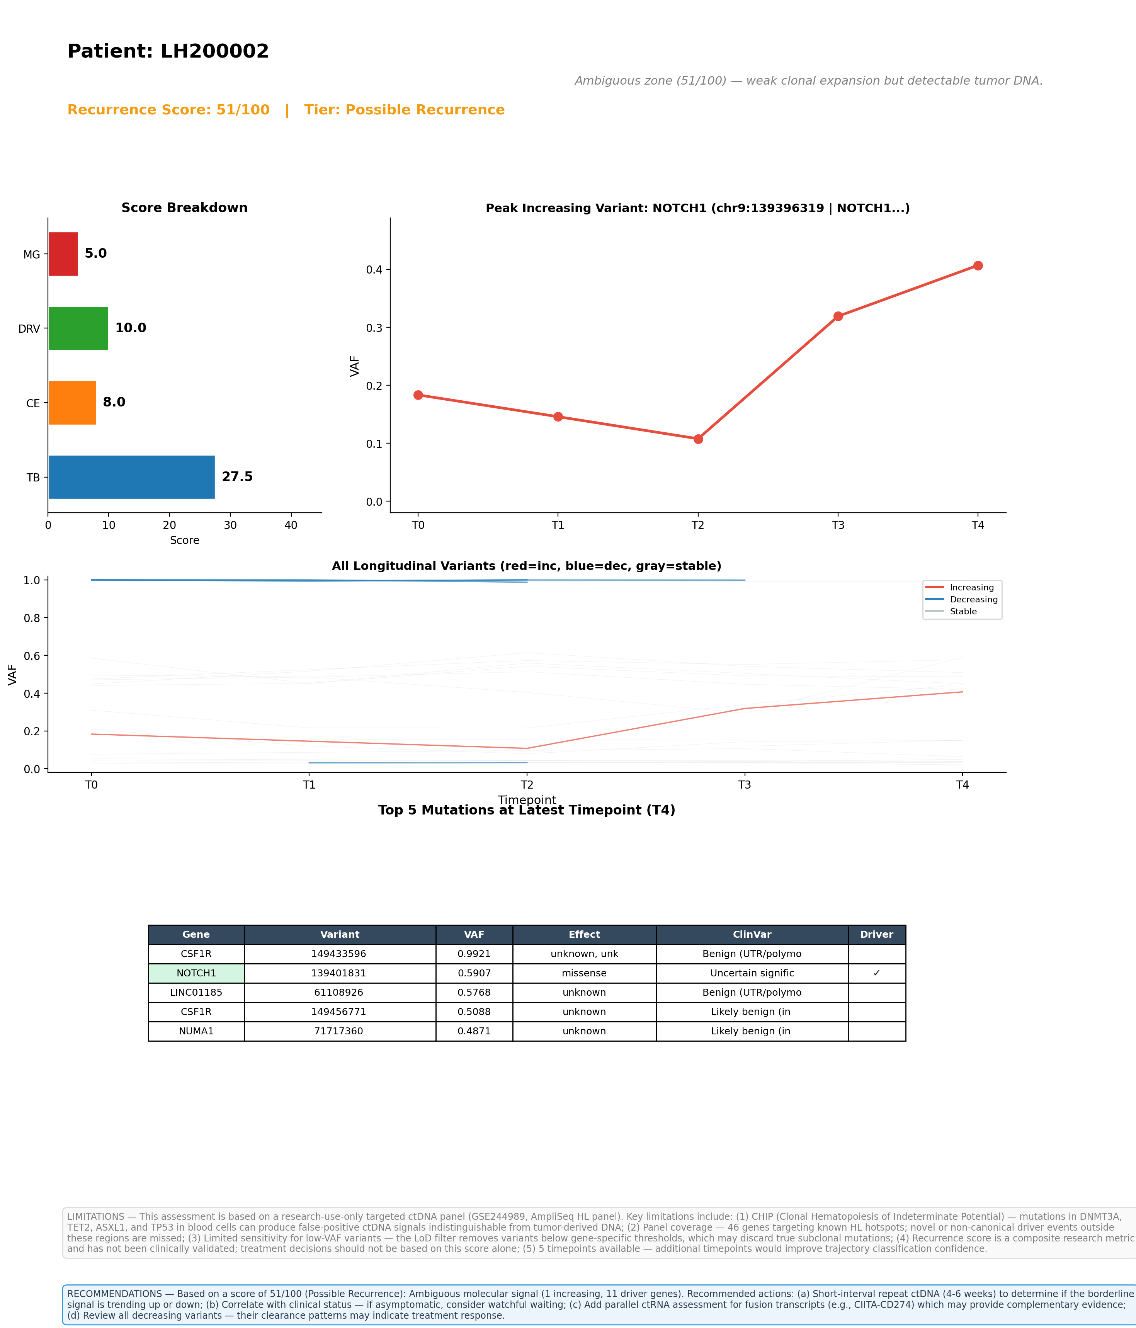

Top 5 Variants by VAF (Latest Timepoint)
See visual summary above for variant details.

Limitations
1. CHIP (Clonal Hematopoiesis): Mutations in DNMT3A, TET2, ASXL1, TP53 from blood cells can produce false-positive ctDNA signals.
2. Panel coverage: 46-gene targeted AmpliSeq panel; novel drivers outside these regions are missed.
3. Sensitivity: Gene-specific LoD filters may discard true subclonal mutations.
4. Research use only: This score is not clinically validated.
5. Timepoints: 3 available; trajectory confidence improves with more timepoints.

Recommendations
Ambiguous molecular signal. Recommended: (a) Short-interval repeat ctDNA (4-6 weeks); (b) Clinical correlation; (c) Consider ctRNA complementary assay; (d) Review decreasing variant clearance patterns.

