Clinical ctDNA Report — Research Use Only
Patient ID | Tier | Total Score | Date
LH210010 | High-Confidence Recurrence | 100.0/100 | 2026-07-29

Score Breakdown
Tumor Burden (0-40): 40.0 Clonal Expansion (0-25): 25.0 Driver Inc. (0-25): 25.0 Mutation Gain (0-10): 10.0
Total: 100.0/100

Component Interpretation
- Tumor Burden (0-40): High
- Clonal Expansion (0-25): High
- Driver Inc. (0-25): High
- Mutation Gain (0-10): High

Visual Summary
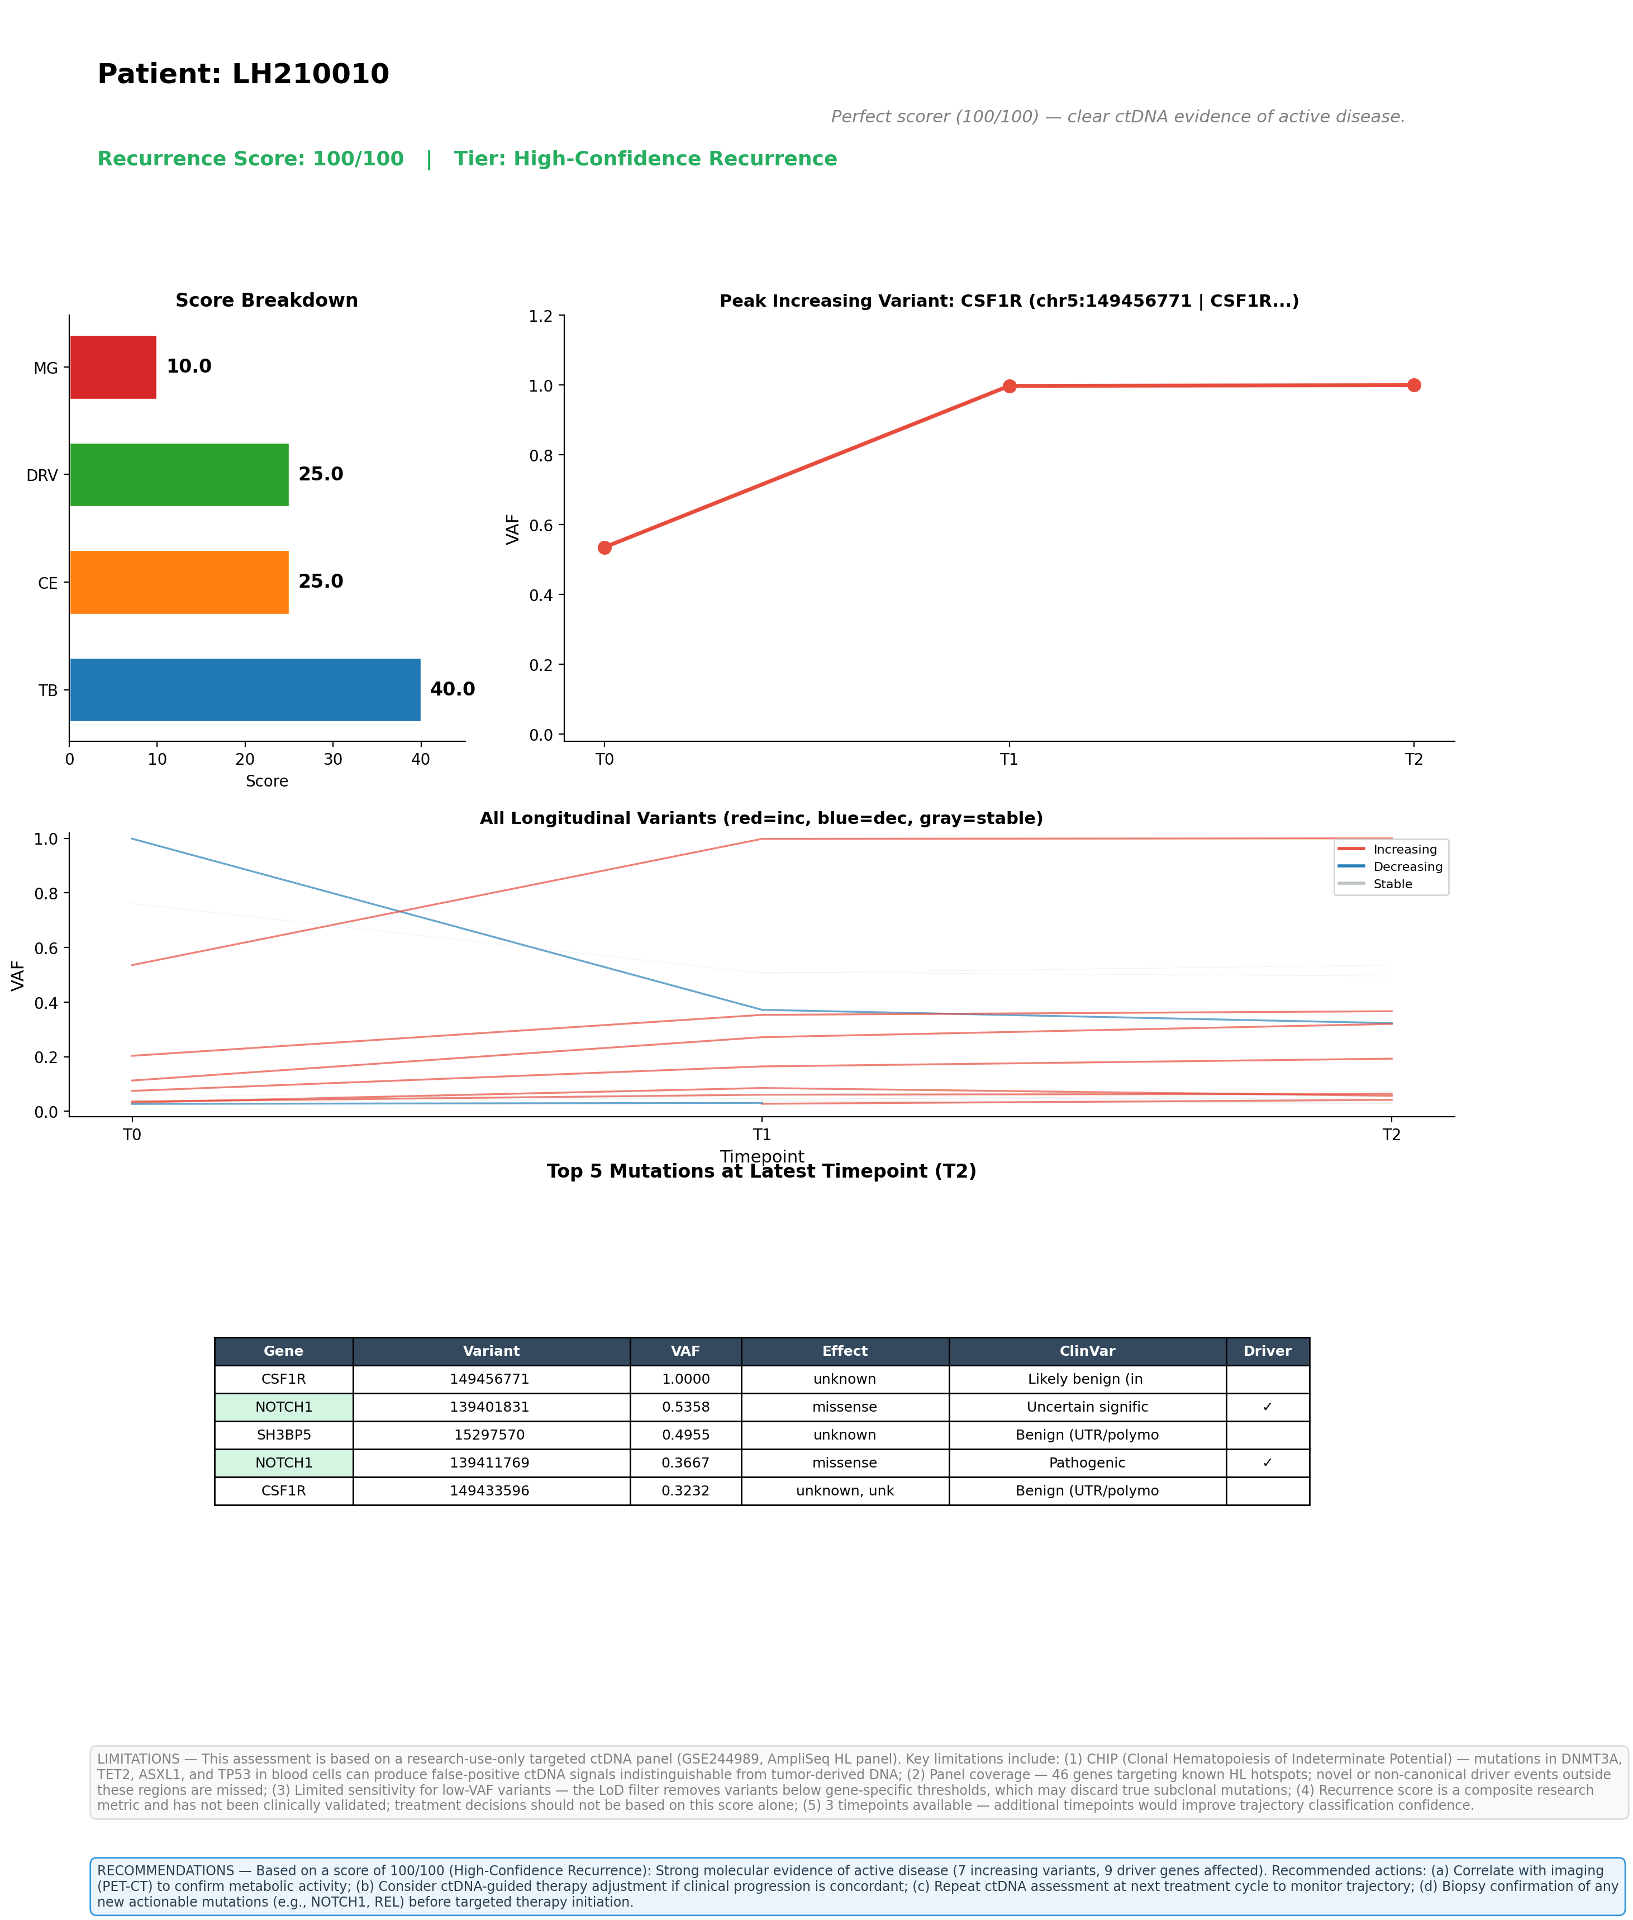

Top 5 Variants by VAF (Latest Timepoint)
See visual summary above for variant details.

Limitations
1. CHIP (Clonal Hematopoiesis): Mutations in DNMT3A, TET2, ASXL1, TP53 from blood cells can produce false-positive ctDNA signals.
2. Panel coverage: 46-gene targeted AmpliSeq panel; novel drivers outside these regions are missed.
3. Sensitivity: Gene-specific LoD filters may discard true subclonal mutations.
4. Research use only: This score is not clinically validated.
5. Timepoints: 3 available; trajectory confidence improves with more timepoints.

Recommendations
Strong molecular evidence of active disease. Recommended: (a) PET-CT correlation; (b) Consider therapy adjustment if clinically indicated; (c) Repeat ctDNA at next cycle; (d) Biopsy confirmation of actionable mutations before targeted therapy.

