User Guide:

1-Python Setup

User must first setup python on his computer version 3 to be able to use our program and run commands on command prompt.

2-Using CMD

1-Open two CMD windows --> run as administrator

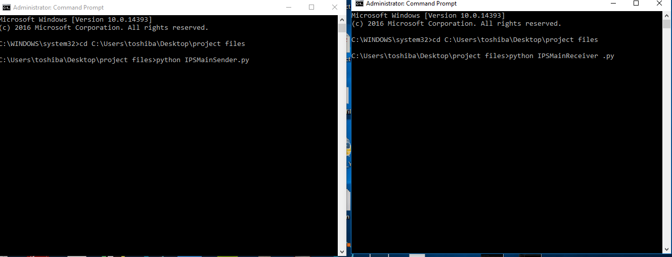
2-Go to the path of our program files:
cd path
Example:
cd C:/Users/toshiba/Desktop/project
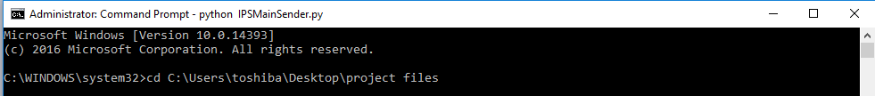

3-Then type in the first window:
python IPSMainReceiver.py

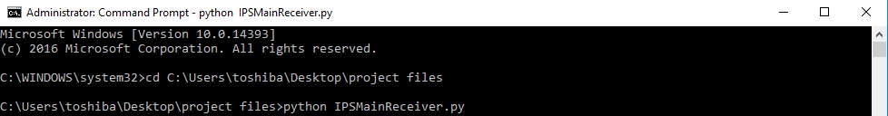

4-Then type in the second window:
python IPSMainSender.py

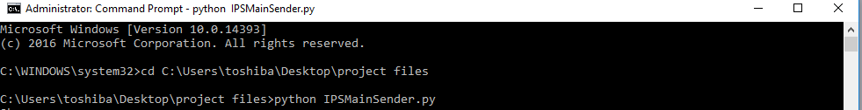

3-The program will run in background
The firewall will be turned off then the program will run in background sniffing the packets first the search in payload for bad signatures and the decision tree classifier will see if there are anomalies in the packets according to standards of RFC

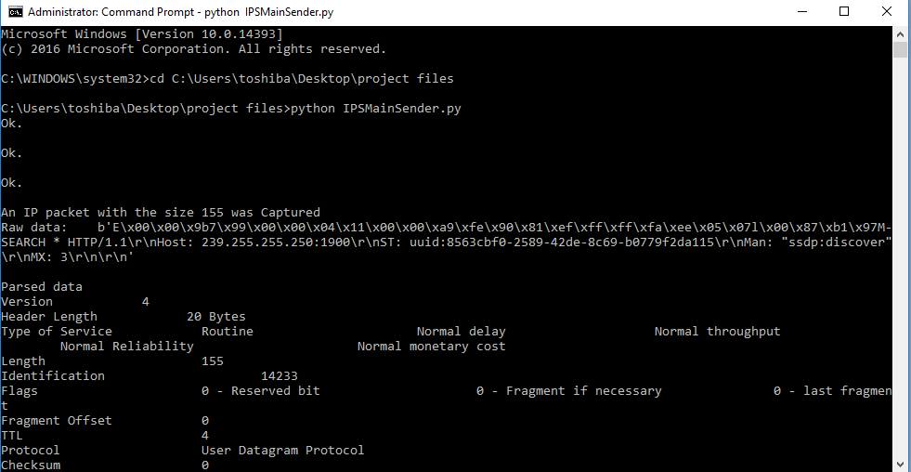

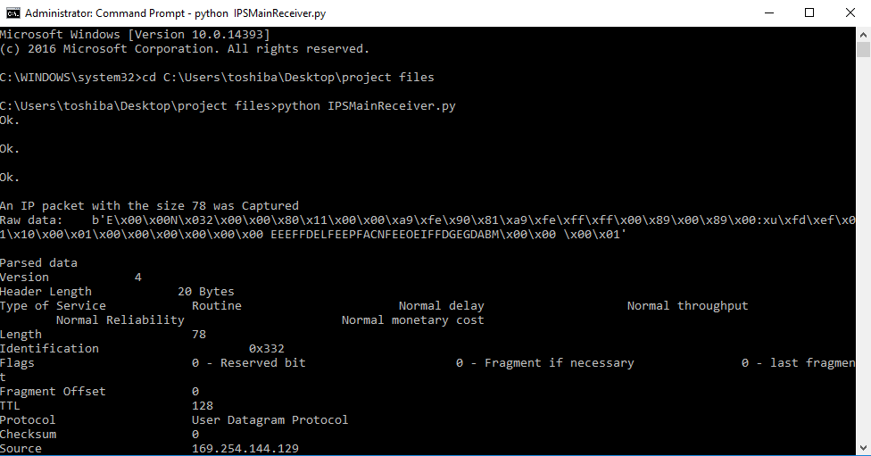

4-Terminate the program
1-Enter CTRL+C on keyboard.
2-Type python Firewall.py.
To turn on the firewall before terminating the program

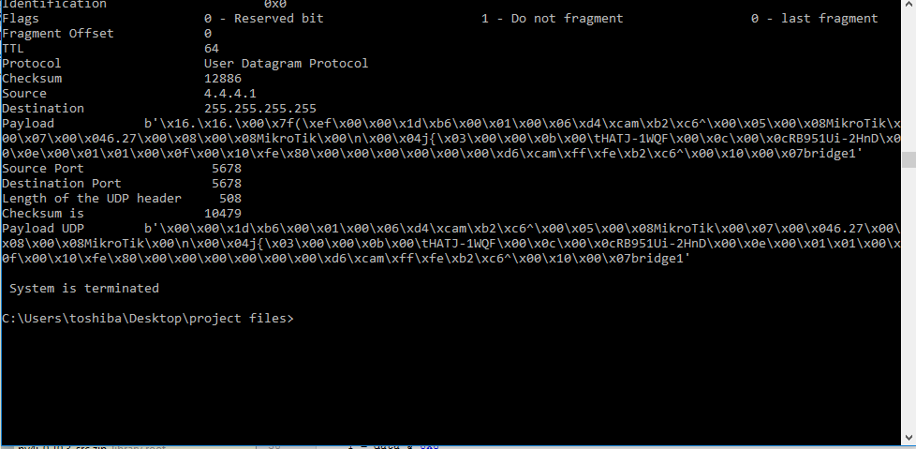

Figure when pressing CTRL+C shows message System is terminated

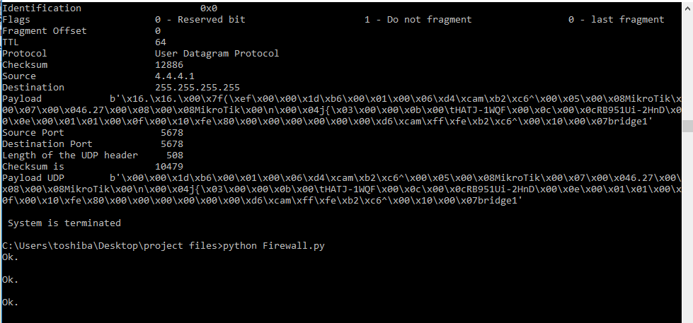

Figure when typing python Firewall.py

