Insurance Policy & Claims Analysis
Data Cleaning & Dashboard Build — Process Documentation
Tools: Power Query · Power BI Desktop

1. Project Overview
This project takes a raw insurance operations export (policies, customers, and claims combined in a single file) and turns it into a clean, analysis-ready model in Power BI. The work covers two phases: (1) importing and cleaning the data in Power Query, and (2) building summary KPIs and visuals in Power BI Desktop to understand how claims activity compares to premium income.

1.1 Data Source
Source file: InsuranceData(1).csv — a single flat file containing one row per policy, with an associated claim (where one exists).
Column | Description
PolicyNumber | Unique identifier for the policy (e.g. P1, P2...)
CustomerID | Unique identifier for the customer (e.g. C1, C2...)
Gender | Policyholder gender
Age | Policyholder age
PolicyType | Auto, Travel, Health, Home, or Life
PolicyStartDate / PolicyEndDate | Policy coverage window
PremiumAmount | Premium charged for the policy
CoverageAmount | Insured coverage value
ClaimNumber | Identifier for a claim linked to the policy
ClaimDate | Date the claim was filed (blank if no claim)
ClaimAmount | Amount claimed
ClaimStatus | Settled, Pending, or Rejected

As loaded, the file contains 10,004 rows across 13 columns.

2. Data Cleaning in Power Query
All cleaning steps were performed in the Power Query Editor (accessed via Get Data → Text/CSV in Power BI Desktop) before the data was loaded into the report model.
Step 1: Connect to the source file
In Power BI Desktop, used Home → Get Data → Text/CSV and selected InsuranceData(1).csv. The preview window showed the 13 columns and offered Load or Transform Data — chose Transform Data to open Power Query and clean the file before loading.
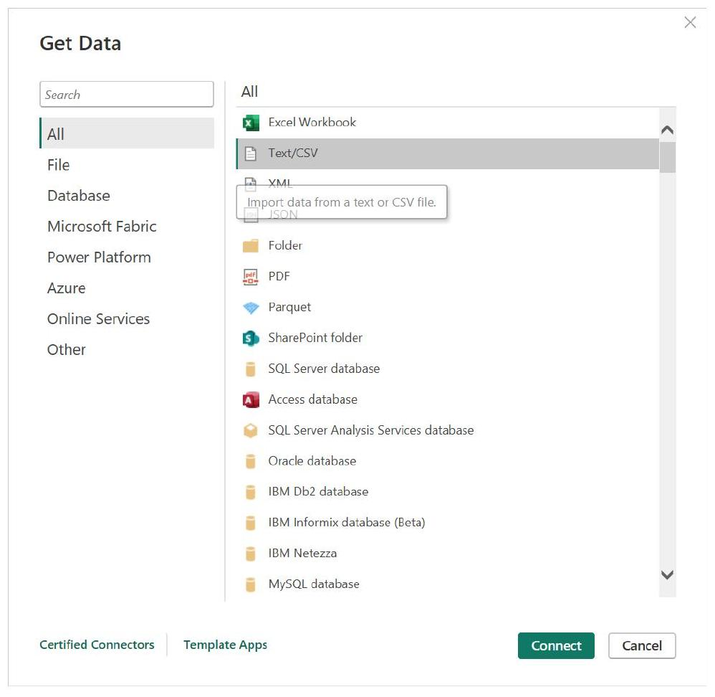
Figure 1 — Get Data → Text/CSV connector in Power BI Desktop.
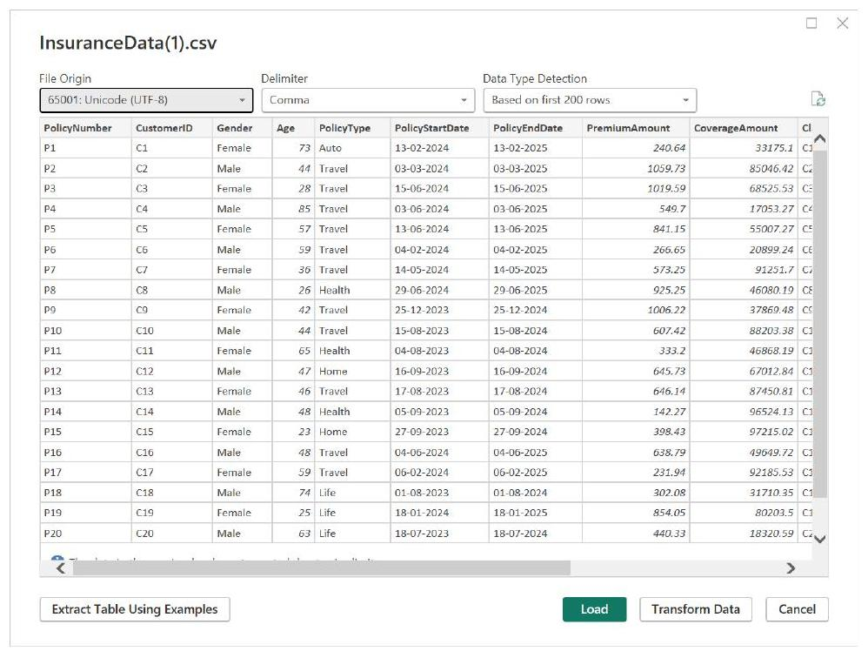
Figure 2 — CSV load preview for InsuranceData(1).csv, showing the 13 source columns.
Step 2: Set column profiling to the full dataset
By default, Power Query's column quality/distribution statistics (the small bar charts under each column header) are based only on the first 1,000 rows, shown by the status bar note "Column profiling based on top 1000 rows." This was changed to "Column profiling based on entire data set" so that data quality issues (errors, duplicates, distinct/unique counts) were evaluated across all 10,000+ rows rather than a sample — this is what first revealed a jump from ~999 to ~10,000 distinct values once full profiling was enabled.
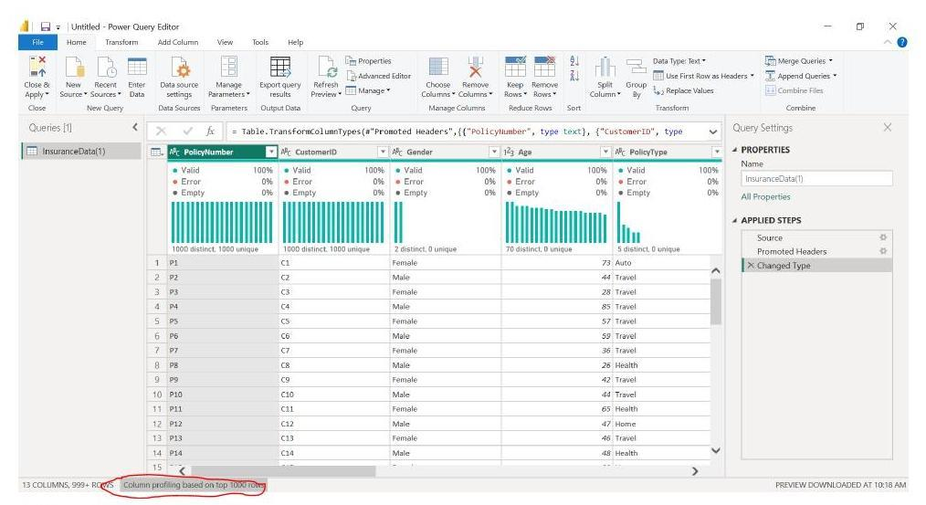
Figure 3 — Column profiling based on only the top 1,000 rows (note the 1,000 distinct/unique counts).
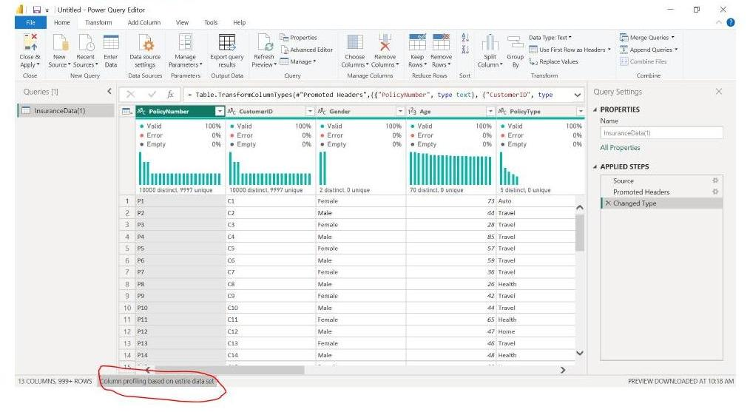
Figure 4 — Column profiling switched to the entire data set (distinct/unique counts jump to ~10,000).
Step 3: Promote headers and set initial data types
Applied Use First Row as Headers, then let Power Query auto-detect data types for each column (Changed Type step). Text-based ID and category columns (PolicyNumber, CustomerID, Gender, PolicyType, ClaimStatus) were set to Text; Age was set to a whole number; monetary columns (PremiumAmount, CoverageAmount, ClaimAmount) were set to decimal number.
Step 4: Remove duplicate rows
Right-clicked the PolicyNumber column header and selected Remove Duplicates from the context menu (alongside options such as Keep Duplicates, Remove Errors, and Replace Errors). This ensured each policy appears only once. After this step, full-dataset profiling confirmed PolicyNumber and CustomerID both showed 10,000 distinct / 10,000 unique values, with no duplicates remaining.
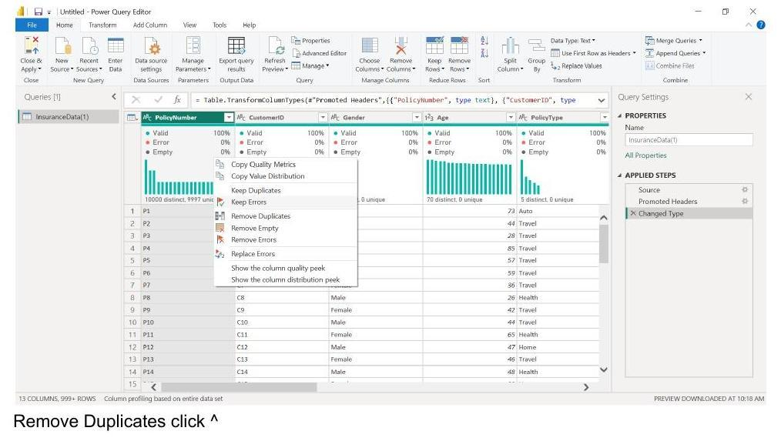
Figure 5 — Right-click context menu on the PolicyNumber column, selecting Remove Duplicates.
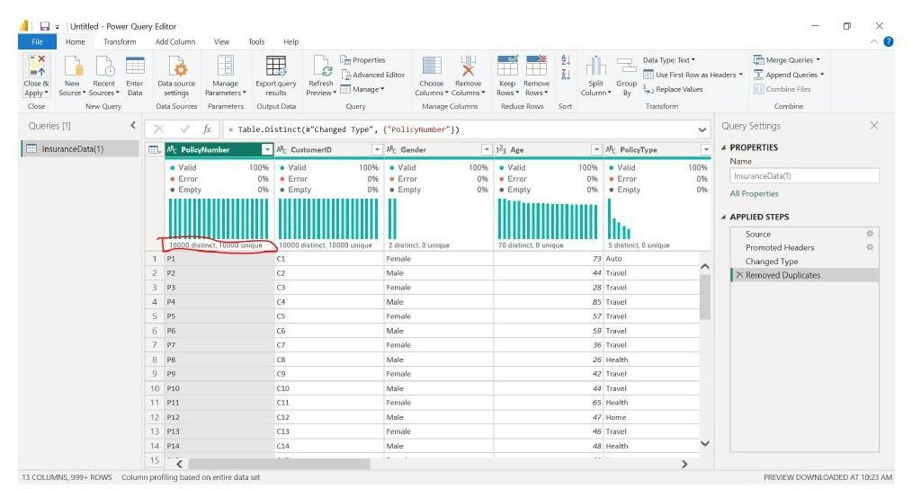
Figure 6 — After removing duplicates: PolicyNumber and CustomerID both show 10,000 distinct / 10,000 unique values.
Step 5: Fix date columns with Change Type Using Locale
Applying a plain Date type to PolicyStartDate, PolicyEndDate, and ClaimDate initially produced conversion errors on a large share of rows (PolicyEndDate showed roughly 60% errors after a first attempt). The cause was the date format in the source file (DD-MM-YYYY), which Power Query's default locale was misreading as month-first.
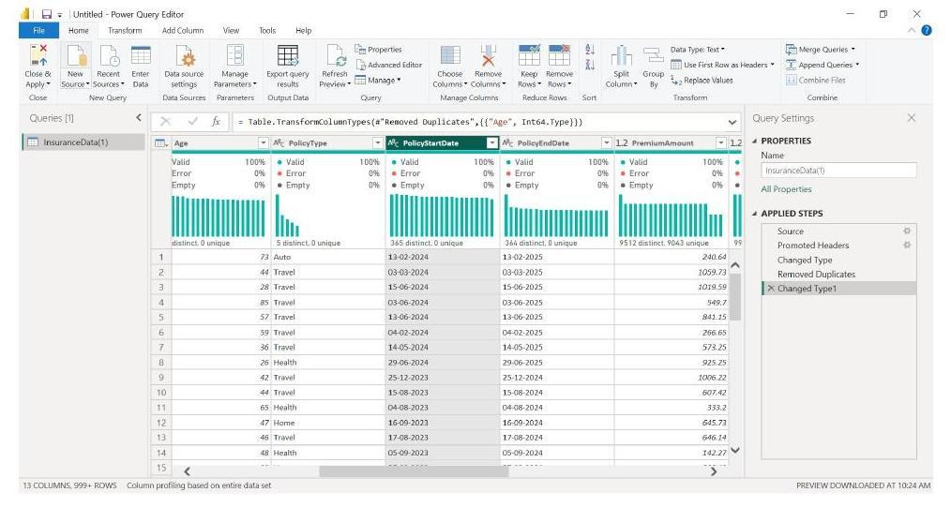
Figure 7 — Initial Changed Type step produces Error values across the date columns.
This was resolved using Transform → Data Type → Using Locale on each date column, explicitly setting Data Type = Date and Locale = English (United Kingdom), which correctly parses day-first dates. This was repeated for PolicyStartDate, PolicyEndDate, and ClaimDate, eliminating the type-conversion errors.
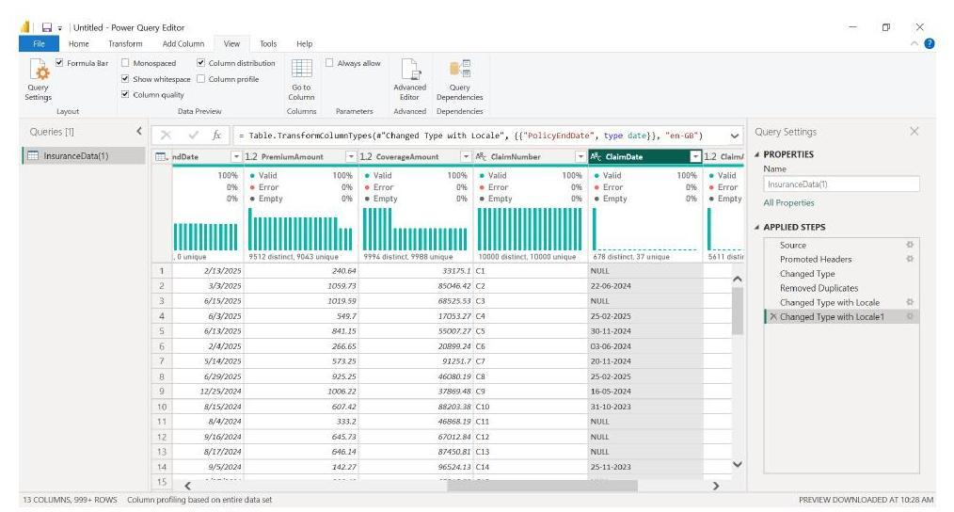
Figure 8 — Change Type with Locale dialog: Data Type = Date, Locale = English (United Kingdom), applied to ClaimDate.
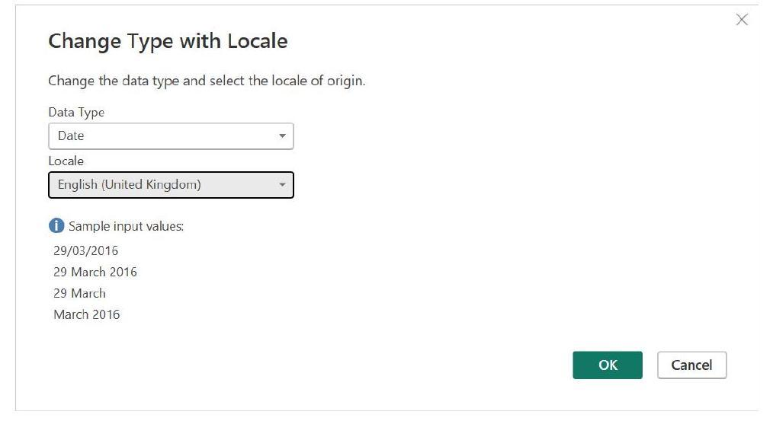
Figure 9 — ClaimDate and neighboring columns showing 0% errors after the locale-aware conversion.
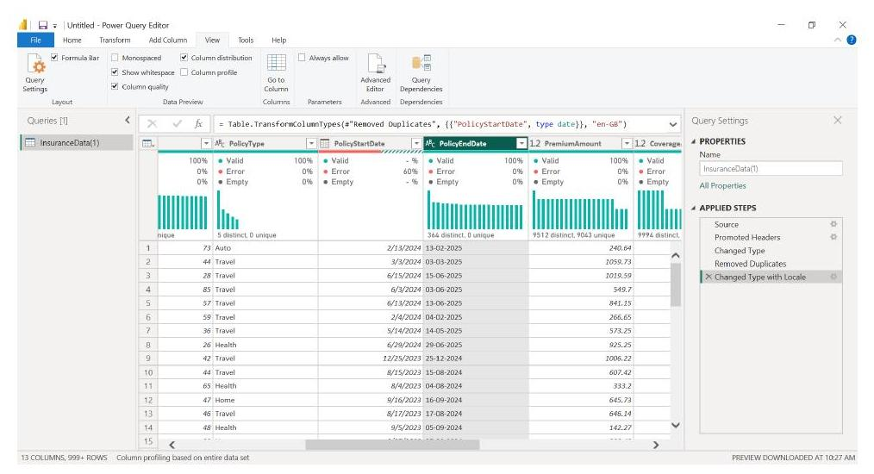
Figure 10 — Locale fix applied to PolicyEndDate; PolicyStartDate still shows ~60% errors before the same fix is applied to it.
Step 6: Verify the cleaned table
After reapplying the locale-aware date conversion, the query showed 0% errors across the key columns, 13 columns and approximately 10,000 rows, and consistent, valid date values throughout. This was marked as the end of the data cleaning phase before loading the query into the Power BI data model.
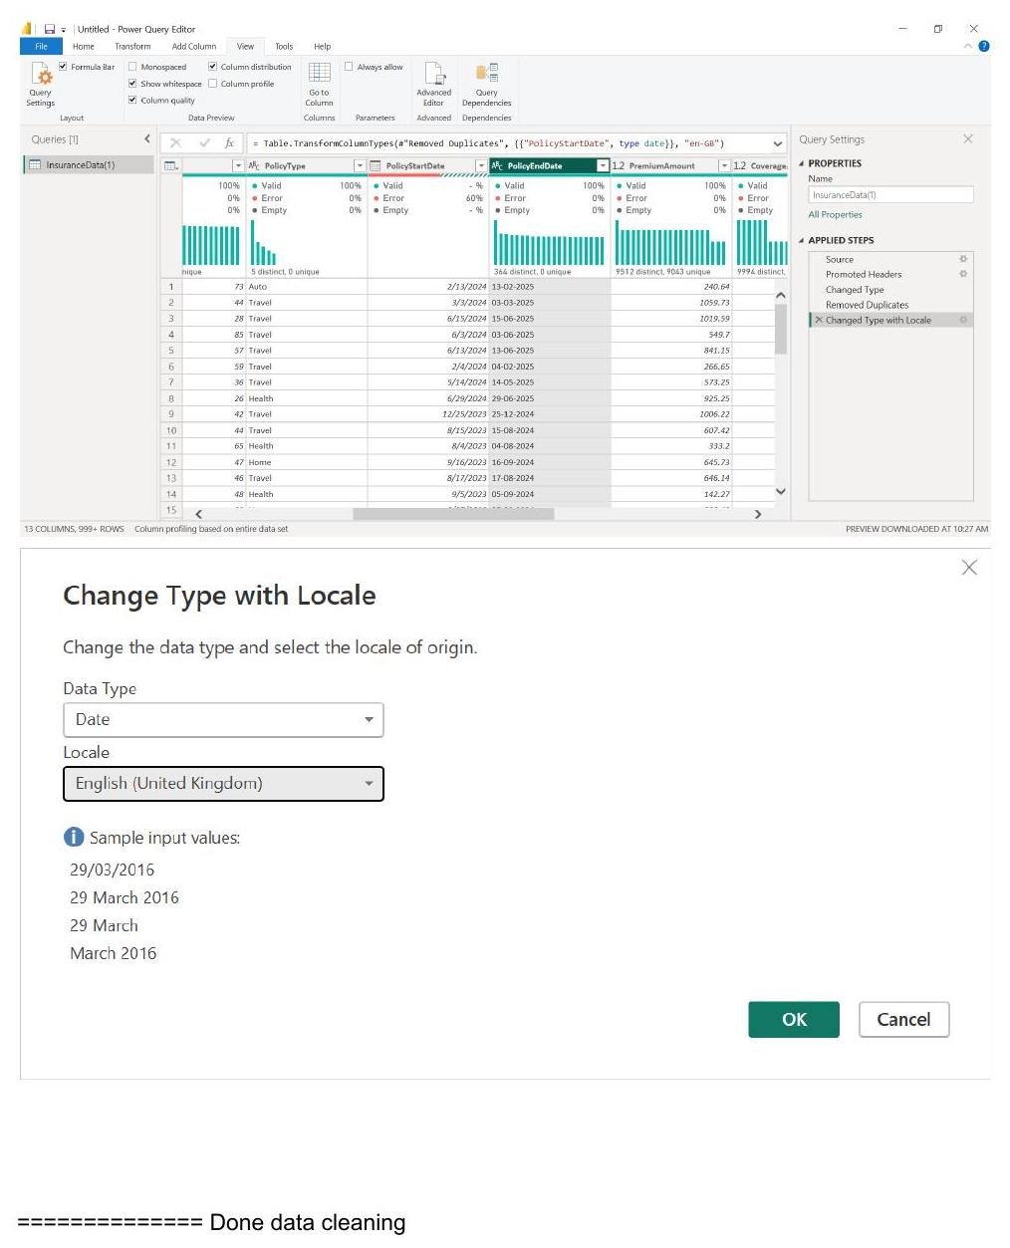
Figure 11 — Change Type with Locale applied to PolicyStartDate; all date columns now show 0% errors — end of data cleaning.

2.1 Summary of cleaning actions
- Loaded InsuranceData(1).csv via Get Data → Text/CSV → Transform Data.
- Set column profiling to evaluate the entire dataset, not just the first 1,000 rows.
- Promoted headers and set appropriate data types for each column.
- Removed duplicate policy records using Remove Duplicates on PolicyNumber.
- Corrected date parsing errors on PolicyStartDate, PolicyEndDate, and ClaimDate using Change Type with Locale (English – United Kingdom) to correctly interpret day-first dates.
- Confirmed a clean, error-free table (13 columns, ~10,000 rows) before loading into the report.

3. Dashboard Build in Power BI Desktop
With the cleaned InsuranceData(1) table loaded into the model, a report page was built to summarize policy volume, premium income, and claims exposure.
Step 7: Build headline KPI cards
Added four card visuals to the top of the page:
- Sum of PremiumAmount — total premium collected (≈ 5.97M).
- Sum of ClaimAmount — total value of claims filed (≈ 16.90M).
- Sum of ClaimAmount ÷ Sum of PremiumAmount — a claims-to-premium ratio (≈ 2.83), created as a quick measure.
- Count of PolicyNumber — total number of policies (10K).
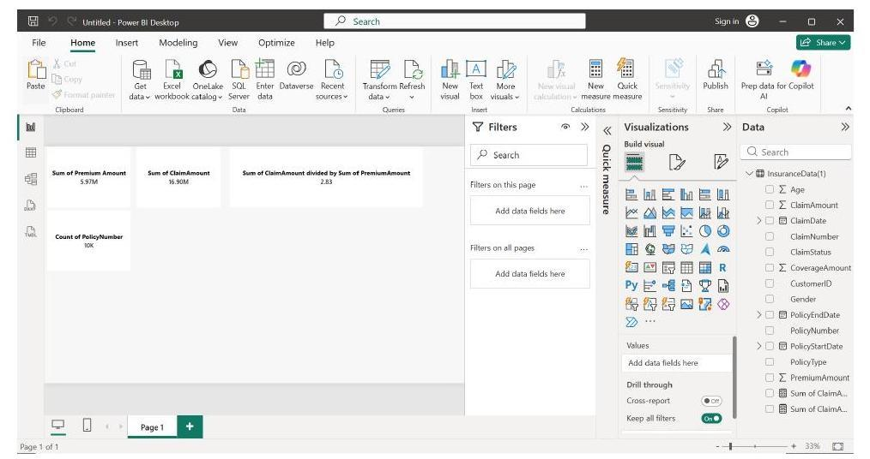
Figure 12 — Headline KPI cards: total premium, total claims, claims/premium ratio, and policy count.
Step 8: Add a Rejection Rate measure
Created a Rejection Rate measure (claims with ClaimStatus = Rejected as a share of total claims) and added it to the model; it was visualized later as a pie/donut chart.
Step 9: Build supporting visuals
Added a set of visuals below the KPI cards to break the headline numbers down by policy line:
- A horizontal bar chart titled "Claims outpace premium in every line," comparing premium and claim amounts across PolicyType — showing that claims exceed premiums for every policy type.
- A bar chart of Average of PremiumAmount by PolicyType.
- A bar chart of Count of ClaimNumber by PolicyType.
- A pie/donut chart showing Rejection Rate (≈ 43.54%) alongside overall claim status mix.
- A card repeating Count of PolicyNumber (10K) for context alongside the breakdowns.
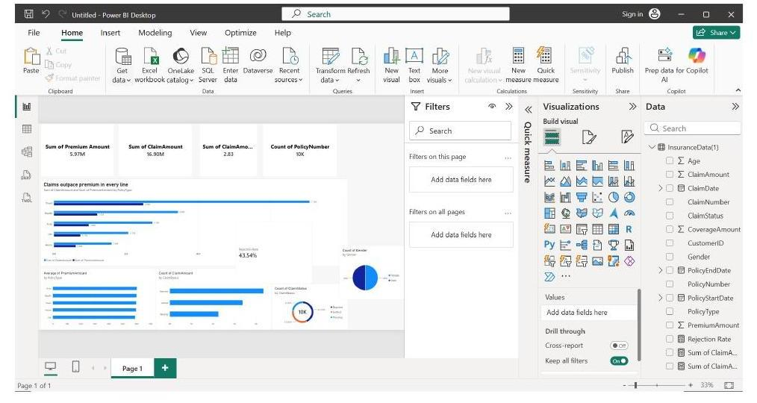
Figure 13 — Final Power BI report page: KPI cards, premium-vs-claims by policy type, average premium, claim counts, and rejection rate.

3.1 Key result
The core finding surfaced by the dashboard is that claims outpace premiums across every policy line — total claims (≈16.9M) run well above total premium collected (≈5.97M), a ratio of roughly 2.8x, with a rejection rate of about 43.5% on filed claims.

4. Files & Artifacts
- InsuranceData(1).csv — raw source data (10,004 rows, 13 columns).
- Power Query cleaning steps — Promoted Headers → Changed Type → Removed Duplicates → Changed Type with Locale (dates).
- Power BI report (Page 1) — KPI cards, premium-vs-claims bar chart, average premium by policy type, claim count by policy type, and rejection rate visual.

