Gaps and Results

Lightweight and Explainable Criminal Activity Detection

Muhammad Mohib Qureshi

25K2617

Identified Research Gaps
Our literature review reveals four critical gaps:
- Computational Efficiency: Most state-of-the-art models employ heavy architectures (ResNet, DenseNet, YOLO) that are impractical for real-time edge deployment. There is a clear need for lightweight alternatives that maintain competitive accuracy.
- Limited Generalization: The overwhelming focus on UCF-Crime for evaluation raises concerns about model generalization. Cross-dataset testing is rarely performed, leaving questions about real-world applicability unanswered.
- Lack of Explainability: The absence of interpretable explanations in current systems limits their practical utility. Security personnel need to understand why the system flagged an event to make informed decisions.

Paper result vs Implementation result

The paper proposes an LSTM–CNN model for anomaly detection in surveillance videos, focusing on selecting only the most relevant features—mainly those related to human motion—while removing redundant background information. CNN layers extract spatial features from each video frame, and the LSTM captures temporal relationships across frames.
In the implemented code, video frames are resized to 64×64×3 (RGB) and passed through TimeDistributed CNN layers with 64 filters and 3×3 kernels, followed by an LSTM layer with 64 units for temporal learning. A final softmax layer classifies activities. This setup aligns with the paper’s approach of combining spatial and temporal feature extraction for effective anomaly detection.

Implementation Flow
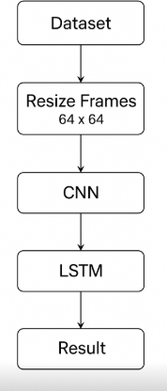
Implementation Flow
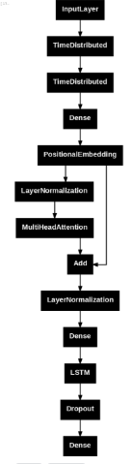

Parameter ,Dataset and Class:
TYPE | Dataset | Classes | Total parameters | Trainable Parameter | Non-trainable parameters
Paper LSTM | UFC-Crime | 14 | 7,170,510 | 5,586,254 | 1,584,256
Implementaion | Anomolous Activity | 10 | 4,250,314 | 4,211,594 | 38,720
Inovation | Anomolous Activity | 10 | 4,416,629 | 4,374,606 | 42,023

Accuracy Per Epoch:
Paper:

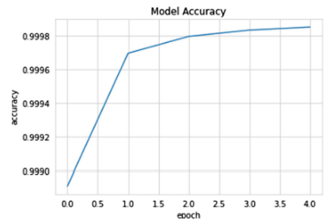
Implementation:

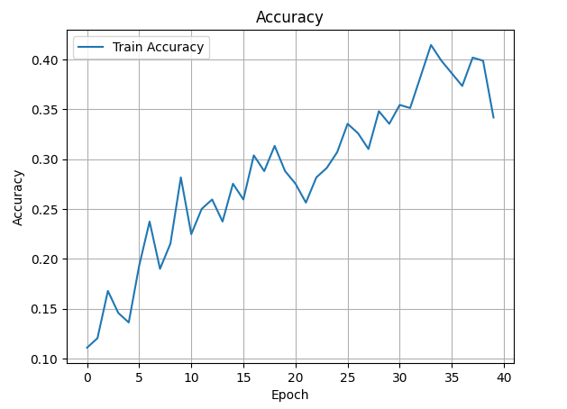
Innovation:

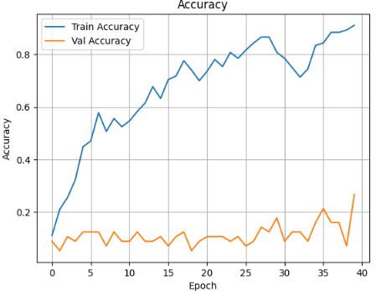
Performace Metrics

Paper
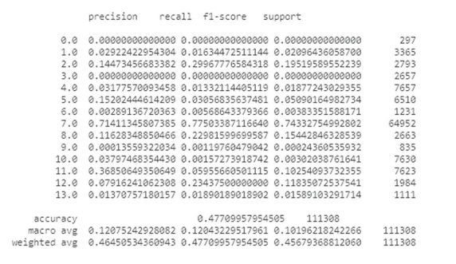

Implementation:
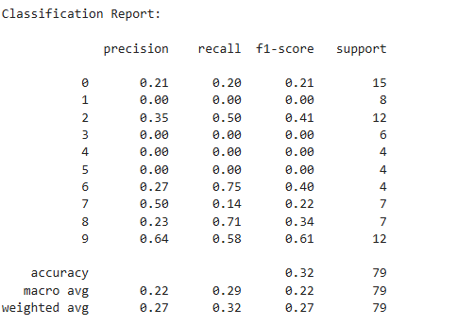

Innovation:

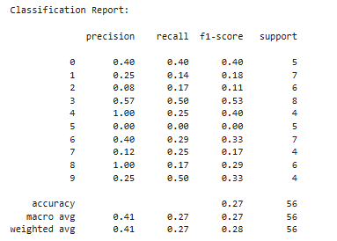

AUC Curve:

Paper:

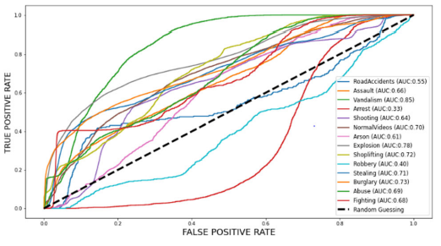

Implementation:
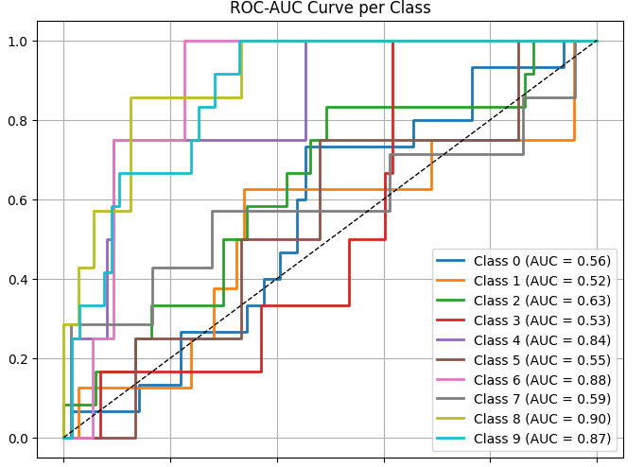
Innovation:

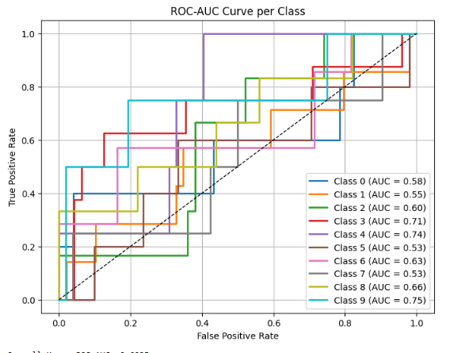
Addressing the Lack of Explainable AI (XAI)
One of the major research goals for our innovative model was tackling the Lack of Explainability in current detection systems. Most existing models are what we call "black boxes," meaning they provide a prediction (like "crime detected!") but offer absolutely no explanation or reasoning for that decision. In a real-world setting, this lack of transparency is a major hurdle because security personnel can't just blindly trust an automated system; they need to understand why the system flagged an event to make a proper, informed decision in a high-stakes situation. Our goal was to create an architecture that could eventually be made more interpretable, thereby boosting its practical utility and trustworthiness.
GRAD-CAM Results:
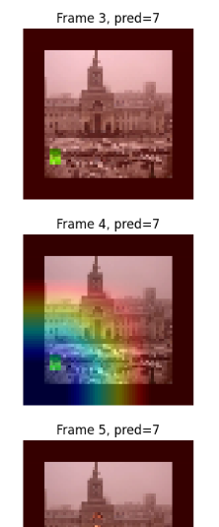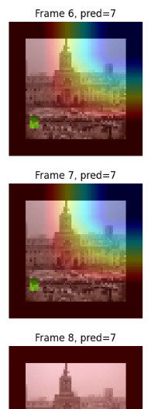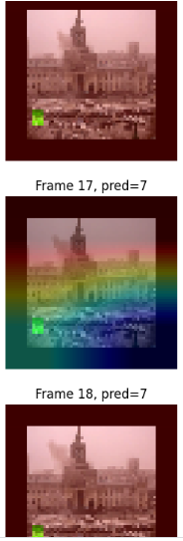
Conclusion:
Compared to the results reported in the referenced paper, the implementation produced relatively low accuracy and precision and far as innovation is concern the suggest model perform better on the training set while the validation test is quite low. The performance gap on paper, implementation is primarily due to the limitation of small dataset size, insufficient training epochs, and suboptimal settings for the learning rate. These factors seriously limit the capabilities of this model to fully capture the spatial-temporal patterns within the video data due to underfitting.
Some improvements may be made to achieve better results: increasing the size of the dataset or using data augmentation to make it more diverse, training the model for more epochs so it can have a deeper learning process, and tuning the learning rate for smoother convergence.
Paper:
[1] K. Ganagavalli and V. Santhi (2024), “YOLO-based anomaly activity detection system for human behavior analysis and crime mitigation,2024
Code:
https://github.com/mohib989/AI-Assignment
https://github.com/mohib988/Crime-Detection-Model
GitHub
https://github.com/mohib988/Crime-Detection-Model

