

Bachelor Of CS And IT

CCP Report

Group Members:
Mohib Ahmed Khan (CT-178)
Shayan Ali (CT-198)
Anas Shahid (CT-179)
Instructor: Sir Abdullah
Discipline: BCIT

Project Title: Cinema Ticket Booking System

Table of Contents
- Abstract .............................................................................................................. 3
- Introduction ........................................................................................................ 3
1.1 Overview
1.2 Objectives
1.3 Importance of the Project
- Code ………………………………………………………………………………. 4
- Technical Terms and Concepts ..................................................................... 8
2.1 Loops
2.2 Conditional Statements
2.3 Switch-Case
2.4 Variables
2.5 Input/Output
2.6 Operators
- System Design and Implementation ............................................................ 9
3.1 Logic Design
3.2 Flow Diagram
3.3 Working Mechanism
- Key Code Snippets .......................................................................................... 10
- Results and Output ......................................................................................... 11
- Assumptions .................................................................................................... 14
- Future Work ..................................................................................................... 14
- Challenges Faced ........................................................................................... 14
- Testing and Verification ............................................................................... 15
- Tools Used ...................................................................................................... 15
- Conclusion ....................................................................................................... 15
- Flowchart .......................................................................................................16

Abstract
This project introduces a Simple Console-Based Cinema Ticket Booking System engineered using the C programming language. It is designed to provide users with essential functionalities: viewing current seat availability, booking new tickets, and cancelling existing reservations.

Implementation and Data Handling: The system's core logic is implemented entirely within a procedural programming paradigm, primarily relying on the main() function, loops (specifically a do-while loop for continuous operation), and robust switch-case statements to manage the main menu and direct user flow.
- Data Structures: The system utilizes simple integer variables to maintain the state of the cinema hall. Key variables include:
  - Total Seats: A constant or fixed integer representing the hall's capacity.
  - Booked Seats: A dynamic counter that tracks the number of tickets sold, serving as the primary state variable.
  - Ticket Price: A fixed integer representing the unit cost per ticket.
- Transaction Logic: Bookings involve arithmetic operations to calculate the total Amount due and conditional checks (if-else if) to ensure that the requested number of tickets does not exceed the remaining capacity (Total Seats – booked Seats). Cancellation logic performs the inverse update to booked Seats.

1. Introduction

1.1 Overview
In recent years, automation has become a central element in almost every industry, and the entertainment sector is no exception. Cinema ticket booking systems have evolved from manual, counter-based processes to digital and online booking platforms. This project Cinema Ticket Booking System aims to simulate this modern automation process through a simple yet effective command-line program that demonstrates the fundamental building blocks of procedural programming.
The purpose of this system is to automate the process of booking, viewing, and canceling movie tickets. It provides a clear example of core programming concepts such as loops, conditionals, input/output handling, and switch-case control structures. The program runs entirely through a terminal interface and allows users to interact with it through menu-driven commands.

1.2 Objectives
The main objectives of the Cinema Ticket Booking System are as follows:
- To design a simple command-line application that simulates a real-world ticket booking process.
- To apply and demonstrate core programming fundamentals such as loops, decision-making, and variables.
- To allow users to perform basic operations: view available seats, book tickets, cancel bookings, and exit.
- To ensure that data is managed effectively within a single program session.
- To provide a strong foundation for future expansion into a full-fledged booking system with persistent data storage and GUI.

1.3 Importance of the Project
This project is particularly useful for beginner programmers learning structured programming using C or similar languages. It helps in understanding program flow, modular design, and user interaction. Moreover, it lays the groundwork for more advanced applications involving databases and file handling.
CODE:
#include <stdio.h>
#include <stdlib.h>

int main() {
int totalSeats = 50; // total seats available
int bookedSeats = 0; // number of seats already booked
int ticketPrice = 400; // ticket price
int choice, tickets, totalAmount;

system("cls"); // clears screen (works on Windows; remove if using Linux/Mac)

printf("====================================================\n");
printf(" ?? CINEMA TICKET BOOKING SYSTEM \n");
printf("====================================================\n");

do {
printf("\n----------------- MAIN MENU -----------------\n");
printf("1. View Available Seats\n");
printf("2. Book Tickets\n");
printf("3. Cancel Tickets\n");
printf("4. Exit\n");
printf("---------------------------------------------\n");
printf("Enter your choice: ");
scanf("%d", &choice);

switch (choice) {
case 1:
printf("\nAvailable Seats: %d\n", totalSeats - bookedSeats);
break;

case 2:
printf("\nEnter number of tickets to book: ");
scanf("%d", &tickets);

if (tickets <= 0) {
printf("Invalid number of tickets!\n");
}
else if (bookedSeats + tickets > totalSeats) {
printf("Sorry, not enough seats available!\n");
}
else {
bookedSeats += tickets;
totalAmount = tickets * ticketPrice;
printf("\nBooking successful! ?\n");
printf("Tickets Booked: %d\n", tickets);
printf("Price per ticket: Rs.%d\n", ticketPrice);
printf("Total Amount: Rs.%d\n", totalAmount);
printf("Remaining Seats: %d\n", totalSeats - bookedSeats);
}
break;

case 3:
printf("\nEnter number of tickets to cancel: ");
scanf("%d", &tickets);

if (tickets <= 0 || tickets > bookedSeats) {
printf("Invalid number of tickets to cancel!\n");
}
else {
bookedSeats -= tickets;
printf("Successfully cancelled %d tickets. ?\n", tickets);
printf("Remaining Seats: %d\n", totalSeats - bookedSeats);
}
break;

case 4:
printf("\nThank you for using the Cinema Ticket Booking System! ??\n");
printf("Have a great day!\n");
break;

default:
printf("Invalid choice! Please try again.\n");
}
} while (choice != 4);
return 0;
}

2. Technical Terms and Concepts
This section explains the key programming concepts utilized in developing the Cinema Ticket Booking System. Understanding these concepts is essential to grasp how the system works behind the scenes.

2.1 Loops
Loops are used to perform repetitive tasks without rewriting code multiple times. In this project, while loops or do-while loops are used to repeatedly display the menu and process user input until the user decides to exit.
Example:
do {
printf("\n1. View Seats\n2. Book Tickets\n3. Cancel Tickets\n4. Exit\n");
printf("Enter your choice: ");
scanf("%d", &choice);
// Process the choice
} while (choice != 4);
This structure ensures the program remains active and interactive until explicitly terminated by the user.

2.2 Conditional Statements
Conditional statements like if-else are used to make logical decisions. For example, when a user tries to book a seat, the system checks if enough seats are available.
Example:
if (seatsToBook <= (totalSeats - bookedSeats)) {
bookedSeats += seatsToBook;
printf("Booking successful!\n");
} else {
printf("Not enough seats available.\n");
}

2.3 Switch-Case
The switch-case structure is used to handle menu-driven choices. It enhances readability and modularity by directing program flow based on user input.
Example:
switch (choice) {
case 1: viewSeats(); break;
case 2: bookTickets(); break;
case 3: cancelTickets(); break;
case 4: printf("Thank you for using the system.\n"); break;
default: printf("Invalid choice. Try again.\n");
}

2.4 Variables
Variables store values that the program manipulates. For instance, total seats, booked seats, and ticket price are key variables that maintain the system’s state.

2.5 Input/Output
The program uses functions like scanf() for input and printf() for displaying output to the user. These are essential for interactive applications.

2.6 Operators
Arithmetic operators such as +, -, and * are used to calculate ticket totals and seat availability dynamically.

3. System Design and Implementation

3.1 Logic Design
The Cinema Ticket Booking System follows a menu-based interaction model. Each menu choice represents a specific operation. The program continuously loops through the menu until the user selects “Exit.”
Key design principles include:
- Modularization: Each function performs a specific task (e.g., viewing seats or booking tickets).
- Validation: Input values are verified to prevent invalid or unrealistic actions (e.g., booking more seats than available).
- Feedback: The system gives immediate feedback on each operation.

3.2 Flow Diagram
┌────────────┐
│ START │
└─────┬──────┘
│
┌──────▼──────┐
│ Display Menu│
└──────┬──────┘
│
┌──────▼──────┐
│ Get Choice │
└──────┬──────┘
│
┌────────────▼─────────────┐
│ 1. View Seats │
│ 2. Book Tickets │
│ 3. Cancel Tickets │
│ 4. Exit │
└────────────┬─────────────┘
│
┌──────▼──────┐
│ Process Task│
└──────┬──────┘
│
┌──────▼──────┐
│ Display Result│
└──────┬──────┘
│
┌──────▼──────┐
│ Exit if 4 │
└──────┬──────┘
│
┌───▼───┐
│ END │
└───────┘

3.3 Working Mechanism
- The user launches the program.
- The main menu is displayed.
- The user selects an option (view, book, cancel, or exit).
- The system processes the input and updates the seat data.
- The loop continues until the user chooses to exit.

4. Key Code Snippets
int totalSeats = 50; // total seats available
int bookedSeats = 0; // number of seats already booked
int ticketPrice = 400; // ticket price per seat
These variables initialize the main parameters for the system, defining capacity, booked seats, and pricing.
Initialization:
int totalSeats = 50;
int bookedSeats = 0;
int ticketPrice = 400;
Booking Logic:
void bookTickets() {
int num;
printf("Enter number of tickets to book: ");
scanf("%d", &num);
if (num <= (totalSeats - bookedSeats)) {
bookedSeats += num;
printf("Booking successful! Total amount: Rs.%d\n", num * ticketPrice);
} else {
printf("Not enough seats available.\n");
}
}
Cancellation Logic:
void cancelTickets() {
int num;
printf("Enter number of tickets to cancel: ");
scanf("%d", &num);
if (num <= bookedSeats) {
bookedSeats -= num;
printf("Cancellation successful.\n");
} else {
printf("Invalid cancellation request.\n");
}
}

5. Results and Output
The program successfully displays the number of available seats, processes bookings and cancellations, and calculates total price. When a user books tickets, the system validates the number and updates the records accordingly. The system performs all intended functions correctly. It displays available seats, handles new bookings, processes cancellations, and calculates the total cost.

Example Run:
1. View Seats
2. Book Tickets
3. Cancel Tickets
4. Exit

Enter choice: 1
Available Seats: 50

Enter choice: 2
Enter number of tickets to book: 3
Booking successful! Total amount: Rs.1200

Enter choice: 1
Available Seats: 47

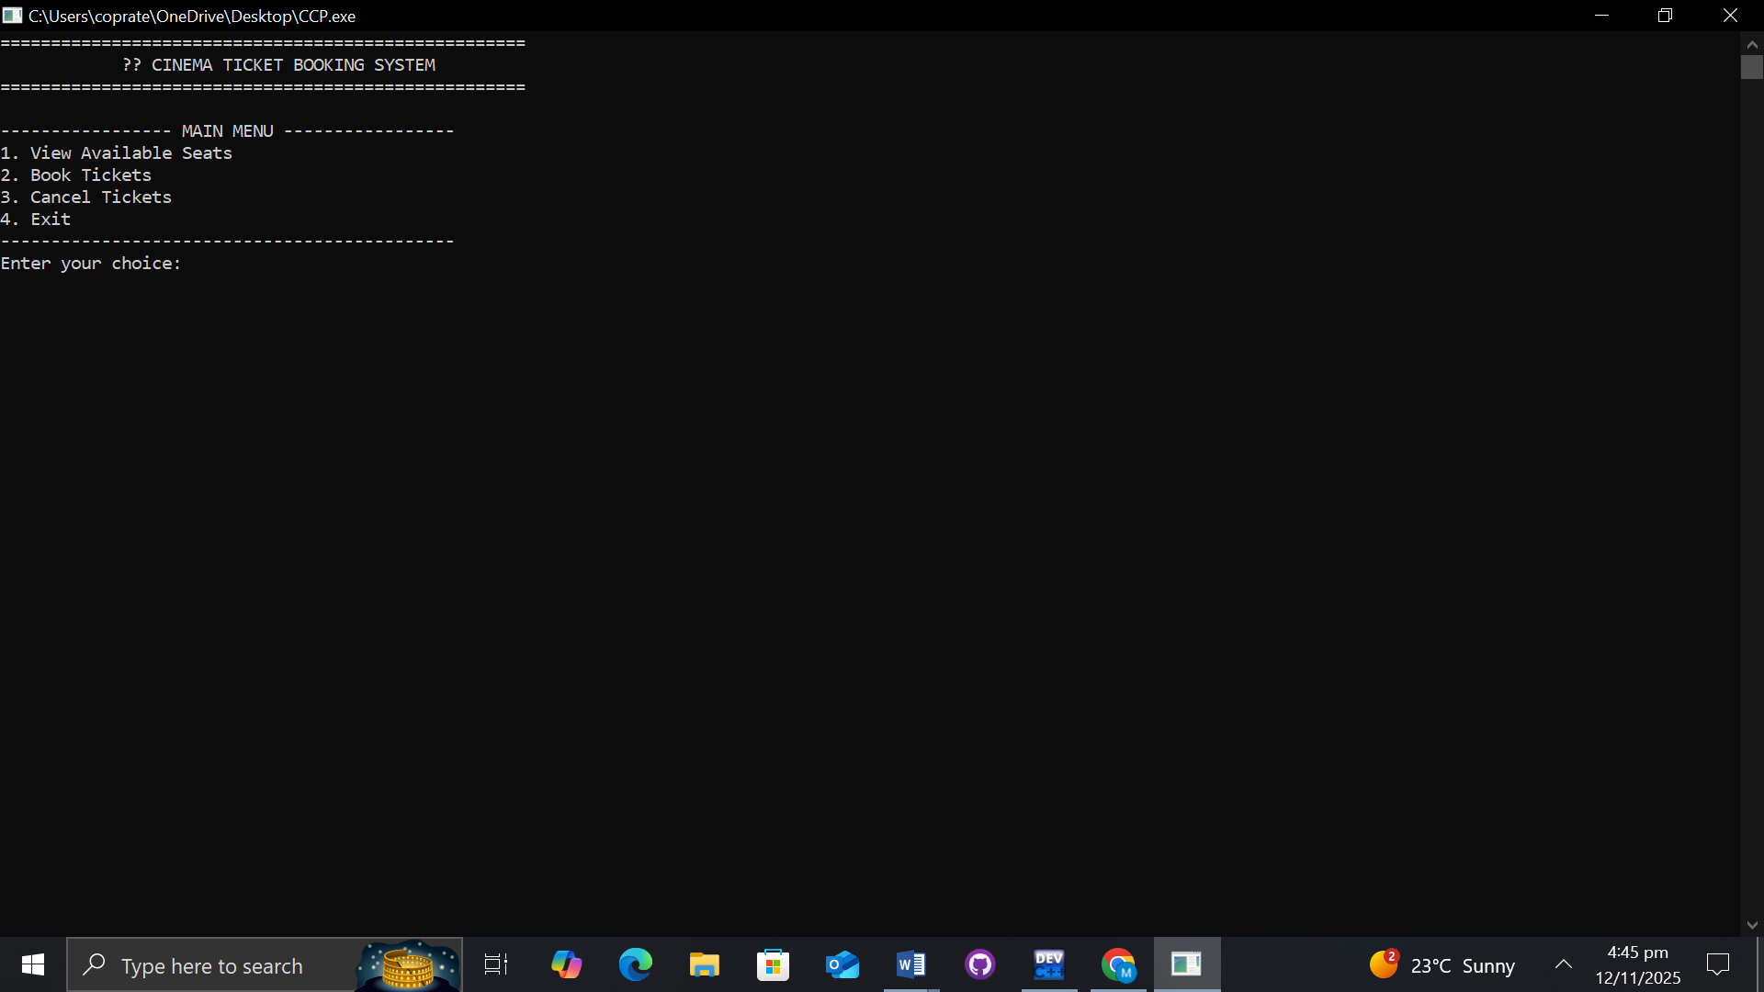

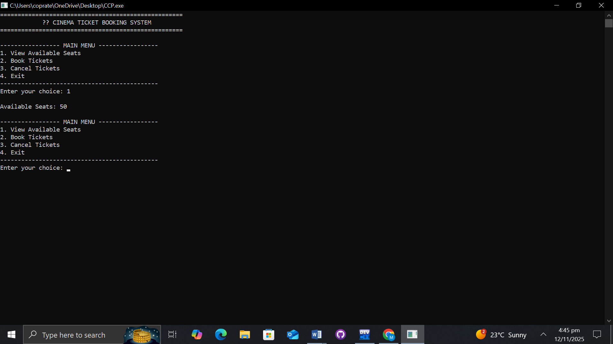

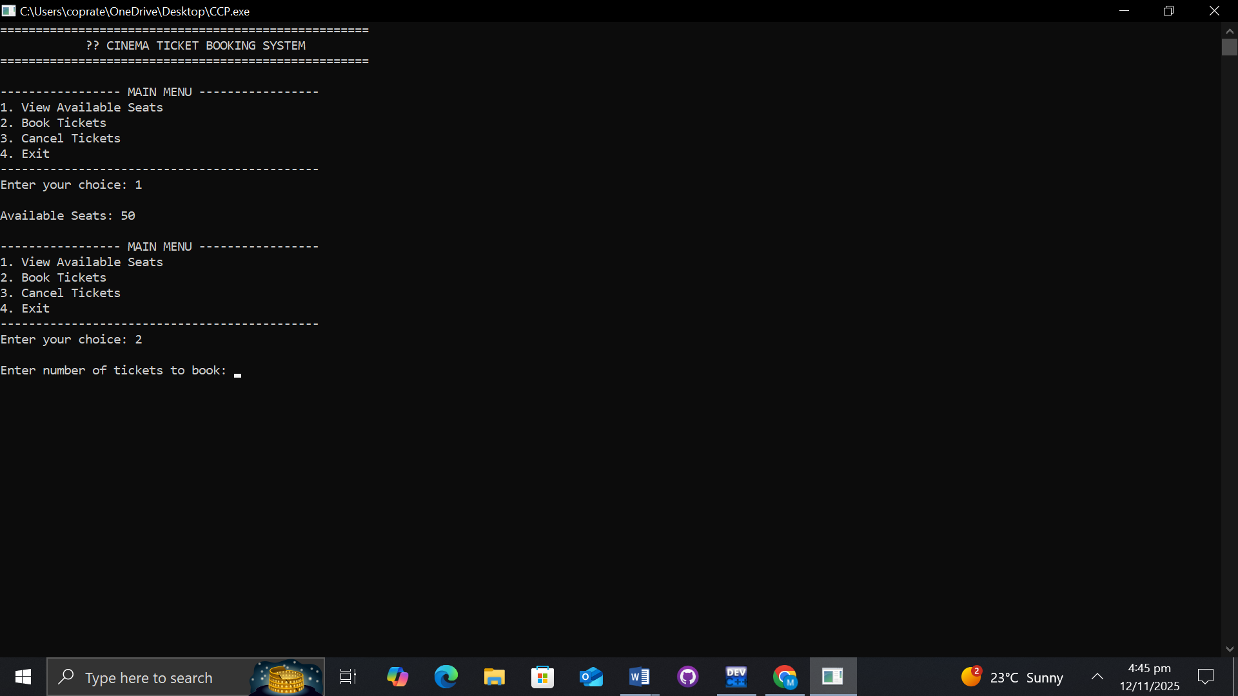

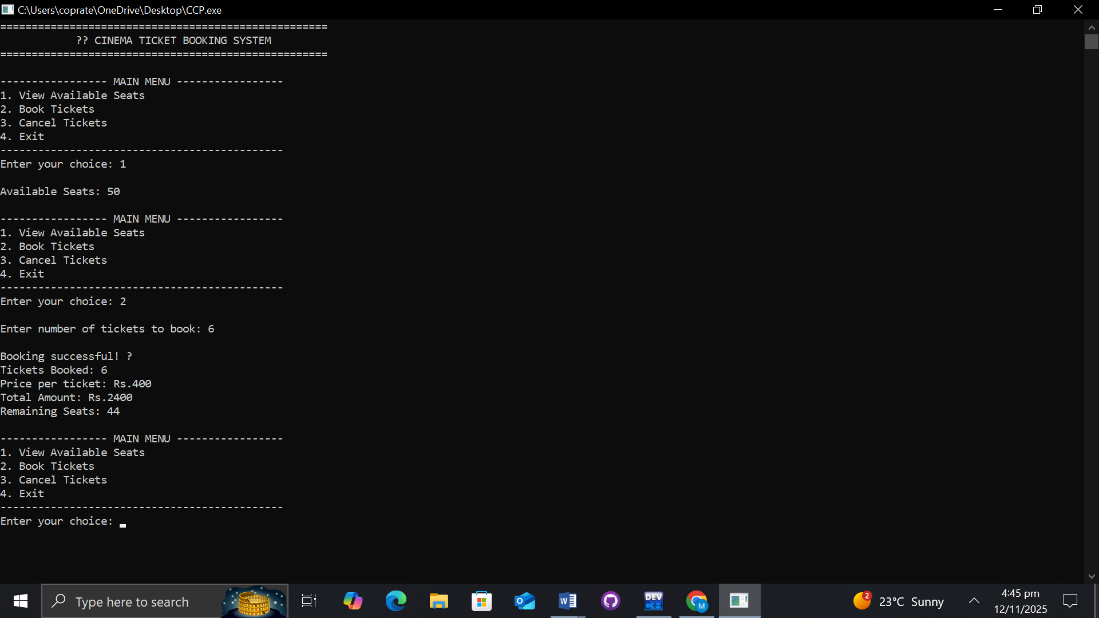

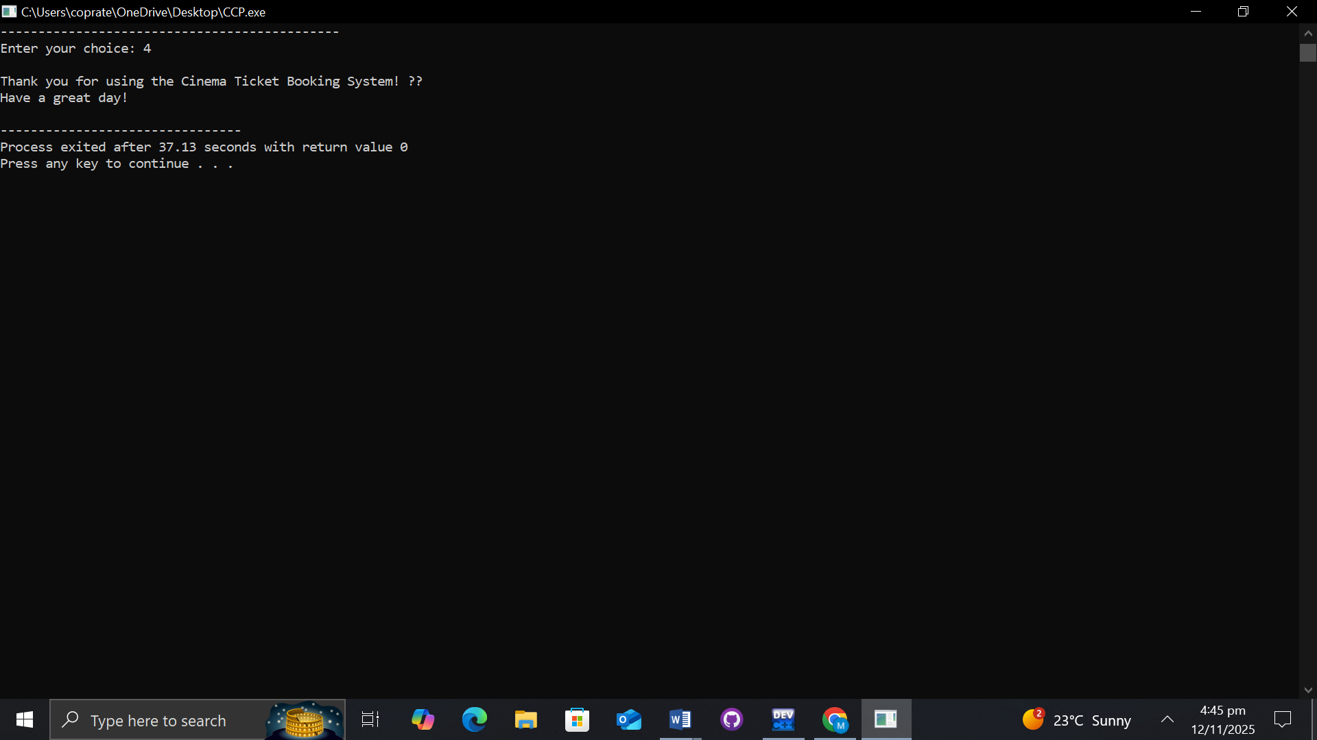

6. Assumptions
• Total seats are fixed at 50.
• Ticket price is constant (Rs. 400).
• Input values are integers.
• Program runs in a single session without data storage.

7. Future Work
In future versions, file handling can be implemented to save booking records permanently. Seat numbering, movie selection, showtimes, and user authentication can also be added. To transform this command-line program into a real-world system, the following improvements are proposed:
- File Handling: Save booking data to files for persistence.
- Seat Numbering: Implement seat layout for better visualization.
- Movie & Showtime Selection: Allow multiple movies and time slots.
- User Authentication: Add user login for secure bookings.
- Graphical Interface: Develop a GUI using frameworks like GTK or Qt.
Online Integration: Expand to a web-based platform using databases

8. Challenges Faced
While implementing the system, common challenges included:
- Managing input validation to avoid negative or overflow seat entries.
- Designing a clean and intuitive menu interface.
- Ensuring accurate updates to seat counts during bookings and cancellations.

9. Testing and Verification
Multiple test cases were run to verify the correctness of the system:
Test Case | Input | Expected Output | Result
View Seats | 1 | Displays total available seats | Pass
Book Tickets (valid) | 2 → 3 | Books 3 seats successfully | Pass
Book Tickets (invalid) | 2 → 60 | Displays “Not enough seats” | Pass
Cancel Tickets (valid) | 3 → 2 | Cancels 2 seats | Pass
Cancel Tickets (invalid) | 3 → 100 | Displays error message | Pass

10. Tools Used
- Programming Language: C
- Compiler: DEV
- Platform: Windows
- IDE: Visual code

11. Conclusion
The Cinema Ticket Booking System effectively demonstrates how fundamental programming concepts can be combined to create a working, interactive application. It shows clear use of variables, loops, conditionals, and modular design. The system is
simple yet scalable a great foundation for larger projects involving file handling, databases, and user interfaces.
Overall, the project not only fulfills its objective but also helps develop a deeper understanding of structured programming and logical problem-solving.

11. Flowchart

