
GROUP ASSIGNMENT
TECHNOLOGY PARK MALAYSIA
CT077-3-2-DSTR
DATA STRUCTURE
GROUP 40

HAND OUT DATE: 16 March 2026

HAND IN DATE: 4 May 2026

WEIGHTAGE: 30%

Name | TP Number | Intake Code
Mohib Bin Aamir | TP085584 | APD2F2509CS(DA)
Nazifa Zaman | TP082217 | APU2F2509CS(AI)
Mohammed H.B. Zendah | TP085164 | APD2F2509CS(AI)
Zeba Waheed Parkar | TP084954 | APD2F2509CS(DA)
Ahmad Muneeb Payab | TP084833 | APU2F2509CS(AI)

Table of Contents
1.0 Workload Matrix.......................................................................................................................
2.0 Introduction................................................................................................................................
2.1 Background...............................................................................................................................
2.2 Problem Statement....................................................................................................................
2.3 Objectives.................................................................................................................................
3.0 Theoretical Explanation............................................................................................................
3.1 Shared Resident Structure.........................................................................................................
3.1.1 Data Structures and Helper Functions................................................................................
3.1.2 Array Implementation.........................................................................................................
3.1.3 Linked List Implementation................................................................................................
3.1.4 Main Execution Logic.........................................................................................................
3.2 Array Implementation...............................................................................................................
3.2.1 Array Resize Logic.............................................................................................................
3.3 Linked List Implementation......................................................................................................
3.3.1 Node Structure....................................................................................................................
3.3.2 Insert at End........................................................................................................................
3.4 Comparison of Array & Linked List.........................................................................................
4.0 Data Processing & System Functions.......................................................................................
4.1 Data Loading (CSV Handling)................................................................................................
4.2 Data Analysis Features.............................................................................................................
5.0 Algorithms Sorting & Searching..............................................................................................
5.1 Purpose of the Task...................................................................................................................
5.2 How this Part fits with the Full Project.....................................................................................
5.3 Data used in this Part................................................................................................................
5.4 Algorithms Used.......................................................................................................................
5.5 Justification of the Algorithms..................................................................................................
5.6 Sorting Part...............................................................................................................................
5.7 Searching Part...........................................................................................................................
5.8 Functions included in the Code..............................................................................................
5.9 Time Complexity......................................................................................................................
5.10 Testing Method.......................................................................................................................
5.11 Integration with the Group Code............................................................................................
5.12 Important Integration Note.....................................................................................................
5.13 Limitations.............................................................................................................................
5.14 Possible Improvements..........................................................................................................
5.15 Conclusion.............................................................................................................................
6.0 Input Output Screenshots.........................................................................................................
6.1 Age Group Analysis................................................................................................................
6.1.1 Array Program Age Group Analysis for One City.........................................................................
6.1.2 Linked List Program Age Group Analysis for One City.................................................................
6.2 Carbon Emission Analysis.......................................................................................................
6.2.1 Total Carbon Emission Summary by City......................................................................................
6.3 Sorting Results.........................................................................................................................
6.3.1 Array Sort by Age...........................................................................................................................
6.3.2 Array Sort by Distance.....................................................................................................................
6.3.3 Array Sort by Carbon Emission.......................................................................................................
6.4 Searching Results.....................................................................................................................
6.4.1 Search by Age Group.......................................................................................................................
6.4.2 Search by Transport Mode................................................................................................................
6.4.3 Search by Distance Threshold...........................................................................................................
6.5 Performance Results..................................................................................................................
6.5.1 Array Memory Footprint..................................................................................................................
6.5.2 Linked List Memory Footprint.........................................................................................................
7.0 Summary Discussions................................................................................................................
7.1 Carbon Emission Analysis........................................................................................................
7.1.1 Carbon Emission Summary..............................................................................................................
7.1.2 Carbon Emission by Transport.........................................................................................................
7.1.3 Carbon Emission by Age Group.......................................................................................................
7.2 Performance Analysis..............................................................................................................
7.2.1 Linked List Implementation............................................................................................................
7.2.2 Array Implementation......................................................................................................................
7.2.3 Array VS Singly Linked List............................................................................................................
7.2.4 Real-world Advantages & Disadvantages........................................................................................
8.0 Conclusion & Reflection............................................................................................................
8.1 Summary...................................................................................................................................
8.2 Strengths & Weaknesses...........................................................................................................
8.3 Future Improvements................................................................................................................
9.0 References...................................................................................................................................

1.0 Workload Matrix

Member | TP Number | Role | Contribution | Signature
Mohib Bin Aamir | TP085584 | Singly Linked List Implementation and Final Integration | 20% | Mohib
Nazifa Zaman | TP082217 | Array-Based Data Structure Implementation | 20% | Nazifa
Mohammed H.B. Zendah | TP085164 | Sorting and Searching Algorithms | 20% | Mohammed
Zeba Waheed Parkar | TP084954 | Carbon Emission Analysis and Performance Evaluation | 20% | Zeba
Ahmad Muneeb Payab | TP084833 | Data Setup and File Handling | 20% | Ahmad

2.0 Introduction

2.1 Background:
One of the most frequent everyday human activities is transportation, although it also adds substantially to carbon emissions. In modern urban environments, people use numerous transportation methods which include cars, buses, bicycles, carpools, school buses and walking to go to work, school, universities, marketplaces, and different places. Although everyday living needs mobility, the kind of transport selected, and the distance traveled has a major effect on how much carbon is released into the atmosphere. Further, knowing the traffic patterns is necessary for planning, convenience, and environmental sustainability as cities continue to expand.
The fundamental basis of this assignment’s case study includes three transportation datasets gathered from three different urban areas such as City A, City B, and City C. Each dataset includes resident’s age, way of transportation, everyday travel distance, carbon emission factor, and average number of travel days each month. These datasets can be employed to evaluate the impact on the environment of different cities, identify which age group generates the maximum emissions, and identify which transportation choices add more to carbon emissions.
To address this issue, two data structures were chosen: arrays and single linked lists. The corresponding resident records can be kept in both data structures, yet they vary significantly in how memory is organized, how data is obtained, and how operations like traversal, insertion, sorting and searching are performed. They can therefore be differentiated in a data structure assignment. As an outcome, the system was designed in two distinct C++ programs, such as one that utilized singly linked lists and the other which utilized arrays. This complies with the assignment necessities that the same three datasets be employed in both formats.
Furthermore, the group needed to prepare the resident data regarding later analysis. This included integrating monthly carbon emissions, calculations, and age-group categorization within the resident data model. Eventually searching, output display, summary reporting, and performance comparison are all based on these preset values. To make sure that the array-based and linked-list based programs utilized the same field names and dataset constants, a common Resident structure was added to resident.h. This enhanced the assignment’s overall consistency and reduced compatibility issues upon integration.
Group-based development was another component of the assignment. Integration proved a vital component of the final work as other group members managed numerous technical aspects including data setup, array implementation, linked-list implementation, and sorting/searching logic. Initially some teammate files were separate demonstration programs with their own main() functions and resident structures. As the assignment only calls for two final programs, these could not have been kept apart in the final submission. To be able to use the same Resident definition. CSV data, and menu-driven design, the beneficial parts of those teammate files were combined into the shared final structure and modified.
Basically, this work includes more than simply just building data-storing code. It aims to show how the data structure selection impacts the organization of data, operation implementation, and the system’s whole utility in addressing real-world problems. The project shows how data structures and algorithms can support environmental analysis via applying arrays and singly linked-lists to transportation and carbon emission data.

2.2 Problem Statement:
Transportation-based data gets larger and more complex as cities expand. It is required to have a system which can quickly process the data, store resident transportation records in a structured way, and give help analysis such as identifying travel trends or high-emissions groups. Sorting. Searching, comparing, and summarizing data becomes difficult if it is not arranged appropriately.
The main issue in this assignment is to figure out how to store and analyze traffic data from three cities utilizing arrays and singly linked-lists, two distinct data structures. To be able to set up the data for additional operations such as sorting, searching, age-group analysis, carbon-emission computation as well as performance observation, the system needs to import the records from CSV files and keep all required fields. The report need to address the pros and cons of the chosen data structures in this particular case.
Consistency is another concern with the project. Given the fact that the work was divided between other team members, distinct demo-style main() functions, variable names, and struct definitions were utilized in the initial writing of other parts of the code. Integration issues resulted from this. As an outcome, one of the project’s key practical difficulties was not just setting the system into place yet also merging the other team members’ contributions altogether to build a workable end structure.

2.3 Objectives:
The objectives of this assignment are given below:
i) To design two distinct C++programs which use arrays and singly linked-lists to implement the three transportation datasets.
ii) To create a common resident record structure which contains the set of analysis values and the original dataset fields.
iii) To identify monthly carbon-emission levels throughout data loading and classify residents into age classifications.
iv) To allow sorting and searching functions in the final applications, especially in the array-based program which integrated sorting and searching.
v) To utilize memory-footing output functions to differentiate the memory usage and behavior of linked lists and arrays.
vi) To generate a structured report which fits the assignment documentation format and involves code snippets, comments, conclusions as well as suggestions.

3.0 Theoretical Explanation
The implementation of the two chosen data structures in the final system is outlined in this part. However, utilizing the corresponding resident fields and transportation datasets, the two programs organize and interpret data in other ways. A singly linked list with nodes is utilized in one while a dynamic array-based class is utilized in the other.

3.1 Shared Resident Structure:
It is a program called a Carbon Footprint Data Management System which processes and organises resident data based on several urban datasets. The main aim of the system is to read raw data on resident demographics (age, transportation habits, etc.) and store them effectively using two basic C++ data structures: Static Arrays and Singly Linked Lists.
The system groups residents into certain age groups (between children and senior citizens) and monitors such metrics as daily travel distance and carbon factors to provide a base to further analysis of the environmental impact.

3.1.1 Data Structures and Helper Functions:
In this section, the information about the resident is defined and the program is defined to establish the age groups.
`struct Resident' A customer data type that is a bundle of all relevant resident attributes (ID, Age, Transport mode, etc.) into a singular object.

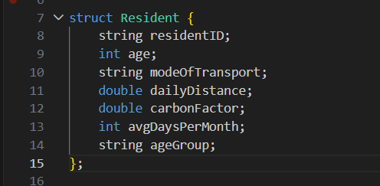
Figure 3.1.1: Resident Data Structure

- getAgeGroup: A utility function that employs conditional logic to give a descriptive category based on the numerical age of the resident.
- <parseResident>: A utility procedure that accepts a raw string in a CSV file and converts it into a structured object, Resident, using string streams.

3.1.2 Array Implementation:
This module takes care of the storage of data through a fixed-size continuous memory block.

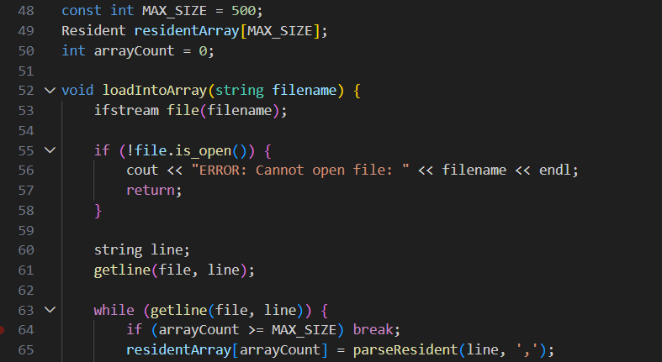
Figure 3.1.2: CSV Loading into Array

- loadIntoArray: This method will load the CSV files, skip the header row, and populate the residentArray[cite: 1]. It has a safety check to make sure that the data is not more than the MAX_SIZE of 500.
- <displayArraySample>: Releases the array indices to print the first five records in a formatted table.

3.1.3 Linked List Implementation:
In this section we are going to show dynamic memory management where one piece of data will point to the next.

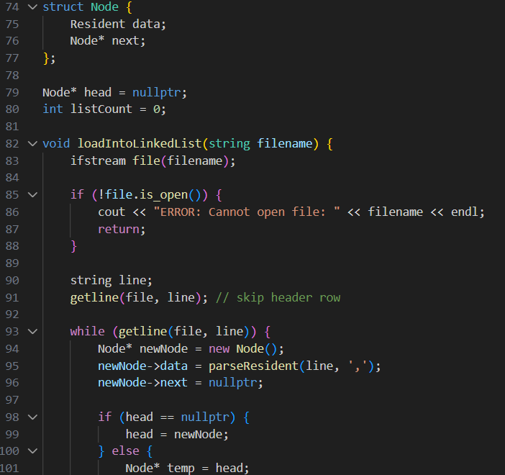
Figure 3.1.3: CSV Loading into Linked List

- struct Node: The structure that defines the building block of the list, which contains the information about the resident and also a pointer of the next node.
- loadIntoLinkedList: Dynamically allocates memory to each new resident and adds them to the end of the list. In contrast to the array, this structure increases as required.
- displayLinkedListSample: Walks the list by using the pointers on the head node as long as it walks the list.

3.1.4 Main Execution Logic:
The main point of the program coordinates the whole working process.
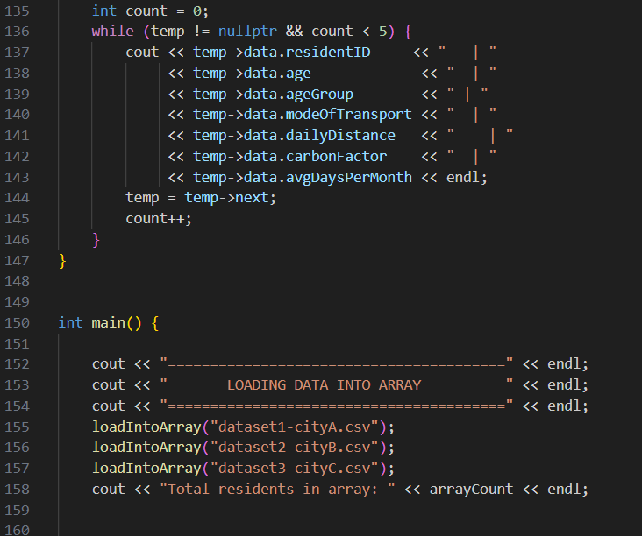
Figure 3.1.4: Display of First Array Records

It invokes the loading functions on three different datasets of cities (`City A, City B, and City C). It gives a summary of the total number of records of both data structures to ensure that all the data has been imported correctly. Lastly, it invokes the display functions to display the formatted output to the user.

3.2 Array Implementation:
Since the assignment requirements prevent the use of built-in containers, such as vectors or lists. The array-based solution was built using a new ResidentArray class instead of using STL containers. The current size and capacity of a dynamically generated block of Resident objects are kept in the class along with a pointer to that block. The array expands via allocating a new block with double capacity, copying the present elements as well as deleting the previous block when it becomes full.
The key functions used in the class are that this design provides an adaptable approximation of a dynamic array whereas following the assignment limitations.
- adding a record
- resizing when full
- getting the number of stored records
- checking if the array is empty
- returning a pointer to the stored data
- displaying the records in the table format.

The key methods in the class include:

- constructor
- destructor
- resizeArray()
- add(...)
- getSize()
- isEmpty()
- getData()
- display(...)

3.2.1 Array Resize Logic:

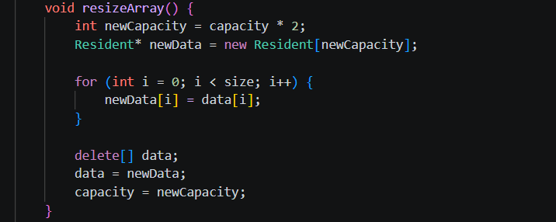
Fig 3.2.1: Dynamic Array Resizing Function

Direct accessibility is the array implementation’s strength. Each resident could be retrieved using their index since the records are stored in linear memory. This supports the implementation of traversal, comparison, as well as sorting. Furthermore, it increases memory locality, which generally results in enhanced cache performance.
Arrays do have some limitations though. The structure is not fundamentally node based such as linked list, and considering that the custom class can resize, insertion in the middle still needs relocating items. However, the first teammate sorting file had already been written in array form. The array file remained at the primary location where sorting and searching were combined for the current prototype.

3.3 Linked List Implementation:
Each node in the linked list program contains a single resident record and a pointer to the node after it. A head pointer is utilized via a SinglyLinkedList class to manage the chain of nodes. By navigating to the final node and selecting the new node there, new records are added at the end of the list. Further, the class supports:
- insertion at end
- checking if the list is empty
- counting nodes
- displaying the list
- clearing all allocated nodes.

3.3.1 Node Structure:

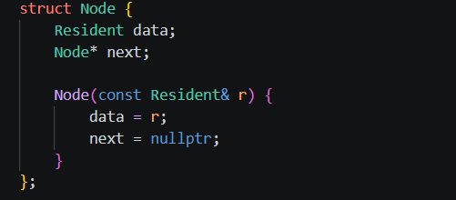
Figure 3.3.1: Linked List Node Structure

3.3.2 Insert at End:

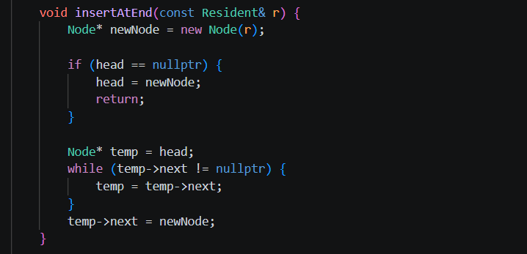
Figure 3.3.2: Linked List Insert Function

Since it demonstrates dynamic node-based storage and precise pointer usage, two key concepts in data structures, the linked list version is beneficial. Linked list does not give direct indexing and does not store elements in linear memory, unlike arrays. Traversal from the header point is required to access a record. Besides slowing down certain operations, this shows the theoretical difference between direct access and sequential traversal structures.
The linked list file in the current final version has searching, memory-footprint output, carbon emission summary and city selection logic, yet it requires the array program’s whole sorting integration. As an existing prototype constraint, this needs to be clearly included in the report.

3.4 Comparison of Array & Linked List:

Property | Array | Linked List
Memory Layout | Uses the dynamic array class to keep resident records in a single memory block | Stores every resident in a distinct node which is allocated to the heap and connected via pointer
Data Access | Index-based array positions provide regarding direct access that simplifies retrieval | To access data, one needs to go from the head node to the required node
Insertion | The next accessible array slot is where new records are added. The program builds a wider array and copies the current elements if the array is full | By creating a new node and linking it to the final node, new records are added at the end of the list
Traversal | Loops using the stored array elements are used for traversal | Employing the next pointer, traversal is executed node by node until nullptr is attained
Sorting Integration | Age, distance and carbon emission sorting has been included into the final array program and linked to the menu | The linked list version presently emphasizes on searching, traversal, summaries and memory footprint are prioritized over full sorting integration
Searching Integration | Use the array of data of the selected city to support searching via age group, mode of transportation, and distance criteria. | Traverses the linked list of the selected city to allow searching via age group, mode of transportation and distance criteria
Memory Overhead | Mainly uses memory regarding the resident records themselves, each record lacks a pointer field | Use extra memory since each node has a pointer along with resident data.
Flexibility | More suitable when menu-based sorting process and consistent direct access to the data are needed | More suitable for demonstrating sequential traversal and pointer-based dynamic storage
Performance in Current Prototype | More stronger regarding sorting and integrating menu-based algorithms in the final system | More stronger regarding the current final system’s node-based storage, searching, carbon-emission summary, and memory contrast
Best Use in this Assignment | Suitable regarding operations rapid access and direct sorting | Suitable regarding demonstrating node traversal, linked storage and dynamic structure behavior

4.0 Data processing & System Functions

4.1 Data Loading (CSV Handling):
Task 1 integration contributed substantially to the final project. The original file from the teammate had its own main() method, another Resident structure and separate parsing algorithms. The useful logic was integrated within the final array and linked-list files instead of keeping a separate standalone application. The two most primary additions were:
- getAgeGroup()
- parseResident()

To match the final shared resident structure, the parseResident() function was updated. When parsing, the following function:
- reads the resident ID
- converts age from string to integer
- assigns the correct age-group label
- reads the transport mode
- converts daily distance
- converts carbon emission factor
- converts average days per month
- calculates carbonEmission

This signifies that before being saved in the array or linked list, each resident is completely ready.

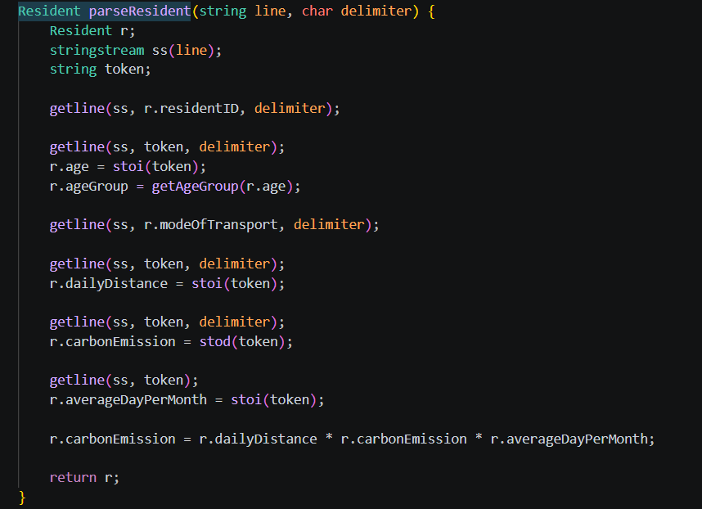
Figure 4.1.1: CSV Row Parsing Function

This parsed resident is subsequently utilized via the loader process to insert it within the correct data structure. The resident is added to the ResidentArray object in the array file using loadCSVIntoArray(...), loadCSVIntoLinkedList(...) adds it to the completion of the linked list file. This ensures coherence in the loading logic between the two applications.

4.2 Data Analysis Features:
Several analysis-style features are now supported via the final code:

In the array program:
- age-group analysis
- carbon-emission summary by city
- carbon-emission by transport mode
- sorting by age, distance, and carbon emission
- searching by age group, transport mode, and distance threshold
- memory-footprint output

In the Linked List program:
- age-group analysis
- carbon-emission summary by city
- carbon-emission by transport mode
- searching by age group, transport mode, and distance threshold
- memory-footprint output

5.0 Algorithms Sorting & Searching
This section focuses on the sorting and searching algorithms implemented for Task 4. The project utilizes resident records, each containing details such as resident ID, age, mode of transportation, daily distance, carbon emissions, and average days. This part is important because it helps the program to organize records and find specific data more easily.

5.1 Purpose of the Task:
The main purpose of this task is to make resident data easier to read, compare, and search. Sorting is used to arrange the records in order, for example, from the youngest to the oldest age or from the lowest to the highest carbon emissions. Searching is used to find records that match a specific condition, such as residents who use a particular transport mode or residents who travel more than a selected distance.

5.2 How this Part fits with the Full Project:
This task does not load the files and it does not create the main array or linked list. Those parts are handled by the other group members. This part is connected after the data is stored. After the records are loaded, the functions can sort the records or search through them based on the selected option in the final menu.
This also means the code should be integrated into the main group program as functions. The testing main function is used only to check that this part works independently before the final integration.

5.3 Data used in this Part:
The functions work with the Resident structure used by the group. The structure stores the main values. needed for sorting and searching. The same field names as the array and linked list parts are used so that the code can be integrated into the final program.
struct Resident {
string residentId;
int age;
string transport;
int dailyDistance;
double carbonEmission;
int averageDay;
};

5.4 Algorithms Used:
Bubble Sort was used for sorting and Linear Search was used for searching. These algorithms were chosen because they are simple, clear, and suitable for a basic Data Structures assignment. They are also easy to test and explain during discussion or presentation.

5.5 Justification of the Algorithms:
Bubble Sort and Linear Search were selected because they are easy to implement and understand. They are also suitable for both array and linked list structures, which is useful for this assignment. Even though Bubble Sort is not the fastest sorting algorithm, it clearly shows the idea of comparing and swapping records. Linear Search is also suitable because it can search data without needing the records to be sorted first.

5.6 Sorting Part:
The sorting functions arrange the records based on three fields: age, daily distance, and carbon emission. In the code, the same Bubble Sort idea is used for all three sorting functions. The only difference is the field being compared.
• sortByAge() sorts records from the lowest age to the highest age.
• sortByDistance() sorts records from the shortest daily distance to the longest daily distance.
• sortByCarbon() sorts records from the lowest carbon emission to the highest carbon emission.

Bubble Sort compares two neighbouring records. If they are in the wrong order, the two records are swapped. The process repeats until the records become sorted.

if (arr[j].age > arr[j + 1].age) {
swap(arr[j], arr[j + 1]);
}

This example shows sorting by age. The same logic is also used for daily distance and carbon emission by changing the compared field.

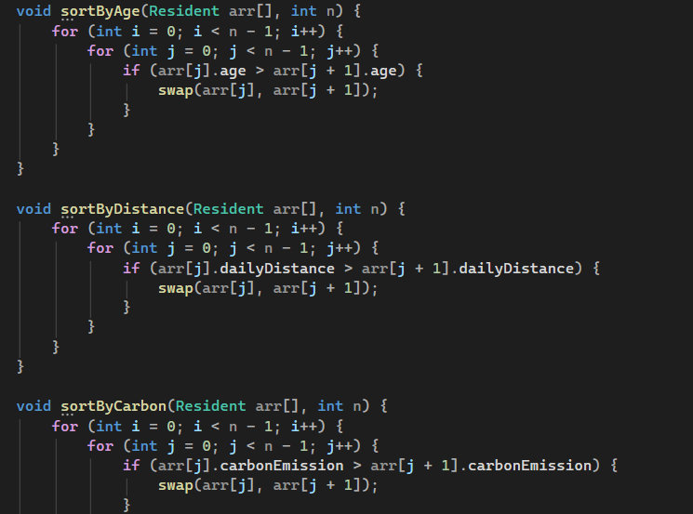
Figure 5.6.1: Sorting functions for age, distance, and carbon emission

5.7 Searching Part:
The searching functions are used to find records based on the user condition. Linear Search was used because it checks every record one by one. This makes it suitable even if the data is not sorted.
• searchByAgeGroup() displays records between the minimum and maximum age.
• searchByTransport() displays records that match the selected transport mode.
• searchByDistance() displays records where the daily distance is above the selected limit.

if (arr[i].age >= minAge && arr[i].age <= maxAge) {
showResident(arr[i]);
}

For transport mode search, the function checks if the resident transport mode matches the selected mode. For distance search, the function checks if the daily distance is greater than the selected limit.

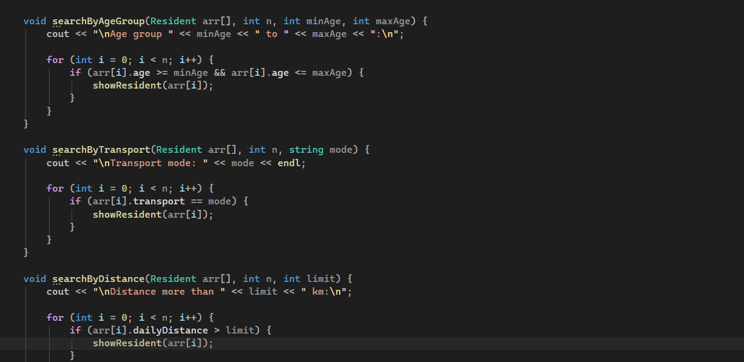
Figure 5.7.1: Linear search functions for age group, transport mode, and distance threshold

5.8 Functions included in the Code:
These are the main functions included in this part:
• showResident() displays one resident record.
• showAll() displays all records in the array.
• sortByAge() sorts the records by age.
• sortByDistance() sorts the records by daily distance.
• sortByCarbon() sorts the records by carbon emission.
• searchByAgeGroup() searches records using an age range.
• searchByTransport() searches records using the transport mode.
• searchByDistance() searches records using a distance limit.

5.9 Time Complexity:
In this implementation, Bubble Sort mainly uses two loops, so the general time complexity is O(n^2). This happens because each record can be compared with other records during the sorting process. Linear Search checks each record once, so its time complexity is O(n). This means the search time increases based on the number of records.
The space usage is also simple because the functions do not create another full dataset. The sorting swaps records inside the same array, and the searching functions only display the matching records.

5.10 Testing Method:
The code was tested using sample resident records before integration. The original data was first displayed, then sorted by age, distance, and carbon emission. After that, the search functions were tested using an age range, a transport mode, and a distance limit.
The test output showed that the functions worked correctly with the sample records. The same functions can be connected to the final data after the group combines the program. The results were checked manually to ensure the sorting order and search conditions were correct.

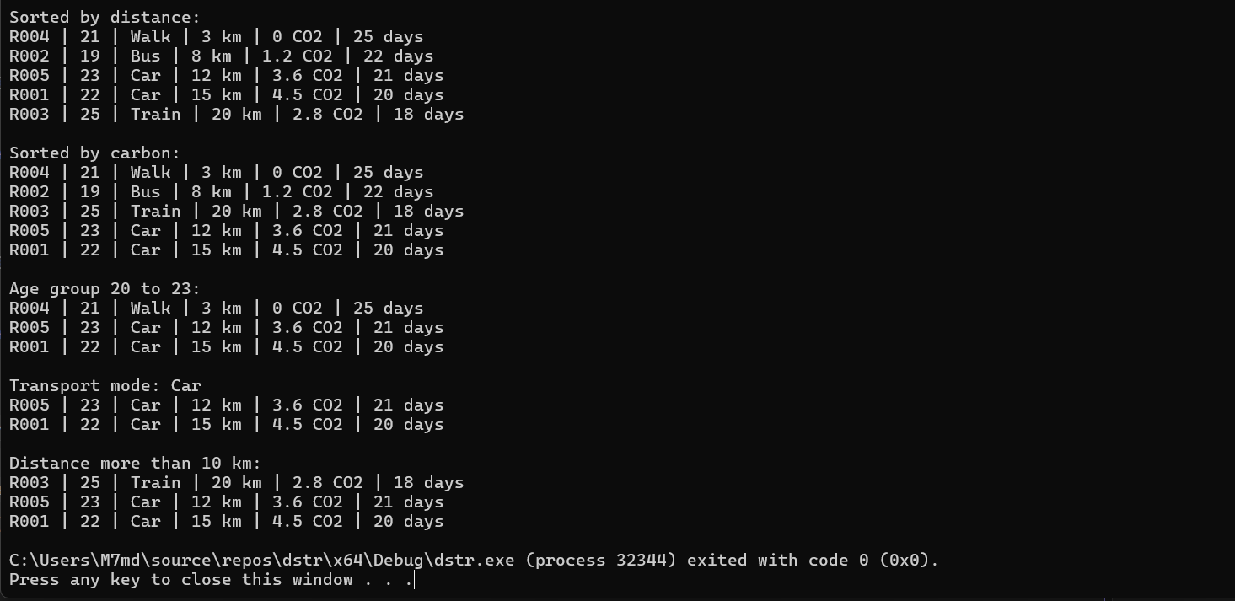
Figure 5.10.1: Console output showing sorting and searching results

5.11 Integration with the Group Code:
The code is written as functions so that it can be added into the final group program. The final program should only have one main function, so the testing main function should not be copied into the final combined version. The functions should be connected to the final menu and called using the resident data from the array and linked list parts.
• Task 1 loads the CSV data.
• Task 2 stores the data using arrays.
• Task 3 stores the data using a singly linked list.
• Task 4 uses the stored records to sort and search the data.
• Task 5 can use the sorted or searched data for analysis and comparison.

5.12 Important Integration Note:
The Resident structure must be defined only once in the shared header file. The field names should be the same in all files. If one file uses age and another file uses residentAge, the program will not compile correctly. The group should use one consistent version of the Resident structure.
The field names used are: residentId, age, transport, dailyDistance, carbonEmission, and averageDay.
This is important because the sorting and searching functions use these names directly.

5.13 Limitations:
The main limitation is that Bubble Sort can become slow when the dataset is very large because it uses repeated comparisons. However, for this assignment it is acceptable because the main goal is to show how sorting works. Another limitation is that Linear Search checks every record, but it is simple and works even when the data is not sorted.

5.14 Possible Improvements:
If the project needs better performance later, Bubble Sort can be replaced with a faster algorithm such as Merge Sort or Quick Sort. Also, if the data is sorted first, Binary Search could be used for some fields such as age. For this assignment, the algorithms were kept simple so they match the data structures topic and are easier to integrate with the group code.

5.15 Conclusion:
In conclusion, the sorting and searching part of the project was completed. The program can sort records by age, daily distance, and carbon emission. It can also search records by age group, transport mode, and distance threshold. This part supports the project by making the data easier to organize, compare, and retrieve. Overall, this task shows an understanding of basic sorting and searching algorithms in a Data Structures module. This task also shows how algorithms can be applied to real data in a structured program.

6.0 Input and Output Screenshots

6.1 Age Group Analysis:

6.1.1 Array Program Age Group Analysis for One City:

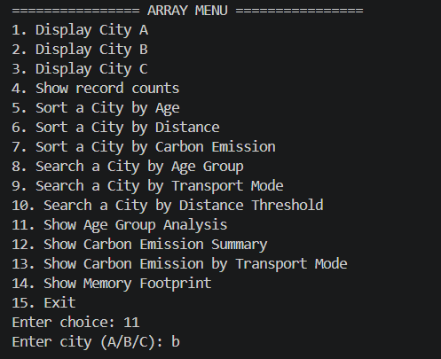
Figure 6.1.1: Array Menu Interface

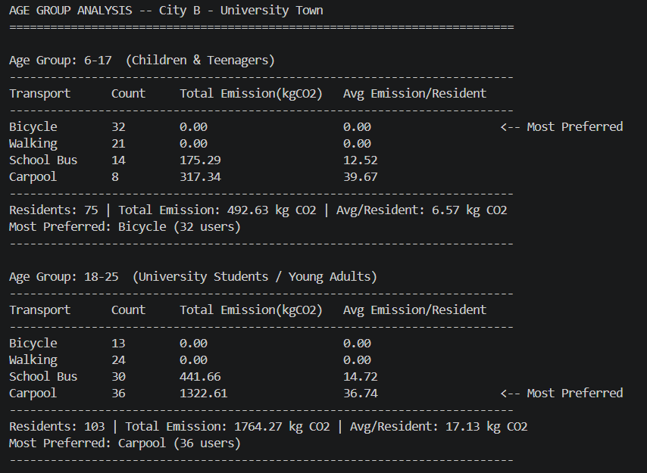
Figure 6.1.1: Age Group Analysis for City B

6.1.2 Linked List Program Age Group Analysis for One City:

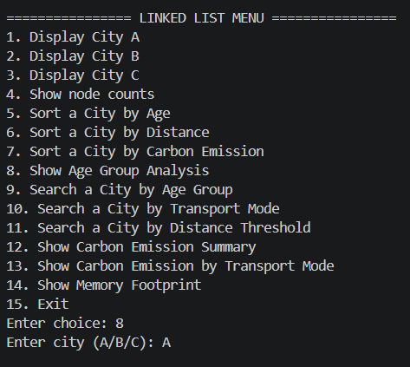
Figure 6.1.2: Linked List Menu Interface

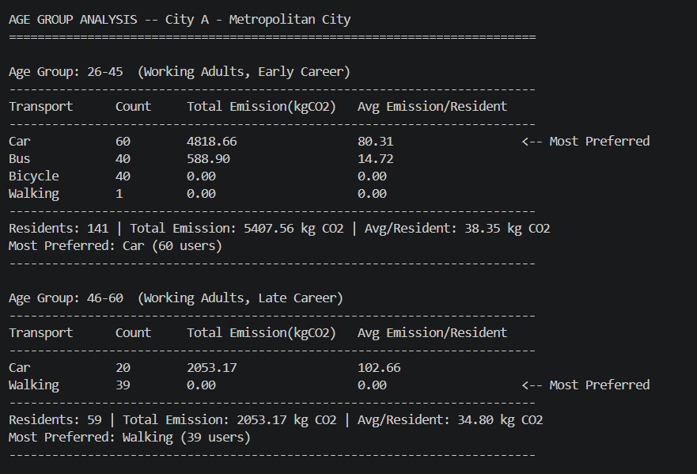
Figure 6.1.2: Age Group Analysis for City A (Linked List Program)

6.2 Carbon Emission Analysis:

6.2.1 Total Carbon Emission Summary by City:

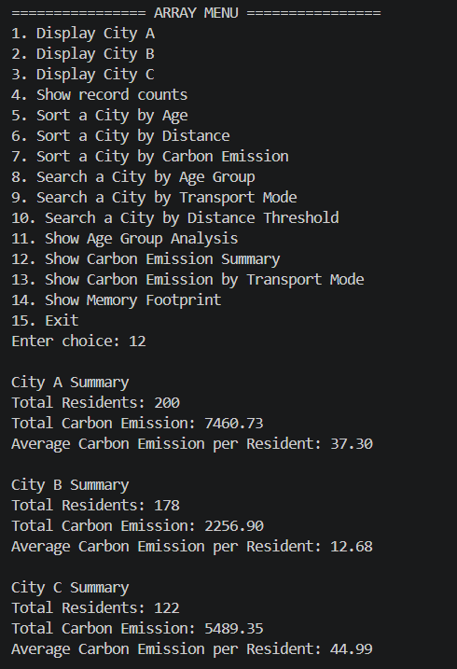
Figure 6.2.1: Total Carbon Emission Summary by City

6.2.2 Total Carbon Emission Summary by Transport:

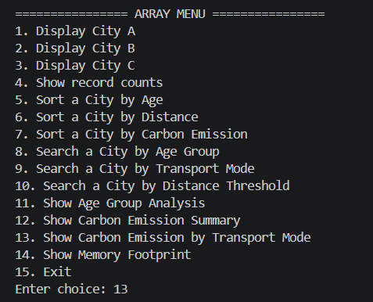
Figure 6.2.2: Array Menu with Analysis Options

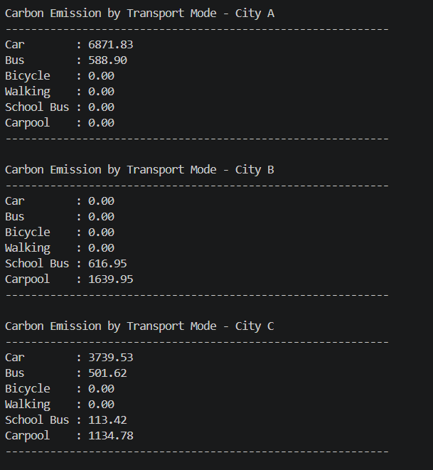
Figure 6.2.2: Carbon Emission by Transport Mode for City A, B, and C

6.3 Sorting Results:

6.3.1 Array Sort by Age:

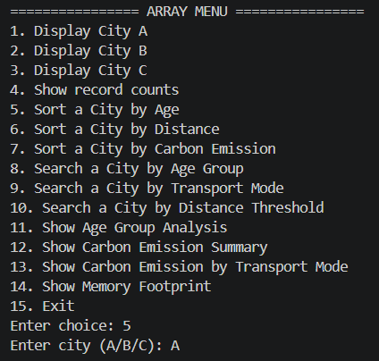
Figure 6.3.1: Array Program Menu for Sort by Age

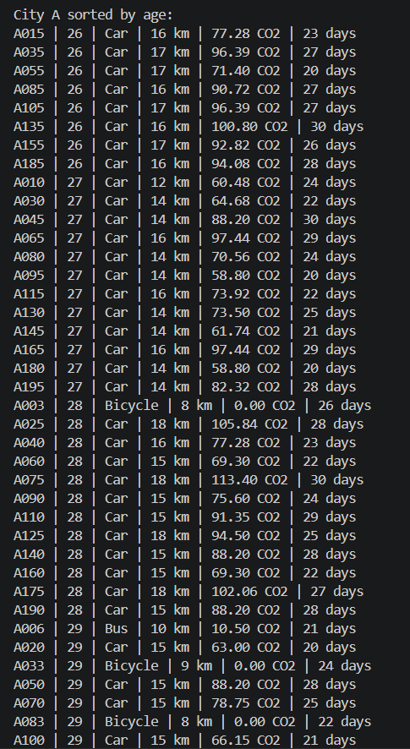
Figure 6.3.1: Sort by Age Output for City A

6.3.2 Array Sort by Distance:

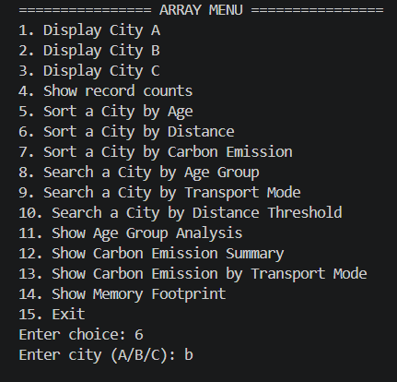
Figure 6.3.2: Array Program Menu for Sort by Distance

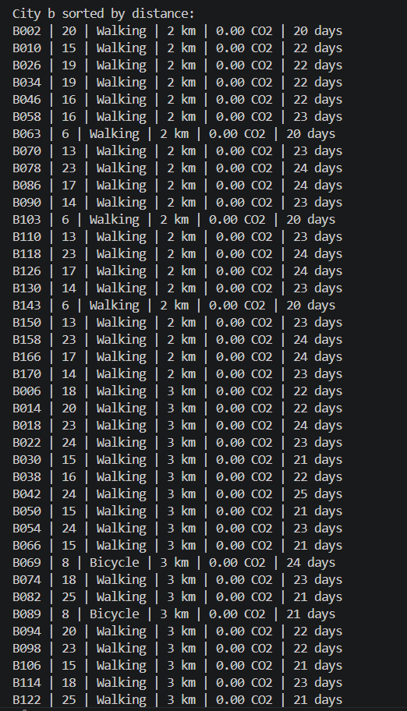
Figure 6.3.2: Sort by Distance Output for City B

6.3.3 Array Sort by Carbon Emission:

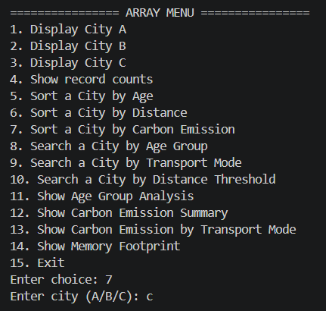
Figure 6.3.3: Array Program Menu for Sort by Carbon Emission

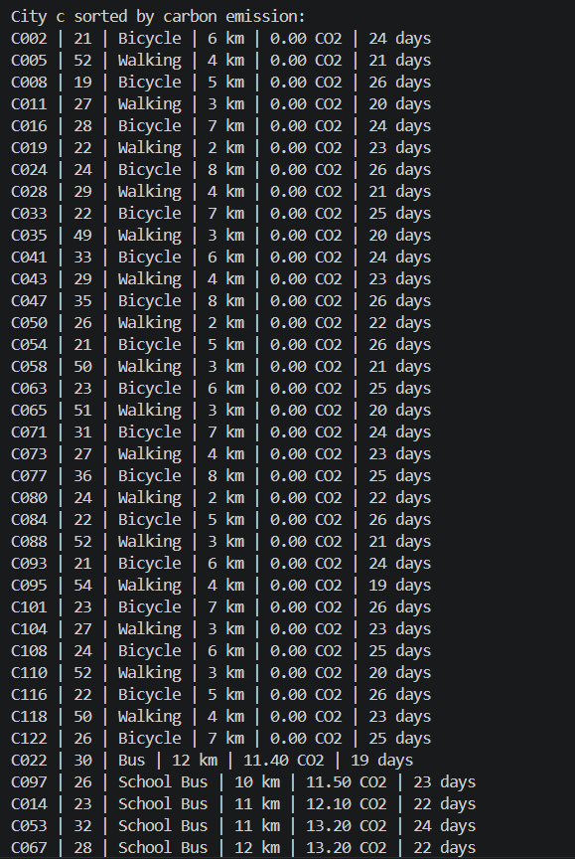
Figure 6.3.3: Sort by Carbon Emission Output for City C

6.4 Searching Results:

6.4.1 Search by Age Group:

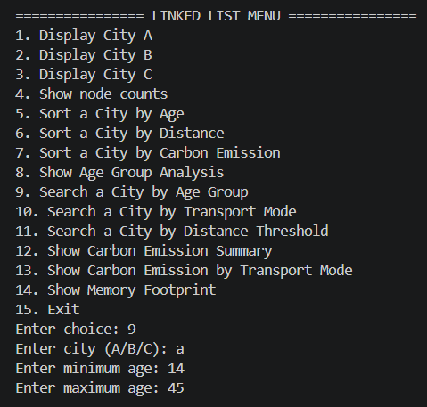
Figure 6.4.1: Linked List Program Menu for Search by Age Group
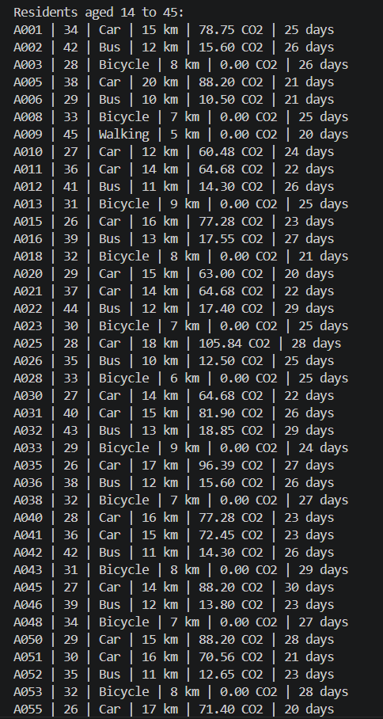
Figure 6.4.1: Search by Age Group Output in Linked List Program

6.4.2 Search by Transport Mode:

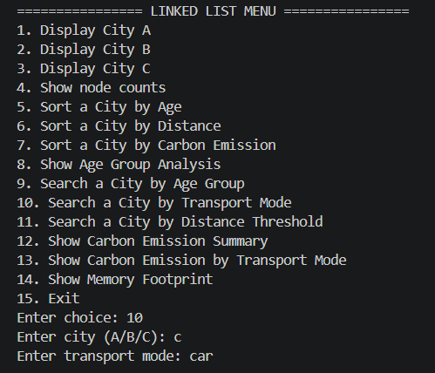
Figure 6.4.2: Linked List Program Menu for Search by Transport Mode

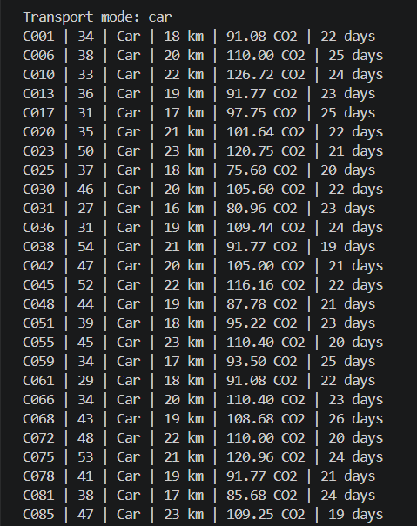
Figure 6.4.2: Search via Transport Mode Output in Linked List Program

6.4.3 Search by Distance Threshold:
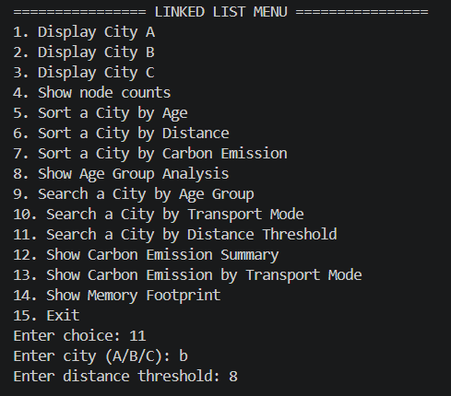
Figure 6.4.3: Linked List Program Menu for Distance Threshold Search

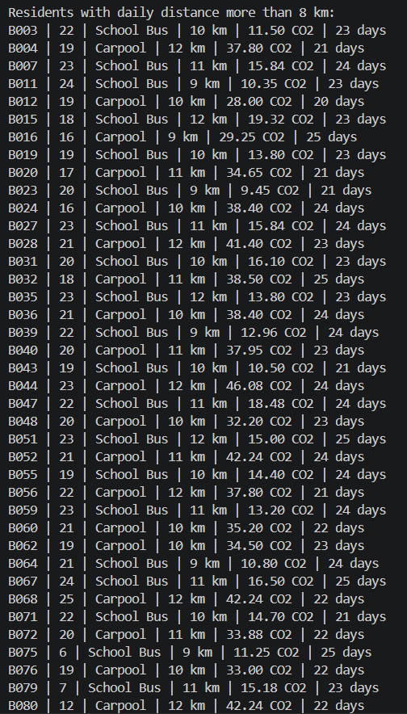
Figure 6.4.3: Search by Distance Threshold Output in Linked List Program

6.5 Performance Results:

6.5.1 Array Memory Footprint:

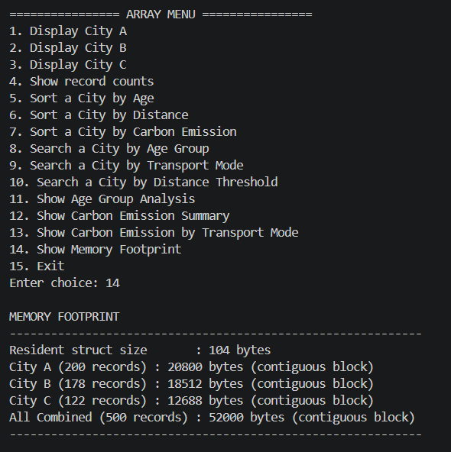
Figure 6.5.1: Array Memory Footprint Output

6.5.2 Linked List Memory Footprint:

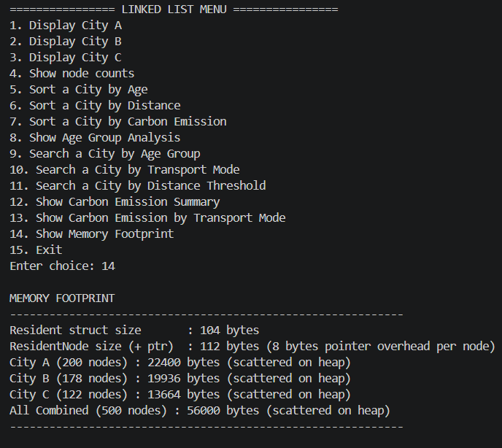
Figure 6.5.2: Linked List Memory Footprint Output

7.0 Summary Discussions

7.1 Carbon Emission Analysis:

7.1.1 Carbon Emission Summary:

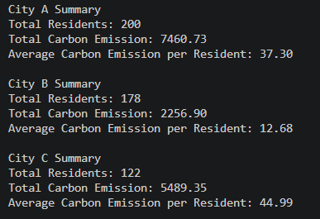
Figure 7.1.1: Carbon Emission Summary by City

We can observe that the data summary for carbon emission has been provided for three different places, namely City A, City B, and City C. The information about each city includes the number of residents, carbon emissions produced, and the average carbon emissions per person. The maximum number of residents lives in City A, which has 200 residents, whereas the minimum average emission per person is in City B, which has 12.68 carbon emissions. However, surprisingly, the least number of people live in City C, having only 122 residents; however, its average carbon emissions per person are the largest, amounting to 44.99.

7.1.2 Carbon Emission by Transport:

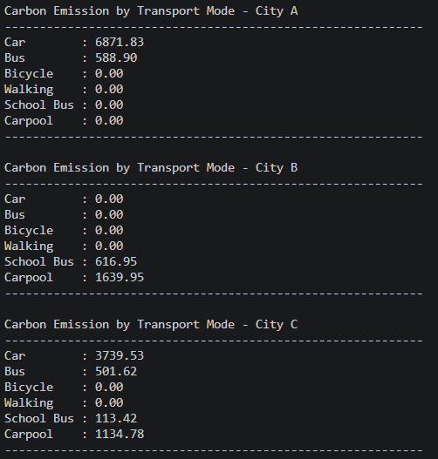
Figure 7.1.2: Carbon Emission by Transport Mode

In City A, the dominant form of transportation is Cars (6871.83) and Buses (588.90). Other forms of transportation, such as bicycles, pedestrians, and school buses, emit no emissions whatsoever.
For City B, there is a total switch from personal cars and city buses. In their place, the only sources of emissions are School Buses (616.95) and Carpools (1639.95).
In City C, there is more diversity in transportation, but there is heavy reliance on emissions from Cars (3739.53) and Carpools (1134.78).

7.1.3 Carbon Emission by Age Group:
Age Group Analysis on transportation behaviour and CO_2 emissions in three different cities:
City A: Metropolitan City
City B: University Town
City C: Suburban/Rural Area

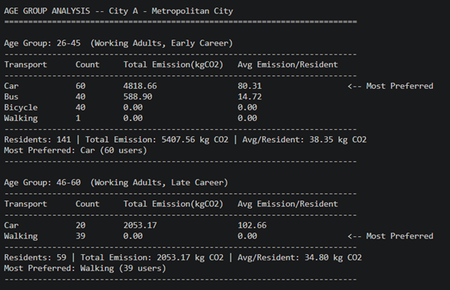
Figure 7.1.3: Age Group Analysis for City A

City A - Metropolitan City:
Age Group | Residents | Total Emission | Avg/Resident | Most Preferred
26–45 | 141 | 5407.56 | 38.35 | Car (60 users)
46–60 | 59 | 2053.17 | 34.80 | Walking (39 users)

Walking versus Driving: Even though individuals in the 46-60 age category have the lowest mean emissions because walking is their favourite way of traveling, the people in this age bracket that drive produce the largest number of emissions at 102.66 kgCO_2.
Volume: In the three cities, this one has the greatest population, and the 26-45 age category contributes more than 5,400 kgCO_2.

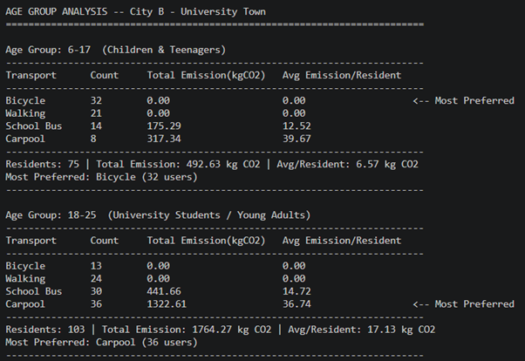
Figure 7.1.3: Age Group Analysis for City B

City B - University Town
Age Group | Residents | Total Emission | Avg/Resident | Most Preferred
6–17 | 75 | 492.63 | 6.57 | Bicycle (32 users)
18–25 | 103 | 1764.27 | 17.13 | Carpool (36 users)

Sustainability among Youth: The age group from 6-17 is the most environmentally friendly one, having 6.57 kgCO_2 per capita, due to their high cycling and walking numbers.
Effect of Carpool: When people start going towards the age range of 18-25 years, they tend to go for carpool, which makes up to about 75% of their CO2 emissions.

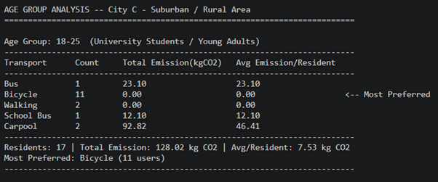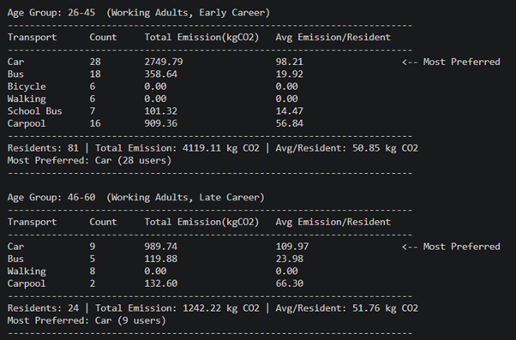
Figure 7.1.3: Age Group Analysis for City C

City C - Suburban / Rural Area
Age Group | Residents | Total Emission | Avg/Resident | Most Preferred
18–25 | 17 | 128.02 | 7.53 | Bicycle (11 users)
26–45 | 81 | 4119.11 | 50.85 | Car (28 users)
46–60 | 24 | 1242.22 | 51.76 | Car (9 us

Most Per Capita Emissions: The 46-60 age category from this region is the one with the most emissions per person at 51.76 kgCO2 among all three cities.
Dependency on Cars: In contrast to City A, those who are more mature in City C prefer to use their vehicles, unlike the young age category of 18-25 years.

Conclusion:
Sources of Emissions: "Car" and "Carpool" show the greatest emissions in all the cities, in all age groups.
Sustainable Transportation: "Bicycle" and "Walking" show 0.00 kg CO_2 always. Hence, they are the most sustainable transportations.
Patterns in the Cities: Emission levels tend to be greater in Metropolitan cities and Suburban cities than in university towns due to the use of vehicles.

7.2 Performance Analysis:

7.2.1 Linked List Implementation:

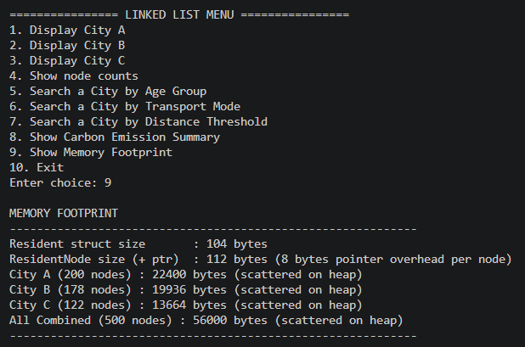
Figure 7.2.1: Linked List Memory Footprint Output

We can see the Linked List Implementation, where each node has an extra pointer node overhead. Therefore, the memory usage is higher (56000 bytes), and the data is Scattered across the heap.

7.2.2 Array Implementation:

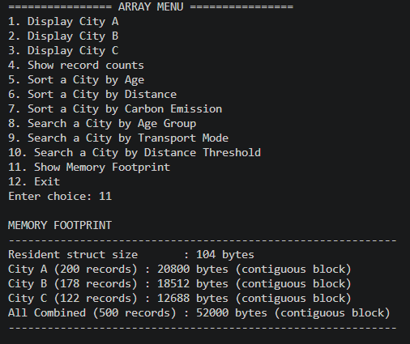
Figure 7.2.2: Array Memory Footprint Output

This is the Array Implementation, where the data has been stored contagiously without a pointer overhead. This makes the memory more efficient (52000 bytes) and is better for cache performance.

7.2.3 Array VS Singly Linked List:
- An array would be an optimal choice if there was any requirement for memory efficient array along with fast access, as arrays have been proven to use less memory space (52,000 bytes) in comparison to the alternatives and on top of that the data is stored in memory close to the location where it is required.
- Singly linked lists would make the optimal choice in situations where there are multiple requirements for insertion or deletion as there is no need to move any data.

7.2.4 Real-world Advantages & Disadvantages:
Arrays:
- 1. Faster access (using array indexes), faster cache mechanism, less memory usage.
- 2. Higher cost associated with insertion/deletion (shifts), static size makes it restrictive at times.

Singly Linked Lists:
- 1. Faster insertion/deletion operations, flexible sizes, do not need contiguous memory.
- 2. Extra memory needed for keeping pointers, slower access (no indexes used), worse caching performance.

Conclusion: An array makes a better fit in case the situation requires frequent read accesses while singly linked lists are a better alternative for write operations.

8.0 Conclusion & Reflection

8.1 Summary:
Thus, this project used two distinct C++ programs such as one using arrays and the other using singly linked lists were effectively built regarding the same transportation datasets. To ensure consistency in data preparation, both applications used a shared Resident structure. In the final system, the three datasets are loaded, age groups as well as carbon emission values are created, searching and array-based sorting are implemented, age group analysis and transport-based emission analysis are given as well as the memory footprint regarding both data structures is reported.

8.2 Strengths & Weaknesses:
Strengths:
- This project remained consistent due to the shared resident structure.
- Data setup and file handling: suitable data preparation via parsing logic.
- Robust sorting and searching features are supported via array programs.
- The linked-list application gives beneficial search and analysis results.
- Regarding report comparison, both application involves memory-footprint output.

Weaknesses:
- The linked-list version does not implement complete sorting evenly.
- The existing code emphasizes integrated functionality over complex algorithm. experimentation.
- Even though the output is good for snippets, the formatting may yet be improved.
- The current prototype still has minimal automatic timing comparison.

8.3 Future Improvements:
- Add linked-list sorting features equal to the array program.
- Add automatic execution-time measurement for both programs.
- Add more cross-city comparison tables.
- Improve output formatting even further.
- Support exporting analysed results to a file.

9.0 References
GeeksforGeeks. (2026). Array Data structure. GeeksforGeeks.
https://www.geeksforgeeks.org/dsa/array-data-structure-guide/
GeeksforGeeks. (2026). Linked List data structure. GeeksforGeeks.
https://www.geeksforgeeks.org/dsa/linked-list-data-structure/
Vyankateshpareek. (2023). Sorting & searching algorithms. Medium.
https://medium.com/@vyankateshpareek733/sorting-algorithms-11a9057d688f

