
Introduction to Artificial Intelligence (IAI) – GROUP ASSIGNMENT

Student declaration:
I/We declare that:
• This assignment is my/our own original work, except where I/we have appropriately cited the original source.
• This assignment or parts of it has not previously been submitted for assessment in this or any other subject.
• I/We understand the definition of plagiarism and its resulting consequences.
• I/We allow the assessor of this assignment to test any work submitted by me/us, using text comparison software for plagiarism.

Group Leader’s Signature: Aayan Date: 30/5/2025
Project Title: Vellora Hotels and Resorts | Team 6 | Intake: APD1F2409CS
Role | Student ID & Name | Signature
Group Leader | TP085049  Muhammad Aayan Ul Haq | Aayan
Group Member 1 | TP084954  Zeba Waheed Parkar | Zeba
Group Member 2 | TP084321  Muhammad Huzaifa | Huzaifa
Group Member 3 | TP085047  Aimen Rizwan | Aimen
Group Member 4 | TP085584  Mohib Bin Aamir | Mohib

Table of Content:
1. Introduction………………………………………………………………………………
1.1 Purpose of the Chatbot…………………………………………………………...
1.2 Need for the Project……………………………………………………………….
1.3 Scope of the Chatbot……………………………………………………………..
1.4 Overview of the Report……………………………………………………………
2. Literature Review…………………………………………………………………………
2.1 Existing Solutions………………………………………………………………….
2.2 Relevant Theories and Technologies……………………………………………
2.3 Gaps in Current Technology………………………………………………………
3. Methodology………………………………………………………………………………
3.1 Design Approach…………………………………………………………………..
3.2 Knowledge Representation……………………………………………………….
3.3 Tools and Technologies Used…………………………………………………….
3.4 Development Process……………………………………………………………..
4. Implementation…………………………………………………………………………..
4.1 Challenges Faced………………………………………………………………….
4.2 Solutions to Challenges……………………………………………………….…..
4.3 Key Functions Implemented………………………………………………………
5. Conclusion………………………………………………………………………………..
5.1 Summary of Achievements………………………………………………………..
5.2 Impact of the Chatbot………………………………………………………………
5.3 Future Work…………………………………………………………………………
5.4 Final Thoughts………………………………………………………………………
6. References………………………………………………………………………………..

1. Introduction -
1.1 Purpose of the Chatbot.
To be available around the clock to respond to customer questions about inquiries, bookings and services.
To serve as a digital concierge, supporting the guest from before they arrive until after they leave the property.
To cut down on the need for employees to do the same tasks over and over again.
To allow for guests who don't like to converse face to face a better and reliable way to make their inquiries.

1.2 Need for the Project.
As technology evolves our guests expect us to be up to the latest trends promoting a better image of our organisation.
Slow and inconvenient manual methods delayed responses and cost opportunities to book guests.
Hotel guests now anticipate being able to use digital services as soon as they need them.
Needs less manpower to attend to guests as the bot can do most of the word.
A chatbot helps run the business more efficiently, makes guests happier and lessens the job workload for employees.

1.3 Scope of the Chatbot.
To improve user experience and efficiency at Vellora Hotels and Resorts.
The team is responsible for reservations, responds to the customer questions and deals with both FAQs and complaints.

It enables users to see what a resort offers on site while they explore.

People can communicate using Facebook, through WhatsApp or on Messenger, on the website.

1.4 Overview of the Report.

It presents the development stage, what the chatbot can do and how it is built.

Indicates the main problems that were solved and the benefits that can be seen by hotel operations.

It describes the method for Utilizing resources and the ways to measure how it goes.

2. LITERATURE REVIEW -

2.2 Existing Solutions.
Millennium and Hilton, as well as other leading hotel groups, are employing chatbots powered by AI. Such assistants resolve many of the same issues a front desk person would and can manage requests, check hotel occupancy and process customer opinions.

Many hotels are now integrating technology with CRM to make the experience for their guests better.

Despite their benefits, these tools tend to be costly, can introduce problems to operations and aren’t always a good match for the community character in Vellora.
2.2 Relevant Theories and Technologies.

Due to Natural Language Processing, the bot acts in a way that humans can relate to.

When users provide feedback, the bot delivers an appropriate response.

The programs can manage both common questions and reservations.

Relies on Human computer interaction in your operations to ensure users like the service and meet their requirements.
2.3 Gaps in Current Technology.
For hotels in places like Vellora Hotels and Resorts, chatbots are less helpful because they don’t support local languages, or deliver regional services. It takes a lot of money to get started with cryptocurrencies.
As the fees for using commercial AI chatbots are so expensive, they are usually outside the budget of most small or mid-sized companies.
Most pre-built chatbots do not adapt well to each hotel’s unique ways of working, systems or branding. It is common for existing bots to pause in the conversation and then start talking about something unrelated.
This chatbot is cost-effective, tuned to the situation and simple to connect, it is a perfect match for Vellora Hotels and Resorts.
3. METHODOLOGY -

3.1 Design Approach.

The goal of this project was to design a conversational bot that allowed users to inquire about Vellora Hotels and Resorts. The bot would answer their inquiries by providing the relevant information.

At the beginning stage we had highlighted simple key ideas and paths that the user could take. At first only had one main path the user could take, later we expanded on the idea by adding more paths the user could take for their inquiry. As well as allowing the user to ask more questions if they want to afterwards. We created a simple flowchart at first to visualize it.
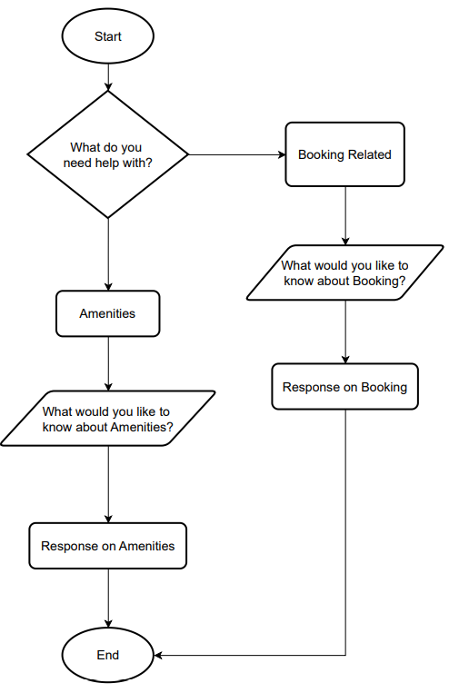
Figure 3.11 Initial Flowchart
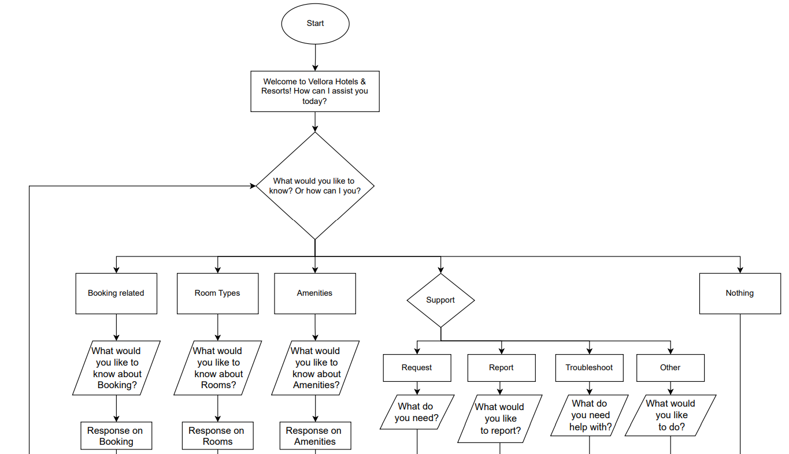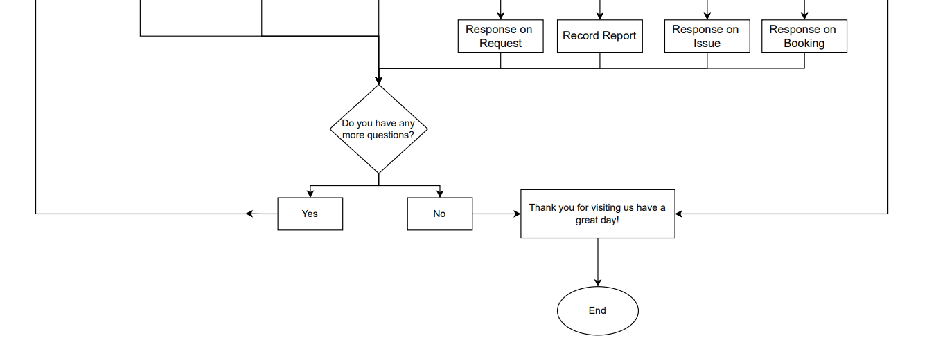
3.12 Final Flowchart

The Vellora Hotels & Resorts chatbot is created so that users experience a smooth and easy conversation journey. It allows guests to quickly find out how to get help or answers by walking them through simple choices.

- You have to begin with a welcome message. A user gets greeted by the bot with clear instructions and a warm voice from the start.
- After that, the bot asks the user what they need assistance with. There are five choices: Booking Related, Room Types, Amenities, Support or Nothing for users who want to navigate without help.
- If a user presses Booking Related, Room Types or Amenities, the chatbot returns a relevant question such as:
- "What would you like to know about booking?"
- "What would you like to know about room types?"
- "What would you like to know about amenities?"
Following the user’s response, helpful information is given in the form of a relevant answer.
- If the user selects Support, the chatbot provides four alternative options:
- Request: The bot requests assistance and responds to fit the user’s requirements.
- Report: The user may report a problem and the chatbot responds by adding it to the report.
- Troubleshoot: If you face a challenge, the bot will help by pointing you in the right direction.
- Other: If the user has a different request, they can say it and the bot often points them to a response involving booking.
- When Nothing is selected, the chatbot concludes the conversation politely since it knows the user doesn’t need more advice.
- As soon as the user’s needs are met, the chatbot says: “Any further questions for me?”
- When the user replies with Yes, the chatbot returns to the previous question and gives them a second chance to look at services.
- Choosing No causes the chatbot to end the chat politely: “Thank you for visiting us. Have a great day!”
- Now, the process ends with the user feeling attended to and courteously served.

3.2 Knowledge Representation

By using various methods for storing information, our chatbot can better manage guest interactions and give highly satisfactory replies. They help hotel staff understand guests clearly, respond quickly and adjust to their requests, which improves Vellora Hotels & Resorts’ guest experience.
1. Production Rule Representation:
To use production rules, we describe what to do using "IF-THEN" conditions. The method allows the chatbot to give rapid and suitable answers to the most frequent questions. Examples include:
Should the guest wonder about booking, the chatbot explains the ways to reserve.
If anyone mentions an amenity problem in their room, the chatbot immediately guides them to solutions from the proper support staff. Thanks to this system, guests get fast, accurate and dependable service.
2. Frame Representation:
By arranging information into given categories in a frame, users can quickly find and return clear answers. Different guest needs are managed by the chatbot using a number of frames.
Booking Frame records fields, including how guests reserve, if they can cancel and what changes are permitted.
This frame brings together data on Wi-Fi connectivity, available gyms, swimming pools and different options for dining.
Technical Issues with Helpful Solutions: The Frame outlines usual issues such as unstable Wi-Fi or broken room equipment, along with how to solve them.
Because each frame is distinct, the chatbot can quickly bring up and provide the information that is right for the conversation.
3. Semantic networks are used in representation:
A chatbot using semantic networks can see and deal with links between various ideas, which results in better conversations and more accurate results. Examples include:
Linking things guests want, such as "extra towels", to the services that handle them, such as housekeeping.
Attaching ordinary issues with the appropriate solutions by making the link "TV remote issues" to front-desk help.
Reasoning and Inference:
Because of rule-based inference and constraint satisfaction, the chatbot can provide proactive service and tailor its service to each guest. If a guest asks for a room or special amenity, the chatbot makes a suggestion for other options if the primary request is taken. It takes care of now and predicts what else can be offered during a stay for a more satisfying experience.

3.3 Tools and Technologies Used

The tool used to design the chatbot is Botpress. It is an open source conversational AI platform used to create, manage and publish chatbots in an efficient and simple manner. We used the Knowledge Base Engine which allowed us to answer questions using information filled in Microsoft Word Documents in a specific format. This also used NLU which allowed the bot to understand what the user wants by examining keywords in the question then answering through the Knowledge Base. We also used Draw.io to make the flowcharts. And finally for the documentation we used Microsoft Word once again. All of these tools and technologies were essential to describe and design our project.

3.4 Development Process
The bot was made very carefully to ensure that there were no errors, and all paths were efficient to keep the users engaged. Firstly, we searched for common questions among users may ask about Vellora Hotels and Resorts, then we developed more on those question building knowledge bases to answer the users inquiries. A simple flow was created to visualize the flow of the conversation by making the flowchart above. Then we tested the bot by sharing it to a few potential users and we asked them to use the bot and provide us with feedback which helped us on error handling and keywords that are commonly used by users. Later we added a way for the user to ask more questions without ending the conversation.
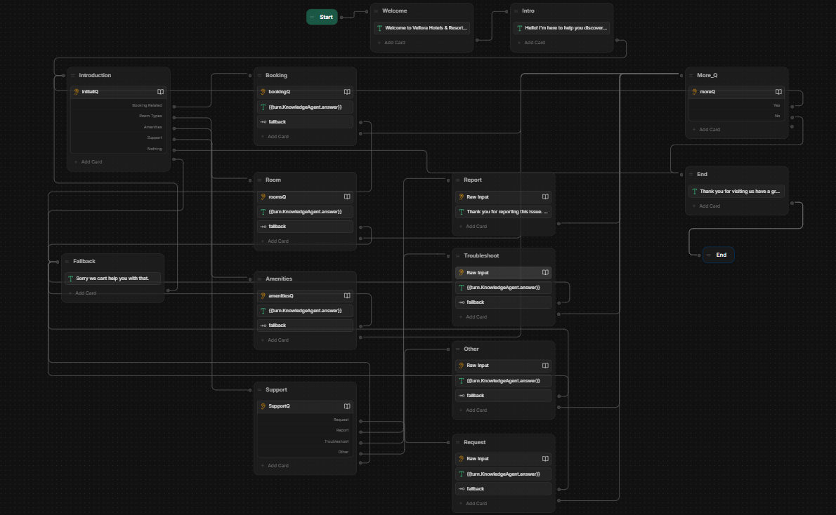
Figure 3.401 Full Workflow

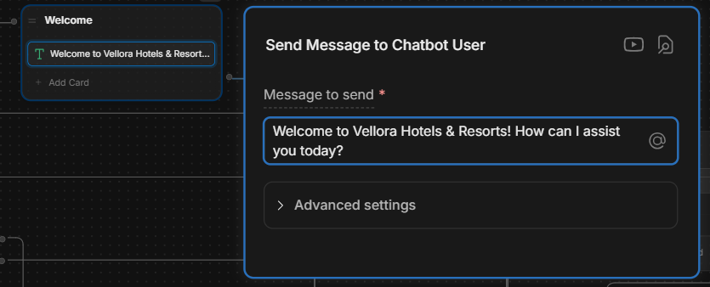
Figure 3.402 Initial Greeting Message

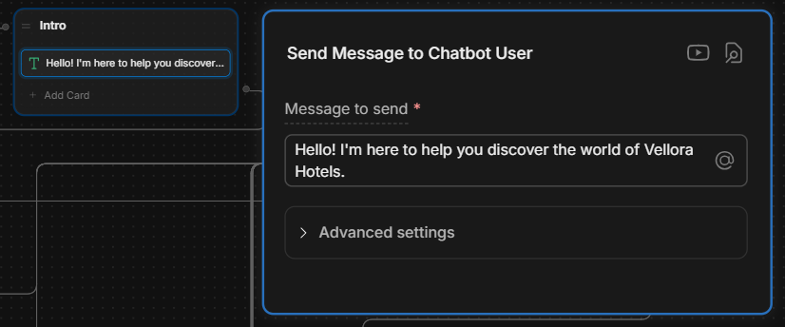
Figure 3.403 Catching Phrase

The chatbot will greet the user gently by displaying a welcome message when it is called for. Then the bot will tell the user that it is for by displaying a catching message.

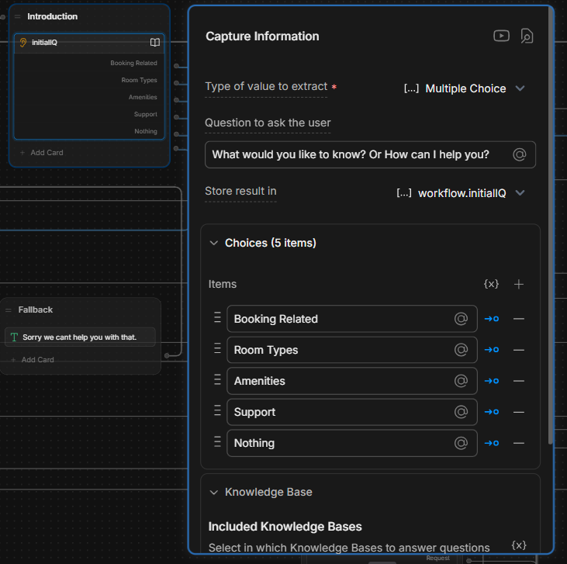
Figure 3.404 Main Question

Then it will display a message asking the user by asking “What can I help you with?” then it will capture the user's response.

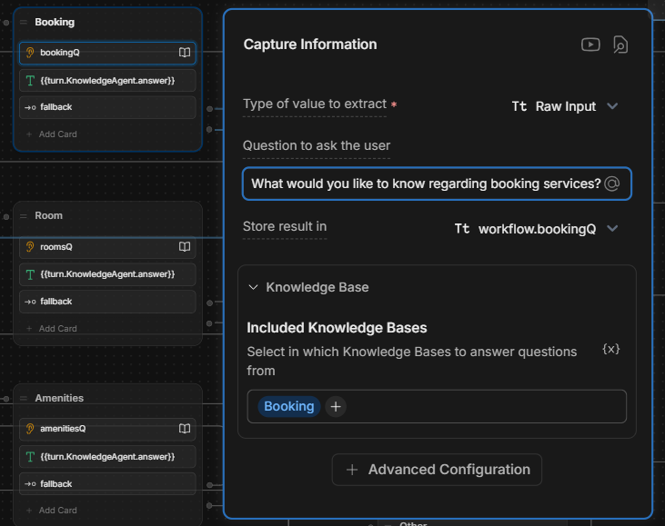
Figure 3.405 Booking Path

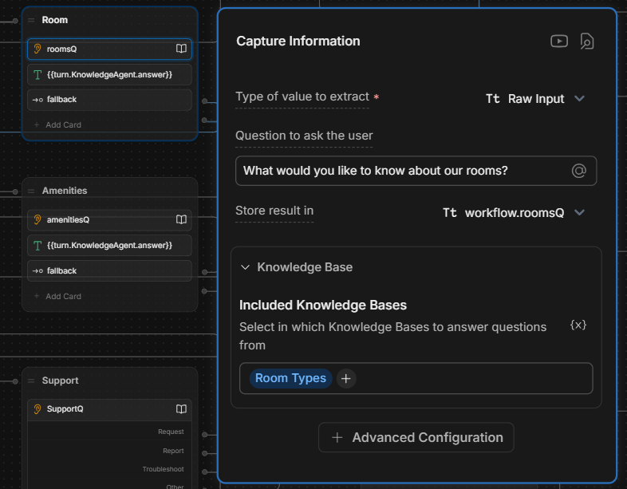
Figure 3.406 Room Types Path

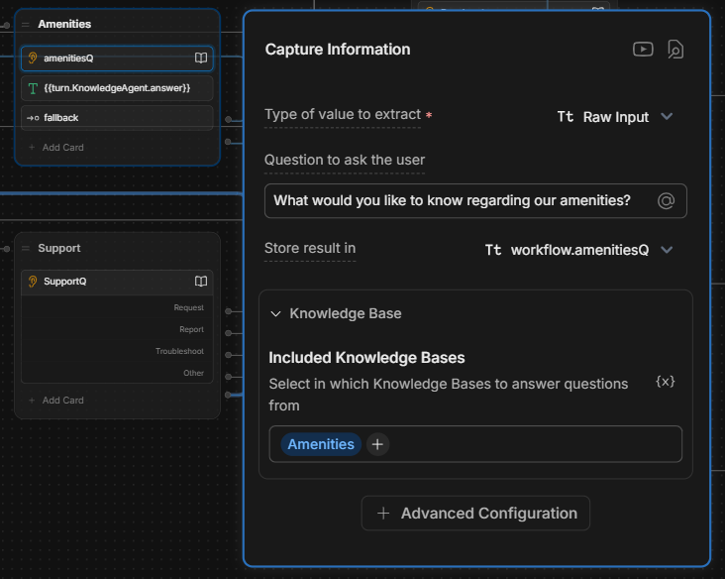
Figure 3.407 Amenities Path

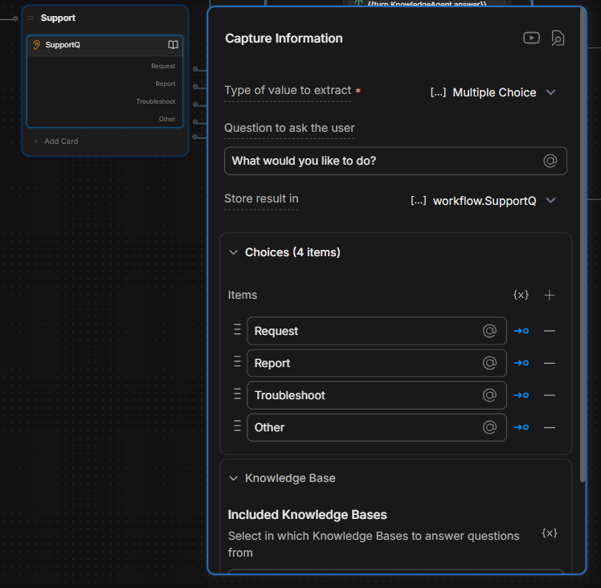
Figure 3.408 Support Path Extended Menu

This path expands further to allow for more categories of questions to ask if users have other concerns users can choose the other path which expand into further paths.

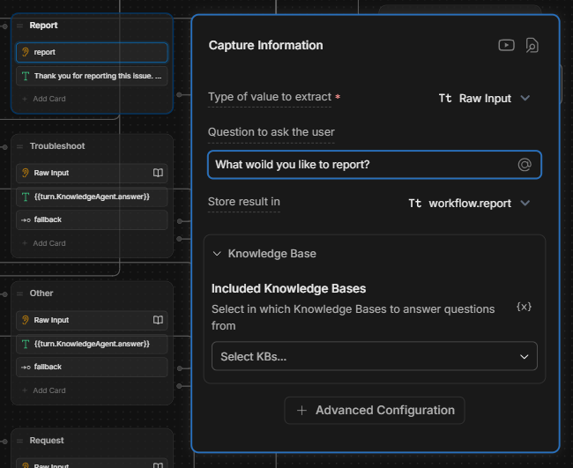
Figure 3.409 Report Path

This path allows the user to make reports which are then captured and saved into the variable report then it displays a message notifying the user the report has been made.

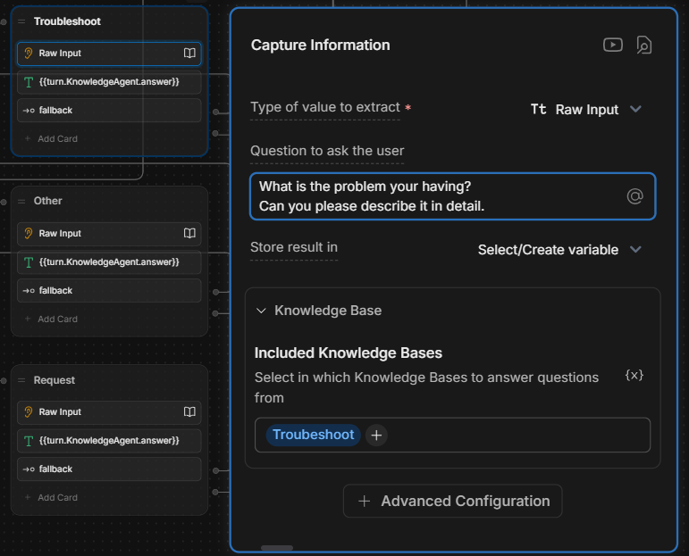
Figure 3.410 Troubleshoot Path
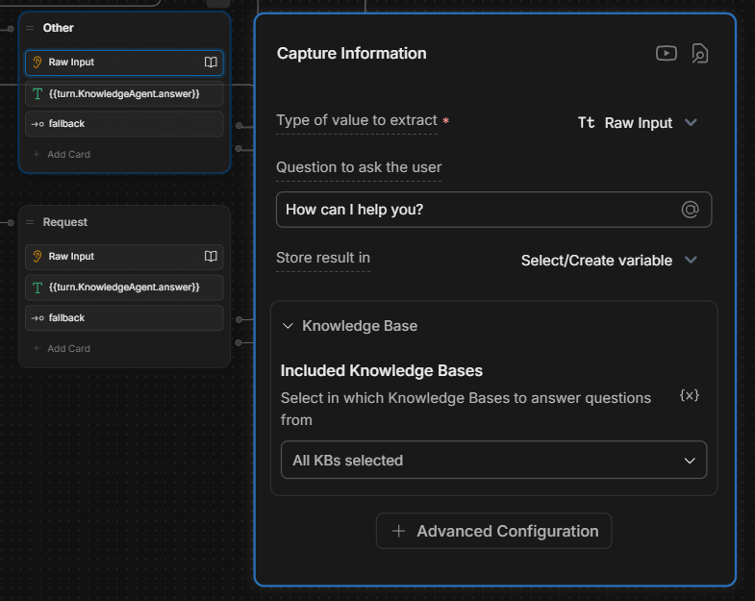
Figure 3.411 Other Path

This path allows the user to enter a custom inquiry which will be captured and searched through all of our knowledge bases if the answer is not found then it will take the conversation to Figure 3.414.

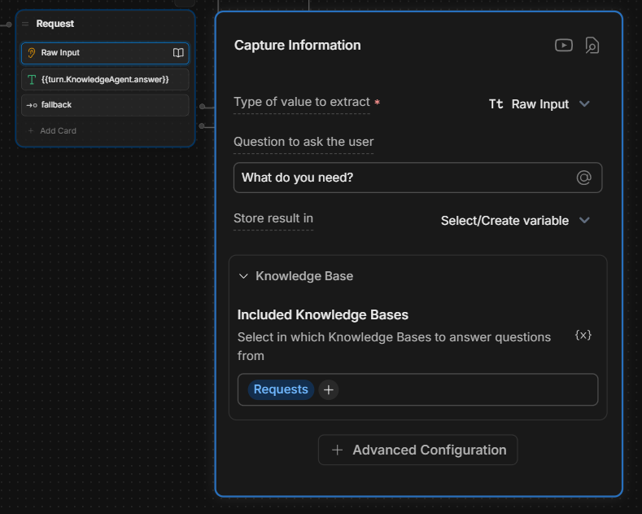
Figure 3.412 Requests Path

If the path chosen is Booking, this message will be displayed and the response will be captured and the question will be searched in the specific knowledge base and a relevant response will be given otherwise if an irrelevant question is asked it will take the conversation back to Figure 3.404 through Figure 3.414. The same format is followed for Figure 3.405, Figure 3.406, Figure 3.407, Figure 3.410, Figure 3.412.

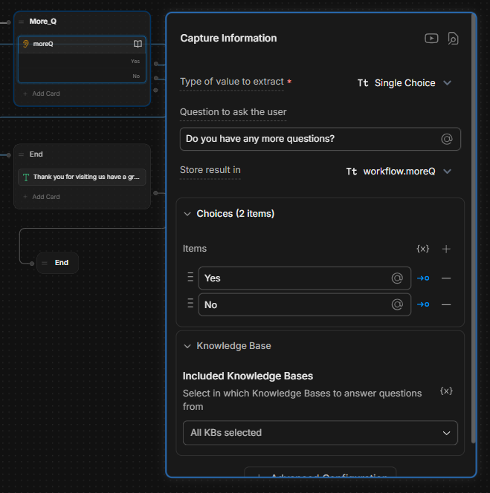
Figure 3.413 More Question

This allows the user to ask more question if they have any it first displays the message asking the user if they have any more questions if yes the conversation will be taken to Figure 3.404.

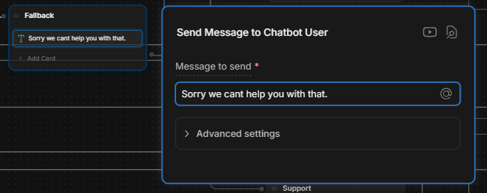
Figure 3.414 Fallback

This acts as a way to go back to previous nodes allowing for error handling in case questions that are irrelevant to the purpose of the bot are asked, this first display a message to the user saying that the bot cannot help the user with this then it takes the conversation to Figure 3.404.

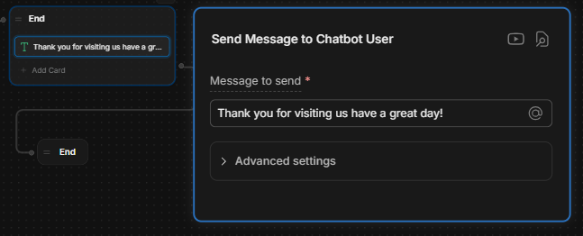
Figure 3.415 Ending

This ends the conversation and also displays a message saying thank you for visiting us then the conversation ends.

4. IMPLEMENTATIONS -

4.1 Challenges Faced.

Some guests used regional or local languages and slangs which the bot was not able to understand.

Some users ask questions that were irrelevant to the purpose of the bot so the bot wasn't able to answer them.

Customers had issues and questions that were not mentioned in the list and the bot couldn't answer them.

If the users continue to talk for long, the bot forgets the previous learned details.
Connecting the bot to the hotel's reservation system was not an easy task.
4.2 Solutions to Challenges.
The bot was trained to spot more local terms and expressions.
More backup replies and the chance to talk to a real staff member were both added.
Set up a method to store user information as chats occurred.
Created easy connections between the chatbot and the hotel’s booking pages.
4.3 Key functions implemented.
Bookings can be started by chat when guests check for available rooms.

The bot deals with classic queries whether it’s day or night.

People can use the chatbot to provide their opinions or file complaints.

The chatbot is available both on the hotel’s website and on social apps.
The chabot can do error handling if it is given input it cannot respond to due to questions that are irrelevant.

5. CONCLUSION -

5.1 Summary of Achievements.
Created and placed into operation a chatbot for customer care in the hospitality sector.
Real-time updates, as well as assistance with booking rooms, answering FAQs and handling complaints are integrated features.
Significantly reduced staff responsibilities and improved the speed at which we answered guest questions.
5.2 Impact of the Chatbot.
Support for guests was improved by making sure they could quickly get answers and use our digital services without difficulty.
Allows people to use information and services anytime, including outside of regular office hours.
By automating many common customer service tasks, staff can now pay more attention to each customer’s needs.
5.3 Future Work.
Allow your chatbot to serve people in different languages when they come from all over the world.
Combine your platform with the hotel’s key systems to show guests the rooms that are open and customize what services they receive.
Suggest activities, place to eat and theme package experiences according to what guests like.

5.4 Final Thoughts.

The chatbot is mainly for the visitors, answers instantly and is easy to use. It handles pre-booking the room, check-in and information shared regarding any ancillary services available locally, to make each conversation fit.

While the regular work is undertaken by chatbots, staff are freed to manage other roles. Thus, the employees respond to different needs more effectively and improve the quality and performance of the hotel.

Aside from Vellora's use of a chatbot, the company is also unveiling the tool for its main service and booking websites. By doing so, your guests can easily receive details from you that improve the service they get from your staff at any time while they are there.

In time, the chatbot will accommodate several languages, have more AI to customize for each user and improve how users provide information. Both customers and visitors will enjoy a greater experience with your company.

6. REFERENCES -

- BotPress | the complete AI agent platform. (n.d.-b). https://botpress.com/
- How to build an AI chatbot in 2025: Step-by-Step guide. (n.d.-b). https://botpress.com/blog/how-to-build-your-own-ai-chatbot
- AI Chatbot. (n.d.-b). Google Cloud. https://cloud.google.com/use-cases/ai-chatbot?utm_source=google&utm_medium=cpc&utm_campaign=japac-MY-all-en-dr-SKWS-all-all-trial-DSA-dr-1710102&utm_content=text-ad-none-none-DEV_c-CRE_651066671986-ADGP_Hybrid+%7C+SKWS+-+BRO+%7C+DSA+-All+Webpages-KWID_39700075532963557-dsa-19959388920&userloc_9065497-network_g&utm_term=KW_&gad_source=1&gad_campaignid=19576131803&gclid=CjwKCAjwi-DBBhA5EiwAXOHsGS3tYttOxfhGQauGnGPGew-OM0lOL9ANK88ceOPMfwFeKU0MttW6yhoCWYcQAvD_BwE&gclsrc=aw.ds
- Text, Inc. (n.d.-b). How to handle Chatbot error messages | ChatBot Academy. ChatBot. https://www.chatbot.com/academy/chatbot-designer-free-course/error-messages/
- Knowledge base chatbots: What they are + how to build one. (2024b, August 6). Zendesk. https://www.zendesk.com/blog/knowledge-base-chatbots/
- Jayachandran, P. (2025b, May 18). FAQ chatbots: What it is, types, use cases, and how to build one for your business. Zoho Blog. https://www.zoho.com/blog/salesiq/faq-chatbot.html
- Ugrinic, J. (2024b, July 30). How to add Multiple Knowledge Bases & link Chatbots. Tiledesk Knowledge Base. https://gethelp.tiledesk.com/articles/how-to-add-multiple-knowledge-bases-link-chatbots/
- GeeksforGeeks. (2024). Rule-based system in AI. GeeksforGeeks. https://www.geeksforgeeks.org/rule-based-system-in-ai//
- Gupta, S. S. (2023). Knowledge representation in AI- scaler topics. Scaler Topics. https://www.scaler.com/topics/artificial-intelligence-tutorial/knowledge-representation-in-ai/

Workload Matrix

Task | Muhammad Aayan Ul Haq  TP085049 | Aimen Rizwan  TP085047 | Zeba Waheed Parkar  TP084954 | Mohib Bin Aamir  TP085584 | Muhammad Huzaifa  TP084321
Operational Chatbot | 20% | 20% | 20% | 20% | 20%
Final Report | 20% | 20% | 20% | 20% | 20%
Video | 20% | 20% | 20% | 20% | 20%
Total Effort(%) | 100% | 100% | 100% | 100% | 100%
Signature | Aayan | Aimen | Zeba | Mohib | Huzaifa

Individual Contribution to the Group Project

Individual Contribution to the Group Project | Poor  (0-2 Points) | Satisfactory  (3-5 Points) | Good  (6-7 Points) | Excellent  (8-10 Points)
 | Extent of Contribution: The student contributed very little to the project. Their work is minimal or significantly below the expectations set for individual contributions.  Collaboration and Communication: Demonstrates poor collaboration skills; rarely communicates effectively with the team. Often isolated or uncooperative.  Problem Solving and Initiative: Shows little problem-solving ability and initiative. Rarely takes on challenges or offers solutions.  Quality of Work: The quality of work is subpar, requiring significant improvements or corrections by other team members. | Extent of Contribution: The student contributed to some parts of the project but was not consistently involved in critical areas. Contributions meet basic requirements but lack depth.  Collaboration and  Communication: Sometimes collaborates and communicates adequately with the team but may be inconsistent.  Participates in group activities but may not be proactive.  Problem Solving and Initiative: Occasionally demonstrates problem-solving skills and shows initiative in certain situations. Efforts are not consistent or particularly innovative.  Quality of Work: The work meets basic standards but lacks refinement. Some dependency on other group members to enhance or finalize tasks. | Extent of Contribution: The student made substantial contributions across various aspects of the project. Actively involved in important stages or components.  Collaboration and Communication: Regularly collaborates and communicates well with the team. Plays a significant role in group discussions and decision-making.  Problem Solving and Initiative: Frequently demonstrates good problem-solving skills and takes initiative. Contributes ideas and solutions that benefit the project.  Quality of Work: Produces high-quality work that rarely needs significant revisions. Work is detailed and well-executed. | Extent of Contribution: The student's contributions are critical to the project's success. They are deeply involved in every phase, delivering work that significantly advances the project.  Collaboration and Communication: Excellent team player; consistently communicates effectively and enhances group dynamics. Leads by example and motivates others.  Problem Solving and Initiative: Shows outstanding problem-solving abilities and initiative. Regularly introduces innovative ideas and solutions, addressing challenges proactively.  Quality of Work: Delivers exceptional work that exceeds standards. Demonstrates thoroughness, creativity, and attention to detail.

