

Documentation
Faculty | Miss Neelam Malik
Batch | 2211C2
Group | C
Serial No. | Enrollment Number | Student Name
1. | Student1430197 | HUZAIFA IMRAN
2. | Student1429956 | HAFIZ MUBASHIR ALI
3. | Student1430202 | MUHAMMAD MOHIB RAZA

TABLE OF CONTENT:

Documentation ---------------------------------------------------------------- 1
Acknowledgement ------------------------------------------------------------ 3
Certification -------------------------------------------------------------------- 4
Problem Statement ------------------------------------------------------------- 5
Screenshots --------------------------------------------------------------------- 8
Task Sheet Review 2 --------------------------------------------------------- 20
Task Sheet Review 3 ----------------------------------------------------------22

ACKNOWLEDGEMENT

We are thankful to Almighty, ALLAH that by His grace we have been successful. we presenting on Dream Weaver in your hands. We have tried our best to take all relevant important topics in consideration so that this project may become comprehensive.

This is our First Year Semester E-project. We have tried our best & struggled for a better outlook to come. This project has been developed in Dream Weaver. We choose to make Webpage for OrigamiForAll.com ❤️ as a project. We find easy to do coding in Dream Weaver.

We earnestly hope that this project will provide all the necessarily information required for the user to fulfill their inspiration. However, suggestions for improvement of the project will be thankful received & acknowledge.

THANKING YOU❤️……

CERTIFICATION:

This is to certify that,
HUZAIFA IMRAN, HAFIZ MUBASHIR ALI,
MUHAMMAD MOHIB RAZA
Have successfully designed, develop and submitted the creative website.

Problem Statement

At Zara Therapy Clinic, we help a person relieve stress, increase relaxation, improve
circulation and gain relief from pain by manipulating the muscle and tissues in the
body. They help rehabilitate injuries through touch and aid in the general wellness of
a patient.
One of the most important marketing tasks one needs to complete is getting a
website built for the respective services. Although a website by itself will not bring
new clients to your practice, it will be very difficult to generate new clients online
without a proper website strategy. Search engine optimization and advertisement
can be used to expand your practice for long-term success once a website strategy is
properly developed. Hence you need to develop a website for a therapist which will
provide complete details about the services.

Requirement Specification:
The portal will be designed as a Single-Page-Application and responsive Website with
a set of pages and menus that represent choice of activities to be performed. The
pages, menus, and other visual elements must be designed in a visually appealing
manner with attractive fonts, colors, and animations. All of these should also be laid
out in a responsive manner.

The Web site is to be created based on the following requirements.
1) The Top of the Page should be presented with a suitable logo and add the
images of therapies/demo sessions.
2) The site must contain the links to navigate through any category for the
information.
3) The site should display a menu which will contain the options for brief
introduction about the various therapists available, contact details and any
other information if required.
4) There should be list of related products and services. The products may
include essential oils, lotions and few helping machines and accessories.

5) Various services should be categorized as per the technique/medical
aid/beauty aids etc.
6) Apart from all above there should be sections like
- Gallery :High quality, premium images make the website aesthetically
pleasing and provide a visual context for the products or services that
the business trades in
- Client testimonials/Reviews: Along with just text reviews,
Video testimonials are also an effective ways.
- An About us section
- Educational Information (About Therapies)
- Offers and discounts
Should also be included in website
7) There should be a “Contact Us” option which will have the Address of the
stylist which should be displayed using GeoLocation API (eg. Google Maps) and
the email address which when clicked will invoke the local mail client from
where they can send an email.

Over and above this, the portal should implement the following functionalities:

• Display a continuous scrolling ticker at the bottom of the page with current
date, time, and location (hint: Use geolocation features of HTML5).
• Display a visitor count at the top right corner of the page beside a logo
image.
• The menu options should change color on hover and also after clicking.
• Fade in and fade out options can be used for the menus.

Hardware/ Software
Requirements

Hardware
- Intel Core i3/i5 Processor or higher
- 8 GB RAM or above
- Color SVGA
- 500 GB Hard Disk space
- Mouse
- Keyboard

Software
Technologies to be used:
- Frontend: HTML5, CSS, Bootstrap, JavaScript, jQuery, AngularJS, XML
- Data Store: JSON files or TXT files

Screenshots Home page
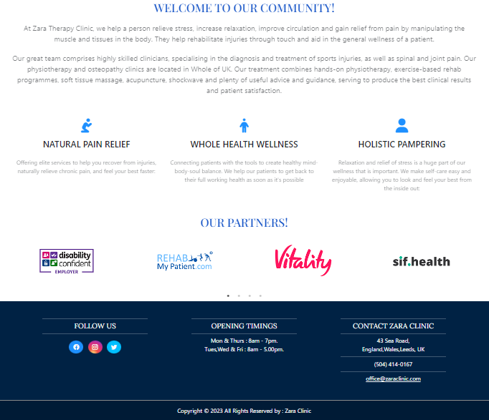
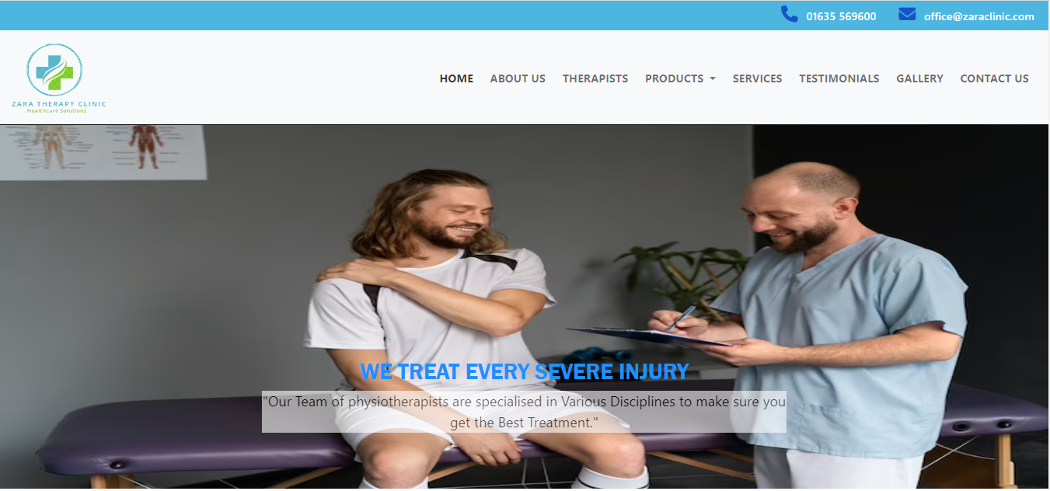

About Us

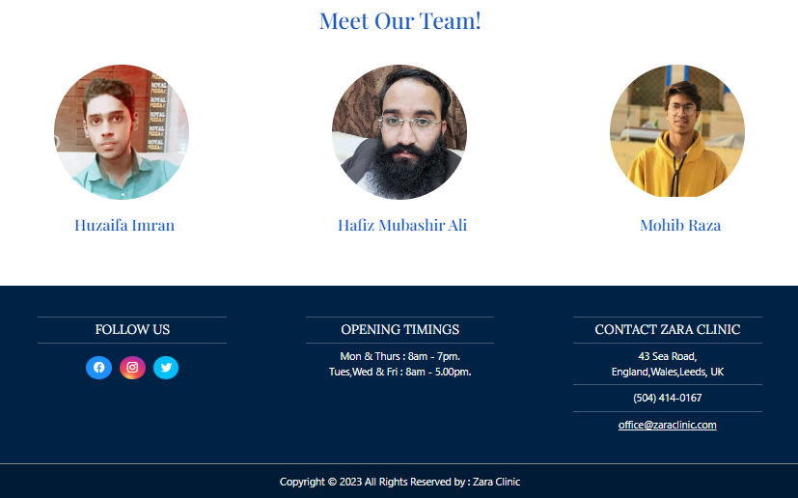
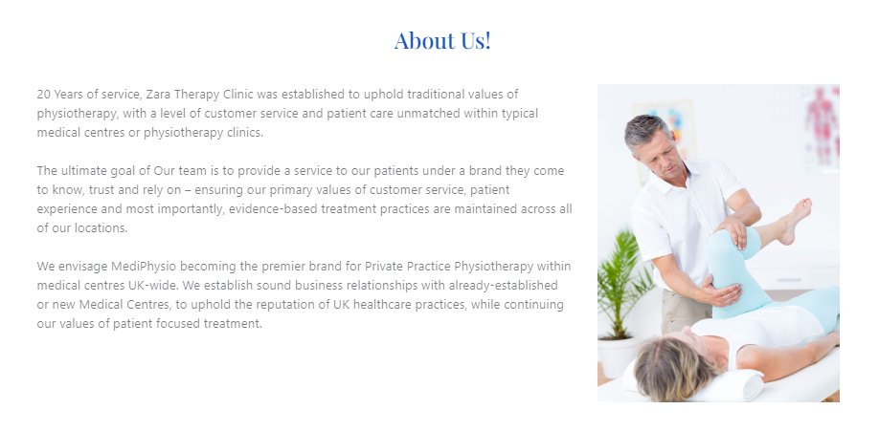
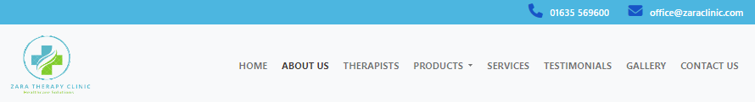
Therapists
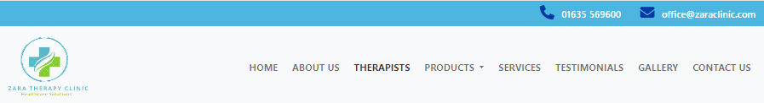


Products

- Essential Oils
- Massage Creams & Lotions
- Physiotherapy Machines

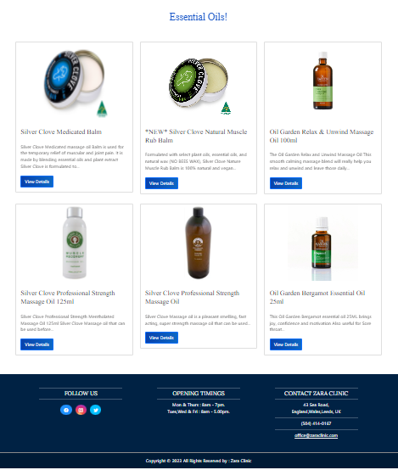


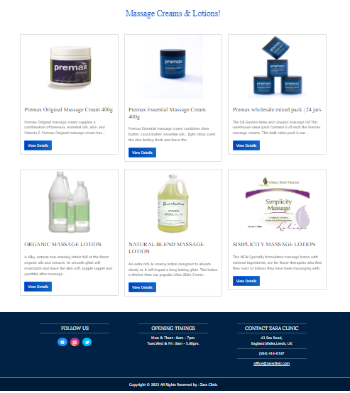
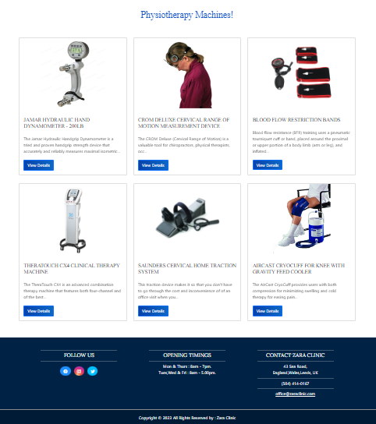


Services

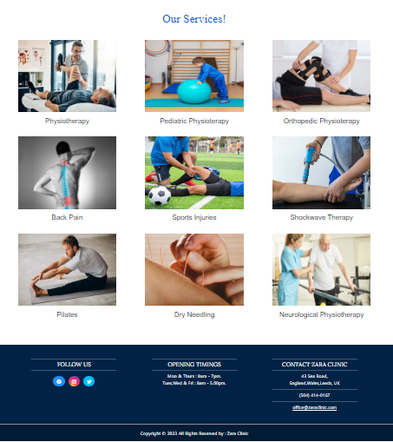


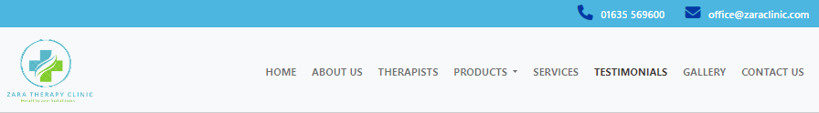
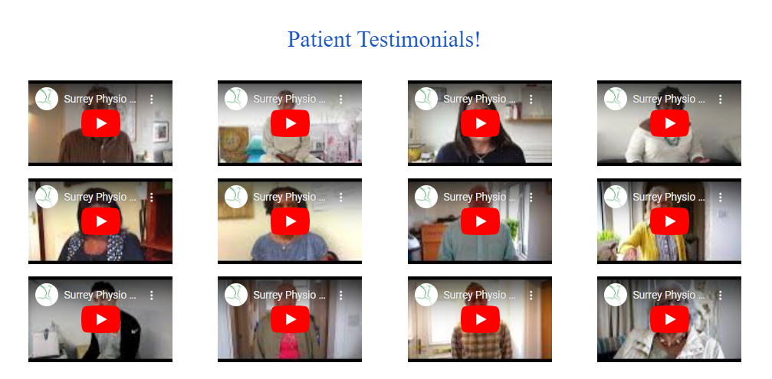
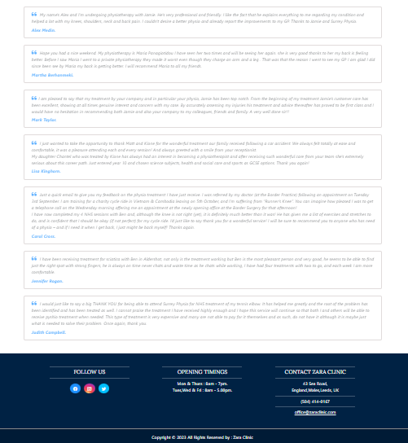

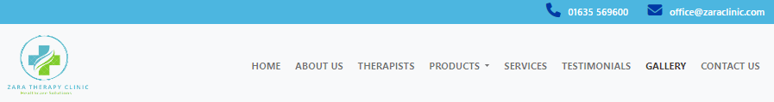
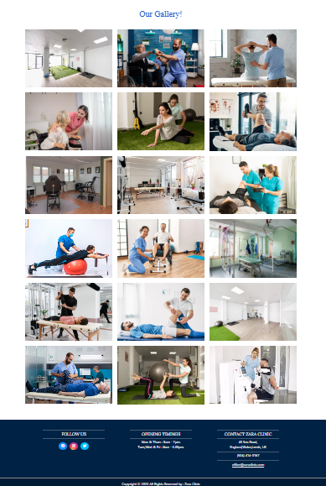

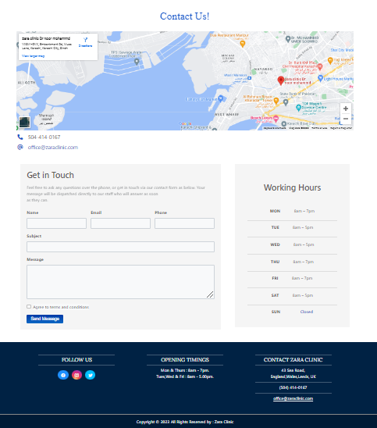
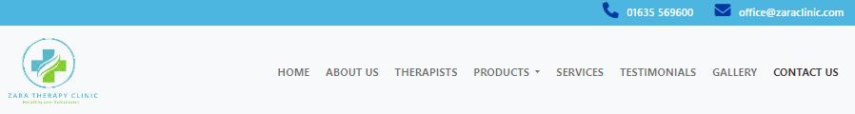

TASK SHEET REVIEW 2

Project Ref. No.: eP/Advertisement Portal Management System/01 |  | Project  title | Date of Preparation of Activity Plan
No | Task | Zara Therapy Clinic | Actual | Actual | Team-mate | Status
 |  |  | Start Date | Days | Names
1 | Header |  | 1/APR/  2023 | 1 | HUZAIFA IMRAN | Complete
2 | Navbar |  | 1/ APR /  2023 | 1 | HUZAIFA IMRAN | Complete
3 | Footer |  | 2/ APR /  2023 | 1 | HUZAIFA IMRAN | Complete
4 | Home Page |  | 4/ APR /  2023 | 2 | HUZAIFA IMRAN | Complete
5 | About Us |  | 5/ APR /2022 | 3 | MUHAMMAD MOHIB RAZA | Complete
6 | Therapists |  | 7/APR /  2023 | 2 | HUZAIFA IMRAN | Complete
7 | Services |  | 11/APR/  2023 | 2 | HUZAIFA IMRAN | Complete
8 | Testimonials |  | 12/APR/  2023 | 1 | HUZAIFA IMRAN | Complete
9 | Gallery |  | 15/APR/  2023 | 2 | HUZAIFA IMRAN | Complete
10 | Contact Us |  | 17/APR/  2023 | 2 | MUHAMMAD MOHIB RAZA | Complete

TASK SHEET REVIEW 3

Project Ref. No.: eP/Advertisement Portal Management System/01 |  | Project title | Date of Preparation of Activity Plan
No | Task | Zara Therapy Clinic | Actual  Start Date | Actual  Days | Team-mate  Names | Status
1 | Products |  | 18/APR/2023 | 1 | HUZAIFA IMRAN | Complete
2 | Essential Oils |  | 19/APR/  2023 | 1 | HUZAIFA IMRAN | Complete
3 | Massage Creams and Lotions |  | 19/APR/  2023 | 1 | HUZAIFA IMRAN | Complete
4 | Physiotherapy Machines |  | 20/APR23 | 1 | HUZAIFA IMRAN | Complete
7 | JavaScript |  | 20/APR/  2023 | 1 | HUZAIFA IMRAN | Complete

