

User Guide

Faculty | Miss Neelam Malik
Batch | 2211C2
Group | C
Serial No. | Enrollment Number | Student Name
1. | Student1430197 | HUZAIFA IMRAN
2. | Student1429956 | HAFIZ MUBASHIR ALI
3. | Student1430202 | MUHAMMAD MOHIB RAZA

Home page Screenshots
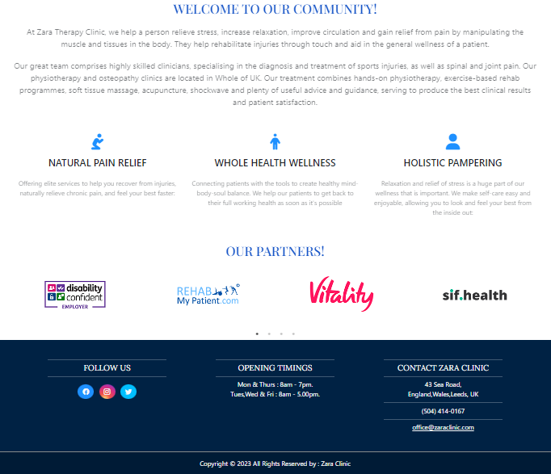
About Us

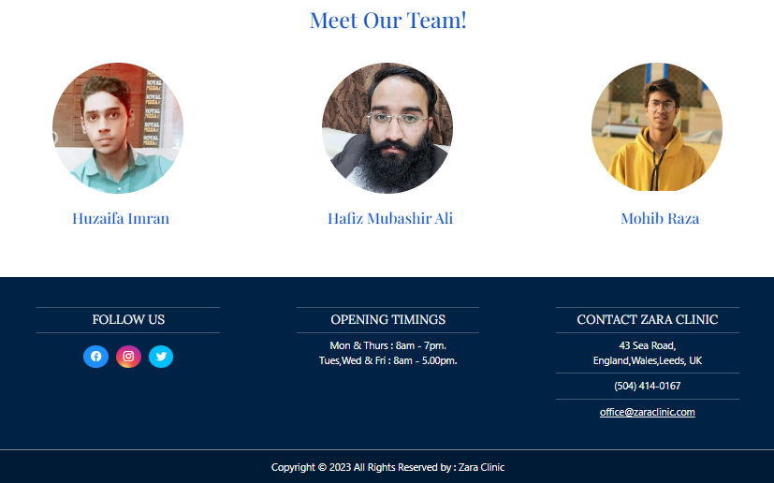



Therapists



Products

- Essential Oils
- Massage Creams & Lotions
- Physiotherapy Machines

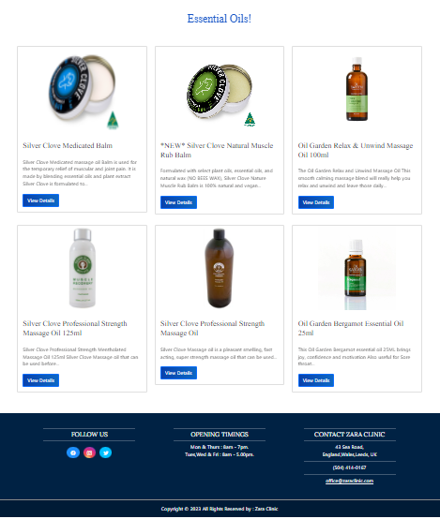


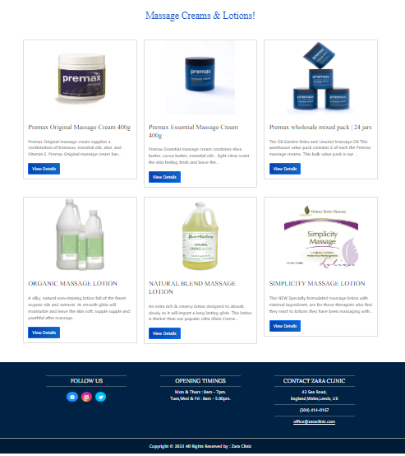
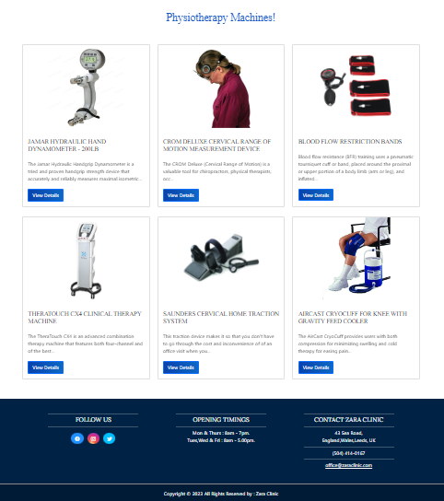


Services

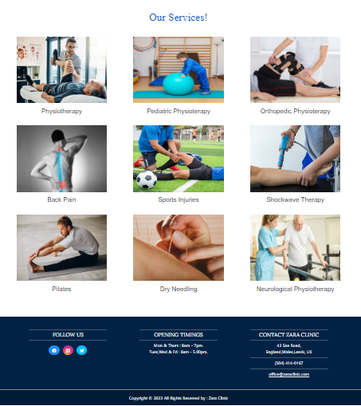



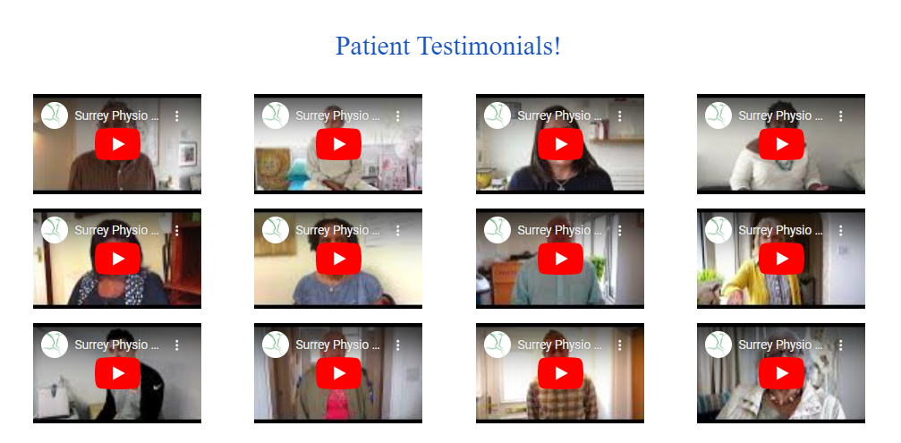
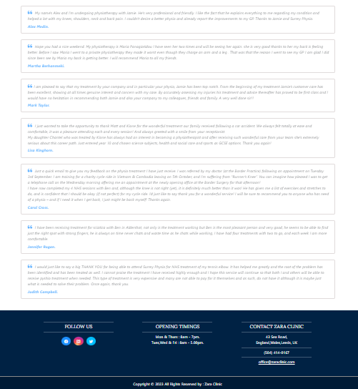

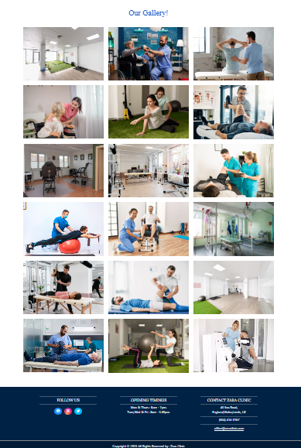
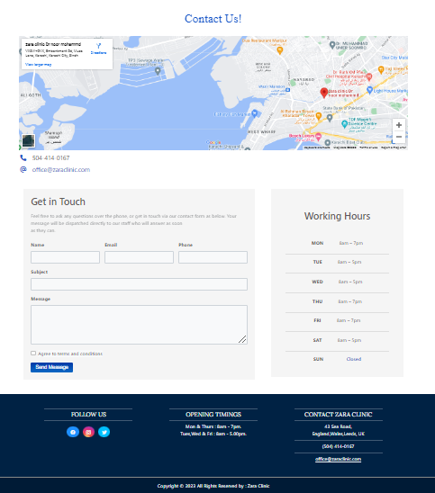


TASK SHEET REVIEW 2

Project Ref. No.: eP/Advertisement Portal Management System/01 |  | Project  title | Date of Preparation of Activity Plan
No | Task | Zara Therapy Clinic | Actual | Actual | Team-mate | Status
 |  |  | Start Date | Days | Names
1 | Header |  | 1/APR/  2023 | 1 | HUZAIFA IMRAN | Complete
2 | Navbar |  | 1/ APR /  2023 | 1 | HUZAIFA IMRAN | Complete
3 | Footer |  | 2/ APR /  2023 | 1 | HUZAIFA IMRAN | Complete
4 | Home Page |  | 4/ APR /  2023 | 2 | HUZAIFA IMRAN | Complete
5 | About Us |  | 5/ APR /2022 | 3 | MUHAMMAD MOHIB RAZA | Complete
6 | Therapists |  | 7/APR /  2023 | 2 | HUZAIFA IMRAN | Complete
7 | Services |  | 11/APR/  2023 | 2 | HUZAIFA IMRAN | Complete
8 | Testimonials |  | 12/APR/  2023 | 1 | HUZAIFA IMRAN | Complete
9 | Gallery |  | 15/APR/  2023 | 2 | HUZAIFA IMRAN | Complete
10 | Contact Us |  | 17/APR/  2023 | 2 | MUHAMMAD MOHIB RAZA | Complete

TASK SHEET REVIEW 3

Project Ref. No.: eP/Advertisement Portal Management System/01 |  | Project title | Date of Preparation of Activity Plan
No | Task | Zara Therapy Clinic | Actual  Start Date | Actual  Days | Team-mate  Names | Status
1 | Products |  | 18/APR/2023 | 1 | HUZAIFA IMRAN | Complete
2 | Essential Oils |  | 19/APR/  2023 | 1 | HUZAIFA IMRAN | Complete
3 | Massage Creams and Lotions |  | 19/APR/  2023 | 1 | HUZAIFA IMRAN | Complete
4 | Physiotherapy Machines |  | 20/APR23 | 1 | HUZAIFA IMRAN | Complete
7 | JavaScript |  | 20/APR/  2023 | 1 | HUZAIFA IMRAN | Complete

