**MOHID MUNIR**

**129613**

**BSCS-5C**

**ADVANCED PROGRAMMING**

**LAB-4**

*Comments in the script file*

**TASK 1:**

data("AirPassengers")

AirPassengers

apmat <- matrix(AirPassengers, nrow=12,byrow=TRUE)

colnames(apmat) <- c("Janauary","February","March","April","May","June","July","August","September","October","November","December")

rownames(apmat) <- c("1949","1950","1951","1952","1953","1954","1955","1956","1957","1958","1959","1960")

max(apmat)

mnthname= which(apmat == max(apmat), arr.ind=TRUE)

cx = colnames(apmat)[mnthname[,2]]

rx = rownames(apmat)[mnthname[,1]]

cat("The most profitable month is",cx ,"with",max(apmat),"passengers.")

apmat2 <- apply(t(apmat),2,cumsum)

max(apmat2,12)

cat("The most profitable year is",rx ,"with",max(apmat2,12),"passengers.")

ts.plot(AirPassengers)

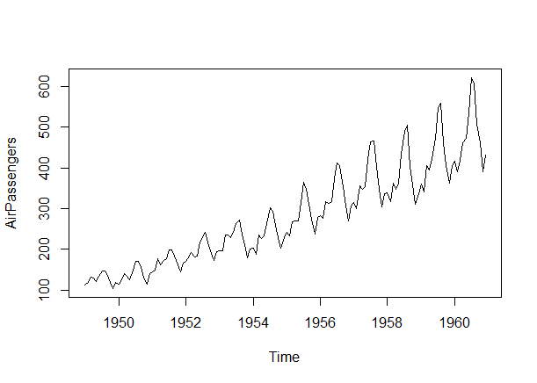

**TASK 2:**

p=8000

for(i in 1:12)

{

for(j in 1:12)

{

apmat3=apmat*p

}

p=p*1.1

}

colnames(apmat3) <- c("Janauary","February","March","April","May","June","July","August","September","October","November","December")

rownames(apmat3) <- c("1949","1950","1951","1952","1953","1954","1955","1956","1957","1958","1959","1960")

max(apmat3)

mnthname= which(apmat3 == max(apmat3), arr.ind=TRUE)

cz = colnames(apmat3)[mnthname[,2]]

rz = rownames(apmat3)[mnthname[,1]]

cat("The month ",cz ,"is with most revenue",max(apmat3))

apmat4 <- apply(t(apmat3),2,cumsum)

max(apmat4,12)

cat("The year ",rz ,"with most revenue",max(apmat4,12))

sum(apmat3)

cat("Total revenue is",sum(apmat3))

**TASK 3:**

plot(decompose(AirPassengers))

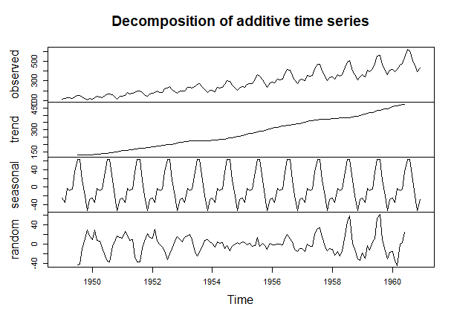

**GITHUB LINK:**

**https://github.com/mohidmk7/AirPassengersLAB-4**