

Submitted By:
Mohed Tanveer – 2025-CYS-43
Assignment:
Lab No. 1
Submitted To:
Mr Shahmeer Nawaz
For the fulfillment of,
Object-Oriented Programming Lab
Department of Computer Engineering
University of Engineering and Technology, Lahore

Java Pac-Man Game
Project Report
Console-Based Game Development in Java

1. Project Overview
This project is a console-based Pac-Man inspired game implemented in Java. The player navigates a character through a maze, collecting dots to earn points while avoiding a ghost. The game ends when all lives are lost. The project demonstrates core object-oriented programming concepts including encapsulation, class decomposition, and separation of concerns.

2. System Architecture
The project follows a multi-class object-oriented architecture. Each class has a single, well-defined responsibility, reflecting the Single Responsibility Principle. The five classes that compose the system are:

Class | File | Role
Game | Game.java | Entry point; orchestrates the main game loop
Maze | Maze.java | Stores and manages the grid layout and dot state
Pacman | Pacman.java | Represents the player character and its behaviour
Ghost | Ghost.java | Represents the AI-controlled enemy
Display | Display.java | Handles all console rendering and output

3. Class Descriptions

3.1 Game.java
Game is the main class containing the entry point (main method). It initialises all game objects, manages the core game loop, and coordinates interactions between Maze, Pacman, Ghost, and Display. It also tracks global state including score and remaining lives.

Key responsibilities:
- Initialises Maze, Pacman, and Ghost objects with starting positions
- Runs the main while loop, continuing until lives reach zero
- Reads player input via Scanner and passes it to Pacman
- Delegates rendering to Display and triggers ghost movement each turn
- Detects collisions, deducts lives, and resets positions accordingly

3.2 Maze.java
Maze stores the 10x15 character grid representing the game world. Walls are represented by '#', dots by '.', and eaten cells by ' '. It exposes utility methods used by both Pacman and Ghost.

Key responsibilities:
- Holds the grid as a 2D char array (char[][] grid)
- isWall(r, c): returns true if the cell contains a wall
- isDot(r, c): returns true if the cell contains a dot
- eat(r, c): removes a dot by replacing it with a space

3.3 Pacman.java
Pacman represents the player character. It stores the current row and column position and provides methods for movement, dot eating, collision detection, and resetting after being caught.

Key responsibilities:
- move(dir, maze): updates position based on W/A/S/D input, respecting walls
- eatsDot(maze): checks if current cell has a dot and consumes it
- collides(ghost): returns true if Pacman and Ghost share the same cell
- reset(r, c): repositions Pacman to the given starting coordinates

3.4 Ghost.java
Ghost is the AI-controlled enemy. It moves randomly around the maze each turn using a java.util.Random instance to select a direction. Like Pacman, it respects walls and can be reset.

Key responsibilities:
- move(maze): picks a random direction from four options and moves if not a wall
- reset(r, c): repositions the ghost to its starting coordinates
- Uses a fixed Random instance for reproducible but unpredictable movement

3.5 Display.java
Display handles all output to the console. It iterates over the maze grid and overlays the Pacman ('P') and Ghost ('G') symbols at their current positions. It also prints the score and lives after the grid.

Key responsibilities:
- draw(maze, pacman, ghost, score, lives): clears the console and renders the full game state
- Prints 20 blank lines to simulate a screen clear on standard consoles
- Overlays player and ghost characters onto the maze grid during rendering

4. Visual Representation

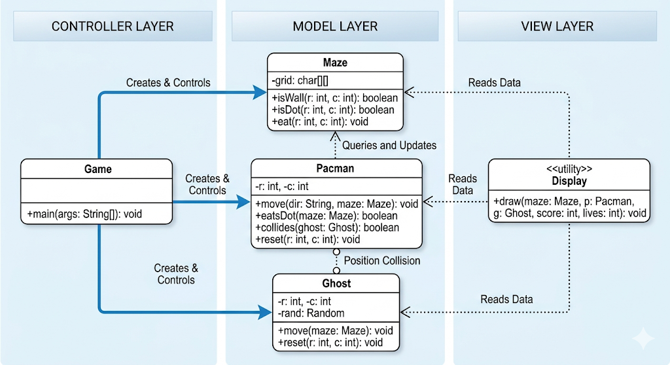

5 Game Loop Flow
The game loop runs once per player move and follows a fixed sequence of steps on each iteration:

Step | Action | Class Responsible
1 | Render the current game state to the console | Display
2 | Prompt the player for a direction input (W/A/S/D) | Game
3 | Move Pacman in the chosen direction if not blocked by a wall | Pacman
4 | Check if Pacman's new cell contains a dot; if so, award 10 points | Pacman / Maze
5 | Move the Ghost in a random valid direction | Ghost
6 | Check if Pacman and Ghost share a cell; if so, deduct a life and reset | Game
7 | Repeat from Step 1 until lives reach zero | Game

6. Data Design
The maze is represented as a 10-row by 15-column 2D character array (char[][]). The layout is hardcoded in Maze.java with the following cell types:

Symbol | Meaning
# | Wall — impassable by both Pacman and Ghost
. | Dot — collectible; awards 10 points when eaten
 | Empty — previously eaten dot; passable
P | Pacman — rendered by Display only; not stored in the grid
G | Ghost — rendered by Display only; not stored in the grid

Pacman and Ghost positions are stored as integer row/column pairs (int r, int c) within their respective classes, independent of the grid. The Display class overlays them visually during rendering without modifying the maze data.

7. Scoring and Win/Loss Conditions
The game tracks score and lives as integer variables in Game.java:

- Each dot collected awards 10 points to the score
- The player begins with 3 lives
- Colliding with the Ghost deducts 1 life and resets both characters to their starting positions
- The game ends when lives reach 0, displaying the final score
- There is no win condition — the game continues until all lives are depleted

8. Limitations and Potential Improvements
The current implementation is a working prototype suitable for demonstrating OOP concepts. Several areas could be improved in a more complete version:

Limitation | Suggested Improvement
Ghost moves randomly with no pathfinding | Implement BFS or A* for intelligent ghost chasing
Console clear uses blank lines | Use ANSI escape codes (\033[H\033[2J) for a true clear
No win condition exists | Add a win state when all dots have been collected
Single ghost enemy | Support multiple ghosts with varied behaviours
Input is line-buffered (requires Enter) | Use a library like JLine for real-time keypress detection
Maze is hardcoded | Load maze layouts from external text files for flexibility
No power-ups or special items | Add power pellets that temporarily allow Pacman to eat ghosts

9. Summary
This project successfully implements a functional, console-based Pac-Man game in Java using a clean five-class architecture. Each class encapsulates a single concern: Maze manages state, Pacman and Ghost handle entity behaviour, Display owns rendering, and Game coordinates the overall loop. The design is readable, extensible, and serves as a solid foundation for further development such as smarter AI, a graphical front-end, or a level system.

