Language Models from Scratch
Homework 1 | Experimental Report
Deep Learning · San José State University
Mohit Manoj Barade
November 9, 2026

Repository: github.com/mohiitt/LLM-from-scratch-HW1

Abstract
This report studies character-level language models on Tiny Shakespeare through four controlled experiments and an optional sampling-diversity extension. First, I manually verified the relationship among validation loss, perplexity, bits per token and bits per byte. Second, I trained six recurrent and Transformer configurations with two random seeds and equal token budgets. Third, I compared LSTM and modern Transformer performance at context lengths of 64, 128, 256 and 512. Fourth, I extracted and quantified interpretable attention-head patterns on three text types. Finally, I varied temperature and top-p at fixed checkpoint bpb and assessed the trade-off between character 4-gram diversity and perceived readability.
The modern Transformer achieved the best final architecture-comparison score (2.1159 mean validation bpb), while the vanilla RNN lagged at 2.4369. Context-length results favored the Transformer at all tested lengths, and two heads showed strong previous-token and current-word-start attention. The extended decoding study found increasing diversity but declining AI-assisted readability at more permissive sampling settings.

1. Scope, dataset and evaluation
The assignment uses the professor-provided nanolm codebase and Tiny Shakespeare character data. The experiments were executed locally on a MacBook Air M4 with PyTorch MPS in FP32 precision. Configuration files, training logs, individual metrics, generated images and scripts are retained in the linked GitHub repository. Except where noted, results below are directly from the student’s reported saved metrics and figures; tutorial values are not substituted for experimental observations.
Validation bpb is lower when the model assigns higher probability to the held-out text, after normalizing prediction cost by UTF-8 byte count. Where two seeds were used, reported uncertainty is sample SD, not a population-level confidence interval. Task 3 used one seed per setting and is interpreted accordingly.

2. Task 1 — Metrics by Hand

2.1 Objective and experimental setup
This experiment checks the relationship between cross-entropy loss, perplexity, bits per token and bits per byte (bpb). I trained a two-layer, 256-hidden-unit character LSTM on Tiny Shakespeare and compared its metrics with two one-step models using character and byte tokenizers. All runs used seed 1337, PyTorch on the Mac M4 MPS backend in FP32 precision, and the same held-out text. The trained model contained 1,069,824 parameters, ran for 2,000 steps, processed 16,384,000 training tokens, and took 167.34 seconds to train. Its evaluation covered 111,488 tokens and 111,488 bytes.
The two nearly untrained LSTMs were each allowed exactly one optimizer step (8,192 tokens). A one-step result approximates, but is not identical to, a strictly zero-step model. The character model had 1,069,824 parameters, and the byte model had 1,118,720 parameters because its embedding vocabulary was larger.

2.2 Manual metric verification
The trained character model saved val_loss = 1.4932519153678405, val_tokens = 111488, and val_bytes = 111488 in metrics.json. Cross-entropy loss is the mean negative log-probability, in nats per predicted token. The model's loss is read from the file; recovering an independently measured loss would require the underlying token probabilities. The derived metrics can be checked arithmetically:
- Validation loss: L = 1.493251915 nats/token.
- Perplexity: exp(L) = exp(1.493251915) = 4.451548.
- Bits/token: L / ln(2) = 2.154307 bits/token.
- Bits/byte: [L / ln(2)] × [val_tokens / val_bytes] = 2.154307 × (111488 / 111488) = 2.154307 bits/byte.
The recalculated perplexity and bpb agree with the logged val_ppl = 4.451548064601809 and val_bpb = 2.1543071330991297 within rounding precision. Because the validation characters are single-byte in this dataset, bits per token equals bits per byte for these character-token runs.
Measure | Trained character LSTM | Logged value | Match?
Loss (nats/token) | 1.493252 | 1.493252 | Source value
Perplexity | 4.451548 | 4.451548 | Yes
Bits/token | 2.154307 | — | Derived
Bits/byte | 2.154307 | 2.154307 | Yes

2.3 One-step models compared with ln(V)
For a uniform predictor over a vocabulary of size V, the theoretical loss is ln(V). The character tokenizer has V = 65, giving ln(65) = 4.174387. The byte tokenizer has V = 256, giving ln(256) = 5.545177. Comparing these reference values with the one-step experiment:
Tokenizer | Vocabulary V | ln(V) | Measured one-step loss | Difference
Character | 65 | 4.174387 | 4.178698 | +0.004311
Byte | 256 | 5.545177 | 5.687762 | +0.142584

The character model is extremely close to the uniform baseline. The byte model is farther from ln(256), but a randomly initialized model does not necessarily output exactly uniform probabilities, and these measurements were taken after one update. This difference alone does not demonstrate an implementation bug. The byte model's higher initial loss is expected because its vocabulary has more possible outcomes.
The trained character LSTM reduced validation bpb from 6.028587 in the one-step character run to 2.154307, a reduction of approximately 64.27%. Its perplexity also fell from 65.280818 to 4.451548, showing that training substantially improved next-character prediction.
For the one-step byte model, val_loss / ln(2) = 5.687762 / ln(2) = 8.205705 bits per byte, compared with 8.000000 bpb for a uniform 256-byte predictor. For the one-step character model, the corresponding value is 6.028587 bits/token, close to log2(65) = 6.022368. Both initial results follow exactly one optimizer update, rather than a strictly untrained zero-step evaluation.
Task 1 and Task 2 report different final values for nominally similar LSTM-256 models: 2.154307 bpb (Task 1) versus 2.133688 (Task 2, seed 1337), a difference of 0.020620 bpb. They are independent runs, not duplicate checkpoint readings. Both use 2 layers, 256 hidden units, seed 1337, 2,000 steps, 16,384,000 training tokens and 1,069,824 parameters, but their saved evaluation counts are 111,488 and 111,360 validation characters, respectively. The Task 2 configuration uses 256-character training sequences, batch size 32, AdamW, learning rate 0.002 and zero weight decay; without the complete saved Task 1 configuration I cannot isolate the reason for the difference. I therefore preserve both logged metrics and do not merge them.

2.4 Interpretation
Loss and perplexity are defined per tokenizer token. Consequently, comparing perplexities between character and byte or subword tokenizers can be misleading: a token may represent different amounts of text. Bits per byte normalizes the total prediction cost by UTF-8 byte count, making it a more appropriate comparison metric across tokenizers. This task verified the logged metrics and established why bpb is used throughout the remaining experiments.

3. Task 2 — RNN, GRU, LSTM, and Transformer Comparison

3.1 Objective and controlled setup
I compared a vanilla RNN, GRU, 256-unit LSTM, 512-unit LSTM, GPT-2-style Transformer and modern Transformer to examine the practical effects of recurrent gating, model capacity and Transformer design. Every model used Tiny Shakespeare, 2,000 training steps, batch size 32, context length 256, and 16,384,000 training tokens. Each configuration was run independently with two seeds (1337 and 42), producing 12 completed runs. Validation bpb was the primary metric (lower is better). Per-step learning curves were recorded during training; final tabulated values came from the full validation-set metrics.
The modern Transformer used RMSNorm, RoPE, SwiGLU and no biases; the textbook Transformer used its GPT-2-style configuration. Models were matched for training tokens, not for parameter count, training time, or FLOPs. Sample standard deviation (SD) across two runs is shown to convey limited seed variability.
This is a reduced laptop-scale version of the instructor's 01_char_models sweep: 2,000 steps per run and 16,384,000 sampled training tokens. Relative to roughly one million training characters, this corresponds to about 16 corpus-length passes of token exposure, not literal sequential epochs because training uses random windows.

3.2 Results
Architecture | Parameters | Seed 1337 bpb | Seed 42 bpb | Mean ± sample SD (bpb)
Vanilla RNN | 280,320 | 2.4409 | 2.4330 | 2.4369 ± 0.0056
GRU | 806,656 | 2.1612 | 2.1587 | 2.1600 ± 0.0018
LSTM (256) | 1,069,824 | 2.1337 | 2.1405 | 2.1371 ± 0.0048
LSTM (512) | 4,236,800 | 2.1794 | 2.1608 | 2.1701 ± 0.0132
GPT-2-style Transformer | 3,438,336 | 2.1864 | 2.1841 | 2.1852 ± 0.0016
Modern Transformer | 3,162,624 | 2.1165 | 2.1152 | 2.1159 ± 0.0010

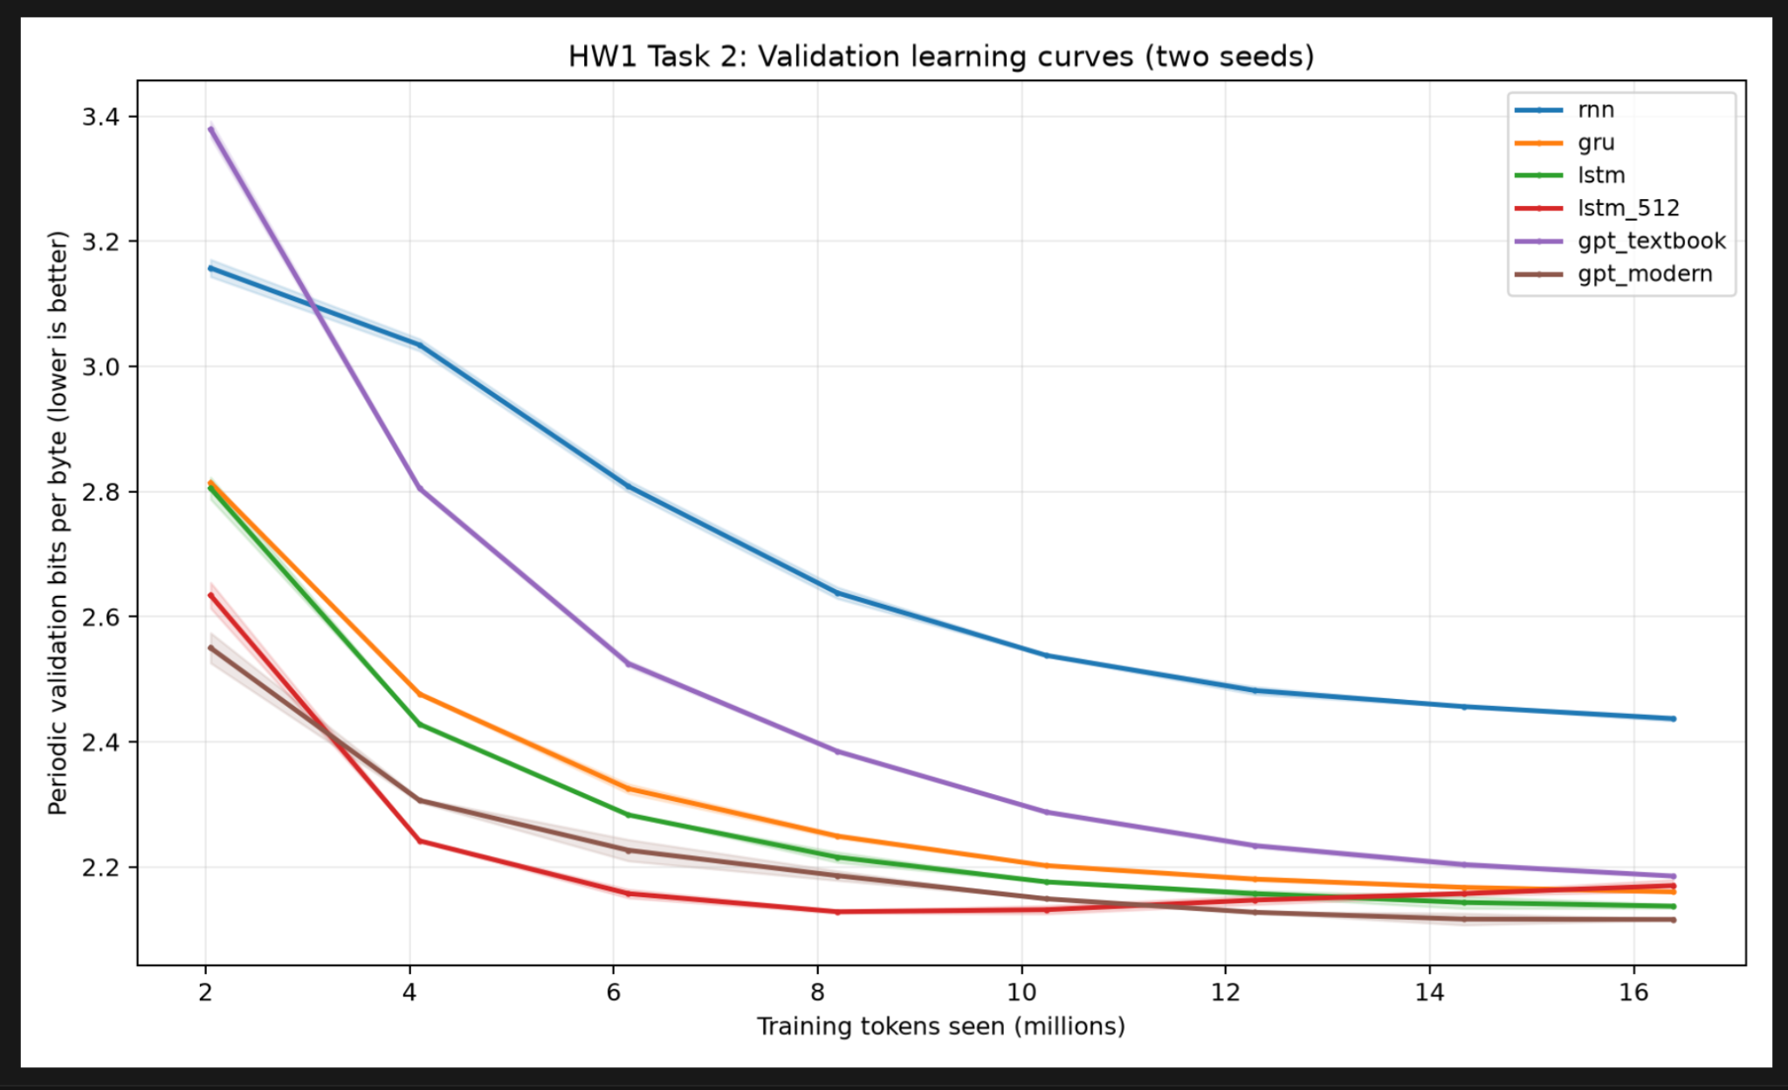
Figure 1. Validation learning curves across six architectures, averaged over two seeds.
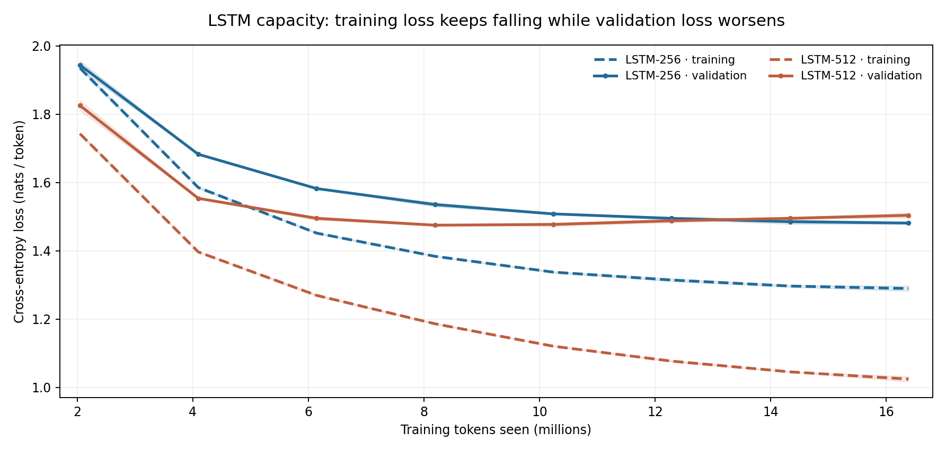
Figure 1b. LSTM-256 and LSTM-512 training versus validation loss at eight shared checkpoints; two-seed means with seed ranges shaded.

3.3 Why does the vanilla RNN fall so far behind?
The vanilla RNN achieved the worst final validation quality (2.4369 bpb), behind the GRU (2.1600) by 0.2769 bpb and behind the 256-unit LSTM (2.1371) by 0.2998 bpb. The model nevertheless learned throughout training: its curve declined, but remained well above the gated recurrent alternatives under the same 16.384-million-token budget. This points to a limitation in the information that its evolving hidden state can preserve, rather than to a run that simply failed to learn.
A basic RNN repeatedly applies a state transformation at every character. When gradients must travel back through many transformations, they can shrink or become unstable; early information may also be overwritten. In a character language model, a distant name, opening quotation mark or grammatical construction can affect predictions many characters later. GRUs make state updates selective with update and reset gates, and LSTMs additionally maintain a cell state controlled by input, forget and output gates. These mechanisms offer practical routes to preserve context, which is consistent with the much stronger results of both gated models. The comparison is not a pure gating ablation: the RNN has 280,320 parameters, while the GRU has 806,656 and the LSTM-256 has 1,069,824. Some of the gap can therefore reflect capacity and optimization as well as recurrence design.

3.4 Is the larger LSTM better or worse? What do the curves show?
The larger LSTM is worse on held-out data at the end of the fixed training budget. Increasing the hidden size from 256 to 512 raises parameter count from 1,069,824 to 4,236,800 (3.96×), yet final mean validation bpb rises from 2.1371 to 2.1701, a disadvantage of 0.0330 bpb. This result is not obvious from early training: the larger model initially improves faster and reaches its lowest validation loss at about 8–10 million observed tokens. After that, the validation loss increases while the smaller model keeps improving or remains nearly flat.
The logged training losses clarify why. Averaging both seeds at step 2,000, LSTM-512 has a training cross-entropy of 1.0245 nats/token but a validation cross-entropy of 1.5042, a 0.4797-nat gap. LSTM-256 finishes at 1.2896 on training and 1.4813 on validation, a narrower 0.1917 gap. For LSTM-512 the gap expanded from roughly 0.2888 at step 1,000 to 0.4797 at step 2,000. Figure 1b plots the two-seed means at the same logged checkpoints. Thus, the higher-capacity model fits the training samples substantially better but generalizes worse: the combination of falling training loss and rising validation loss supplies direct evidence of overfitting.
The model saw about 16 corpus-length passes of sampled token exposure on roughly one million training characters; because sampling is random, these are not 16 unique sequential epochs. This limited corpus makes repeated exposure plausible. Early stopping near the validation minimum, stronger regularization or more data might improve LSTM-512, so these results demonstrate overfitting in this particular training regime, not an inherent inferiority of larger recurrent models. The 512-unit model also has greater between-seed variability (0.0132 versus 0.0048 bpb sample SD).

3.5 Transformer variants and seed variation
The modern Transformer achieved the lowest validation bpb, 2.1159, beating the textbook Transformer (2.1852) by 0.0693 bpb while using slightly fewer parameters. Its combination of normalization, rotary positional embeddings, feed-forward activation and bias choices was effective at this scale. Because multiple components changed at once, these runs cannot identify which change caused the gain; that would require an ablation. The modern model performed consistently across the two seeds (2.1165 and 2.1152). Two seeds are adequate for the assigned replication but insufficient for strong significance claims about small differences.

3.6 Conclusion
Gated recurrent models performed markedly better than the small vanilla RNN, the larger LSTM displayed diminishing generalization at the end of training, and the modern Transformer was best overall. The learning curves show why final validation results and generalization matter more than parameter count or early learning speed alone.

4. Task 3 — Effect of Context Length

4.1 Objective and setup
I studied whether longer preceding character sequences improved the performance of a 256-unit LSTM and a modern Transformer. For both architectures, context lengths were 64, 128, 256 and 512. Each setting used seed 1337 and 2,000 steps, with batch sizes of 128, 64, 32 and 16, respectively, keeping the total at 16,384,000 training tokens per run. The LSTM had 1,069,824 parameters and the Transformer had 3,162,624. Eight runs finished successfully in about 73 minutes on the Mac M4 MPS backend.
Equal token budgets control for token exposure, but the changing batch size can influence optimization. Training FLOPs and attention cost are not equal across architectures or context lengths.

4.2 Results
Context (characters) | Batch size | LSTM bpb | Modern Transformer bpb
64 | 128 | 2.184226 | 2.155792
128 | 64 | 2.150726 | 2.107150
256 | 32 | 2.133803 | 2.116539
512 | 16 | 2.125149 | 2.102364

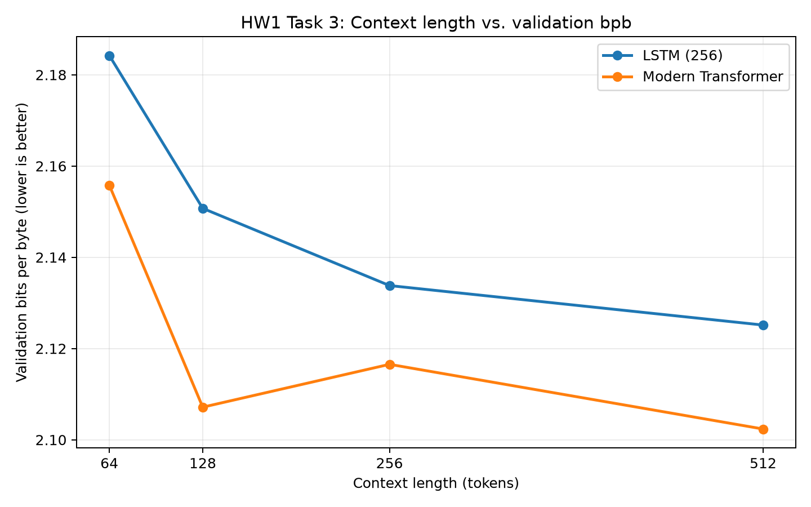
Figure 2. Validation bpb versus context length for LSTM and modern Transformer.

4.3 Where does the LSTM stop benefiting?
The LSTM improves monotonically from 2.184226 at 64 characters to 2.125149 at 512, a reduction of 0.059077 bpb (2.70%). However, the additional gain decreases at every doubling: 0.033500 bpb for 64→128, 0.016924 for 128→256 and only 0.008654 for 256→512. The last increment is below 0.01 bpb, giving a concrete point of diminishing returns after roughly 256 characters, rather than a mathematically flat plateau. A recurrent network must maintain earlier context through a finite-dimensional hidden/cell state; storing increasingly distant detail becomes difficult.

4.4 Where does the Transformer stop benefiting?
The Transformer gains the most when context grows from 64 to 128: bpb decreases from 2.155792 to 2.107150 (a 0.048642-bpb improvement). It rises by 0.009390 between 128 and 256, then drops by 0.014175 between 256 and 512, reaching its best result of 2.102364. Crucially, the net improvement from 128 all the way to 512 is only 0.004786 bpb: most of the overall 0.053428-bpb (2.48%) gain has already occurred by context 128. Thus, 128 is a practical near-saturation point for this single-seed experiment, while 512 remains the best measured context. The non-monotonicity and changing batch sizes prevent a claim that longer context is intrinsically harmful at 256 or that a universal plateau was established.

4.5 Which architecture uses longer context more effectively?
The modern Transformer is the better architecture for absolute validation quality in this experiment: it has lower bpb at all four context lengths. Its 128-character result (2.107150) is even better than the LSTM's 512-character result (2.125149). That is the clearest answer if “uses longer context more effectively” means making stronger predictions while varying the context available. Self-attention can access earlier token representations directly, whereas the LSTM transports them through recurrent states. Nevertheless, the LSTM shows a slightly larger proportional 64→512 improvement (2.70% versus 2.48%), so the experiment does not establish that the Transformer gets more marginal benefit from each additional character. The two models have different parameter counts, and Task 3 used one seed per context and different batch sizes.

4.6 Conclusion
Longer context helped both models overall. The LSTM showed steady but diminishing gains beyond about 256 characters; the Transformer gave the strongest final bpb at 512, with no stable saturation point established in the tested range.

5. Task 4 — Attention Head Analysis

5.1 Objective and setup
This experiment inspected the attention matrices of the trained modern Transformer with 512-character context and seed 1337 from Task 3, whose validation bpb was 2.102364. No additional model training was performed. I used the professor's nanolm.viz attention functionality and attention-weight extraction to analyze 16 heads (four layers × four heads) on three character sequences: dialogue, repetition and punctuation. Layer/head indices are zero-based.
Text type | Input
Dialogue | ROMEO:\nBut soft! what light through yonder window breaks?
Repetition | the king and the queen and the king return.
Punctuation | To be, or not to be: that is the question.

The selected head averages were calculated over eligible query positions. The uniform-causal reference is the mean of 1/(t + 1) over those positions, not a fixed attention percentage; this accounts for how many past and current positions each query is allowed to attend to.
Character-count verification: the dialogue string contains one actual newline between “ROMEO:” and “But soft!”, not literal backslash-plus-n text. It therefore has 57 characters and 56 valid previous-token queries (t > 0), matching the saved table. The other inputs have 43 and 42 characters, respectively.

5.2 Pattern A: previous-token attention
For each query at position t > 0, I measured its weight assigned to the previous position t − 1. Layer 0, Head 1 gave the clearest previous-token candidate, with a pooled average 50.35% attention across 139 eligible query positions, compared with 7.41% under the uniform-causal reference (6.79× enrichment).
Input | Eligible queries | Previous-token weight | Uniform baseline
Dialogue | 56 | 49.72% | 6.48%
Repetition | 42 | 47.52% | 7.98%
Punctuation | 41 | 54.09% | 8.11%
Pooled | 139 | 50.35% | 7.41%

The upper heatmaps in Figure 3 show a strong band just below the diagonal: current positions repeatedly attend to the preceding character. Such a local pattern may help recognize common character transitions and short motifs.

5.3 Pattern B: current-word-start attention
For each noninitial letter within a word, I measured the attention directed toward the first letter of that same word. Layer 2, Head 0 assigned a pooled average of 44.13% across 82 eligible positions, compared with a 7.50% uniform-causal reference (5.89× enrichment).
Input | Eligible queries | Word-start weight | Uniform baseline
Dialogue | 37 | 43.26% | 6.83%
Repetition | 25 | 51.75% | 8.51%
Punctuation | 20 | 36.24% | 7.48%
Pooled | 82 | 44.13% | 7.50%

The lower heatmaps show vertical concentrations at earlier letters within the current word, consistent with a head that revisits word beginnings while predicting later letters. It may help preserve lexical context during character generation.
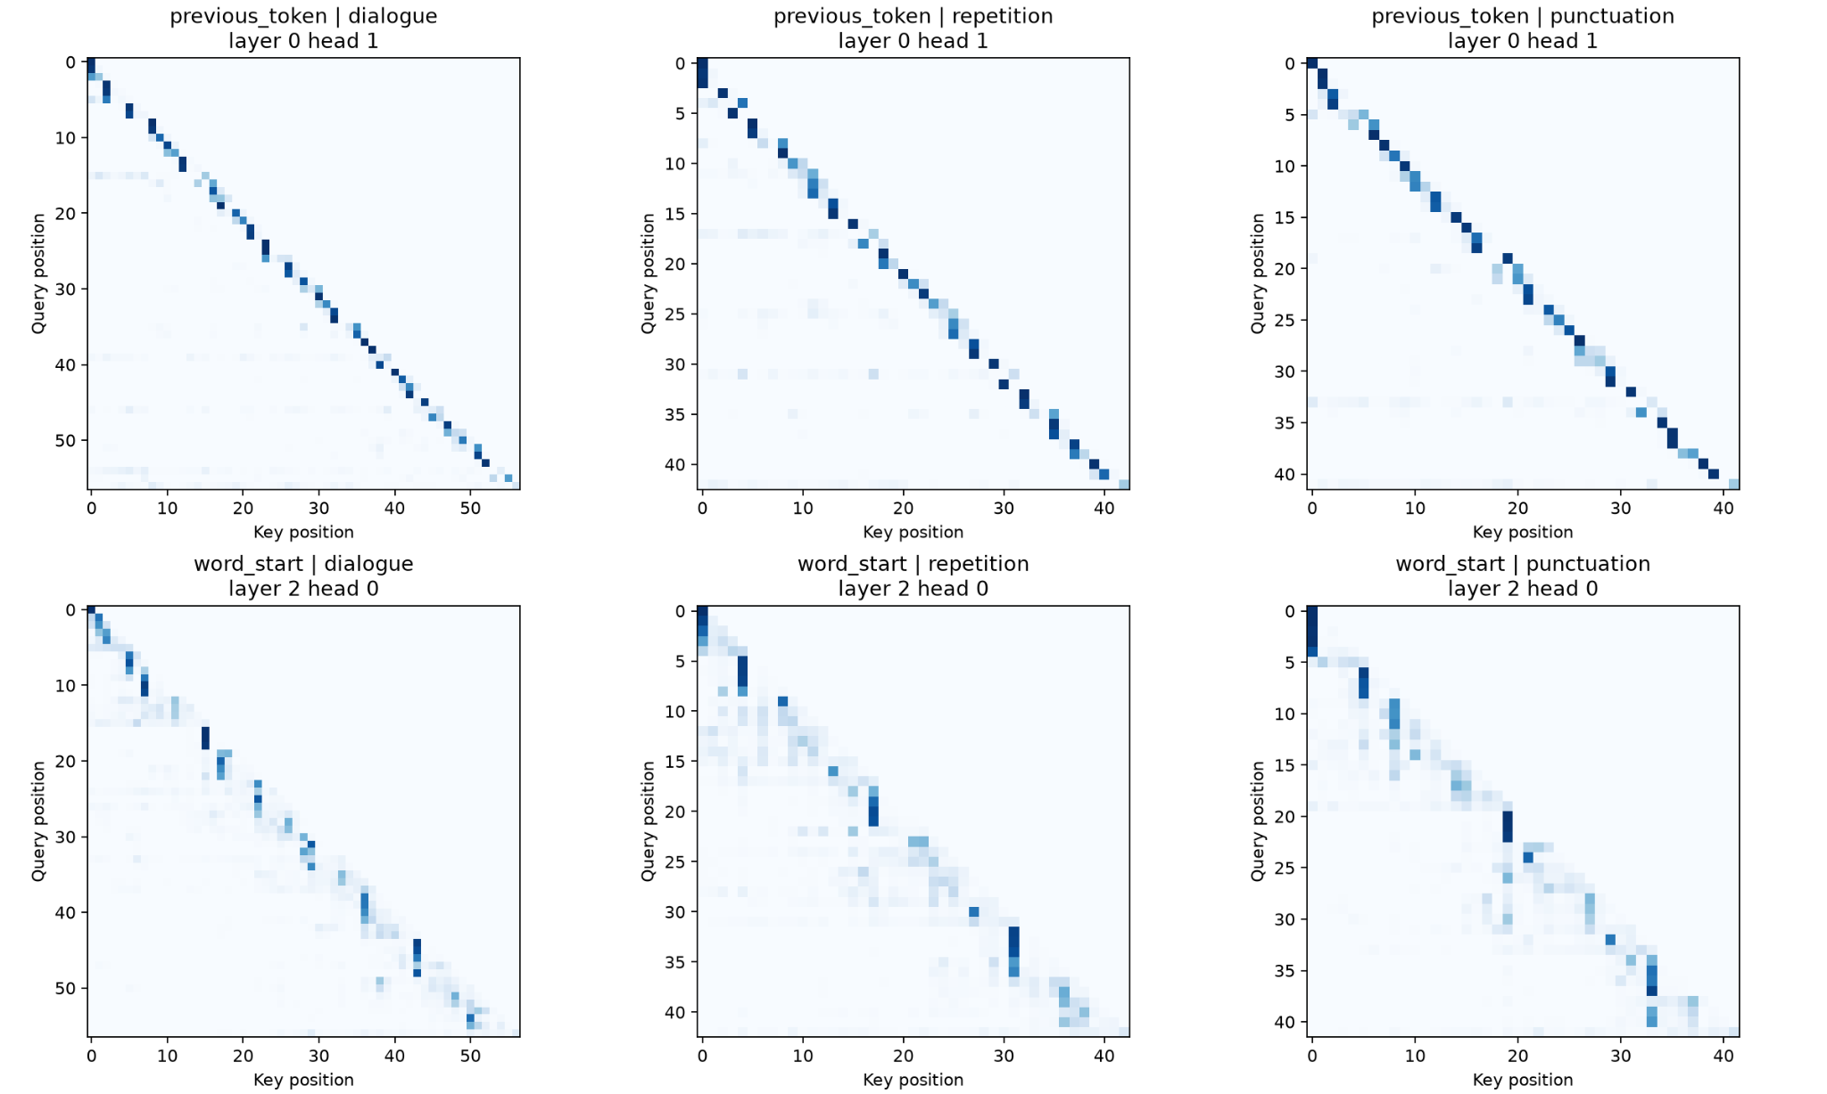
Figure 3. Selected previous-token (top) and word-start (bottom) head attention maps on three texts.

5.4 Interpretation and limitations
Both candidates appeared across dialogue, repeated phrases and punctuation, though their strengths differed. The previous-token head was comparatively stable (47.52–54.09%), whereas word-start attention varied from 36.24–51.75%. These are descriptive measurements from short inputs and one checkpoint. A large attention weight is not proof of a head's exclusive purpose or causal contribution to model predictions, especially because heads were selected after inspecting all 16. Nonetheless, the quantified patterns and heatmaps satisfy the assignment's request for two interpretable head types supported by average attention weights.

6. Extra Credit — Sampling Diversity at Fixed Bits per Byte

6.1 Objective
This experiment examined how temperature and nucleus sampling (top-p) affect the diversity of character-level text generated by a fixed language model. I also extended the experiment to investigate whether higher diversity is accompanied by changes in readability, coherence, and repetition.

6.2 Experimental Setup
I reused the modern character-level Transformer trained on Tiny Shakespeare in Experiment 3 (512-token context; seed 1337). Its validation bits per byte (bpb) was 2.102364 throughout this experiment. No additional training or model-weight updates were performed.
All samples started from the same prompt, ROMEO:\n. I tested temperature values of 0.5, 1.0, and 1.5, crossed with top-p values of 0.8, 0.9, and 1.0. Top-k filtering was disabled. For the extended study, each of the nine combinations used 10 generation seeds, yielding 90 generated passages, each consisting of 200 new characters. This expanded an initial two-seed pilot to give a more reliable estimate of sampling variability.
Diversity was calculated on the generated suffix only, excluding the prompt:
Distinct-4 = number of unique overlapping character 4-grams / total overlapping character 4-grams.
A 200-character output has 197 overlapping 4-grams. I report mean distinct-4 percentages and sample standard deviations (SD) across the 10 generated passages at each setting.
For a supplementary qualitative assessment, 27 passages (three generation seeds per setting) were shuffled and rated by ChatGPT without displaying the decoding settings. Ratings used 1–5 scales for readability, coherence, and repetition severity; a higher repetition-severity score indicates more undesirable repetition. These are AI-assisted, subjective ratings, not independent human evaluations.

6.3 Results
Temperature | Top-p | Distinct-4, mean ± SD | Readability / 5 | Coherence / 5 | Repetition severity / 5
0.5 | 0.8 | 81.52% ± 6.11 pp | 4.00 | 3.33 | 1.67
0.5 | 0.9 | 82.94% ± 5.31 pp | 4.00 | 2.67 | 2.00
0.5 | 1.0 | 86.40% ± 4.74 pp | 4.00 | 3.33 | 1.00
1.0 | 0.8 | 90.51% ± 4.32 pp | 3.67 | 2.67 | 1.33
1.0 | 0.9 | 93.86% ± 2.34 pp | 3.00 | 2.33 | 1.00
1.0 | 1.0 | 96.34% ± 1.64 pp | 2.67 | 2.00 | 1.33
1.5 | 0.8 | 95.03% ± 2.31 pp | 3.00 | 2.00 | 1.33
1.5 | 0.9 | 96.70% ± 1.73 pp | 2.00 | 1.67 | 1.00
1.5 | 1.0 | 98.33% ± 1.31 pp | 1.33 | 1.33 | 1.00

Distinct-4 statistics use 10 generated passages per combination; qualitative scores average three AI-assisted reviews per combination. “pp” means percentage points.
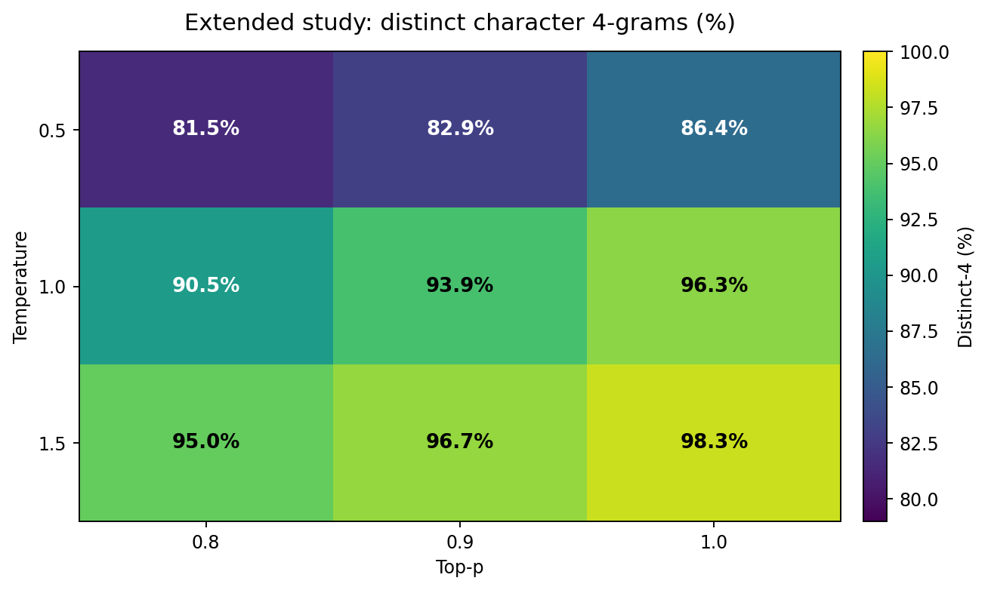
Figure 4. Mean distinct-4 percentages in the extended 90-sample experiment.
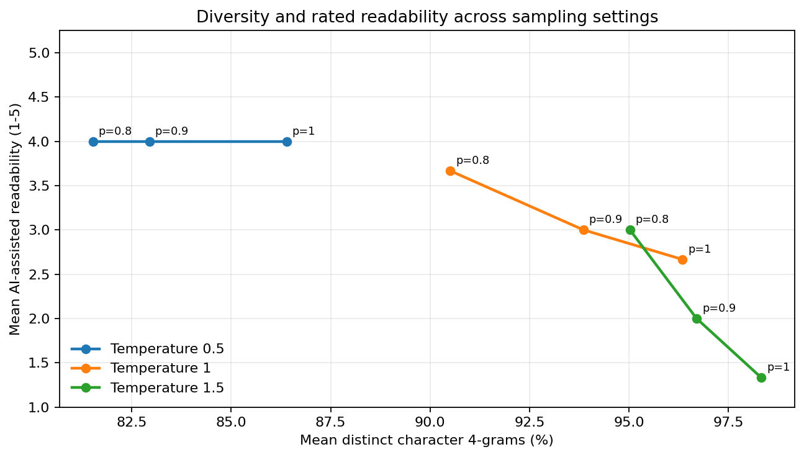
Figure 5. Diversity and AI-assisted readability by decoding setting.

6.4 Interpretation
Temperature. At fixed top-p = 1.0, mean distinct-4 increased from 86.40% at temperature 0.5 to 96.34% at 1.0 and 98.33% at 1.5. A higher temperature spreads probability across more possible next characters, making outputs less repetitive at the character 4-gram level. However, AI-assisted readability fell from 4.00/5 to 1.33/5 across those same settings, while coherence declined from 3.33/5 to 1.33/5. The most diverse outputs were not the most understandable.
Top-p. Increasing top-p generally increased diversity at each fixed temperature. At temperature 1.0, the mean rose from 90.51% (top-p 0.8) to 93.86% (0.9) and 96.34% (1.0). Including more low-probability candidates can introduce novel sequences, but the accompanying readability ratings also decreased from 3.67/5 to 2.67/5 in these settings. These are descriptive associations across this small set of conditions, not a causal estimate of text quality.
Repetition and fluency are different. Repetition-severity ratings remained low across nearly all settings, including highly diverse outputs with poor readability. The generated passage identified as R03 in the blinded review includes a relatively fluent Shakespeare-like fragment: “That set the house of York, and shall be better.” By contrast, R10 includes hard-to-interpret forms such as “TouchosNouble san ye. Speak cought, ho!” These illustrative excerpts demonstrate that a passage may contain many distinct 4-grams while still lacking grammatical or semantic quality. The unblinded review key maps R03 to temperature 0.5, top-p 1.0, seed 8 and R10 to temperature 1.5, top-p 1.0, seed 2. They illustrate the more-readable and high-diversity settings, respectively, but individual passages are not controlled evidence by themselves.
Why bpb stayed fixed. Every condition used the same trained model checkpoint with validation bpb 2.102364. Temperature and top-p only change the token-selection procedure during generation; they do not alter the model's evaluation probabilities on the held-out dataset. Thus, the fixed bpb refers to the underlying checkpoint, not to identical likelihoods for each generated passage.

6.5 Limitations
The experiment used one checkpoint, one fixed prompt, and short 200-character passages. Ten samples per condition give a clearer estimate of variability than the original two samples, but the estimates remain noisy. Only three passages per condition received qualitative ratings, all from a single AI evaluator rather than independent human readers. Ratings may reflect evaluator preferences and should not be interpreted as objective measurements of literary quality. Moreover, distinct character 4-grams measure local novelty, not syntactic correctness, coherence, or factual accuracy.

6.6 Conclusion
Increasing temperature and relaxing top-p generally raised the fraction of distinct character 4-grams in generated Shakespeare-style text. In the extended experiment, mean diversity ranged from 81.52% (temperature 0.5, top-p 0.8) to 98.33% (temperature 1.5, top-p 1.0), a difference of 16.80 percentage points. The most diverse setting received the lowest AI-assisted readability and coherence ratings (1.33/5 each). The findings illustrate a practical trade-off: decoding settings can increase surface-level diversity without improving, and sometimes while reducing, perceived text quality. The validation bpb of the trained model remained fixed throughout.
Reproducibility: The raw generated samples, per-setting qualitative_summary.csv, the blinded review sheet, and the analysis scripts are retained in the assignment repository. The review provenance must remain labeled as AI-assisted.

7. Overall answers and conclusion
Why did the vanilla RNN fall behind?
The vanilla RNN is the poorest final model at 2.4369 bpb, while the GRU and LSTM-256 reach 2.1600 and 2.1371 bpb under the identical 16.384-million-token exposure. Its validation curve still improves but remains consistently behind gated models. Repeated hidden-state transformations make it hard to preserve distant character information or propagate gradients through many time steps. GRU update/reset gates and LSTM memory and gates are designed to reduce that difficulty. The result supports the value of gating in this setting, though the RNN also has considerably fewer parameters and therefore the comparison cannot attribute the full gap exclusively to gates.
Was the larger LSTM better?
No. The 512-unit LSTM has 3.96× as many parameters but a worse final mean validation bpb (2.1701 versus 2.1371). Its validation curve reverses direction after approximately 8–10 million tokens, even as training loss continues falling. At step 2,000, the 512-unit model records 1.0245 mean training loss versus 1.5042 validation loss (gap 0.4797), while the 256-unit model records 1.2896 versus 1.4813 (gap 0.1917). Figure 1b makes this widening generalization gap visible. With about 16 corpus-length passes of sampled exposure to a small corpus, the larger network appears to fit repeated training windows increasingly closely instead of continuing to improve on held-out text. Early stopping or regularization could change the outcome.
Which architecture uses longer context more effectively?
The modern Transformer makes better held-out predictions at every tested context length: 64, 128, 256 and 512 characters. At 128 characters it already reaches 2.107150 bpb, better than the 256-unit LSTM at 512 (2.125149). Its largest benefit arrives from 64→128, and the net improvement from 128→512 is only 0.004786 bpb; the best recorded value remains 2.102364 at 512. The LSTM improves more steadily but its gain drops below 0.01 bpb after 256. If “more effective” means lower absolute bpb for a given context, choose the Transformer. If it means relative gain from 64 to 512, the LSTM is slightly higher (2.70% versus 2.48%). These one-seed results do not support a stronger claim about marginal long-context utilization.
Across all tasks, the main lesson is to ground architectural claims in held-out metrics, training trajectories, fair budget definitions and uncertainty. The extra-credit extension further shows that decoder-level diversity can rise without improving the perceived quality of the resulting text.

References and reproducibility
[1] lkk688, “Language Models from Scratch to Frontier: a hands-on course with nanolm,” DeepDataMiningLearning, GitHub, 2026. https://github.com/lkk688/DeepDataMiningLearning/blob/main/DeepDataMiningLearning/llm/TUTORIAL_nanolm.md
[2] lkk688, “nanolm implementation and experiment sweeps,” DeepDataMiningLearning, GitHub. https://github.com/lkk688/DeepDataMiningLearning/tree/main/DeepDataMiningLearning/llm/nanolm
[3] M. M. Barade, “LLM-from-scratch-HW1: configs, scripts, logs and visualizations,” GitHub, 2026. https://github.com/mohiitt/LLM-from-scratch-HW1

