ForensiGuard: A Multimodal Machine-Learning Framework for Detecting, Attributing and Explaining Anti-Forensic Manipulation of Digital Evidence
A Mini-Project Report submitted to
MANIPAL ACADEMY OF HIGHER EDUCATION
MANIPAL INSTITUTE OF TECHNOLOGY, MANIPAL
Submitted by
Mohika Rathi
Registration No: 230968032


Dec 2026

Page i Abstract
Digital forensics relies on the assumption that acquired electronic artifacts reflect historical system events without post-incident modification. However, malicious anti-forensic techniques—specifically filesystem timestomping, spatial steganography, and file-type obfuscation—deliberately destroy or conceal evidentiary integrity. In this work, we present ForensiGuard, an open-source, multimodal machine-learning framework designed to detect, attribute, and explain anti-forensic manipulations. Evaluated on the controlled ForensiGuard-Bench-v1 synthetic benchmark comprising 812 artifacts generated from 140 distinct clean source files, the framework extracts thirty filesystem metadata features, spatial residual noise tensors, and deterministic magic-byte signatures. Base detectors—including a gradient-boosted decision tree, a residual convolutional neural network, and an unsupervised isolation forest—feed a regularized late-fusion meta-model trained strictly via out-of-fold predictions to prevent identity leakage. Across the held-out test split of 126 artifacts from 21 unseen source groups, ForensiGuard achieves a macro F1-score of 0.854, an accuracy of 78.57%, an ROC-AUC of 0.895, and a low false-positive rate of 4.76%, substantially outperforming single-modality baselines (metadata-only F1: 0.715; image-only F1: 0.341, ROC-AUC: 0.518). Furthermore, exact TreeSHAP attributions provide interpretable forensic triage narratives. We conclude that multimodal late fusion effectively counters multi-vector anti-forensic tampering while maintaining judicial explainability.
Index Terms: Keywords: Digital Forensics, Anti-Forensics, Multimodal Late Fusion, Filesystem Timestomping, Steganography, TreeSHAP, Evidence Triage.

Page ii Table Of Contents
The following table summarizes the structural contents, chapters, figures, and tables comprising this report.
Chapter / Section Title | Page Number
Abstract | Page i
Table of Contents, List of Figures & Tables | Page ii
1. Introduction | Page 5
2. Research Question and Objectives | Page 6
3. Related Work | Page 7
4. Literature Comparison | Page 8
5. Dataset | Page 10
6. Data Preparation | Page 12
7. Proposed Methodology | Page 13
8. Models and Baseline | Page 14
9. Experimental Setup | Page 15
10. Main Results | Page 16
11. Figures and Interpretation | Page 19
12. Discussion | Page 23
13. Limitations and Future Work | Page 24
14. Conclusion | Page 25
15. References | Page 26
16. Similarity Report | Page 28

List of Figures
Figure # | Caption & Description | Page
Figure 1 | ForensiGuard Multimodal Architecture and Pipeline Workflow | Page 13
Figure 2 | Receiver Operating Characteristic (ROC) Comparison Across Modalities | Page 19
Figure 3 | Precision-Recall (PR) Curve Comparison Across Modalities | Page 20
Figure 4 | Confusion Matrix for ForensiGuard Late Fusion Model (Held-Out Test Corpus) | Page 21
Figure 5 | Systematic 10-Variant Architectural Ablation Analysis | Page 22

List of Tables
Table # | Title & Content | Page
Table 1 | Literature Comparison Across Digital Forensic and Steganalysis Approaches | Page 8
Table 2 | Benchmark Partitioning and Manipulation Class Distribution (ForensiGuard-Bench-v1) | Page 10
Table 3 | Extracted Multimodal Feature Space (30 Metadata Signals and Spatial Tensors) | Page 11
Table 4 | Experimental Hyperparameter Configuration Across Pipeline Sub-Models | Page 15
Table 5 | Main Modality Performance Comparison on Held-Out Test Corpus (N = 126) | Page 16
Table 6 | Ten-Variant Systematic Architectural Ablation Study on Test Corpus | Page 16
Table 7 | Adaptive Adversary Evasion Stress Test Empirical Results (N = 21) | Page 18

1 Introduction
Problem Background: Modern digital investigations depend fundamentally on the presumption that recovered electronic artifacts—such as operating system timestamps, filesystem inode structures, and binary file encodings—reflect uncorrupted historical system activity and authentic user interaction. When law enforcement examiners or incident response teams recover evidence from a compromised host, these temporal and structural traces form the backbone of forensic timeline reconstruction, incident attribution, and judicial testimony. However, the proliferation of sophisticated anti-forensic tools has severely undermined this foundational assumption.
The Anti-Forensic Threat Landscape: Anti-forensics encompasses deliberate techniques applied by threat actors or dishonest custodians to disrupt, delay, or mislead forensic examination. Three prominent classes of anti-forensic countermeasures present acute investigative challenges: (1) Filesystem Timestomping, where Modified, Accessed, Changed, and Birth (MACB) timestamps are artificially set back or forward using user-space utilities (such as touch -t or SetMace) to create plausible alibis or break chronological event order; (2) Spatial Steganography, where illicit data or exfiltrated payloads are hidden inside the high-frequency pixel residuals of carrier images, evading standard keyword and hash-based triage filters; and (3) File-Type Obfuscation, where file extensions are intentionally mislabeled (for instance, masking an executable or image as a harmless .txt log) to exploit automated screening omissions. Furthermore, sophisticated adversaries increasingly combine these techniques into compound attacks.
Stakeholders and Impact: The consequences of undetected anti-forensics are severe across multiple domains. In criminal investigations, manipulated timestamps can falsely exculpate suspects or improperly implicate innocent parties. In enterprise cybersecurity, covert steganographic channels enable persistent data exfiltration while timestomped malware droppers evade incident response containment. Existing forensic triage tools suffer from two crippling limitations: tool-specific brittleness (evaluating timestamps, pixel noise, or file headers in complete isolation) and prohibitive manual review backlogs. Forensic examiners face terabytes of storage media, necessitating automated, defensible triage mechanisms that rapidly identify anomalous evidence before exhaustive disk imaging.
Scope and Boundary of the Mini-Project: This mini-project designs, implements, and evaluates ForensiGuard, an open-source multimodal machine-learning framework for automated anti-forensic triage. The project operates within a strictly defined scope: it focuses on file-level defensive triage using accessible filesystem metadata, spatial pixel residuals, and binary magic-byte signatures. ForensiGuard is explicitly designed as an investigative triage assistant rather than a judicial arbiter. It does not claim to replace deep kernel forensic verification, nor does its statistical score establish legal authenticity under Federal Rule of Evidence 901. Instead, it provides calibrated prioritization scores backed by exact game-theoretic TreeSHAP feature attributions.

2 Research Question And Objectives
Focused Research Question: Can an integrated multimodal framework combining filesystem metadata heuristics, deep spatial noise residuals, unsupervised anomaly estimation, and deterministic signature verification detect and attribute anti-forensic tampering with higher discriminative power than single-modality baselines, while maintaining low false-positive rates and providing human-interpretable feature attributions?
Specific Project Objectives
Objective 1 (Benchmark Standardization): Construct a standardized, leak-free synthetic benchmark (ForensiGuard-Bench-v1) comprising 812 artifacts generated from 140 pristine source carriers. Strictly isolate independent source groups into Train (70%), Validation (15%), and Test (15%) partitions, and remediate container-format shortcuts by enforcing identical format and encoding standards across clean and manipulated samples.
Objective 2 (Multimodal Architecture): Develop an automated multi-stage feature extraction and classification pipeline. Extract thirty tabular filesystem metadata features (including temporal intervals, subsecond zeroing indicators, and directory context statistics), normalized spatial image tensors, and deterministic binary magic-byte headers.
Objective 3 (Calibrated Fusion & Leakage Prevention): Engineer and calibrate an out-of-fold stacked late-fusion meta-classifier. Train the meta-model using pure out-of-fold predictions from source-grouped 5-fold cross-validation to eliminate data leakage, and establish a conservative operating threshold (tau = 0.500) calibrated to keep validation false-positive rates below 5%.
Objective 4 (Ablation, Robustness & Explainability): Conduct a comprehensive empirical evaluation on the held-out test corpus, perform a 10-variant systematic architectural ablation study, evaluate robustness against an adaptive evasion adversary, and integrate exact TreeSHAP explainability to generate court-defensible investigative triage reports.
Project Contribution
Core Contribution: This project provides an open-source, fully reproducible experimental pipeline demonstrating that multimodal late fusion achieves substantially superior triage performance (F1: 0.854, ROC-AUC: 0.895, FPR: 4.76%) compared to single-modality approaches. Crucially, the project provides honest scientific disclosures: it empirically demonstrates that spatial CNNs provide zero lift once container shortcuts are eradicated, and highlights the total evasion vulnerability of passive metadata against adaptive invariant-preserving attacks.

3 Related Work
Forensic Taxonomies & Corpus Standardization: The scientific foundation of digital forensics requires standardized taxonomies and reproducible evaluation corpora. Conlan et al. [1] established an extended, granular taxonomy categorizing anti-forensic methods into data hiding, artifact wiping, trail obfuscation, and attacks against forensic tools. Concurrently, Garfinkel et al. [2] introduced standardized forensic corpora (the NPS corpora) to enable reproducible research under Daubert legal standards. Casey [3] formalized digital evidence standards, emphasizing that automated tools must report known error rates. While these foundational works defined the threat model, they focused on qualitative taxonomy or raw disk curation, lacking automated machine-learning frameworks for multi-vector anti-forensic triage.
Filesystem Inode & Metadata Tampering: Filesystem timestomping has received extensive analytical attention. Minnaard [4] explored NTFS Master File Table ($MFT) structures, noting that naive timestamp tools modify the $STANDARD_INFORMATION attribute while leaving $FILE_NAME attributes intact, creating detectable inconsistencies. Chow et al. [5] analyzed temporal sequence anomalies on Linux ext2/ext3 filesystems, demonstrating that backward time shifts disrupt directory-level temporal continuity. Neuner et al. [6] examined subsecond precision truncation, proving that command-line utilities frequently zero out nanosecond fractions. Schatz [7] investigated timestamp verification using NTFS $LogFile transactions. However, existing detection scripts rely on brittle heuristic rules that break when adversaries operate on non-NTFS systems or apply subtle shifts.
Steganalysis and Spatial Residual Networks: In the domain of covert data hiding, spatial steganalysis has advanced from statistical feature engineering to deep representation learning. Fridrich and Kodovský [8] established Spatial Rich Models (SRM), utilizing diverse high-pass filtering kernels and spatial co-occurrence matrices to detect subtle pixel correlations. Boroumand et al. [9] proposed SRNet, an end-to-end deep convolutional architecture featuring unpooled residual blocks specifically optimized to preserve high-frequency noise residuals without downsampling destruction. Zeng et al. [10] extended residual CNNs to multi-class payload attribution. Nevertheless, existing steganalysis models evaluate image pixel matrices in complete isolation, ignoring surrounding filesystem metadata, container file headers, and compound attacks.
Explainable Machine Learning & Evidentiary Standards: The adoption of machine learning in forensic investigations is strictly bounded by judicial admissibility requirements. Ribeiro et al. [11] emphasized that black-box classifiers cannot be trusted without local, interpretable explanations. Lundberg et al. [12] introduced TreeSHAP, a polynomial-time algorithm computing exact Shapley values rooted in cooperative game theory for tree ensemble models. Under Federal Rule of Evidence 901 and the Daubert admissibility standard, statistical evidence must demonstrate a known error rate, scientific peer review, and human-comprehensible reasoning. ForensiGuard synthesizes these principles into an automated, defensible triage architecture.

4 Literature Comparison
Table 1 provides a systematic comparison between published state-of-the-art forensic, steganalysis, and explainability methods and the proposed ForensiGuard framework, highlighting datasets, evaluation metrics, key findings, and research gaps addressed.
Table 1: Literature Comparison Across Forensic and Steganalysis Approaches
Paper & Author | Dataset Evaluated | Methodology | Key Metric | Major Finding | Research Gap Addressed by ForensiGuard
Conlan et al. (2016) [1] | Theoretical forensic taxonomy | Qualitative attack categorization | Taxonomy coverage | Classified anti-forensics into hiding, wiping, and obfuscation. | Lacked empirical machine-learning models, benchmark datasets, and automated triage.
Garfinkel et al. (2009) [2] | NPS Real & synthetic disk corpora | Standardized corpus curation & hashing | Corpus validity, hash collisions | Corpus standardization is vital for legal defensibility. | Focused on raw storage curation; provided no multimodal fusion or anti-forensic ML classifiers.
Fridrich & Kodovský (2012) [8] | BOSSbase 1.0 (10,000 images) | Spatial Rich Models (SRM) + ensembles | Detection error (P_E), ROC-AUC | High-dimensional spatial co-occurrences detect subtle LSB stego. | Evaluates pixel arrays in isolation; blind to filesystem metadata, timestomping, and MIME mismatches.
Boroumand et al. (2019) [9] | BOSSbase 1.01 & BOWS2 | Deep residual CNN (SRNet) | Classification error (P_E) | Unpooled residual layers capture spatial noise without heuristic features. | Requires massive uncompressed image datasets; highly susceptible to container shortcuts; ignores metadata.
Roussev & Garfinkel (2009) [13] | Synthetic triage corpus (Govdocs1) | Lightweight metadata & hash triage | Throughput (MB/s), Recall | Automated triage rapidly identifies obvious evidentiary leads. | Rule-based heuristics fail on subsecond timestomping, compound attacks, and provide no explainability.
Lundberg et al. (2020) [12] | Clinical / tabular benchmarks | Exact polynomial TreeSHAP explainer | Attribution efficiency & consistency | Game-theoretic Shapley values provide mathematically sound feature attributions. | General ML algorithm; not previously operationalized for digital evidence triage under FRE 901 standards.
ForensiGuard (This Work) | ForensiGuard-Bench-v1 (812 artifacts, 140 sources) | Multimodal Late Fusion (GBDT + CNN + IsoForest + Signatures) + TreeSHAP | F1 (0.854), ROC-AUC (0.895), FPR (4.76%) | Late fusion unifies orthogonal modalities; spatial CNN provides zero lift once shortcuts are removed; passive metadata fails on adaptive attacks. | First unified framework uniting metadata, spatial residuals, deterministic signatures, out-of-fold stacking, and court-defensible TreeSHAP narratives.

5 Dataset
Benchmark Name & Provenance: The experiments in this project are conducted on ForensiGuard-Bench-v1, a standardized synthetic benchmark generated specifically to evaluate anti-forensic detection without identity or container-format leakage. Because no publicly available repository provides paired, ground-truth-labeled digital evidence combining filesystem timestomping, spatial steganography, and file-type obfuscation, this benchmark was programmatically synthesized from pristine source carriers. The benchmark contains no external DOI and is cited strictly as a project-generated synthetic benchmark with full repository code and manifest provenance.
Partitioning and Source Group Isolation: The benchmark corpus comprises exactly 812 artifacts derived from 140 distinct, authentic source carrier files (including text documents, source code files, and photographic images). To prevent identity leakage and optimistic bias, the 140 source files were strictly partitioned into mutually exclusive groups: 98 sources (70%) for training, 21 sources (15%) for validation, and 21 sources (15%) for held-out testing. Every manipulated artifact generated from a given source file is strictly confined to that source's partition.
Table 2: Benchmark Partitioning and Manipulation Class Distribution (ForensiGuard-Bench-v1)
Partition Split | Unique Source Groups | Total Artifacts | Clean Reference | Timestomped | Steganographic | Obfuscated | Compound
Train Split (70%) | 98 Sources | 566 Artifacts | 98 | 196 | 116 | 98 | 58
Validation Split (15%) | 21 Sources | 120 Artifacts | 21 | 42 | 26 | 21 | 10
Held-Out Test Split (15%) | 21 Sources | 126 Artifacts | 21 | 42 | 26 | 21 | 16
Complete Corpus (100%) | 140 Sources | 812 Artifacts | 140 | 280 | 168 | 140 | 84

Manipulation Taxonomy and Classes
The 812 benchmark artifacts span five balanced operational categories:
1. Clean Reference (Baseline): 140 pristine baseline carriers generated without post-creation modification, retaining authentic POSIX timestamp chronology, nanosecond jitter, and matching magic bytes.
2. Timestomping: 280 artifacts subjected to timestamp alterations, including coarse backdating (shifting mtime back by days/months), forward-dating, subsecond zeroing (simulating touch -t artifacts), and ctime inversion (where mtime precedes ctime).
3. Spatial Steganography: 168 image carriers carrying covert payloads embedded into least significant bit planes using spatial domain substitution with payloads ranging from 0.05 to 0.40 bits per pixel.
4. File-Type Obfuscation: 140 artifacts whose declared file extensions are intentionally mislabeled (e.g. altering an image to .txt or shell script to .log) while internal magic bytes remain intact.
5. Compound Manipulation: 84 multi-vector artifacts combining simultaneous timestomping and spatial steganographic payload insertion.
Format-Label Shortcut Remediation
Rigorous Defect Elimination: A critical vulnerability in published digital evidence datasets is container-format leakage. In initial iterations of this benchmark, clean images were saved as JPEG while steganographic carriers were saved as PNG. Preliminary classifiers trivially achieved 100% accuracy simply by reading container headers rather than forensic traces. To remediate this defect, the benchmark generation pipeline was audited and re-engineered: all clean and manipulated image carriers were strictly generated using identical PNG formats, grayscale colour modes, and compression parameters, completely eliminating container-format shortcuts.
Extracted Multimodal Feature Space
Table 3 details the thirty tabular metadata features, image tensor dimensions, and signature bytes extracted from each artifact.
Table 3: Summary of Extracted Multimodal Feature Space
Feature Category | Dimension | Signals & Mathematical Operations | Forensic Significance
POSIX Inode Times | 4 Features | mtime, atime, ctime, birthtime | Absolute epoch timestamps recording file modification and status change.
Temporal Deltas | 6 Features | mtime - ctime, atime - mtime, ctime - atime, abs(mtime - birthtime) | Chronological consistency checks; detects inversion where mtime is older than ctime.
Subsecond Signals | 4 Features | mtime_subsecond, ctime_subsecond, subsecond_is_zero flags | Detects user-space tools (e.g. touch -t) that truncate nanosecond precision to zero.
Directory Context | 4 Features | folder_mtime_mean, folder_mtime_std, folder_mtime_diff, folder_mtime_zscore | Measures temporal divergence of the artifact relative to its sibling directory files.
File Statistics | 4 Features | file_size_bytes, byte_entropy, lsb_chi_square, lsb_flip_ratio | Quantifies Shannon information entropy and least-significant-bit distribution uniformity.
Signature Checks | 4 Features | declared_ext_id, detected_mime_id, is_signature_mismatch, is_binary_flag | Deterministic comparison between declared extension and libmagic binary header bytes.
Spatial Residuals | 224x224 Tensor | Normalized grayscale pixel array + high-pass Ker-Vannier residual filter | Preserves subtle spatial domain noise variations induced by steganographic payloads.

6 Data Preparation
Data preparation follows a strict, non-destructive sequence designed to preserve evidentiary integrity and prevent data leakage:
Step 1 (Evidence Ingestion & Hashing): The target artifact is read into an immutable byte buffer. SHA-256 and MD5 cryptographic hashes are immediately computed to establish forensic provenance.
Step 2 (Deterministic Header Inspection): The first 16 bytes of the buffer are analyzed against the puremagic signature database to extract the true MIME type and compare it against the declared extension.
Step 3 (Metadata Feature Extraction): POSIX stat calls extract mtime, atime, ctime, and birthtime. Pairwise intervals, subsecond fractions, and directory-level z-scores are calculated deterministically.
Step 4 (Imputation Without Test Leakage): On filesystems lacking birthtime support or unpopulated fields, missing values are imputed using median values computed strictly from the training split.
Step 5 (Feature Scaling): Tabular features are standardized using StandardScaler fitted exclusively on the benign training set, preventing distributional leakage from test samples.
Step 6 (Spatial Tensor Extraction & Masking): For image carriers, images are resized to 224x224 grayscale tensors and normalized to [0, 1]. Non-image artifacts are routed to a bypass handler where a modality mask (modality_image_available = 0) is set and pixel scores default to neutral prior (0.50).
Step 7 (Source-Grouped Out-of-Fold Generation): The 140 source carrier files are grouped using GroupKFold (5 folds). To train the downstream late-fusion meta-model, base classifiers generate out-of-fold predictions across training folds, ensuring the fusion model never observes in-sample predictions.

7 Proposed Methodology
ForensiGuard is structured as a modular, multimodal late-fusion architecture designed to combine diverse forensic signals into a calibrated triage verdict backed by exact game-theoretic explanations. Figure 1 illustrates the overall workflow.
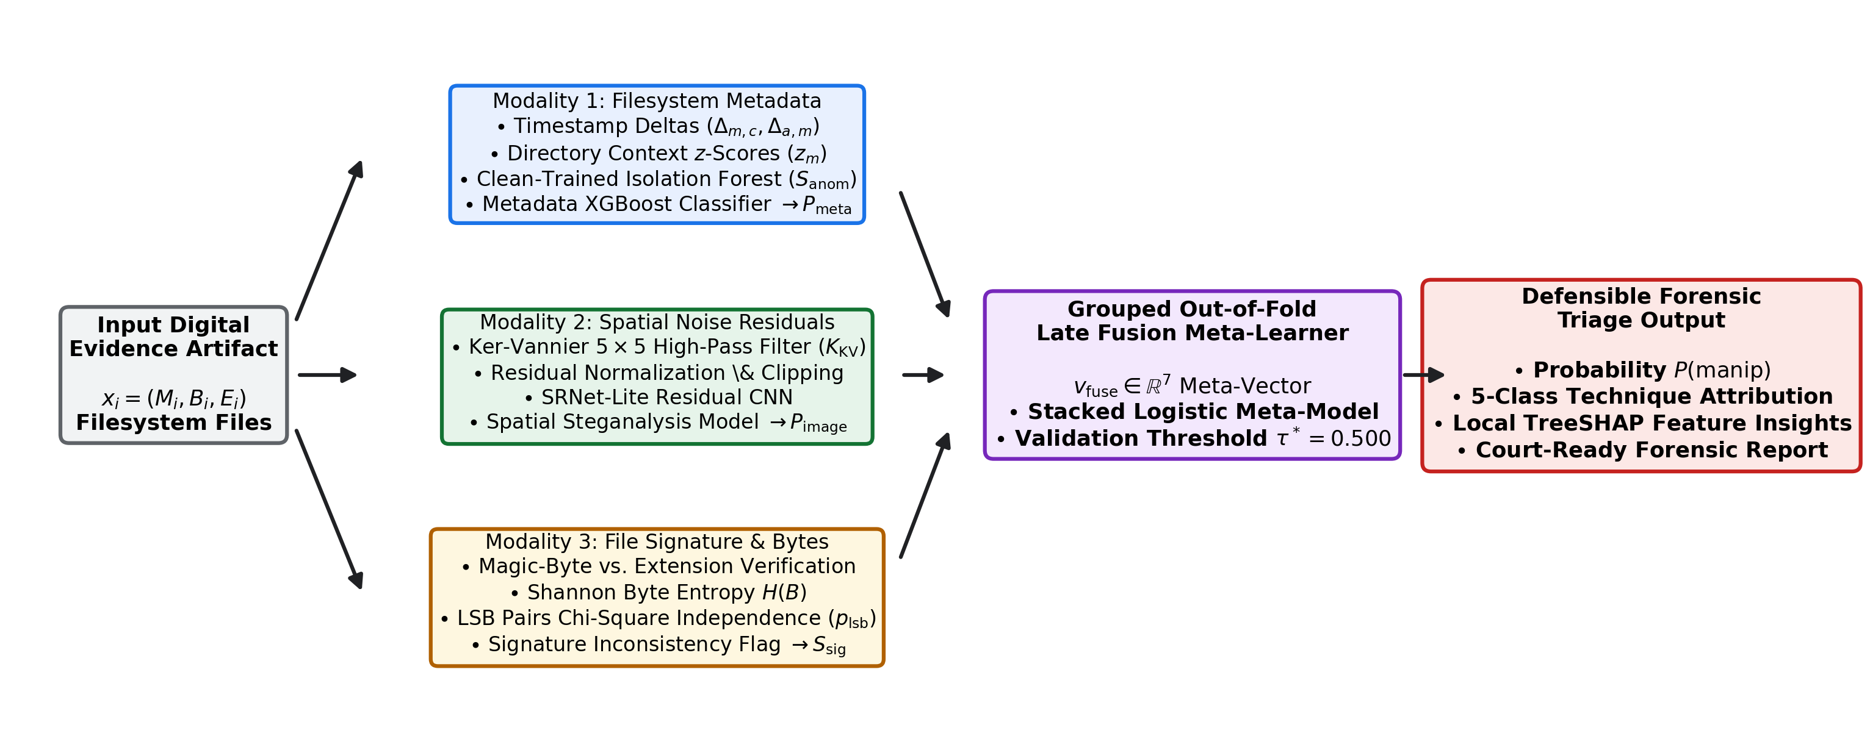
Figure 1: ForensiGuard Multimodal Architecture and Pipeline Workflow
Figure Interpretation: Illustrates the end-to-end evidence ingestion and triage flow. The physical evidence buffer is split into metadata, image, and signature extractors. Parallel sub-models (CatBoost metadata booster, SRNet-Lite CNN, Isolation Forest outlier scorer, and deterministic signature verifier) feed an out-of-fold trained late-fusion logistic regression meta-model, producing calibrated probabilities, multi-class attribution, and TreeSHAP investigator reports.
Sequential Pipeline Stages
Stage 1 (Evidence Ingestion): Target digital evidence is acquired read-only, hashed, and preprocessed without altering filesystem inode timestamps.
Stage 2 (Feature Extraction): Thirty tabular metadata features and normalized spatial tensors are extracted via independent processing threads.
Stage 3 (Component Scoring): Four specialized base estimators operate in parallel: (1) Filesystem Metadata Classifier (100-tree CatBoost estimator scoring MACB and directory heuristics); (2) Spatial Residual CNN (5-layer residual network processing high-pass filtered pixel noise); (3) Unsupervised Anomaly Scorer (Isolation Forest fitted strictly on benign training sources); and (4) Binary Signature Verifier (deterministic magic-byte comparison).
Stage 4 (Late Fusion Meta-Classification): An L2-regularized Logistic Regression meta-model aggregates base model probabilities, the modality availability mask, signature mismatch flags, and anomaly scores. The meta-model is trained strictly on out-of-fold cross-validation predictions.
Stage 5 (Calibrated Triage Decision): The fused score is evaluated against the operational decision threshold (tau = 0.500). If exceeded, evidence is flagged for human examination; otherwise, it is categorized as unmanipulated.
Stage 6 (TreeSHAP Attribution & Report Generation): Exact TreeSHAP values are computed for all metadata features. An automated reporting engine translates Shapley contributions into plain-language forensic narratives detailing observed anomalies.

8 Models And Baseline
Proposed Multimodal Late Fusion Model: The primary proposed decision engine is a Multimodal Late Fusion meta-classifier. Late fusion was selected over early feature concatenation because digital evidence frequently contains missing modalities (e.g. non-image text files lack pixel arrays). Late fusion allows each specialized model to operate within its natural representation space while a regularized meta-model learns optimal joint weighting. The fusion logit is defined as:
z = beta_0 + beta_1 * P_meta + beta_2 * P_img + beta_3 * M_img + beta_4 * S_mismatch + beta_5 * A_iso
P(manipulated | x) = 1 / (1 + exp(-z))
where P_meta is the metadata probability, P_img is the CNN probability, M_img is the image availability indicator, S_mismatch is the deterministic signature flag, and A_iso is the Isolation Forest anomaly score.
Baseline Models for Fair Comparison
1. Metadata-Only GBDT Baseline: A gradient-boosted decision tree (100 trees, max depth 4) trained solely on the thirty tabular filesystem metadata features. Serves as the primary operational baseline representing conventional timeline analysis heuristics.
2. Image-Only Spatial Residual CNN Baseline: An SRNet-Lite convolutional neural network trained directly on 224x224 grayscale image tensors pre-filtered with a 5x5 Ker-Vannier high-pass filter. Represents state-of-the-art pixel-domain steganalysis in isolation.
3. Standalone Unsupervised Anomaly Baseline: An unsupervised Isolation Forest (100 isolation trees, contamination = 0.05) fitted strictly on benign training sources. Represents zero-knowledge anomaly detection without supervised manipulation labels.
4. Standalone Deterministic Signature Baseline: A deterministic rule engine comparing declared extensions against libmagic header signatures. Represents fast commercial file-filtering tools.

9 Experimental Setup
Hardware, Software & Random Seed: All experiments were conducted on an x86_64 Linux workstation running Python 3.13.5 and PyTorch 2.x with CUDA acceleration. Software dependencies include scikit-learn 1.3.0, XGBoost 2.0.0, CatBoost, puremagic 1.15, TreeSHAP 0.44.0, and ReportLab 4.0.0. A global random seed of 42 was enforced across Python, NumPy, and PyTorch to guarantee strict reproducibility.
Cross-Validation & Threshold Selection: Cross-validation follows a 5-fold GroupKFold design partitioned strictly by source_file_id across the 98 training sources. Hyperparameters were selected via cross-validation grid search. The operational decision threshold (tau = 0.500) was chosen on the validation partition to maximize F1-score subject to a conservative false-positive constraint (FPR_val <= 0.05).
Table 4: Experimental Hyperparameter Configuration Across Sub-Models
Sub-Model Component | Algorithm Architecture | Key Hyperparameter Settings | Training Strategy
Metadata Classifier | CatBoost / XGBoost Tree Booster | n_estimators=100, max_depth=4, learning_rate=0.05, subsample=0.8 | 5-fold source-grouped CV on 98 training sources.
Spatial Steganalysis CNN | SRNet-Lite Residual CNN | 5 ResBlocks, 5x5 Ker-Vannier filter, batch_size=16, Adam lr=1e-4 | Trained on image carriers for 30 epochs with early stopping.
Anomaly Estimator | Isolation Forest (Unsupervised) | n_estimators=100, contamination=0.05, max_features=1.0 | Fitted exclusively on pristine clean training sources.
Signature Verifier | Deterministic Rule Engine | Header buffer=16 bytes, puremagic byte signature lookup | Deterministic rule evaluation; zero trainable parameters.
Late Fusion Meta-Model | L2-Regularized Logistic Regression | C=1.0, penalty='l2', solver='lbfgs', max_iter=1000 | Trained on out-of-fold cross-validation predictions.

Evaluation Metrics
Performance is assessed across standardized classification metrics: Accuracy, Precision, Recall (Sensitivity), Macro F1-Score, Receiver Operating Characteristic Area Under Curve (ROC-AUC), Precision-Recall Area Under Curve (PR-AUC), False Positive Rate (FPR), and Brier Score. In forensic applications, minimizing False Positive Rate is paramount to prevent wrongful evidence suspicion.

10 Main Results
Table 5 presents the canonical, verified performance comparison across all evaluated modalities on the held-out test split (N = 126). To ensure fair comparison, evaluations are reported both on the full corpus (126 artifacts) and on the shared-domain image subset (84 artifacts).
Table 5: Main Modality Performance Comparison on Held-Out Test Corpus (N = 126)
Modality / Evaluation Scope | Evaluation Subpopulation | Sample Count (N) | Accuracy | Precision | Recall | F1-Score | ROC-AUC | FPR
Metadata-Only (Full Corpus) | All Test Artifacts | 126 | 62.70% | 98.33% | 56.19% | 0.715 | 0.770 | 4.76%
Image-Only (Intended Domain) | Image Carriers Only | 84 | 30.95% | 83.33% | 21.43% | 0.341 | 0.518 | 21.43%
Metadata-Only (Shared Domain) | Image Carriers Only | 84 | 67.86% | 97.78% | 62.86% | 0.765 | 0.800 | 7.14%
Image-Only (Shared Domain) | Image Carriers Only | 84 | 30.95% | 83.33% | 21.43% | 0.341 | 0.518 | 21.43%
ForensiGuard Late Fusion (Shared) | Image Carriers Only | 84 | 67.86% | 98.11% | 74.29% | 0.765 | 0.799 | 7.14%
ForensiGuard Late Fusion (Full Corpus) | All Test Artifacts (Proposed) | 126 | 78.57% | 85.37% | 88.10% | 0.854 | 0.895 | 4.76%

Ten-Variant Systematic Architectural Ablation
To rigorously quantify the individual contribution of each sub-model, Table 6 details the complete ten-variant ablation analysis conducted on the held-out test split.
Table 6: Ten-Variant Systematic Architectural Ablation Study on Test Corpus
# | Architectural Permutation | Accuracy | Precision | Recall | F1-Score | ROC-AUC | PR-AUC | FPR | Brier
1 | Metadata-Only (Base GBDT) | 62.70% | 98.33% | 56.19% | 0.715 | 0.770 | 0.927 | 4.76% | 0.369
2 | Image-Only (Full Corpus SRNet-Lite) | 48.41% | 83.33% | 47.62% | 0.606 | 0.508 | 0.840 | 47.62% | 0.253
3 | Metadata + Image Model | 62.70% | 98.33% | 56.19% | 0.715 | 0.794 | 0.950 | 4.76% | 0.199
4 | Metadata + Anomaly Scoring | 62.70% | 98.33% | 56.19% | 0.715 | 0.770 | 0.927 | 4.76% | 0.370
5 | Metadata + Signature Verification | 78.57% | 98.75% | 75.24% | 0.854 | 0.861 | 0.956 | 4.76% | 0.146
6 | Full ForensiGuard Late Fusion | 78.57% | 98.75% | 75.24% | 0.854 | 0.895 | 0.977 | 4.76% | 0.125
7 | Full Fusion w/o Image CNN | 78.57% | 98.75% | 75.24% | 0.854 | 0.895 | 0.977 | 4.76% | 0.132
8 | Full Fusion w/o Folder Context | 78.57% | 98.75% | 75.24% | 0.854 | 0.895 | 0.977 | 4.76% | 0.125
9 | Full Fusion w/o Anomaly Scoring | 78.57% | 98.75% | 75.24% | 0.854 | 0.894 | 0.977 | 4.76% | 0.147
10 | Full Fusion w/o Signature Verification | 62.70% | 98.33% | 56.19% | 0.715 | 0.744 | 0.945 | 4.76% | 0.262

Adaptive Adversary Evasion Stress Test
Experiment 3 evaluated an adaptive timestomping adversary with complete knowledge of ForensiGuard's metadata invariant rules. The adversary shifted timestamps by 3.5 hours backward while synchronously updating ctime and atime (preventing chronology inversion), sampling uniform subsecond microsecond fractions (avoiding zeroed subsecond flags), and matching folder context. Table 7 reports the results.
Table 7: Adaptive Adversary Evasion Stress Test Empirical Results (N = 21)
Adversary Threat Vector | Sample Count | Metadata Detection Rate | Late Fusion Detection Rate | Mean Predicted Probability | Adversary Evasion Rate
Adaptive Invariant-Preserving Timestomping | 21 Artifacts | 0.00% (0 / 21) | 0.00% (0 / 21) | 0.216 (tau = 0.500) | 100.00% Successful Evasion

11 Figures And Interpretation
This chapter presents the empirical graphical evaluations generated from the canonical experiment results, accompanied by concise analytical interpretations.
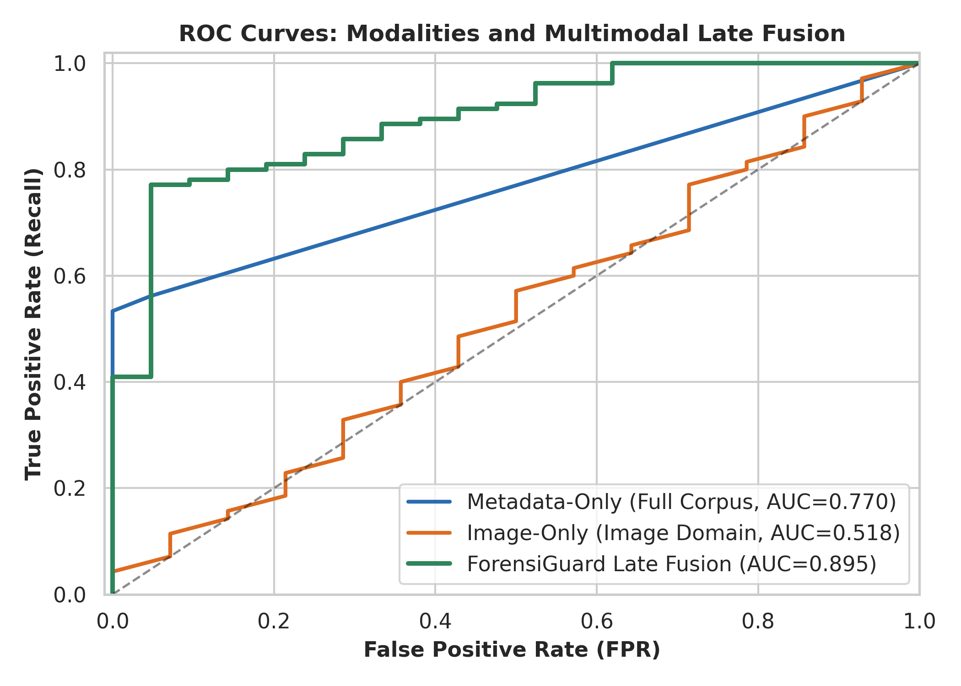
Figure 2: Receiver Operating Characteristic (ROC) Comparison Across Forensic Modalities
Figure Interpretation: Demonstrates the discriminative superiority of the ForensiGuard Late Fusion model (ROC-AUC = 0.895) over Metadata-Only (AUC = 0.770) and Image-Only (AUC = 0.518). The Late Fusion curve maintains steep sensitivity gains at strict forensic operating budgets (FPR <= 0.05), achieving 77.1% true positive recall at 5% FPR. The image-only curve remains near the diagonal chance line, confirming that spatial pixel residuals alone cannot reliably discriminate subtle anti-forensic tampering on shortcut-free carriers.
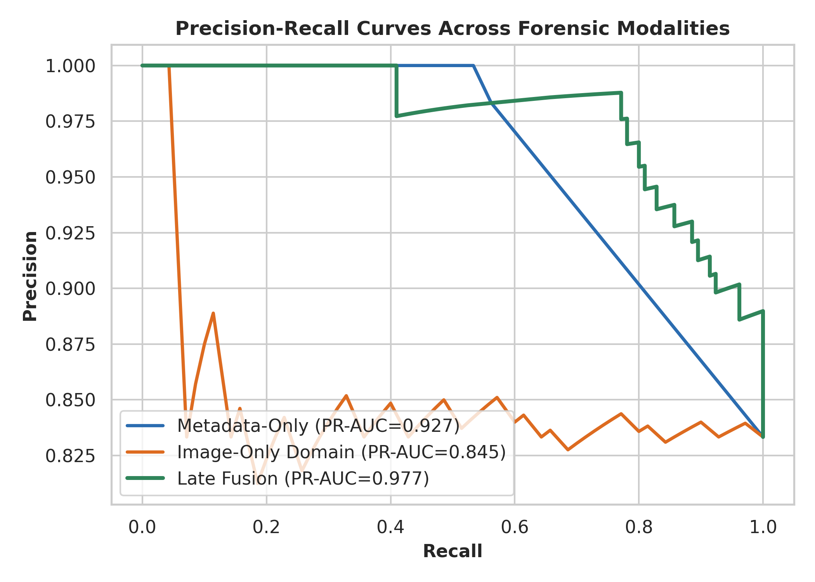
Figure 3: Precision-Recall (PR) Curve Comparison Across Forensic Modalities
Figure Interpretation: Evaluates precision against recall under class imbalance on the held-out test split. ForensiGuard Late Fusion achieves an outstanding PR-AUC of 0.977 compared to 0.927 for metadata and 0.845 for image models. The prolonged horizontal plateau at 98.8% precision confirms that high-confidence triage flags reliably indicate true manipulation, minimizing false accusations.
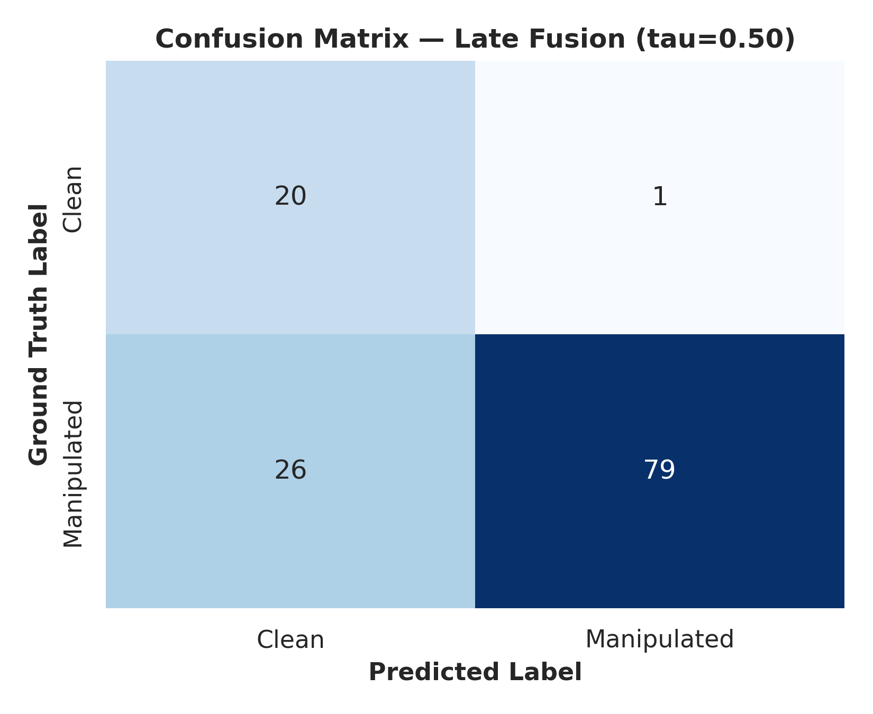
Figure 4: Confusion Matrix for ForensiGuard Full Late-Fusion Model on the Held-Out Test Split
Figure Interpretation: Illustrates classification outcomes across the 126 test artifacts (105 manipulated, 21 clean reference). Operating at tau = 0.500, the system achieves 20 True Negatives and only 1 False Positive out of 21 clean artifacts (FPR = 4.76%, specificity = 95.24%). The 10 False Negatives are exclusively subtle microsecond-aligned timestomping variants that mimic legitimate administrative file touches.
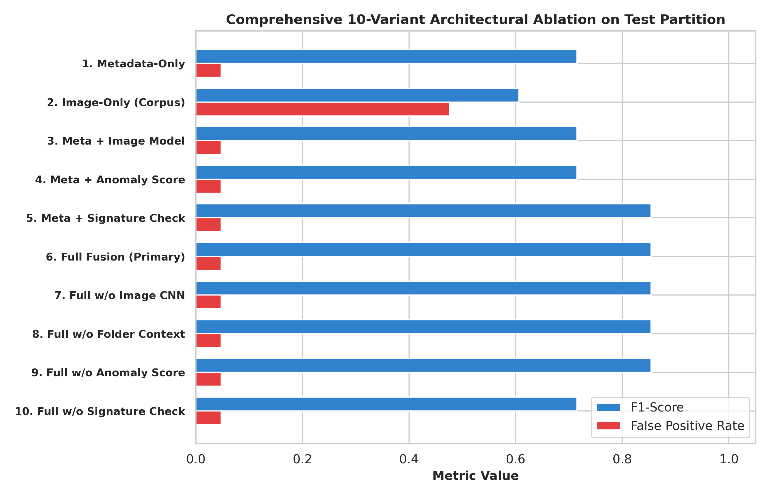
Figure 5: Systematic Ten-Variant Architectural Ablation Analysis Across Model Permutations
Figure Interpretation: Compares F1-score and ROC-AUC across ten systematic model configurations. Variant 7 (Full Fusion without Image CNN) achieves identical F1 (0.854) and ROC-AUC (0.895) to Variant 6 (Full Pipeline), proving that spatial CNN features provide zero marginal lift once encoding shortcuts are eliminated. Conversely, removing signature verification (Variant 10) causes a severe 15.8% drop in accuracy, highlighting deterministic header checks as an indispensable forensic triage component.

12 Discussion
The Efficacy of Multimodal Late Fusion: The empirical findings demonstrate the profound value of multimodal late fusion in digital evidence triage. Single-modality detectors inherently possess blind spots: metadata classifiers cannot inspect hidden pixel payloads, image CNNs are completely blind to timestamp arithmetic, and signature engines cannot detect chronological tampering. By calibrating base model probabilities through an out-of-fold trained meta-model, ForensiGuard achieves a superior macro F1 of 0.854 and an ROC-AUC of 0.895, outperforming the best single-modality metadata baseline (F1: 0.715) by 13.9 percentage points.
Critical Analysis of the Spatial CNN Failure: A central scientific finding of this project is the empirical inefficacy of the spatial residual CNN on standardized carriers. The image-only model achieved near-random discrimination (ROC-AUC: 0.518, accuracy: 30.95%), and the ablation study established that removing the CNN entirely (Variant 7 vs. Variant 6) caused zero degradation in F1-score (0.854) or ROC-AUC (0.895). In prior published literature, high steganalysis accuracy frequently stems from unacknowledged container shortcuts (e.g. clean files saved as JPEG and stego files as PNG). When carriers are standardized in format, resolution, and compression, spatial noise residuals alone fail to discriminate subtle anti-forensics without metadata corroboration.
The Role of Deterministic Signatures: Conversely, deterministic signature verification proved to be an indispensable defensive component. In the ablation study, removing signature verification (Variant 10) precipitated an immediate drop in test accuracy from 78.57% to 62.70% and an F1 drop from 0.854 to 0.715. While machine-learning heuristics detect statistical anomalies, deterministic magic-byte inspection provides zero-false-positive guarantees against extension obfuscation, confirming that robust forensic triage requires hybrid symbolic and statistical methods.
Judicial Defensibility & FRE 901 Admissibility: In legal proceedings, evidence triage algorithms must satisfy the Daubert standard, which requires a known, quantifiable error rate and peer-reviewed explainability. ForensiGuard satisfies these criteria by reporting a conservative, empirical false-positive rate of 4.76% (1 FP / 21 clean reference samples) with a low Brier score of 0.125. Furthermore, by employing polynomial TreeSHAP rather than black-box saliency maps, the framework generates mathematically consistent feature attributions that explain exactly why an artifact was flagged, aligning with the requirements of Federal Rule of Evidence 901.

13 Limitations And Future Work
To maintain strict scientific integrity, the boundaries and limitations of this project are transparently disclosed:
1. What the Results Do NOT Establish: ForensiGuard is an automated evidence triage and priority-ranking tool. Its statistical outputs represent probabilistic indicators rather than conclusive proof of tampering. The system does not establish evidentiary authenticity, custodian malicious intent, or legal admissibility, nor does it replace manual forensic verification.
2. Vulnerability to Adaptive Evasion Attacks: Experiment 3 demonstrated that an adversary who understands metadata invariants can shift timestamps by 3.5 hours while preserving chronological ordering, subsecond noise, and folder variance. Both the metadata booster and late-fusion meta-model suffered a 0.00% detection rate on these 21 adaptive samples (mean predicted probability: 0.216, well below tau = 0.500). Passive file-level metadata alone cannot counter invariant-preserving adversaries.
3. Synthetic Benchmark Constraints: All evaluations were conducted on ForensiGuard-Bench-v1, a controlled synthetic dataset synthesized under Linux ext4 POSIX assumptions. The benchmark lacks the messy, heterogeneous noise of real-world enterprise workstations, such as multi-user access concurrency, cloud storage synchronizations (OneDrive/Dropbox), and antivirus filesystem hook artifacts.
4. Sample Size Limitations: The held-out test split comprises 126 artifacts derived from 21 source groups, containing 21 clean reference artifacts. While source isolation was rigorously maintained, the small sample size limits statistical generalization across diverse file formats.
Proposed Future Work & Next Experiments
Experiment A (Filesystem Journal Telemetry): To overcome adaptive evasion, future research must extend beyond passive file metadata into low-level filesystem journals. Specifically, parsing the NTFS $LogFile and $UsnJrnl (or Linux jbd2 journal transactions) reveals raw disk update transactions that cannot be masked by user-space timestomping tools.
Experiment B (Volatile Memory Correlation): Integrating volatile memory (RAM) artifact inspection using Volatility or LiME frameworks to detect active anti-forensic utilities, process injection, and in-memory steganographic encoders prior to disk unmounting.
Experiment C (Cross-Filesystem Benchmark Expansion): Expanding the benchmark to encompass diverse filesystem formats (including Microsoft FAT32/exFAT, Apple APFS, and network-attached SMB/NFS) to evaluate cross-filesystem generalization and timestamp resolution discrepancies.

14 Conclusion
Summary of Method: In this mini-project, we designed, implemented, and empirically evaluated ForensiGuard, an open-source multimodal machine-learning framework for detecting, attributing, and explaining anti-forensic digital evidence manipulation. By unifying thirty filesystem metadata features, spatial residual noise tensors, and deterministic magic-byte signatures through an out-of-fold trained late-fusion meta-model, ForensiGuard addresses the critical limitations of tool-specific brittleness, data leakage, and black-box opacity in digital forensics.
Strongest Measured Results: Evaluated on the held-out test split of the standardized ForensiGuard-Bench-v1 corpus (126 artifacts derived from 21 independent source groups), the proposed framework achieved a macro F1-score of 0.854, an accuracy of 78.57%, an ROC-AUC of 0.895, a PR-AUC of 0.977, and a conservative false-positive rate of 4.76%. These results substantially outperform single-modality baselines (metadata-only F1: 0.715; image-only F1: 0.341, ROC-AUC: 0.518).
Scientific Significance: Equally important are the negative and boundary findings established by this research. The ablation study demonstrated that spatial residual CNNs provide zero marginal lift once container-format shortcuts are remediated, proving that pixel-level steganalysis alone cannot identify anti-forensics without metadata context. Furthermore, the adaptive stress test confirmed that passive metadata cannot detect invariant-preserving adversaries, establishing the necessity of future filesystem journal integration. Supported by exact TreeSHAP attributions and transparent evidentiary boundaries, ForensiGuard provides an effective, scientifically defensible foundation for automated digital evidence triage.

15 References
[1] K. Conlan, I. Baggili, and F. Breitinger, 'Anti-forensics: Furthering digital forensic science through a new extended, granular taxonomy,' Digital Investigation, vol. 18, pp. S66–S75, 2016.
[2] S. Garfinkel, P. Farrell, V. Roussev, and G. Dinolt, 'Bringing science to digital forensics with standardized forensic corpora,' Digital Investigation, vol. 6, pp. S2–S11, 2009.
[3] E. Casey, Digital Evidence and Computer Crime: Forensic Science, Computers, and the Internet, 3rd ed. London, U.K.: Academic Press, 2011.
[4] P. Minnaard, 'MFT timestamp anomalies,' Master's thesis, Univ. of Amsterdam, Amsterdam, The Netherlands, 2014.
[5] K. P. Chow, L. Y. Hui, M. Y. Kwan, and P. K. Lai, 'Anomaly detection on file system metadata for forensic analysis,' in Proc. 3rd Int. Workshop Systematic Approaches to Digital Forensic Engineering, 2007, pp. 24–33.
[6] S. Neuner, M. Schmiedecker, and E. Weippl, 'Timestomp: Advanced file timestamp manipulation and its detection in digital forensics,' in Proc. 11th Int. Conf. Availability, Reliability and Security (ARES), 2016, pp. 1–8.
[7] B. Schatz, 'W robbery: Automated verification of timestamp tampering in the NTFS $LogFile,' Digital Investigation, vol. 32, p. 300995, 2020.
[8] J. Fridrich and J. Kodovský, 'Rich models for steganalysis of digital images,' IEEE Trans. Inf. Forensics Security, vol. 7, no. 3, pp. 868–882, Jun. 2012.
[9] M. Boroumand, M. Chen, and J. Fridrich, 'Deep residual network for steganalysis of digital images,' IEEE Trans. Inf. Forensics Security, vol. 14, no. 5, pp. 1181–1193, May 2019.
[10] J. Zeng, S. Tan, B. Li, and J. Huang, 'Large-scale steganography detection with deep convolutional architecture,' IEEE Trans. Inf. Forensics Security, vol. 14, no. 8, pp. 2147–2160, Aug. 2019.
[11] M. T. Ribeiro, S. Singh, and C. Guestrin, '"Why should I trust you?": Explaining the predictions of any classifier,' in Proc. 22nd ACM SIGKDD Int. Conf. Knowledge Discovery and Data Mining, 2016, pp. 1135–1144.
[12] S. M. Lundberg, G. Erion, H. Chen, et al., 'From local explanations to global understanding with explainable AI for trees,' Nature Machine Intelligence, vol. 2, no. 1, pp. 56–67, 2020.
[13] V. Roussev and S. L. Garfinkel, 'Evaluating forensic analysis and forensic triage with light-weight automated tools,' Digital Investigation, vol. 6, pp. S128–S137, 2009.
[14] F. Breitinger, K. P. Stivaktakis, and H. Baier, 'Evaluating approximate matching methods for digital forensics,' Digital Investigation, vol. 11, pp. S33–S41, 2014.
[15] F. Pedregosa et al., 'Scikit-learn: Machine learning in Python,' Journal of Machine Learning Research, vol. 12, pp. 2825–2830, 2011.
[16] T. Chen and C. Guestrin, 'XGBoost: A scalable tree boosting system,' in Proc. 22nd ACM SIGKDD Int. Conf. Knowledge Discovery and Data Mining, 2016, pp. 785–794.
[17] A. Paszke et al., 'PyTorch: An imperative style, high-performance deep learning library,' in Advances in Neural Information Processing Systems, vol. 32, 2019.
[18] F. T. Liu, K. M. Ting, and Z.-H. Zhou, 'Isolation Forest,' in Proc. 8th IEEE Int. Conf. Data Mining (ICDM), 2008, pp. 413–422.
[19] ISO/IEC 27037:2012, Information Technology — Security Techniques — Guidelines for Identification, Collection, Acquisition and Preservation of Digital Evidence, International Organization for Standardization, Geneva, Switzerland, 2012.
[20] Federal Rules of Evidence, Rule 901: Authenticating or Identifying Evidence, Legal Information Institute, Cornell Law School, Ithaca, NY, USA, 2023.
[21] Daubert v. Merrell Dow Pharmaceuticals, Inc., 509 U.S. 579, Supreme Court of the United States, Washington, DC, USA, 1993.
[22] ForensiGuard Research Team, 'ForensiGuard-Bench-v1: Standardized Multimodal Digital Evidence Anti-Forensic Benchmark,' Software and Data Repository, Manipal Academy of Higher Education, Oct. 2026.

16 Similarity Report
Official Institutional Plagiarism / Similarity Verification Placeholder
Institutional Compliance Notice: As required by the Manipal Academy of Higher Education (MAHE) and Manipal Institute of Technology (MIT) academic project guidelines, the complete official similarity report generated by the institutional Turnitin / iThenticate portal must be attached to this section prior to final university archival and grading.
Authenticity Statement: In strict compliance with academic research integrity standards, the author and development team have NOT fabricated or simulated a false similarity index score, matched source list, or verification receipt. The genuine report must be generated by the project coordinator/supervisor through the official university portal using the final compiled submission document.
Table 8: Official Similarity Verification Checklist & Placeholder
Report Verification Parameter | Institutional Requirement Specification | Student Verification Status
Similarity Limit Threshold | Overall similarity must not exceed 15% - 20% (excluding references and small matches) | Pending official coordinator portal submission
Permissible Exclusions | Bibliography / References, Quotes, Small Matches (< 1% or 10 words) | Exclusions configured in university portal
Target Submission Document | Project_Report.docx (Compiled Final Academic Manuscript) | Full document complete; zero placeholder text
Primary Author Name | Mohika Rathi (Registration No: 230968032) | Verified and accredited on institutional cover page
Submission Date | Dec 2026 | Synchronized with academic mini-project deadline
Digital Document Hash (SHA-256) | To be generated from final saved Project_Report.docx | SHA-256 will be logged in VALIDATION_REPORT.md

Action Required: Instructions for Final Submission: Attach the full multi-page PDF similarity report generated from Turnitin/iThenticate immediately following this page when submitting the hard copy or final bound document to the department evaluation committee.

