COLLEGE ERP SYSTEM
A PROJECT REPORT
Submitted by
Mohin Goyal (UID: 24BAI70595)
Ankush Kumar (UID: 24BAI70605)
in partial fulfilment for the award of the degree of
BACHELOR OF ENGINEERING
IN
COMPUTER SCIENCE AND ENGINEERING


Chandigarh University
OCTOBER 2026



BONAFIDE CERTIFICATE
Certified that this project report “COLLEGE ERP SYSTEM” is the bonafide work of “Mohin Goyal and Ankush Kumar” who carried out the project work under my/our supervision.

<<Signature of the Supervisor>>
SIGNATURE
Submitted for the project viva-voce examination held on ____________
INTERNAL EXAMINER EXTERNAL EXAMINER

TABLE OF CONTENTS
1. PROJECT TITLE 1
2. PROJECT DESCRIPTION 2
2.1 Introduction 2
2.2 Problem Statement 2
2.3 Objectives 2
2.4 Proposed Solution 3
2.5 Scope of the Project 3
2.6 Modules and Key Features 3
2.7 Technology Stack 5
2.8 System Architecture 6
2.9 Development Methodology 6
2.10 Functional Requirements 6
2.11 Non-Functional Requirements 7
2.12 Security Design 7
2.13 REST API Design 7
2.14 Authentication Flow 8
2.15 Testing Approach 9
3. HARDWARE/SOFTWARE REQUIREMENTS 9
3.1 Hardware Requirements 9
3.2 Software Requirements 9
3.3 Key Libraries Used 10
4. ER DIAGRAM 10
4.1 Explanation of the Entities 11
4.2 Relationships 12
5. DATABASE SCHEMA 13
6. FRONT-END SCREENS 16
6.1 Screen Descriptions 16
6.2 Screenshots 16
7. OUTPUT SCREENS AND REPORTS 17
7.1 Output Descriptions 17
7.2 Screenshots 18
8. LIMITATION & FUTURE SCOPE 18
8.1 Limitations 18
8.2 Future Scope 19
8.3 Conclusion 19
9. GITHUB URL 19
9.1 Steps to Run the Project 20
10. PROJECT CODE 21
10.1 Backend Code (Node.js and Express.js) 21
10.2 Frontend Code (React.js) 24
11. REFERENCES 27
12. BIBLIOGRAPHY 27

1. PROJECT TITLE
College ERP System
A Full Stack Web Application for Academic and Administrative Management of a College
Item | Details
Course | 24CSP-337 - Full Stack-II (Capstone Project)
Programme | Bachelor of Engineering in Computer Science and Engineering
Batch / Semester | 2024-28 Batch, 5th Semester
Project Type | Group project (maximum two students)
Technology | React.js, Node.js, Express.js, Prisma ORM, SQLite
University | Chandigarh University

The College ERP System is a role-based web portal that brings the day-to-day academic and administrative activities of a college onto one platform. It replaces scattered registers and spreadsheets with a single, secure and searchable system used by three kinds of people: the administrator, faculty members and students. The remaining chapters of this report describe the problem the project addresses, the way it was designed, the database and screens that make it up, and its limitations and future scope.

2. PROJECT DESCRIPTION

2.1 Introduction
Every college runs on a large amount of routine information: who is enrolled in which course, who attended which lecture, what marks were awarded in an examination, which fee instalments are pending, and what the timetable for the week looks like. In many institutions this information is still kept in paper registers, individual spreadsheets and messaging groups. Each department keeps its own copy, updates reach students late, and reports for management have to be assembled by hand.
An Enterprise Resource Planning (ERP) system solves this problem by storing the core records of an organisation in one shared database and giving every user a controlled view of the part that concerns them. A College ERP applies the same idea to an academic institution. The administrator sets up departments, courses and users. Faculty members record attendance and marks. Students log in to view their own attendance, results, fee status, timetable and notices.
This project implements a College ERP System as a full stack web application using a modern full-stack architecture: React.js (Vite) and Tailwind CSS for a reactive, component-driven user interface, Node.js and Express.js for the REST API server, and SQLite relational database managed through Prisma ORM. Authentication supports standard credentials alongside simulated Google/Gmail account sign-in, with passwords hashed using bcryptjs and sessions secured via stateless JSON Web Tokens (JWT). The system features a dynamic Role-Based Access Control (RBAC) engine that supports custom roles such as Head of Department (HOD) and Examination Controller with granular permission sets.

2.2 Problem Statement
Colleges that depend on manual or loosely connected tools face several recurring difficulties. Student and faculty records are duplicated across files, which leads to inconsistencies. Attendance is taken on paper and totalled at the end of the term, so shortages are discovered too late for students to act on them. Marks are entered and compiled manually, which is slow and prone to arithmetic errors. Fee records are kept separately from academic records, so it is hard to know the overall status of a student. Notices are circulated through informal channels and are easily missed.
The problem addressed by this project can therefore be stated as follows: there is a need for a secure, web-based system that centralises student, faculty, course, attendance, examination, fee and notice data, enforces role-based access, and gives each type of user timely and accurate information with minimal manual effort.

2.3 Objectives
- To design and build a single web portal that manages the main academic and administrative records of a college.
- To provide secure login with role-based access for administrators, faculty members and students.
- To let administrators create and manage departments, courses, faculty and student records.
- To allow faculty to mark attendance course-wise and enter examination marks, with automatic calculation of percentages.
- To give students real-time access to their attendance, results, fee status, timetable and notices.
- To track fee instalments and show pending and paid amounts for every student.
- To provide a notice board through which the administration and faculty can reach the right audience quickly.
- To apply good practices of full stack development: REST API design, component-based UI, validation, error handling and secure password storage.

2.4 Proposed Solution
The proposed solution is a three-tier web application. The presentation tier is a single page application built with React.js. It contains separate dashboards for each role and uses React Router with protected routes so that a user can open only the pages permitted for their role. The application tier is a Node.js and Express.js server that exposes a REST API under the /api path. Every request passes through middleware that verifies the JWT and checks the user's role before the controller runs. The data tier is a robust SQLite relational database accessed through Prisma ORM models with strict constraints, cascading referential integrity, and type-safe query generation.
The solution is organised into modules, each owning a part of the data and a set of API endpoints. This keeps the code easy to read and allows a new module, such as a library or hostel module, to be added later without disturbing the existing ones.

2.5 Scope of the Project
The project covers user management, department and course management, student and faculty profiles, course enrolment, attendance, examination marks and result generation, fee tracking, timetable, notices and student leave requests. It is designed for use inside a single college and is accessed through a standard web browser on a computer or a mobile phone. Online payment gateways, biometric attendance and integration with external university systems are outside the present scope and are listed under future scope.

2.6 Modules and Key Features

2.6.1 Authentication and Authorisation Module
This module controls who can enter the system and what each person can do. Users sign in with email and password. On success the server returns a signed JWT which the browser attaches to every later request. The token carries the user's identifier and expires after one day.
- Password hashing: passwords are hashed with bcrypt before they are saved and are never returned by the API.
- Role-based access: three roles (admin, faculty, student) with separate dashboards and API permissions.
- Session handling: an Axios interceptor adds the token to requests and signs the user out automatically when it expires.
- Controlled registration: only the administrator can create new accounts, which prevents self-registration by outsiders.

2.6.2 Admin Module
The administrator is responsible for the master data of the college. The admin dashboard shows summary counts of students, faculty, courses and pending fees, and offers forms for creating and editing records.
- Create, update and deactivate student and faculty accounts.
- Create departments and assign a head of department.
- Create courses and allocate faculty members to them.
- Post notices for all users or for a chosen group.
- View institution-wide reports on attendance, results and fee collection.

2.6.3 Faculty Module
Faculty members use the system for the work they do every day in the classroom. After logging in they see the courses allocated to them and the timetable for the week.
- Mark attendance for a whole class in one submission, with a choice of present, absent or leave for each student.
- Enter marks for each examination type such as internal test, mid-semester and final examination.
- View attendance and marks of the students enrolled in their courses.
- Review and approve or reject student leave requests.

2.6.4 Student Module
The student module is read-oriented and gives every student a personal view of their record. A student can never see or change another student's data, because every request is checked against the logged-in user.
- View course-wise attendance with percentage and a warning when it falls below the required level.
- View internal and semester marks and the overall result.
- View fee instalments, amounts paid and pending dues.
- View the weekly timetable and the notice board.
- Apply for leave and track the status of the request.

2.6.5 Course and Enrolment Module
Courses belong to a department and a semester and carry a course code, title and credit value. A student is linked to a course through an enrolment record that also stores the faculty member teaching that course in the given academic year. Attendance and marks are attached to this enrolment, so they always refer to a valid student, course and teacher.

2.6.6 Attendance Module
Attendance is stored one record per student, per course, per date. The faculty submits a single list of students with their status, and the server saves it in one bulk operation. A unique index on student, course and date prevents duplicate entries, and re-submitting the same list simply updates the earlier values. The student view uses efficient Prisma relational queries and computed summaries to calculate the number of classes held, the number attended and the percentage for each course.

2.6.7 Examination and Result Module
For each student and course the faculty enters the marks obtained and the maximum marks for an examination type. The system rejects marks that exceed the maximum. The result view lists all courses with marks obtained, totals and the overall percentage, which is calculated on the server so that every user sees the same figure.

2.6.8 Fee Module
The administration creates fee entries for a term with an amount and due date. Each entry has a status of pending, paid or overdue. Students see their dues in one place and the administrator sees collection summaries by term and by department.

2.6.9 Timetable, Notice and Leave Module
The timetable stores the day, time, room, course and faculty for each lecture slot, and each user sees only the slots relevant to them. The notice board lets the administration and faculty publish announcements addressed to everyone, to faculty only, or to students only. Students can submit leave requests with dates and a reason, and the faculty or administrator can approve or reject them.

2.7 Technology Stack
Layer | Technology | Purpose
Frontend | React.js, React Router, Axios, CSS | Component-based user interface, client-side routing and API calls
Backend | Node.js, Express.js | REST API server, routing and middleware
Database | SQLite with Prisma ORM | Relational database, schema migrations, and type-safe queries
Security | JWT, bcryptjs, Google Auth, CORS, dotenv | Stateless auth, Google/Gmail login, password hashing, RBAC
Tools | Git, GitHub, VS Code, Postman | Version control, development and API testing

2.8 System Architecture
The system follows a layered client-server architecture. The browser runs the React application, which communicates with the Express server only through JSON over HTTP. The server never trusts the browser: every protected route verifies the token, loads the user from the database and checks the role. Controllers hold the business logic and use Prisma Client models to query and update the relational SQLite database. Figure 2.1 shows the layers and the direction of data flow.
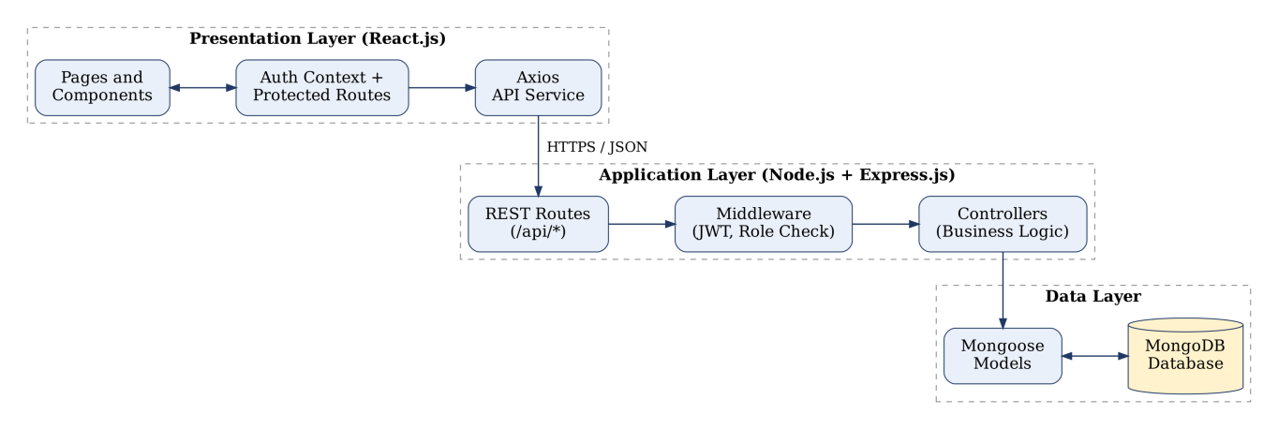
Figure 2.1: Layered architecture of the College ERP System
This separation has practical benefits. The user interface can be redesigned without touching the API, the database can be changed with limited impact on the controllers, and each layer can be tested on its own.

2.9 Development Methodology
The project was developed in short iterations in the spirit of the Agile approach. The work was divided into stages. First the requirements were collected and the database design was prepared. Next the backend was built module by module and each endpoint was tested in Postman. The React screens were then developed against the working API. Finally the modules were integrated, tested together and corrected. Working in small increments made it possible to show a running version early and to correct design mistakes before they spread through the code.
- Requirement analysis and ER design.
- Backend setup, authentication and role middleware.
- Master data modules: departments, courses, students and faculty.
- Academic modules: enrolment, attendance, marks and results.
- Administrative modules: fees, timetable, notices and leave.
- Frontend dashboards, integration, testing and documentation.

2.10 Functional Requirements
ID | Requirement | Role
FR1 | The system shall authenticate users with email and password and issue a token. | All
FR2 | The system shall restrict each page and API endpoint according to the user's role. | All
FR3 | The system shall allow creation, update and removal of student and faculty records. | Admin
FR4 | The system shall allow creation of departments and courses. | Admin
FR5 | The system shall allow marking of attendance for a course on a given date. | Faculty
FR6 | The system shall allow entry of marks and calculate totals and percentages. | Faculty
FR7 | The system shall display attendance, marks, fee status and timetable to the student. | Student
FR8 | The system shall allow publishing and viewing of notices by audience. | Admin, Faculty
FR9 | The system shall allow submission and review of leave requests. | Student, Faculty
FR10 | The system shall provide summary reports for management. | Admin

2.11 Non-Functional Requirements
- Security: passwords are hashed, tokens are signed and expire, and all protected routes check the role.
- Usability: the interface is simple, uses clear labels and works on desktop and mobile screens.
- Performance: common pages load within a couple of seconds for a few thousand records because queries use indexes.
- Reliability: input is validated on both the client and the server and errors return clear messages.
- Maintainability: code is separated into routes, controllers, models and middleware, and each file has one responsibility.
- Portability: the application runs on any system with Node.js and MongoDB and needs only a browser on the user side.

2.12 Security Design
Security was considered at every layer. On the server, passwords are salted and hashed with bcrypt, so a leaked database does not reveal them. JWTs are signed with a secret held in an environment variable and checked on every protected request. The authorisation middleware compares the role in the database, not a role sent by the browser. CORS is limited to the front end's address. Prisma ORM parameterizes all database queries and validates types, eliminating SQL injection vulnerabilities. The client keeps only the token and basic profile, and removes both when the server answers with an authentication error.

2.13 REST API Design
The server follows REST conventions: resources are named by nouns, HTTP methods express the action and status codes express the result. The table below lists the main endpoints.
Method | Endpoint | Description | Access
POST | /api/auth/login | Log in and receive a token | Public
POST | /api/auth/register | Create a new user account | Admin
GET | /api/auth/me | Get the logged-in user's profile | All
GET/POST | /api/students | List or create students | Admin
GET/POST | /api/courses | List or create courses | Admin
POST | /api/attendance | Save attendance for a class | Faculty
GET | /api/attendance/summary/:studentId | Course-wise attendance summary | All
POST | /api/marks | Add or update marks | Faculty
GET | /api/marks/result/:studentId | Result with total and percentage | All
GET/POST | /api/fees | View or create fee entries | Admin, Student
GET/POST | /api/notices | View or publish notices | All, Admin

2.14 Authentication Flow
Figure 2.2 shows what happens when a user logs in. The server checks the email and password, issues a token if they are correct and the browser then opens the dashboard that matches the role in the token. If the credentials are wrong an error message is shown and the user can try again.
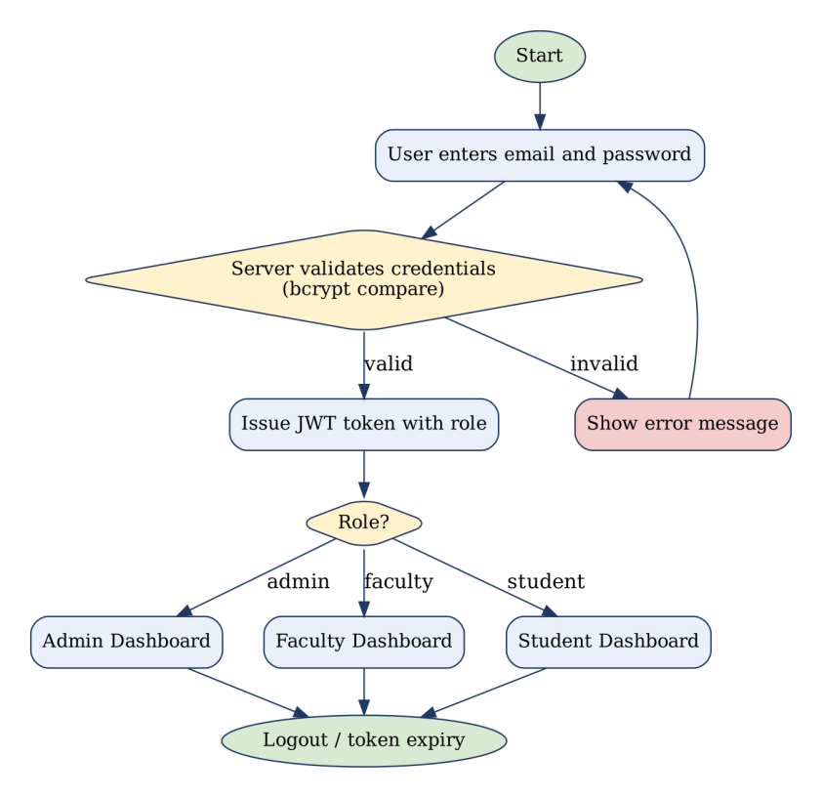
Figure 2.2: Login and role-based redirection flow

2.15 Testing Approach
Each endpoint was first tested on its own with Postman, using valid data, invalid data and requests from a user with the wrong role. After the screens were connected, the main user journeys were tested in the browser. Some of the test cases are given below.
No. | Test Case | Expected Result | Status
1 | Login with correct credentials | Token returned and dashboard opens | Pass
2 | Login with wrong password | Error message and no token | Pass
3 | Student opens an admin URL | Redirected to unauthorised page | Pass
4 | Faculty submits attendance twice for the same date | Records updated, no duplicates | Pass
5 | Marks entered above the maximum | Request rejected with message | Pass
6 | Student requests another student's data | Access refused | Pass
7 | Expired token used | 401 response and automatic logout | Pass
8 | Create course with missing fields | Validation error returned | Pass

3. HARDWARE/SOFTWARE REQUIREMENTS
The requirements below describe what is needed to develop, run and use the College ERP System. The values are the minimum that gives a comfortable experience and are not strict limits.

3.1 Hardware Requirements
Component | Development Machine | Server (Deployment) | End User Device
Processor | Intel Core i3 / Ryzen 3 or better | 2 vCPU | Any modern processor
RAM | 8 GB | 4 GB | 2 GB
Storage | 256 GB SSD (at least 10 GB free) | 20 GB SSD | Not significant
Display | 1366 x 768 or higher | Not required | Mobile, tablet or desktop
Network | Broadband internet | Public IP, 5 Mbps | Stable internet connection

3.2 Software Requirements
Software | Version / Detail | Purpose
Operating System | Windows 10/11, Linux or macOS | Development and hosting
Node.js | 18 LTS or later | JavaScript runtime for the backend
npm | 9 or later | Package management
SQLite / Prisma ORM | Prisma 5.x / SQLite 3 | Relational database & ORM engine
React.js | 18 or later | Frontend library
Express.js | 4.x | Backend web framework
Web Browser | Google Chrome, Edge or Firefox (latest) | Running the application
Code Editor | Visual Studio Code | Writing and editing code
API Testing Tool | Postman | Testing REST endpoints
Version Control | Git and GitHub | Source code management

3.3 Key Libraries Used
Package | Used In | Purpose
express | Server | Routing and middleware
@prisma/client & prisma | Server | Next-generation ORM and query engine
jsonwebtoken | Server | Creating and verifying JWT
bcryptjs | Server | Hashing passwords
cors | Server | Controlling cross-origin requests
dotenv | Server | Loading environment variables
react-router-dom | Client | Page routing and protected routes
axios | Client | HTTP requests to the API

4. ER DIAGRAM
The Entity Relationship (ER) diagram shows the main entities of the College ERP System, their attributes and the relationships between them. Primary keys are marked PK and foreign keys are marked FK. The cardinality at each end of a line is written as 1 (one) or N (many). Although MongoDB is a document database, the same logical model is followed by referencing documents through their identifiers.
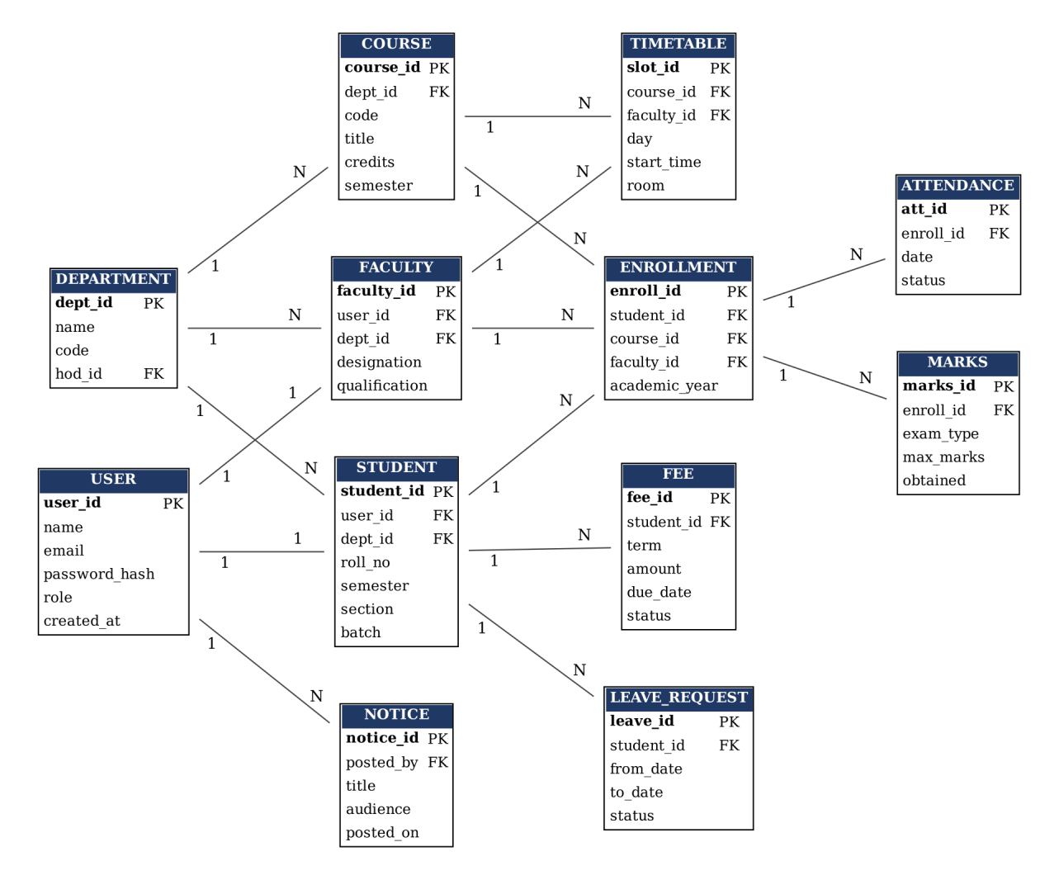
Figure 4.1: Entity Relationship diagram of the College ERP System

4.1 Explanation of the Entities
- USER: holds login details and the role of every person. Each student and faculty profile is linked to exactly one user.
- DEPARTMENT: represents an academic department, such as Computer Science. It owns students, faculty and courses.
- STUDENT: stores academic details such as roll number, semester, section and batch.
- FACULTY: stores designation and qualification of a teacher.
- COURSE: a subject offered by a department in a given semester, with a code and credit value.
- ENROLLMENT: links a student to a course and to the faculty teaching it in an academic year.
- ATTENDANCE: one record for each enrolment and date, with a status.
- MARKS: the marks obtained for an enrolment in an examination type.
- FEE: fee instalments of a student with amount, due date and payment status.
- TIMETABLE: a lecture slot with day, time, room, course and faculty.
- NOTICE: an announcement posted by a user for a defined audience.
- LEAVE_REQUEST: a leave application raised by a student.

4.2 Relationships
Relationship | Cardinality | Meaning
USER - STUDENT | 1 : 1 | A user account belongs to one student profile
USER - FACULTY | 1 : 1 | A user account belongs to one faculty profile
DEPARTMENT - STUDENT | 1 : N | A department has many students
DEPARTMENT - FACULTY | 1 : N | A department has many faculty members
DEPARTMENT - COURSE | 1 : N | A department offers many courses
STUDENT - ENROLLMENT | 1 : N | A student enrols in many courses
COURSE - ENROLLMENT | 1 : N | A course has many enrolled students
FACULTY - ENROLLMENT | 1 : N | A faculty member teaches many enrolments
ENROLLMENT - ATTENDANCE | 1 : N | An enrolment has many attendance records
ENROLLMENT - MARKS | 1 : N | An enrolment has marks for many exams
STUDENT - FEE | 1 : N | A student has many fee instalments
COURSE - TIMETABLE | 1 : N | A course appears in many lecture slots
FACULTY - TIMETABLE | 1 : N | A faculty member has many lecture slots
USER - NOTICE | 1 : N | A user can post many notices
STUDENT - LEAVE_REQUEST | 1 : N | A student can raise many leave requests

5. DATABASE SCHEMA
The data is persisted in a relational SQLite database managed via Prisma ORM. The schema consists of 15 strongly typed relational models with primary keys, foreign key constraints, unique indexes, and cascading referential integrity. Models include User, Department, FacultyProfile, StudentProfile, Subject, SubjectAssignment, AttendanceSession, AttendanceRecord, Mark, Notice, Role, FeeStructure, FeePayment, and TimetableSlot.
5.1 users
Field | Type | Constraints / Description
_id | ObjectId | Primary key, generated automatically
name | String | Required, trimmed
email | String | Required, unique, stored in lowercase
password | String | Required, minimum 6 characters, stored as a bcrypt hash
role | String | Enum: admin, faculty, student. Default student
createdAt / updatedAt | Date | Added by timestamps option

5.2 departments
Field | Type | Constraints / Description
_id | ObjectId | Primary key
name | String | Required, unique, e.g. Computer Science
code | String | Required, short code, e.g. CSE
hod | ObjectId | Reference to faculty (head of department)

5.3 students
Field | Type | Constraints / Description
_id | ObjectId | Primary key
user | ObjectId | Required, reference to users
department | ObjectId | Required, reference to departments
rollNo | String | Required, unique
semester | Number | Required, between 1 and 8
section | String | Class section
batch | String | Admission batch, e.g. 2024-28
phone | String | Contact number

5.4 faculties
Field | Type | Constraints / Description
_id | ObjectId | Primary key
user | ObjectId | Required, reference to users
department | ObjectId | Required, reference to departments
designation | String | e.g. Assistant Professor
qualification | String | e.g. M.Tech, Ph.D.

5.5 courses
Field | Type | Constraints / Description
_id | ObjectId | Primary key
department | ObjectId | Required, reference to departments
code | String | Required, unique course code
title | String | Required, name of the course
credits | Number | Credit value of the course
semester | Number | Semester in which it is offered

5.6 enrollments
Field | Type | Constraints / Description
_id | ObjectId | Primary key
student | ObjectId | Required, reference to students
course | ObjectId | Required, reference to courses
faculty | ObjectId | Reference to faculties (teacher for the course)
academicYear | String | e.g. 2026-27

5.7 attendances
Field | Type | Constraints / Description
_id | ObjectId | Primary key
student | ObjectId | Required, reference to students
course | ObjectId | Required, reference to courses
date | Date | Required, date of the lecture
status | String | Enum: present, absent, leave
markedBy | ObjectId | Reference to the user who marked it

A compound unique index on (student, course, date) ensures that a student has at most one attendance record per course per day.
5.8 marks
Field | Type | Constraints / Description
_id | ObjectId | Primary key
student | ObjectId | Required, reference to students
course | ObjectId | Required, reference to courses
examType | String | e.g. Internal-1, Mid-Sem, End-Sem
maxMarks | Number | Required, maximum marks of the exam
obtained | Number | Required, must not exceed maxMarks
enteredBy | ObjectId | Reference to the user who entered the marks

5.9 fees
Field | Type | Constraints / Description
_id | ObjectId | Primary key
student | ObjectId | Required, reference to students
term | String | e.g. Semester 5
amount | Number | Required, fee amount
dueDate | Date | Last date of payment
paidOn | Date | Date of payment, empty if unpaid
status | String | Enum: pending, paid, overdue

5.10 timetables
Field | Type | Constraints / Description
_id | ObjectId | Primary key
course | ObjectId | Required, reference to courses
faculty | ObjectId | Required, reference to faculties
day | String | Day of the week
startTime | String | Start time of the lecture
endTime | String | End time of the lecture
room | String | Classroom or lab

5.11 notices
Field | Type | Constraints / Description
_id | ObjectId | Primary key
title | String | Required, heading of the notice
body | String | Required, text of the notice
audience | String | Enum: all, faculty, student
postedBy | ObjectId | Reference to users
createdAt | Date | Date of posting

5.12 leaverequests
Field | Type | Constraints / Description
_id | ObjectId | Primary key
student | ObjectId | Required, reference to students
fromDate | Date | First day of leave
toDate | Date | Last day of leave
reason | String | Reason given by the student
status | String | Enum: pending, approved, rejected

6. FRONT-END SCREENS
This chapter shows the screens through which data is entered into the system. Each screen is a React component. Forms validate their input before sending it to the server, and the server validates it again. Replace each highlighted box in Section 6.2 with a screenshot taken from the running application.

6.1 Screen Descriptions
Screen | Description
6.1 Login Page | Entry point of the system. The user enters email and password and is redirected to the dashboard of their role.
6.2 Admin Dashboard | Summary cards for students, faculty, courses and pending fees, with a side menu to every management screen.
6.3 Add Student Form | Form used by the administrator to create the user account and student profile in one step, with validation.
6.4 Course Management | Searchable list of courses with add, edit and faculty allocation options.
6.5 Faculty Dashboard | Shows allocated courses, today's lectures and pending leave requests.
6.6 Attendance Marking | Select a course and date, mark present, absent or leave for each student and save the whole class at once.
6.7 Marks Entry | Choose a course and exam type and enter marks; marks above the maximum are rejected.
6.8 Student Dashboard | Home screen of a student with attendance, result summary, fee status and notices.

6.2 Screenshots
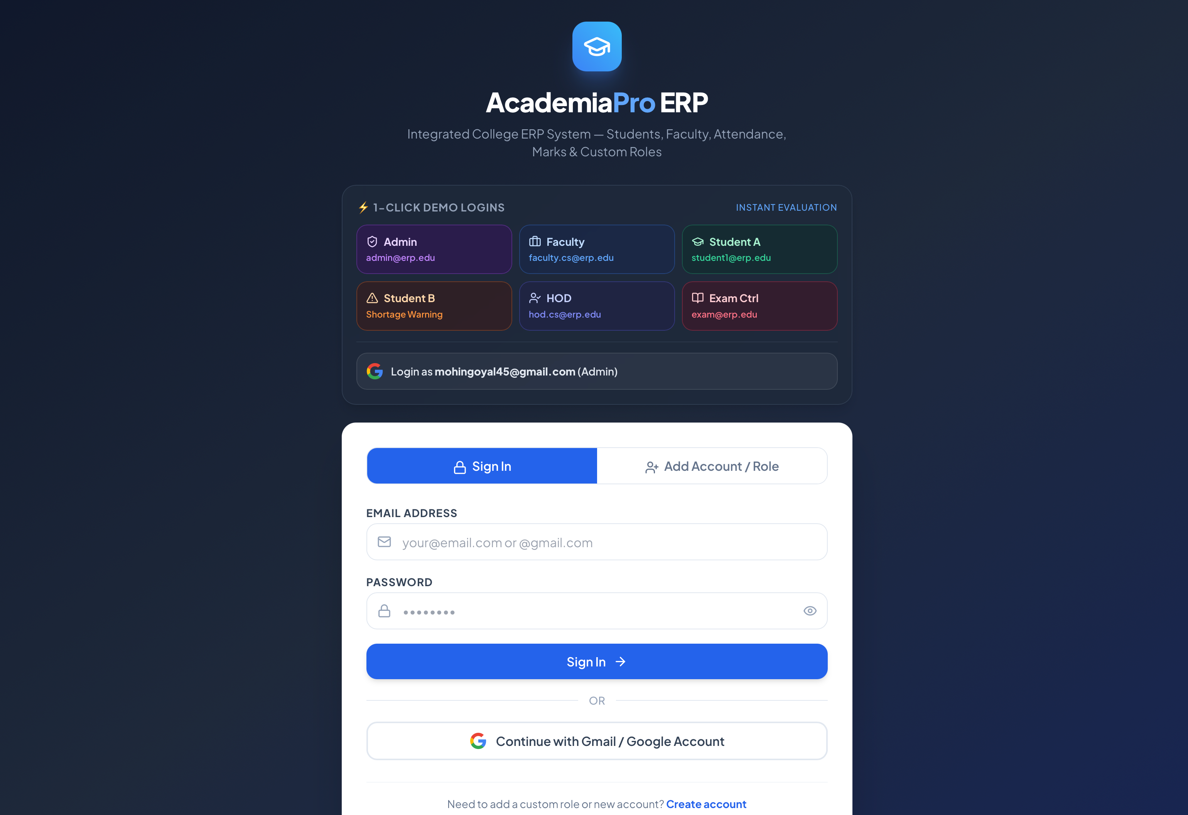 |  | 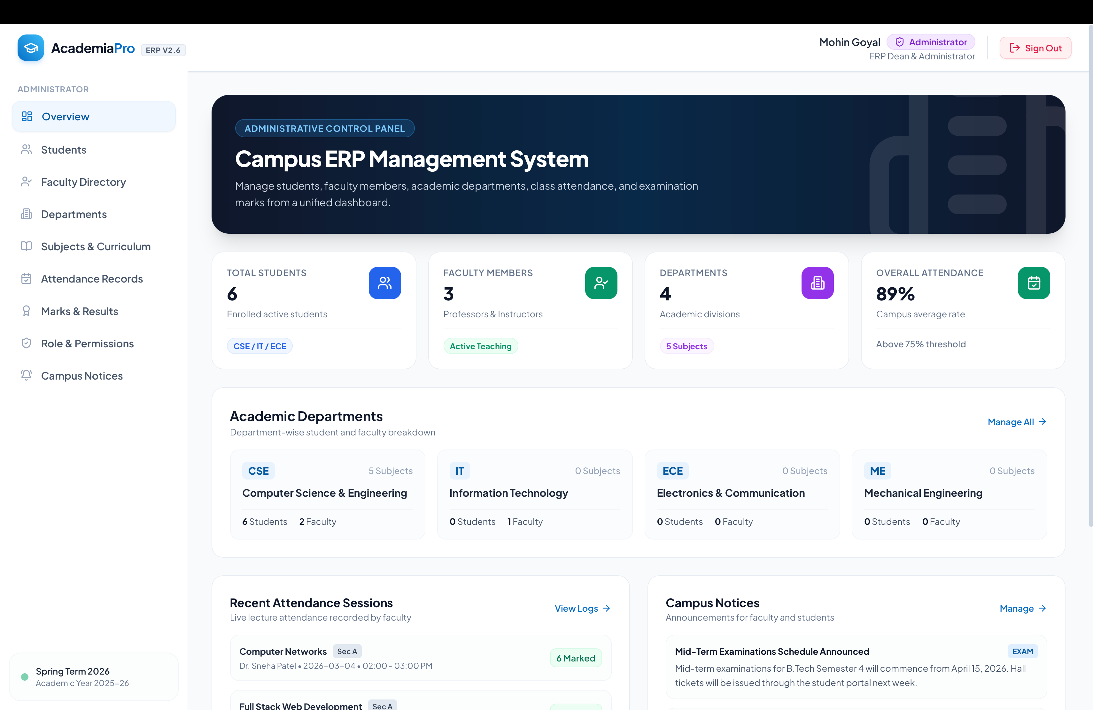
Figure 6.1: Login Page |  | Figure 6.2: Admin Dashboard
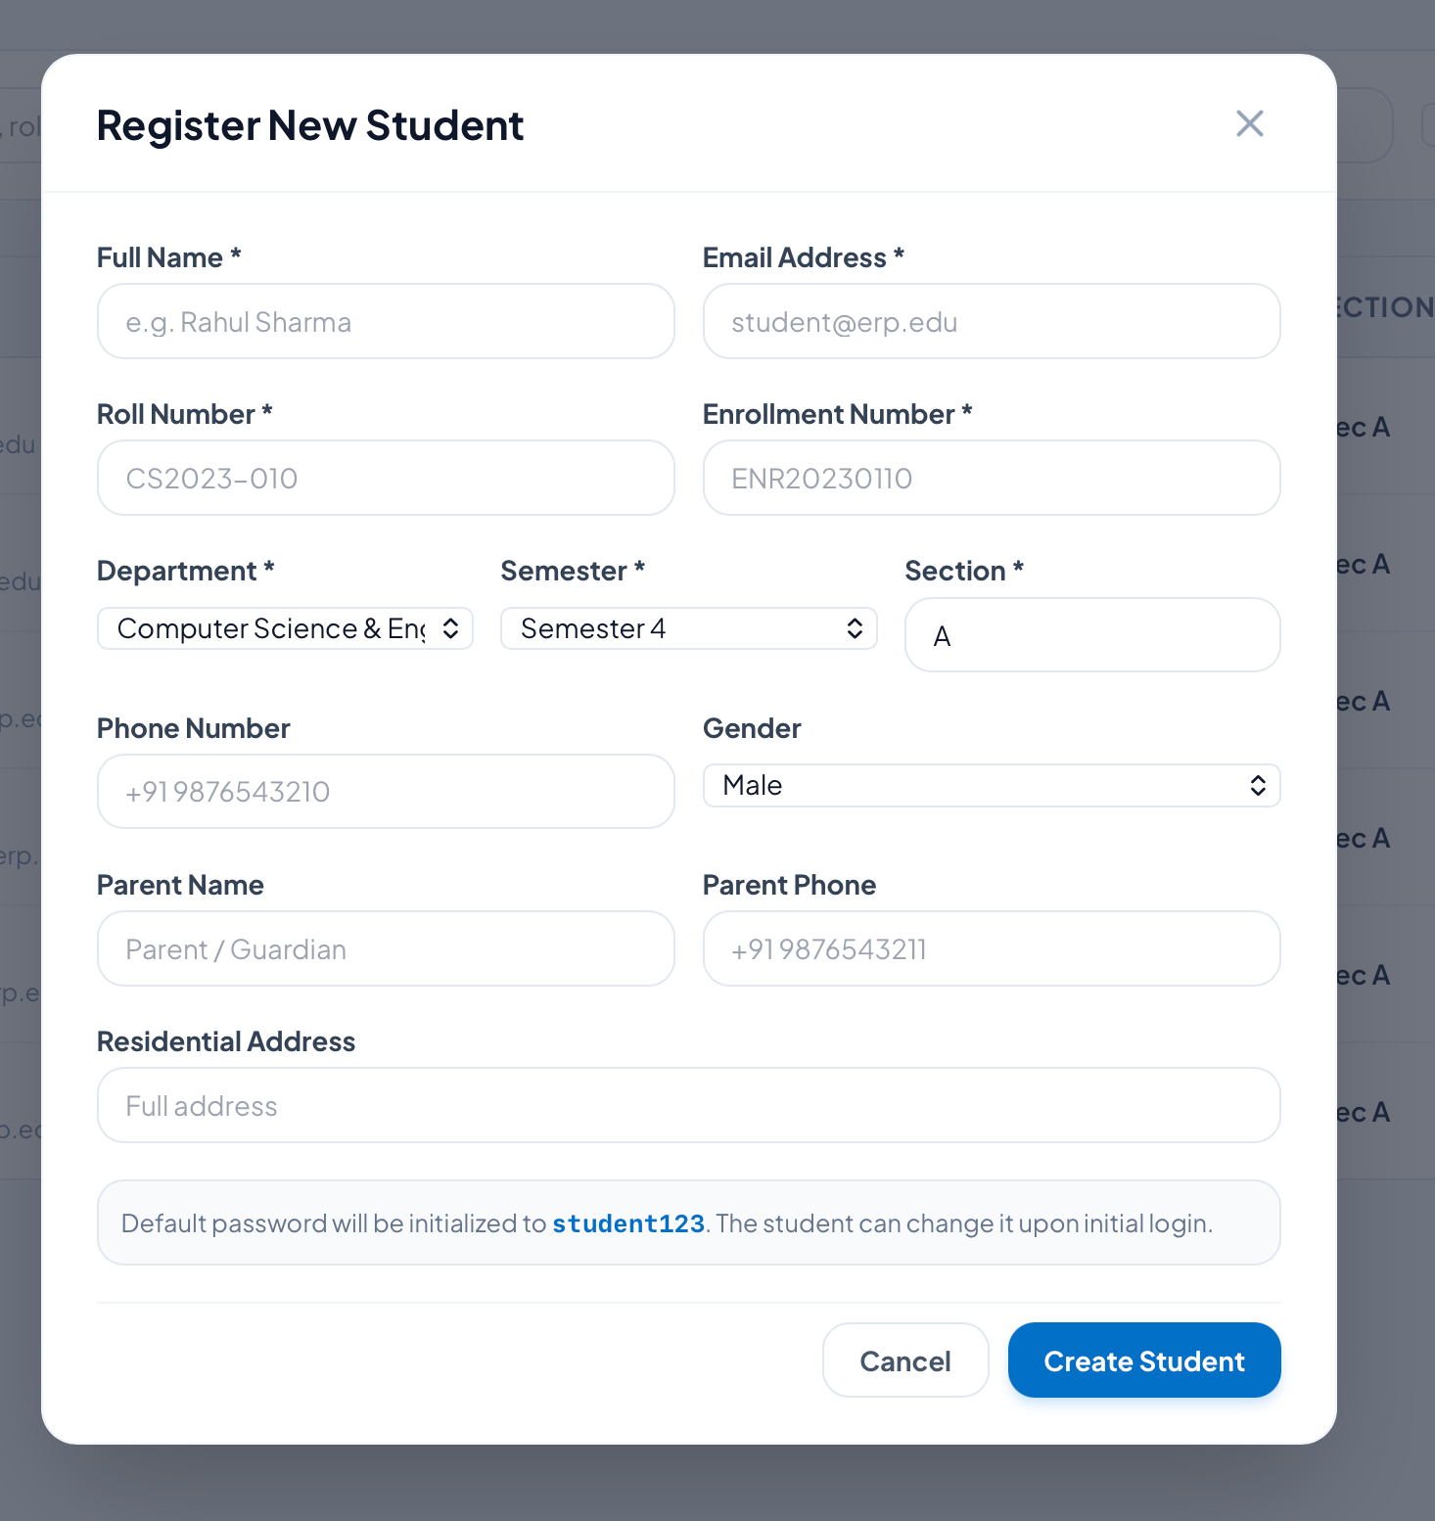 |  | 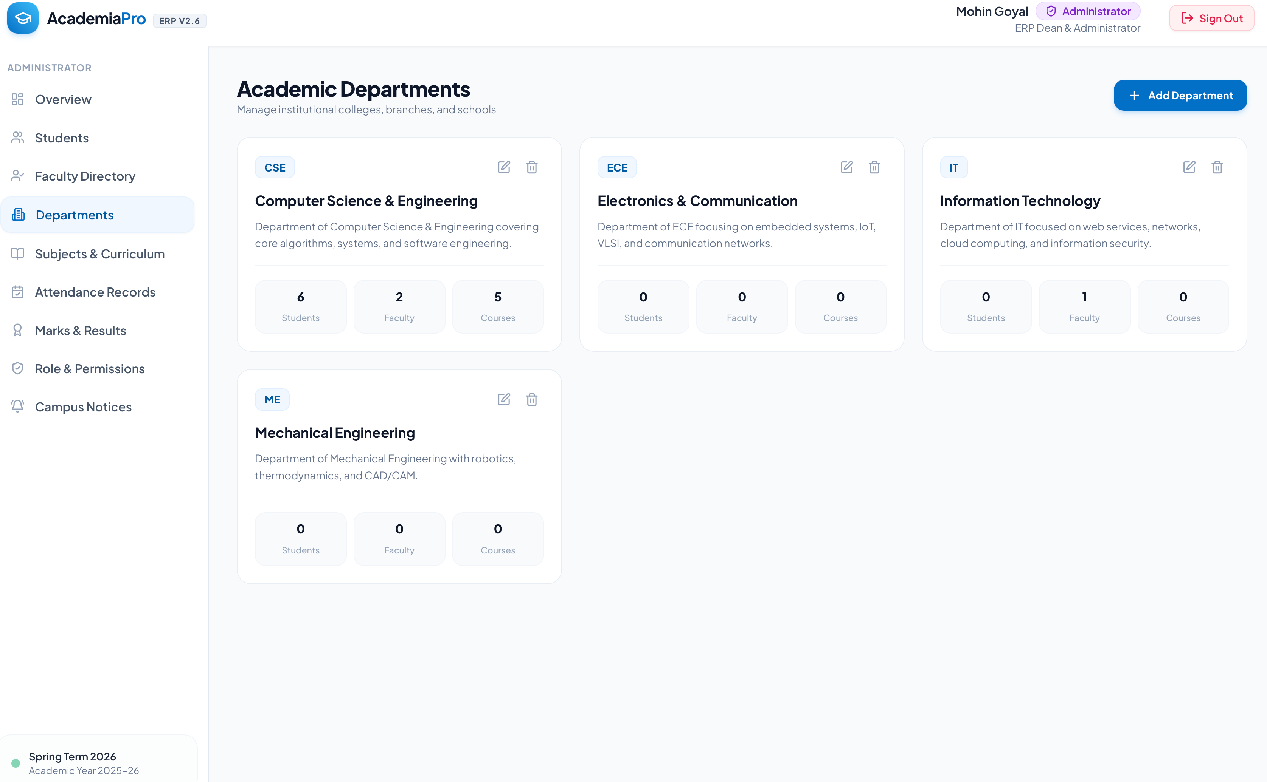
Figure 6.3: Add Student Form |  | Figure 6.4: Course Management
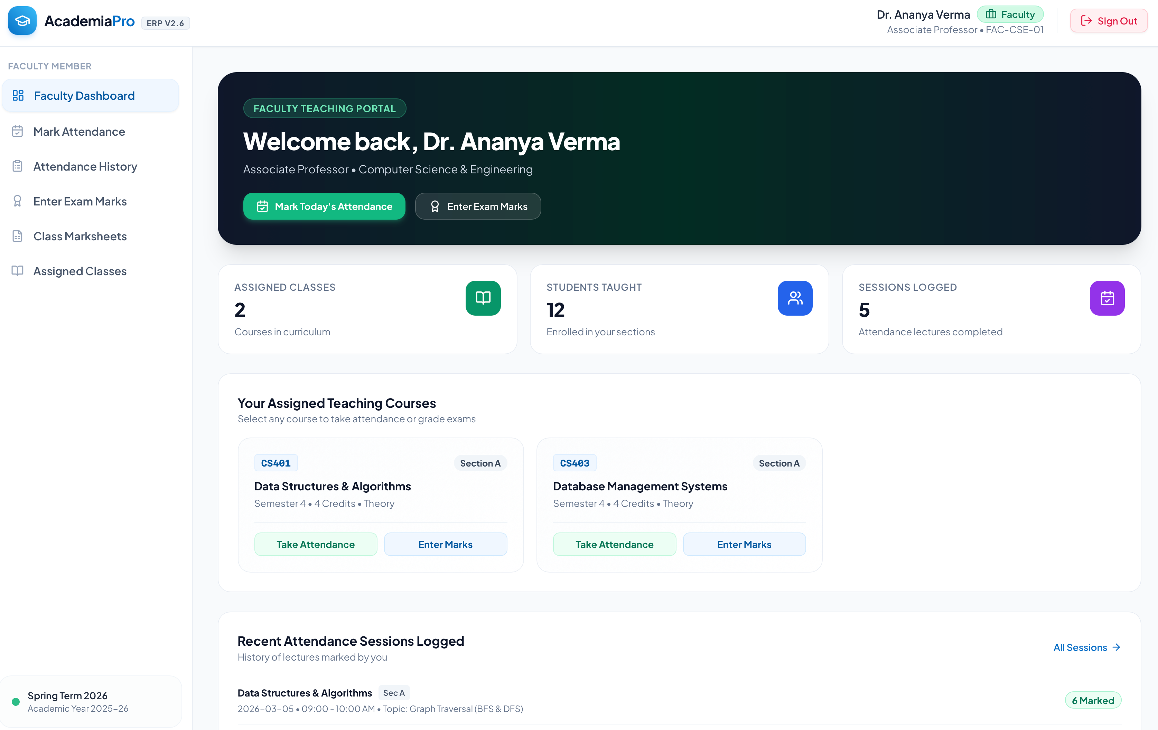 |  | 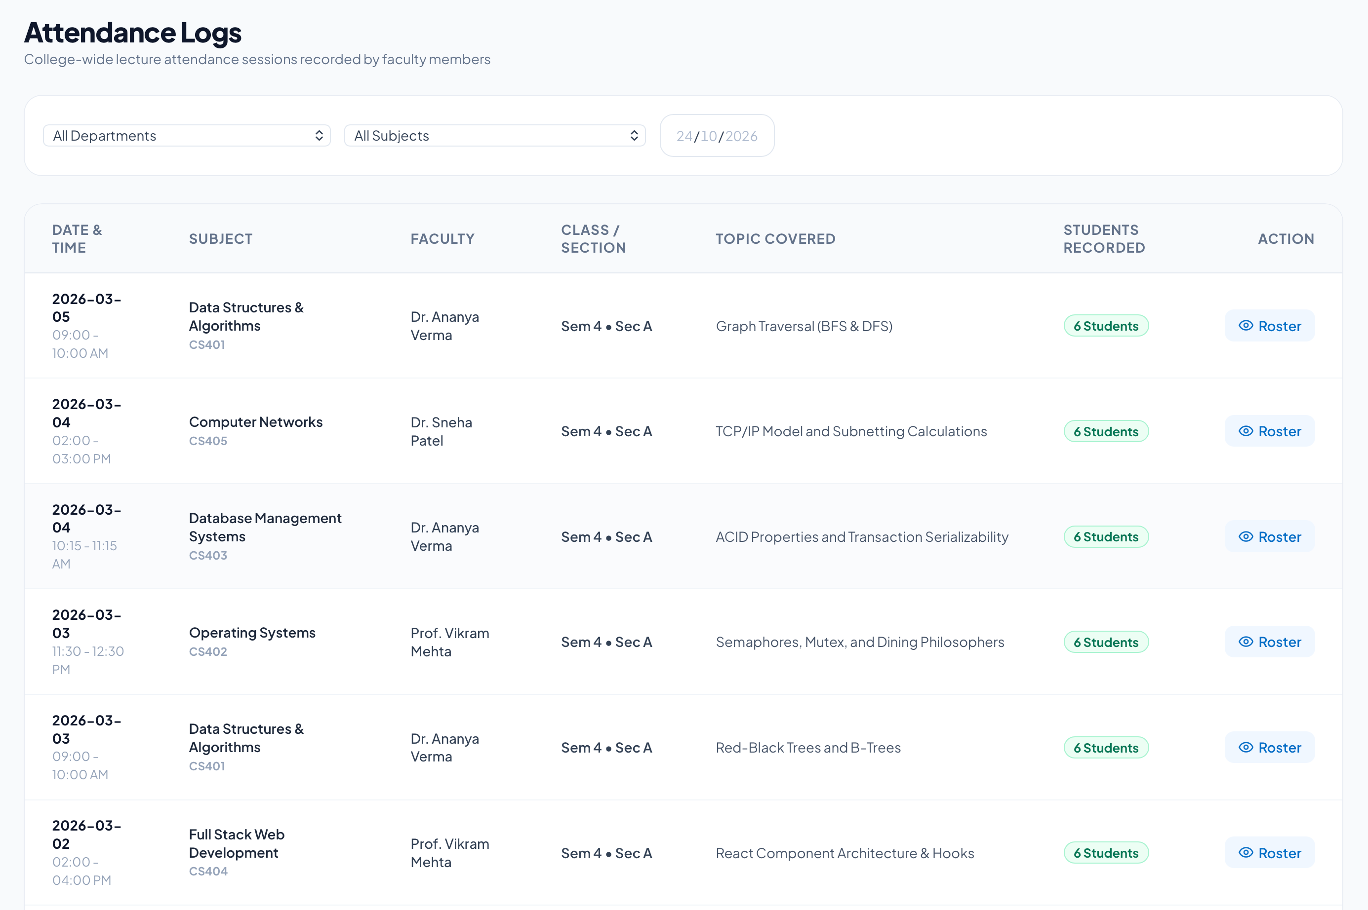
Figure 6.5: Faculty Dashboard |  | Figure 6.6: Attendance Marking
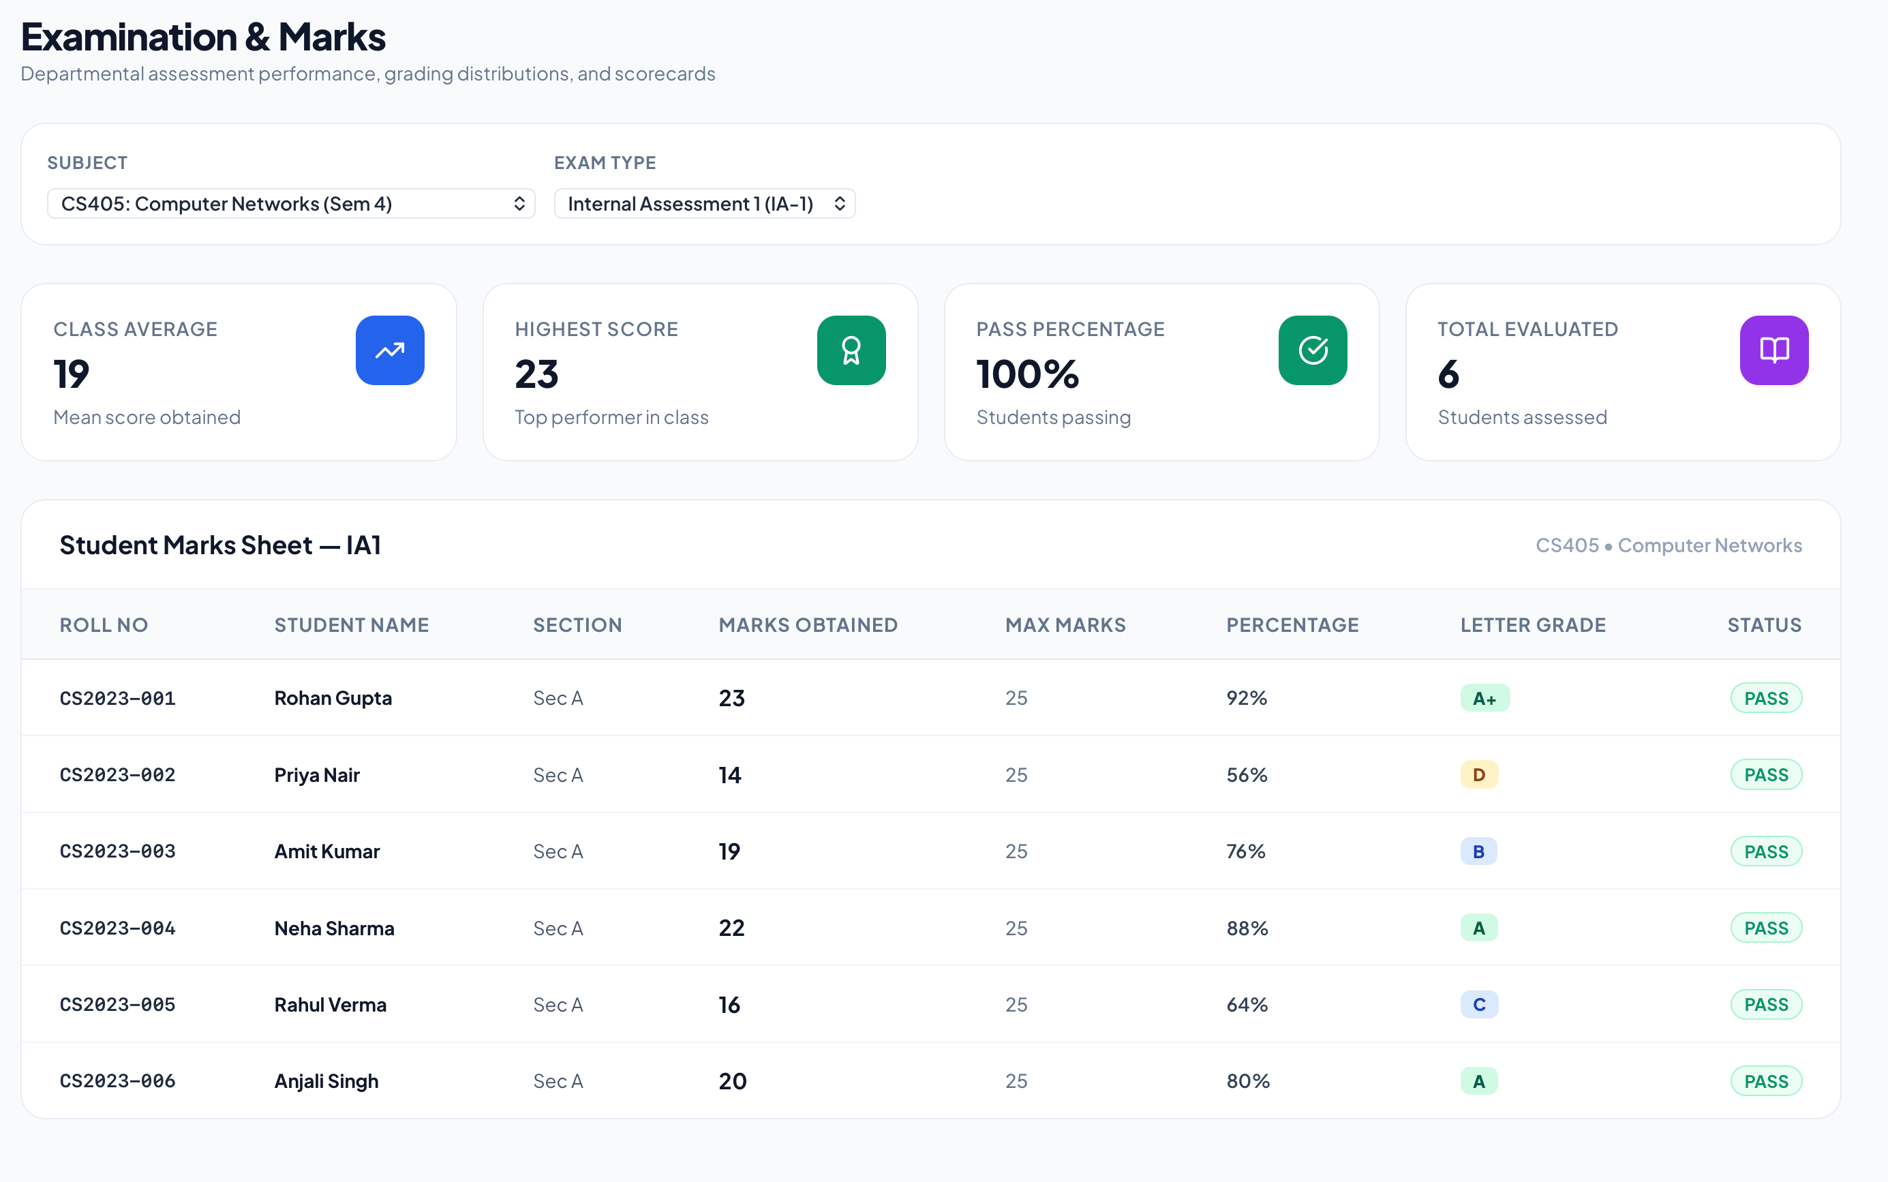 |  | 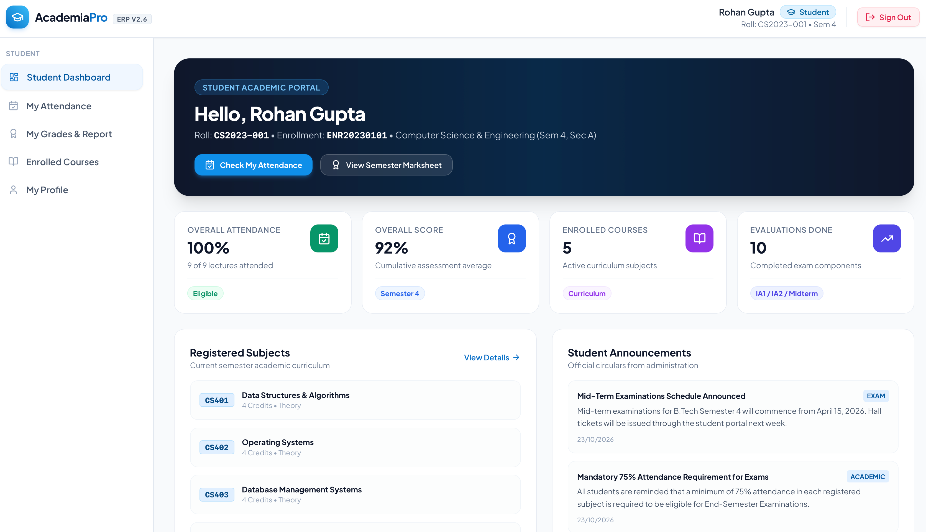
Figure 6.7: Marks Entry |  | Figure 6.8: Student Dashboard

7. OUTPUT SCREENS AND REPORTS
This chapter presents the screens and reports that the system produces from the stored data. Replace each highlighted box in Section 7.2 with a screenshot of the corresponding output from your application.

7.1 Output Descriptions
Output | Description
7.1 Student Attendance Report | Course-wise classes held, attended and percentage, with a warning below the required level.
7.2 Semester Result Card | Marks of every course with total, maximum and overall percentage calculated on the server.
7.3 Fee Status Report | Instalments with amount, due date, payment date and status, with totals paid and pending.
7.4 Weekly Timetable | Weekly grid of lectures with time, course and room, shown according to the user's role.
7.5 Notice Board | Announcements with newest first, filtered by the audience of the logged-in user.
7.6 Admin Summary Report | Department-wise attendance and fee collection and counts of users by role.

7.2 Screenshots
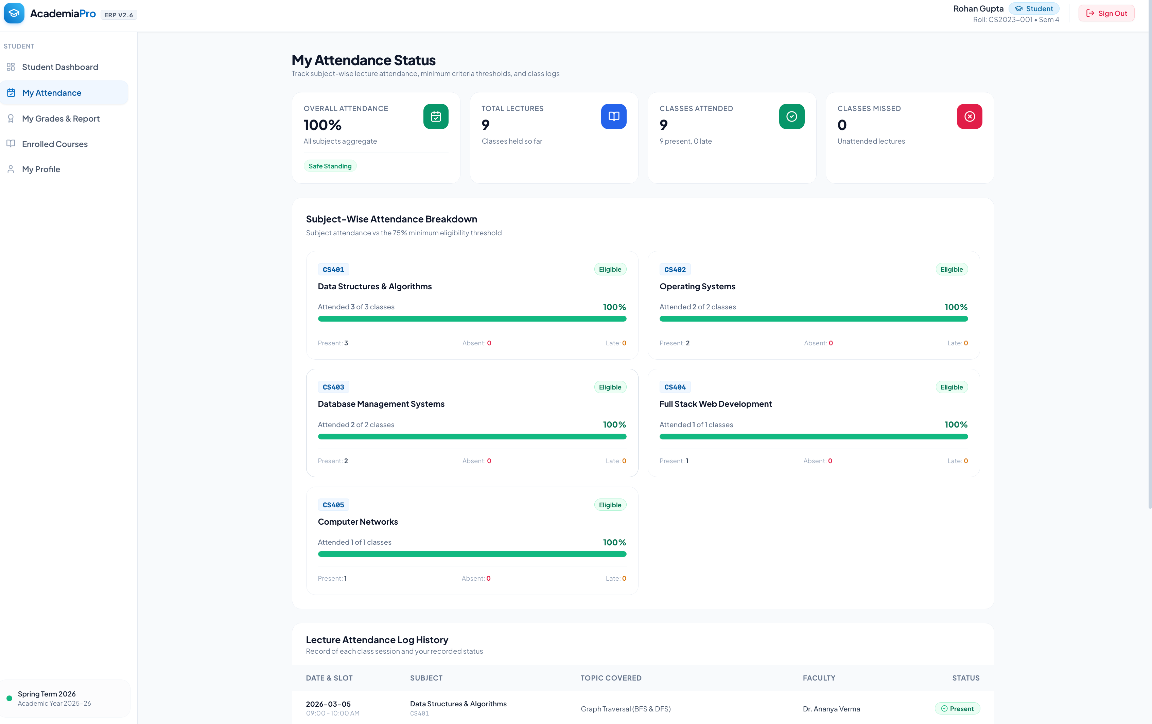 |  | 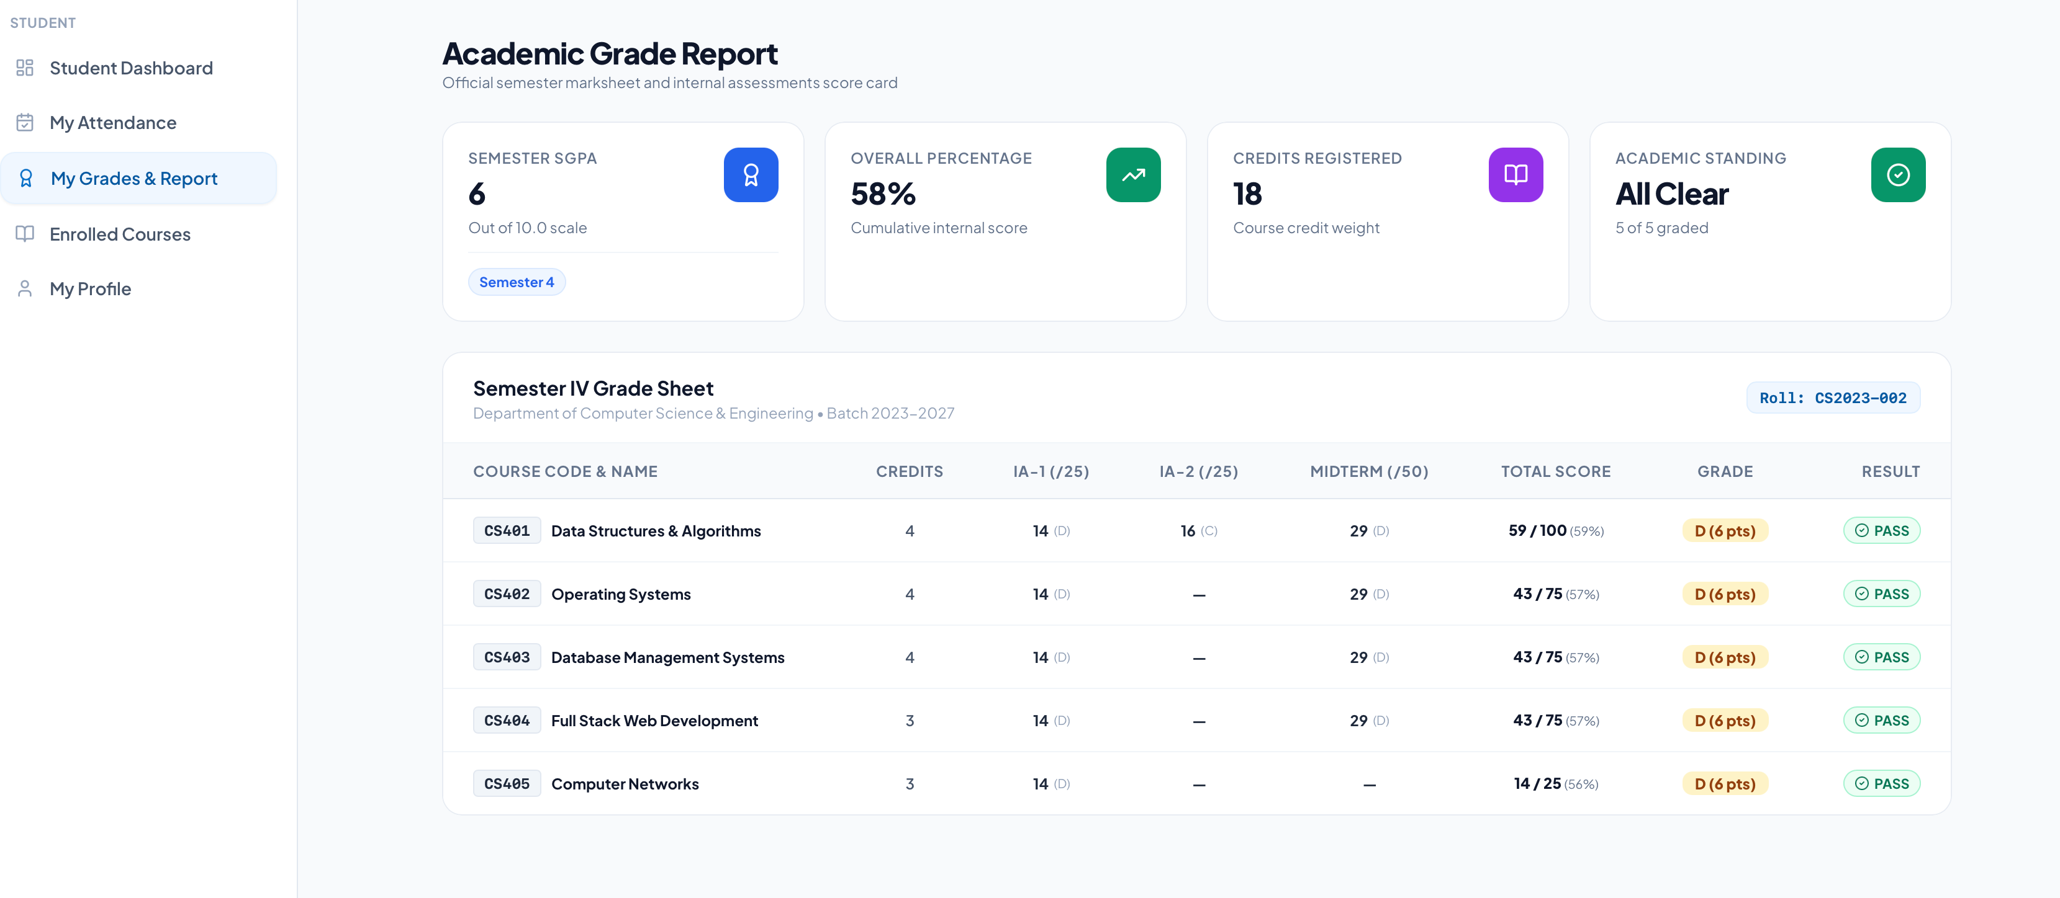
Figure 7.1: Student Attendance Report |  | Figure 7.2: Semester Result Card
[ Paste screenshot: Fee Status Report ] |  | [ Paste screenshot: Weekly Timetable ]
Figure 7.3: Fee Status Report |  | Figure 7.4: Weekly Timetable
[ Paste screenshot: Notice Board ] |  | [ Paste screenshot: Admin Summary Report ]
Figure 7.5: Notice Board |  | Figure 7.6: Admin Summary Report

8. LIMITATION & FUTURE SCOPE

8.1 Limitations
Like any project built within a limited time, the College ERP System has some limitations. They are listed here so that the present state of the work is stated honestly.
- No online payment: fee status is recorded by the administration, but students cannot pay through a payment gateway inside the system.
- No real-time updates: pages show new data when they are loaded or refreshed. Live notifications are not implemented.
- Limited reporting: reports are shown on screen and are not yet exportable to PDF or Excel.
- No email or SMS alerts: low attendance, new notices and fee reminders are not sent outside the portal.
- Single institution: the system is designed for one college and does not support several institutions in one installation.
- Basic analytics: charts and trend analysis are limited to simple summaries.
- No offline support: an internet connection is needed to use the application.
- Manual master data entry: bulk import of students and courses from files is not yet available.

8.2 Future Scope
The modular design makes it easy to extend the system. The following improvements are planned or possible.
- Payment gateway integration: allow online payment of fees with automatic receipts.
- Notifications: email, SMS and push notifications for attendance shortage, new notices, results and fee due dates.
- Export and import: download reports as PDF and Excel, and import student data from spreadsheets.
- Analytics dashboard: charts of performance trends, attendance patterns and fee collection for management.
- Additional modules: library, hostel, transport, placement and alumni modules.
- Mobile application: a React Native application for students and faculty.
- Biometric or QR attendance: faster and more reliable attendance capture.
- AI-based insights: prediction of students at risk of poor performance based on attendance and marks.
- Two-factor authentication: an extra layer of security for administrators.
- Multi-tenant support: one installation serving several colleges with separate data.

8.3 Conclusion
The College ERP System shows how the technologies learnt in Full Stack Development-II can be combined to solve a real problem. It centralises academic and administrative data, protects it with role-based access and gives students, faculty and administrators the information they need in a clear form. The project also gave practical experience in designing a database, building a REST API, creating a component-based interface and securing an application. With the future enhancements listed above, the system can grow into a complete campus management platform.

9. GITHUB URL
The complete source code of the project is available in the following public GitHub repository.
[ Paste your GitHub repository URL here, e.g. https://github.com/your-username/college-erp-system ]
The repository follows the structure shown below. Instructions for installing and running the project are given in the README file.
college-erp-system/
client/ React front end
src/components/
src/context/
src/pages/
src/services/
server/ Node and Express back end
config/
controllers/
middleware/
models/
routes/
server.js
README.md

9.1 Steps to Run the Project
- Clone the repository and open it in a code editor.
- In the server folder run npm install, create a .env file with PORT, MONGO_URI, JWT_SECRET and CLIENT_URL, and start the server with npm start.
- In the client folder run npm install and start the React application with npm start.
- Open http://localhost:3000 in a browser and log in with the administrator account.

10. PROJECT CODE
This chapter contains the important source files of the project with their file names. Code that comes from library templates, such as the default files created by create-react-app, is not included. The remaining files follow the same pattern and are available in the GitHub repository.

10.1 Backend Code (Node.js and Express.js)
server/server.js
const express = require("express");
const cors = require("cors");
const dotenv = require("dotenv");
const connectDB = require("./config/db");

dotenv.config();
connectDB();

const app = express();
app.use(cors({ origin: process.env.CLIENT_URL, credentials: true }));
app.use(express.json());

app.use("/api/auth", require("./routes/authRoutes"));
app.use("/api/students", require("./routes/studentRoutes"));
app.use("/api/courses", require("./routes/courseRoutes"));
app.use("/api/attendance", require("./routes/attendanceRoutes"));
app.use("/api/marks", require("./routes/marksRoutes"));
app.use("/api/fees", require("./routes/feeRoutes"));
app.use("/api/notices", require("./routes/noticeRoutes"));

app.use((err, req, res, next) => {
console.error(err.stack);
res.status(err.status || 500).json({ message: err.message || "Server error" });
});

const PORT = process.env.PORT || 5000;
app.listen(PORT, () => console.log("Server running on port " + PORT));
server/models/User.js
const mongoose = require("mongoose");
const bcrypt = require("bcryptjs");

const userSchema = new mongoose.Schema(
{
name: { type: String, required: true, trim: true },
email: { type: String, required: true, unique: true, lowercase: true },
password: { type: String, required: true, minlength: 6 },
role: { type: String, enum: ["admin", "faculty", "student"], default: "student" },
},
{ timestamps: true }
);

userSchema.pre("save", async function (next) {
if (!this.isModified("password")) return next();
this.password = await bcrypt.hash(this.password, 10);
next();
});

userSchema.methods.matchPassword = function (entered) {
return bcrypt.compare(entered, this.password);
};

module.exports = mongoose.model("User", userSchema);
server/models/Attendance.js
const mongoose = require("mongoose");

const attendanceSchema = new mongoose.Schema({
student: { type: mongoose.Schema.Types.ObjectId, ref: "Student", required: true },
course: { type: mongoose.Schema.Types.ObjectId, ref: "Course", required: true },
date: { type: Date, required: true },
status: { type: String, enum: ["present", "absent", "leave"], required: true },
markedBy: { type: mongoose.Schema.Types.ObjectId, ref: "User" },
});

attendanceSchema.index({ student: 1, course: 1, date: 1 }, { unique: true });

module.exports = mongoose.model("Attendance", attendanceSchema);
server/middleware/auth.js
const jwt = require("jsonwebtoken");
const User = require("../models/User");

exports.protect = async (req, res, next) => {
try {
const header = req.headers.authorization || "";
if (!header.startsWith("Bearer ")) {
return res.status(401).json({ message: "Not authorised, token missing" });
}
const decoded = jwt.verify(header.split(" ")[1], process.env.JWT_SECRET);
req.user = await User.findById(decoded.id).select("-password");
if (!req.user) return res.status(401).json({ message: "User no longer exists" });
next();
} catch (err) {
res.status(401).json({ message: "Token invalid or expired" });
}
};

exports.authorize = (...roles) => (req, res, next) => {
if (!roles.includes(req.user.role)) {
return res.status(403).json({ message: "Access denied for role: " + req.user.role });
}
next();
};
server/controllers/authController.js
const jwt = require("jsonwebtoken");
const User = require("../models/User");

const signToken = (id) =>
jwt.sign({ id }, process.env.JWT_SECRET, { expiresIn: "1d" });

exports.register = async (req, res) => {
const { name, email, password, role } = req.body;
const exists = await User.findOne({ email });
if (exists) return res.status(400).json({ message: "Email already registered" });
const user = await User.create({ name, email, password, role });
res.status(201).json({
_id: user._id, name: user.name, email: user.email, role: user.role,
token: signToken(user._id),
});
};

exports.login = async (req, res) => {
const { email, password } = req.body;
const user = await User.findOne({ email });
if (!user || !(await user.matchPassword(password))) {
return res.status(401).json({ message: "Invalid email or password" });
}
res.json({
_id: user._id, name: user.name, email: user.email, role: user.role,
token: signToken(user._id),
});
};

exports.me = async (req, res) => res.json(req.user);
server/controllers/attendanceController.js
const Attendance = require("../models/Attendance");

exports.markAttendance = async (req, res) => {
const { course, date, records } = req.body; // records: [{ student, status }]
const ops = records.map((r) => ({
updateOne: {
filter: { student: r.student, course, date },
update: { $set: { status: r.status, markedBy: req.user._id } },
upsert: true,
},
}));
await Attendance.bulkWrite(ops);
res.status(201).json({ message: "Attendance saved", count: records.length });
};

exports.getStudentSummary = async (req, res) => {
const summary = await Attendance.aggregate([
{ $match: { student: new (require("mongoose").Types.ObjectId)(req.params.studentId) } },
{
$group: {
_id: "$course",
total: { $sum: 1 },
present: { $sum: { $cond: [{ $eq: ["$status", "present"] }, 1, 0] } },
},
},
{ $addFields: { percentage: { $multiply: [{ $divide: ["$present", "$total"] }, 100] } } },
]);
res.json(summary);
};
server/controllers/marksController.js
const Marks = require("../models/Marks");

exports.addMarks = async (req, res) => {
const { student, course, examType, maxMarks, obtained } = req.body;
if (obtained > maxMarks) {
return res.status(400).json({ message: "Obtained marks cannot exceed maximum" });
}
const entry = await Marks.findOneAndUpdate(
{ student, course, examType },
{ maxMarks, obtained, enteredBy: req.user._id },
{ new: true, upsert: true }
);
res.status(201).json(entry);
};

exports.getResult = async (req, res) => {
const rows = await Marks.find({ student: req.params.studentId }).populate("course", "code title credits");
const total = rows.reduce((s, r) => s + r.obtained, 0);
const max = rows.reduce((s, r) => s + r.maxMarks, 0);
res.json({ rows, total, max, percentage: max ? ((total / max) * 100).toFixed(2) : 0 });
};
server/routes/authRoutes.js
const router = require("express").Router();
const { register, login, me } = require("../controllers/authController");
const { protect, authorize } = require("../middleware/auth");

router.post("/register", protect, authorize("admin"), register);
router.post("/login", login);
router.get("/me", protect, me);

module.exports = router;

10.2 Frontend Code (React.js)
client/src/context/AuthContext.js
import { createContext, useContext, useState } from "react";
import api from "../services/api";

const AuthContext = createContext();

export const AuthProvider = ({ children }) => {
const [user, setUser] = useState(() => {
const stored = localStorage.getItem("erpUser");
return stored ? JSON.parse(stored) : null;
});

const login = async (email, password) => {
const { data } = await api.post("/auth/login", { email, password });
localStorage.setItem("erpUser", JSON.stringify(data));
setUser(data);
return data;
};

const logout = () => {
localStorage.removeItem("erpUser");
setUser(null);
};

return (
<AuthContext.Provider value={{ user, login, logout }}>
{children}
</AuthContext.Provider>
);
};

export const useAuth = () => useContext(AuthContext);
client/src/App.js
import { BrowserRouter, Routes, Route, Navigate } from "react-router-dom";
import { AuthProvider } from "./context/AuthContext";
import ProtectedRoute from "./components/ProtectedRoute";
import Login from "./pages/Login";
import AdminDashboard from "./pages/AdminDashboard";
import FacultyDashboard from "./pages/FacultyDashboard";
import StudentDashboard from "./pages/StudentDashboard";

export default function App() {
return (
<AuthProvider>
<BrowserRouter>
<Routes>
<Route path="/login" element={<Login />} />
<Route path="/admin/*" element={<ProtectedRoute roles={["admin"]}><AdminDashboard /></ProtectedRoute>} />
<Route path="/faculty/*" element={<ProtectedRoute roles={["faculty"]}><FacultyDashboard /></ProtectedRoute>} />
<Route path="/student/*" element={<ProtectedRoute roles={["student"]}><StudentDashboard /></ProtectedRoute>} />
<Route path="*" element={<Navigate to="/login" replace />} />
</Routes>
</BrowserRouter>
</AuthProvider>
);
}
client/src/pages/Login.js
import { useState } from "react";
import { useNavigate } from "react-router-dom";
import { useAuth } from "../context/AuthContext";

export default function Login() {
const { login } = useAuth();
const navigate = useNavigate();
const [form, setForm] = useState({ email: "", password: "" });
const [error, setError] = useState("");

const handleSubmit = async (e) => {
e.preventDefault();
try {
const user = await login(form.email, form.password);
navigate("/" + user.role);
} catch (err) {
setError(err.response?.data?.message || "Login failed");
}
};

return (
<form className="login-card" onSubmit={handleSubmit}>
<h2>College ERP Login</h2>
{error && <p className="error">{error}</p>}
<input type="email" placeholder="Email" required
value={form.email} onChange={(e) => setForm({ ...form, email: e.target.value })} />
<input type="password" placeholder="Password" required
value={form.password} onChange={(e) => setForm({ ...form, password: e.target.value })} />
<button type="submit">Sign In</button>
</form>
);
}

11. REFERENCES

Axios. (n.d.). Axios documentation. Retrieved October 2026, from https://axios-http.com/docs/intro
Express.js. (n.d.). Express: Fast, unopinionated, minimalist web framework for Node.js. Retrieved October 2026, from https://expressjs.com/
Fielding, R. T. (2000). Architectural styles and the design of network-based software architectures (Doctoral dissertation). University of California, Irvine.
Jones, M., Bradley, J., & Sakimura, N. (2015). JSON Web Token (JWT). RFC 7519. Internet Engineering Task Force.
Meta Platforms. (n.d.). React documentation. Retrieved October 2026, from https://react.dev/
MongoDB Inc. (n.d.). MongoDB manual. Retrieved October 2026, from https://www.mongodb.com/docs/manual/
Mongoose. (n.d.). Mongoose documentation. Retrieved October 2026, from https://mongoosejs.com/docs/
Node.js Foundation. (n.d.). Node.js documentation. Retrieved October 2026, from https://nodejs.org/docs/latest/api/
OWASP Foundation. (n.d.). OWASP Top Ten. Retrieved October 2026, from https://owasp.org/www-project-top-ten/
Provos, N., & Mazieres, D. (1999). A future-adaptable password scheme. Proceedings of the USENIX Annual Technical Conference.
React Router. (n.d.). React Router documentation. Retrieved October 2026, from https://reactrouter.com/

12. BIBLIOGRAPHY

Banks, A., & Porcello, E. (2020). Learning React: Modern patterns for developing React apps (2nd ed.). O'Reilly Media.
Cantelon, M., Harter, M., Holowaychuk, T. J., & Rajlich, N. (2014). Node.js in action. Manning Publications.
Chodorow, K. (2013). MongoDB: The definitive guide (2nd ed.). O'Reilly Media.
Elmasri, R., & Navathe, S. B. (2016). Fundamentals of database systems (7th ed.). Pearson Education.
Flanagan, D. (2020). JavaScript: The definitive guide (7th ed.). O'Reilly Media.
Sommerville, I. (2015). Software engineering (10th ed.). Pearson Education.

