**Week 4 Spring Rest Hands-On**

**1.Create a Spring Web Project using Maven**

Code:

SpringLearnApplication.java

package com.cognizant.springlearn;  
  
import org.springframework.boot.SpringApplication;  
import org.springframework.boot.autoconfigure.SpringBootApplication;  
  
@SpringBootApplication  
public class SpringLearnApplication {  
 public static void main(String[] args) {  
 System.out.println("SpringLearnApplication is starting...");  
 SpringApplication.run(SpringLearnApplication.class, args);  
 System.out.println("SpringLearnApplication has started.");  
 }  
}

pom.xml

<project xmlns="http://maven.apache.org/POM/4.0.0"

xmlns:xsi="http://www.w3.org/2001/XMLSchema-instance"

xsi:schemaLocation="http://maven.apache.org/POM/4.0.0

http://maven.apache.org/xsd/maven-4.0.0.xsd">

<modelVersion>4.0.0</modelVersion>

<groupId>com.cognizant</groupId>

<artifactId>spring-learn</artifactId>

<version>0.0.1-SNAPSHOT</version>

<packaging>jar</packaging>

<name>spring-learn</name>

<description>Demo project for Spring Boot</description>

<parent>

<groupId>org.springframework.boot</groupId>

<artifactId>spring-boot-starter-parent</artifactId>

<version>3.2.0</version>

<relativePath/> <!-- lookup parent from repository -->

</parent>

<properties>

<java.version>17</java.version>

</properties>

<dependencies>

<dependency>

<groupId>org.springframework.boot</groupId>

<artifactId>spring-boot-starter-web</artifactId>

</dependency>

<dependency>

<groupId>org.springframework.boot</groupId>

<artifactId>spring-boot-devtools</artifactId>

<scope>runtime</scope>

<optional>true</optional>

</dependency>

<dependency>

<groupId>org.springframework.boot</groupId>

<artifactId>spring-boot-starter-test</artifactId>

<scope>test</scope>

</dependency>

</dependencies>

<build>

<plugins>

<plugin>

<groupId>org.springframework.boot</groupId>

<artifactId>spring-boot-maven-plugin</artifactId>

</plugin>

</plugins>

</build>

</project>

Output:

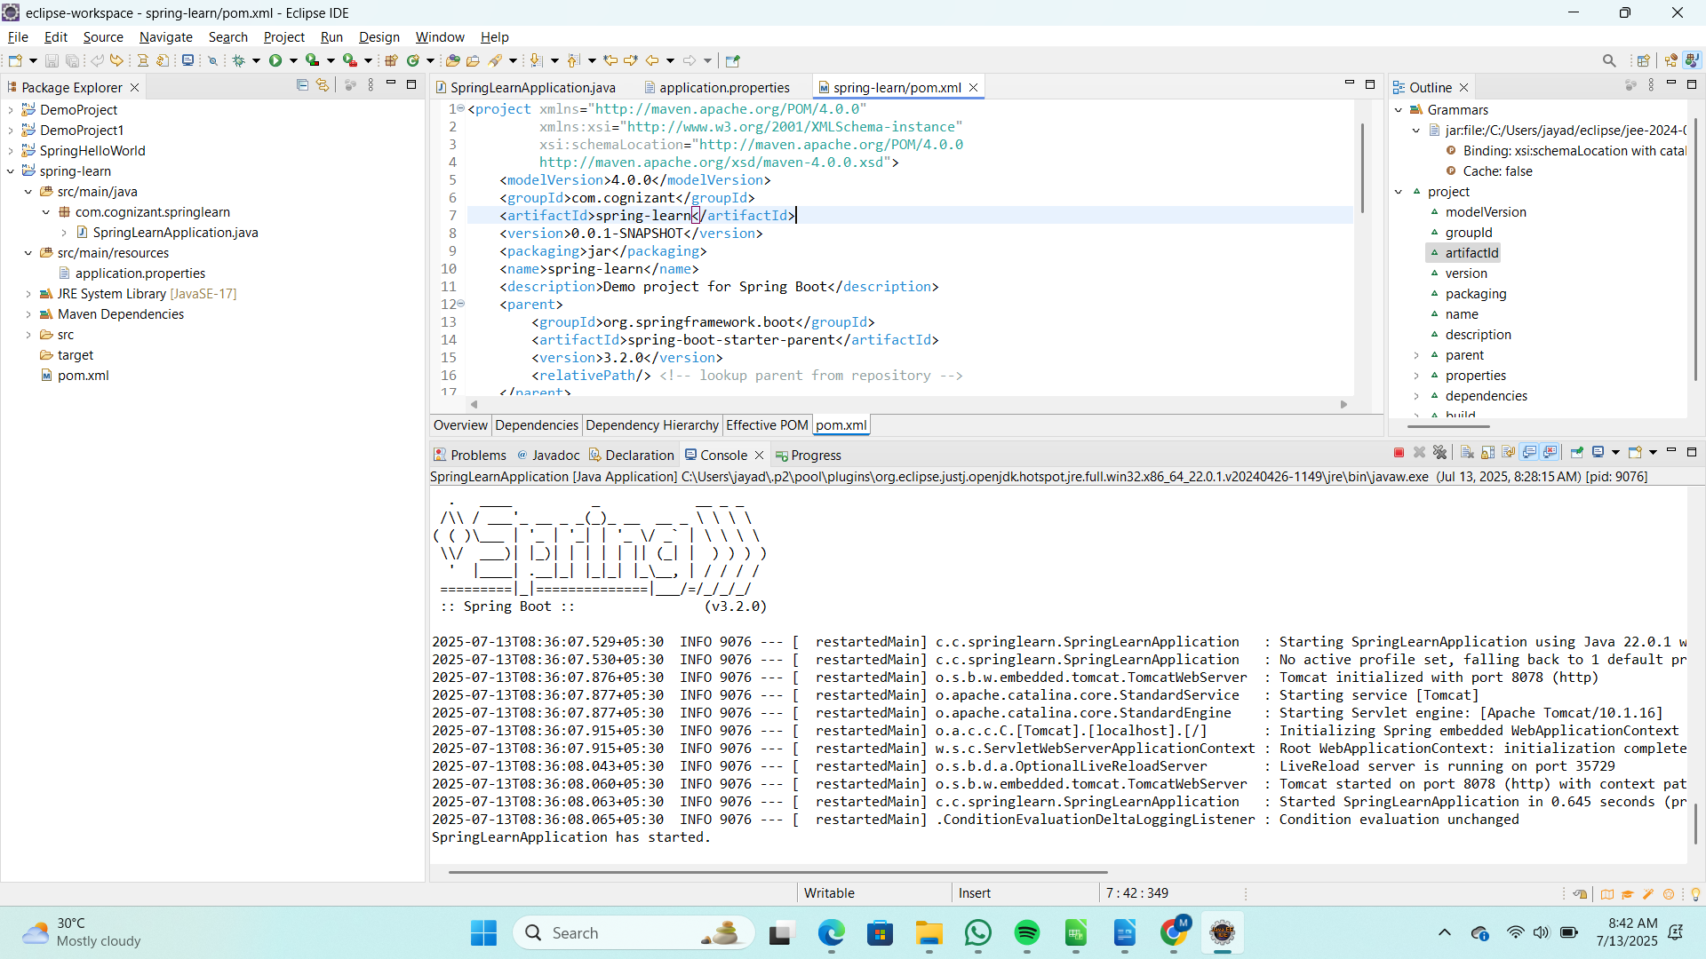  
  
**2.Spring Core – Load SimpleDateFormat from Spring Configuration XML**

Code:

SpringLearnApplication.java

package com.cognizant.springlearn;  
  
import org.springframework.boot.SpringApplication;  
import org.springframework.boot.autoconfigure.SpringBootApplication;  
import org.springframework.context.ApplicationContext;  
import org.springframework.context.support.ClassPathXmlApplicationContext;  
  
import java.text.SimpleDateFormat;  
import java.util.Date;  
  
@SpringBootApplication  
public class SpringLearnApplication {  
  
 public static void main(String[] args) throws Exception {  
 System.out.println("SpringLearnApplication is starting...");  
 SpringApplication.run(SpringLearnApplication.class, args);  
 System.out.println("SpringLearnApplication has started.");  
 displayDate();  
 }  
  
 public static void displayDate() throws Exception {  
 ApplicationContext context = new ClassPathXmlApplicationContext("date-format.xml");  
 SimpleDateFormat format = context.getBean("dateFormat", SimpleDateFormat.class);  
 Date parsedDate = format.parse("31/12/2018");  
 System.out.println("Parsed Date: " + parsedDate);  
 }  
}

pom.xml

<project xmlns="http://maven.apache.org/POM/4.0.0"

xmlns:xsi="http://www.w3.org/2001/XMLSchema-instance"

xsi:schemaLocation="http://maven.apache.org/POM/4.0.0

http://maven.apache.org/xsd/maven-4.0.0.xsd">

<modelVersion>4.0.0</modelVersion>

<groupId>com.cognizant</groupId>

<artifactId>spring-learn</artifactId>

<version>0.0.1-SNAPSHOT</version>

<packaging>jar</packaging>

<name>spring-learn</name>

<description>Demo project for Spring Boot and Spring Core</description>

<parent>

<groupId>org.springframework.boot</groupId>

<artifactId>spring-boot-starter-parent</artifactId>

<version>3.2.0</version>

<relativePath/>

</parent>

<properties>

<java.version>17</java.version>

</properties>

<dependencies>

<dependency>

<groupId>org.springframework.boot</groupId>

<artifactId>spring-boot-starter</artifactId>

</dependency>

<dependency>

<groupId>org.springframework.boot</groupId>

<artifactId>spring-boot-devtools</artifactId>

<scope>runtime</scope>

<optional>true</optional>

</dependency>

<dependency>

<groupId>org.springframework</groupId>

<artifactId>spring-context</artifactId>

</dependency>

</dependencies>

<build>

<plugins>

<plugin>

<groupId>org.springframework.boot</groupId>

<artifactId>spring-boot-maven-plugin</artifactId>

</plugin>

</plugins>

</build>

</project>

Output:

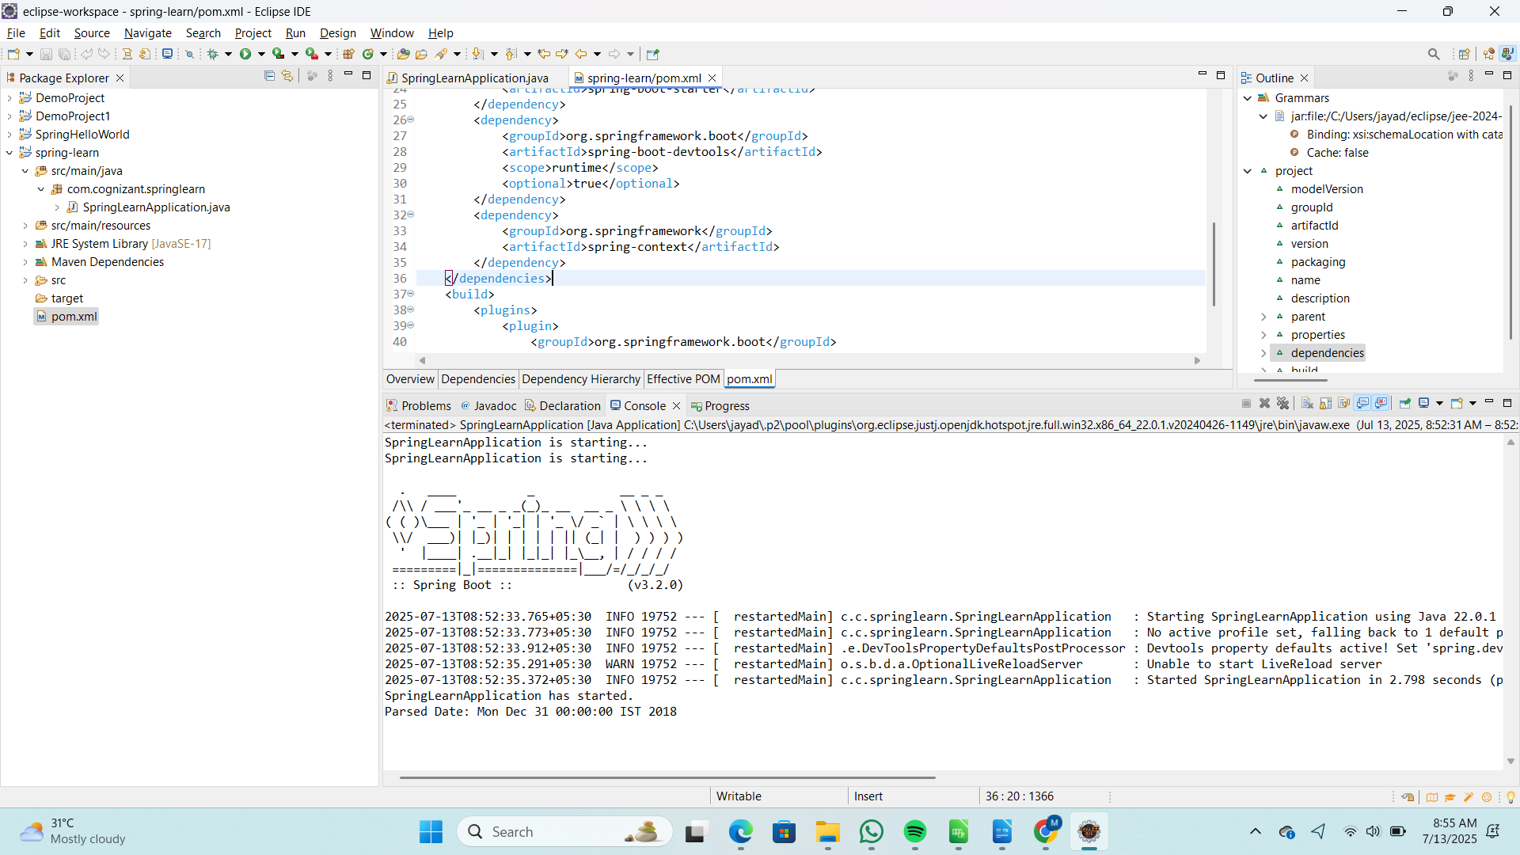  
  
**3.Hello World RESTful Web Service**

Code:

SpringLearnApplication.java

package com.cognizant.spring_learn;  
  
import org.springframework.boot.SpringApplication;  
import org.springframework.boot.autoconfigure.SpringBootApplication;  
  
@SpringBootApplication  
public class SpringLearnApplication {  
  
 public static void main(String[] args) {  
 SpringApplication.run(SpringLearnApplication.class, args);  
 }  
  
}

HelloController.java

**package** com.cognizant.spring_learn.controller;

**import** org.slf4j.Logger;

**import** org.slf4j.LoggerFactory;

**import** org.springframework.web.bind.annotation.GetMapping;

**import** org.springframework.web.bind.annotation.RestController;

@RestController

**public** **class** HelloController {

**private** **static** **final** Logger ***LOGGER*** = LoggerFactory.*getLogger*(HelloController.**class**);

@GetMapping("/hello")

**public** String sayHello() {

***LOGGER***.info("START: sayHello()");

String message = "Hello World!!";

***LOGGER***.info("END: sayHello()");

**return** message;

}

}

Output:

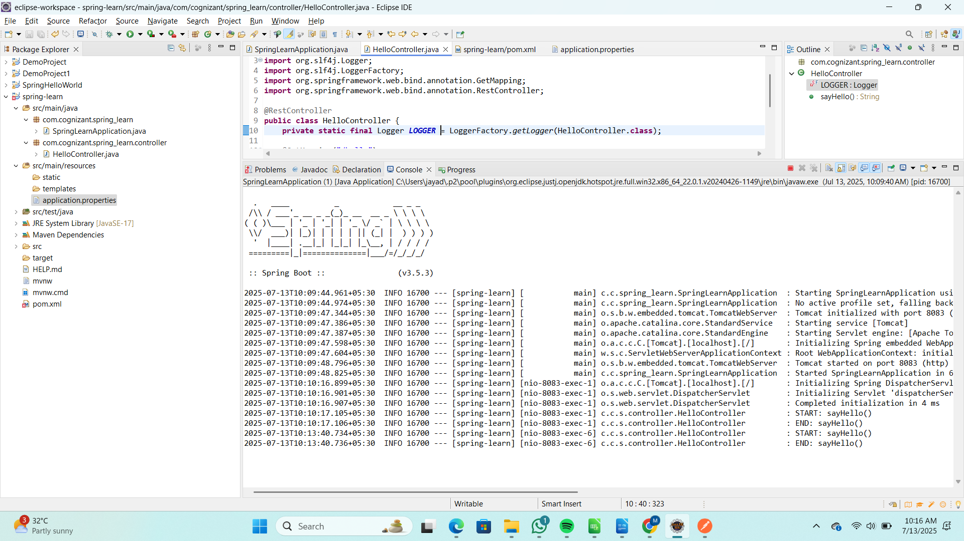  
  
  
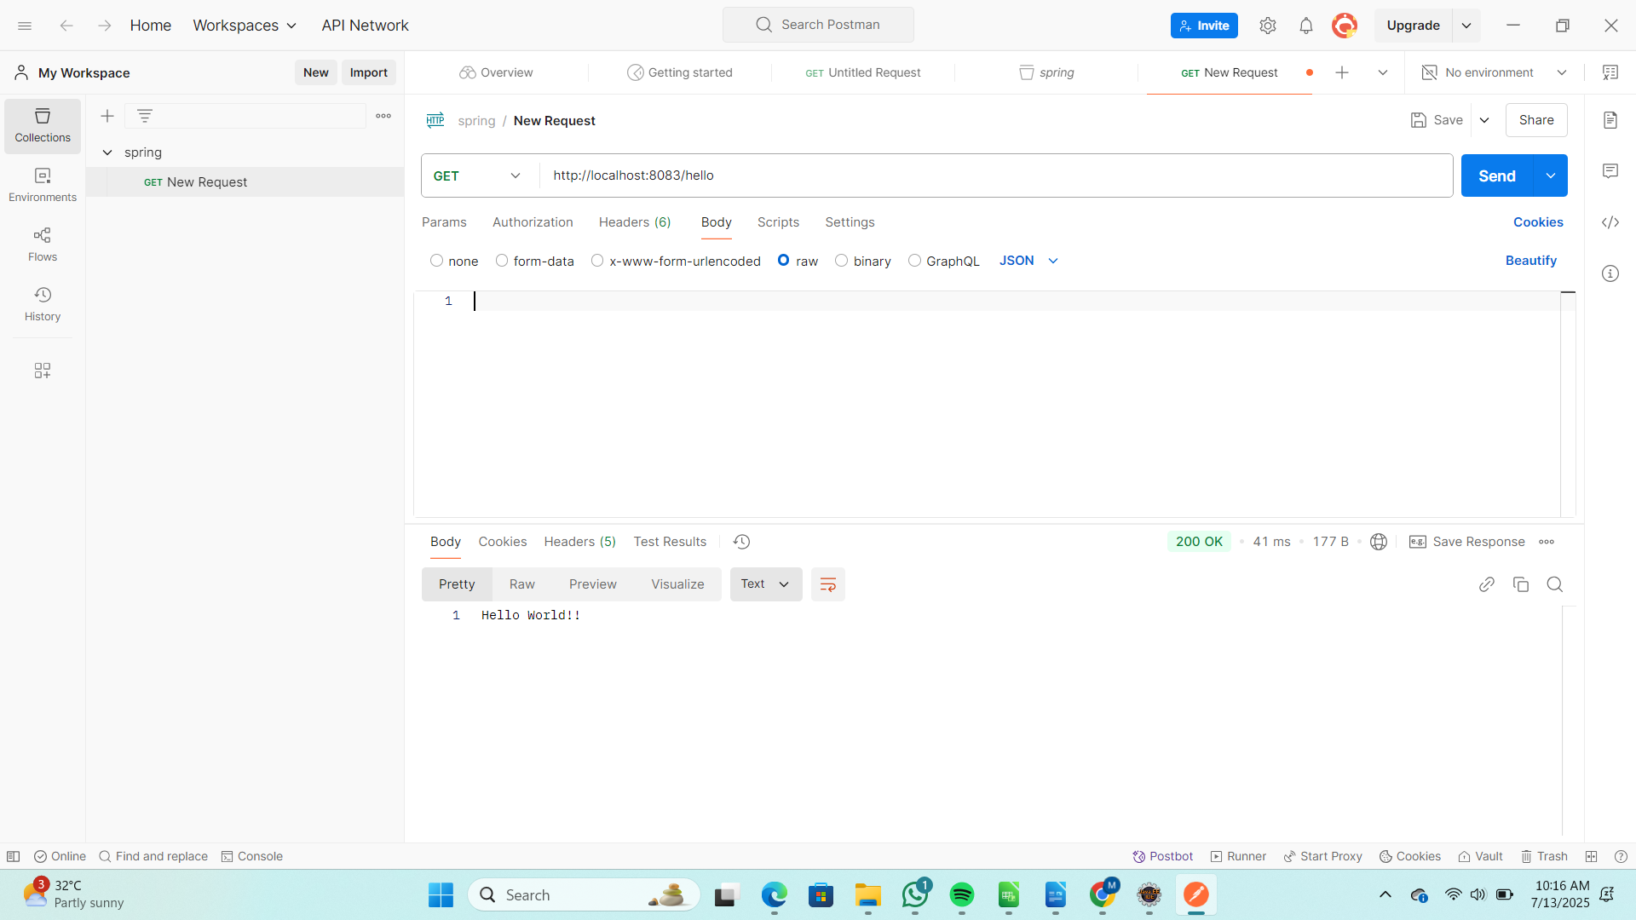

**4. Country Web Service**

Code:

SpringLearnApplication.java

package com.cognizant.spring_learn;  
  
import org.springframework.boot.SpringApplication;  
import org.springframework.boot.autoconfigure.SpringBootApplication;  
  
@SpringBootApplication  
public class SpringLearnApplication {  
  
 public static void main(String[] args) {  
 SpringApplication.run(SpringLearnApplication.class, args);  
 }  
  
}

CountryController.java

**package** com.cognizant.spring_learn.controller;

**import** com.cognizant.spring_learn.model.Country;

**import** org.slf4j.Logger;

**import** org.slf4j.LoggerFactory;

**import** org.springframework.context.support.ClassPathXmlApplicationContext;

**import** org.springframework.web.bind.annotation.RequestMapping;

**import** org.springframework.web.bind.annotation.RestController;

@RestController

**public** **class** CountryController {

**private** **static** **final** Logger ***LOGGER*** = LoggerFactory.*getLogger*(CountryController.**class**);

@RequestMapping("/country")

**public** Country getCountryIndia() {

***LOGGER***.info("START: getCountryIndia()");

ClassPathXmlApplicationContext context = **new** ClassPathXmlApplicationContext("country.xml");

Country in = (Country) context.getBean("in");

***LOGGER***.info("END: getCountryIndia()");

**return** in;

}

}

Country.java

**package** com.cognizant.spring_learn.model;

**public** **class** Country {

**private** String code;

**private** String name;

**public** String getCode() {

**return** code;

}

**public** **void** setCode(String code) {

**this**.code = code;

}

**public** String getName() {

**return** name;

}

**public** **void** setName(String name) {

**this**.name = name;

}

@Override

**public** String toString() {

**return** "Country [code=" + code + ", name=" + name + "]";

}

}

country.xml

<?xml version="1.0" encoding="UTF-8"?>

<beans xmlns="http://www.springframework.org/schema/beans"

xmlns:xsi="http://www.w3.org/2001/XMLSchema-instance"

xsi:schemaLocation="

http://www.springframework.org/schema/beans

https://www.springframework.org/schema/beans/spring-beans.xsd">

<bean id="in" class="com.cognizant.spring_learn.model.Country">

<property name="code" value="IN"/>

<property name="name" value="India"/>

</bean>

</beans>

Output:

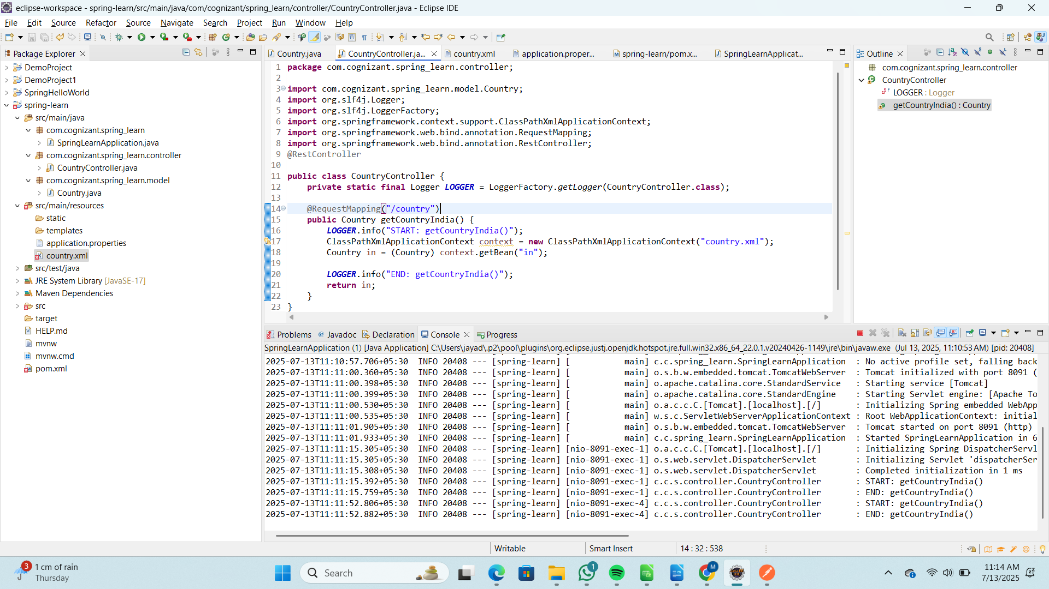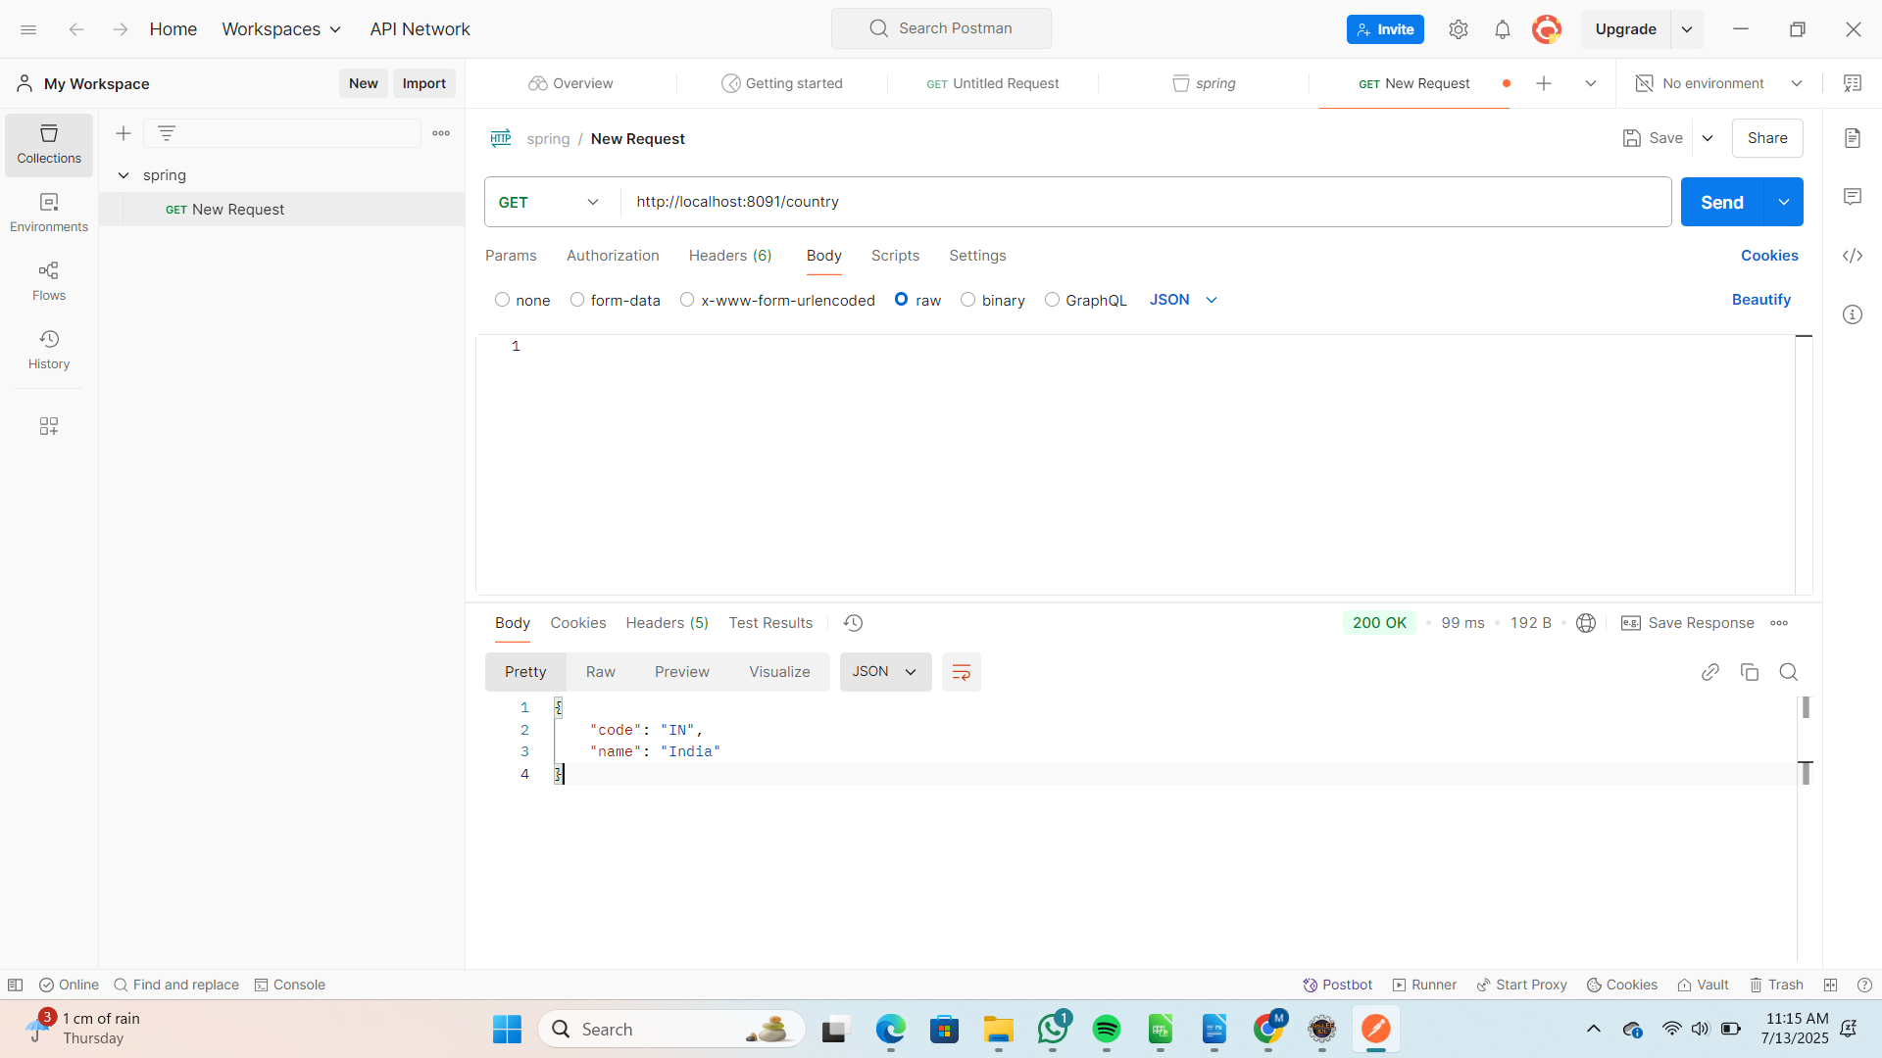

**5. Get country based on country code**

Code:

SpringLearnApplication.java

package com.cognizant.spring_learn;  
  
import org.springframework.boot.SpringApplication;  
import org.springframework.boot.autoconfigure.SpringBootApplication;  
  
@SpringBootApplication  
public class SpringLearnApplication {  
  
 public static void main(String[] args) {  
 SpringApplication.run(SpringLearnApplication.class, args);  
 }  
  
}  
  
CountryController.java

**package** com.cognizant.spring_learn.controller;

**import** org.springframework.beans.factory.annotation.Autowired;

**import** org.springframework.web.bind.annotation.*;

**import** com.cognizant.spring_learn.model.Country;

**import** com.cognizant.spring_learn.service.CountryService;

@RestController

**public** **class** CountryController {

@Autowired

**private** CountryService countryService;

@GetMapping("/countries/{code}")

**public** Country getCountry(@PathVariable String code) {

**return** countryService.getCountry(code);

}

}

Country.java

**package** com.cognizant.spring_learn.model;

**public** **class** Country {

**private** String code;

**private** String name;

**public** String getCode() {

**return** code;

}

**public** **void** setCode(String code) {

**this**.code = code;

}

**public** String getName() {

**return** name;

}

**public** **void** setName(String name) {

**this**.name = name;

}

@Override

**public** String toString() {

**return** "Country [code=" + code + ", name=" + name + "]";

}

}

CountryService.java

**package** com.cognizant.spring_learn.service;

**import** java.util.List;

**import** java.util.Optional;

**import** org.springframework.context.support.ClassPathXmlApplicationContext;

**import** org.springframework.stereotype.Service;

**import** com.cognizant.spring_learn.model.Country;

@Service

**public** **class** CountryService {

**public** Country getCountry(String code) {

ClassPathXmlApplicationContext context = **new** ClassPathXmlApplicationContext("country.xml");

List<Country> countries = (List<Country>) context.getBean("countries");

context.close();

Optional<Country> countryOptional = countries.stream()

.filter(c -> c.getCode().equalsIgnoreCase(code))

.findFirst();

**return** countryOptional.orElse(**null**);

}

}

country.xml

<?xml version="1.0" encoding="UTF-8"?>

<beans xmlns="http://www.springframework.org/schema/beans"

xmlns:xsi="http://www.w3.org/2001/XMLSchema-instance"

xsi:schemaLocation="http://www.springframework.org/schema/beans

https://www.springframework.org/schema/beans/spring-beans.xsd">

<bean id="in" class="com.cognizant.spring_learn.model.Country">

<property name="code" value="IN"/>

<property name="name" value="India"/>

</bean>

<bean id="us" class="com.cognizant.spring_learn.model.Country">

<property name="code" value="US"/>

<property name="name" value="United States"/>

</bean>

<bean id="countries" class="java.util.ArrayList">

<constructor-arg>

<list>

<ref bean="in"/>

<ref bean="us"/>

</list>

</constructor-arg>

</bean>

</beans>

Output:

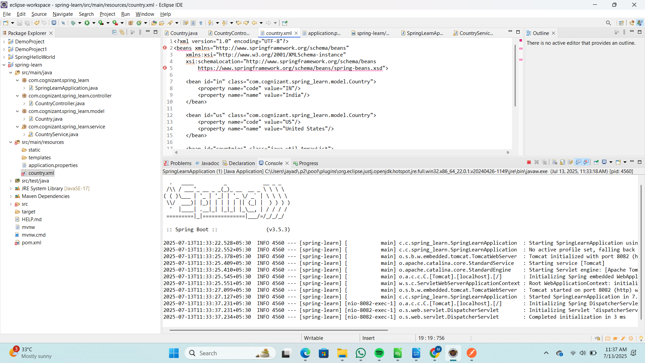  
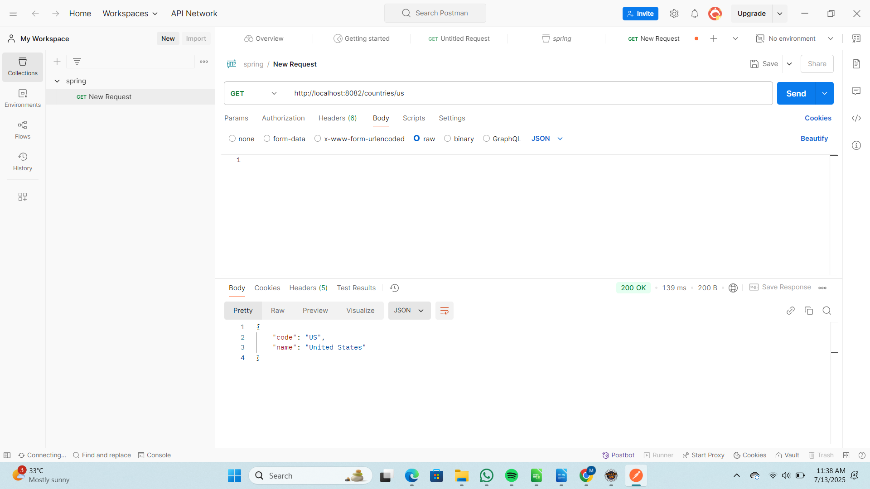  
  
**6.Create authentication service that returns JWT**

Code:

pom.xml

<dependencies>

<dependency>

<groupId>org.springframework.boot</groupId>

<artifactId>spring-boot-starter-web</artifactId>

</dependency>

<dependency>

<groupId>org.springframework.boot</groupId>

<artifactId>spring-boot-starter-security</artifactId>

</dependency>

<dependency>

<groupId>io.jsonwebtoken</groupId>

<artifactId>jjwt-api</artifactId>

<version>0.11.5</version>

</dependency>

<dependency>

<groupId>io.jsonwebtoken</groupId>

<artifactId>jjwt-impl</artifactId>

<version>0.11.5</version>

<scope>runtime</scope>

</dependency>

<dependency>

<groupId>io.jsonwebtoken</groupId>

<artifactId>jjwt-jackson</artifactId>

<version>0.11.5</version>

<scope>runtime</scope>

</dependency>

</dependencies>

AuthResponse.java

package com.cognizant.springjwt.model;

public class AuthResponse {

private String token;

public AuthResponse(String token) {

this.token = token;

}

public String getToken() {

return token;

}

}

JwtUtil.java

package com.cognizant.springjwt.util;

import io.jsonwebtoken.Jwts;

import io.jsonwebtoken.SignatureAlgorithm;

import io.jsonwebtoken.security.Keys;

import java.security.Key;

import java.util.Date;

public class JwtUtil {

private static final Key key = Keys.secretKeyFor(SignatureAlgorithm.HS256);

public static String generateToken(String username) {

return Jwts.builder()

.setSubject(username)

.setIssuedAt(new Date())

.setExpiration(new Date(System.currentTimeMillis() + 1000 * 60 * 10))

.signWith(key)

.compact();

}

}

AuthenticationController.java

package com.cognizant.springjwt.controller;

import com.cognizant.springjwt.model.AuthResponse;

import com.cognizant.springjwt.util.JwtUtil;

import org.springframework.web.bind.annotation.GetMapping;

import org.springframework.web.bind.annotation.RestController;

import java.nio.charset.StandardCharsets;

import java.util.Base64;

import javax.servlet.http.HttpServletRequest;

@RestController

public class AuthenticationController {

@GetMapping("/authenticate")

public AuthResponse authenticate(HttpServletRequest request) {

String authHeader = request.getHeader("Authorization");

if (authHeader != null && authHeader.startsWith("Basic ")) {

String base64Credentials = authHeader.substring("Basic ".length());

byte[] credDecoded = Base64.getDecoder().decode(base64Credentials);

String credentials = new String(credDecoded, StandardCharsets.UTF_8);

String[] values = credentials.split(":", 2);

String username = values[0];

String password = values[1];

if ("user".equals(username) && "pwd".equals(password)) {

String token = JwtUtil.generateToken(username);

return new AuthResponse(token);

}

}

throw new RuntimeException("Unauthorized");

}

}

SecurityConfig.java

package com.cognizant.springjwt.config;

import org.springframework.context.annotation.Bean;

import org.springframework.security.config.annotation.web.builders.HttpSecurity;

import org.springframework.security.web.SecurityFilterChain;

import org.springframework.context.annotation.Configuration;

@Configuration

public class SecurityConfig {

@Bean

public SecurityFilterChain filterChain(HttpSecurity http) throws Exception {

http.csrf().disable()

.authorizeHttpRequests()

.anyRequest()

.permitAll();

return http.build();

}

}