**Week 6 React Hands-On Exercises**

1.Create a new React Application with the name “myfirstreact”, Run the application to print “welcome to the first session of React” as heading of that page.

Code:

App.js

function App(){

  return(

    <div className = "center-container">

      <h1>This is my first react project</h1>

    </div>

  );

}

export default App;

App.css

.center-container {

  display: flex;

  justify-content: center;

  align-items: center;

  height: 100vh;

  background-color: #f4f4f4;

  text-align: center;

}

h1 {

  color: blue;

  font-size: 2rem;

  size: 100vh;

}

Output:

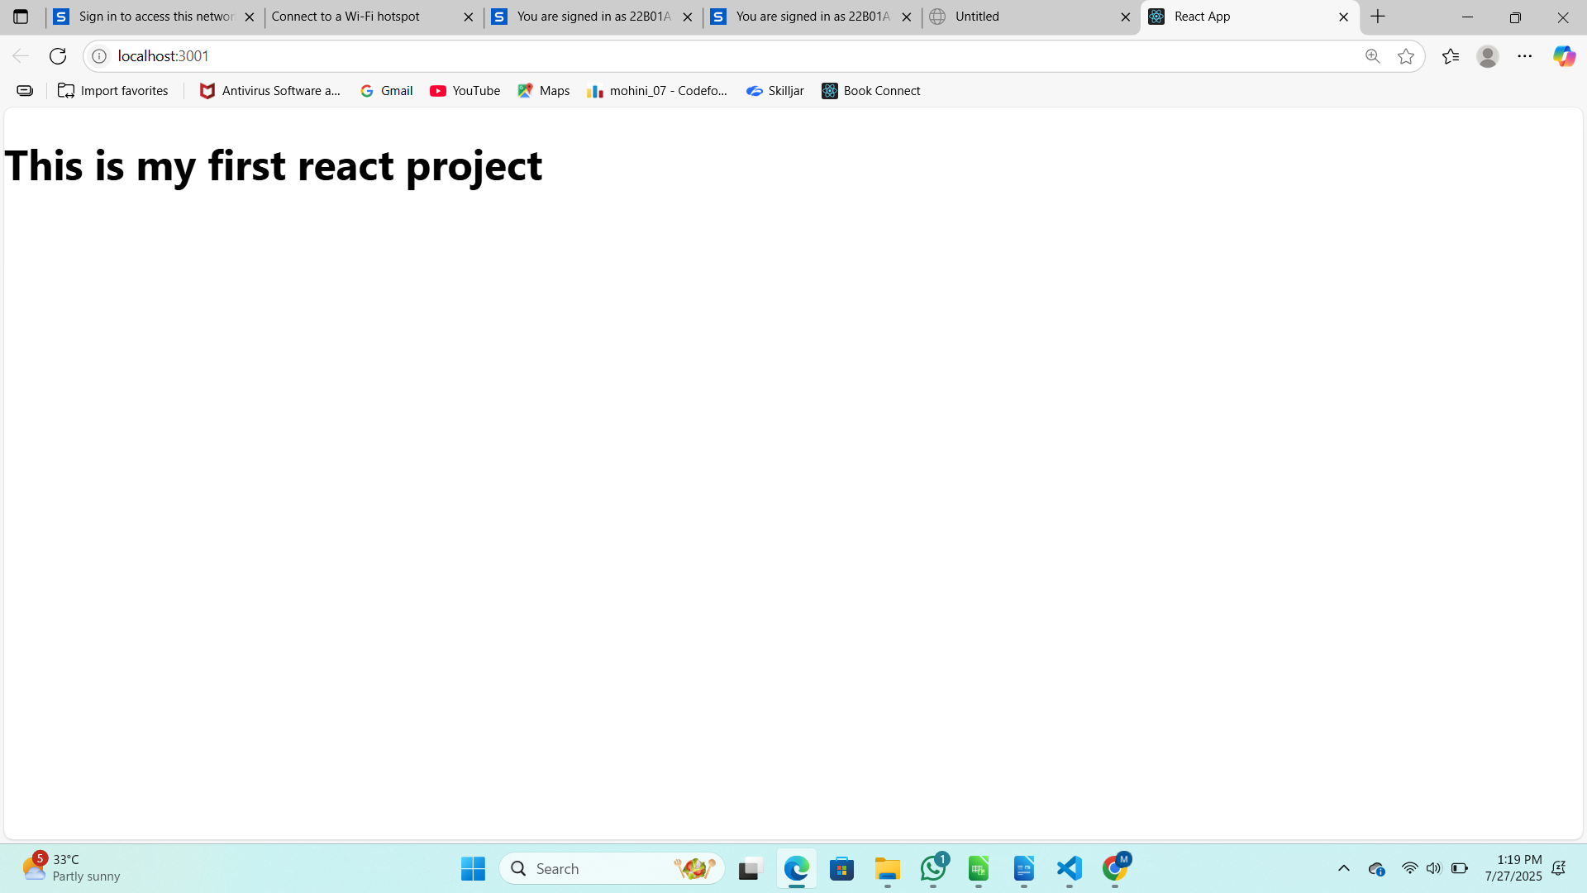  
  
2.Create a react app for Student Management Portal named StudentApp and create a component named Home which will display the Message “Welcome to the Home page of Student Management Portal”. Create another component named About and display the Message “Welcome to the About page of the Student Management Portal”. Create a third component named Contact and display the Message “Welcome to the Contact page of the Student Management Portal”. Call all the three components.

Code:

About.js

import React, { Component } from "react";

class About extends Component {

  render() {

    return (

      <div>

        <h3>Welcome to the About page of the Student Management Portal</h3>

      </div>

    );

  }

}

export default About;

Contact.js

import React, { Component } from "react";

class Contact extends Component {

  render() {

    return (

      <div>

        <h3>Welcome to the Contact page of the Student Management Portal</h3>

      </div>

    );

  }

}

export default Contact;

Home.js

import React, { Component } from "react";

class Home extends Component {

  render() {

    return (

      <div>

        <h3>Welcome to the Home page of Student Management Portal</h3>

      </div>

    );

  }

}

export default Home;

Output:

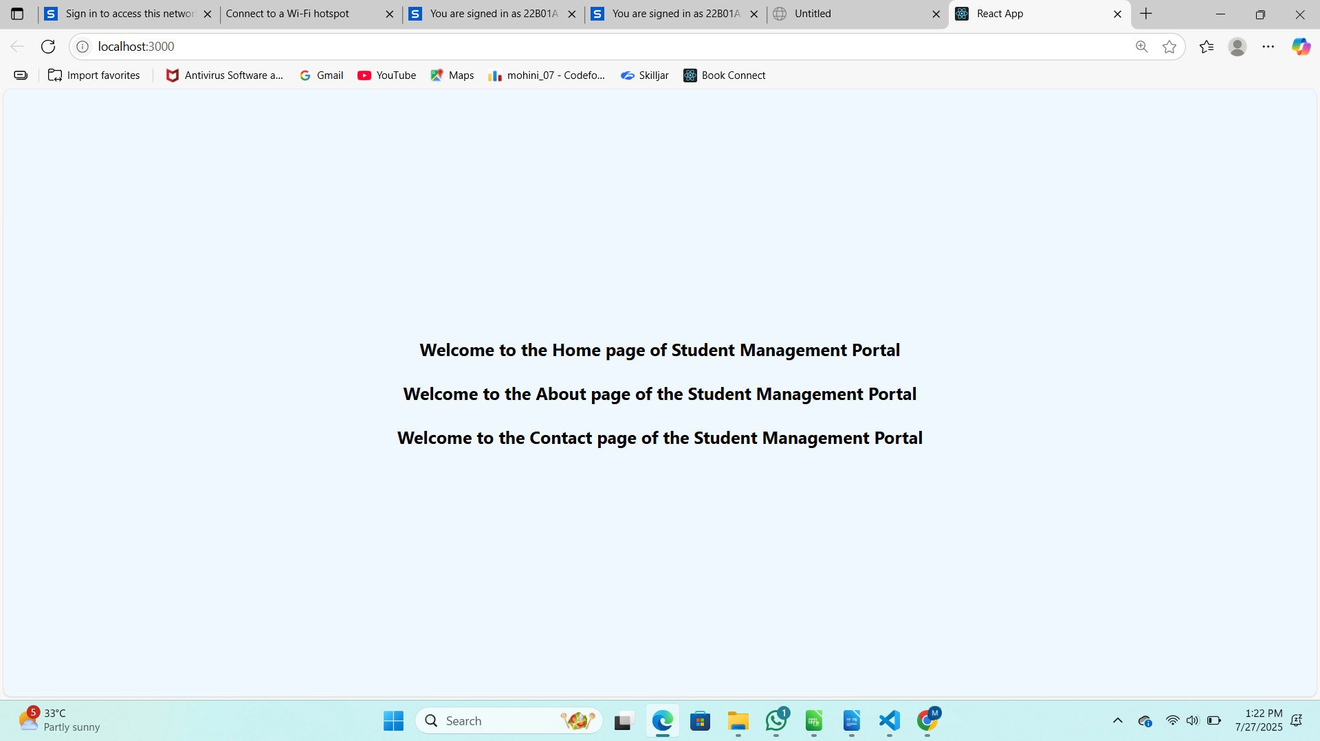  
  
3.Create a react app for Student Management Portal named scorecalculatorapp and create a function component named “CalculateScore” which will accept Name, School, Total and goal in order to calculate the average score of a student and display the same.

Code:

calculateScore.js

import React from "react";

import "../Stylesheets/mystyle.css";

function CalculateScore(props) {

  const { name, school, total, goal } = props;

  const average = total / goal;

  return (

    <div className="score-container">

      <h2>Student Score Calculator</h2>

      <p><strong>Name:</strong> {name}</p>

      <p><strong>School:</strong> {school}</p>

      <p><strong>Total Marks:</strong> {total}</p>

      <p><strong>Goal Subjects:</strong> {goal}</p>

      <h3>Average Score: {average.toFixed(2)}</h3>

    </div>

  );

}

export default CalculateScore;

mystyle.css

.score-container {

  text-align: center;

  background-color: #f0f8ff;

  padding: 20px;

  border: 2px solid #ddd;

  border-radius: 10px;

  width: 400px;

  margin: 50px auto;

  box-shadow: 0 4px 8px rgba(0, 0, 0, 0.1);

}

.score-container h2 {

  color: #2a4d69;

  margin-bottom: 15px;

}

.score-container p,

.score-container h3 {

  font-size: 18px;

  margin: 5px 0;

}

Output:

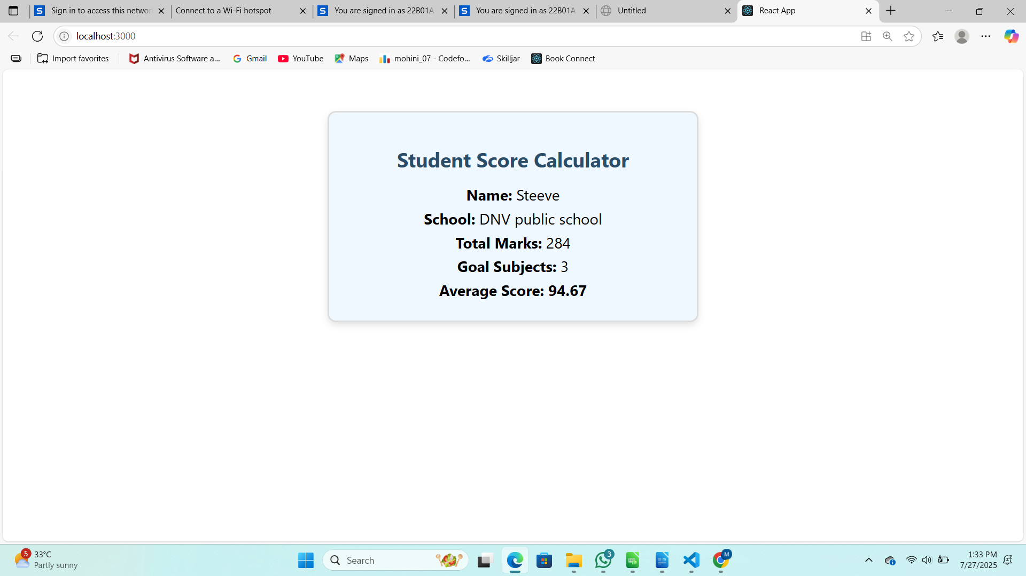  
  
4.Create a new react application using *create-react-app* tool with the name as “blogapp”.

Code:

Posts.js

import React from "react";

import Post from "./Post";

class Posts extends React.Component {

  constructor(props) {

    super(props);

    this.state = {

      posts: [],

      error: null

    };

  }

  loadPosts = () => {

    fetch("https://jsonplaceholder.typicode.com/posts")

      .then(response => response.json())

      .then(data => {

        this.setState({ posts: data });

      })

      .catch(error => {

        this.setState({ error: error.message });

      });

  };

  componentDidMount() {

    this.loadPosts();

  }

  componentDidCatch(error, info) {

    alert("An error occurred: " + error);

  }

  render() {

    const { posts, error } = this.state;

    if (error) {

      return <p style={{ color: "red" }}>Error: {error}</p>;

    }

    return (

      <div>

        <h2>Blog Posts</h2>

        {posts.length === 0 ? (

          <p>Loading posts...</p>

        ) : (

          posts.map(post => <Post key={post.id} title={post.title} body={post.body} />)

        )}

      </div>

    );

  }

}

export default Posts;

Output:

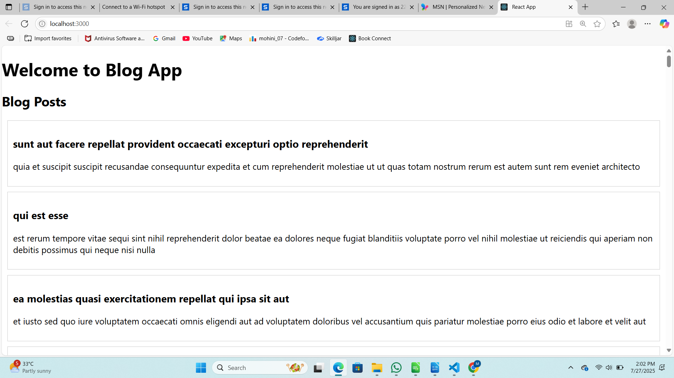  
  
5.My Academy team at Cognizant want to create a dashboard containing the details of ongoing and completed cohorts. A react application is created which displays the detail of the cohorts using react component. You are assigned the task of styling these react components.

Code:

CohortDetails.js

import styles from './CohortDetails.module.css';

function CohortDetails(props) {

  const { name, status, startDate, endDate } = props;

  const headingStyle = {

    color: status === "ongoing" ? "green" : "blue"

  };

  return (

    <div className={styles.box}>

      <h3 style={headingStyle}>{name}</h3>

      <dl>

        <dt>Status:</dt>

        <dd>{status}</dd>

        <dt>Start Date:</dt>

        <dd>{startDate}</dd>

        <dt>End Date:</dt>

        <dd>{endDate}</dd>

      </dl>

    </div>

  );

}

export default CohortDetails;

CohortDetails.module.css

.box {

  width: 300px;

  display: inline-block;

  margin: 10px;

  padding: 10px 20px;

  border: 1px solid black;

  border-radius: 10px;

}

dt {

  font-weight: 500;

}

Output:

