Week 7 React Hands-On
9. cricketapp

Code:

ListofPlayers.js

import React from "react";

const ListofPlayers = () => {
const players = [
{ name: "Virat Kohli", score: 85 },
{ name: "Rohit Sharma", score: 60 },
{ name: "Shubman Gill", score: 45 },
{ name: "Hardik Pandya", score: 75 },
{ name: "Suryakumar Yadav", score: 50 },
{ name: "Rishabh Pant", score: 90 },
{ name: "Ravindra Jadeja", score: 40 },
{ name: "KL Rahul", score: 100 },
{ name: "Bumrah", score: 65 },
{ name: "Shami", score: 30 },
{ name: "Kuldeep Yadav", score: 80 },
];

const lowScorers = players.filter((player) => player.score < 70);

return (
<div>
<h2>All Players and Scores</h2>
<ul>
{players.map((player, index) => (
<li key={index}>
{player.name} - {player.score}
</li>
))}
</ul>

<h2>Players with Score Below 70</h2>
<ul>
{lowScorers.map((player, index) => (
<li key={index}>
{player.name} - {player.score}
</li>
))}
</ul>
</div>
);
};

export default ListofPlayers;

IndianPlayers.js

import React from "react";

const IndianPlayers = () => {
const team = ["Virat", "Rohit", "Gill", "Hardik", "Pant", "Jadeja"];

const oddTeamPlayers = team.filter((_, index) => index % 2 !== 0);
const evenTeamPlayers = team.filter((_, index) => index % 2 === 0);

const T20players = ["Virat", "Rohit", "Bumrah"];
const RanjiTrophyPlayers = ["Pujara", "Rahane", "Ishant"];

const mergedPlayers = [...T20players, ...RanjiTrophyPlayers];

return (
<div>
<h2>Odd Team Players</h2>
<ul>
{oddTeamPlayers.map((player, index) => (
<li key={index}>{player}</li>
))}
</ul>

<h2>Even Team Players</h2>
<ul>
{evenTeamPlayers.map((player, index) => (
<li key={index}>{player}</li>
))}
</ul>

<h2>Merged T20 and Ranji Trophy Players</h2>
<ul>
{mergedPlayers.map((player, index) => (
<li key={index}>{player}</li>
))}
</ul>
</div>
);
};

export default IndianPlayers;

Output:

when flag=true
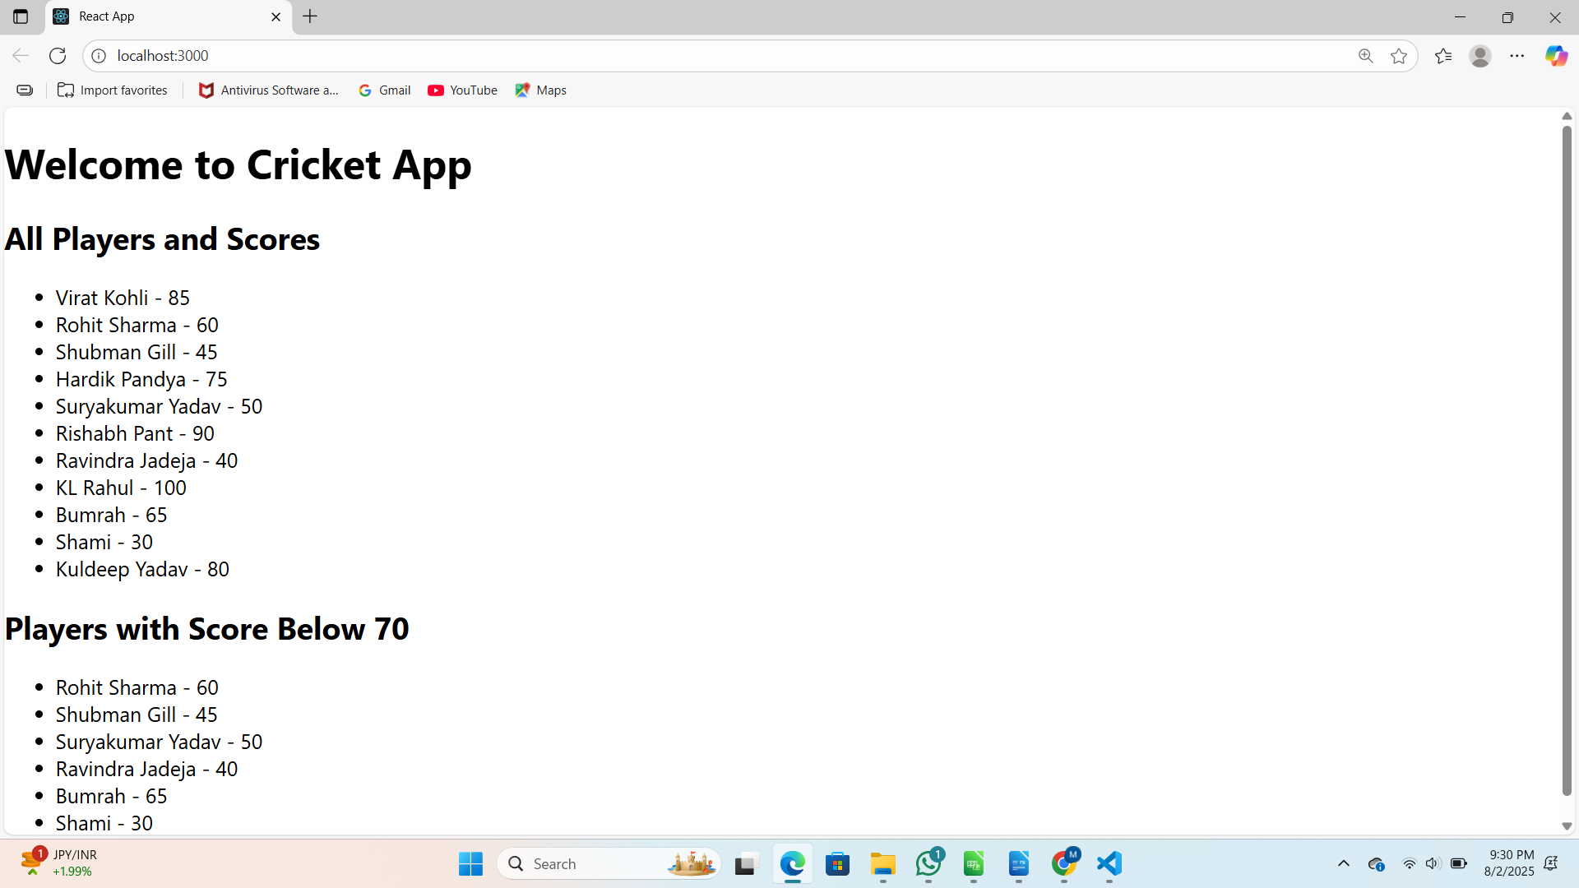
when flag is false
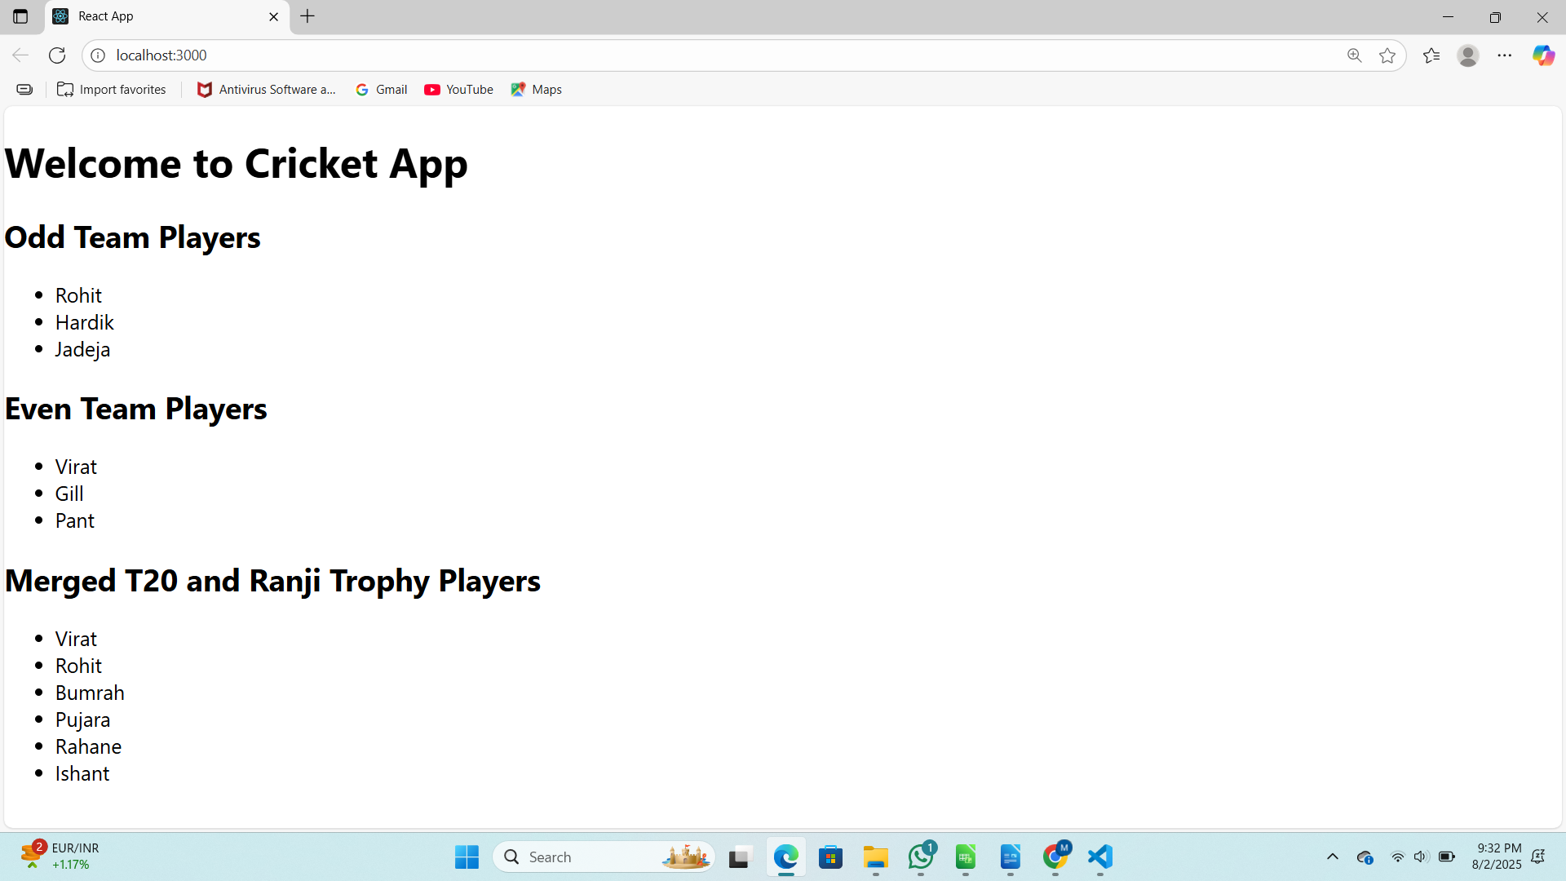
10. officespacerentalapp

Code:

App.js

import React from "react";
import "./App.css";

function App() {
const office = {
name: "WeWork Tower",
rent: 55000,
address: "Bangalore, MG Road",
image:
"https://images.unsplash.com/photo-1504384308090-c894fdcc538d?w=600&auto=format&fit=crop"
};

const officeList = [
{
name: "WeWork Tower",
rent: 55000,
address: "Bangalore, MG Road",
image:
"https://images.unsplash.com/photo-1504384308090-c894fdcc538d?w=600&auto=format&fit=crop"
},
{
name: "Regus Office",
rent: 70000,
address: "Hyderabad, Gachibowli",
image:
"https://images.unsplash.com/photo-1590490360182-c33d57733427?w=600&auto=format&fit=crop"
},
{
name: "Innov8 Space",
rent: 45000,
address: "Mumbai, Andheri",
image:
"https://images.unsplash.com/photo-1524758631624-e2822e304c36?w=600&auto=format&fit=crop"
}
];

return (
<div className="App">
{/* Heading */}
<h1>Office Space Rental</h1>

{/* Displaying Single Office Details */}
<div className="office-card">
<img src={office.image} alt={office.name} width="250" />
<h2>{office.name}</h2>
<p>
Rent:{" "}
<span
style={{
color: office.rent < 60000 ? "red" : "green"
}}
>
₹{office.rent}
</span>
</p>
<p>Address: {office.address}</p>
</div>

{/* Display list of offices */}
<h2>All Available Offices</h2>
<div className="office-list">
{officeList.map((officeItem, index) => (
<div key={index} className="office-card">
<img src={officeItem.image} alt={officeItem.name} width="250" />
<h3>{officeItem.name}</h3>
<p>
Rent:{" "}
<span
style={{
color: officeItem.rent < 60000 ? "red" : "green"
}}
>
₹{officeItem.rent}
</span>
</p>
<p>Address: {officeItem.address}</p>
</div>
))}
</div>
</div>
);
}

export default App;

App.css

.App {
text-align: center;
font-family: Arial, sans-serif;
padding: 20px;
}

.office-card {
border: 1px solid #ddd;
border-radius: 8px;
padding: 15px;
margin: 15px auto;
width: 300px;
text-align: center;
box-shadow: 0px 2px 6px rgba(0,0,0,0.2);
}

.office-list {
display: flex;
justify-content: center;
flex-wrap: wrap;
gap: 20px;
}

Output:

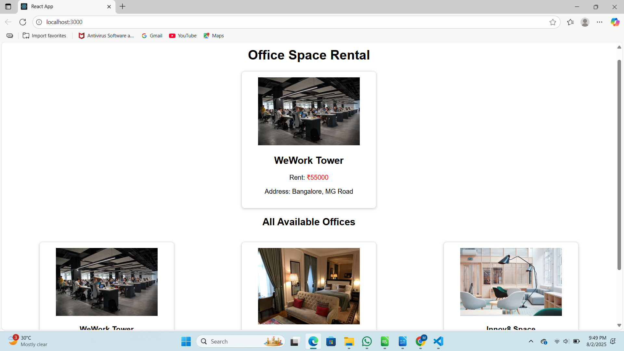
11. eventexamplesapp

Code:

CurrencyConvertor.js

import React, { useState } from "react";
import "./App.css";
import CurrencyConvertor from "./CurrencyConvertor";

function App() {
const [counter, setCounter] = useState(0);

const handleIncrement = () => {
setCounter(counter + 1);
};

const sayHello = () => {
alert("Hello! This is a static message.");
};

const handleDecrement = () => {
setCounter(counter - 1);
};

const sayWelcome = (message) => {
alert(message);
};

const handleSyntheticEvent = (e) => {
alert("I was clicked");
};

const handleMultiple = () => {
handleIncrement();
sayHello();
};

return (
<div className="App">
<h1>Event Examples App</h1>
<h2>Counter: {counter}</h2>

{/* Increment and Decrement Buttons */}
<button onClick={handleMultiple}>Increment (Multiple Actions)</button>
<button onClick={handleDecrement}>Decrement</button>

<hr />

{/* Say Welcome Button */}
<button onClick={() => sayWelcome("Welcome!")}>Say Welcome</button>

<hr />

{/* Synthetic Event Button */}
<button onClick={handleSyntheticEvent}>Synthetic Event Button</button>

<hr />

{/* CurrencyConvertor Component */}
<CurrencyConvertor />
</div>
);
}

export default App;

Output:
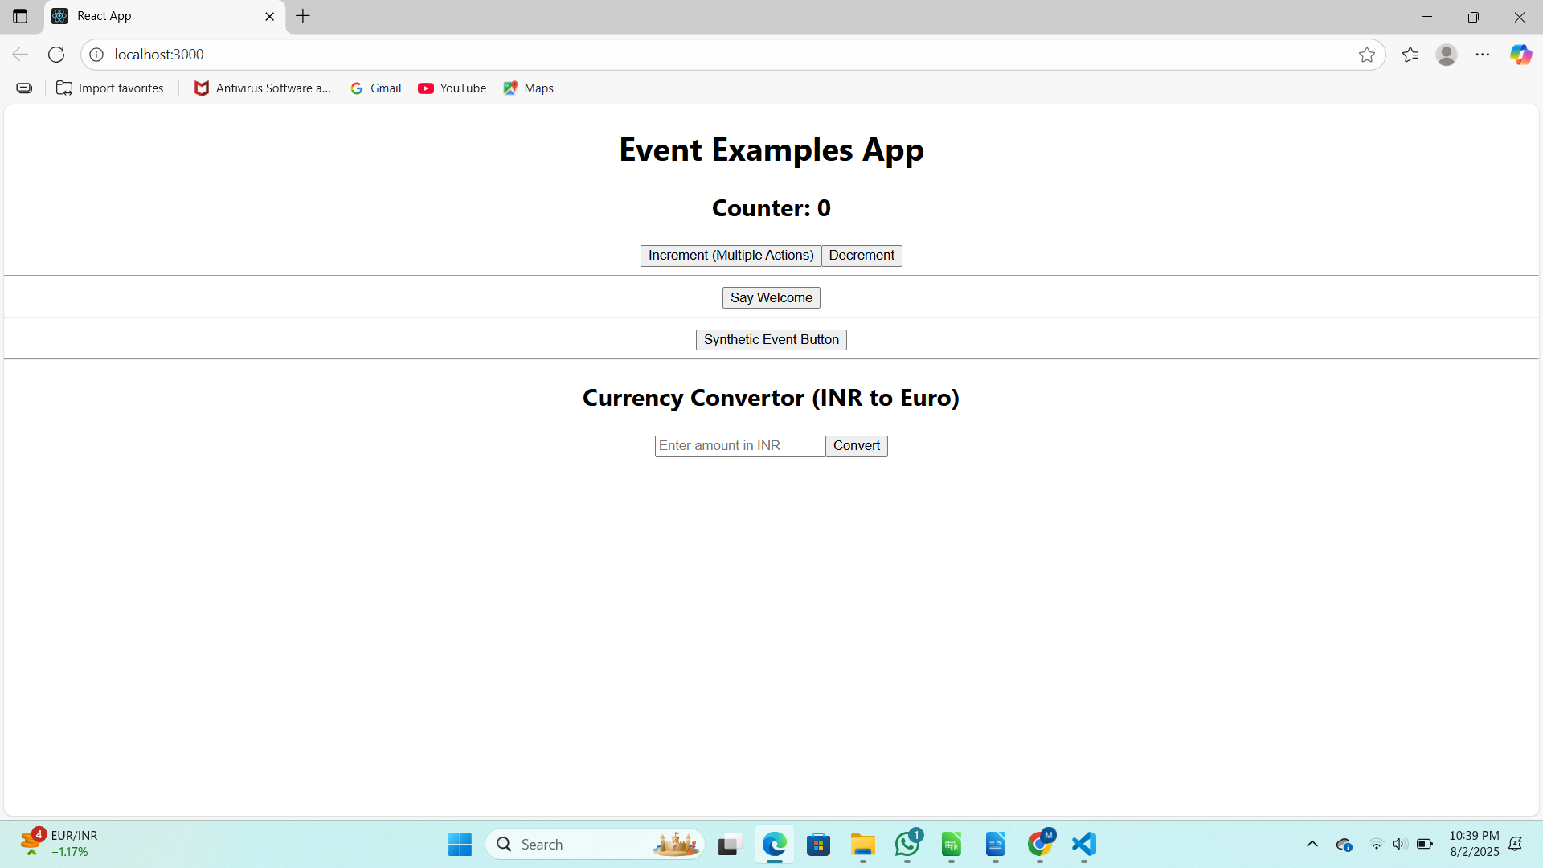
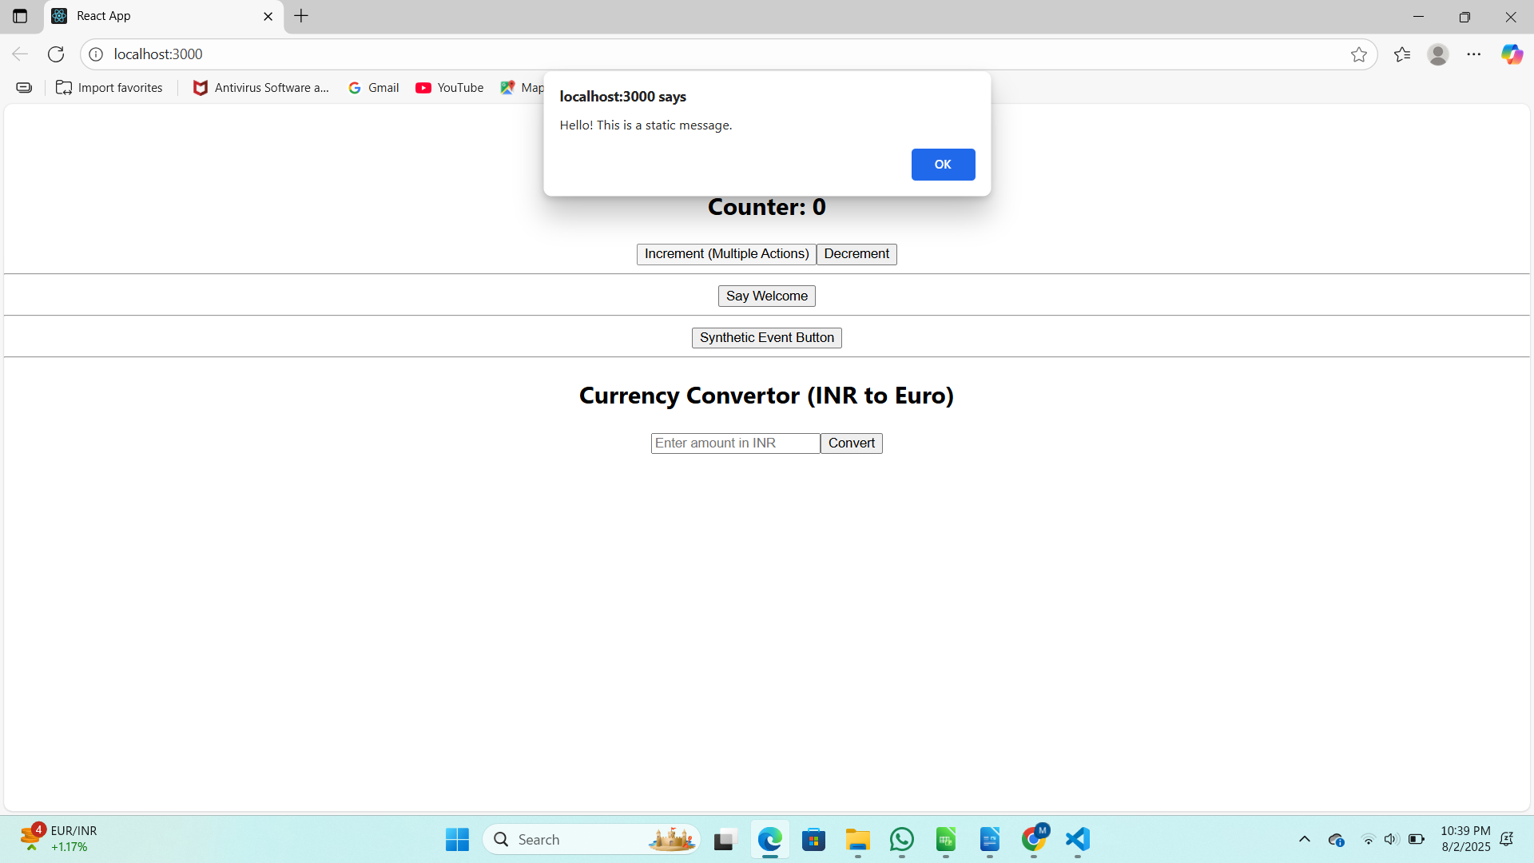
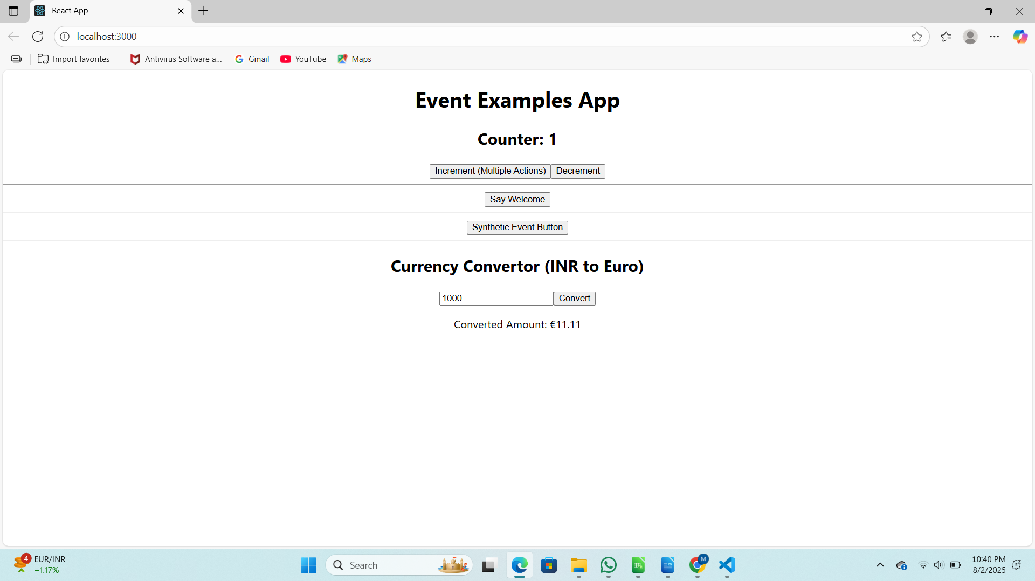

12. ticketbookingapp

Code:

GuestPage.js

import React from "react";

function GuestPage() {
return (
<div>
<h2>Welcome Guest</h2>
<p>You can browse the available flights below:</p>
<ul>
<li>Flight 101 - Delhi to Mumbai - 10:00 AM</li>
<li>Flight 102 - Bangalore to Pune - 2:00 PM</li>
<li>Flight 103 - Chennai to Hyderabad - 6:00 PM</li>
</ul>
<p>Please login to book tickets.</p>
</div>
);
}

export default GuestPage;

UserPage.js

import React from "react";

function UserPage() {
return (
<div>
<h2>Welcome User</h2>
<p>You are logged in and can now book tickets:</p>
<ul>
<li>
Flight 101 - Delhi to Mumbai - 10:00 AM{" "}
<button>Book Now</button>
</li>
<li>
Flight 102 - Bangalore to Pune - 2:00 PM{" "}
<button>Book Now</button>
</li>
<li>
Flight 103 - Chennai to Hyderabad - 6:00 PM{" "}
<button>Book Now</button>
</li>
</ul>
</div>
);
}

export default UserPage;

Output:

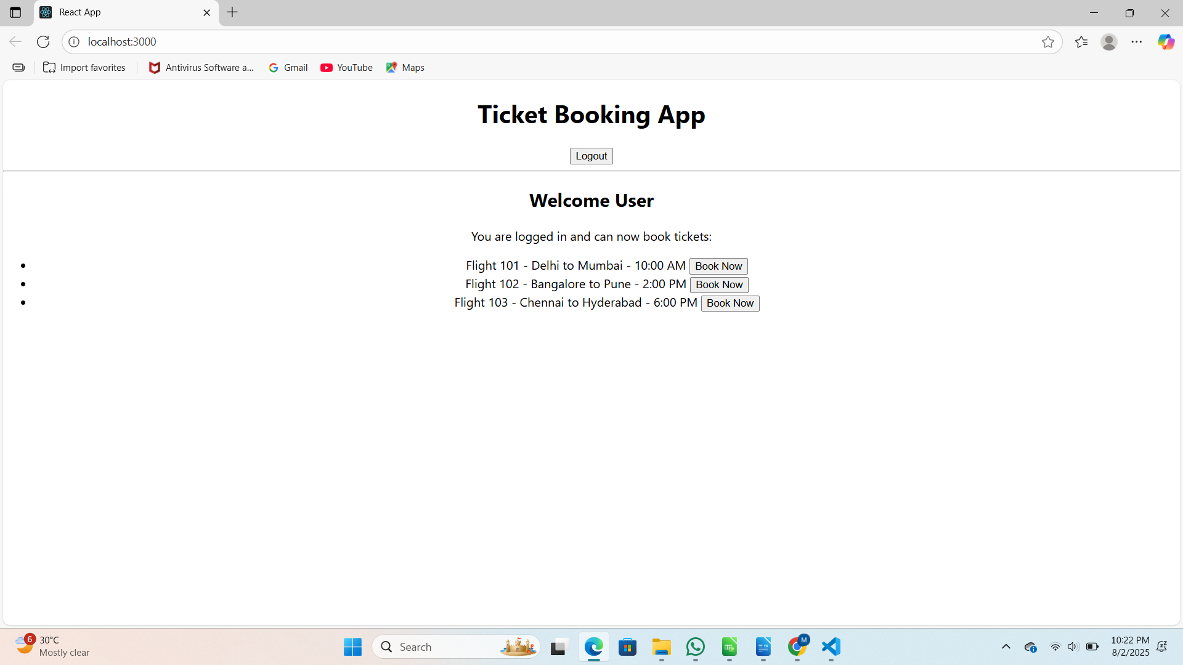

13. bloggerapp

Code:

BlogDetails.js

import React from "react";

function BlogDetails() {
return (
<div>
<h2>Blog Details</h2>
<p>Title: Learning Conditional Rendering in React</p>
<p>Author: Jane Smith</p>
</div>
);
}

export default BlogDetails;

CourseDetails.js

import React from "react";

function CourseDetails() {
return (
<div>
<h2>Course Details</h2>
<p>Course: Advanced React</p>
<p>Duration: 3 Months</p>
</div>
);
}

export default CourseDetails;
Output:
